Supplemental appendix

Effectiveness and safety of regdanvimab in patients with mild-to-moderate COVID-19: A retrospective cohort study

Table of contents (page)
2 | Supplemental Figure 1. Distribution of covariates before and after propensity matching study patients who were and were not treated with regdanvimab.
4 | Supplemental Figure 2. Standardized mean differences in unadjusted and adjusted cohorts.
5 | Supplemental Table 1. Missing baseline laboratory data in propensity score-matched cohort.
6 | Supplemental Table 2. Associations between regdanvimab and primary endpoint in propensity score-matched and overall cohorts.
7 | Supplemental Table 3. Clinical outcomes in overall cohort.
8 | Supplemental Table 4. Other exposures for treating COVID-19 in propensity score matched cohort.

Supplemental Figure 1. Distribution of covariates before and after propensity matching study patients who were and were not treated with regdanvimab.
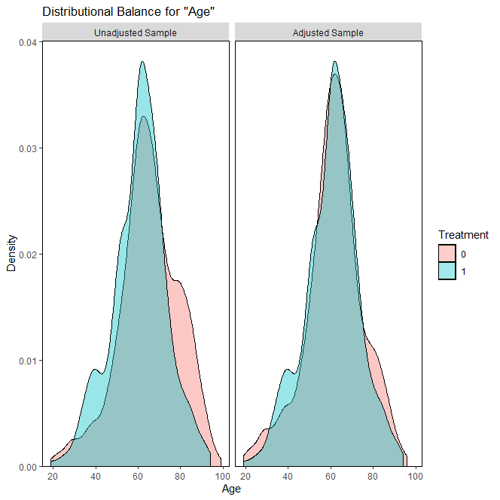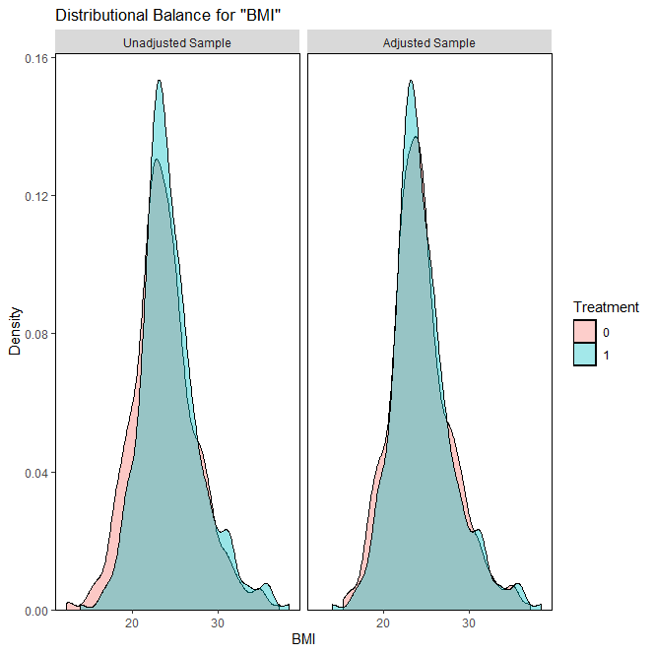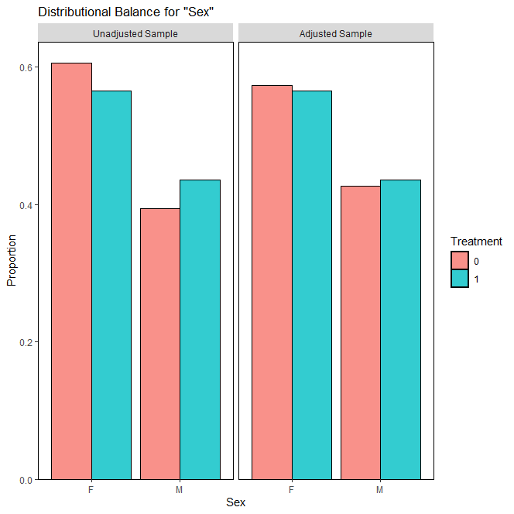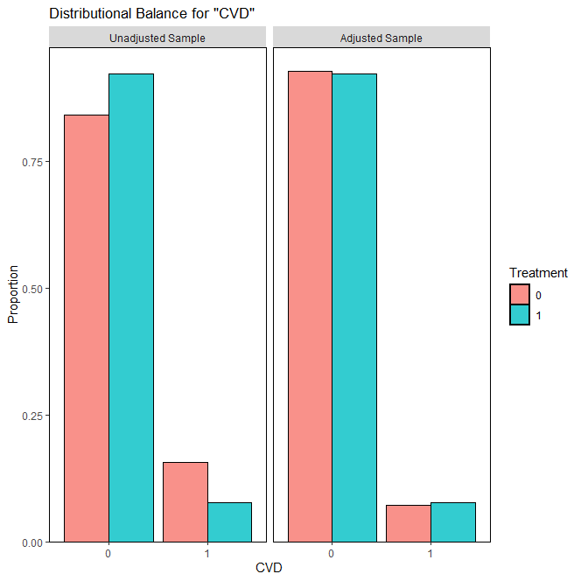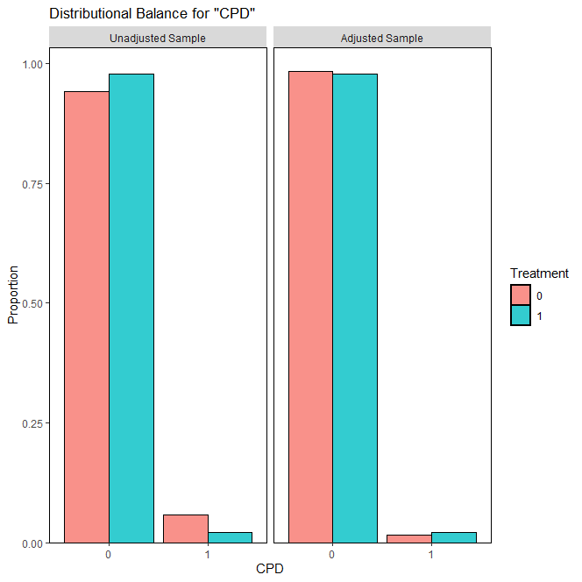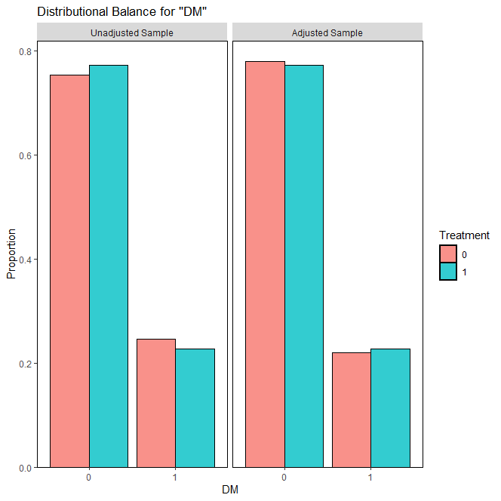
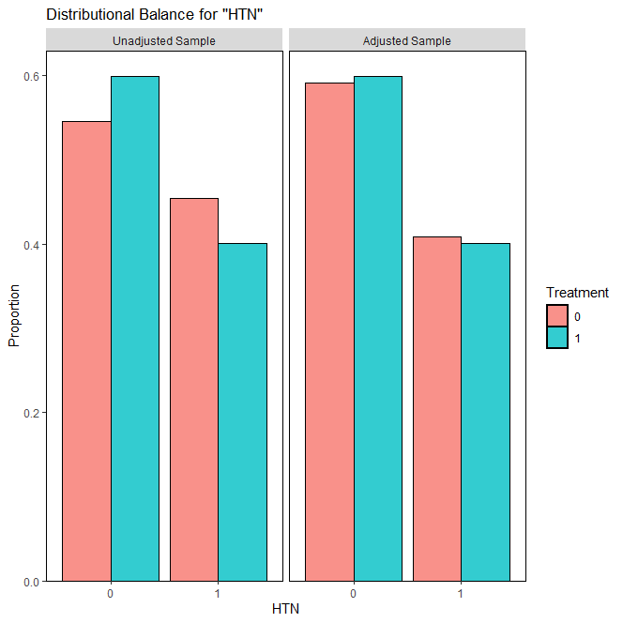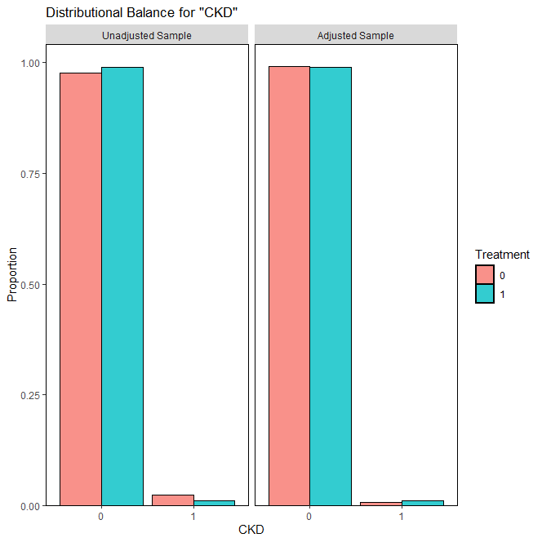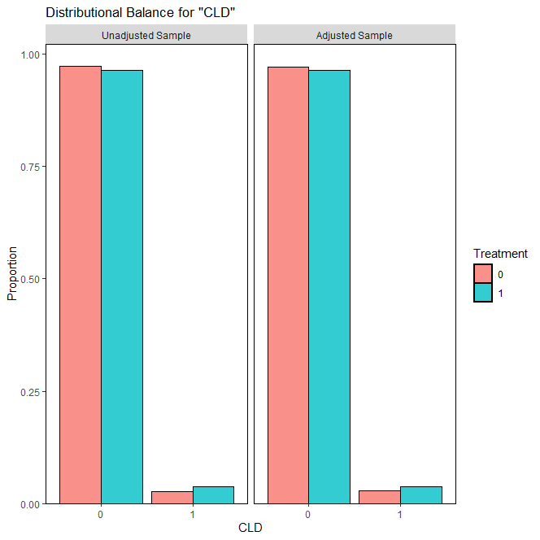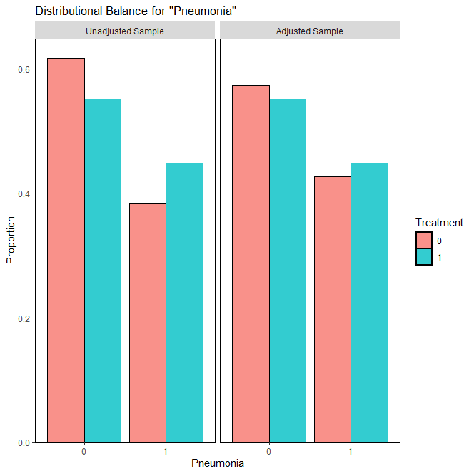

Supplemental Figure 2. Standardized mean differences in unadjusted and adjusted cohorts.
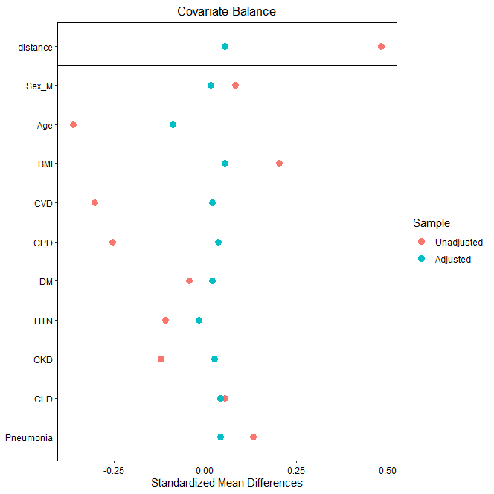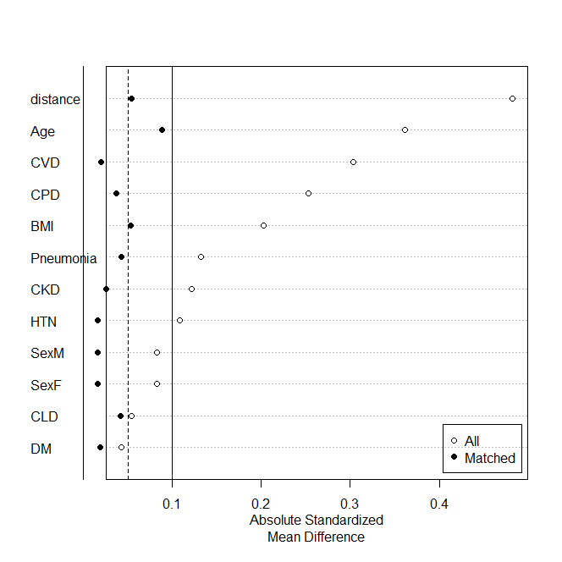

Supplemental Table 1. Missing baseline laboratory data in propensity score-matched cohort.
 | No Regdanvimab  (n=377) | Regdanvimab  (n=377)
White blood cell count | 2 (0.5%) | 0
Hemoglobin | 2 (0.5%) | 0
Platelet count | 2 (0.5%) | 0
Absolute neutrophil count | 2 (0.5%) | 0
Absolute lymphocyte count | 2 (0.5%) | 0
Na | 2 (0.5%) | 0
K | 2 (0.5%) | 0
Creatinine | 2 (0.5%) | 0
Glomerular filtration rate | 2 (0.5%) | 0
AST | 2 (0.5%) | 0
ALT | 2 (0.5%) | 0
Total bilirubin | 2 (0.5%) | 0
CRP | 2 (0.5%) | 0
LDH | 2 (0.5%) | 1 (0.3%)
D-dimer | 33 (8.8%) | 49 (13.0%)
Troponin I | 23 (6.1%) | 48 (12.7%)
Ferritin | 59 (15.6%) | 62 (16.4%)
Creatine kinase | 21 (5.6%) | 47 (12.5%)

ALT, alanine transaminase; AST, aspartate transaminase; CRP, C-reactive protein; LDH, lactate dehydrogenase.

Supplemental Table 2. Associations between regdanvimab and primary endpoint in propensity score-matched and overall cohorts.
 | OR | 95% CI | p value
PS-matched cohort
Univariate | 0.194 | 0.112-0.320 | <0.001
Multivariable | 0.169 | 0.095-0.289 | <0.001
Multivariable (by stepwise) | 0.169 | 0.095-0.287 | <0.001
Overall cohort
Multivariable | 0.148 | 0.084-0.247 | <0.001
Multivariable (by stepwise) | 0.151 | 0.087-0.251 | <0.001
CI, confidence interval; OR, odds ratio; PS, propensity score.

Supplemental Table 3. Clinical outcomes in overall cohort.
 | No Regdanvimab  (n=520, 58.0%) |  | Regdanvimab  (n=377, 42.0%) |  | p
Death | 17 | (3.3%) | 0 | (0.0%) | <0.001
Disease aggravation | 132 | (25.4%) | 19 | (5.0%) | <0.001
Composite primary endpoint | 133 | (25.6%) | 19 | (5.0%) | <0.001

Supplemental Table 4. Other exposures for treating COVID-19 in propensity score-matched cohort.
 | No Regdanvimab  (n=377) |  | Regdanvimab  (n=377) |  | p
Remdesivir | 62 | (16.4%) | 10 | (2.7%) | <0.001
Hydroxychloroquine | 1 | (0.3%) | 1 | (0.3%) | 1.000*
Azithromycin | 235 | (62.3%) | 21 | (5.6%) | <0.001
Lopinavir/ritonavir | 59 | (15.6%) | 0 | (0.0%) | <0.001
Corticosteroids | 180 | (47.7%) | 90 | (23.9%) | <0.001
Variables and hydroxychloroquine were respectively analyzed using chi-squared and *Fisher’s exact test.

