SUPPLEMENTARY INFORMATION:

Theoretical Insights into Drug–Solvent Interactions of Ibuprofen and Mefenamic Acid in Water and Choline Chloride–Propylene Glycol Deep Eutectic Solvent

Toyese Oyegoke* and Umar Mogaji Muhammed
CAD Engineering of Processes & Reactive Interfaces (CEPRIs) Group, Chemical Engineering Department, Ahmadu Bello University, Faculty of Engineering, Samaru, Zaria, Nigeria.
*Corresponding email: OyegokeToyese@gmail.com

Contents
Appendix S1. Molecular Properties and Validation of DES Model Components 2
Appendix S2. Evaluation of DES Formation Pathways and Stability 3
Appendix S3. Identification of Thermodynamically Feasible DES Formation Routes 7
Appendix S4. Other Information for Computational Method Details 9
4.01 Study strategy 9
4.02 Modelling of HBA, HBD, water, and drugs used in the study 10
4.03 Evaluation of the DES models’ components and its formation mechanism 10
4.04 Molecular interaction analysis of the solvents with IBU and MFA 11
4.05 Evaluation of the solubility of the drugs in DES and water 11
Appendix S5. Solvation Correct Energy & Thermodynamic Calculations 11
5.01 Selecting Computational Method for Solvation Correct Energy Calculations 11
5.02 Details of the Results Collected for Corrected Solubility Strength (SScorr) and the Uncorrected (SS) Calculations 13
5.03 Details of the Results Collected for Thermodynamic Calculations 13
(a) Computational Methodology for Gas and Liquid-Phase Thermodynamic Properties 13
(b) Enthalpy change calculations 15
(c) Entropy changes calculations 15
(d) Gibbs free energy change calculations 15
(e) Summary of the solubility and thermodynamic analysis 15
List of relevant references 16

Molecular Properties and Validation of DES Model Components
The frontier molecular orbital (FMO) analysis (Table 1) shows that choline chloride (CHL) possesses a smaller HOMO–LUMO energy gap than propylene glycol (PG), indicating higher chemical reactivity of CHL in the CHL–PG Deep Eutectic Solvent (DES). The interaction of CHL through its HOMO and PG through its LUMO results in an electronic compatibility gap of 11.60 eV, consistent with the established role of CHL as the electron donor and PG as the electron acceptor during hydrogen-bond formation.
Table 1: HOMO-LUMO properties of the DES model components
Specie | E (HOMO) (eV) | E (LUMO) (eV) | E Gap
Choline chloride (CHL) | -7.85 | 3.06 | 10.91
Propylene Glycol (PG) | -9.70 | 3.75 | 13.45

The reliability of the molecular models was assessed through infrared (IR) spectral validation. CHL had been previously validated in our earlier studies. For PG, a DFT-calculated IR spectrum (Figure 1) was
generated and compared with experimental data from literature [1]. The computed peak positions, including C–H stretching (2916–2933 cm⁻¹), C–H bending (1304–1475 cm⁻¹), C–O stretching (1041–1211 cm⁻¹), and C–H wagging (814–960 cm⁻¹), which show good agreement with experimental absorptions (Table 2).
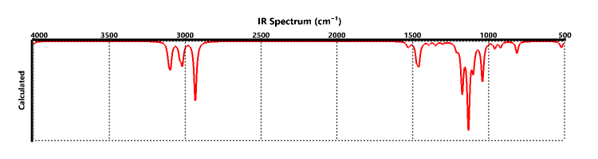
Figure 1: IR analysis of Propylene glycol using DFT

Table 2: Comparison of theoretical and experimental IR peaks for propylene glycol
Peaks | DFT (cm⁻¹) | Expt. (cm⁻¹) [2]
O–H stretching, broad (3200–3600) | - | 3550–3200
C–H stretching (2850–3000) | 2916, 2933 | 2975, 2935, 2870
C–H stretching (3000–3100) | 3019, 3035, 3096, 3108 | 3000
C–H bending (1350–1470) | 1304, 1349, 1394, 1439, 1460, 1475 | 1460, 1375
C–O stretching of alcohol  (1000–1260) | 1041, 1101, 1133, 1174, 1211 | 1120, 1070, 1040
C–H wagging (720–900) | 814, 922, 960 | 890, 820, 750
Not available | 521 | 600
Although the broad O–H stretch typically observed at 3550–3200 cm⁻¹ does not appear as a distinct DFT band, the overall spectral concordance confirms the accuracy of the optimized PG structure. These results validate the suitability of the CHL–PG molecular models for subsequent DES interaction and CO₂ capture simulations.

Evaluation of DES Formation Pathways and Stability
Possible hydrogen-bonding interactions between CHL (HBA) and PG (HBD) were evaluated across six CHL functional sites (H₃C, H₂C, H₂CO, NCl, ClN, and OHC) using their respective hydrogen donors on PG (HOCH, HCOH, HCH₂, HCH, HOCH₂). The unbonded CHL–PG pair exhibits a formation energy of −0.96 eV (Table 3), confirming thermodynamic feasibility prior to hydrogen-bond formation.
Table 3:Electronic energies of DES model components
Label | Mol. Wt. (amu) | Energy (eV) | Formation Energy (eV)
Choline Chloride (CHL) | 139.63 | -21467.85 | -
Propylene Glycol (PG) | 76.10 | -7332.78 | -
CHL: PG (Unbonded) | 215.72 | -28801.59 | −0.96

Across the evaluated single-site interactions, several stabilizing pathways were identified. At the H₃C site, the H₃C–HOCH configuration (−1.04 eV) was the most favorable (Table 4). The H₂C site produced stronger interactions, notably H₂C–HCOH (−1.08 eV) and H₂C–HCH₂ (−1.06 eV) (Table 5).
Table 4: Stability of the CHL-PG DES via H3C- as a point of interaction
HBA Sites | HBD Sites | Energy (eV) | Formation Energy (eV)
H₃C | HOCH | -28801.66 | -1.04
H₃C | HCOH | -28801.59 | -0.96
H₃C | HCH₂ | -28801.59 | -0.96
H₃C | HCH | -28800.88 | -0.25
H₃C | HOCH₂ | -28800.95 | -0.33
Table 5: Stability of the CHL-PG DES via H₂C- as a point of interaction
HBA Sites | HBD Sites | Energy (eV) | Formation Energy (eV)
H₂C | HOCH | -28801.62 | -1.00
H₂C | HCOH | -28801.71 | -1.08
H₂C | HCH₂ | -28801.69 | -1.06
H₂C | HCH | -28801.56 | -0.93
H₂C | HOCH₂ | -28801.62 | -0.99

Table 6: Stability of the CHL-PG DES via OHC- as a point of interaction
HBA Sites | HBD Sites | Energy (eV) | Formation Energy (eV)
OHC | HOCH | -28801.51 | -0.89
OHC | HCOH | -28801.20 | -0.58
OHC | HCH₂ | -28801.71 | -1.08
OHC | HCH | -28802.03 | -1.40
OHC | HOCH₂ | -28801.49 | -0.86

The OHC site demonstrated significant stabilization via the OHC–HCH pathway (−1.40 eV) in the result presented in Table 6. The NCl and ClN sites showed comparatively weaker interactions (−0.38 to −0.86 eV), indicating limited but non-negligible contributions to DES structuring as shown in Tables 7 and 8, which was due to their lower negative formation energies obtained for NCl and ClN sites compared to what was obtained for other sites involved in other pathways, in line with the existing related literature [1, 3, 4] that suggest that more negative formation or reaction energies implies easier or less energy-demanding compared the more positive ones.

Table 7: Stability of the CHL-PG DES via ClN- as a point of interaction
HBA Sites | HBD Sites | Energy (eV) | Formation Energy (eV)
ClN | HOCH | -28801.04 | -0.41
ClN | HCOH | -28801.45 | -0.83
ClN | HCH₂ | -28801.23 | -0.60
ClN | HCH | -28801.49 | -0.86
ClN | HOCH₂ | -28801.34 | -0.71

Table 8: Stability of the CHL-PG DES via NCl - as a point of interaction
HBA Sites | HBD Sites | Energy (eV) | Formation Energy (eV)
NCl | HOCH | -28801.24 | -0.61
NCl | HCOH | -28801.26 | -0.64
NCl | HCH₂ | -28801.37 | -0.74
NCl | HCH | -28801.01 | -0.38
NCl | HOCH₂ | -28801.49 | -0.86

Table 9: Stability of the CHL-PG DES via H₂CO - as a point of interaction
HBA Sites | HBD Sites | Energy (eV) | Formation Energy (eV)
H₂CO | HOCH | -28802.04 | -1.41
H₂CO | HCOH | -28801.20 | -0.57
H₂CO | HCH₂ | -28801.32 | -0.69
H₂CO | HCH | -28801.65 | -1.03
H₂CO | HOCH₂ | -28802.14 | -1.51

The most stable single-site pathway was identified as H₂CO–HOCH₂, with a formation energy of −1.51 eV as shown in Table 9. This strong stabilization underscores the role of the ether oxygen and hydroxyl functionalities in governing CHL–PG association.

 | 
Figure 4: The most stable geometric structure of the DES for the H₃C-X interaction (a) one view (b) another view.

 | 
Figure 5: The most stable geometric structure of the DES for the ClN-X interaction (a) one view (b) another view.

 | 
Figure 6: The most stable geometric structure of the DES for the H₂C-X interaction (a) one view (b) another view.

 | 
Figure 7: The most stable geometric structure of the DES for the OHC-X interaction (a) one view (b) another view.

 | 
Figure 8: The most stable geometric structure of the DES for the NCl-X interaction (a) one view (b) another view

 | 
Figure 9: The most stable geometric structure of the DES for the H₂CO-X interaction (a) one view (b) another view

The corresponding geometries obtained for the most stable and thermodynamically feasible formation pathway evaluated are presented in the Figures presented above in this section, presenting two views for each of the images collected from the study. However, other details regarding the formation of the DES are reported in our previous studies [3].

Identification of Thermodynamically Feasible DES Formation Routes
A summary of the strongest single-site pathways is presented in Table 10. Among these, the H₂CO–HOCH₂ interaction produced the lowest formation energy (−1.51 eV), confirming it as the most favorable single hydrogen-bonding mechanism for the DES (CHL–PG) complexation or formation from CHL and PG molecules respectively. The optimized geometrical structure is presented in Figure 10.
Table 10: Most stable interactions across the different single site DES formation pathways
Label |  | Energy (eV) | Formation Energy (eV)
CHL-PG (before bonding or unbonded) |  | -28801.59 | -0.96
HBA Sites | HBD Sites | - | -
H₃C | HOCH | -28801.66 | -1.04
H₂C | HCOH | -28801.71 | -1.08
H₂CO | HOCH₂ | -28802.14 | -1.51
NCl | HOCH₂ | -28801.49 | -0.86
ClN | HCH | -28801.49 | -0.86
OHC | HCH | -28802.03 | -1.40


Figure 10: The most stable geometric structure of the single site formed DES via H₂CO-HOCH₂

A dual-site formation mechanism was further examined by coupling the most favorable H₂CO–HOCH₂ pathway with the NCl–HOCH interaction. The dual-site configuration exhibited a formation energy of −1.50 eV and hydrogen-bond distances of 1.826 Å (O–H) and 2.437 Å (Cl–H), values closely matching those of the optimal single-site configuration (Table 11). These observations suggest cooperative hydrogen bonding without significant additional stabilization. The optimized dual-site structure is shown in Figure 11. Table 11 presents the analysis results (formation energies, bond lengths etc) of the double site configuration in comparison with the single site configuration.

Table 11: Analysis of single and double sites DES showing bond lengths
Most stable | Energy (eV) | Formation Energy (eV) | Shortest bond length (Å)  O-H (H₂CO-HOCH₂) | Shortest bond length (Å)  Cl-H (NCl-HOCH)
Single site | -28802.14 | -1.51 | 1.826 | 2.426
Double site | -28802.13 | -1.50 | 1.826 | 2.437

Overall, the combined analysis of single- and dual-site mechanisms using their geometrical structure and atom distances for the shortest points on interactions leading to the formation of the DES, indicates that CHL and PG formed are both similar and can be said to be the same due to the similar optimized geometrical structure obtained for both cases in Figure 10 and 11 show same bond distance as reported in Table 11 for the two pair of atoms (CHL–PG (H₂CO–HOCH₂ : NCl–HOCH)) leading to the formation of dual hydrogen bonding interaction which confirms the most stable formation pathway of the single and double site evaluation to be same and their slight difference in the energy values can be associated to be numerical error, showing they both exhibited dual hydrogen bonding interaction in the formed most stable and thermodynamically feasible DES formation pathway. This implies either of the structure can hence be used in further studies (although, using the double site model form would be easier to manage when interacting the DES with another system) for the evaluation of the DES prospects like solvent extraction, enhanced oil recovery, or the case of this current study which focuses on drug delivery via enhancement of drug solubility.
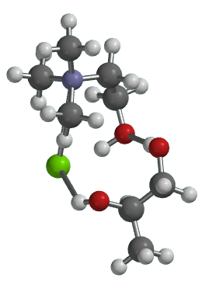
Figure 11: The most stable geometric structure of the double site formed DES via H₂CO-HOCH₂ and NCl-HOCH.

The analyses presented in this Appendix provide a complete framework for understanding and validating the molecular basis of CHL–PG DES formation. By integrating FMO characteristics, IR spectral validation, single- and dual-site interaction energetics, and optimized structural geometries, the Appendix establishes a rigorous computational foundation for the DES model employed in the main study. These detailed results not only support reproducibility but also offer a reference methodology for extending similar evaluations to other HBA–HBD systems in future DES, solvation, or CO₂ capture research.

Other Information for Computational Method Details

Study strategy
The approach employed in our study is diagrammatically illustrated in Figure 1. Beginning with the building of the molecular models for water, IBU, MFA, and deep eutectic solvent (DES, that is, CHL-PG) building from the combination of choline chloride (CHL) and propylene glycol (PG). Each model was then subjected to geometry optimization to obtain most relax form of structures suitable for subsequent analysis using MMFF [5, 6] method.
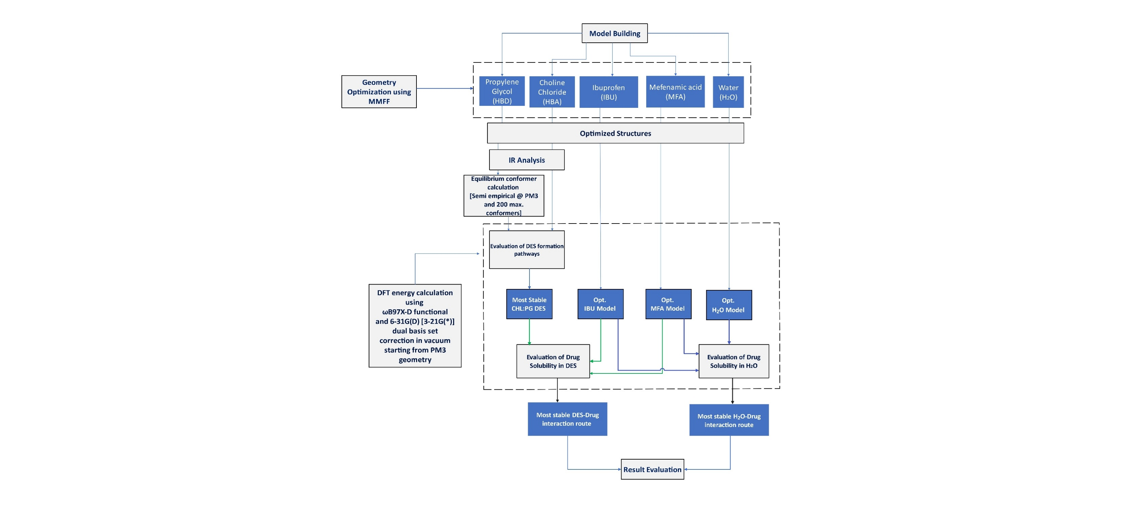
Figure 1: Block flow diagram of the overall process employed in the study
Next was the conformation of PG that was carried out through equilibrium conformer calculations performed using semi-empirical PM3 theoretical method, considering 200 conformers. The optimized conformer was then used to evaluate the possible pathways for DES (CHL-PG) formation from which the most stable structure was identified. The solubility evaluation of the drugs was then carried out by analyzing their interaction with the most stable DES and water. This step enabled identification of the most favorable DES–drug and H₂O–drug interaction routes. Finally, all results were assessed to determine the extent of solubility of the drugs in the DES compared to water. Noting that all the geometries and energies were obtained using the computational details presented earlier in Section 1.1.

Modelling of HBA, HBD, water, and drugs used in the study
The approaches of modeling the ionic interaction of CHL as the HBA of the DES was employed using single bond to maintain consistency in the study; in accordance with the literature [7] that established that the use of no bond, generic, or single bond shows no significant difference across different the level of calculation evaluated. Further analysis of the conformer structures of PG as the HBD for the potential DES was evaluated using PM3 semi-empirical computational method [8] to employ the use of the most stable structure for this application. Similarly, water, IBU, and MFA structural models were built, geometrically optimized to represent the actual structures of these components for the study.

Evaluation of the DES models’ components and its formation mechanism
An infrared (IR) spectroscopy plot was computationally generated for the HBA and HBD employed and was compared with experimental value obtained from a wet laboratory. The similarities and differences visible on their respective plots were analyzed to determine the accuracy of the modeled structures and are presented in the Supplementary Information (SI).
The study evaluated several DES (CHL-PG) formation mechanisms by analyzing different interaction points on CHL (-C, -N, -O, and -Cl) and PG (-H) with their corresponding formation energy (FE). The energies are computed as FE = Edes - EHBA – EHBD, where the Edes is the electronic energies of the DES, EHBA is the electronic energies of the hydrogen bond acceptor, and EHBD is the electronic energies of the hydrogen bond donor. All the electronic energies are collected in eV.
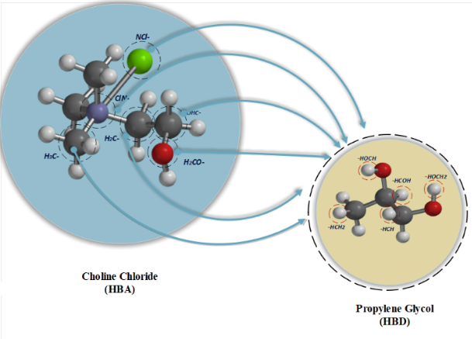
Figure 2: The different molecular interaction pathways investigated in our study.

The energy that is the most negative predict or confirms the most feasible interaction formation pathway that would lead to the formation of the DES. In Figure 2, we demonstrated different interaction pathways explored in our study.

Molecular interaction analysis of the solvents with IBU and MFA
The stability analysis of all component structures was evaluated using the energy band gap (Egap), which is the absolute difference between the energy of the highest occupied molecular orbital (EHOMO) and energy of the lowest unoccupied molecular orbital (ELUMO) as expressed in the literature reports [9–11].
In addition, the interaction energy band gap (IEG) [9] of the different solvents for the dissolution of drug (IBU and MFA) were computed as IEG = min(abs(ELUMO(drug) – EHOMO(solvent)), abs(ELUMO(solvent) – EHOMO(drug))), where ELUMO(drug) is the ELUMO of the drugs, EHOMO(drug) is the EHOMO of the drugs, ELUMO(solvent) is the ELUMO of the solvents, EHOMO(solvent) is the EHOMO of the solvents, using the computational details presented in Section 2 of the article report.

Evaluation of the solubility of the drugs in DES and water
To evaluate the solubility strength of the drugs in the solvent, we measure the drug solubility as a function of binding energy [1, 10, 12] with the solvent, which was computed as SS_{drug} = E (solvent/drug) – E(solvent) – E (drug), where SS_{drug} is solubility strength, E (solvent/drug) is combined energy of drug interactions with the solvent, E(solvent) is total energy of the solvents, and E (drug) is total energy of the drug.

Solvation Correct Energy & Thermodynamic Calculations

Selecting Computational Method for Solvation Correct Energy Calculations
One was to carry out the calculation fully using a setting the deploy approach presented in Figure A accounting for the solvation effect with IR frequency calculation, while the second method seeks to employed the use of strategy that tend to the compute the solvation effect (in presence of water) separating and the IR frequency calculation to be computed in absence of water as shown in Figure B.

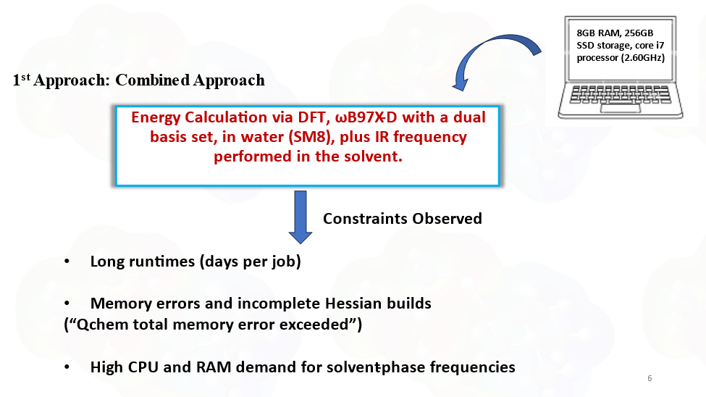
Figure A. Details on the method and challenges encountered in our study using first approach.

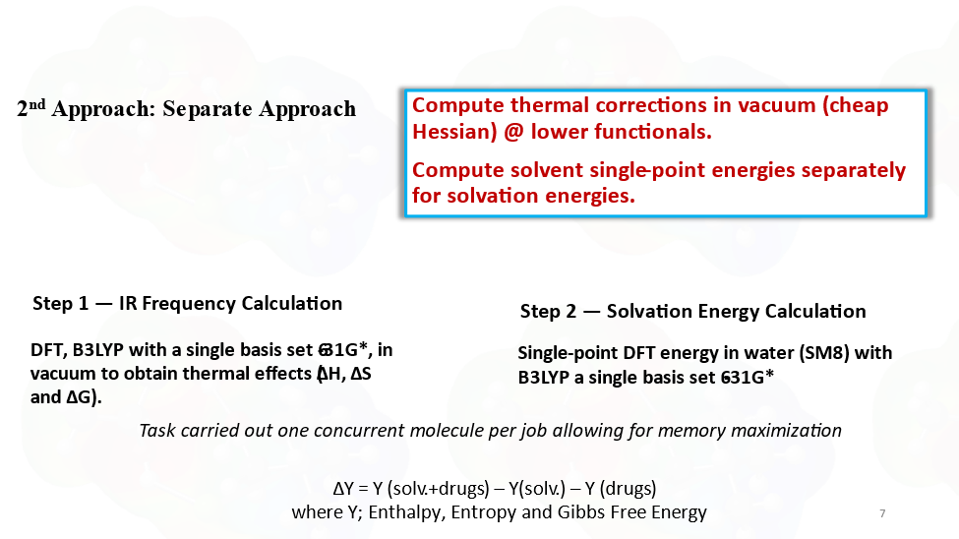
Figure B. Details on the method and measure employed addressing the first approach challenges in our study during use of second approach.

The first approach failed to work out for us due to the computational resource capacity constraints like low memory (8GB) and low CPU (core i7) personal laptop that we use for the computational job, which took long running time, which repeated pops out low memory error. This made us opt for the second approach (Figure B) which our computing set could afford.

Details of the Results Collected for Corrected Solubility Strength (SScorr) and the Uncorrected (SS) Calculations
Table 12: Summary of drug selected solubility strength (SS and SScorr) obtained in our study and literature.
Species |  | Mol. Wt (amu) | E (eV) | Ecorr (eV) | ΔE (eV) | SS (eV) | SScorr (eV) | ΔE | LSS (mg/g) | LSS  Ref
CHL-PG DES |  | 215.72 | -28802.13 | -28808.07 | -5.94 | - | - | - | -
H₂O |  | 18.02 | -2078.59 | -2079.55 | -0.96 | - | - | - | -
IBU |  | 206.29 | -17864.02 | -17869.83 | -5.81 | - | - | - | -
MFA |  | 241.29 | -21377.18 | -21384.47 | -7.29 | - | - | - | -
IBU | IBU–H₂O | 224.30 | -19943.15 | -19949.69 | -6.54 | -0.54 | -0.307 | 0.233 | 0.021 | [13]
IBU | IBU–DES | 422.01 | -46666.89 | -46678.04 | -11.15 | -0.75 | -0.146 | 0.604 | 204.52 | [14]
MFA | MFA–H₂O | 259.31 | -23456.39 | -23464.34 | -7.95 | -0.62 | -0.313 | 0.307 | 0.042 | [15]
MFA | MFA–DES | 457.01 | -50179.88 | -50192.09 | -12.21 | -0.57 | 0.455 | 1.025 | 1.06 | [14]

Note: Corr is corrected value including solvation effect in energy and solubility strength.

Details of the Results Collected for Thermodynamic Calculations
To gain further insight into the thermodynamic feasibility of use the DES for the enhancement of the drugs (IBU and MFA) solubility, we employed the computation of the thermodynamic properties for IBU-DES and MFA-DES to which one could best enhanced. The details are provided below:

Computational Methodology for Gas and Liquid-Phase Thermodynamic Properties
Geometry Optimization: Each DES component (e.g., choline chloride, propylene glycol) was optimized in the gas phase using Spartan ’14 at the B3LYP/6-31G(d) level of theory (or equivalent). And vibrational frequency calculations were performed to obtain thermal corrections to enthalpy and entropy, including contributions from translational, rotational, and vibrational motions.

Gas-Phase Calculations
Extraction of Gas-Phase Properties: It is vital to note that Hgas is total gas-phase enthalpy, including electronic energy, zero-point vibrational energy, and thermal corrections, while Sgas is the total gas-phase entropy accounting for all degrees of freedom. The Hgas and Sgas were automatically provided by the Spartan software as part of the calculation outputs.

Liquid-Phase Corrections
Since Spartan ’14 outputs are inherently gas-phase, liquid-phase properties were estimated using physically justified scaling based on vaporization behavior and restricted molecular motion in the condensed phase.

Liquid Entropy (Sliq) approximation
Volatile liquid approximation: For systems with non-negligible volatility, the entropy was corrected using $S_{liq} = S_{gas} - 0.33 ΔS_{vap}$, where $ΔS_{vap}$​ was estimated using a Trouton-type relation. According to Turton rule:
$ΔS_{vap}= 4.5R + RlnT = 4.5*8.314 + 8.314*\ln\left(300K\right)$ ≈ 85 J/mol.K
ΔSvap ≈ 85 J/mol·K, consistent with Trouton’s rule [16–18], which provides a first-order approximation of the entropy change on vaporization for small to medium-sized organic molecules. The 0.33 scaling factor accounts for the reduction in translational and rotational degrees of freedom in the liquid phase, consistent with the observed behavior of H-bonded DES components.
For non-volatile liquid approximation: The approximation Sliq ≈ 0.33 Sgas​ is based on statistical thermodynamics, where entropy is related to the number of accessible molecular microstates. In the gas phase, molecules possess significant translational, rotational, and vibrational freedom, with translational motion contributing the largest share to the total entropy. However, in the liquid phase, intermolecular interactions significantly restrict translational and rotational degrees of freedom, leaving vibrational motion as the dominant contributor. As a result, the entropy of the liquid phase is substantially reduced, and is often approximated as about one-third of the gas-phase entropy for non-volatile and strongly interacting systems such as deep eutectic solvents. It is important to note that entropy largely depends on phase of the specie or material.

Liquid-Phase Enthalpy (Hliq) approximation
For volatile liquid approximations: The model used is presented as: $H_{liq}= H_{gas}- 0.33 T ΔS_{vap}$​ where T = temperature (K) of interest. This formula approximates the enthalpy loss associated with gas to liquid condensation, consistent with thermodynamic principles (ΔH = T ΔS for phase transition).
For non-volatile liquid approximations: The approximation presents: $H_{liq}≈ H_{gas}$ ​, asuuming $ΔH_{vap}$ is negligible due to extremely low vapor pressure at room temperature and enthalpy is weakly phase-dependent.
Deep eutectic solvent (DES), IBU, and MFA are non-volatile liquids under normal conditions; therefore, this study employed the non-volatile liquid-phase correction approximation in the computation of thermodynamic parameters.

Enthalpy change calculations

Table 13: Enthalpy change in eV for the drug solubility @ 300K, a gas-phase calculation (Spartan Computed Version) approximately same as for the nonvolatile liquid-phase correction calculation adopted for our study.
Label | Molecular Wt.(amu) | Ecorr (eV) | dH(DESibu), eV | dH(DESmfa), eV
DES | 215.721 | -28807.24 | - | -
IBU | 206.285 | -17869.6 | - | -
MFA | 241.29 | -21384.22 | - | -
DES+IBU (min) | 422.006 | -46677.22 | -0.3942 | -
DES+MFA (min) | 457.011 | -50191.27 | - | 0.1794

Entropy changes calculations

Table 14: Entropy change for the drug solubility @ 300K.
Label | Other data |  | Gas-phase calculation (Spartan Computed One) in eV/K |  | Nonvolatile liquid-phase correction calculation in eV/K
Label | Molecular Wt.(amu) | Ecorr (eV) | dS(DESibu) | dS(DESmfa) | dS(DESibu) | dS(DESmfa)
DES | 215.721 | -28807.24 | - | - | - | -
IBU | 206.285 | -17869.6 | - | - | - | -
MFA | 241.29 | -21384.22 | - | - | - | -
DES+IBU (min) | 422.006 | -46677.22 | -0.0025 | - | -0.0008254 | -
DES+MFA (min) | 457.011 | -50191.27 | - | -0.0025 | - | -0.0008407

Gibbs free energy change calculations

Table 15A: Gibbs free energy for the drug solubility feasibility @ 300K, using gas-phase calculation (Spartan Computed one) and
Nonvolatile liquid-phase correction approximations in eV.
Solubility | Approximation used | dG (eV)
DES+IBU (min) | Nonvolatile Liquid-phase correction | -0.1466
DES+MFA (min) | Nonvolatile Liquid-phase correction | 0.4316
DES+IBU (min) | Gas-phase calculation | 0.3562
DES+MFA (min) | Gas-phase calculation | 0.9437

Summary of the solubility and thermodynamic analysis

Table 16: Drugs solubility strength (SS) in solvents (ETH is ethanol, SS is in vacuum and SScorr in water)
Drugs | SS (eV) | SScorr (eV) | ΔSS (eV) | LSS (mg/g) | LSS Ref
IBU-DES | -0.75 | -0.146 | 0.60 | 204.52 | [14]
MFA-DES | -0.57 | 0.455 | 1.03 | 1.06 | [14]
ETH-H₂O | -0.315 | -0.2203 | 0.10 | 1000 | Pubchem

Table 17: Thermodynamic analysis on drug solubility potentials
Solubility | Enthalpy (ΔH) |  | Entropy (ΔS) |  | Gibb Free Energy (ΔG) |  | Lab Experiment
Solubility | dHgas (eV) | dHliq (eV) | dSgas (eV/K) | dSliq (eV/K) | dGgas (eV) | dGliq (eV) | LSS (mg/g) | LSS Ref
DES+IBU (min) | -0.3942 | -0.3942 | -0.0025 | -0.000825 | 0.3562 | -0.1466 | 204.52 | [14]
DES+MFA (min) | 0.1794 | 0.1794 | -0.0025 | -0.000841 | 0.9437 | 0.4316 | 1.06 | [14]
R-value | -1 | -1 | na | na | -1 | -1 | 1 | Calc

IBU is ibuprofen, MFA is mefenamic acid, ETH is ethanol, DES is deep eutectic solvent. Note the study is to see how DES can effectively Improve the drug solubility.

List of relevant references
1. Uzochukwu MI, Oyegoke T, Momoh RO, Isa MT, Shuwa SM, Jibril BY (2023) Computational insights into deep eutectic solvent design: Modeling interactions and thermodynamic feasibility using choline chloride & glycerol. Chemical Engineering Journal Advances 16:100564. https://doi.org/10.1016/J.CEJA.2023.100564
2. NIST (2025) Propylene Glycol. In: NIST Chemistry WebBook, SRD 69. https://webbook.nist.gov/cgi/cbook.cgi?ID=C57556&Units=SI&Type=IR-SPEC&Index=1. Accessed 22 Nov 2025
3. Muhammed UM, Oyegoke T (2025) Enhancing the Solubility of Metronidazole Using Deep Eutectic Solvents: A Computational Insight Into a Green Formulation Strategy. Res Sq 1:1–24. https://doi.org/10.21203/RS.3.RS-8106095/V1
4. Ayeni OI, Oyegoke T (2024) Computational insights into graphene-based materials for arsenic removal from wastewater: a hybrid quantum mechanical study. Discover Water 4:103. https://doi.org/10.1007/S43832-024-00160-3
5. Halgren TA (1998) Force Fields: MMFF94. Encyclopedia of Computational Chemistry
6. Thomas A. Halgren (1996) Merck molecular force field. I. Basis, form, scope, parameterization, and performance of MMFF94. Journal of Computational Chemistry - Wiley Online Library 17:490–519. https://doi.org/https://doi.org/10.1002/(SICI)1096-987X(199604)17:5/6%3C490::AID-JCC1%3E3.0.CO;2-P
7. Uzochukwu MI, Oyegoke T, Momoh RO, Isa MT, Shuwa SM, Jibril BY (2023) Computational insights into deep eutectic solvent design: Modeling interactions and thermodynamic feasibility using choline chloride & glycerol. Chemical Engineering Journal Advances 16:100564. https://doi.org/10.1016/J.CEJA.2023.100564
8. Wu YY, Zhao FQ, Ju XH (2014) A Comparison of the Accuracy of Semi-empirical PM3, PDDG and PM6 methods in Predicting Heats of Formation for Organic Compounds. J Mex Chem Soc 58:223–229. https://doi.org/10.29356/JMCS.V58I2.182
9. Olusola Ibraheem A, Toyese O (2025) DFT Fukui descriptor-based prediction of Arsenic adsorption on graphene. European Journal of Materials Science and Engineering 10:181–194. https://doi.org/10.36868/ejmse.2025.10.03.181
10. Oyegoke T, Dabai FadimatuN, Adamu U, Baba YJ (2020) Quantum mechanics calculation of molybdenum and tungsten influence on the CrM-oxide catalyst acidity. Hittite Journal of Science & Engineering 7:297–311. https://doi.org/10.17350/HJSE19030000199
11. Oyegoke T, Ademola O, Olusanya JJ (2021) Preliminary Investigation on the Screening of Selected Metallic Oxides, M2O3 (M = Fe, La, and Gd) for the Capture of Carbon Monoxide Using a Computational Approach. The Journal of Engineering, Science and Computing 3:1–14
12. Oyegoke T, Aliyu A, Uzochuwu MI, Hassan Y (2024) Enhancing hydrogen sulphide removal efficiency: A DFT study on selected functionalized graphene-based materials. Carbon Trends 15:100362. https://doi.org/10.1016/J.CARTRE.2024.100362
13. PubChem (2026) Ibuprofen, (+-)- | C13H18O2 | CID 3672 . In: PubChem Report. https://pubchem.ncbi.nlm.nih.gov/compound/Ibuprofen. Accessed 20 Mar 2026
14. Nica MA, Anuța V, Nicolae CA, Popa L, Ghica MV, Cocoș FI, Dinu-Pîrvu CE (2024) Exploring Deep Eutectic Solvents as Pharmaceutical Excipients: Enhancing the Solubility of Ibuprofen and Mefenamic Acid. Pharmaceuticals (Basel) 17:1316. https://doi.org/10.3390/ph17101316
15. PubChem (2026) Mefenamic Acid | C15H15NO2 | CID 4044. In: PubChem Report. https://pubchem.ncbi.nlm.nih.gov/compound/4044#section=Solubility. Accessed 20 Mar 2026
16. Krimizis-Tsatsoulis C (2021) Trouton’s rule mysteries: An attempt to a better understanding. Journal of Chemical Thermodynamics 152:. https://doi.org/10.1016/j.jct.2020.106256
17. McLachlan D, Marcus RJ (1957) The statistical-mechanical basis of Trouton’s rule. J Chem Educ 34:460. https://doi.org/10.1021/ed034p460
18. Wikipedia (2026) Trouton’s rule. In: Wikipedia Encyclopedie. https://en.wikipedia.org/wiki/Trouton%27s_rule. Accessed 20 Mar 2026

