Supplementary Material
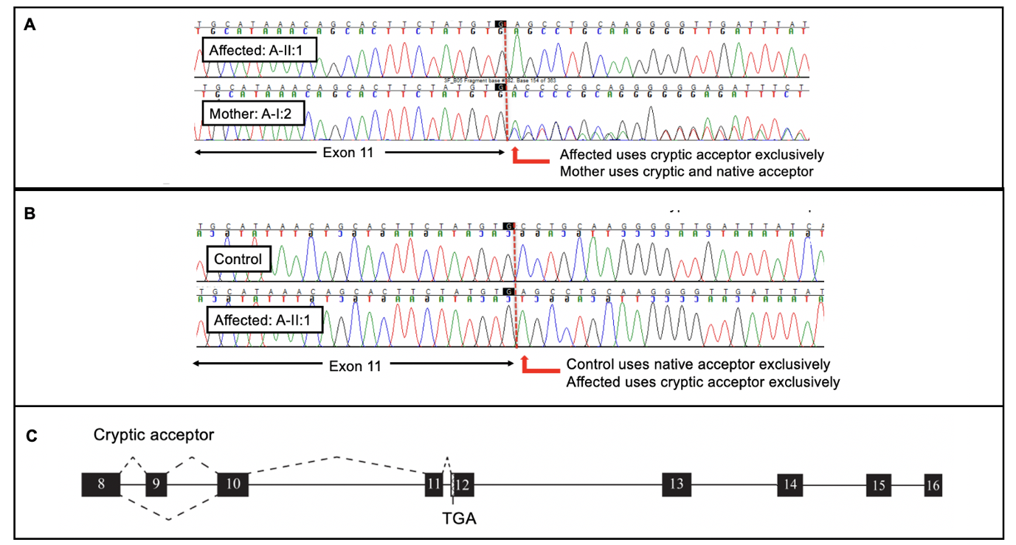
Supplementary Figure 1. Confirmation of splicing abnormality in Family A. (A) cDNA sequencing of proband A-II:1 (homozygous for c.1221–3A>G) and her mother A-I:2 (heterozygous), showing the use of a cryptic acceptor site in the proband and partial use in the mother. (B) cDNA from control and proband fibroblasts shows exclusive use of the cryptic acceptor in the proband. (C) Schematic showing the splicing defect caused by c.1221–3A>G, leading to the use of a cryptic acceptor, a frameshift, and a premature stop codon (TGA). Exon 13A is included in both affected and control samples.

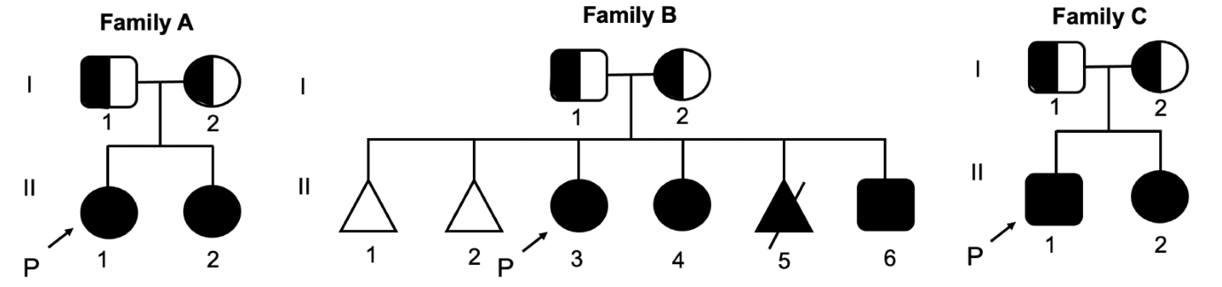
Supplementary Figure 2. Pedigree analysis of Families A, B, and C showing affected individuals and reproductive history. Arrows indicate probands. Family B includes two miscarriages and one terminated pregnancy due to suspected PGAP1-related disorder.

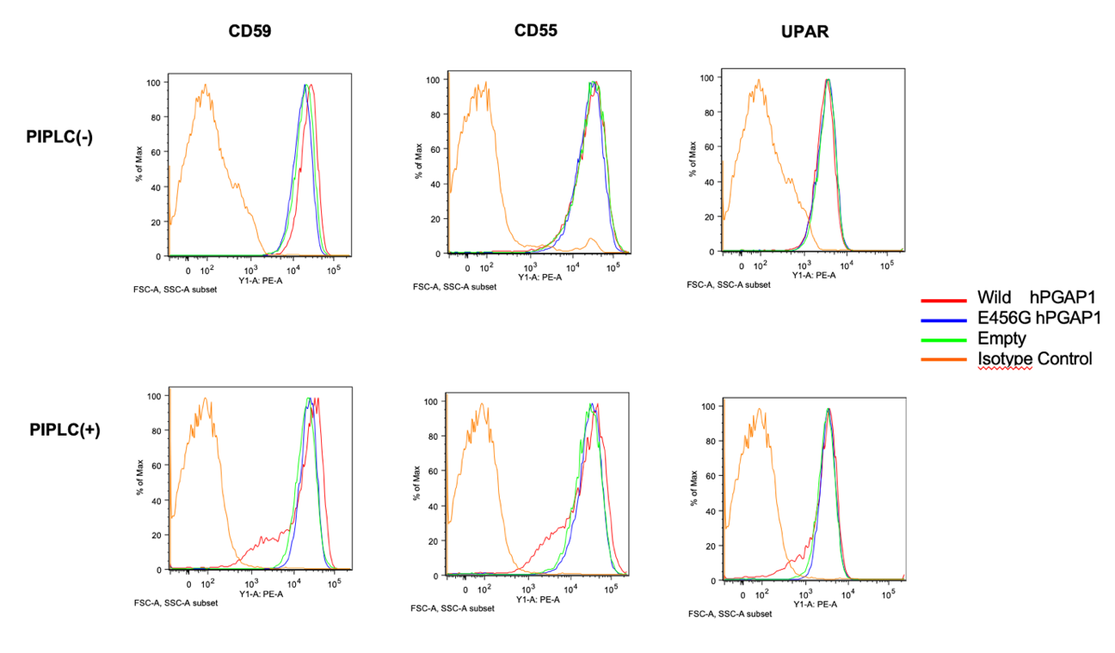
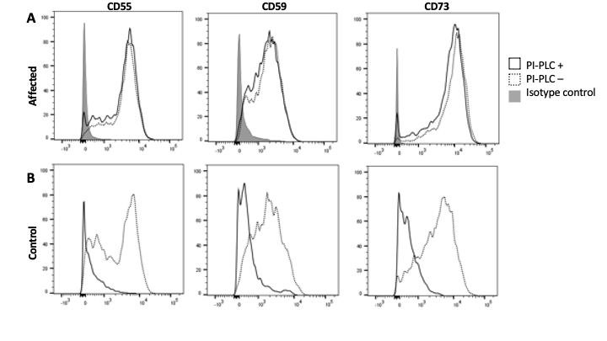
Supplementary Figure 3. Reduced surface GPI-anchored proteins and altered PI-PLC sensitivity in two independent PGAP1-deficient patients (Family A) primary dermal fibroblasts from affected individual A-II:1, cells were stained with monoclonal antibodies to CD55, CD59 and CD73. Overlay histograms compare PI-PLC–treated cells (solid black line) with untreated cells (dotted black line); grey-shaded peaks denote isotype controls. All three GPI-anchored proteins are markedly reduced and PI-PLC‐resistant in-patient fibroblasts, consistent with a PGAP1 trafficking defect. (Family E) peripheral-blood mononuclear cells (PBMCs) from affected individual E-II, analysed before and after lentiviral rescue). PBMCs were transduced with (i) wild-type human PGAP1 (blue), (ii) the patient missense allele E456G-PGAP1 (green) or (iii) empty vector (orange); dashed black peaks are isotype controls. Histograms are shown for CD55, CD59 and uPAR (CD87) before (upper row, PI-PLC –) and after (lower row, PI-PLC +) incubation with PI-PLC (1 U mL⁻¹, 37 °C, 1 h). Wild-type PGAP1 fully restores both surface expression and PI-PLC sensitivity of all three GPI-APs, whereas the E456G allele provides no rescue, confirming pathogenicity of the endogenous mutation. Because the two datasets were produced in different laboratories with non-harmonised fluorochrome panels, colour schemes differ between panels.
Family A
Family E
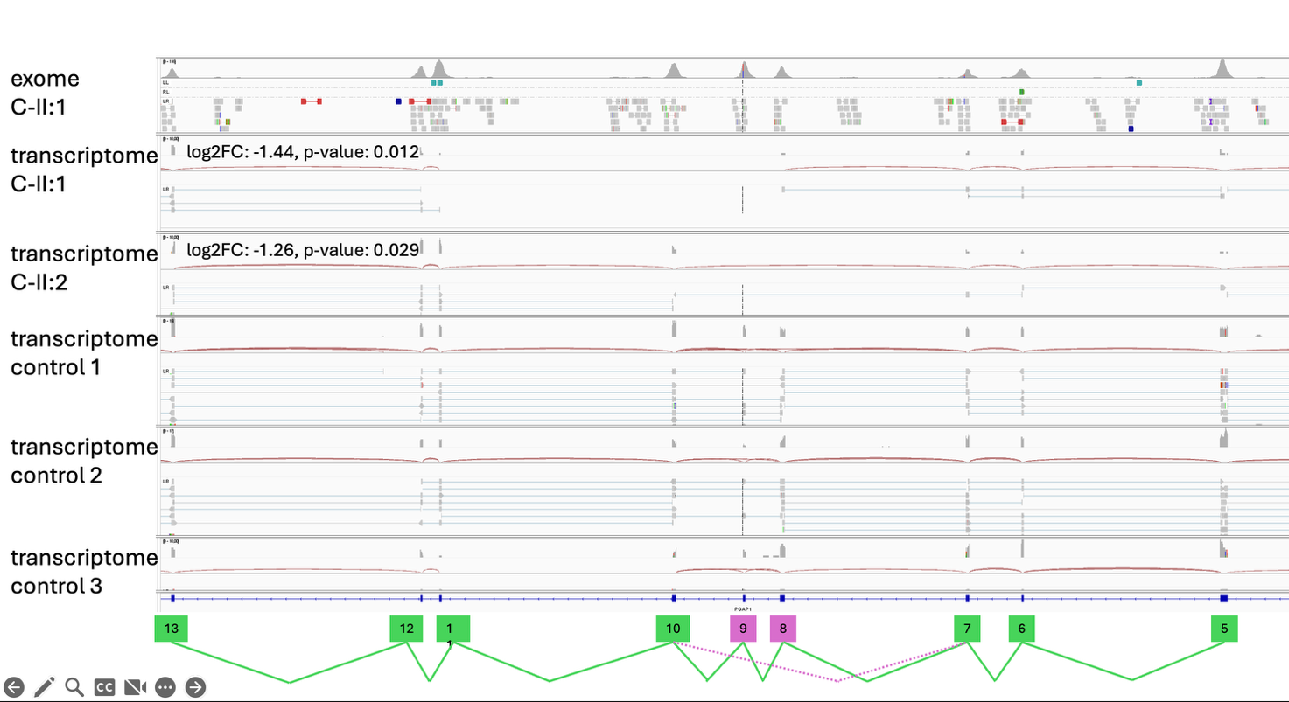
Supplementary Table 1. In silico characterization of PGAP1 variants identified in the cohort, including predicted splicing effects, frameshift/nonsense-mediated decay potential, and missense variant impact. Greyed variants correspond to the already published cases mentioned in Table 1 of this report.
Supplementary Figure 3. RNA-seq shows reduced PGAP1 expression in Family C (C-II:1 and C-II:2). Integrated Genomics Viewer (IGV) scoverage plots across PGAP1 (NM_024989.3) displaying, from top to bottom, whole-exome read coverage for C-II:1, RNA-seq coverage and splice junction arcs for C-II:1 and C-II:2, and three unrelated controls processed in parallel. Numbers above the patient RNA-seq tracks indicate the gene-level differential expression results (C-II:1: log₂FC = −1.44, p = 0.012; C-II:2: log₂FC = −1.26, p = 0.029). At the display depth shown, splice-junction arcs reflect predominantly canonical exon–exon junctions without a reproducible novel junction, while overall PGAP1 transcript abundance is reduced in both affected siblings relative to controls. The gene model is shown below with exon boxes; arcs represent junction reads and coverage tracks represent per-base read depth.
cDNA | Protein | Variant type | Location | Prediction / Score | Conservation | Consequence / Interpretation
c.1221-3A>G | – | Splice (acceptor) | Intron 10 (upstream exon 11) | Acceptor  weakening (MaxEnt –14.5 %) | High (phyloP > 4) | Likely exon skipping or cryptic-site activation
c.2286+5G>A | – | Splice (donor) | Intron 23 | Splice site weakening (MaxEnt –19.9 %) |  | Likely splicing disruption / exon skipping
c.2286+5G>T | – | Splice (donor) | Intron 23 | Splice site weakening (MaxEnt –19.9 %) |  | Likely splicing disruption / exon skipping
c.1089+1G>A | – | Splice (canonical donor +1) | Intron 9 | Complete loss of donor site |  | Exon skipping or intron retention
c.1089+5delG | – | Splice (near canonical donor) | Intron 9 | Significant donor weakening |  | Splicing defect
c.1081_1089+3del | – | Splice (donor disruption) | Exon–intron junction (9) | Donor site disrupted |  | Abnormal splicing expected
c.289del | p.Ser97Valfs*30 | Frameshift | Exon 2 | PTC < NMD threshold |  | Predicted NMD
c.2199del | p.Leu735* | Frameshift | Exon 23 | - |  | Nonsense coding effect
c.2357_2358insTA | p.Ser787* | Frameshift | Exon 25 | PTC generated |  | Likely NMD, premature reading frame interruption
c.1367A>G | p.(Glu456Gly) | Missense | Exon 14 | Predicted change at acceptor site 17 bps upstream: +1.4%  MaxEnt: 0.0%  NNSPLICE: +4.3% | High | Likely damaging missense; supports LoF mechanism in trans/homozygous context
c.2241T>G | p.Cys747Trp | Missense | Exon 23 | Predicted damaging across standard tools (PolyPhen-2: probably damaging; SIFT: deleterious; MutationTaster: disease-causing) | High | Likely damaging- codon change
c.2024delT | p.Leu681Argfs*4 | Frameshift | Exon 22 | The frameshift starts at codon Leu681.  The new reading frame ends in a stop codon at position 4. |  | Likely NMD
c.2286+5G>A | – | Splice (donor) | Intron 23 | Splice site weakening (MaxEnt –19.9 %) |  | Likely splicing disruption / exon skipping
c.1952+1G>T | – | Splice (donor +1)
c.589_591del | p.Leu197del | In-frame deletion
c.274_276del | p.Pro92del | In-frame deletion
c.921_925del | p.Lys308Asnfs*25 | Frameshift
c.1572T>A | p.Tyr524* | Nonsense
c.1396C>T | p.Gln466* | Nonsense
c.1090-2A>G | – | Splice (acceptor -2)
c.334_335insA | p.Arg112fs | Frameshift
c.1173G>C | p.Leu391Leu | Synonymous (splice?)
c.2349delinsATAATCCCAAACAA | p.His783Glnfs*2 | Frameshift
c.1226_1229dup | [p.(Val411Argfs*3)]

