Unique thermal properties of polyvinyl alcohol embedded with reduced graphene oxide-copper nanoparticles composite
Roghayeh Tayebi, Esmaiel Soleimani*

Inorganic Chemistry Research Laboratory, Faculty of Chemistry, Shahrood University of Technology, Shahrood, Iran

Supplementary Information

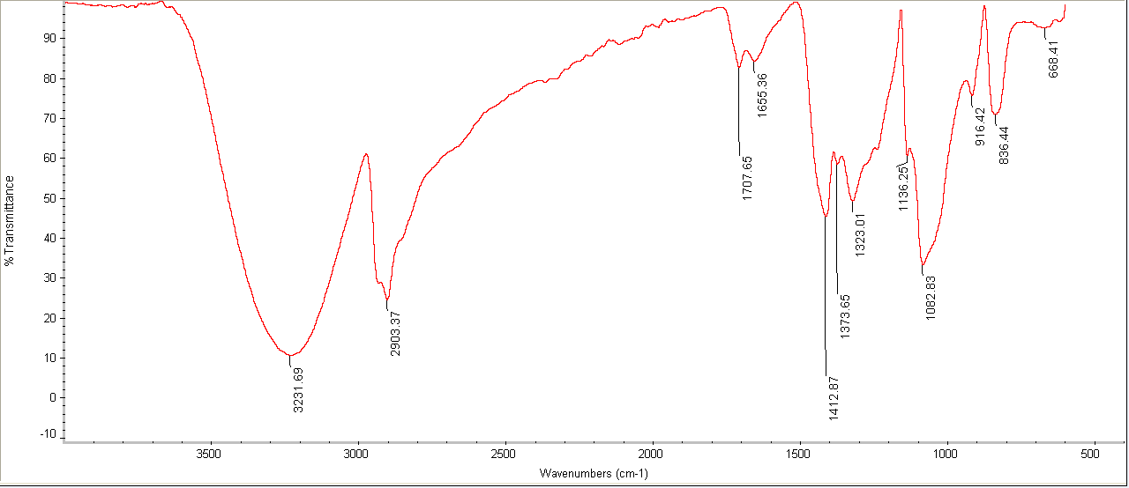
Fig. S1: FT-IR spectrum of polyvinyl alcohol.

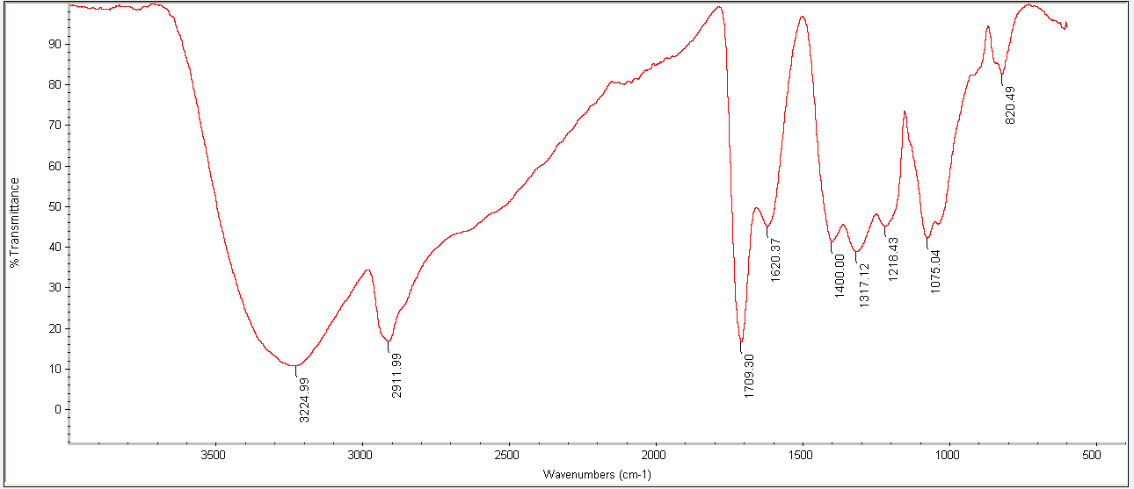
Fig. S2: FT-IR spectrum of PVA/Cu nanocomposite.
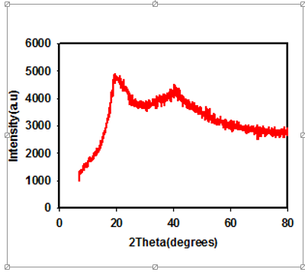
Fig. S3: XRD diffraction pattern of PVA/Cu nanocomposite.

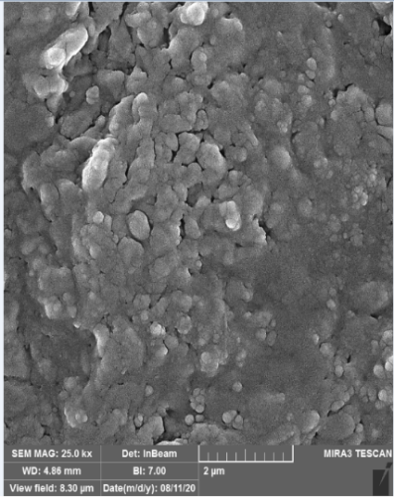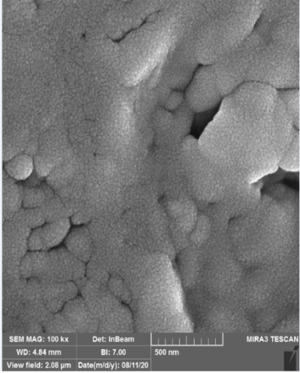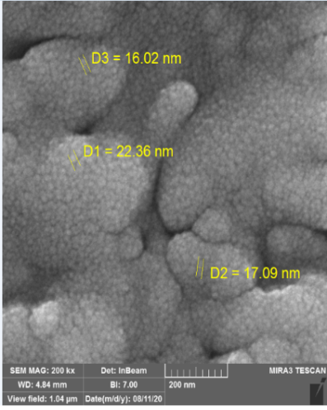
Fig. S4: FE-SEM image of PVA/Cu nanocomposite
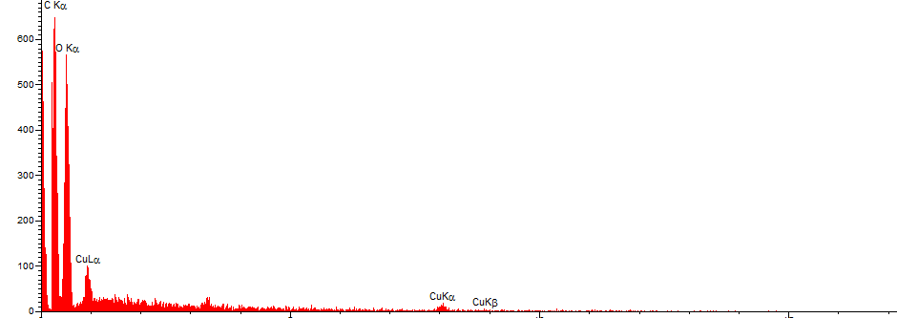
Fig. S5: EDS spectrum of PVA/Cu nanocomposite.

