Structure-based computational screening and molecular dynamics reveal potential inhibitors of norovirus VP1 and RdRp proteins: an in-silico study
Hasan Huzayfa Rahaman^{1#}, Nadim Sharif ^{1*#}, Al Imran Kafi¹, Wasifuddin Ahmed², Nazmul Sharif³, Fuad M. Alzahrani⁸, Khalaf F. Alsharif⁸, Khalid J. Alzahrani⁸, Shuvra Kanti Dey^{1*}

Supplementary Figure i. Predicted proteins structures and their stability by the ERRAT2 and ProSA: A. The predicted structures and ERRAT overall quality scores, B. The Z-scores, C. The plot of residue scores, and D. The Ramachandran plot for RNA-dependent RNA-polymerase.
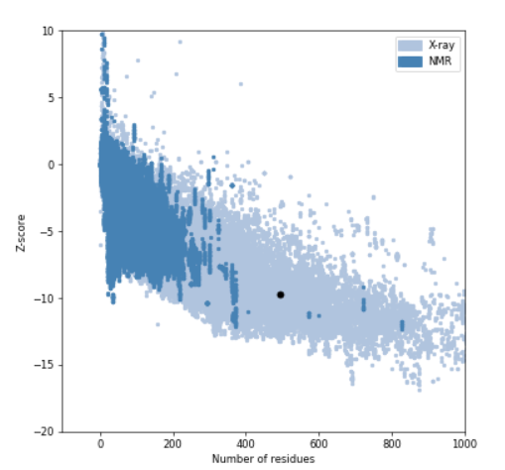
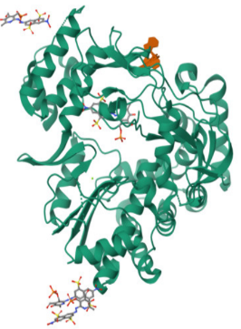
B
A

ERRAT Overall Quality Factor 95.16; Z-score -9.69

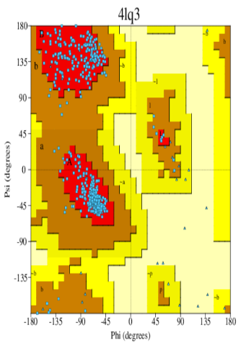
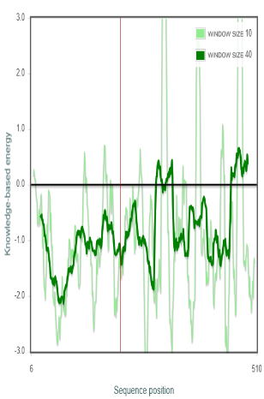
C
D

Supplementary Figure ii. Predicted proteins structures and their stability by the ERRAT2 and ProSA: A. The predicted structures and ERRAT overall quality scores, B. The Z -scores, C. The plot of residue scores, and D. The Ramachandran plot for VP1.
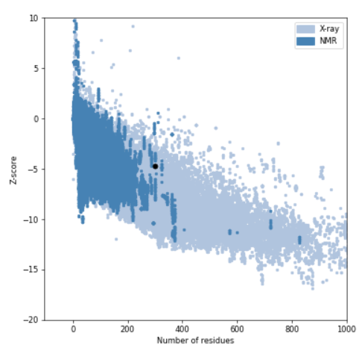
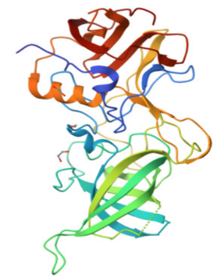
B
A

ERRAT Overall Quality Factor 95.27; Z-score -4.69
C
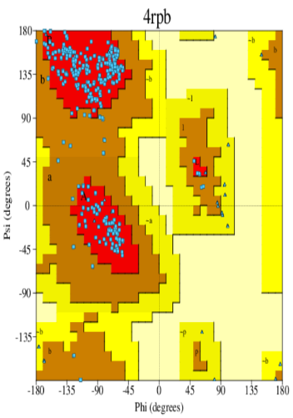
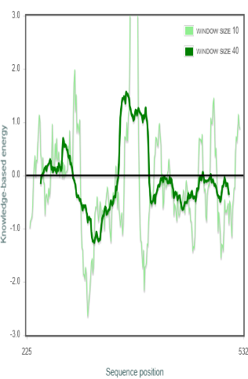
D

Supplementary Figure iii. Showing the Solvent Accessible Surface Analysis (SASA) of both proteins: A. RdRp and B. VP1.
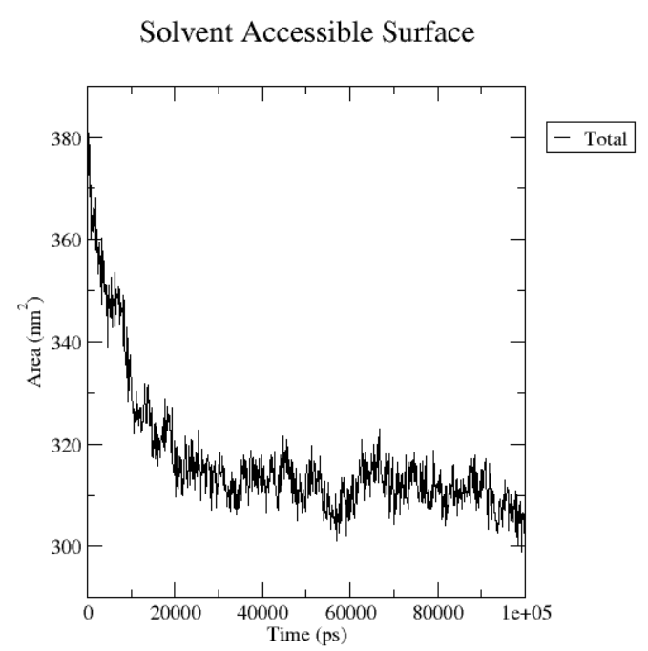
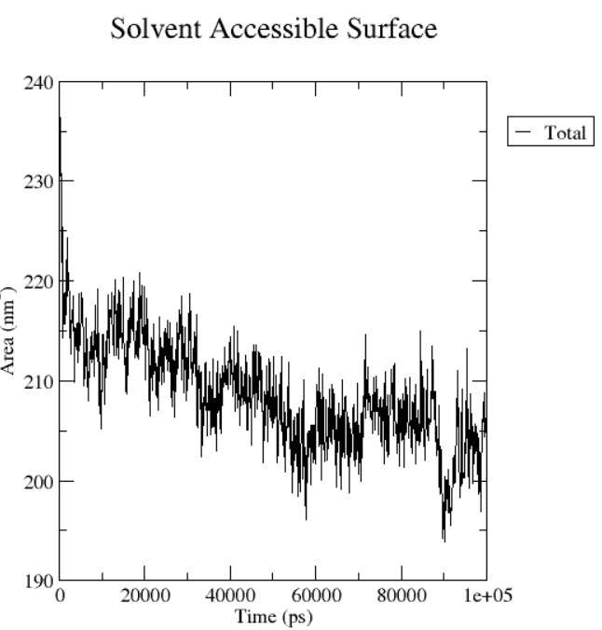
A
B

Supplementary Table 1: Two-dimensional Structure of the best 59 ligands and control with their binding affinity, compound id and compounds name.
Plant | Compound | Pubchem ID | Structure | Binding energy
Ada | Zingiberene | 92776 | 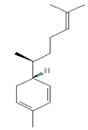 | (4lq3)  -5.7
(4rpb)
-7.2
Ada | Zingiberol | 5317270 | 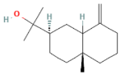 | (4lq3)  -8.7
(4rpb)
-8.9
Ada | Gingerols | 442793 | 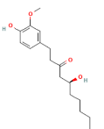 | (4lq3)  -5.7
(4rpb)
-6.6
Ada | Shogaols, | 5281794 | 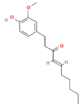 | (4lq3)  -5.5
(4rpb)
-6.3
Ada | Terpenoids | 21601966 | 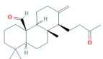 | (4lq3)  -7.8
(4rpb)
-7.3
Akand | Cardenolide | 53957771 | 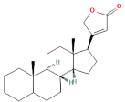 | (4lq3)  -8.7
(4rpb)
-8.6
Akand | Flavonoids | 11349 | 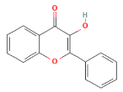 | (4lq3)  -7.3
(4rpb)
-7.3
Aparajita | anthraquinone, | 6780 | 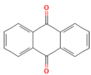 | (4lq3)  -6.9
(4rpb)
-6.8
Basak | Vasicine | 667496 | 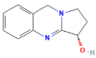 | (4lq3)  -6.2
(4rpb)
-6.7
Basak | l-vasicinone | 442935 | 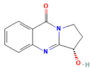 | (4lq3)  -7
(4rpb)
-6.7
Basak | Deoxyvasicine | 442894 | 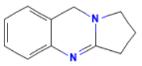 | (4lq3)  -5.9
(4rpb)
-5.9
Barun | Mannitol | 6251 | 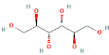 | (4lq3)  -5.1
(4rpb)
-4.9
Bel | Marmelide | 10212 | 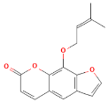 | (4lq3)  -7.2
(4rpb)
-7
Bherenda | Ricinine | 10666 | 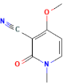 | (4lq3)  -5.1
(4rpb)
-4.9
Bhui kumra | Daidzein | 5281708 | 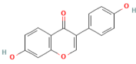 | (4lq3)  -7
(4rpb)
-7.6
Bhui kumra | Irisolidone | 5281781 | 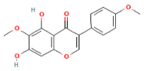 | (4lq3)  -7.1
(4rpb)
-7.8
Dhutra | Atropine | 174174 | 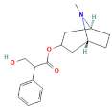 | (4lq3)  -6.6
(4rpb)
-6.7
Gamar | Apigenin | 5280443 | 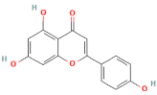 | (4lq3)  -7.4
(4rpb)
-7.5
Halud | Curcumadiol | 5316212 | 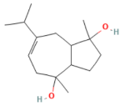 | (4lq3)  -6.3
(4rpb)
-6.6
Halud | Phellandrene, | 7460 | 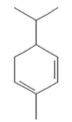 | (4lq3)  -5
(4rpb)
-5.6
Halud | Terpinolene | 11463 | 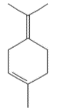 | (4lq3)  -5.3
(4rpb)
-5.5
Haritaki | Pyrogallol | 1057 | 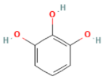 | (4lq3)  -5.4
(4rpb)
-5.9
Katphal | Furfurals | 7362 | 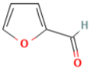 | (4lq3)  -4.1
(4rpb)
-4.1
Khayer | Quercetin | 5280343 | 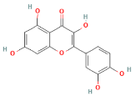 | (4lq3)  -7.7
(4rpb)
-8.4

Khayer | Fisetin | 5281614 | 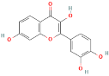 | (4lq3)  -7.8
(4rpb)
-8.3
Khude  dhekishak | Coumarins | 54678486 | 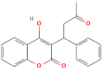 | (4lq3)  -7.6
(4rpb)
-7.4
Khude  dhekishak | Quinones | 4650 | 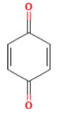 | (4lq3)  -5
(4rpb)
-4.8
Kusum fool | Carthamidin | 188308 | 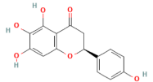 | (4lq3)  -7.4
(4rpb)
-7.9
Lajjabati | Phenolics | 996 | 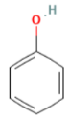 | (4lq3)  -4.8
(4rpb)
-4.9
Methi | isoleucine | 6306 | 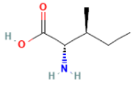 | (4lq3)  -4.5
(4rpb)
-4.9
Morog fool | Sterols | 1107 | 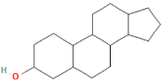 | (4lq3)  -7.3
(4rpb)
-7.5
Mutha | Kaempferol | 5280863 | 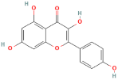 | (4lq3)  -7.3
(4rpb)
-7.7
Mutha | Luteolin | 5280445 | 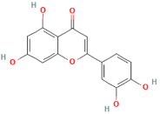 | (4lq3)  -7.5
(4rpb)
-7.9
Nishinda | Stilbene | 638088 | 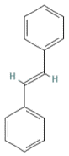 | (4lq3)  -7.2
(4rpb)
-6.7
Patte madar | Caffeic acid | 689043 | 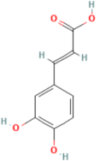 | (4lq3)  -5.6
(4rpb)
-6.6
Pipul | Piperine | 638024 | 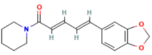 | (4lq3)  -7.2
(4rpb)
-7
 | Volatile oils | 5971 | 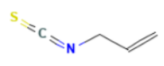 | (4lq3)  -3.4
(4rpb)
-3.1
 | Amides | 2850046 | 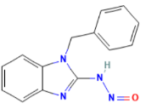 | (4lq3)  -7.4
(4rpb)
-7.5
Punarnava | Boeravinone B | 14018348 | 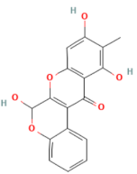 | (4lq3)  -8.1
(4rpb)
-8.7
 | Dimethylflavone | 70446911 | 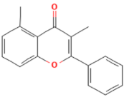 | (4lq3)  -7.5
(4rpb)
-7.7
Randhuni | Thymohydroquinone  dimethyl ether, | 6427071 | 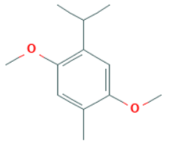 | (4lq3)  -5.1
(4rpb)
-5.5
Randhuni | Thymol  methyl ether | 14104 | 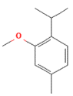 | (4lq3)  -5.2
(4rpb)
-5.4
Randhuni | Isothymol  methyl ether | 161716 | 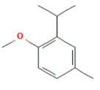 | (4lq3)  -5
(4rpb)
-5.5
Randhuni | Cuminaldehyde | 326 | 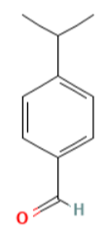 | (4lq3)  -5.4
(4rpb)
-6.4
Rasun | Allitridin | 16315 | 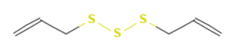 | (4lq3)  -3.3
(4rpb)
-3.4
Rasun | Alliin | 9576089 | 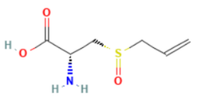 | (4lq3)  -4.5
(4rpb)
-4.6
Rasun | Allicin, | 65036 | 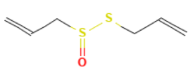 | (4lq3)  -3.7
(4rpb)
-3.5
Rasun | Diallyl sulfide, | 11617 | 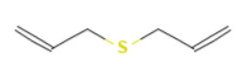 | (4lq3)  -3.2
(4rpb)
-3.2
Rasun | Ajoene | 5386591 | 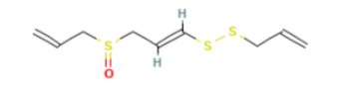 | (4lq3)  -4.1
(4rpb)
-4
Sal-parni | Pterocarpans, | 6451349 | 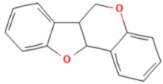 | (4lq3)  -7
(4rpb)
-7.5
Sal-parni | Phenylpropanoids | 3314 | 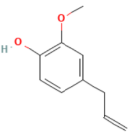 | (4lq3)  -5.3
(4rpb)
-5.8
Sarisa | Indole | 798 | 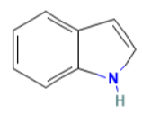 | (4lq3)  -5.2
(4rpb)
-6.2
 | Phenanthrene | 995 | 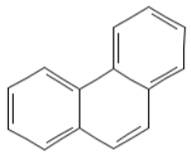 | (4lq3)  -6.6
(4rpb)
-6.8
Shimul | Bombamalones C | 23642717 | 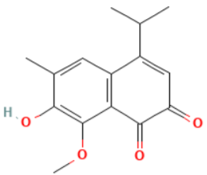 | (4lq3)  -6.4
(4rpb)
-6.7
Shimul | Bombaxquinone B, | 328066 | 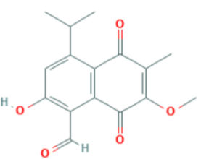 | (4lq3)  -6.7
(4rpb)
-6.7
Tulsi | B-elemene | 6918391 | 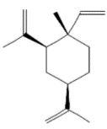 | (4lq3)  -7.7
(4rpb)
-9.4
Tulsi | Limonene, | 22311 | 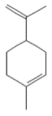 | (4lq3)  -5
(4rpb)
-5.4
Tulsi | Carvacrol | 10364 | 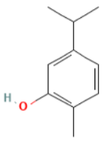 | (4lq3)  -5.3
(4rpb)
-5.7
Tut begun | Gallic acid | 370 | 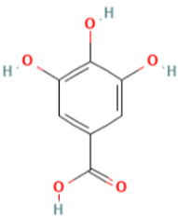 | (4lq3)  -6
(4rpb)
-6.1

Supplementary Table 2: Drug likeness properties of 59 phytochemical compounds.

Compound ID | MW  (g/mol) | RO5 | Log p | Log s | HBD | HBA | TPSA  (Å²) | Bioavailability score
CID 92776 | 204.35 g/mol | 1 | 5.63 | -5.41 | 0 | 0 | 0.00 Å² | 0.55
CID 5317270 | 222.37 g/mol | 0 | 4.68 | -4.19 | 1 | 1 | 20.23 Å² | 0.55
CID 442793 | 294.39 g/mol | 0 | 3.58 | -3.63 | 2 | 4 | 66.76 Å² | 0.55
CID 5281794 | 276.37 g/mol | 0 | 3.6 | -4.47 | 1 | 3 | 46.53 Å² | 0.55
CID 21601966 | 344.53 g/mol | 1 | 5.47 | -5.78 | 0 | 2 | 34.14 Å² | 0.55
CID 53957771 | 342.51 g/mol | 1 | 5.14 | -6.65 | 0 | 2 | 26.30 Å² | 0.55
CID 11349 | 238.24 g/mol | 0 | 3.03 | -3.23 | 1 | 3 | 50.44 Å² | 0.55
CID 6780 | 208.21 g/mol | 0 | 3.6 | -4.18 | 0 | 2 | 34.14 Å² | 0.55
CID 667496 | 188.23 g/mol | 0 | 1.05 | -1.59 | 1 | 3 | 35.83 Å² | 0.55
CID 442894 | 172.23 g/mol | 0 | 1.85 | -1.89 | 0 | 2 | 15.60 Å² | 0.55
CID 6251 | 182.17 g/mol | 1 | -3.32 | 1.13 | 6 | 6 | 121.38 Å² | 0.55
CID 442935 | 202.21 g/mol | 0 | -0.14 | -0.9 | 1 | 4 | 55.12 Å² | 0.55
CID 10212 | 270.28 g/mol | 0 | 3.22 | -4.52 | 0 | 4 | 52.58 Å² | 0.55
CID 10666 | 164.16 g/mol | 0 | 0.48 | -0.8 | 0 | 4 | 55.02 Å² | 0.55
CID 5280343 | 302.24 g/mol | 0 | 2.17 | -3 | 5 | 7 | 131.36 Å² | 0.55
CID 5281708 | 254.24 g/mol | 0 | 2.68 | -3.08 | 2 | 4 | 70.67 Å² | 0.55
CID 5281781 | 314.29 g/mol | 0 | 2.81 | -3.16 | 2 | 6 | 89.13 Å² | 0.55
CID 5280443 | 270.24 g/mol | 0 | 3.11 | -3.19 | 3 | 5 | 90.90 Å² | 0.55
CID 174174 | 289.37 g/mol | 0 | 1.71 | -2.43 | 1 | 4 | 49.77 Å² | 0.55
CID 5316212 | 238.37 g/mol | 0 | 2.57 | -1.89 | 2 | 2 | 40.46 Å² | 0.55
CID 7460 | 136.23 g/mol | 0 | 4.9 | -4.85 | 0 | 0 | 0.00 Å² | 0.55
CID 11463 | 136.23 g/mol | 0 | 4.67 | -3.88 | 0 | 0 | 0.00 Å² | 0.55
CID 1057 | 126.11 g/mol | 0 | 0.48 | -0.49 | 3 | 3 | 60.69 Å² | 0.55
CID 7362 | 96.08 g/mol | 0 | 0.23 | 0.19 | 0 | 2 | 30.21 Å² | 0.55
CID 5281614 | 86.24 g/mol | 0 | 2.55 | -2.85 | 4 | 6 | 111.13 Å² | 0.55
CID 54678486 | 308.33 g/mol | 0 | 2.41 | -3.47 | 1 | 4 | 67.51 Å² | 0.55
CID 4650 | 108.09 g/mol | 0 | 0.14 |  | 0 | 2 | 34.14 Å² | 0.55
  -0.67
CID 188308 | 288.25 g/mol | 0 | 2.33 | -2.88 | 4 | 6 | 107.22 Å² | 0.55
CID 996 | 94.11 g/mol | 0 | 1.65 | -0.86 | 1 | 1 | 20.23 Å² | 0.55
CID 6306 | 131.17 g/mol | 0 | -2.58 | 0.27 | 2 | 2 | 63.32 Å² | 0.55
CID 1107 | 248.40 g/mol | 1 | 5.04 | -5.76 | 1 | 1 | 20.23 Å² | 0.55
CID 5280863 | 286.24 g/mol | 0 | 2.64 | -3 | 4 | 6 | 111.13 Å² | 0.55
CID 5280445 | 286.24 g/mol | 0 | 2.34 | -2.81 | 4 | 6 | 111.13 Å² | 0.55
CID 638088 | 180.25 g/mol | 1 | 4.25 | -4.89 | 0 | 0 | 0.00 Å² | 0.55
CID 689043 | 180.16 g/mol | 0 | 1.25 | -1.5 | 3 | 3 | 77.76 Å² | 0.56
CID 638024 | 285.34 g/mol | 0 | 2.94 | -3.79 | 0 | 3 | 38.77 Å² | 0.55
CID 2850046 | 252.27 g/mol | 0 | 2.69 | -4.13 | 1 | 4 | 59.28 Å² | 0.55
CID 14018348 | 312.27 g/mol | 0 | 2.44 | -3.7 | 3 | 6 | 100.13 Å² | 0.55
CID 70446911 | 250.29 g/mol | 0 | 3.76 | -5.02 | 0 | 2 | 30.21 Å² | 0.55
CID 6427071 | 194.27 g/mol | 0 | 4.16 | -3.85 | 0 | 2 | 18.46 Å² | 0.55
CID 14104 | 164.24 g/mol | 0 | 4.26 | -4 | 0 | 1 | 9.23 Å² | 0.55
CID 161716 | 164.24 g/mol | 0 | 4.24 | -3.97 | 0 | 1 | 9.23 Å² | 0.55
CID 326 | 148.20 g/mol | 0 | 2.9 | -2.63 | 0 | 1 | 17.07 Å² | 0.55
CID 16315 | 178.34 g/mol | 0 | 3.91 | -4.1 | 0 | 3 | 75.90 Å² | 0.55
CID 9576089 | 177.22 g/mol | 0 | -3.32 | 0.44 | 2 | 3 | 99.60 Å² | 0.55
CID 65036 | 162.27 g/mol | 0 | 1.98 | -1.87 | 0 | 2 | 61.58 Å² | 0.55
CID 11617 | 114.21 g/mol | 0 | 2.3 | -1.7 | 0 | 1 | 25.30 Å² | 0.55
CID 5386591 | 234.40 g/mol | 0 | 2.44 | -2.66 | 0 | 3 | 86.88 Å² | 0.55
CID 6451349 | 224.25 g/mol | 0 | 3.92 | -4 | 0 | 2 | 18.46 Å² | 0.55
CID 5971 | 99.15 g/mol | 0 | - | - | - | - | 44.45 Å² | 0.55
CID 3314 | 164.20 g/mol | 0 | 2.32 | -1.53 | 1 | 2 | 29.46 Å² | 0.55
CID 798 | 117.15 g/mol | 0 | 2.16 | -1.79 | 1 | 0 | 15.79 Å² | 0.55
CID 23642717 | 260.29 g/mol | 0 | 2.95 | -3.25 | 1 | 4 | 63.60 Å² | 0.55
CID 328066 | 288.30 g/mol | 0 | 3.05 | -3.35 | 1 | 5 | 80.67 Å² | 0.56
CID 6918391 | 204.35 g/mol | 1 | 5.78 | -5.41 | 0 | 0 | 0.00 Å² | o.55
CID 22311 | 136.23 g/mol | 0 | 4.67 | -4.1 | 0 | 0 | 0.00 Å² | 0.55
CID 10364 | 150.22 g/mol | 0 | 3.28 | -2.55 | 1 | 1 | 20.23 Å² | 0.55
CID 370 | 170.12 g/mol | 0 | 0.52 | -1.67 | 4 | 4 | 97.99 Å² | 0.56

Supplementary Table 3: Toxicity properties of 59 phytochemical ligand molecules
Compound ID | HIA | BBB | Caco-2 | p-glycoprotein substrate | p-glycoprotein inhibitor | Ames test | Carcinogenicity
CID 92776 | + | + | + | substrate | Non-inhibitor | - | No
CID 5317270 | + | + | + | substrate | Non-inhibitor | - | No
CID 442793 | + | + | + | substrate | Non-inhibitor | - | No
CID 5281794 | + | + | + | substrate | Non-inhibitor | - | No
CID 21601966 | + | + | + | substrate | Non-inhibitor | - | No
CID 53957771 | + | + | + | Non-substate | inhibitor | - | No
CID 11349 | + | + | + | substrate | Non-inhibitor | + | No
CID 6780 | + | + | + | substrate | Non-inhibitor | + | Yes
CID 667496 | + | + | + | substrate | Non-inhibitor | + | Yes
CID 442894 | + | + | + | Non-substrate | Non-inhibitor | + | Yes
CID 6251 | - | - | - | substrate | Non-inhibitor | - | No
CID 442935 | + | + | + | substrate | Non-inhibitor | - | Yes
CID 10212 | + | + | + | substrate | inhibitor | + | Yes
CID 10666 | + | + | + | substrate | Non-inhibitor | - | No
CID 10666 | + | + | + | substrate | Non-inhibitor | - | No
CID 5280343 | + | - | - | substrate | Non-inhibitor |  | No
CID 5281708 | + | + | + | substrate | Non-inhibitor | + | Yes
CID 5281781 | + | + | + | substrate | inhibitor | + | Yes
CID 5280443 | + | + | - | substrate | Non-inhibitor | + | Yes
CID 174174 | + | + | + | Non-substrate | Non-inhibitor | - | No
CID 5316212 | + | + | + | substrate | Non-inhibitor | - | Yes
CID 7460 | + | + | + | substrate | Non-inhibitor | - | No
CID 11463 | + | + | + | substrate | Non-inhibitor | - | Yes
CID 1057 | + | + | - | substrate | Non-inhibitor | - | No
CID 7362 | + | + | + | substrate | Non-inhibitor | - | Yes
CID 5281614 | + | - | - | substrate | Non-inhibitor | + | No
CID 54678486 | + | + | + | substrate | Non-inhibitor | - | No
CID 4650 | + | + | + | substrate | Non-inhibitor | - | Yes
CID 188308 | + | - | - | substrate | Non-inhibitor | + | No
CID 996 | + | + | + | substrate | Non-inhibitor | - | Yes
CID 6306 | + | + | - | substrate | Non-inhibitor | - | No
CID 1107 | + | + | + | substrate | Non-inhibitor | - | No
CID 5280863 | + | - | - | substrate | Non-inhibitor | + | Yes
CID 5280445 | + | - | - | substrate | Non-inhibitor | + | No
CID 638088 | + | + | + | substrate | Non-inhibitory | - | No
CID 689043 | + | + | - | substrate | Non-inhibitory | - | No
CID 638024 | + | + | + | substrate | inhibitor | + | Yes
CID 2850046 | + | + | + | substrate | Non-inhibitor | + | Yes
CID 14018348 | + | - | - | substrate | inhibitor | + | Yes
CID 70446911 | + | + | + | substrate | inhibitor | + | Yes
CID 6427071 | + | + | + | substrate | Non-inhibitor | - | No
CID 14104 | + | + | + | substrate | Non-inhibitor | - | Yes
CID 161716 | + | + | + | substrate | Non-inhibitor | - | Yes
CID 16315 | + | + | + | substrate | Non-inhibitor | + | No
CID 9576089 | - | - | - | substrate | inhibitor | + | Yes
CID 65036 | + | + | + | substrate | Non-inhibitor | + | Yes
CID 11617 | + | + | + | substrate | Non-inhibitor | + | No
CID 5386591 | + | + | + | substrate | inhibitor | + | Yes
CID 6451349 | + | + | + | substrate | Non-inhibitor | - | No
CID 5971 |  |  |  |  |  |  | Yes
CID 3314 | + | + | + | substrate | Non-inhibitor | - | No
CID 798 | + | + | + | substrate | Non-inhibitory | - | No
CID 23642717 | + | + | + | substrate | Non-inhibitory | + | Yes
CID 328066 | + | + | - | substrate | Non-inhibitory | + | Yes
CID 6918391 | + | + | + | substrate | Non-inhibitor | - | Yes
CID 22311 | + | + | + | substrate | Non-inhibitor | - | No
CID 10364 | + | + | + | substrate | Non-inhibitor | - | No
CID 370 | + | - | - | substrate | Non-inhibitor | - | No
CID 326 | + | + | + | substrate | Non-inhibitor | - | No

