Supplementary materials for
Single-cell analysis reveals a kynurenine pathway enriched epithelial subpopulation and a HAAO/QA-FDPS metabolic axis in prostate cancer
Hongchang Zhang et al.
*Correspondence:
CONTENTS
Figure. S1-S6
Tables. S1 to S6

Figure S1
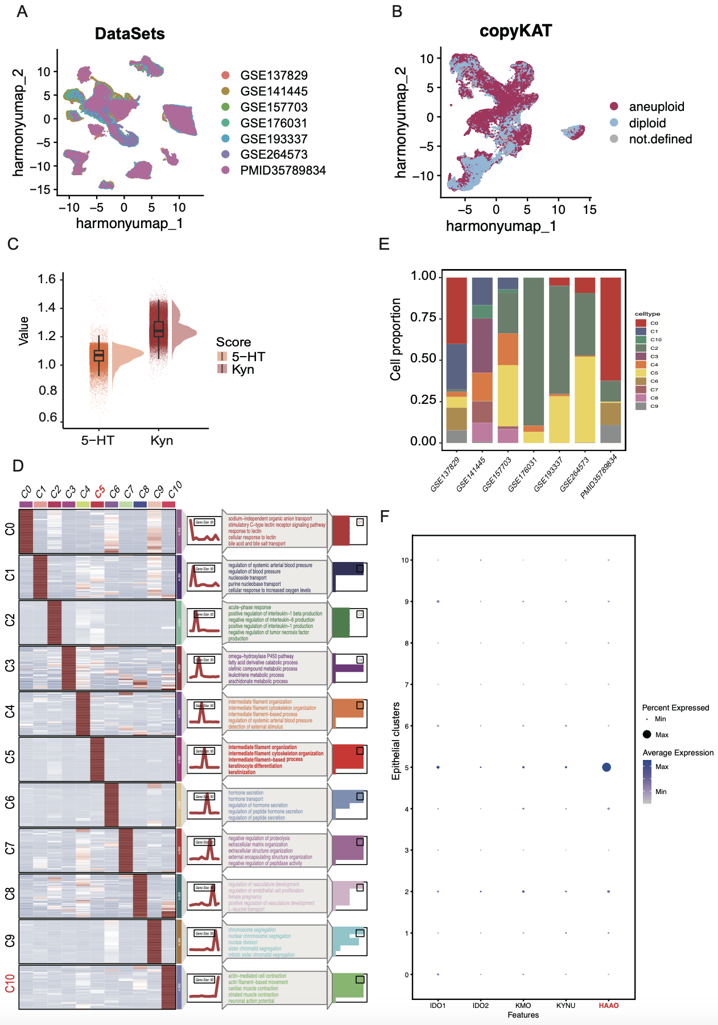
Figure S1. Single-cell transcriptomic landscape and kynurenine pathway activity across malignant epithelial cells. (A) Integrated analysis of 123,986 cells from 7 published human scRNA-seq datasets. (B) UMAP plot showing the aneuploid, diploid and not defined epithelial cells in = prostate cancer tissues. (C) UMAP plot showing the activity distribution of the kynurenine and 5-HT pathways in aneuploid epithelial cells, with pathway activity scores quantified using GSVA. (D) Box plot showing the GSVA scores of the kynurenine and 5-HT pathways in malignant cells. Wilcoxon rank-sum test used for comparison, ***p < 0.001. (E) Violin plot showing the expression levels of kynurenine and 5-HT pathways in each malignant cluster, with “Diff” representing Kyn minus 5-HT. (F) Stacked bar plot showing the distribution proportions of malignant epithelial clusters across various datasets. (G) KEGG analysis showing the top five enriched pathways for each malignant epithelial cluster. (H) Bubble plot showing the expression levels of kynurenine pathway genes in the C5 cluster.
Figure S2
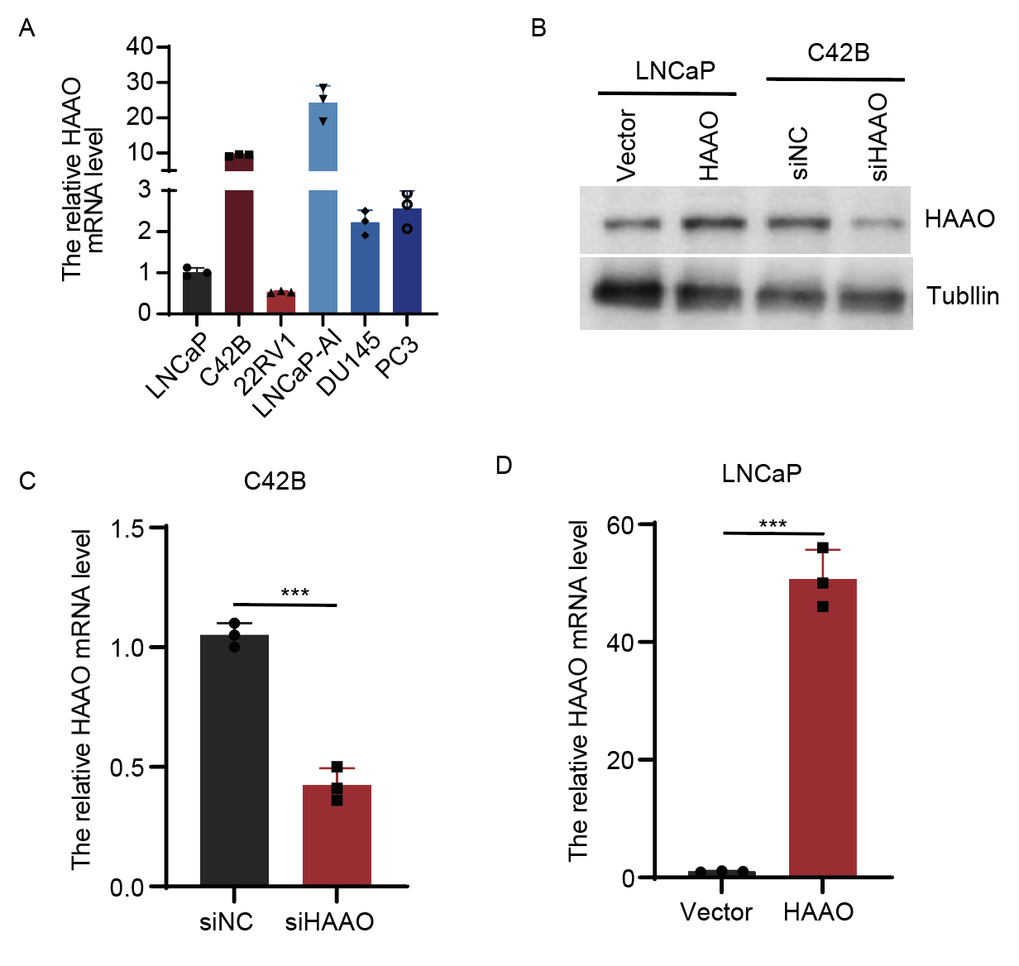
Figure S2. Validation of HAAO overexpression and knockdown at the protein and mRNA levels. (A) Relative mRNA levels of HAAO in prostate cancer cells. (B) Western blot analysis of HAAO level in HAAO-OE LNCaP and siHAAO C4-2B. (C) The relative HAAO mRNA level in siHAAO C4-2B cells. Data are presented as mean ± SD. Unpaired two-tailed Student’s t-test used for comparison. ∗∗∗p < 0.001. (D) The relative HAAO mRNA level in HAAO-OE LNCaP cells. Data are presented as mean ± SD. Unpaired two-tailed Student’s t-test used for comparison. ∗∗∗p < 0.001.

Figure S3
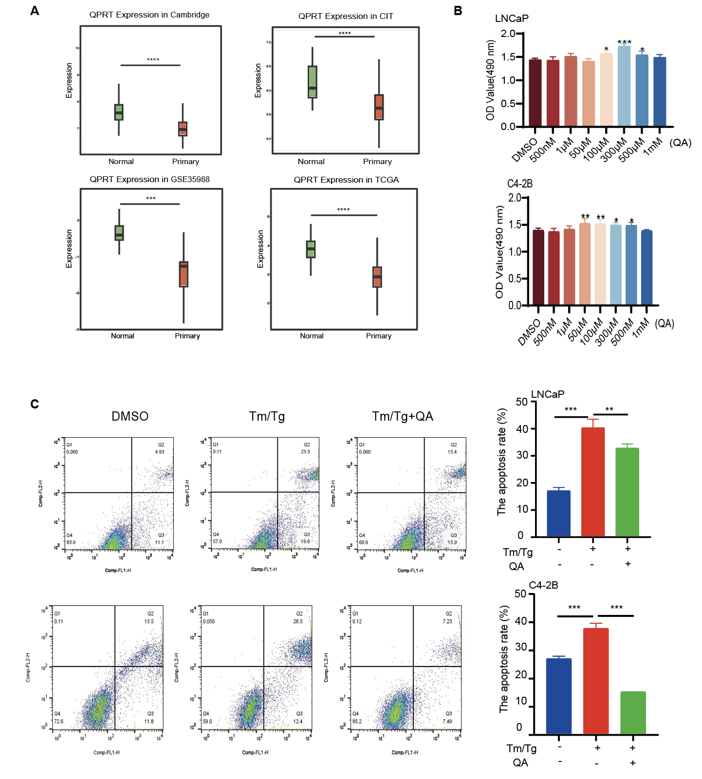
(A) Box plot showing QPRT expression in primary vs normal tissue of prostate cancer patients across different datasets. Wilcoxon rank-sum test used for comparison, ***p < 0.001, ****p < 0.0001. (B) Bar plot showing the OD values (490 nm) of LNCaP and C4-2B cells treated with different QA concentrations. Data are presented as mean ± SD. Unpaired two-tailed Student’s t-test used for comparison. ∗p < 0.05, ∗∗p < 0.01, ∗∗∗p < 0.001. (C) Flow cytometry analysis showing the apoptosis levels of LNCaP and C4-2B cells after Tm/Tg induced apoptosis, with or without QA treatment. Data are presented as mean ± SD, and endpoint data were analyzed using one-way ANOVA followed by Dunnett’s test for multiple comparisons. ∗∗p < 0.01, ∗∗∗p < 0.001.

Figure S4
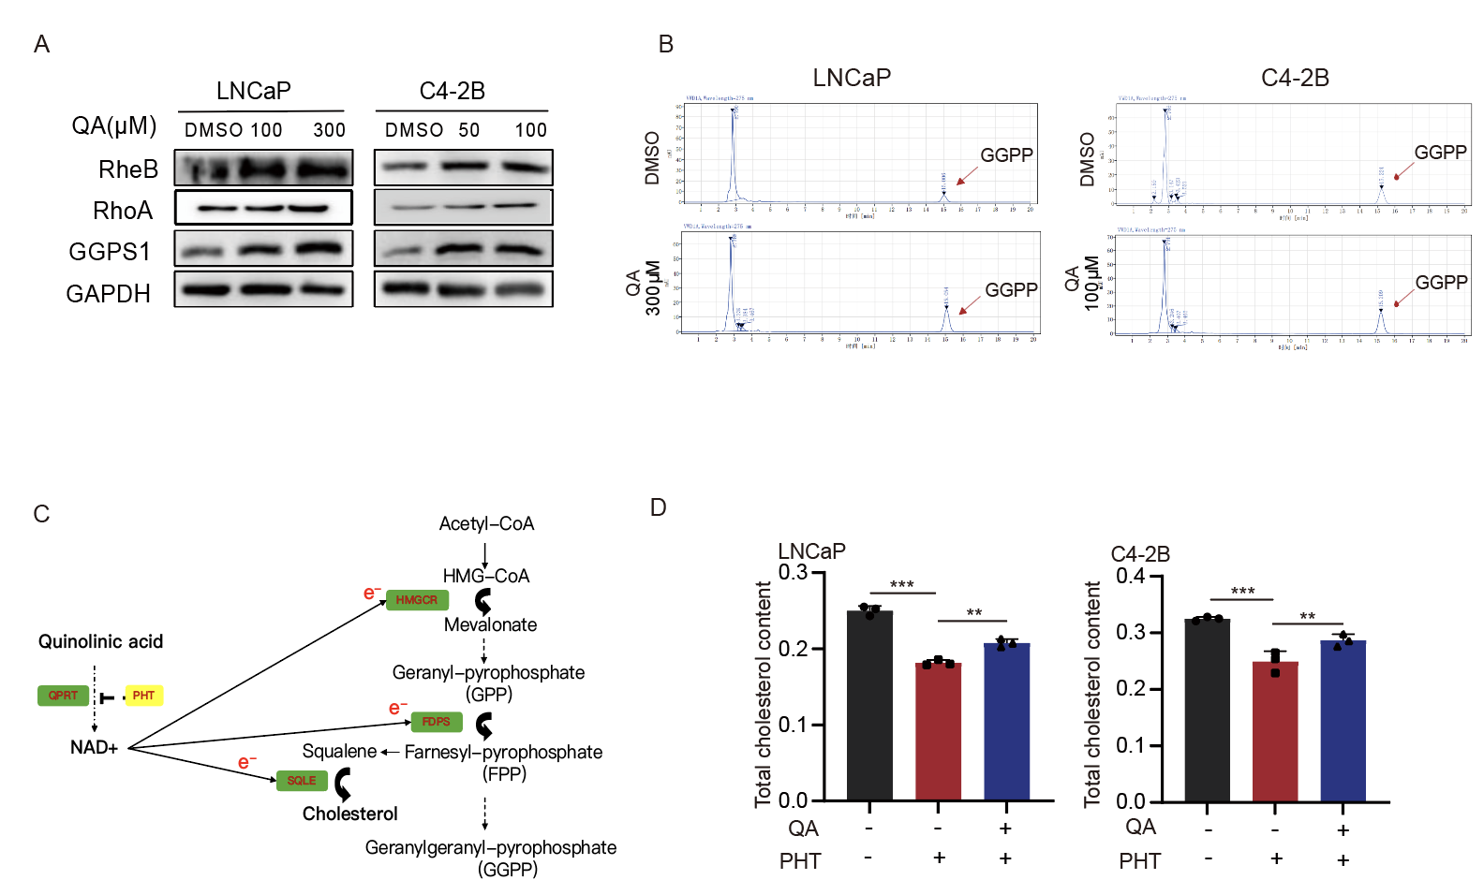
Figure S4. QA modulates the MVA pathway in prostate cancer cells. (A) Western blot analysis showing the expression of MVA pathway proteins in LNCaP and C4-2B cells treated with different QA concentrations. (B) GGPP levels of LNCaP and C4-2B cells treated with QA. (C) Schematic diagram showing the crosstalk between the kynurenine pathway and the mevalonate (MVA) pathway. (D) Bar chart show results from LNCaP and C42B cells treated under three conditions: (1) no QA or PHT; (2) PHT only; and (3) QA + PHT with simultaneous measurement of cholesterol levels.

Figure S5
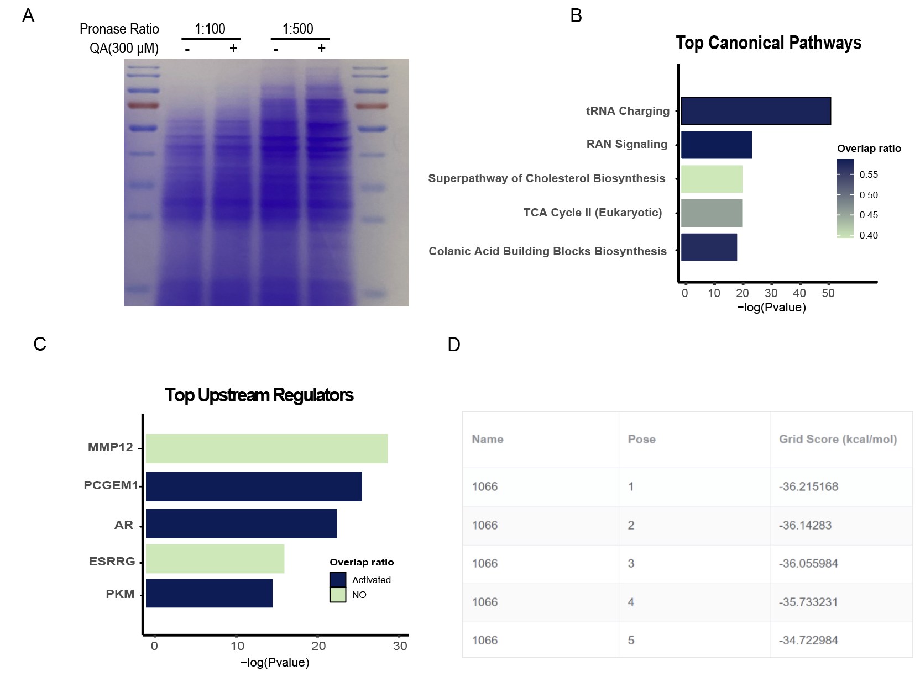
Figure S5. QA associated proteomic and structural analyses. (A) LNCaP cells were treated with 300 µM quinolinic acid (QA), followed by protease digestion of the cell lysates and Coomassie Brilliant Blue staining. (B) IPA analysis showing the top canonical pathways in LNCaP cells treated with QA. (C) IPA analysis showing the top canonical transcription factor in LNCaP cells treated with QA. (D) Molecular docking model showing the relative binding affinities of quinolinic acid at different sites.

Figure S6
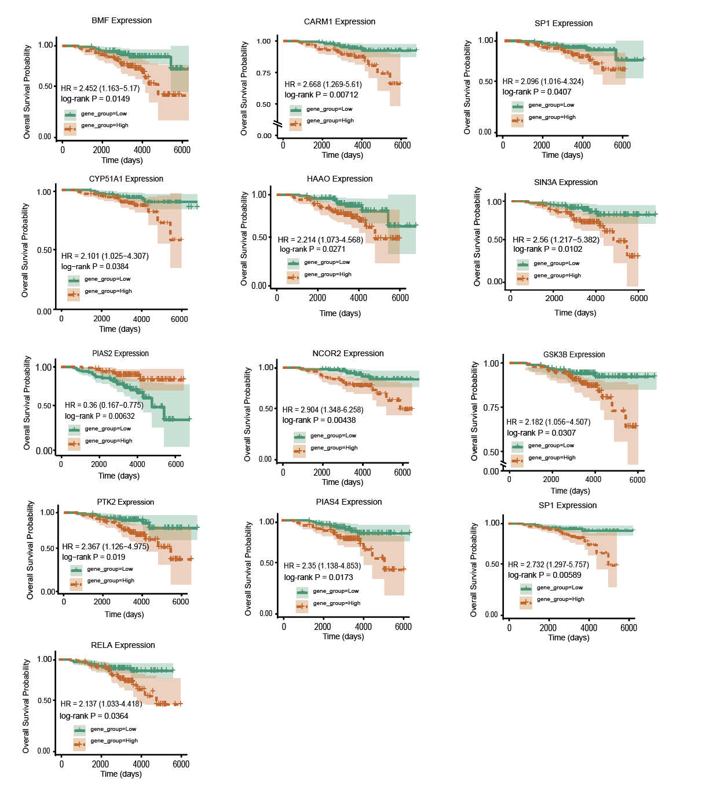
Figure S6. Kaplan–Meier survival analysis of genes stratified by high and low expression. (A) Kaplan-Meier survival of high and low expression groups of survival-related genes.

Table S1. Single cell RNAseq datastes
Dataset | Patient ID | SampleID | Stage（TNM） | PSA | Gleason score | Site of Biopsy
GSE137829 | P1 | GSM4089151-P1 | cT2cN0M0 | 8.88 | 4+5=9 | Prostate
GSE137829 | P2 | GSM4089152-P2 | cT3bN1M0 | 56.53 | 7(4+3) | Prostate
GSE137829 | P3 | GSM4089153-P3 | cT2cN0M0 | 55.16 | 8(4+4) | Prostate
GSE137829 | P4 | GSM4089154-P4 | cT4N0M0 | 149 | 7(4+3) | Prostate
GSE137829 | P5 | GSM4089155-P5 | cT3bN1M1a | 15.6 | 8(4+4) | Prostate
GSE137829 | P6 | GSM4089156-P6 | cT4N1M1 | 72.72 | Small-cell NEPC | Prostate
GSE141445 | P7 | GSM4203181-1 | cT4N1M0 | 79.44 | 9(4+5) | Prostate
GSE141445 | P8 | GSM4203181-2 | cT4N0M0 | 18.51 | 10(5+5) | Prostate
GSE141445 | P9 | GSM4203181-3 | cT3aN0M0 | 7.05 | 9(4+5) | Prostate
GSE141445 | P10 | GSM4203181-4 | cT3aN0M0 | 22.57 | 9(4+5) | Prostate
GSE141445 | P11 | GSM4203181-5 | cT2cN0M0 | 10.5 | 7(4+3) | Prostate
GSE141445 | P12 | GSM4203181-6 | cT2cN1M0 | 336 | 7(4+3) | Prostate
GSE141445 | P13 | GSM4203181-7 | cT2cN1M1b | 16 | 9(4+5) | Prostate
GSE141445 | P14 | GSM4203181-8 | cT2cN1M1b | 16 | 9(4+5) | Prostate
GSE141445 | P15 | GSM4203181-9 | cT2cN0M0 | 20 | 9(4+5) | Prostate
GSE141445 | P16 | GSM4203181-10 | cT2cN0M0 | 81.09 | 7 (3 + 4) | Prostate
GSE141445 | P17 | GSM4203181-11 | cT3aN0M1b | 19 | 9(4+5) | Prostate
GSE141445 | P18 | GSM4203181-12 | cT3aN0M0 | 51 | 7(4+3) | Prostate
GSE141445 | P19 | GSM4203181-13 | cT2bN0M1a | 14 | 9(4+5) | Lymph node
GSE157703 | P20 | GSM4773521_PCa1 | pT2N0 | NA | 6 (3 + 3) | Prostate
GSE157703 | P21 | GSM4773522_PCa2 | pT3aN1 | NA | 7 (3 + 4) | Prostate
GSE193337 | P22 | GSM5793828_P1t | pT2cN0 | 20 | NA | Prostate
GSE193337 | P23 | GSM5793829_P2t | pT2aN0 | 2.4 | NA | Prostate
GSE193337 | P24 | GSM5793831_P3t | pT3aN0 | 14 | NA | Prostate
GSE193337 | P25 | GSM5793832_P4t | pT3bN0 | 2.32 | NA | Prostate
GSE264573 | P26 | GSM8222914_HMP22 | NA | NA | NA | Lymph node
GSE264573 | P27 | GSM8222915_HMP23A | NA | NA | NA | Prostate
GSE264573 | P28 | GSM8222916_HMP23B | NA | NA | NA | Prostate
GSE264573 | P29 | GSM8222917_HMP24 | NA | NA | NA | Pelvic Mass
PMID35789834 | P30 | PMID35789834-P1 | cT3bN1M1b | 8.63 | 9(4+5) | Lymph node
PMID35789834 | P31 | PMID35789834-P2 | cT1cNxMx | 6.39 | 9(4+5) | Prostate
PMID35789834 | P32 | PMID35789834-P3 | cT3bN1M0 | 71.64 | 9(4+5) | Lymph node
PMID35789834 | P33 | PMID35789834-P6 | cT3bN1M1b | 147.71 | 9(4+5) | Prostate
GSE176031 | P34 | GSM5353232_PA_PR5249_T1_S3 | cT2b | 5.2 | 7 (3 + 4) | left lateral gland
GSE176031 | P34 | GSM5353233_PA_PR5249_T2_S4
GSE176031 | P35 | GSM5353236_PA_PR5251_T1_S7 | cT2c | 7.7 | 7 (3 + 4) | left mid
GSE176031 | P35 | GSM5353237_PA_PR5251_T2_S8
GSE176031 | P36 | GSM5353240_PA_PR5254_T1_S15 | cT2a | 7.8 | 7(4+3) | left mid
GSE176031 | P37 | GSM5353243_PA_PR5261_T1_S23 | cT2a | 3.89 | 7 (3 + 4) | central mid towards apex
GSE176031 | P37 | GSM5353244_PA_PR5261_T1_S24
GSE176031 | P38 | GSM5353245_PA_PR5269_1_S25 | cT1c | 4.1 | 7 (3 + 4) | NA
GSE176031 | P38 | GSM5353246_PA_PR5269_2_S26
GSE176031 | P38 | GSM5353247_PA_PR5269_3_S27
GSE176031 | P38 | GSM5353248_PA_PR5269_4_S28

Table S2. Gene expression signatures related to tryptophan metabolism
Kynurenine pathway | 5-hydroxytryptamine (5-HT) pathways
AFMID | TPH1
HAAO | TPH2
IDO1 | AADC
IDO2 | MAO
KMO | AANAT
KYNU | ASMT

Table S3. Antibodies
Antibody Target | Source | Application
GAPDH | Selleckchem;Catalog No.: F0003 | WB
HMGCS1 | ABclonal;Catalog No.:A3916 | WB
HMGCR | ABclonal;Catalog No.:A1633 | WB
MVK | ABclonal;Catalog No.:A20906 | WB
FDPS | ABclonal;Catalog No.:A23475 | WB
RheB | ABclonal;Catalog No.:A1165 | WB
RhoA | ABclonal;Catalog No.:A0272 | WB
GGPS1 | ABclonal;Catalog No.:A16233 | WB
Rap1A | Thermo Fisher;Catalog No.:MA5-17164 | WB
Tubulin | Thermo Fisher;Catalog No.:MA5-16308 | WB
AR | Thermo Fisher;Catalog No.:MA5-13426 | WB
PSA | Thermo Fisher;Catalog No.:MA1-10447 | WB
Lamin B1 | Thermo Fisher;Catalog No.:702972 | WB
FDFT1 | Thermo Fisher;Catalog No.:MA5-44872 | WB

Table S4. Primers
Gene Name | Sequence (5´to 3´)
GAPDH | F: CTT GTG TTC GCT CCC AGG CAT A
GAPDH | R: GGC TGT TGT CAT ACT TCT CAT GG
HAAO | F: CCT GAG ACA GAA TG TGG ACG TG
HAAO | R: CTT GTG TTC GCT CCC AGG CAT A
PSA | F: GAC CAA GTT CAT GCT GTG TGC
PSA | R: CCA CTC ACC TTTCCC CTC AAG
TMPRSS2 | F: CAA GTG CTC CAA CTC TGG GAT
TMPRSS2 | R: AAC ACA CCG ATT CTC GTC CTC
S100P | F: AAG GAT GCC GTG GAT AAA TTG C
S100P | R: ACA CGA TGA ACT CAC TGA AGT C
KLK2 | F: TCA GAG CCT GCC AAG ATC AC
KLK2 | R: CAC AAG TGT CTT TAC CAC CTG T

Table S5. siRNAs.
siRNA | Sequence (5´to 3´)
siHAAO | CGAAGAGGGUGAAGAGGUATTUACCUCUUCACCCUCUUCGTT
siHAAO | GAGCAGUACAGAACAGGAATTUUCCUGUUCUGUACUGCUCTT
siFDPS | CCAGAAUUCAGAUGUUUAUTT
siFDPS | CCAUCAAUGAUGCUAACCUTT

Table S6. Risk genes
ENSG | Gene | Hazard Ratio | CI_Low | CI_Up | Pvalue | Beta
ENSG00000196498 | NCOR2 | 2.904 | 1.348 | 6.258 | 0.0044 | 1.066089
ENSG00000185591 | SP1 | 2.732 | 1.297 | 5.757 | 0.0059 | 1.005034
ENSG00000078043 | PIAS2 | 0.36 | 0.167 | 0.775 | 0.0063 | -1.02165
ENSG00000142453 | CARM1 | 2.668 | 1.269 | 5.61 | 0.0071 | 0.981329
ENSG00000169375 | SIN3A | 2.56 | 1.217 | 5.382 | 0.0102 | 0.940007
ENSG00000104081 | BMF | 2.452 | 1.163 | 5.17 | 0.0149 | 0.896904
ENSG00000105229 | PIAS4 | 2.35 | 1.138 | 4.853 | 0.0173 | 0.854415
ENSG00000169398 | PTK2 | 2.367 | 1.126 | 4.975 | 0.019 | 0.861623
ENSG00000162882 | HAAO | 2.214 | 1.073 | 4.568 | 0.0271 | 0.794801
ENSG00000082701 | GSK3B | 2.182 | 1.056 | 4.507 | 0.0307 | 0.780242
ENSG00000173039 | RELA | 2.137 | 1.033 | 4.418 | 0.0364 | 0.759403
ENSG00000001630 | CYP51A1 | 2.101 | 1.025 | 4.307 | 0.0384 | 0.742413
ENSG00000103275 | UBE2I | 2.096 | 1.016 | 4.324 | 0.0407 | 0.740031

