Supporting Information for:
Seagrass sediment organic carbon burial rates are globally significant
Ariane Arias-Ortiz^{1*}, Anna Lafratta², Phil Colarusso³, James W. Fourqurean^{4,5}, Chuancheng Fu⁶, Hilary Kennedy⁷, Johannes R. Krause⁴, Paul S. Lavery², Carmen Leiva-Dueñas⁸, Nuria Marbà⁹, Miguel A. Mateo^{2,10}, Inés Mazarrasa¹¹, Dimitris Poursanidis¹², Cristian Salinas², Oscar Serrano¹⁰, Milica Stankovic^{13, 14}, Nerea Piñeiro¹⁵, Axel Werner², Marlene Wesselmann², Carlos M. Duarte⁶, Jordi Garcia-Orellana¹, Pere Masqué²

¹Department de Física, Universitat Autonoma de Barcelona, Bellaterra, 08193 Barcelona, Spain
²School of Science & Centre for Marine Ecosystems Research, Edith Cowan University, Joondalup WA 6027, Australia.
³United States Environmental Protection Agency, Boston, Massachusetts 02109, USA.
⁴ Institute of Environment, Florida International University, 11200 SW 8th St, Miami, FL 33199, USA
⁵ Department of Biological Sciences, Florida International University, 11200 SW 8th St, Miami, FL 33199, USA
⁶ Marine Science Program, Biological and Environmental Science and Engineering Division (BESE), King Abdullah University of Science and Technology (KAUST), Thuwal 23955-6900, Saudi Arabia.
⁷School of Ocean Sciences, Bangor University, Menai Bridge, Wales, UK
⁸Department of Ecoscience, Aarhus University, C.F. Møllers Allé, building 1131, DK-8000 Aarhus, Denmark
⁹Global Change Research Group, IMEDEA (CSIC-UIB) Institut Mediterrani d’Estudis Avançats, Miquel Marqués 21, 07190 Esporles, (Spain)
¹⁰Centre for Advanced Studies of Blanes, Spanish Council for Scientific Research, 17300 Blanes, Spain.
¹¹IH Cantabria, Instituto de Hidráulica Ambiental de la Universidad de Cantabria C/. Isabel Torres, 15, 39011 Santander, Cantabria
¹² Foundation for Research and Technology—Hellas (FORTH), Institute of Applied and Computational Mathematics, N. Plastira 100, Vassilika Vouton, 70013 Heraklion, Greece
¹³Excellenece Center for Biodiversity of Peninsular Thailand, Faculty of Science, Prince of Songkla University, Hat Yai, Songkhla 90110, Thailand
¹⁴Dugong and Seagrass Research Station, Faculty of Science,Prince of Songkla University, Hat Yai, Songkhla, 90110, Thailand
¹⁵Centro de Investigacions Mariñas, Departamento de Xeocencias Mariñas e Ordenación do Territorio, Universidad de Vigo, Vigo, Spain.

Correspondence: Ariane Arias-Ortiz (ariane.arias@uab.cat)

Figures
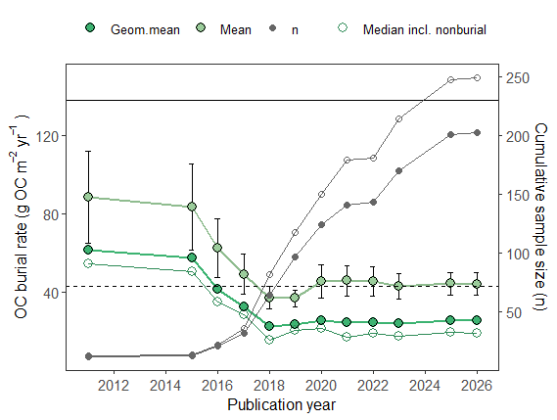
Figure S1. Summary statistics for direct organic carbon (OC) burial rates in seagrass sediments by publication year. Solid symbols represent statistics for seagrass cores showing net positive accumulation, while open symbols include the same stats for both depositional and non-depositional seagrass sediments. Horizontal lines indicate the IPCC Tier 1 estimate (dashed) and the mean OC burial rate reported by McLeod et al. (2011) (solid).

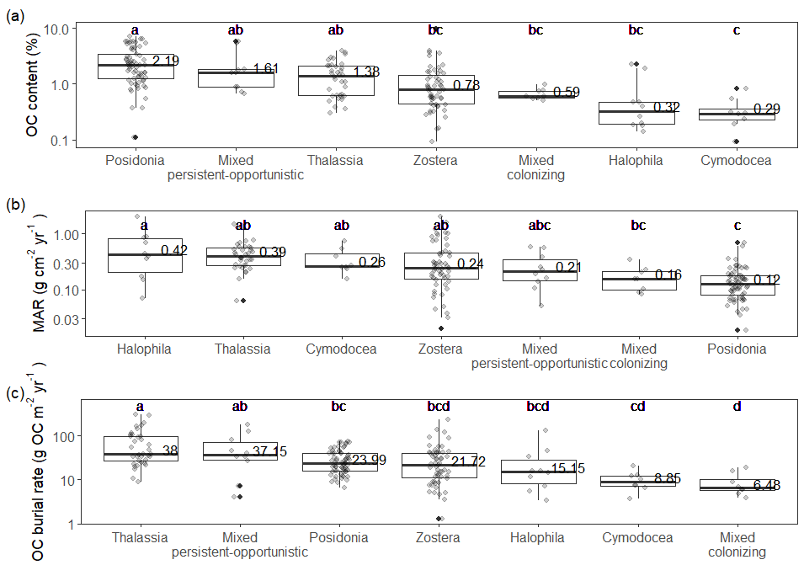
Figure S2. (a) Sediment organic carbon (OC) content in the dated sediment column (b) mass accumulation rates (c) and OC burial rates grouped by seagrass genus. Genus containing less than 5 observations are not shown. Boxes show the interquartile range, horizontal lines indicate the median, and whiskers extend to 1.5 times the IQR, individual data points are overlaid. Solid dark data points represent outliers and values on the box plot represent median values. Mixed persistent-opportunistic records included combinations of species of the genera Posidonia and Amphibolis, Thalassia and Syringodium, or Thalassia and Cymodocea. Mixed colonizing records referred to cases where species from the genera Halodule, Ruppia, or Halophila were reported together. Different lower-case letters represent significant differences between coastal geomorphologies as a result of a Kruskal–Wallis Dunn's multiple comparison test with p < 0.05 adjusted using the Bonferroni procedure (p < α/2). Median OC burial rates do not exactly equal the product of median OC content and median MAR in the boxplots because medians are not multiplicative statistics, and OC content and MAR are skewed and covary across sites. Burial rates are computed for each individual core from its specific OC content and MAR, whereas the medians shown for OC and MAR represent marginal distributions that do not necessarily co-occur.

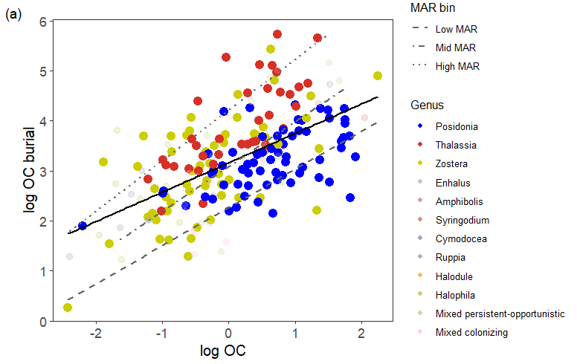
Figure S3. Log-log relationship of organic carbon (OC) burial and OC content in vegetated sediments. Individual observations are colored by seagrass genera, with Posidonia, Thalassia and Zostera, the dominant genus in the dataset colored bright. Mixed persistent-opportunistic records included combinations of species of the genera Posidonia and Amphibolis, Thalassia and Syringodium, or Thalassia and Cymodocea. Mixed colonizing records referred to cases where species from the genera Halodule, Ruppia, or Halophila were reported together. Dashed lines represent linear fits for each MAR quantile (0–25%, 25–75%, 75–100%) and the solid line represents the overall mean linear fit across all points (equation for mean fit shown in Fig. 4 in the main manuscript).

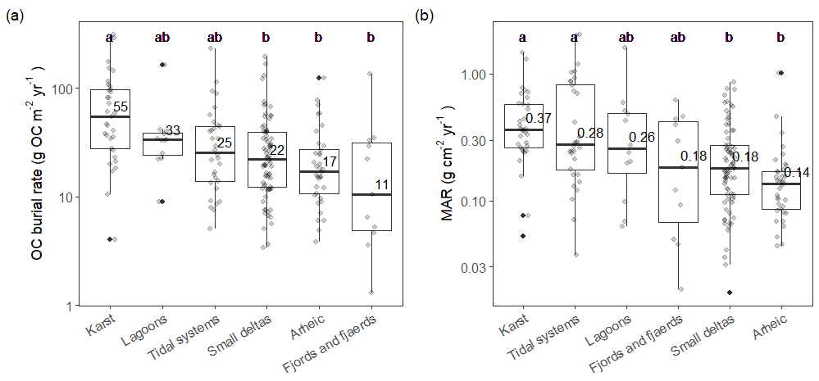
Figure S4. Organic carbon (OC) burial rates (a) and mass accumulation rates (b) in vegetated seagrass sediments with measurable accumulation grouped by coastal geomorphological categories in Dür et al. 2011. Different lower-case letters represent significant differences between coastal geomorphologies as a result of a Kruskal–Wallis Dunn's multiple comparison test with p < .05 adjusted using the Bonferroni procedure (p < α/2). Values on the box plot represent median values.

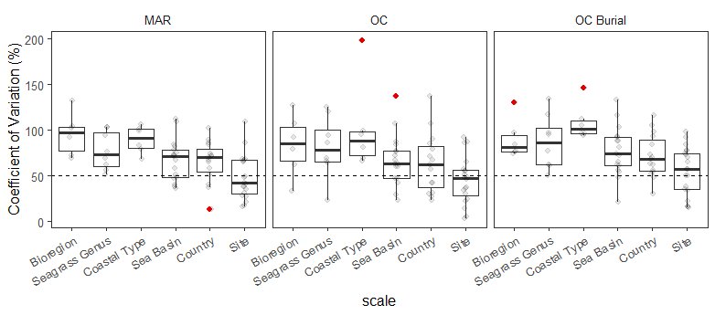
Figure S5. Coefficients of variation in organic carbon (OC) burial rates, mass accumulation rates, and OC content across different spatial scales. Boxes show the interquartile range, horizontal lines indicate the median, and whiskers extend to 1.5 times the IQR, individual data points are overlaid, red data points represent outliers.

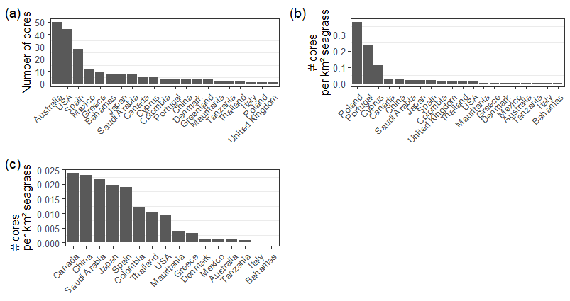
Figure S6. Number of cores in dataset. (a) Cores per country, (b) core per country normalized by mapped seagrass area, (c) core per country normalized by mapped area for countries with > 100 km² of seagrass extent. Cores from Greenland (n = 3) were excluded from panel (c) due to the unknown seagrass area.

Tables
Table S1. Summary statistics for organic carbon burial rates (g OC m⁻² yr⁻¹) in vegetated seagrass sediments with net positive accumulation, grouped by bioregion.
Bioregion | n | Distribution | min | max | mean | SD | median | geom. mean
Mediterranean | 41 | log-normal | 3.40 | 75 | 27 | 21 | 20 | 20
North Atlantic | 21 | log-normal | 1.30 | 230 | 44 | 57 | 20 | 22
North Pacific | 32 |  | 4.63 | 976 | 55 | 169 | 22 | 22
Southern Oceans | 50 | log-normal | 7.02 | 130 | 33 | 28 | 25 | 26
Tropical Atlantic | 46 | log-normal | 4.00 | 309 | 72 | 70 | 39 | 47
Tropical Indo-Pacific | 12 | log-normal | 3.80 | 45 | 15 | 12 | 13 | 12
All | 203 | log-normal | 1.30 | 976 | 44 | 80 | 25 | 26

Table S2. Summary statistics for organic carbon (OC) content, mass accumulation rates (MAR), and OC burial rates in vegetated seagrass sediments with net positive accumulation binned by OC burial rate percentile ranges (0-25%, 25-75%,75-100%).
 |  | OC (%) |  |  |  |  | MAR (g cm⁻² yr⁻¹) |  |  |  |  | OC burial rate (g C m⁻² yr⁻¹)
OC burial percentile bins | n | Min | Q1 | Q2 | Q3 | Max | Min | Q1 | Q2 | Q3 | Max | Min | Q1 | Q2 | Q3 | Max
Low (0-25%) | 51 | 0.09 | 0.33 | 0.54 | 0.79 | 6.30 | 0.02 | 0.09 | 0.16 | 0.26 | 0.62 | 1.3 | 6.0 | 8.5 | 11.1 | 13.4
Intermediate (25-75%) | 100 | 0.15 | 0.67 | 1.19 | 1.93 | 6.80 | 0.04 | 0.11 | 0.21 | 0.36 | 2.04 | 13.5 | 19.1 | 25.0 | 33.7 | 42.0
High (75-100%) | 51 | 0.19 | 1.64 | 2.29 | 3.65 | 9.45 | 0.05 | 0.18 | 0.35 | 0.69 | 2.01 | 43.8 | 56.4 | 75.0 | 118.9 | 308.7

Table S3. Parameters and their standard errors and statistics for the fitted quantile regression
equations between organic carbon (OC) content and sediment mass accumulation rates (MAR), and OC content and OC burial rate in Figure 4a and 4b, respectively.
Function | Percentile bin | Intercept ± SE (a) | Slope ± SE (b) | p-value
OC% = a·exp(b·MAR) | 0-25 | 3.0 ± 0.6 | -11 ± 3 | <0.001
OC% = a·exp(b·MAR) | 25-75 | 5.6 ± 0.5 | -7.8 ± 0.8 | <0.0001
OC% = a·exp(b·MAR) | 75-100 | 6.6 ± 07 | -2.6 ± 0.5 | <0.0001
logOC burial = a + b·logOC | 0-25 | 2.27 ± 0.08 | 0.76 ± 0.07 | <0.0001
logOC burial = a + b·logOC | 25-75 | 3.09 ± 0.04 | 0.91 ± 0.06 | <0.0001
logOC burial = a + b·logOC | 75-100 | 4.25 ± 0.07 | 1.04 ± 0.07 | <0.0001

Table S4. Mapped seagrass area by country updated from McKenzie et al. 2020 (see supplementary spreadsheet file Table S4)

Table S5. Estimates of organic carbon (OC) burial rates in vegetated coastal habitats, and their relative contribution to OC burial in both the coastal and global ocean. Modified from Duarte et al.¹, incorporating updated mapped area estimates^{2–4} and revised areal organic carbon burial rates for vegetated coastal ecosystem^{5,6} and updated global rates for the continental margin⁷, and the deep sea⁸.
Compartment | Area extent  mapped | OC Burial |  |  | Global OC burial
 | 10³ km² | g OC m⁻² yr⁻¹ |  |  | Tg OC yr⁻¹
Vegetated coastal habitats
Mangroves | 82²-146³ | 139 |  | ± 18 | 11 ± 2 | 20 ± 3
Tidal Marsh | 32-60⁴ | 133ª |  | ± 8 | 4.3 ± 0.2 | 8.8 ± 0.5
Seagrass | 248-366 | 33 |  | ± 10 | 8 ± 2 | 12 ± 4
Total vegetated habitats |  | 305 |  | ± 22 | 23 ± 3 | 41 ± 5
% Seagrass |  |  |  |  | 35 ± 10 | 29 ± 10
Depositional marine areas
Continental margin |  |  |  |  | 248⁷
Total coastal OC burial |  |  |  |  | 271 ± 3 | 289 ± 5
Deep Sea burial |  |  |  |  | 20⁸
Total oceanic OC burial |  |  |  |  | 291 ± 3 | 309 ± 5
% Seagrass (based on mapped area) |  |  |  |  | 3 ± 1 | 4 ± 1
ª Median OC burial rate from Wang et al. (2021) was used as the most appropriate measure of central tendency.

References
1. Duarte, C. M., Middelburg, J. J. & Caraco, N. Major role of marine vegetation on the oceanic carbon cycle. Biogeosciences 2, 1–8 (2005).
2. Hamilton, S. E. & Casey, D. Creation of a high spatio-temporal resolution global database of continuous mangrove forest cover for the 21st century (CGMFC-21). Global Ecology and Biogeography 25, 729–738 (2016).
3. Worthington, T. A. et al. A global biophysical typology of mangroves and its relevance for ecosystem structure and deforestation. Sci Rep 10, 1–11 (2020).
4. Worthington, T. A. et al. The distribution of global tidal marshes from Earth observation data. Global Ecology and Biogeography 33, 1–13 (2024).
5. Wang, F. et al. Global blue carbon accumulation in tidal wetlands increases with climate change. Natl Sci Rev 8, (2021).
6. Breithaupt, J. L. & Steinmuller, H. E. Refining the Global Estimate of Mangrove Carbon Burial Rates Using Sedimentary and Geomorphic Settings. Geophys Res Lett 49, (2022).
7. Burdige, D. J. Preservation of organic matter in marine sediments: Controls, mechanisms, and an imbalance in sediment organic carbon budgets? Chem Rev 107, 467–485 (2007).
8. Hayes, C. T. et al. Global Ocean Sediment Composition and Burial Flux in the Deep Sea. Global Biogeochem Cycles 35, 1–25 (2021).

