Supplementary Figures and Tables

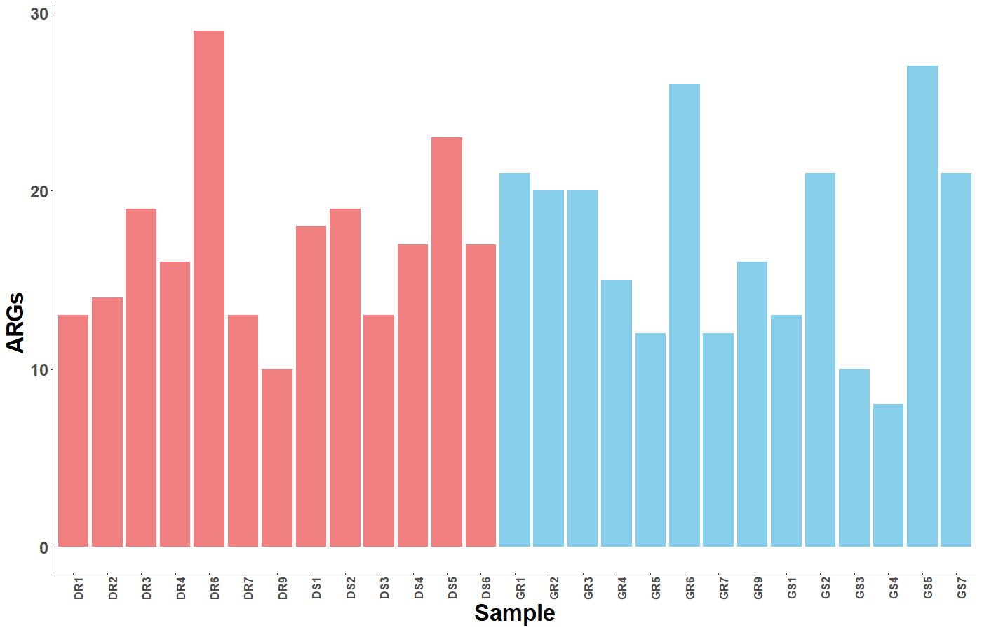

Fig. S1. Distribution of antibiotic resistance genes (ARGs) across soil samples. Bar plots illustrate the total number of ARGs predicted in the microbiomes of rooftop and surface garden soil samples from Dhaka (brick red) and Gazipur (sky blue) districts, Bangladesh. The plot highlights the variation in ARG abundance across different garden types and locations, providing insights into the prevalence of antibiotic resistance in these environments.
Table S1: Study sample information, SRA accession numbers of the shotgun whole metagenome sequences and reads mapped against antibiotic resistance genes (ARGs).
Sl. No. | Sample ID | Collection site | Coordinates | Source | No. of Raw Read Pairs | No. of quality reads (after trimming) | GC Content (%) | SRA accessions
1 | DR1 | DNCC, Bangladesh | 23.78° N, 90.41° E | DRG | 29779648 | 29636639 | 39.46 | SRR32835637
2 | DR2 | DNCC, Bangladesh | 23.78° N, 90.41° E | DRG | 29649252 | 29471130 | 62.04 | SRR32835631
3 | DR3 | DNCC, Bangladesh | 23.78° N, 90.41° E | DRG | 23287537 | 23232035 | 61.78 | SRR32835620
4 | DR4 | DNCC, Bangladesh | 23.78° N, 90.41° E | DRG | 21731087 | 21613037 | 62.94 | SRR32835612
5 | DR6 | DNCC, Bangladesh | 23.78° N, 90.41° E | DRG | 23111024 | 22975156 | 63.54 | SRR32835611
6 | DR7 | DNCC, Bangladesh | 23.78° N, 90.41° E | DRG | 24429423 | 24317641 | 44.44 | SRR32835636
7 | DR9 | DNCC, Bangladesh | 23.78° N, 90.41° E | DRG | 22325712 | 22192955 | 46.56 | SRR32835635
8 | DS1 | DNCC, Bangladesh | 23.78° N, 90.41° E | DSG | 25690404 | 25569069 | 42.56 | SRR32835634
9 | DS2 | DNCC, Bangladesh | 23.78° N, 90.41° E | DSG | 21521300 | 21392353 | 55.96 | SRR32835633
10 | DS3 | DNCC, Bangladesh | 23.78° N, 90.41° E | DSG | 23093248 | 22955591 | 61.5 | SRR32835632
11 | DS4 | DNCC, Bangladesh | 23.78° N, 90.41° E | DSG | 27849938 | 27659560 | 51.18 | SRR32835630
12 | DS5 | DNCC, Bangladesh | 23.78° N, 90.41° E | DSG | 30378999 | 30259676 | 42.89 | SRR32835629
13 | DS6 | DNCC, Bangladesh | 23.78° N, 90.41° E | DSG | 21237551 | 21146204 | 40.31 | SRR32835628
14 | GR1 | GCC, Bangladesh | 23.99° N, 90.38° E | GRG | 21786215 | 21665627 | 60.78 | SRR32835626
15 | GR2 | GCC, Bangladesh | 23.99° N, 90.38° E | GRG | 24639131 | 24489187 | 62.43 | SRR32835627
16 | GR3 | GCC, Bangladesh | 23.99° N, 90.38° E | GRG | 25198511 | 25070828 | 45.54 | SRR32835625
17 | GR4 | GCC, Bangladesh | 23.99° N, 90.38° E | GRG | 20783178 | 20702232 | 38.89 | SRR32835624
18 | GR5 | GCC, Bangladesh | 23.99° N, 90.38° E | GRG | 21389519 | 21289176 | 41.78 | SRR32835623
19 | GR6 | GCC, Bangladesh | 23.99° N, 90.38° E | GRG | 21711373 | 21572157 | 41.71 | SRR32835622
20 | GR7 | GCC, Bangladesh | 23.99° N, 90.38° E | GRG | 22611444 | 22478939 | 64.29 | SRR32835621
21 | GR9 | GCC, Bangladesh | 23.99° N, 90.38° E | GRG | 22104607 | 22014781 | 44.23 | SRR32835619
22 | GS1 | GCC, Bangladesh | 23.99° N, 90.38° E | GSG | 32917251 | 32796709 | 39.03 | SRR32835618
23 | GS2 | GCC, Bangladesh | 23.99° N, 90.38° E | GSG | 29980331 | 29865313 | 42.49 | SRR32835617
24 | GS3 | GCC, Bangladesh | 23.99° N, 90.38° E | GSG | 24704774 | 24576770 | 60.37 | SRR32835615
25 | GS4 | GCC, Bangladesh | 23.99° N, 90.38° E | GSG | 22808240 | 22662472 | 63.87 | SRR32835616
26 | GS5 | GCC, Bangladesh | 23.99° N, 90.38° E | GSG | 23058381 | 22923630 | 59.88 | SRR32835614
27 | GS7 | GCC, Bangladesh | 23.99° N, 90.38° E | GSG | 24775876 | 24632171 | 61.08 | SRR32835613
Total |  |  |  |  | 662553954 | 659161038
Average |  |  |  |  | 24539035.33 | 24413371.78 | 51.91
DNCC: Dhaka North City Corporation, GCC: Gazipur City Corporation, DRG: Dhaka Rooftop Garden, DSG: Dhaka Surface Garden, GRG: Gazipur Rooftop Garden,
GSG: Gazipur Surface Garden, DR: Dhaka Rooftop, DS: Dhaka Surface, GR: Gazipur Rooftop, and GS: Gazipur Surface.

Table S2. Distribution of antibiotic resistance genes (ARGs) across metagenomes from Dhaka rooftop gardens (DRG), Dhaka surface gardens (DSG), Gazipur rooftop gardens (GRG), and Gazipur surface gardens (GSG) soils.
ARGs | DRG | DSG | GRG | GSG
vanW(I cluster) | 21.9 | 16.84 | 18.4 | 17.84
vanT(G cluster) | 8.52 | 18.18 | 15.34 | 14.86
vanY(M cluster) | 11.19 | 6.73 | 9.82 | 9.46
vanY(B cluster) | 13.14 | 9.76 | 8.18 | 5.41
adeF | 9.25 | 0 | 4.09 | 7.84
qacG | 4.62 | 3.7 | 4.91 | 7.3
FosBx1 | 2.43 | 4.71 | 5.93 | 3.78
vanY(A cluster) | 2.92 | 4.38 | 4.29 | 2.97
vanW(G cluster) | 1.95 | 5.05 | 3.27 | 3.51
vanY(G cluster) | 3.41 | 4.04 | 2.66 | 2.43
vanY(F cluster) | 3.16 | 3.03 | 1.64 | 2.43
qacJ | 0.73 | 2.02 | 2.86 | 2.97
rsmA | 2.92 | 0.34 | 2.04 | 2.97
BcIII | 1.22 | 2.02 | 1.64 | 1.62
tetB(P) | 0.24 | 3.03 | 1.23 | 0.54
vanG | 0.24 | 2.69 | 0.82 | 0.81
FosI | 0.73 | 0 | 1.23 | 1.89
BcI | 0.24 | 1.68 | 1.02 | 0.27
Pa soxR | 1.46 | 0 | 0.82 | 0.27
vanW(B cluster) | 0.73 | 0.34 | 0.2 | 1.35
FosA8 | 0.73 | 0 | 0.2 | 1.62
norC | 0 | 0.34 | 0.61 | 1.35
vanXY(G cluster) | 0 | 1.01 | 1.02 | 0.27
FosB | 0.24 | 1.68 | 0.61 | 0
Mt rpsL | 0.49 | 0.34 | 0.82 | 0
ErmD | 0.49 | 0.67 | 0.2 | 0.54
msr(G) | 0 | 0 | 1.23 | 0
Bp cat86 | 0 | 0.7 | 0.41 | 0.54
AbaQ | 0.97 | 0 | 0 | 0
mefF | 0.24 | 0.34 | 0.2 | 0.27
BcII | 0.24 | 0.67 | 0 | 0
vanH(O cluster) | 0.24 | 0 | 0.2 | 0.27
msr(I) | 0 | 0.67 | 0.2 | 0
Sr otr(A) | 0.24 | 0.67 | 0 | 0
tet(Q) | 0 | 0 | 0 | 0.81
AAC(6')-Ib' | 0 | 0 | 0.41 | 0
aadK | 0.24 | 0 | 0.2 | 0
ykkC | 0.24 | 0 | 0.2 | 0
ykkD | 0.24 | 0 | 0.2 | 0
AIM-1 | 0 | 0 | 0.2 | 0.27
mphL | 0.24 | 0.34 | 0 | 0
TEM-116 | 0 | 0.34 | 0 | 0.27
nimJ | 0.24 | 0 | 0 | 0.27
ArnT | 0 | 0 | 0 | 0.54
FosG | 0 | 0 | 0.41 | 0
FosH | 0.24 | 0 | 0.2 | 0
FosXCC | 0.24 | 0.34 | 0 | 0
sul1 | 0.24 | 0 | 0 | 0.27
sul2 | 0.24 | 0 | 0 | 0.27
AAC(3)-VIa | 0 | 0 | 0 | 0.27
ANT(3'')-IIa | 0.24 | 0 | 0 | 0
ANT(4')-Ia | 0 | 0 | 0.2 | 0
aadA7 | 0 | 0 | 0 | 0.27
amrA | 0 | 0 | 0.2 | 0
qacEdelta1 | 0.24 | 0 | 0 | 0
qacL | 0.24 | 0 | 0 | 0
vanA | 0 | 0.34 | 0 | 0
vanH(A cluster) | 0 | 0.34 | 0 | 0
vanH(B cluster) | 0 | 0 | 0 | 0.27
vanH(F cluster) | 0 | 0.34 | 0 | 0
vanO | 0 | 0 | 0 | 0.27
vanR(A cluster) | 0 | 0.337 | 0 | 0
vanR(F cluster) | 0 | 0.337 | 0 | 0
vanR(M cluster) | 0 | 0 | 0 | 0.27
vanX(B cluster) | 0 | 0.34 | 0 | 0
LnuH | 0 | 0 | 0 | 0.27
lmrB | 0 | 0 | 0.2 | 0
cipA | 0 | 0.34 | 0 | 0
vmlR | 0 | 0 | 0.2 | 0
mphK | 0 | 0 | 0.2 | 0
Type B NfxB | 0.24 | 0 | 0 | 0
nalD | 0.24 | 0 | 0 | 0
MexL | 0.24 | 0 | 0 | 0
TEM-181 | 0 | 0 | 0.2 | 0
TEM-207 | 0 | 0.34 | 0 | 0
TEM-245 | 0 | 0.34 | 0 | 0
SAT-4 | 0.24 | 0 | 0 | 0
tmrB | 0 | 0 | 0.2 | 0
bcrA | 0.24 | 0 | 0 | 0
bcrB | 0.24 | 0 | 0 | 0
bcrC | 0.24 | 0 | 0 | 0
Pa catB7 | 0.24 | 0 | 0 | 0
catB11 | 0 | 0 | 0.2 | 0
Ab AbaF | 0 | 0 | 0.2 | 0
tet(36) | 0 | 0 | 0 | 0.27
tet(45) | 0 | 0 | 0.2 | 0
tet(W/N/W) | 0.24 | 0 | 0 | 0
poxtA | 0 | 0.34 | 0 | 0

