Supplementary Information
Pulse-picking coherent anti-Stokes Raman scattering microscopy for highly sensitive chemical imaging

Matthew G. Clark¹; Gil A. Gonzalez¹; Chi Zhang¹*
¹Department of Chemistry, Purdue University
*zhan2017@purdue.edu

1. Calculation of the AOM rise time
The AOM rise time satisfies
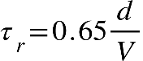,
where d is the beam diameter, and V is the acoustic velocity.
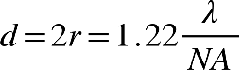
For the Stokes beam at 1045 nm and a NA value of 0.01, the beam diameter at focus is 1.27 x 10⁻⁴ m. The acoustic velocity (V) inside the AOM crystal is 3630 m/s. This gives ~23 ns AOM rise time for the Stokes beam. For the pump beam at 800 nm, the rise time is calculated to be ~17 ns.

2. CARS signal intensity as a function of pump or Stokes power
To prevent PMT saturation, we used lower laser power for CARS excitation at low duty cycles. To calibrate the sensitivity enhancement curve, we measured the CARS signals as functions of pump and Stokes laser powers, as shown in Figure S1. We found that CARS signals have excellent linear dependence with the Stokes power, and quadratic dependence with the pump power.
A table of input laser power used at the sample is shown below (Table S1) for generating results in Figure 1 and Figure S2.
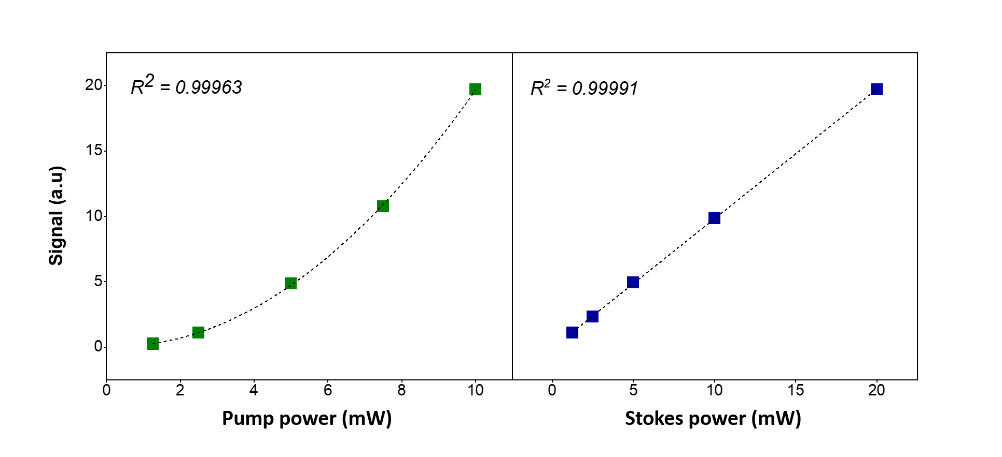
Figure S1. FCARS signal versus input pump (left) and Stokes (right) power. The power is measured before the microscope.

Modality | Duty cycle | Pump | Stokes
CARS | 97-98% | 1.7 mW | 2.0 mW
CARS | 50% | 1.7 mW | 2.0 mW
CARS | 20% | 0.9 mW | 1.0 mW
CARS | 10% | 0.9 mW | 1.0 mW
CARS | 5% | 0.4 mW | 0.5 mW
CARS | <4% | 0.4 mW | 0.5 mW
TPEF | All duty cycles | 0.9 mW
SHG | All duty cycles |  | 1.4 mW
Table S1. Pump/Stokes power (at the sample) used to measure sensitivity enhancement of FCARS, TPEF, and SHG shown in Figure 1 and Figure S3.

3. TPEF and SHG sensitivity enhancement at different modulation frequencies
TPEF and SHG sensitivity enhancement was measured at different modulation frequencies, and the results are shown in Figure S2. We found that the maximum enhancement for TPEF is 19.5 at 300 kHz modulation frequency and 2% duty cycle, and for SHG is 21.3 at 300 kHz modulation frequency and 4% duty cycle.
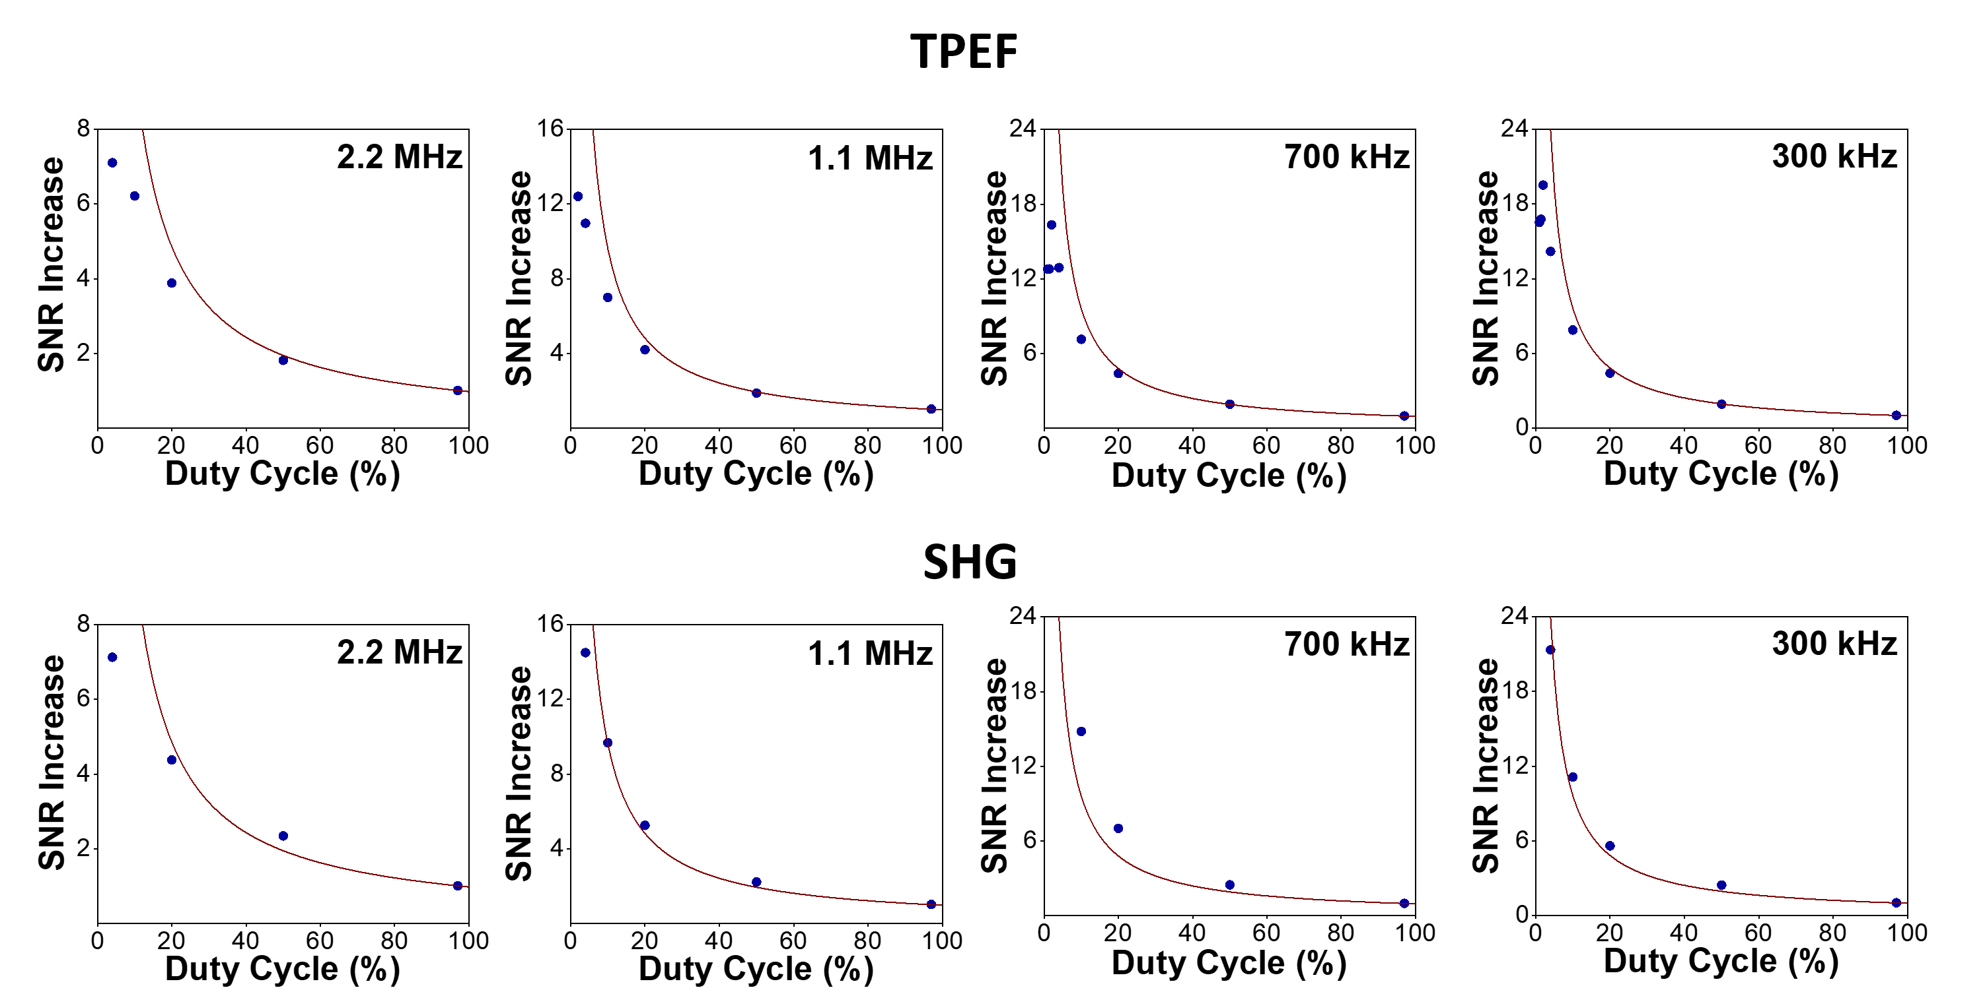

Figure S2. SNR increase versus duty cycle (%) plots for TPEF (top row) and SHG (bottom row) at 2.2MHz, 1.1 MHz, 700 kHz, and 300 kHz modulation frequencies. A theoretical 1/D curve is plotted as the reference for each plot.

4. Sensitivity analysis using DMSO
We measured the SNR of phase-retrieved DMSO Raman spectra at 2915 cm⁻¹ to determine the lowest detection concentration using PPCARS in the C-H region. The SNR is calculated as: [(average intensity around the 2915 cm⁻¹ peak)-(average intensity between 2810-2850 cm⁻¹)]/(standard deviation of intensity between 2810-2850 cm⁻¹). For the 0.05%, 0.1%, 0.5%, and 1% DMSO in D₂O, the SNR at 1.1MHz modulation and 4% duty cycle were -1.77, 1.31, 15.67, and 33.25, respectively. Therefore, we conclude that the lowest DMSO concentration that we can detect at 1.1 MHz modulation is 0.1%, by using 5.2 mW pump and 6.2 mW Stokes at the sample.
At 700 kHz modulation, the optimal duty cycle can be further reduced to 1.4%. We then measured 0.05%, 0.1%, and 0.5% DMSO in D₂O using only 2.0 mW pump and 3.7 mW Stokes beams at the sample. The SNR values of the 2915 cm⁻¹ peak are 1.82, 4.24, and 35.3, respectively. The phase-retrieved Raman spectra are shown in Figure S3. Therefore, we conclude that the lowest concentration of DMSO can be detected at 700 kHz modulation is 0.05%, corresponding to 7.1 mM.
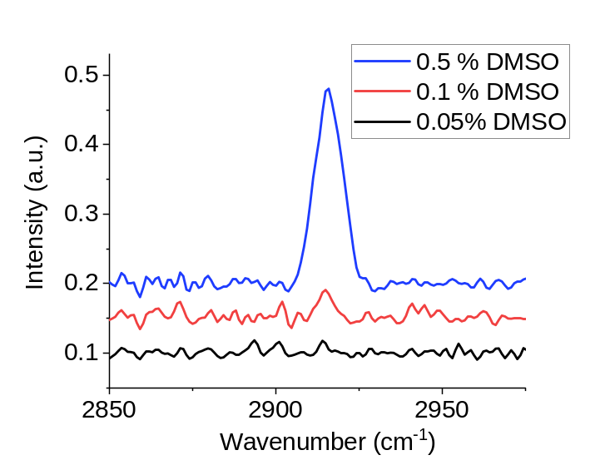
Figure S3. Retrieved Raman spectra of DMSO in D₂O detected using 700 kHz modulation, 1.4% duty cycle, 10 µs pixel dwell time, and 2.0 mW pump and 3.7 mW Stokes beams at the sample.

5. Cell imaging using 1.1 MHz modulation frequency
Besides at 700 kHz modulation frequency, MIA PaCa-2 cells were also imaged at 1.1 MHz modulation frequency and different duty cycle values, as shown in Figure S4. We can see significant contrast and sensitivity enhancement for both FCARS and ECARS (Figure S4a). Intensity profiles along the solid lines in images are plotted in Figure S4b.
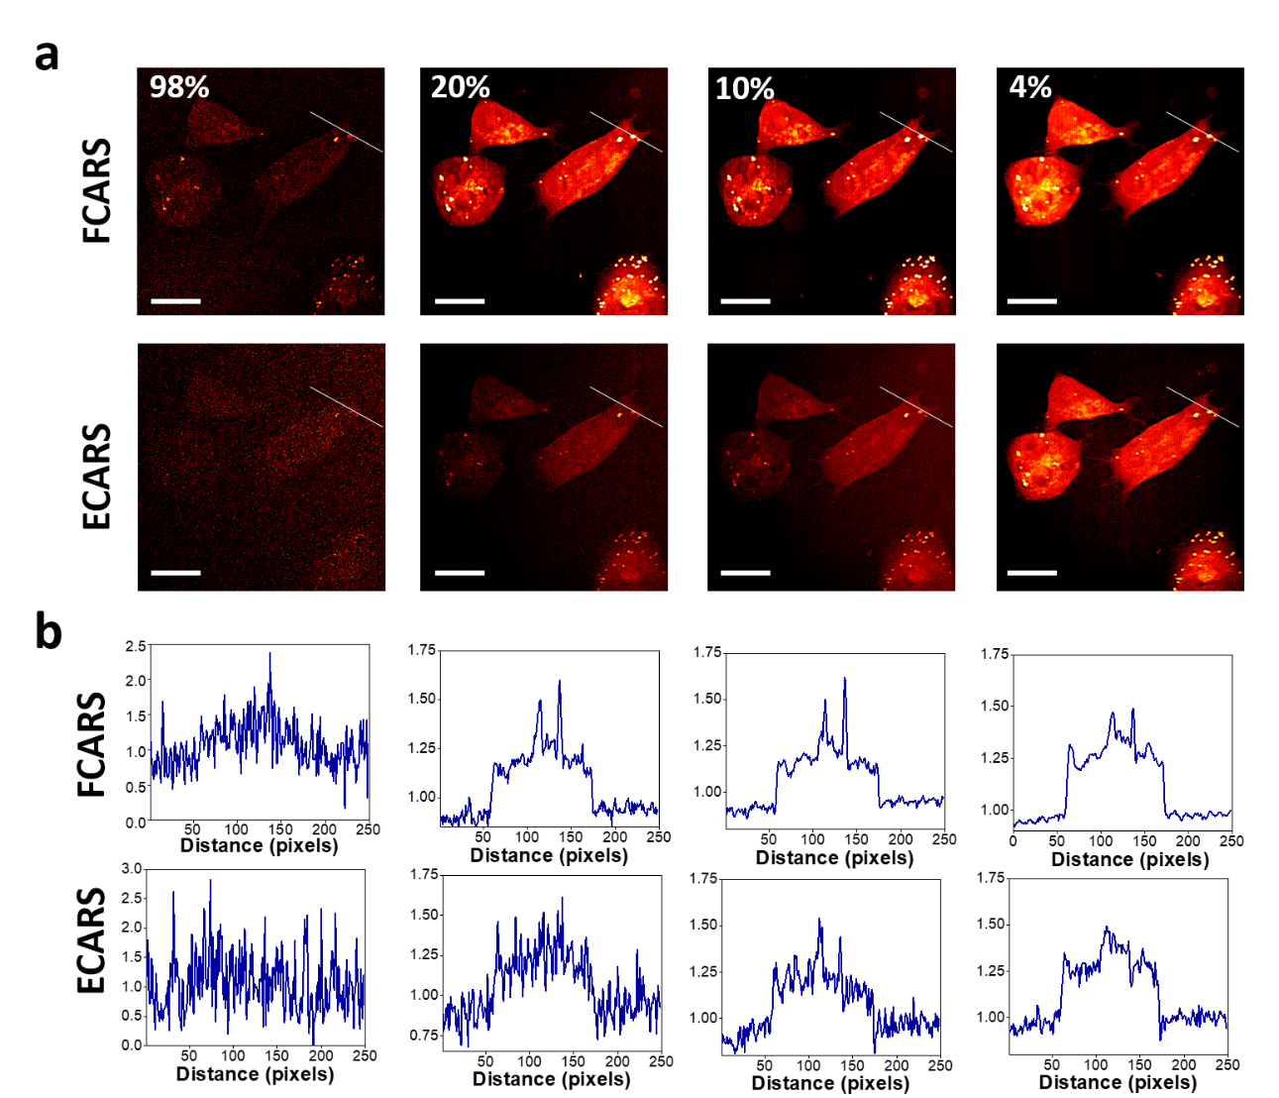
Figure S4. Mia PaCa-2 cell imaging with PPCARS microscopy at 1.1 MHz modulation frequency. (a) FCARS and ECARS images at 98%, 20%, 10%, and 4% duty cycle. (b) Line intensity profiles along the lines in images of panel a. The intensities are scaled separately for each plot. Scale bars, 10 μm.

6. Live-cell CARS and fluorescence imaging
Live-cell imaging is performed using MIA PaCa-2 cells labeled with MitoView mitochondria stains. The images comparing 97% and 10% duty cycles are shown in Figure S5. These images show clear sensitivity improvement of both CARS and TPEF at 450 nm at lower duty cycles for live cells.
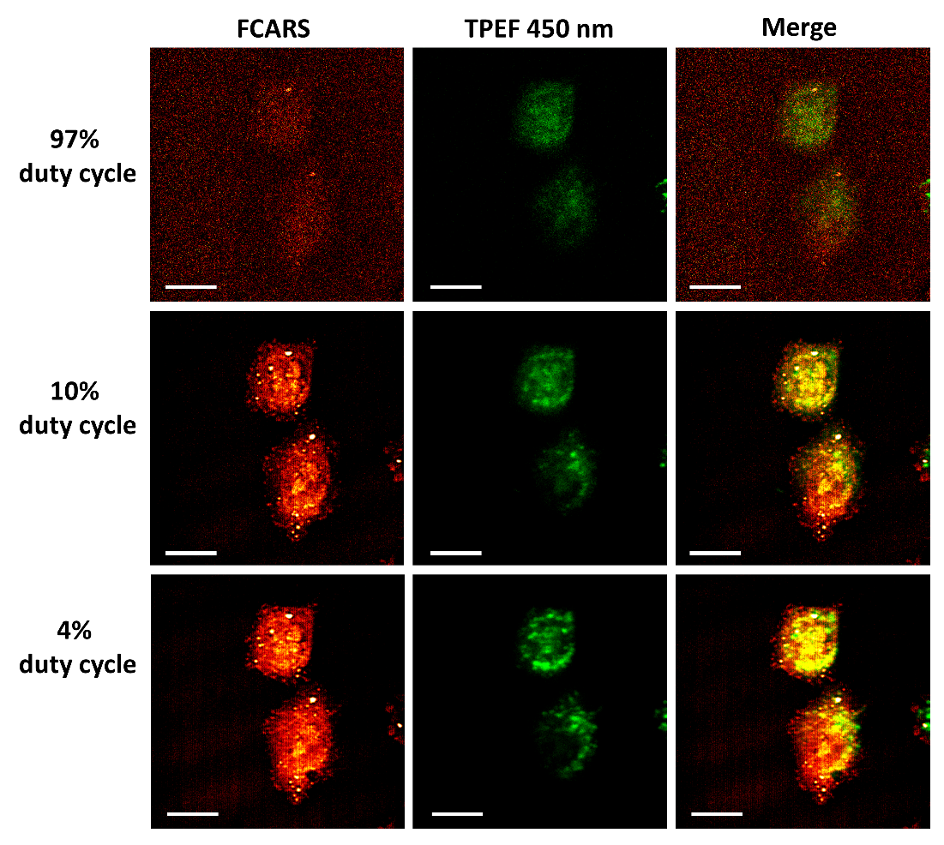

Figure S5. Live Mia PaCa-2 cell imaging of lipid droplets (FCARS) and stained mitochondria (TPEF 450 nm) at 97%, 10%, and 4% duty cycles. Images on the right are merged images from FCARS and TPEF channels. Scale bars, 10 µm.

7. Phasor spectral unmixing of epi-CARS imaging of cells
We used spectral phasor analysis (a spectral Phasor Plugin of ImageJ) to separate different chemical compositions in MIA PaCa-2 cells, including the cytosol, endoplasmic reticulum, nuclei, and lipid droplets. The gates were manually selected for segmentation. Results for FCARS are shown in Fig. 3b-c and for ECARS are shown in Figure S6.
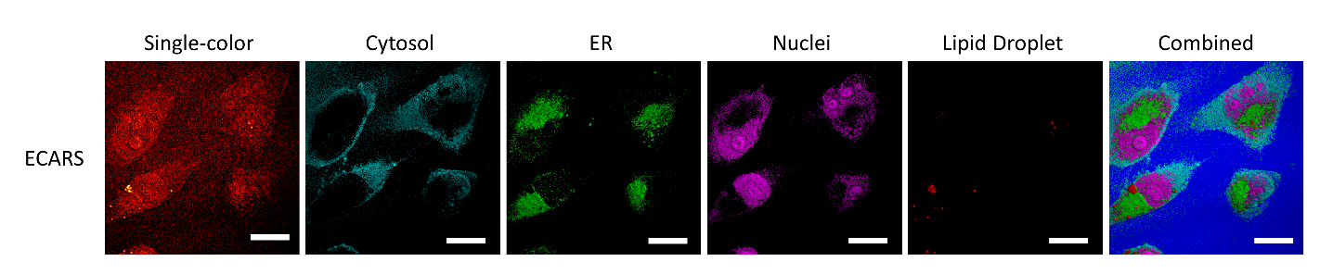
Figure S6. Single-color CARS and spectral unmixing images for Mia PaCa-2 cells. Scale bar, 10 μm. ER, endoplasmic reticulum; LD, lipid droplets. A combined chemical map of the individual images is shown on the right.

8. 3D PPCARS imaging of cells
We have performed 3D PPCARS imaging of a Mia PaCa-2 cell using the CH₂ vibration, as shown in Figure S7. A 60X microscope objective (UPLSAPO 60X, Olympus) was used for imaging. The 3D image is reconstructed by 150 CARS images at different axial positions. A video of this 3D image is shown as Supplementary Video 1. Power at the samples: pump 1.7 mW, Stokes 2.0 mW.
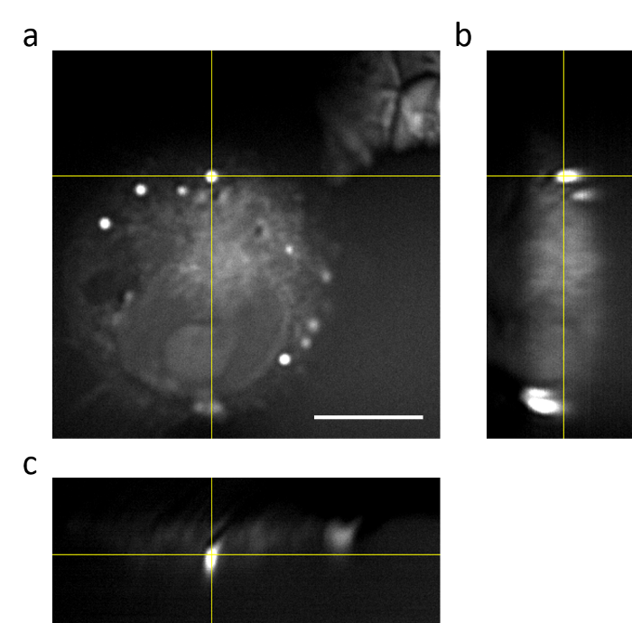
Figure S7. 3D imaging of a Mia PaCa-2 cell. (a) X-Y projection of the 3D image. (b) Y-Z projection of the 3D image. (c) X-Z projection of the 3D image. The scale bar is 10 µm.

9. PPCARS imaging of mouse tissue samples
Besides Mouse liver and kidney images shown in Fig. 4, we also imaged other tissue samples using FCARS, ECARS, and TPEF at different modulation frequency and duty cycles. Figure S8-S11 compares multimodal images of mouse brain using 98%, 10%, and 4% duty cycle at 1.1 MHz modulation frequency. Figure S12 shows images from all modalities of mouse kidney using 98% and 10% duty cycle at 1.1 MHz modulation frequency.
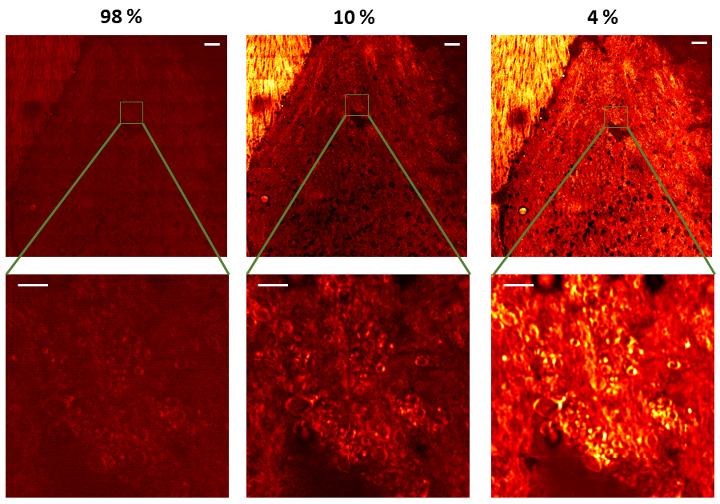Figure S8. FCARS images of mouse brain tissue using 98%, 10%, and 4% duty cycle at 1.1 MHz modulation frequency. Scale bars, top row: 50 μm, bottom row: 10 μm.

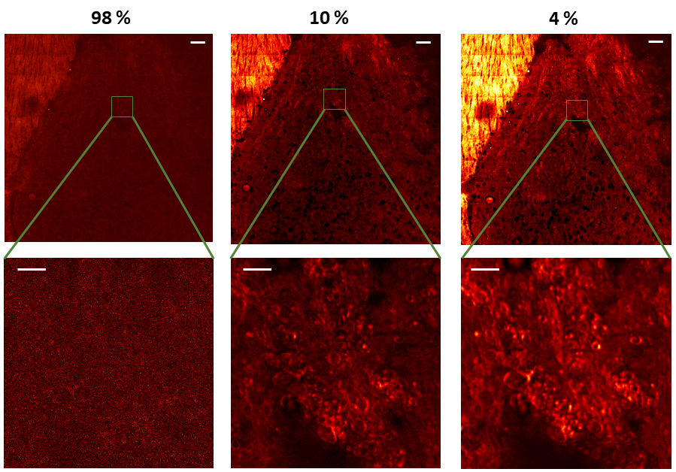Figure S9. ECARS images of mouse brain tissue using 98%, 10%, and 4% duty cycle at 1.1 MHz modulation frequency. Scale bars, top row: 50 μm, bottom row: 10 μm.

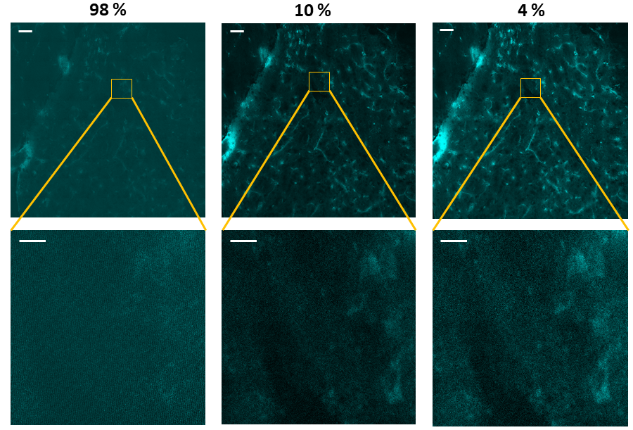Figure S10. TPEF 450 nm images of mouse brain tissue using 98%, 10%, and 4% duty cycle at 1.1 MHz modulation frequency. Scale bars, top row: 50 μm, bottom row: 10 μm.
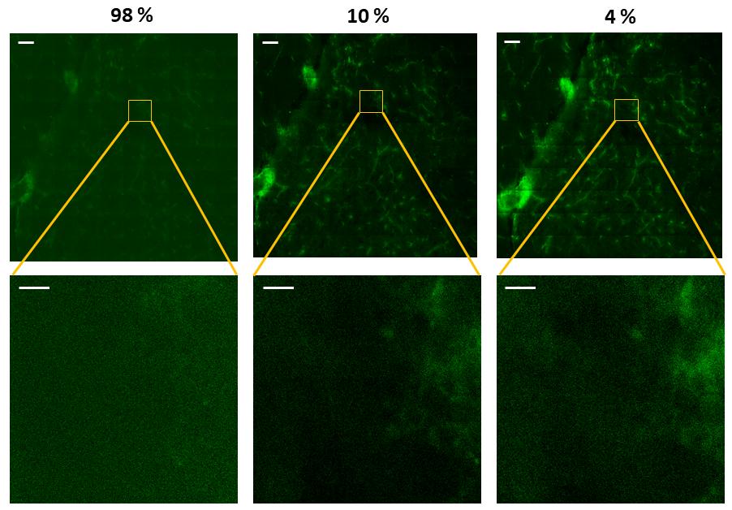Figure S11. TPEF 570 nm images of mouse brain tissue using 98%, 10%, and 4% duty cycle at 1.1 MHz modulation frequency. Scale bars, top row: 50 μm, bottom row: 10 μm.

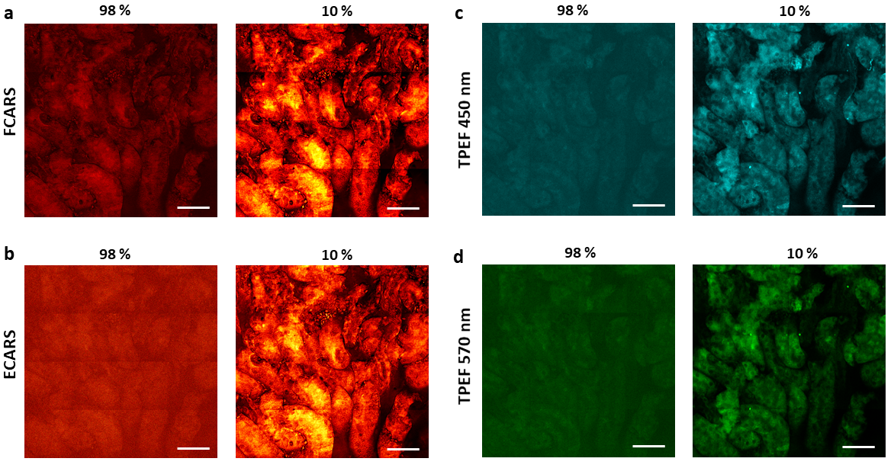Figure S12. FCARS, ECARS, TPEF 450 nm, and TPEF 570 images of mouse kidney tissue using 98% and 10% duty cycle at 1.1 MHz modulation frequency. Scale bars, 50 μm.

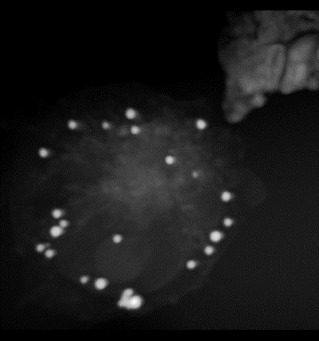
Supplementary Video 1. 3D PPCARS imaging of lipid droplets in a Mia PaCa-2 cell using the CH₂ stretching.

