Supplementary Information
Figs. S1-S4 · Tables S1-S7

Wood taxonomic division and nutrient type jointly influence wood decomposition responses to nutrient additions in a subtropical forest

Lulu Ma^{a,b,†}, Xiangyu Ji^{a,†}, Shahla Hosseini Bai^{c}, Xian He^{d}, Zhiyuan Xu^{a,b}, Zhenyin Bai^{d}, Zhuqi Zhao^{d}, Guoping Zhao^{e,*}, Zhenhong Hu^{a,d,f,*}
ª State Key Laboratory of Soil and Water Conservation and Desertification Control, College of Soil and Water Conservation Science and Engineering, Northwest A&F University, Yangling, Shaanxi 712100, China
^{b} College of Natural Resources and Environment, Northwest A&F University, Yangling, Shaanxi 712100, China
^{c} Centre for Planetary Health and Food Security, School of Environment and Science, Griffith University, Nathan, QLD 4111, Australia
^{d} State Key Laboratory of Soil and Water Conservation and Desertification Control, Institute of Soil and Water Conservation, Chinese Academy of Sciences and Ministry of Water Resources, Yangling 712100, China
^{e} National Forestry Bureau Key Laboratory of Soil and Water Conservation and Ecological Restoration on Loess Plateau, Shaanxi Academy of Forestry, Xi’an 710082, China
^{f} CREAF, Cerdanyola del Vallès, Barcelona E-08193, Catalonia, Spain

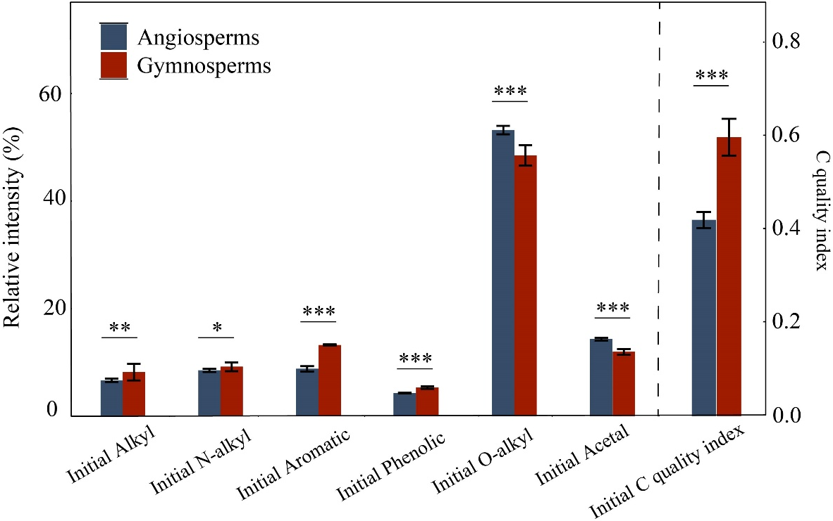
Fig. S1 The initial C quality in both angiosperms and gymnosperms. The height of the bars are means and error bars represent SD. *, ** and *** indicate significant correlation at the level of p < 0.05, p < 0.01 and p < 0.001.
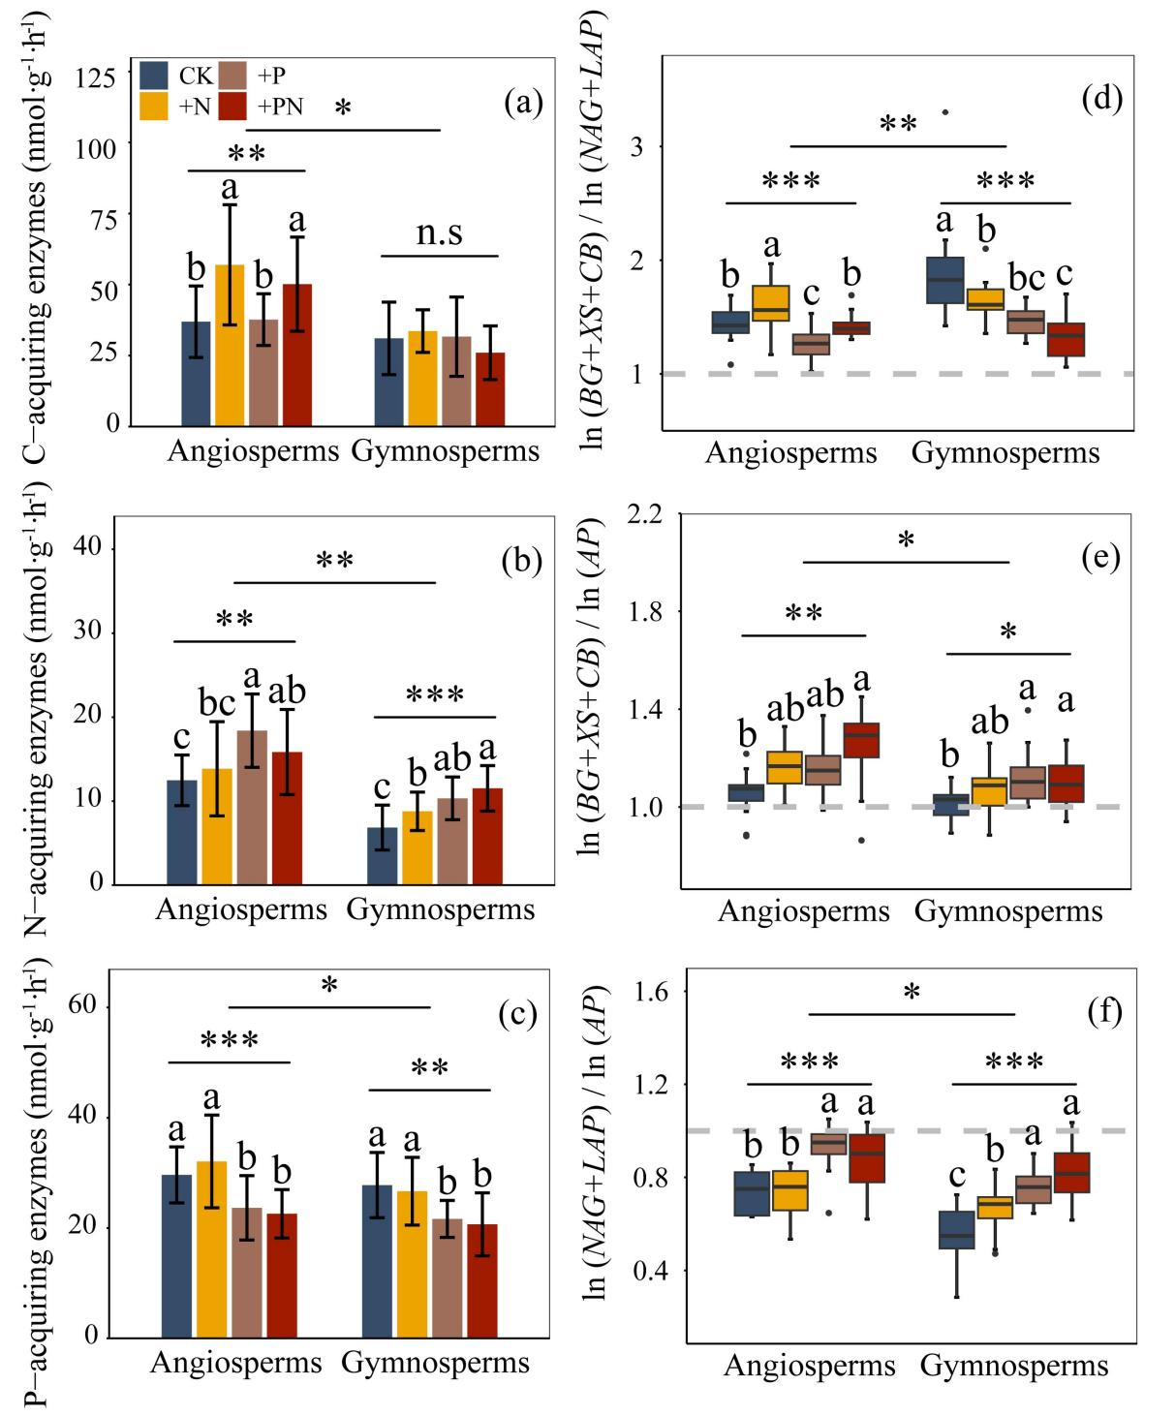
Fig. S2 Wood enzyme activities and enzyme stoichiometry involved in C, N and P metabolism of angiosperms and gymnosperms wood in different nutrient addition. (a) C-acquiring enzyme activities, (b) N-acquiring enzyme activities, (c) P-acquiring enzyme activities, (d) ecoenzymatic C: N acquisition ratio, (e) ecoenzymatic C: P acquisition ratio, (f) ecoenzymatic N: P acquisition ratio. Note: the mean ratio for C: N: P activities near 1: 1: 1 in the global.
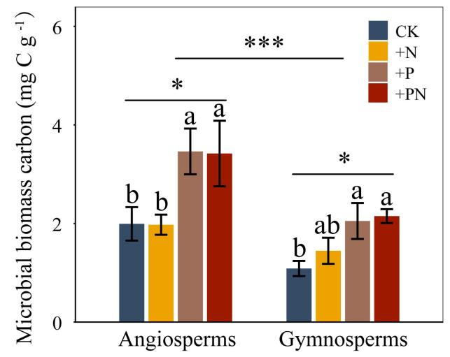
Fig. S3 Wood microbial biomass carbon of angiosperms and gymnosperms in different nutrient addition. The height of the bars are means (n = 96) and error bars represent SD. * and *** indicate significant correlation at the level of p < 0.05 and p < 0.001, respectively.
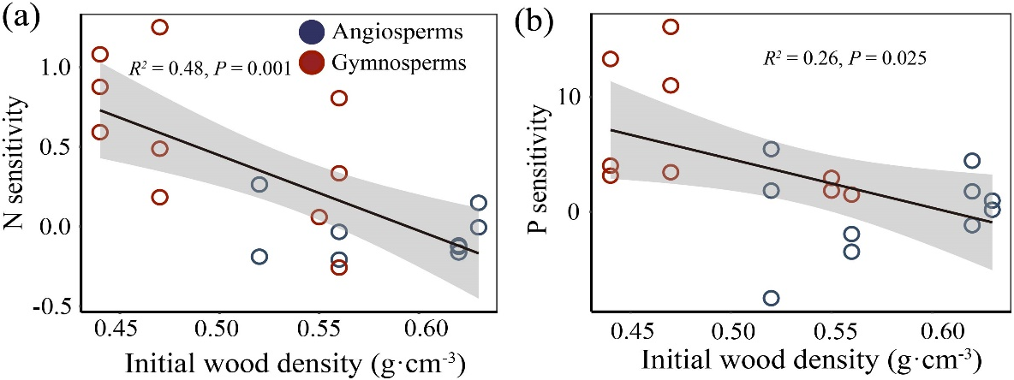
Fig. S4 Relationships between wood nutrient sensitivity and initial wood density (n = 24). (a) Wood N sensitivity and initial wood density; (b) wood P sensitivity and initial wood density.
Table S1 Before the decomposition experiment, we sampled and analyzed the soil beneath the dead wood samples. The specific analysis method was as (Zheng et al. 2025). The following are the basic soil properties beneath decomposing wood in our study area (Mean±SE). Different lowercase letters indicate significant differences among different tree taxonomic groups (LSD Duncan test, p < 0.05).
Tree identity | Species | Soil C  (mg g⁻¹) | Soil N  (mg g⁻¹) | Soil P  (mg g⁻¹)
Angiosperm | L. formosana | 34.75±0.80b | 2.55±0.03a | 0.25±0.01a
Angiosperm | M. maudiae | 42.54±12.20ab | 2.66±0.42a | 0.26±0.01a
Angiosperm | C. fargesii | 39.33±4.99ab | 2.74±0.18a | 0.25±0.01a
Angiosperm | S. superba | 39.80±4.76ab | 3.00±0.18a | 0.27±0.01a
Gymnosperm | P. amabilis | 43.94±2.86ab | 2.95±0.40a | 0.28±0.03a
Gymnosperm | C. fortunei | 38.34±2.33b | 2.97±0.31a | 0.24±0.03a
Gymnosperm | P. massoniana | 45.25±4.19ab | 2.83±0.11a | 0.26±0.02a
Gymnosperm | C. lanceolata | 49.22±7.26a | 2.98±0.31a | 0.26±0.03a

Table S2 Initial diameter, age and density of angiosperms and gymnosperms wood in our study area (Mean±SE). Different lowercase letters indicate significant differences among different tree taxonomic groups (LSD Duncan test, p < 0.05).
 | Diameter (cm) | Tree age (year) | Density (g cm⁻³)
Angiosperms | 12.40±0.16a | 24.90±0.04b | 0.58±0.02a
Gymnosperms | 13.90±0.21a | 36.65±1.74a | 0.48±0.01b

Table S3 Linear mixed-effects model results showing effects of nutrient addition and the host tree taxonomic group on wood nutrients and their ratios. The results of ANOVA analysis were consistent with the values shown in Fig. 2.
Fixed-effect term | NumDF | DenDF | F value | p
C concentration
Treatment | 3 | 82 | 3.65 | 0.016
Taxonomic group | 1 | 6 | 10.84 | 0.017
Treatment × group | 3 | 82 | 1.63 | 0.188
N concentration
Treatment | 3 | 82 | 4.20 | 0.008
Taxonomic group | 1 | 6 | 16.29 | 0.007
Treatment × group | 3 | 82 | 2.48 | 0.067
P concentration
Treatment | 3 | 82 | 7.56 | <0.001
Taxonomic group | 1 | 6 | 12.37 | 0.013
Treatment × group | 3 | 82 | 2.56 | 0.061
C: N ratio
Treatment | 3 | 82 | 2.52 | 0.064
Taxonomic group | 1 | 6 | 18.40 | 0.005
Treatment × group | 3 | 82 | 0.84 | 0.475
C: P ratio
Treatment | 3 | 82 | 12.23 | <0.001
Taxonomic group | 1 | 6 | 74.11 | <0.001
Treatment × group | 3 | 82 | 6.98 | <0.001
N: P ratio
Treatment | 3 | 82 | 19.13 | <0.001
Taxonomic group | 1 | 6 | 12.50 | 0.012
Treatment × group | 3 | 82 | 4.70 | 0.004

Table S4 Linear mixed-effects model results showing effects of nutrient addition and the host tree taxonomic group on wood enzyme activities. The results of ANOVA analysis were consistent with the values shown in Fig. 3.
Fixed-effect term | NumDF | DenDF | F value | p
BG
Treatment | 3 | 82 | 9.33 | 0.000
Taxonomic group | 1 | 6 | 12.06 | 0.013
Treatment × group | 3 | 82 | 5.98 | 0.001
XS
Treatment | 3 | 82 | 1.61 | 0.194
Taxonomic group | 1 | 6 | 3.44 | 0.113
Treatment × group | 3 | 82 | 0.97 | 0.411
CB
Treatment | 3 | 82 | 3.01 | 0.035
Taxonomic group | 1 | 6 | 3.89 | 0.096
Treatment × group | 3 | 82 | 4.21 | 0.008
NAG
Treatment | 3 | 82 | 8.59 | 0.000
Taxonomic group | 1 | 6 | 18.59 | 0.005
Treatment × group | 3 | 82 | 1.68 | 0.178
LAP
Treatment | 3 | 82 | 3.46 | 0.020
Taxonomic group | 1 | 6 | 4.84 | 0.070
Treatment × group | 3 | 82 | 2.08 | 0.109
AP
Treatment | 3 | 82 | 11.92 | 0.000
Taxonomic group | 1 | 6 | 4.17 | 0.087
Treatment × group | 3 | 82 | 0.56 | 0.644

Table S5 Linear mixed-effects model results showing effects of nutrient addition and the host tree taxonomic group on the activities of wood enzymes involved in C, N, P metabolism and the vector model of enzymes. The results of ANOVA analysis were consistent with the values shown in Figs. S1 and 4.
Fixed-effect term | NumDF | DenDF | F value | p
C-acquiring enzymes
Treatment | 3 | 82 | 4.49 | 0.006
Taxonomic group | 1 | 6 | 7.19 | 0.036
Treatment × group | 3 | 82 | 4.45 | 0.006
N-acquiring enzymes
Treatment | 3 | 82 | 9.93 | <0.001
Taxonomic group | 1 | 6 | 16.14 | 0.007
Treatment × group | 3 | 82 | 1.39 | 0.252
P-acquiring enzyme
Treatment | 3 | 82 | 11.92 | <0.001
Taxonomic group | 1 | 6 | 4.17 | 0.087
Treatment × group | 3 | 82 | 0.56 | 0.644
Vector length
Treatment | 3 | 82 | 2.84 | 0.043
Taxonomic group | 1 | 6 | 3.70 | 0.103
Treatment × group | 3 | 82 | 6.54 | 0.001
Vector angle
Treatment | 3 | 82 | 20.35 | <0.001
Taxonomic group | 1 | 6 | 6.91 | 0.039
Treatment × group | 3 | 82 | 0.81 | 0.490

Table S6 Linear mixed-effects model results showing effects of nutrient addition and the host tree taxonomic group on wood decomposition rates and their increase. The results of ANOVA analysis were consistent with the values shown in Fig. 5.
Fixed-effect term | NumDF | DenDF | F value | p
Decomposition rates
Treatment | 3 | 82 | 36.40 | <0.001
Taxonomic group | 1 | 6 | 22.22 | 0.003
Treatment × group | 3 | 82 | 3.98 | 0.011
Decomposition rates increase
Treatment | 2 | 60 | 12.39 | <0.001
Taxonomic group | 1 | 6 | 28.57 | 0.002
Treatment × group | 2 | 60 | 0.54 | 0.586

Table S7 Fixed-effect estimates, standard errors (SE), Satterthwaite-approximated degrees of freedom (df), t-values, and p-values from the linear mixed-effects models testing the main and interactive effects of nitrogen and phosphorus concentrations on wood decomposition for all woods combined and separately for angiosperm and gymnosperm wood. N: nitrogen concentration; P: phosphorus concentration; N×P, the interaction between nitrogen and phosphorus concentrations.
Group | Parameter | Estimate | SE | df | t | p
All | Intercept | 0.040 | 0.031 | 56.557 | 1.277 | 0.207
All | N | 0.009 | 0.008 | 91.175 | 1.158 | 0.250
All | P | 0.171 | 0.112 | 91.911 | 1.528 | 0.130
All | N×P | -0.015 | 0.022 | 91.544 | -0.686 | 0.495
Angiosperms | Intercept | 0.157 | 0.071 | 43.640 | 2.217 | 0.032
Angiosperms | N | -0.010 | 0.015 | 43.845 | -0.657 | 0. 5147
Angiosperms | P | -0.082 | 0.213 | 43.162 | -0.387 | 0.701
Angiosperms | N×P | 0.033 | 0.040 | 42.457 | 0.819 | 0.417
Gymnosperms | Intercept | 0.029 | 0.038 | 43.966 | 0.770 | 0.445
Gymnosperms | N | 0.001 | 0.013 | 43.256 | 0.102 | 0.919
Gymnosperms | P | 0.033 | 0.242 | 41.971 | 0.139 | 0.890
Gymnosperms | N×P | 0.048 | 0.080 | 42.132 | 0.599 | 0.552

