Supplementary Material
Supplementary Table S1 Comparison of clinical characteristics between patients with and without mechanical complications in the derivation cohort
Supplementary Table S2 Performance of LightGBM models with different number of features for mechanical complications prediction.
Supplementary Figure S1 Decision analysis curves of the LightGBM model with different features.
Supplementary Figure S2 P-R curves of LightGBM model with different features.
Supplementary Figure S3 Calibration curve for the 13-feature LightGBM model.
Supplementary Figure S4 Brier scores for LightGBM model with different number of features.
Supplementary Figure S5 Prediction performance of the final LightGBM model with 13 features in cross validation.

Variables | mechanical complications (n=239) | Non-mechanical complications (n=611) | P value
Age, year | 73(66.5,79) | 64(53.5,71) | ＜0.001
Sex, n (%)  Male  Female | 94(39.33)  145(60.67%) | 424(69.39%)  187(30.61%) | ＜0.001
Body weight, kg | 63(52,70) | 70(60,75) | ＜0.001
Category of AMI, n (%)  STEMI  NSTEMI | 206(86.19%)  33(13.81%) | 433(70.87%)  178(29.13%) | ＜0.001
Location of myocardial infarction n (%)  Anterior wall,  Inferior wall,  posterior wall  lateral wall, | 128(53.56%)  81(33.89%)  21(8.79%)  8(3.35%) | 207(33.88%)  215(35.19%)  3(0.49%)  13(2.13%) | ＜0.001  0.782  ＜0.001  0.433
ICM, n (%) | 6(2.51%) | 16(2.62%) | 0.97
MA, n (%) | 83(34.73%) | 51(8.35%) | ＜0.001
Killip classification, n (%)  I  II  III  IV | 17(7.11%)  47(19.67%)  49(20.5%)  71(29.71%) | 99(16.2%)  110(18.0%)  64(10.47%)  16(2.62%) | ＜0.001
SBP, mmHg | 117(99.5,140) | 133(117,151.5) | ＜0.001
HR, beats/min | 86(70,105.5) | 80(68,91.5) | ＜0.001
History of CHD, n (%) | 36(15.06%) | 189(30.93%) | ＜0.001
History of OMI, n (%) | 13(5.44%) | 67(10.97%) | 0.0188
History of HTN, n (%) | 136(56.9%) | 310(50.74%) | 0.123
History of DM, n (%) | 86(35.98%) | 182(29.79%) | 0.096
History of HLP, n (%) | 67(28.03%) | 81(13.26%) | ＜0.001
History of HF, n (%) | 15(6.28%) | 37(6.06%) | 0.96
History of tumor, n (%) | 15(6.28%) | 16(2.62%) | 0.0186
History of CLD, n (%) | 67(28.03%) | 15(2.45%) | ＜0.001
History of RI, n (%) | 60(25.1%) | 27(4.42%) | ＜0.001
Thyroid disease, n (%) | 21(8.79%) | 28(4.58%) | 0.0278
Cerebrovascular disease, n (%)  cerebral infarction  cerebral hemorrhage | 70(29.29%)  3(1.26%) | 157(25.7%)  6(0.98%) | 0.52
smoking history, n (%) | 156(65.27%) | 295(48.28%) | ＜0.001
drinking history, n (%) | 134(56.07%) | 114(18.66%) | ＜0.001
LAD, mm  LVDd, mm  IVSd, mm  LVEF, %  mitral E peak, m/s  mitral A peak, m/s | 37(34.5,40)  49(45,52)  9.5(8.7,10.2)  46(39.75,54)  0.7(0.51,0.91)  0.81(0.69,0.94) | 36(34,39)  48(45.25,52)  9.9(9.1,10.6)  50(43.5,58)  0.6(0.48,0.75)  0.78(0.65,0.89) | 0.007  0.402  ＜0.001  ＜0.001  ＜0.001  ＜0.001
T3  T4  TSH | 2.17(1.87,2.71)  1.14(1.02,1.33)  1.38(0.7,2.51) | 2.36(2.09,2.62)  1.06(0.95,1.23)  1.02(0.57,1.83) | 0.027  0.0018  0.016
CHOL, mmol/L  TG, mmol/L  HDL, mmol/L  Lpa, mg/L | 4.54(3.74,5.09)  1.35(1.01,1.69)  1.05(0.84,1.28)  187.05(103,341.65) | 4.7(4.11,5.59)  1.47(1.11,2.28)  1.07(0.91,1.26)  157.07(77,331.11) | 0.009  0.0017  0.355  0.208
PT, sec  APTT, sec  FIB, g/L  TT, sec  D-Dimer, mg/L | 12.6(11.8,13.9)  28.7(25.6,31.1)  3.78(2.79,4.85)  16.6(15.6,17.7)  1.42(0.77,3.36) | 11.4(11,12)  27.3(25.7,29.6)  3.24(2.65,4.06)  17.6(16.9,18.4)  0.4(0.23,0.82) | ＜0.001  0.006  ＜0.001  ＜0.001  ＜0.001
ALT, U/L  BUN, mmol/L  UA, μmol/L | 47(27.7,96)  7.95(5.69,12.66)  358.65(288.4,492.6) | 37.5(24.2,62.33)  5.85(4.52,7.45)  324.05(269.1,408.63) | ＜0.001  ＜0.001  ＜0.001
NEUT, 10⁹/L  LYMPH, 10⁹/L  MONO, 10⁹/L  HGB, g/L  PLT, 10⁹/L  MPV, fl | 10.28(7.86,13.33)  1.33(1.02,1.9)  0.69(0.47,0.99)  131(117.75,145.25)  213(174.75,269.25)  10.25(9.12,10.91) | 6.8(5.05,8.89)  1.69(1.21,2.17)  0.7(0.54,0.93)  137(123.5,150)  213(178,252)  10.4(9.9,11) | ＜0.001  ＜0.001  0.576  ＜0.001  0.767  ＜0.001
cTNI, ng/L | 15836.29(4843.68,41984.4) | 5971.3(738.85,31033.3) | ＜0.001
LDH, IU/L | 761(555.9,1187) | 579(341.35,877.45) | ＜0.001
NT-proBNP, pg/mL | 4467(1947,9143.5) | 1662(775.9,3863) | ＜0.001
hsCRP, mg/L  GLU, mmol/L | 44.9(15.8,87)  9.35(7.58,14.36) | 7.81(2.89,20)  8.05(6.51,11.28) | ＜0.001  ＜0.001
Na, mmol/L  K, mmol/L  Ca, mmol/L  Mg, mmol/L | 137.1(133.6,140.22)  4.13(3.8,4.61)  2.17(2.08,2.3)  0.89(0.82,0.98) | 139.1(136.95,141.1)  4.05(3.79,4.36)  2.32(2.23,2.41)  0.87(0.82,0.92) | ＜0.001  0.015  ＜0.001  ＜0.001
Time from onset to visit,h | 9(5,24) | 7(4,22) | 0.062
Antiplatelet therapy  SAPT (%)  DAPT (%)  GPI (%)  Nonoral anticoagulants (%)  ACEI/ARB/ARNI (%)  β-blockers (%)  MRA (%)  SGLT2i (%)  thrombolytic therapy, n(%）  PCI (%)  No or only angiography  Coronary stenting  PTCA or thrombus aspiration  Stent+PTCA+thrombus aspiration  IABP | 4(1.67%)  219(91.63%)  28(11.72%)  166(69.46%)  44(18.41%)  69(28.87%)  51(21.34%)  31(12.97%)  9(3.77%)  180(75.31%)  21(8.79%)  21(8.79%)  17(7.11%)  5(2.09%) | 19(3.11%)  583(95.42%)  264(43.21)  534(87.4%)  287(46.97%)  382(62.52%)  248(40.59%)  217(35.52%)  9(1.47%)  176(28.81%)  216(35.35%)  75(12.27%)  144(23.57%)  14(2.29%) | ＜0.001  ＜0.001  ＜0.001  ＜0.001  ＜0.001  ＜0.001  ＜0.001  0.0684  ＜0.001  0.96
Supplementary Table S1 Comparison of clinical characteristics between patients with and without mechanical complications in the derivation cohort

Feature numbers | AUC | Accuracy | Sensitivity | Specificity | PPV | NPV | F1
58  53  48  43  38  33  28  23  18  16  15  14  13  12  11  10  8  3 | 0.9622  0.9650  0.9671  0.9671  0.9602  0.9647  0.9617  0.9597  0.9625  0.9603  0.9576  0.9592  0.9587  0.9545  0.9545  0.9482  0.9329  0.8896 | 0.9137  0.9098  0.9137  0.9020  0.8863  0.9176  0.902  0.902  0.898  0.898  0.902  0.898  0.898  0.8902  0.8902  0.8824  0.8706  0.8392 | 0.8194  0.8056  0.8194  0.8056  0.7500  0.8194  0.7917  0.7917  0.7917  0.7778  0.7917  0.7917  0.7779  0.7778  0.7778  0.7222  0.7083  0.5556 | 0.9508  0.9508  0.9508  0.9399  0.9399  0.9563  0.9454  0.9454  0.9399  0.9454  0.9454  0.9399  0.9454  0.9344  0.9344  0.9454  0.9344  0.9508 | 0.8676  0.8657  0.8676  0.8406  0.8308  0.8806  0.8507  0.8507  0.8382  0.8485  0.8507  0.8382  0.8485  0.8235  0.8235  0.8387  0.8095  0.8163 | 0.9305  0.9255  0.9305  0.9247  0.9053  0.9309  0.9202  0.9202  0.9198  0.9153  0.9202  0.9198  0.9153  0.9144  0.9144  0.8964  0.8906  0.8447 | 0.8429  0.8345  0.8429  0.8227  0.7883  0.8489  0.8201  0.8201  0.8143  0.8116  0.8201  0.8143  0.8116  0.8000  0.8000  0.7761  0.7556  0.6612
Supplementary Table S2 Performance of LightGBM models with different number of features for mechanical complications prediction.

Supplementary Figure S1 Decision analysis curves of the LightGBM model with different features.
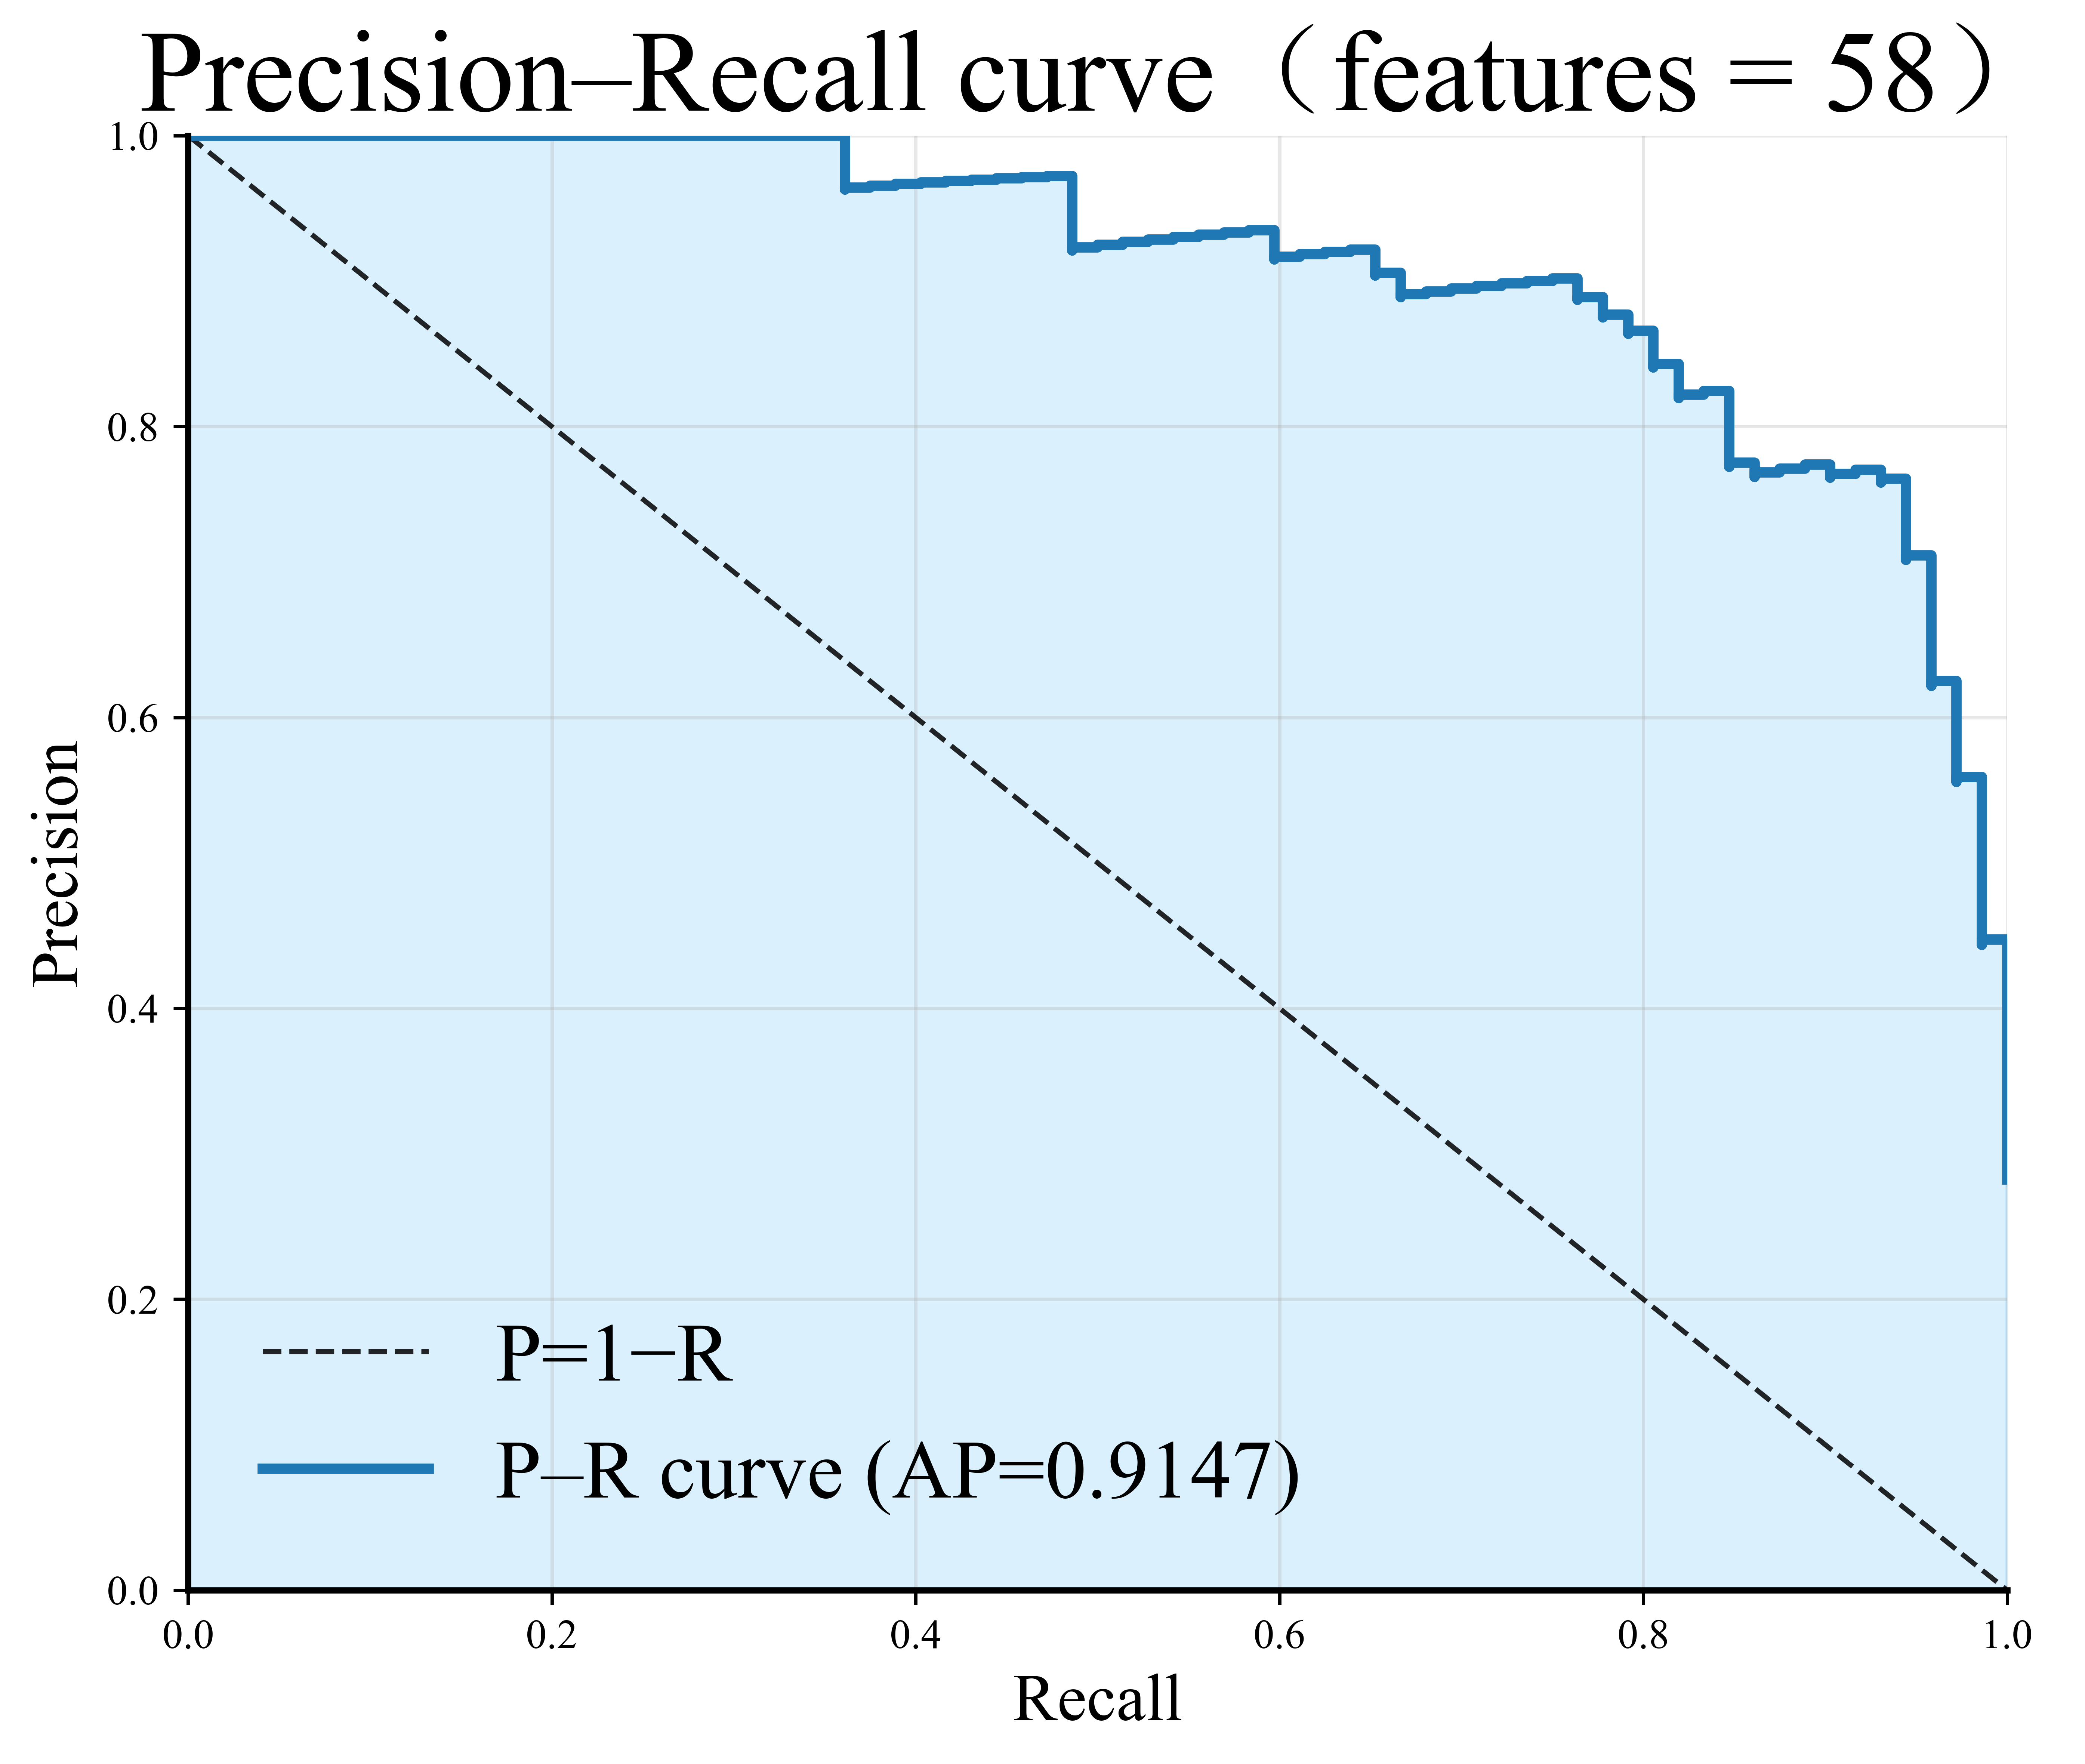 | 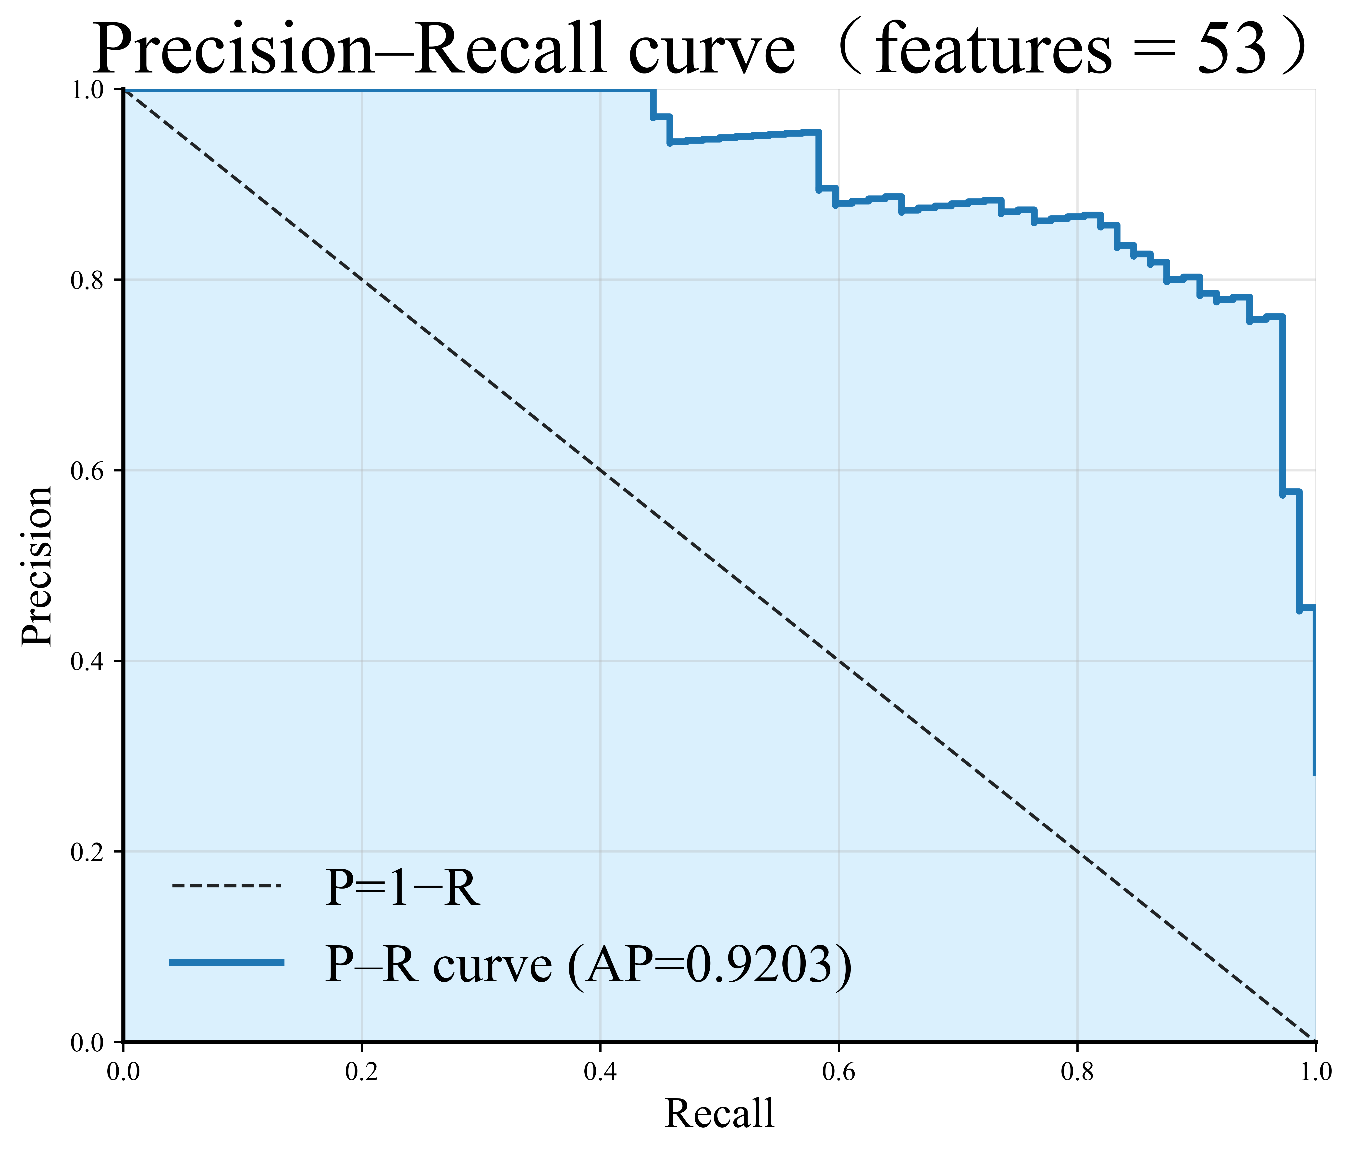 | 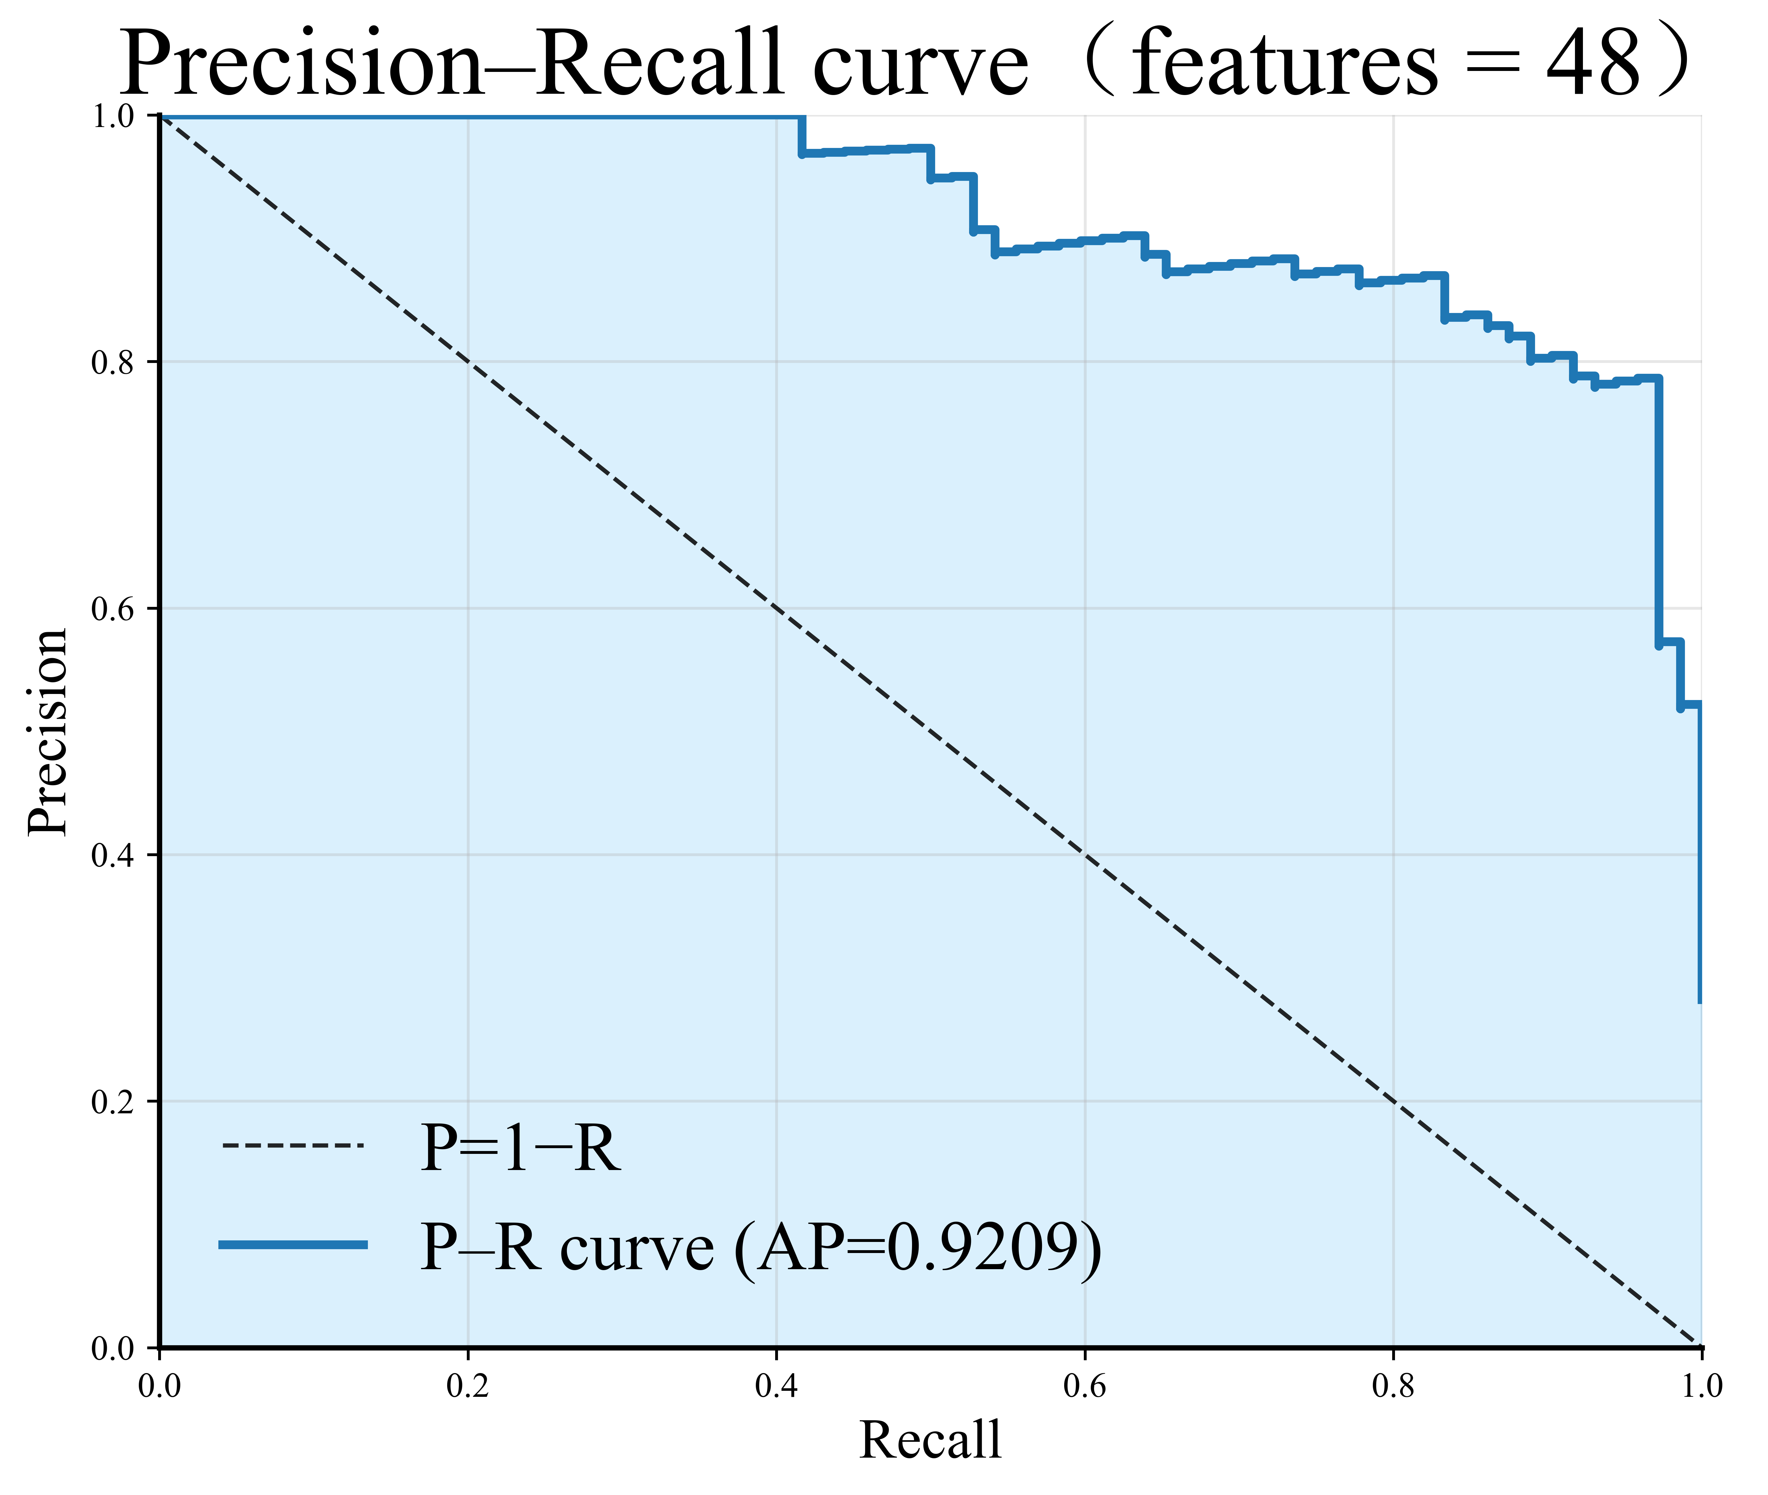
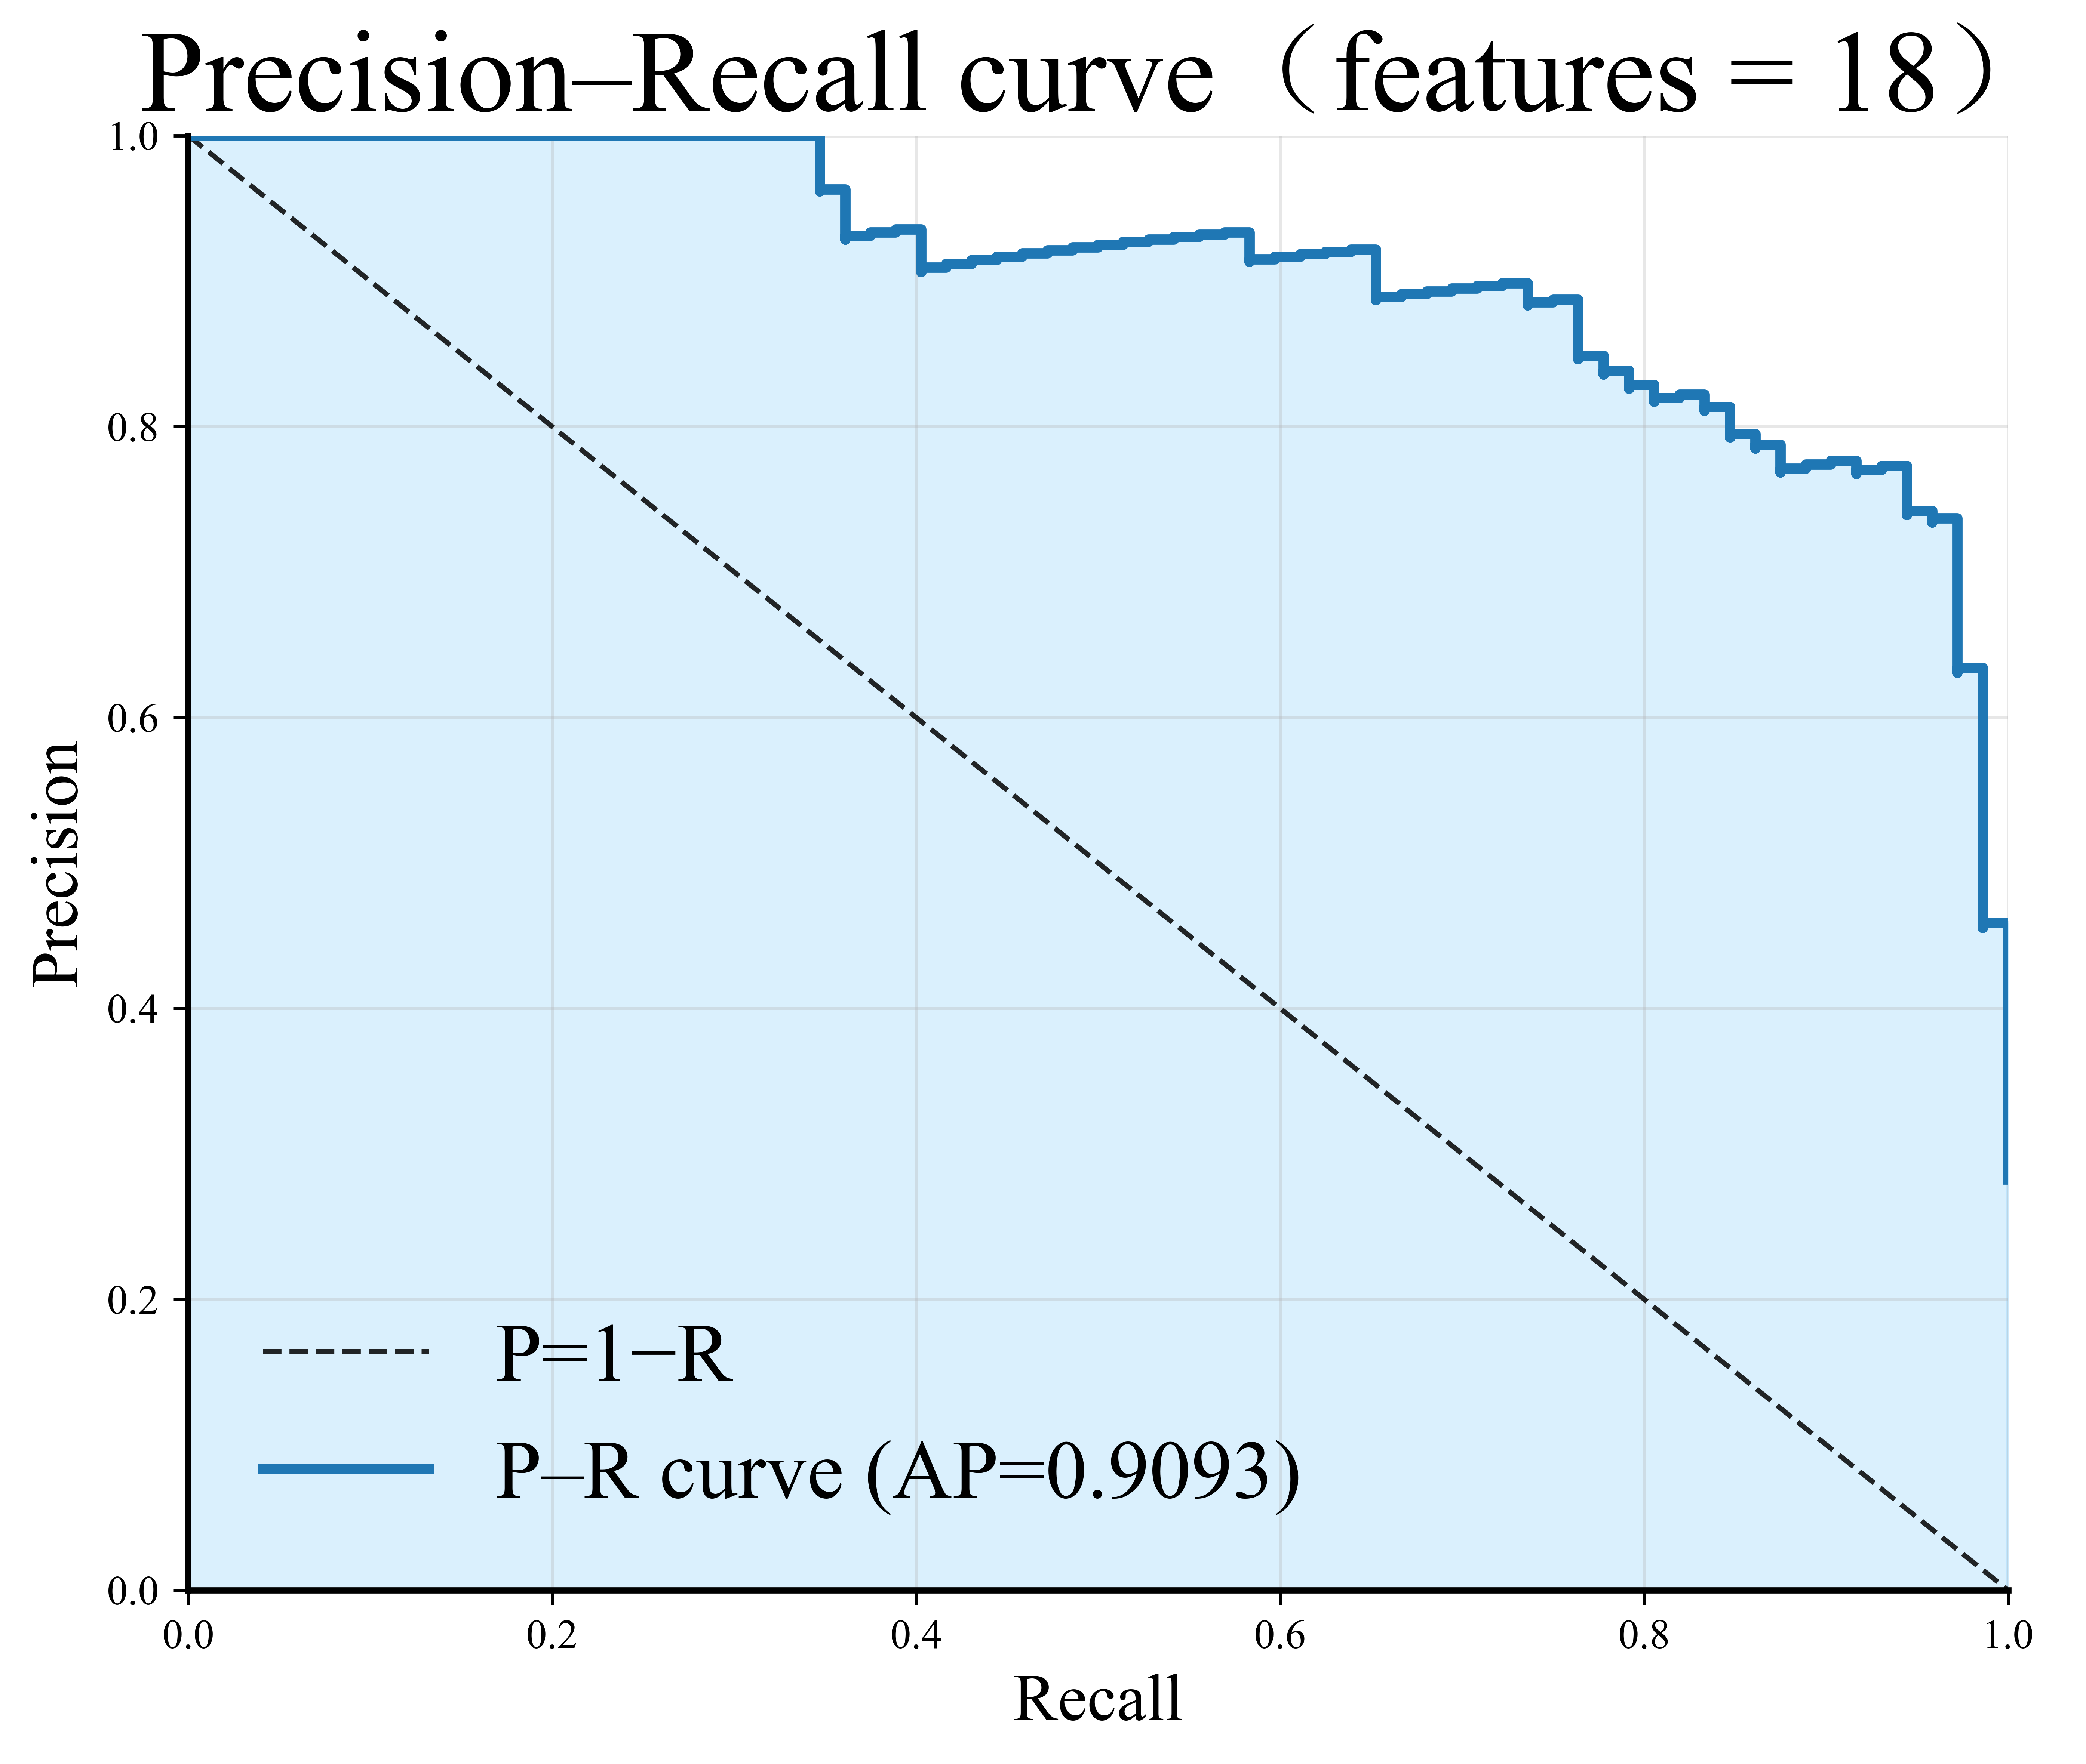 | 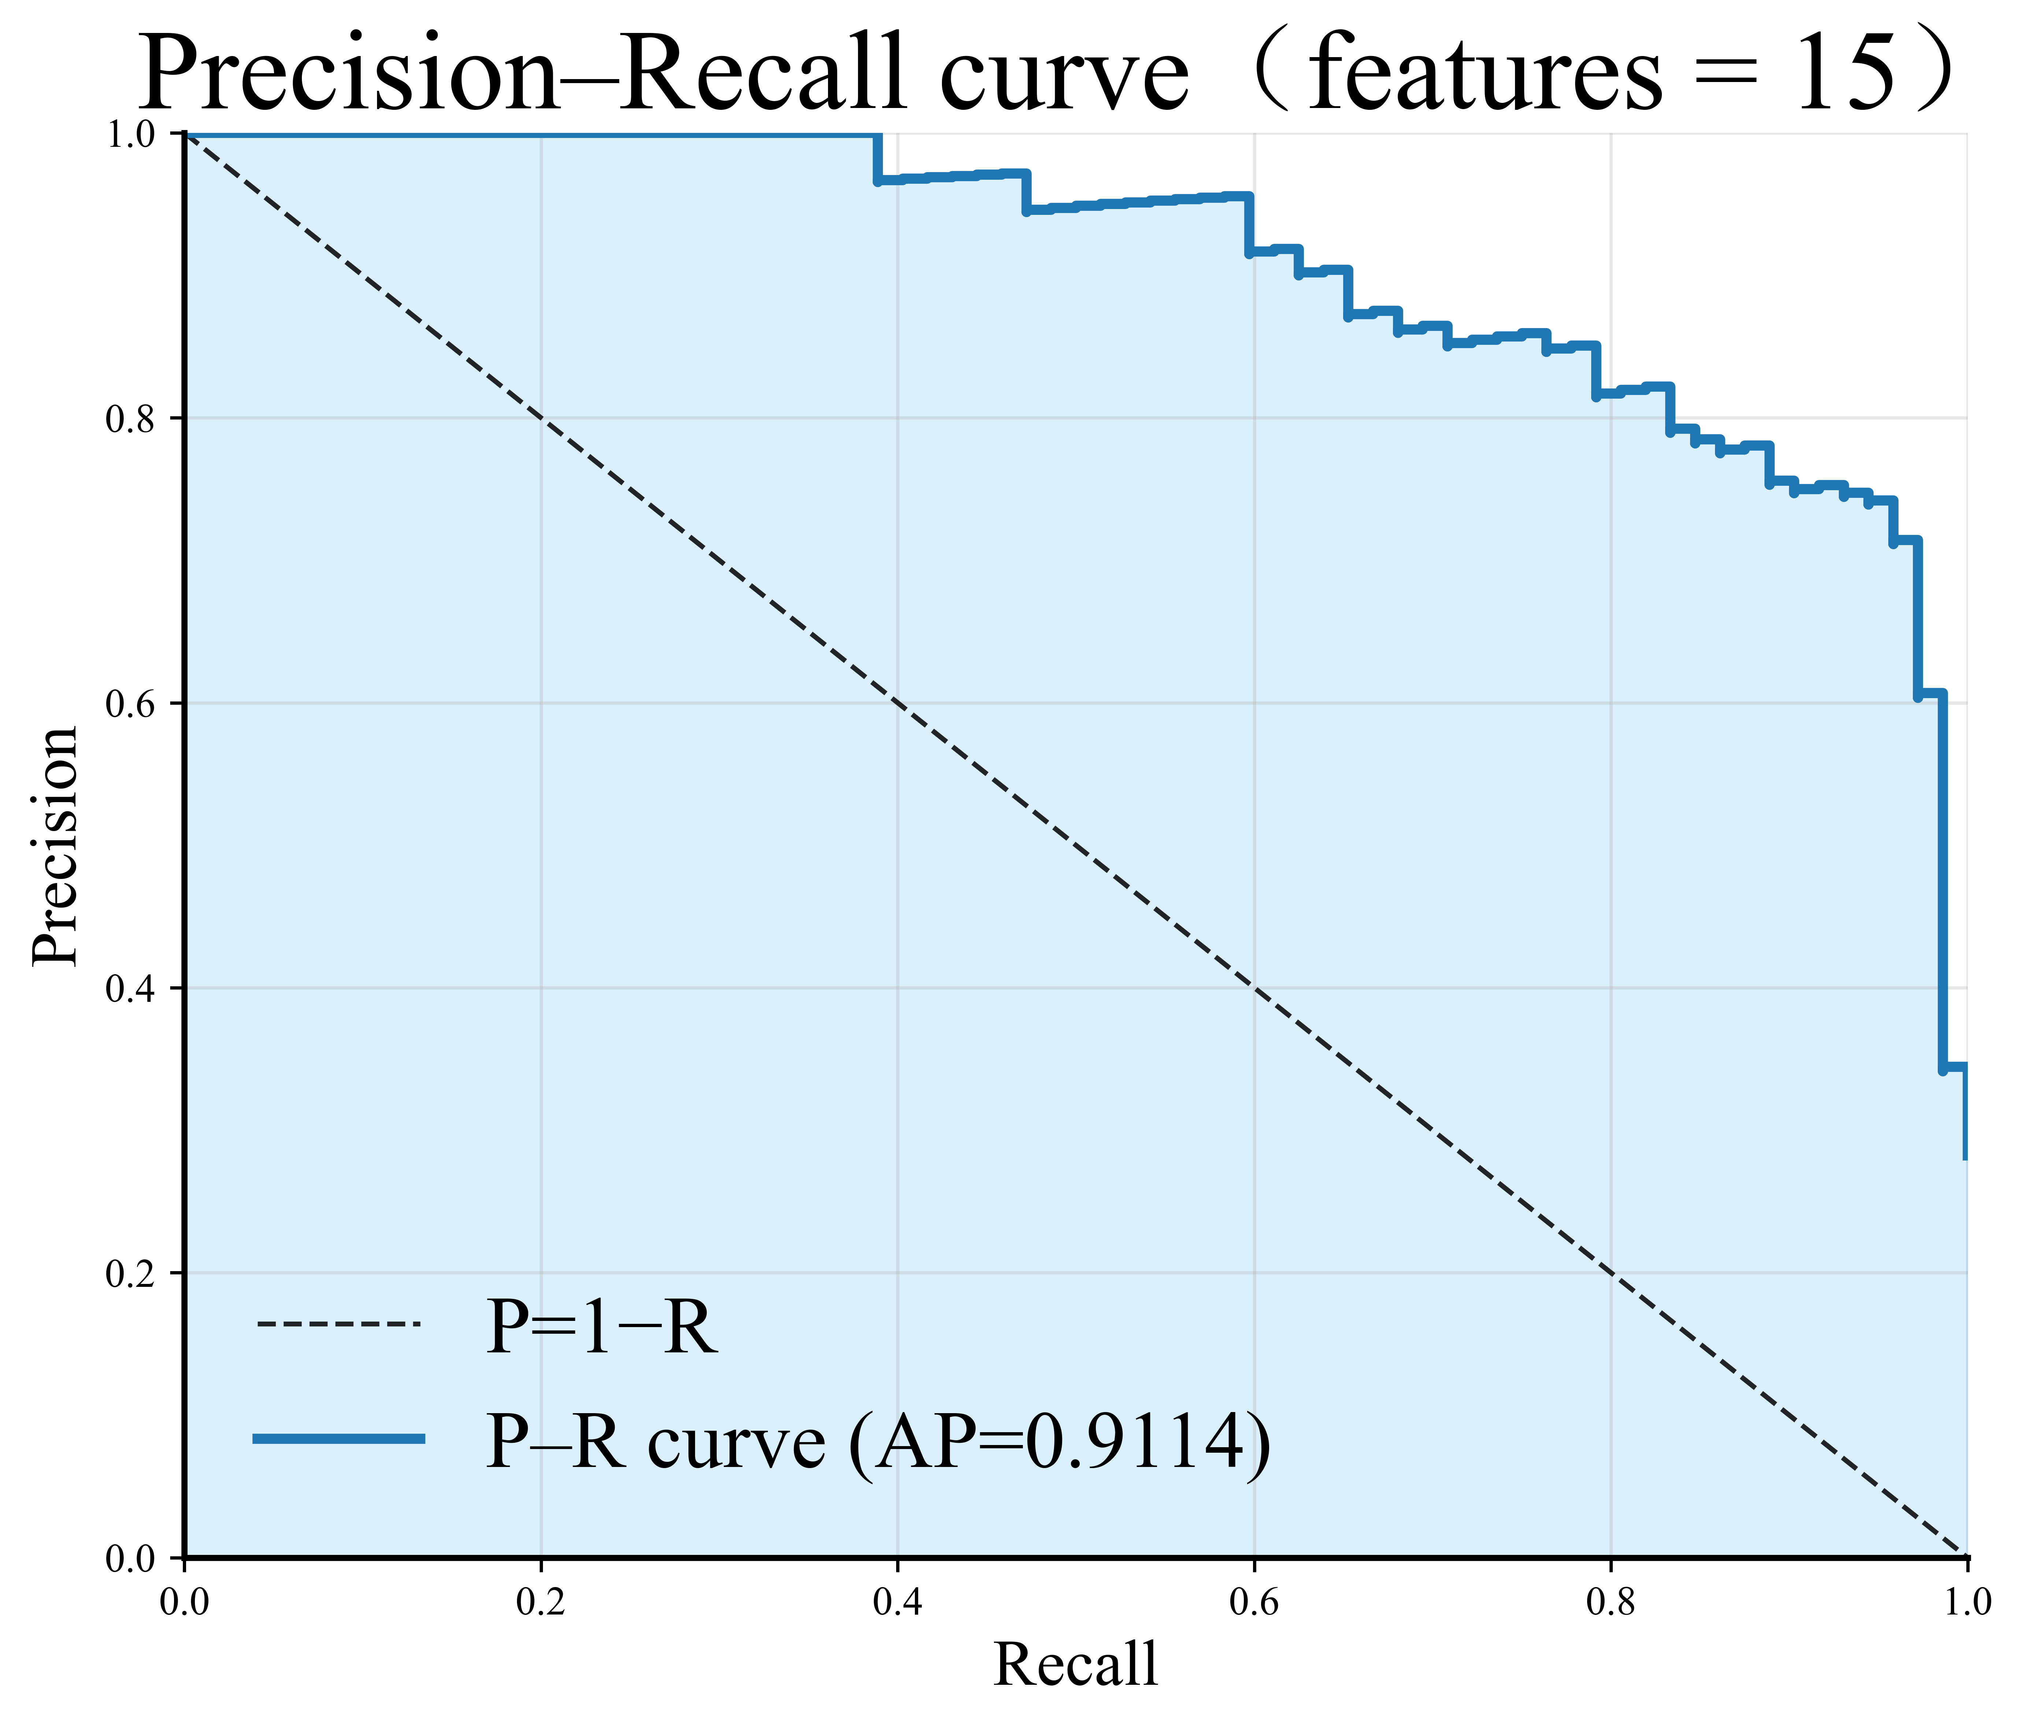 | 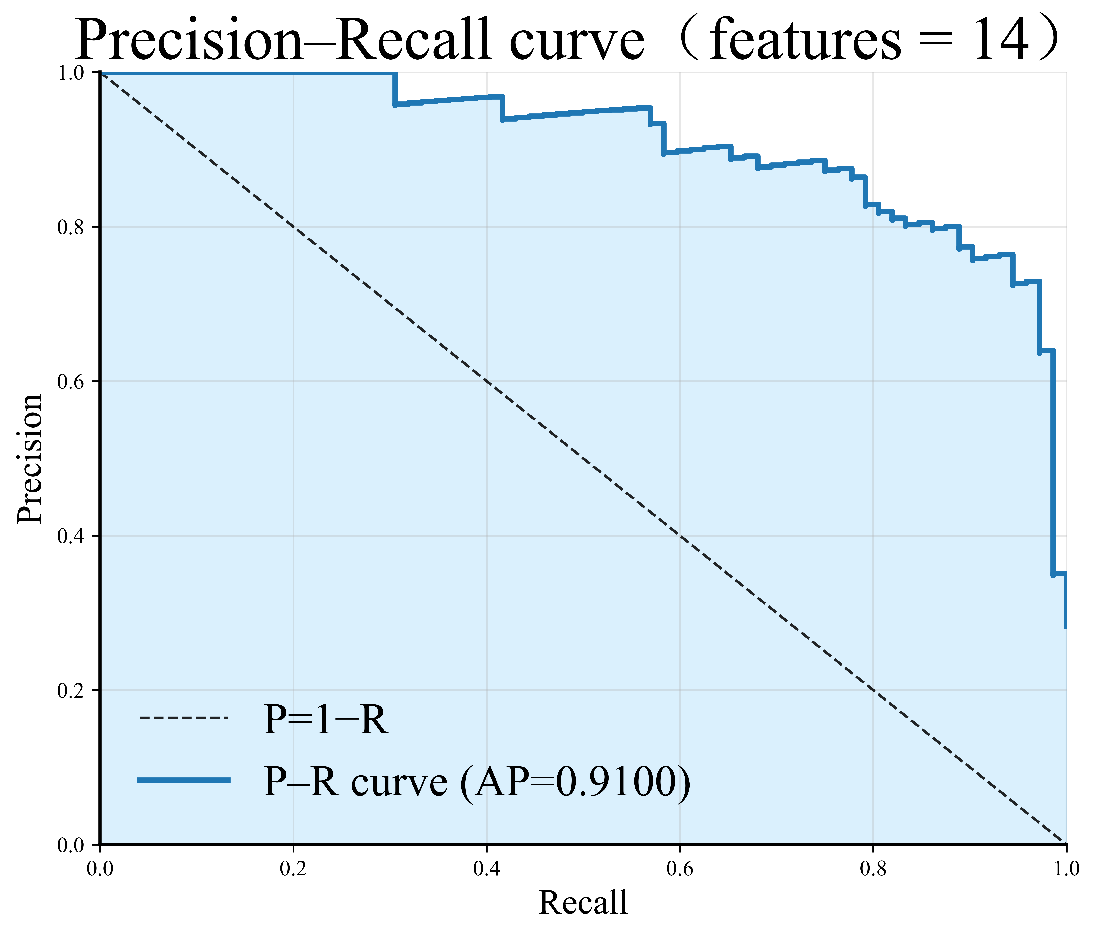
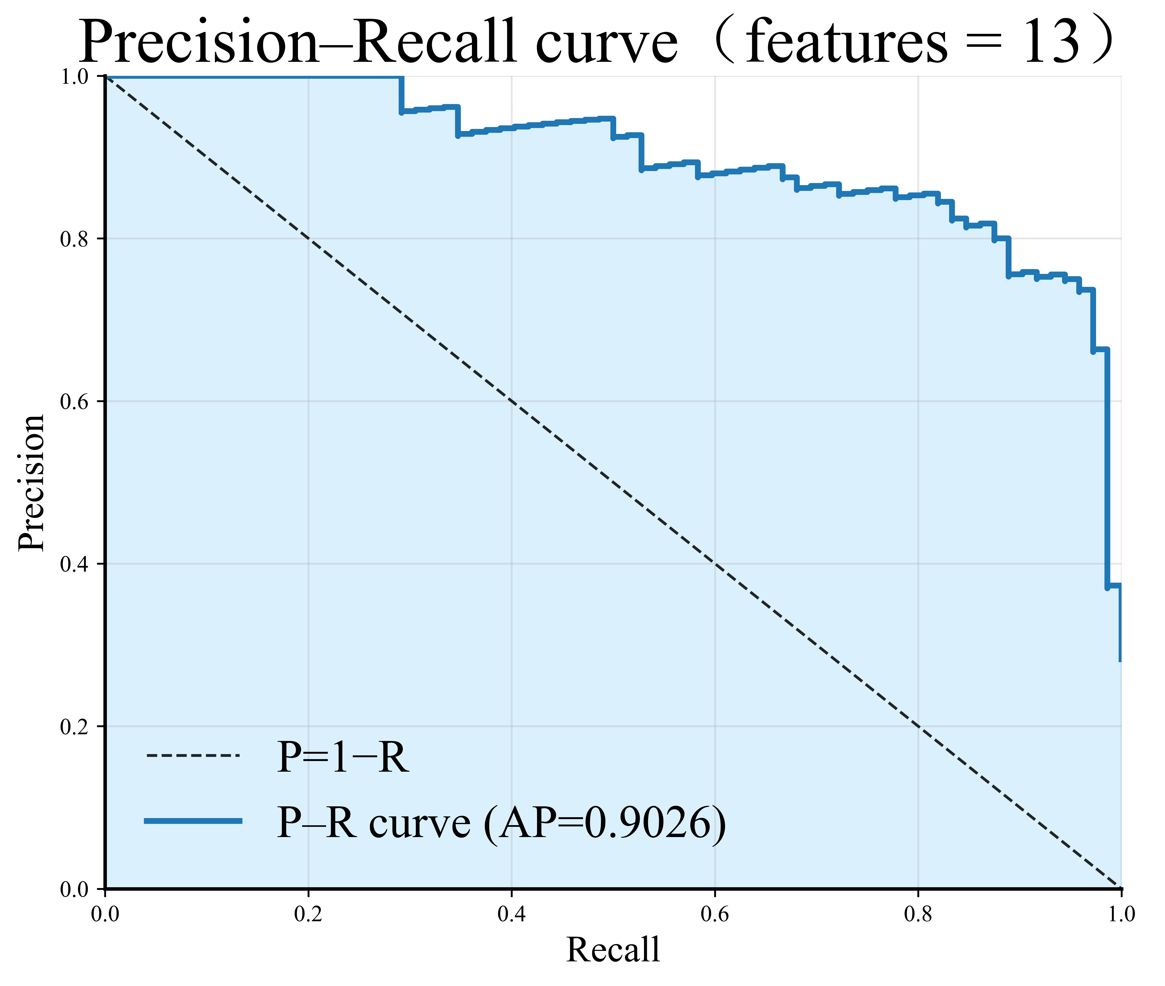 | 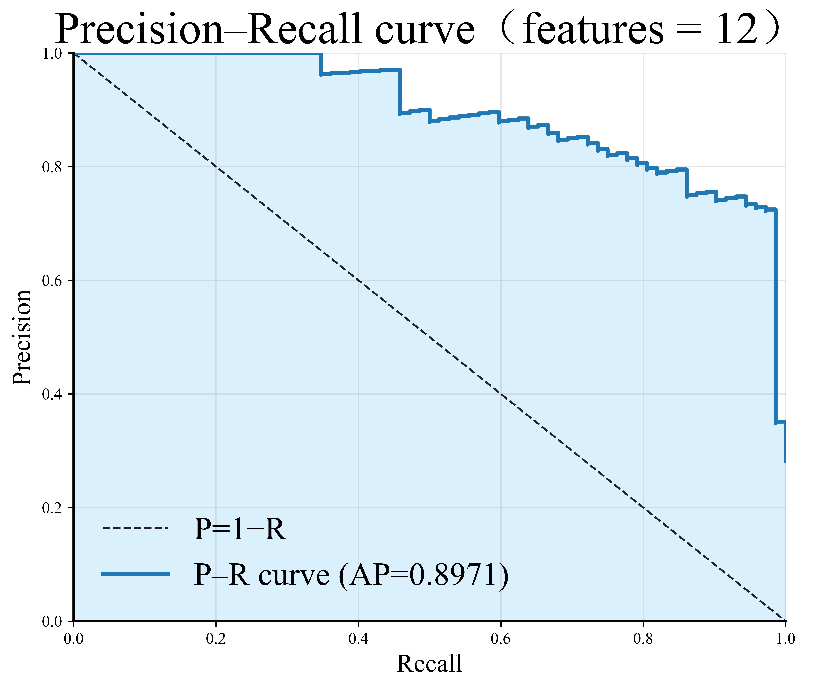 | 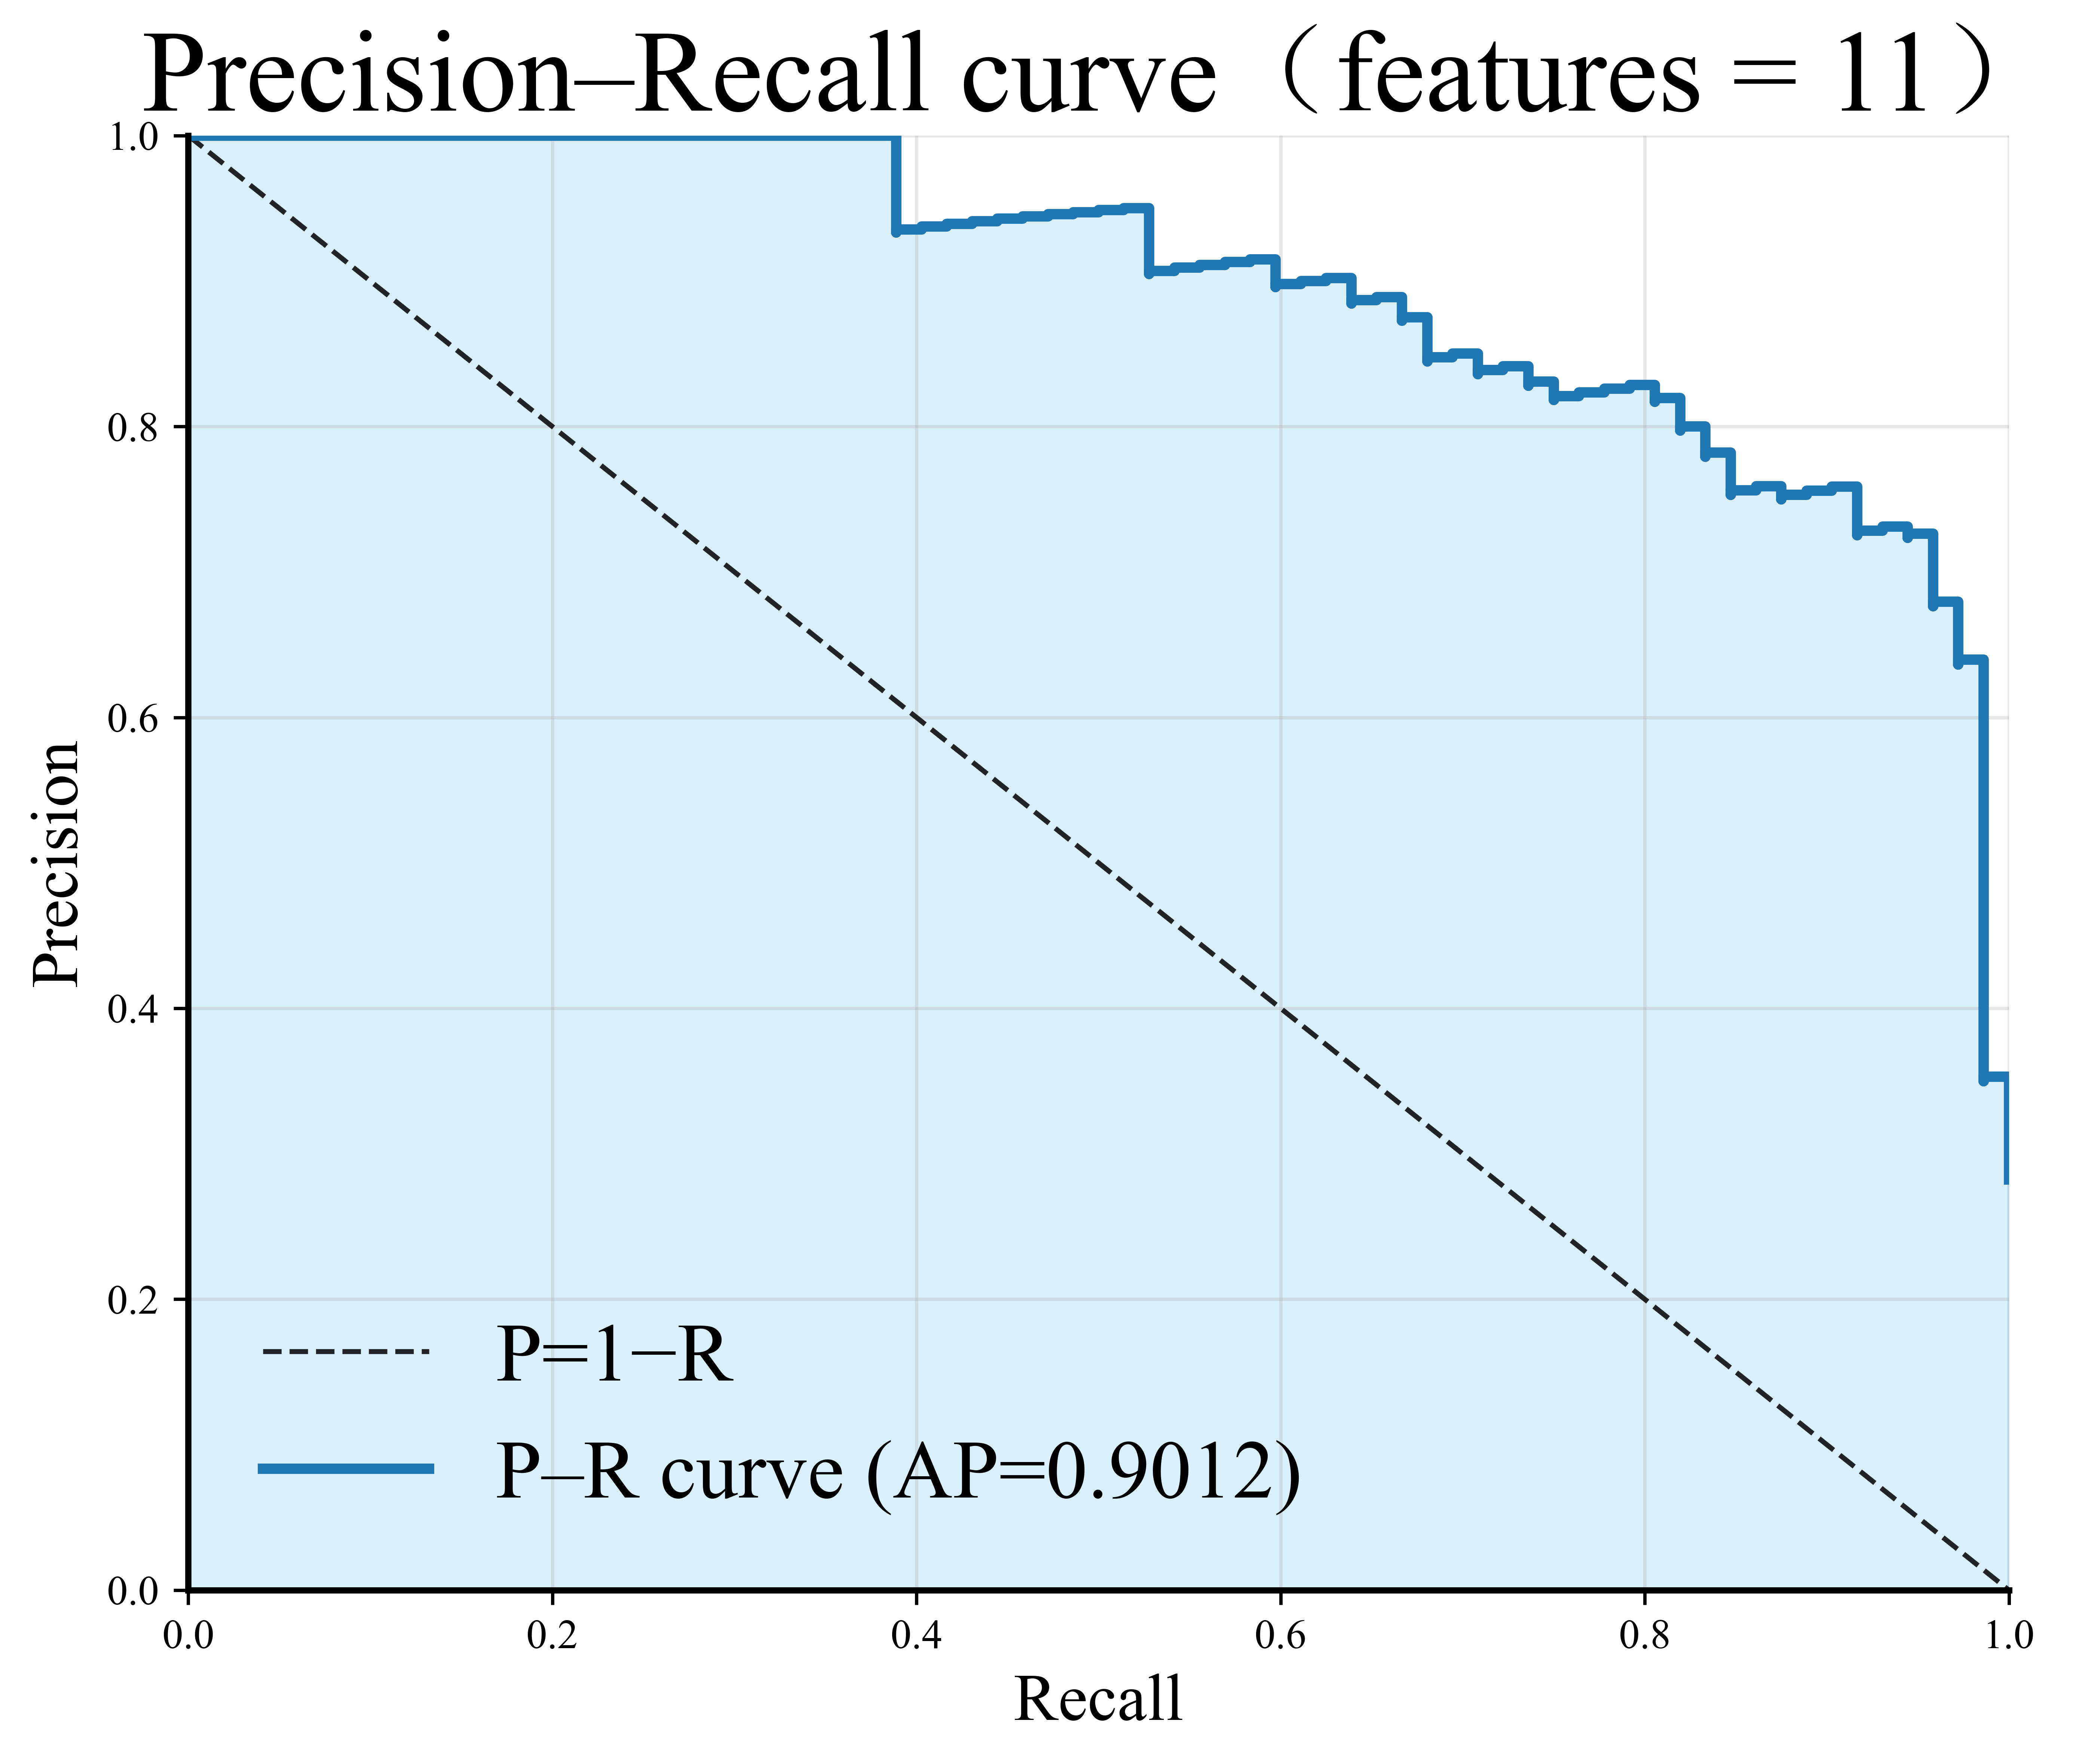
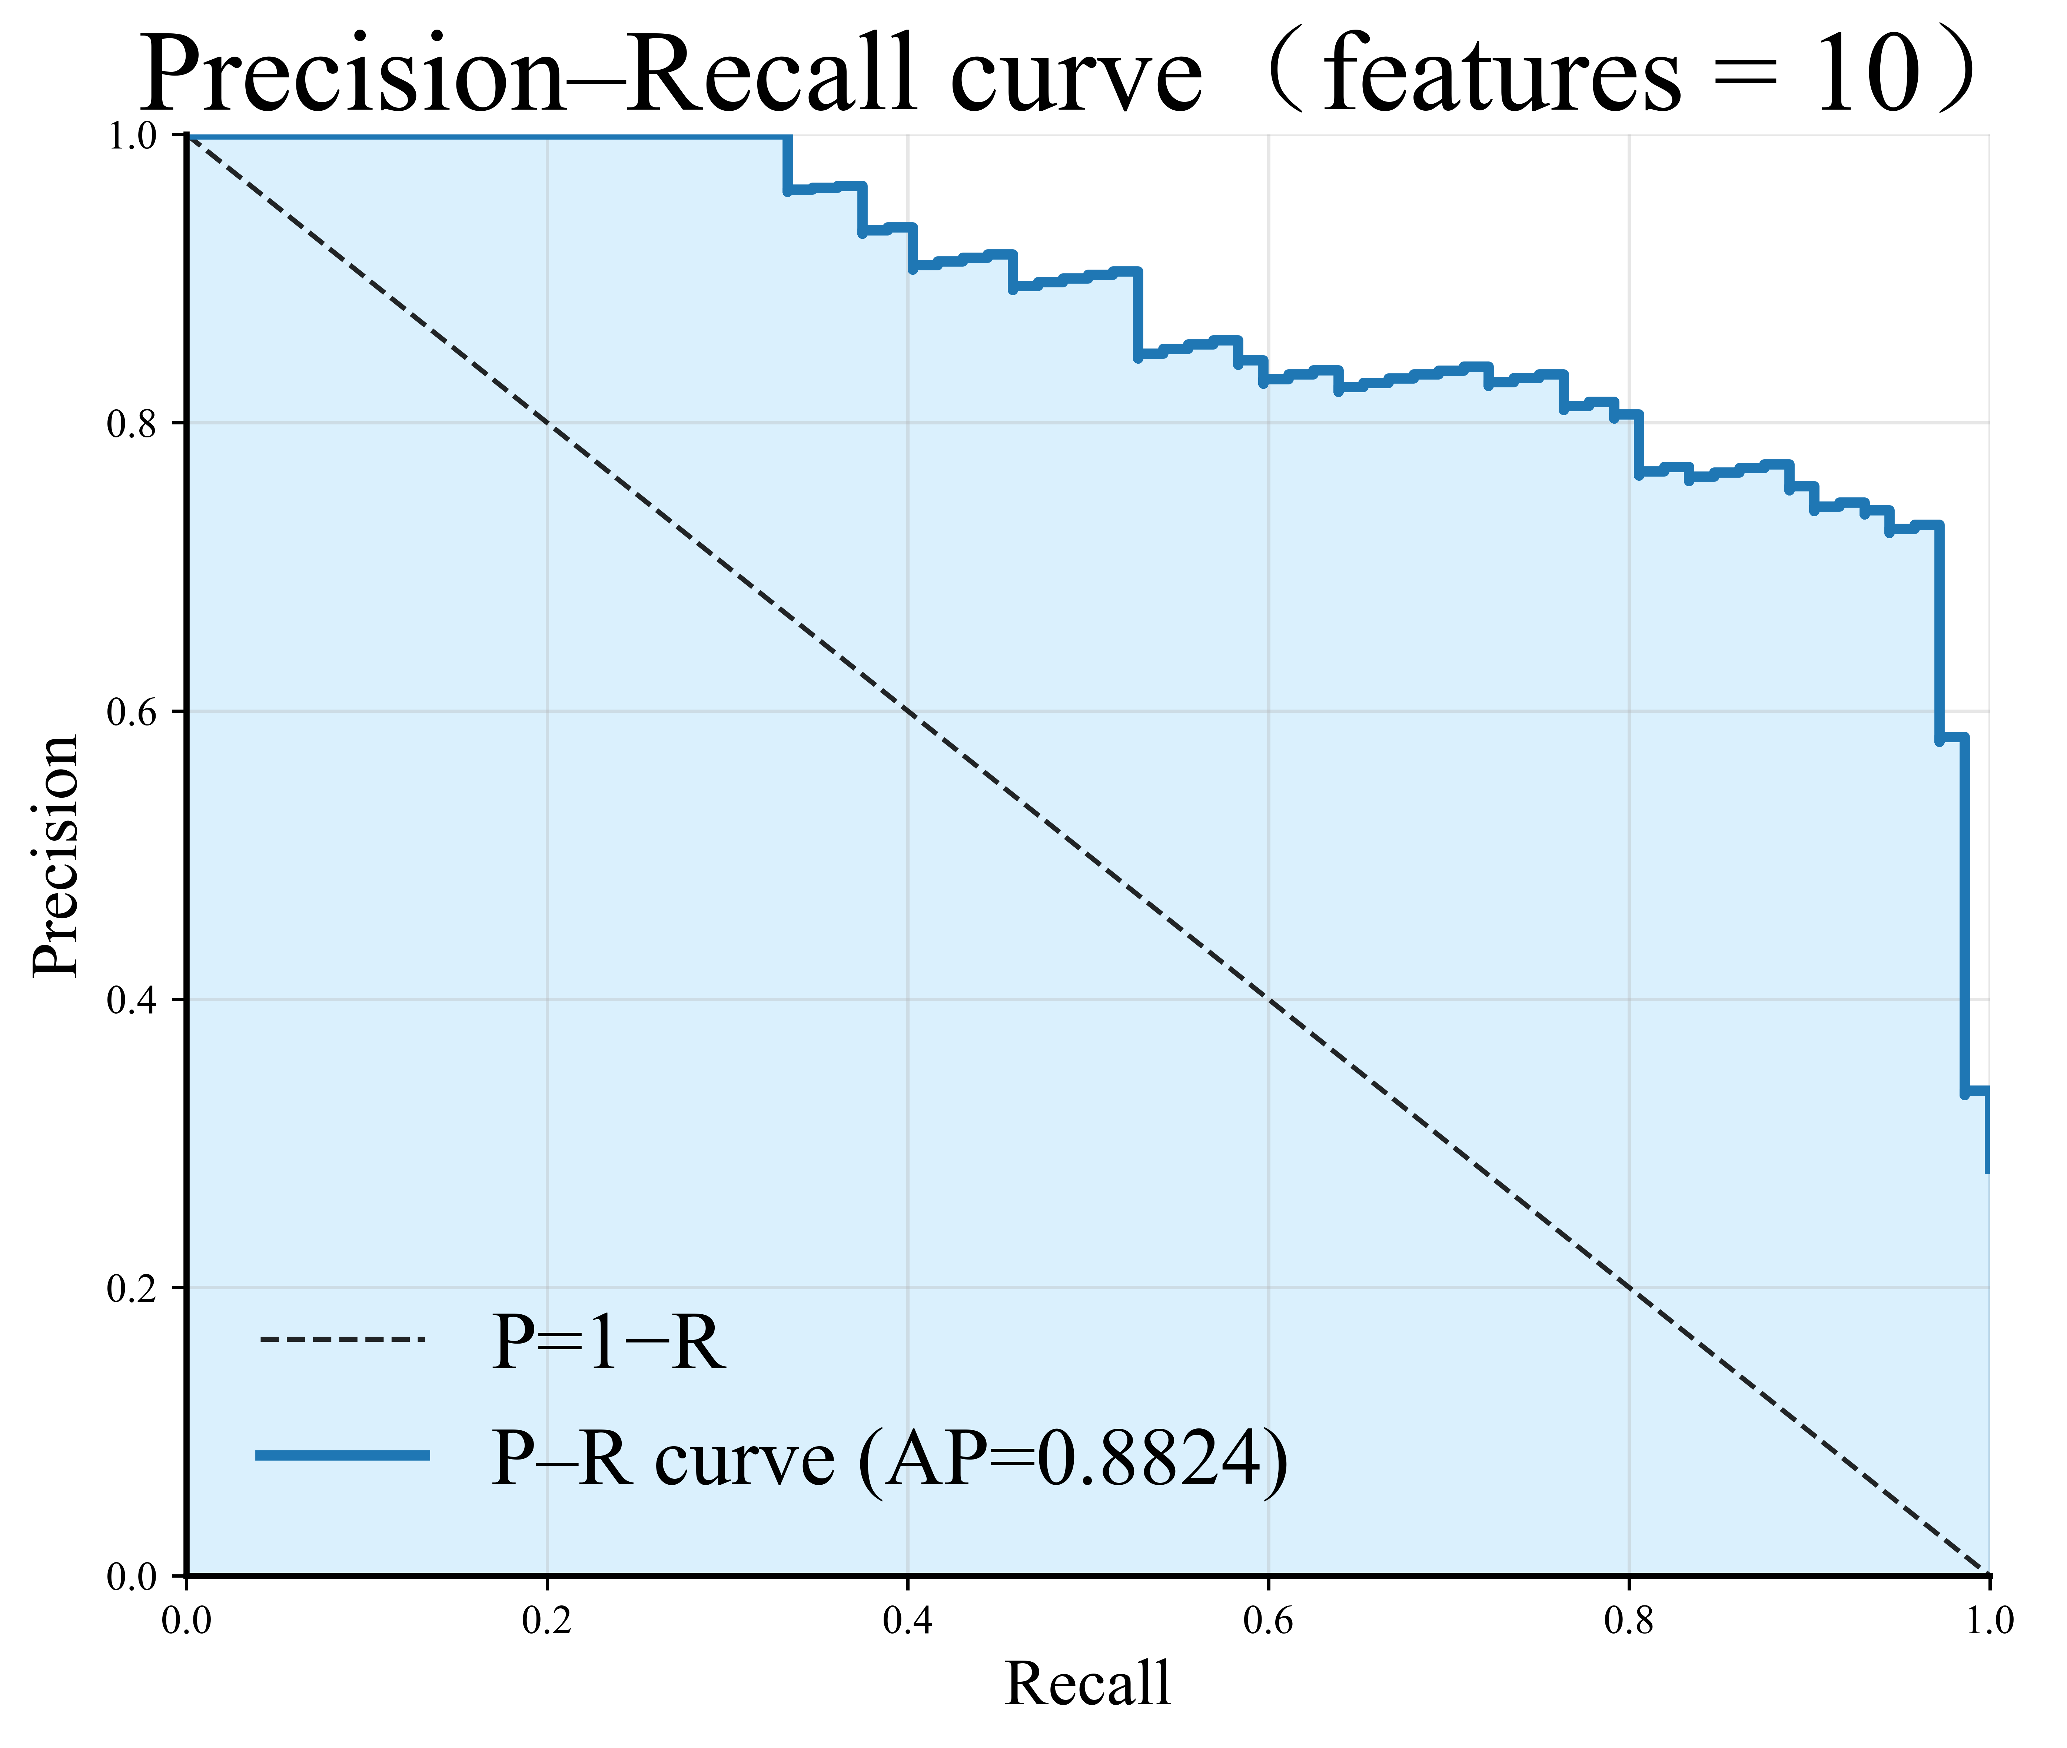 | 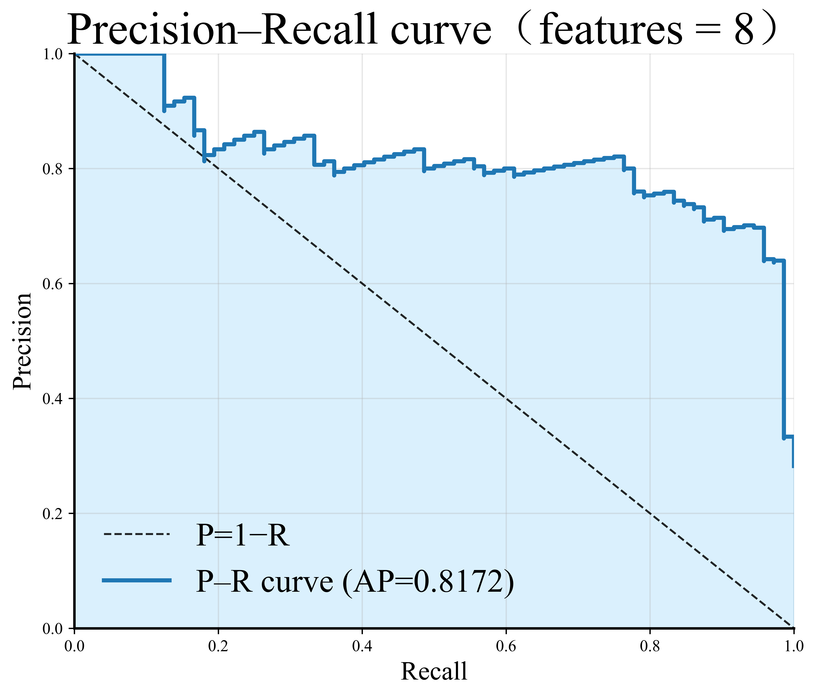 | 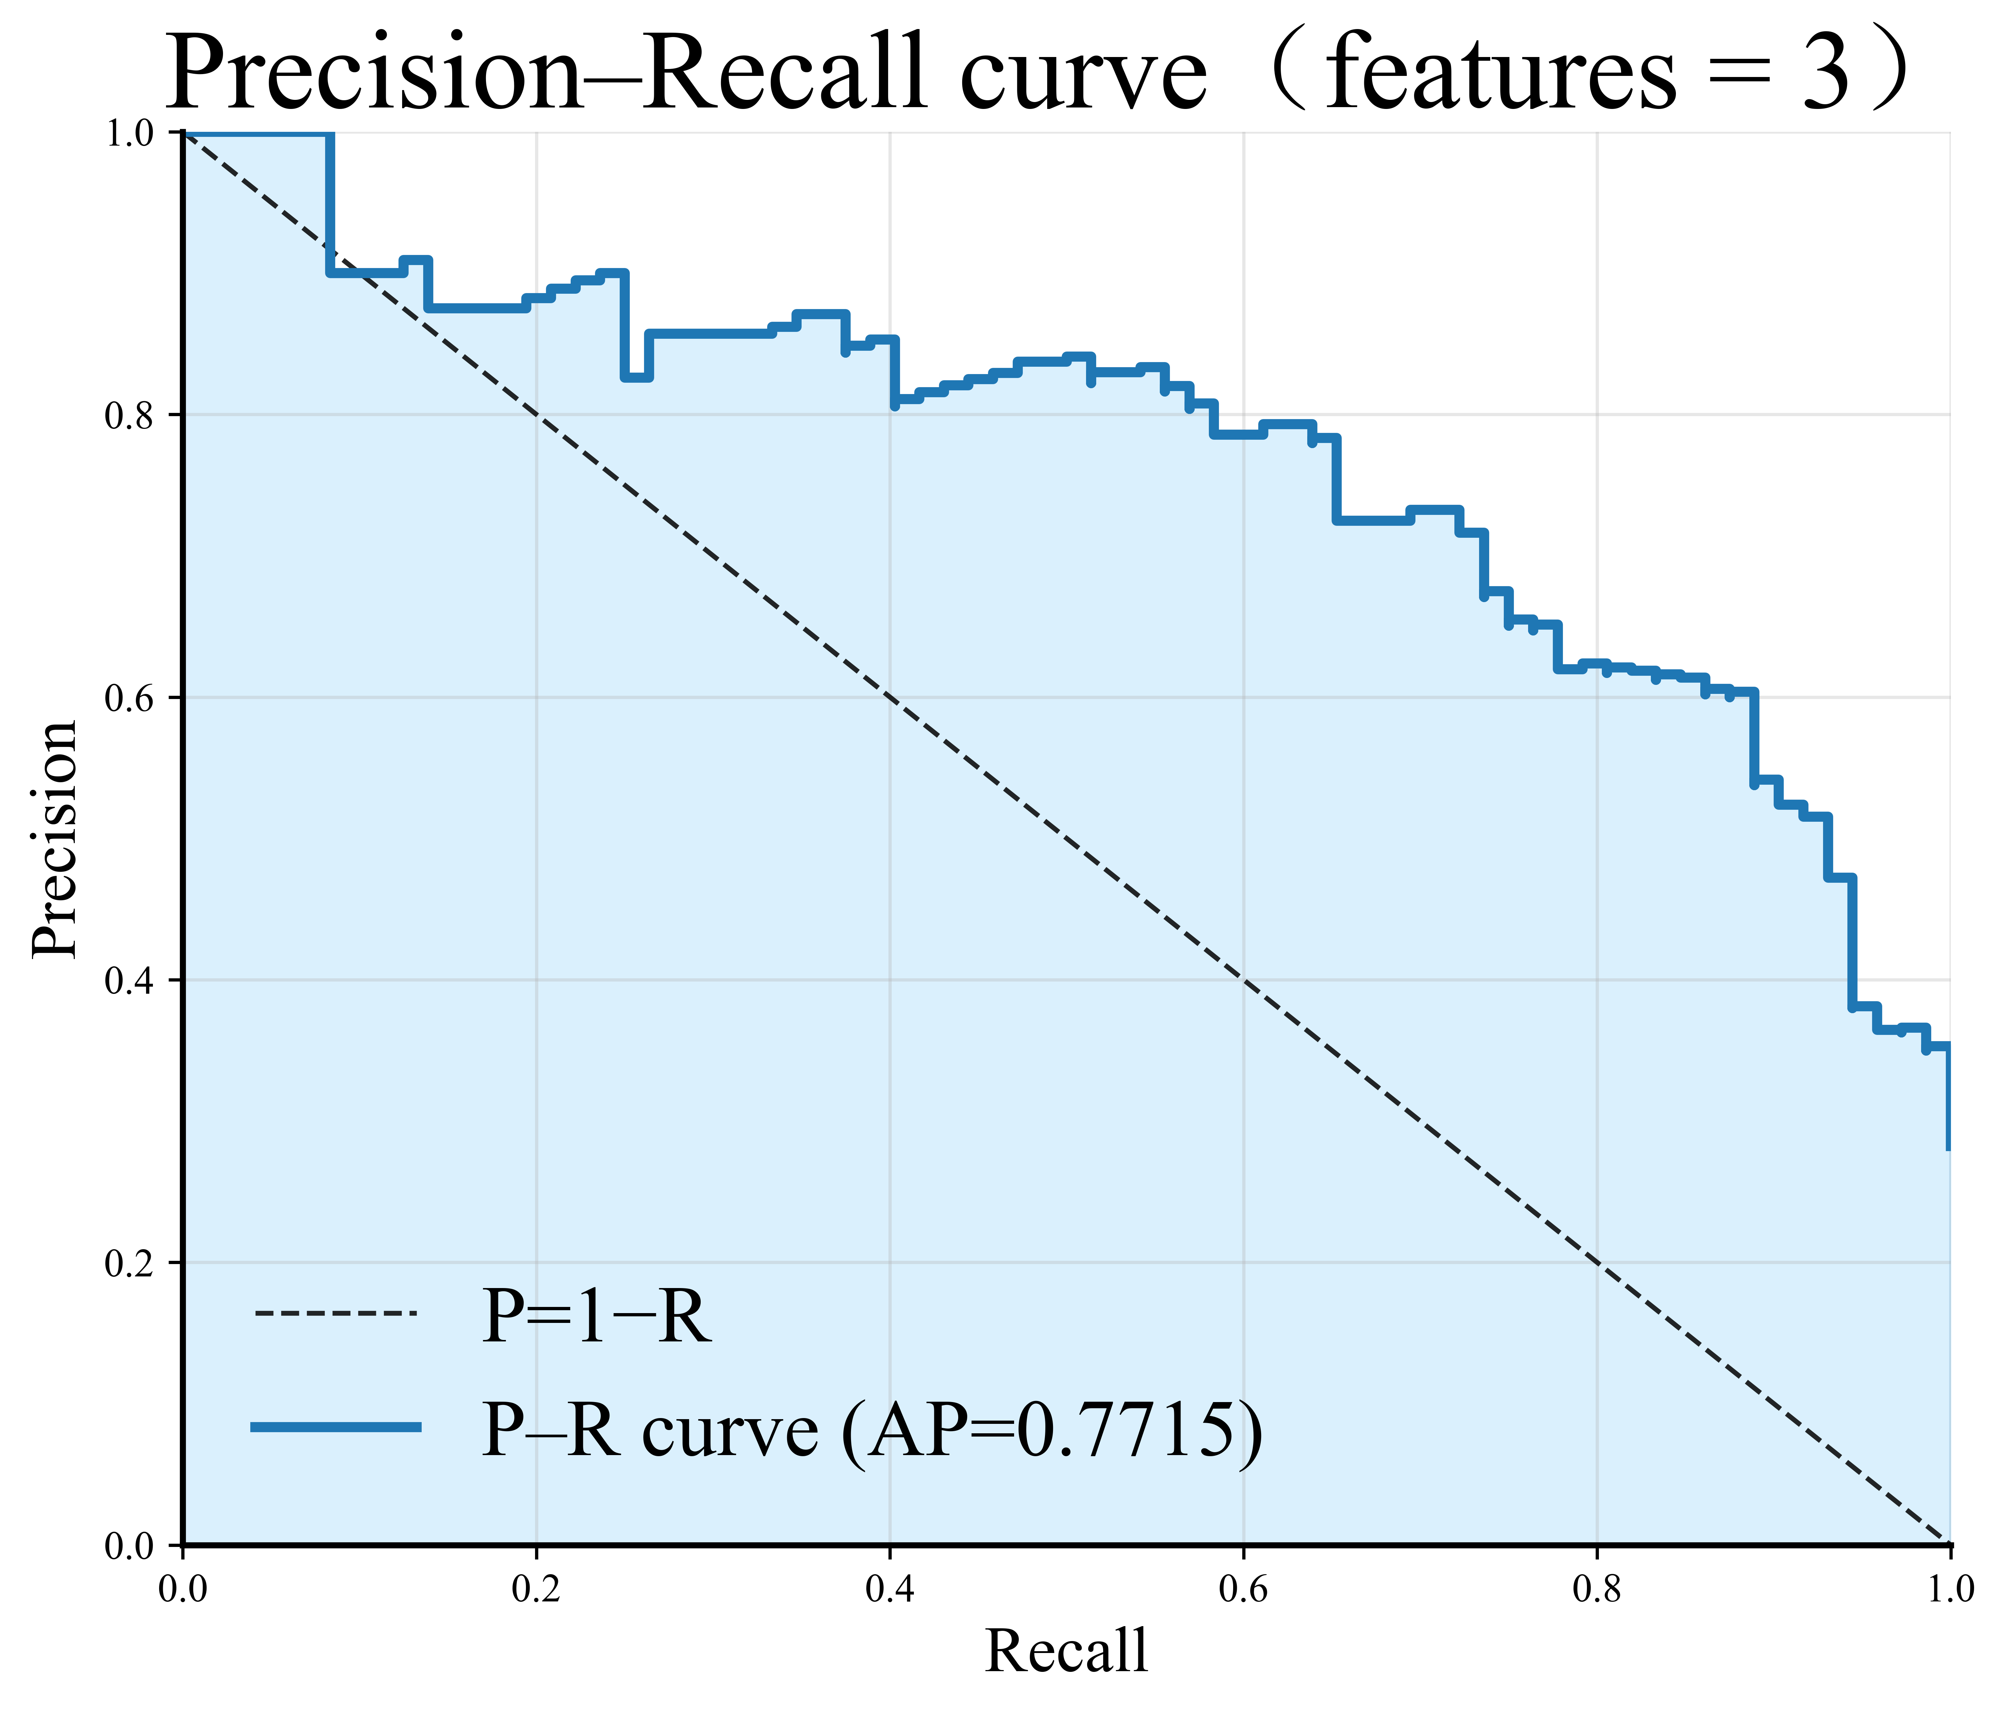
Supplementary Figure S2 P-R curves of LightGBM model with different features.

Supplementary Figure S3 Calibration curve for the 13-feature LightGBM model.

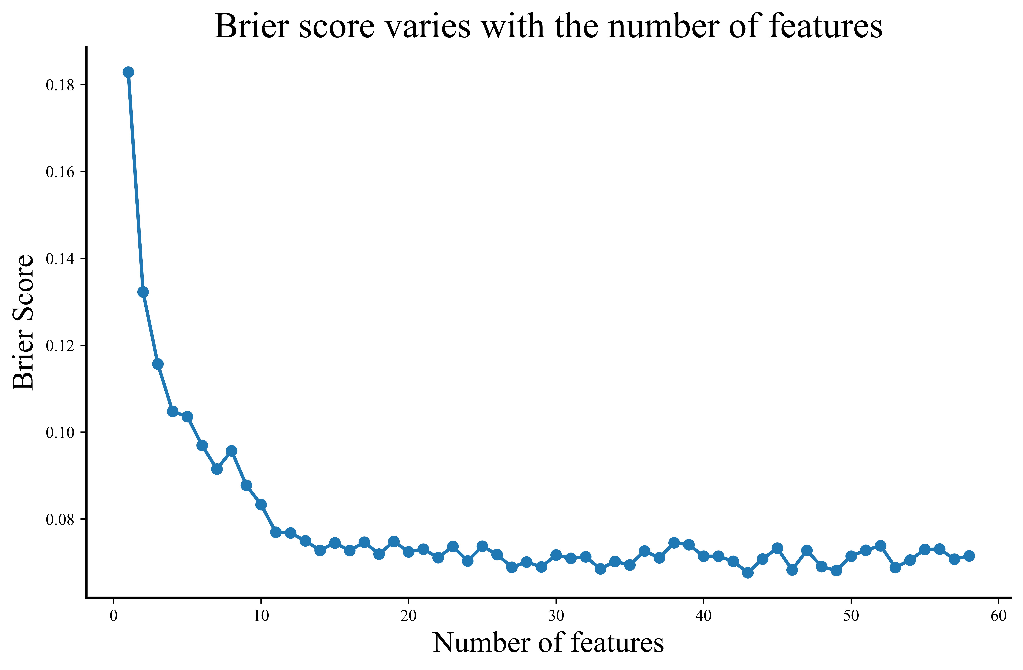
Supplementary Figure S4 Brier scores for LightGBM model with different number of features.

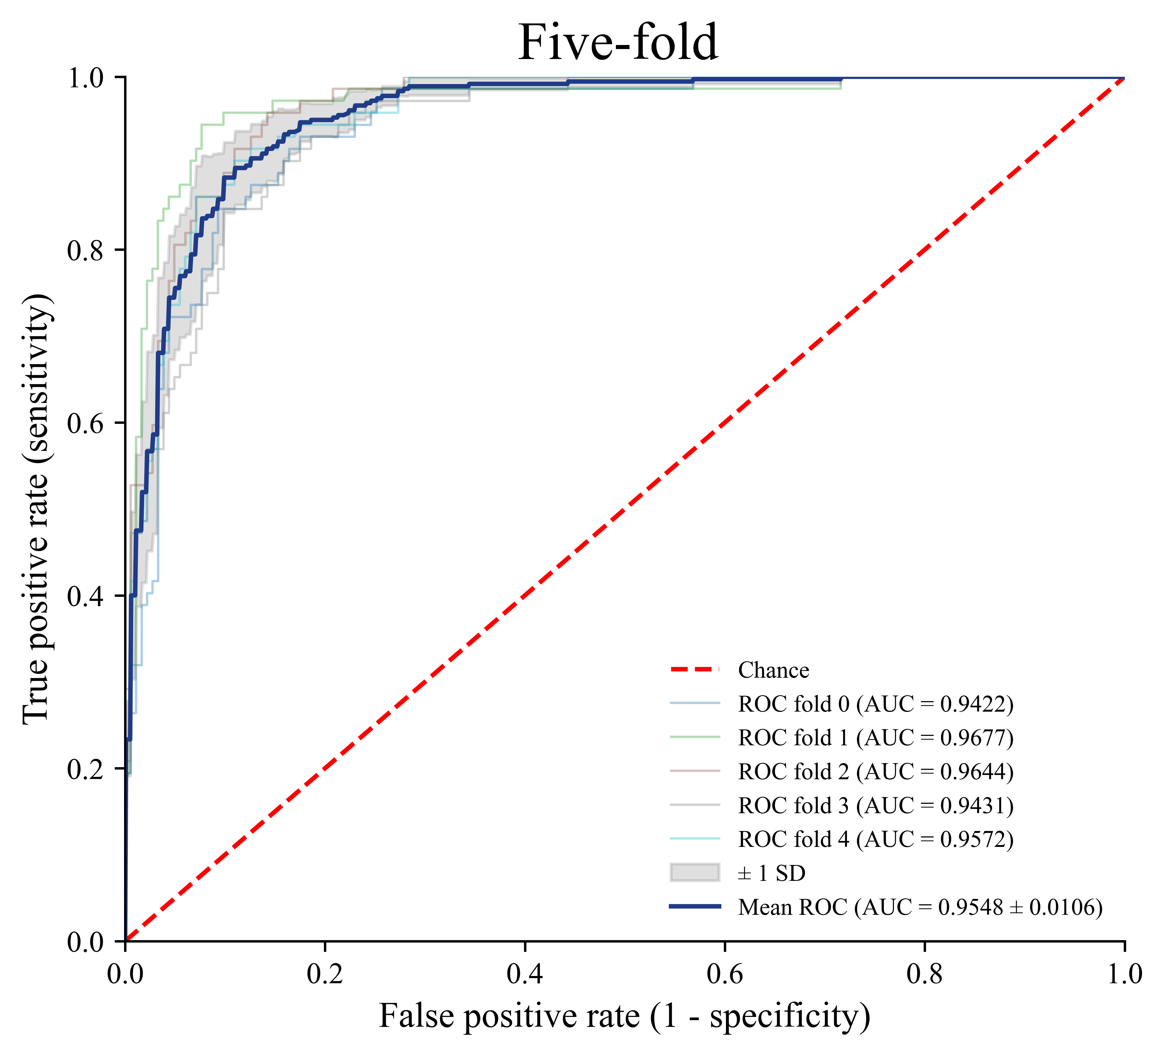 | 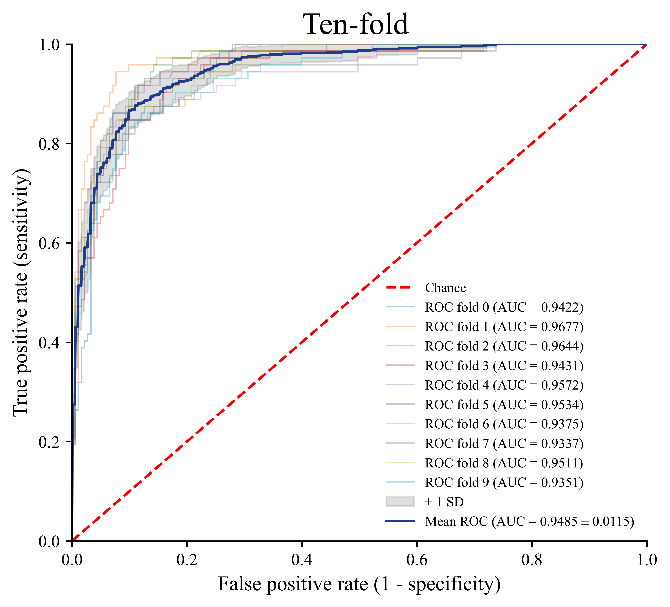
(A) | (B)
Supplementary Figure S5 Prediction performance of the final LightGBM model with 13 features in cross validation. (A) Five-fold (B) Ten-fold.

