Suppl. 1: Comprehensive Report on Gardenia imperialis activity-guided metabolomics
Samples were investigated using Nuclear Magnetic Resonance, Chromatographic techniques, Global Natural Products Social Molecular Networking (GNPS), Smart NMR and Mass Spectrometry data analysis to find the bioactive compounds in the extract.
GI-4 & 2
GI-4 extract had the best bioactivity and so the analysis for GI-4 proceeded first with the degrees of purification getting to Medium Pressure Liquid Chromatography (MPLC) where none of the fractions showed the above bioactivity. This was said to have been because of synergy or combinatorial effect taking place within the sample. Whilst GI-2 sample did not produce interesting chemistry and bioactive data, it was not prioritized and hence no data was obtained.
GI-3
Extract 3 was a hexane/ethyl acetate fraction from the leaf, had an IC50 of 18.12ug/ml. The extract was subjected to a Medium Pressure Liquid Chromatography (MPLC) Fig 1.0 with fraction G or 7 (Retention Time 20-22.5mins) showing a sharp UV peak, a conjugated compound that absorbs ultraviolet radiation at 254nm wavelength as well as Fraction L or 12 (RT: 41-43mins).
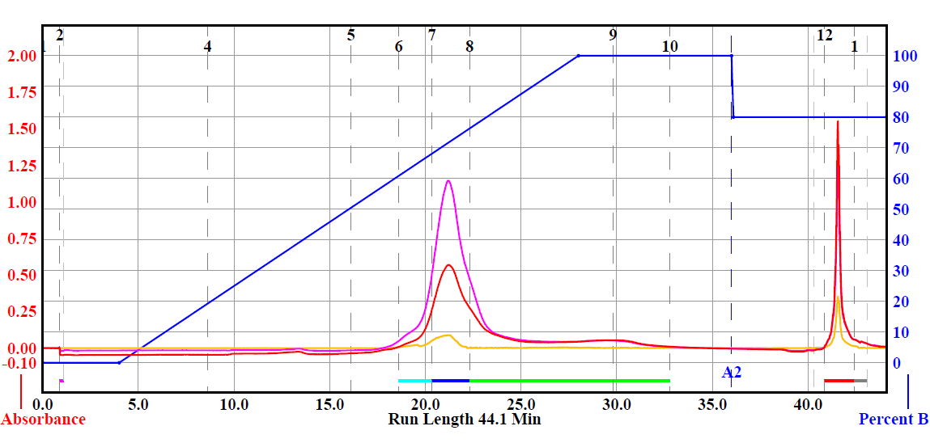
Fig 1.0 Medium Pressure Liquid Chromatography of GI-3

The NMR of all fractions were obtained, and fraction G showed a clean 1H NMR spectra with peaks showing off at the olefinic region, aromatic and less fatty acid as shown in Fig 1.1. It had a total mass of 313mg.
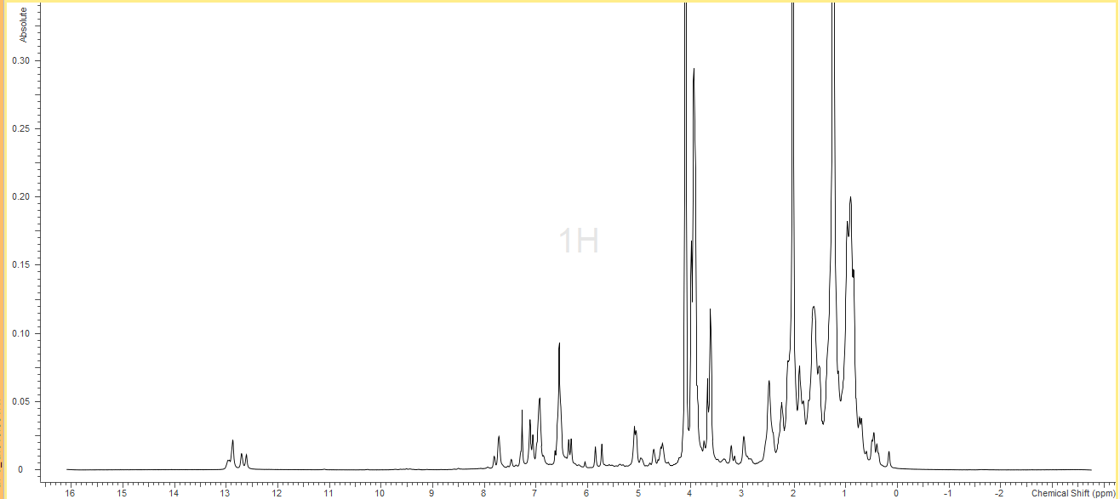
Fig.1.1 Proton NMR of GI-3G
High Pressure Liquid Chromatography has the purity percentage higher and gives better separation and resolution to obtaining pure compounds. GI-3G was fractionated using the HPLC Fig1.4 and several fractions were obtained and screened against several pathogens.
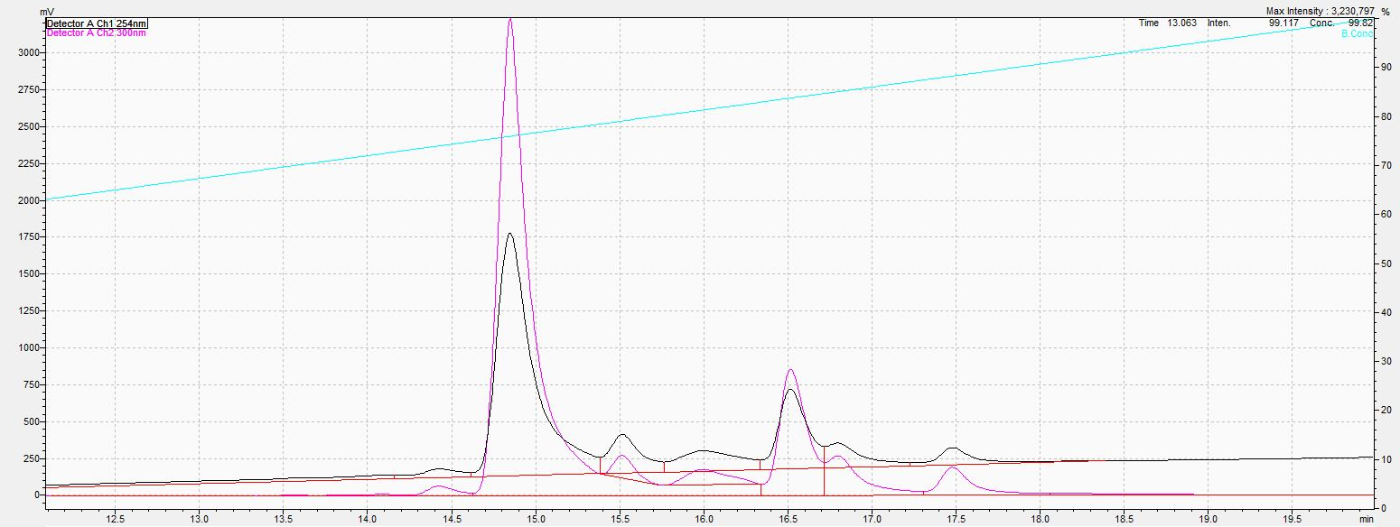
7
5
4
6
Fig.1.4 HPLC of GI-3G fraction
Nuclear Magnetic Resonance technique showed various peaks in the GI-3G6 fraction and further purification was needed. GI-3G6 was fractionated using the HPLC Fig1.6 and several fractions were obtained including a pure compound. A full data set was obtained to confirm the structure of the pure compound.
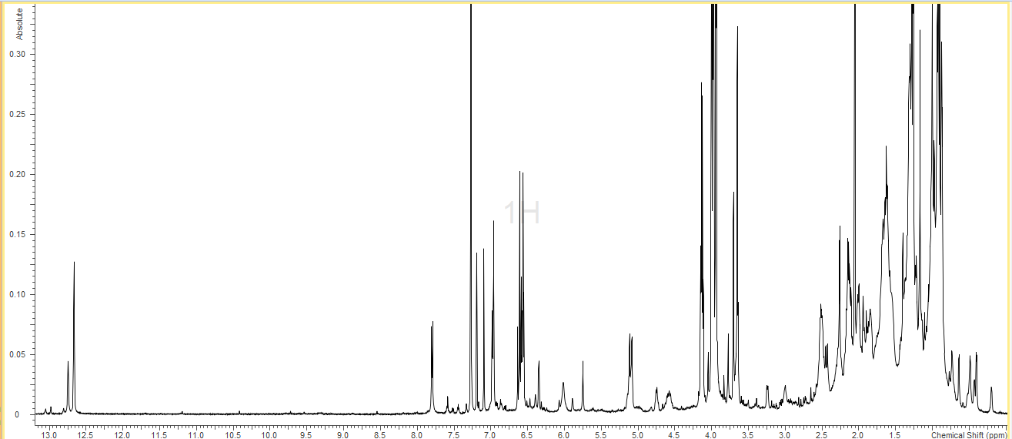
Fig.1.5 Proton NMR GI-3G6
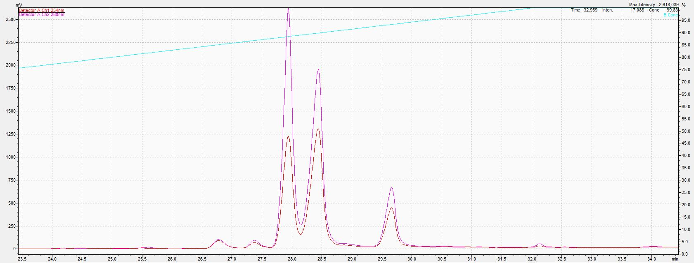
C
A
B
E
D
Fig.1.6 HPLC GI-3G6
FULL DATA SET TO COMPOUND IDENTIFICATION
1H NMR (Proton NMR)
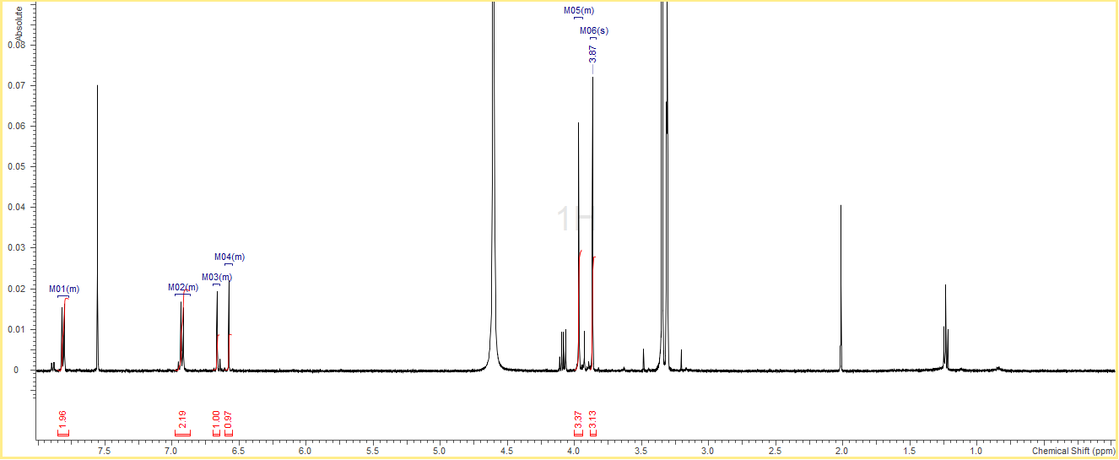

COSY (Correlation Spectroscopy)
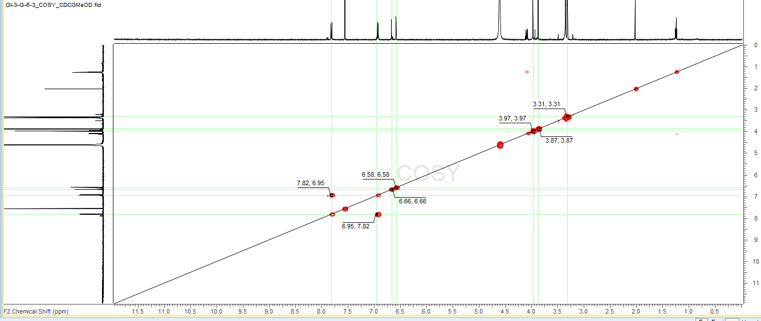

HSQC (Heteronuclear Single Quantum Coherence)
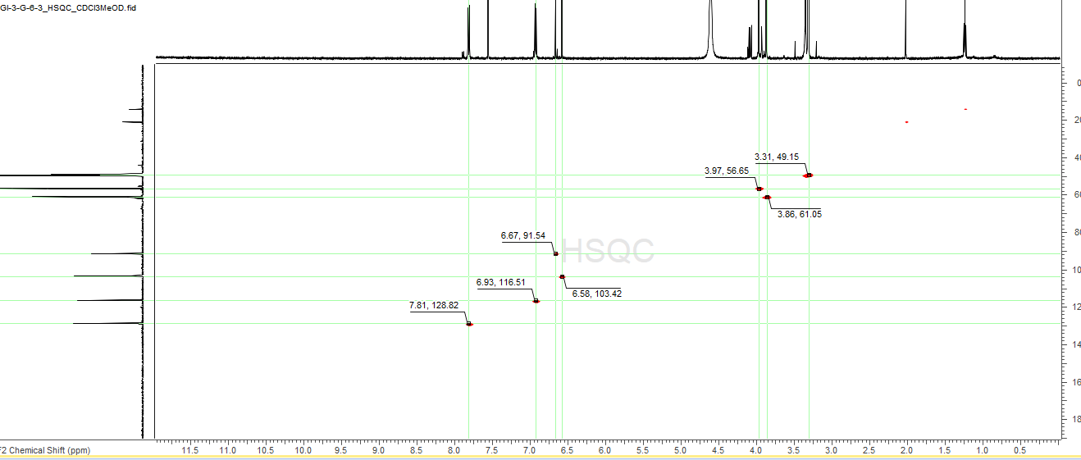

NOESY (Nuclear Overhauser Effect Spectroscopy)
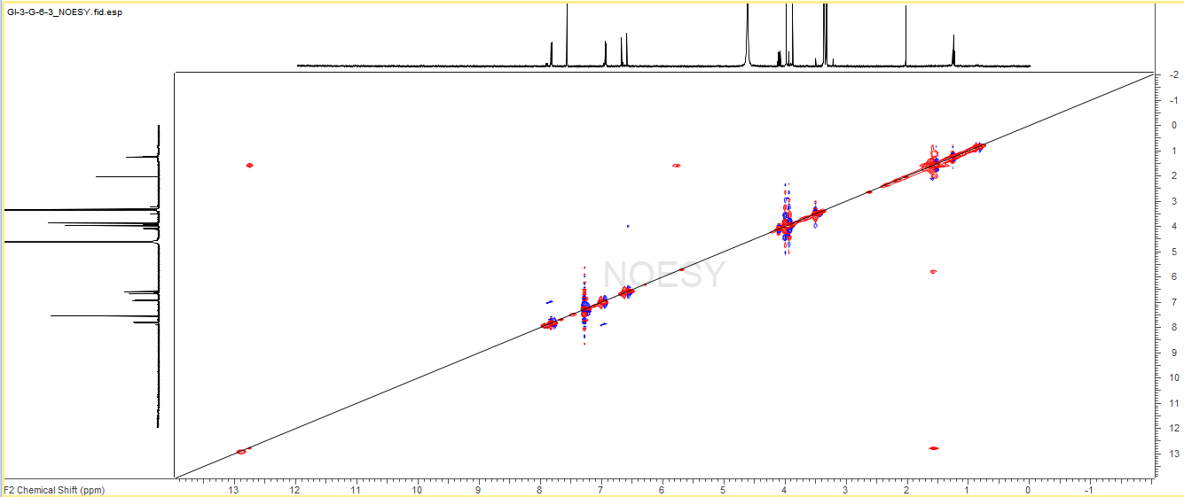

Mass Spectroscopy (Neg MS)
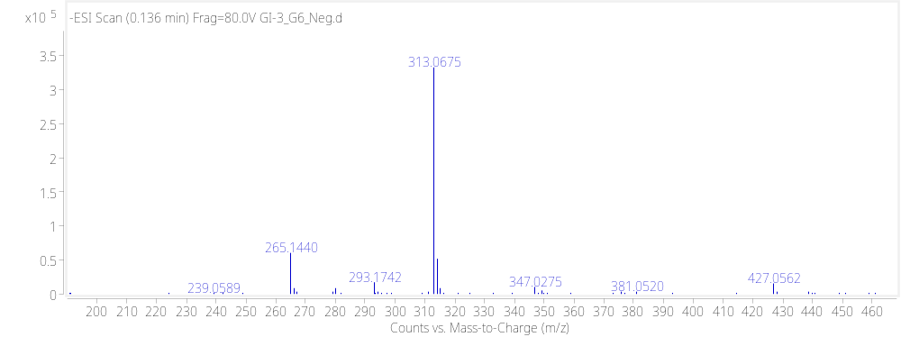
Mass Spectroscopy (Pos MS)
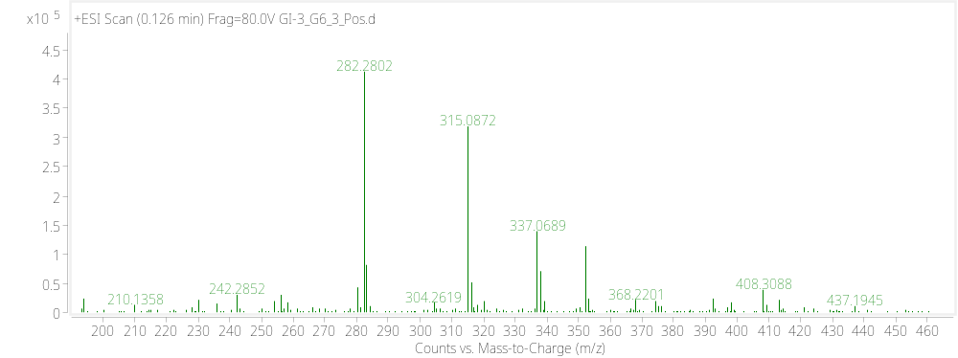

ANALYSIS

STRUCTURE OF CIRSIMARITIN
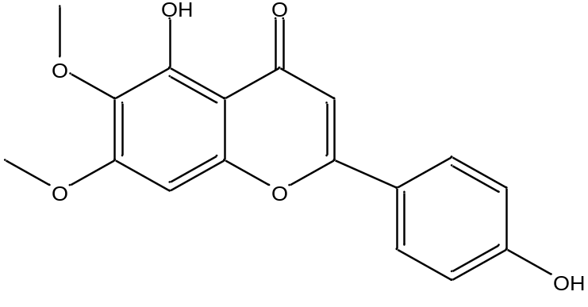

GI-1
Extract 1 was obtained from the hexane ethyl acetate (80:20) and an IC50 of 6.69ug/ml. A strong biological activity against P. falciparum Dd2. It was also subjected to the sequence of fractionation and further analysis led to the dereplication of four known flavonoids.
The sequence of fractionation from MPLC (Fig2.0), HPLC and Proton NMR aided in the identification of these pure compounds. Fractions were prioritized based on their bioactivity Fig.2.1. The table below indicates the prevalence of fraction GI-1E as being bioactive against Antitrypanosomal and Antiplasmodial pathogens.
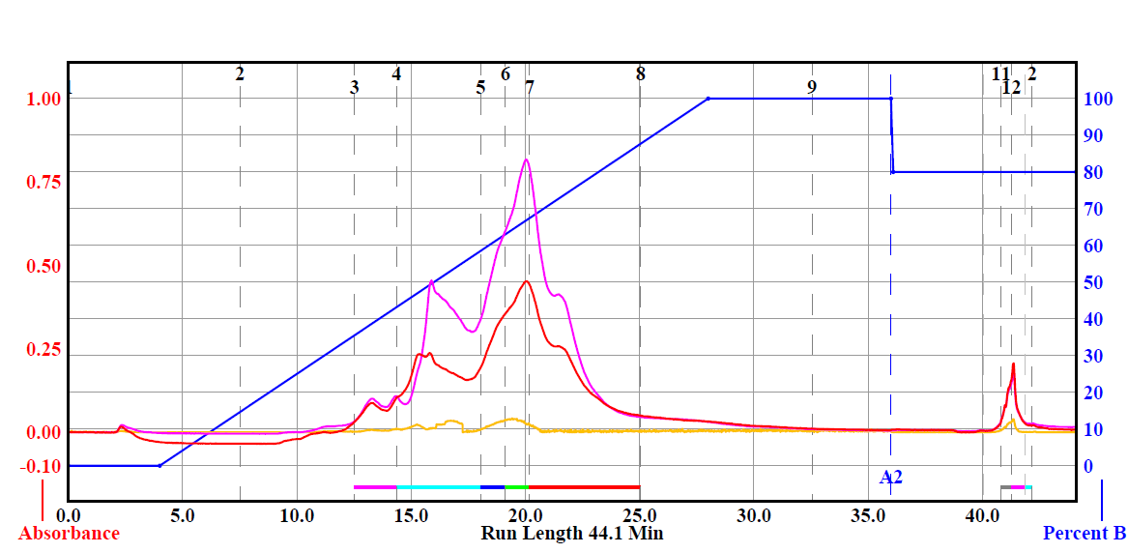
Fig.2.0 Medium Pressure Liquid Chromatography (MPLC) of GI-1
The fraction E OR 5 (Retention Time: 19-20mins) showed a sharp UV peak known to have some conjugated chromophores in the extract.

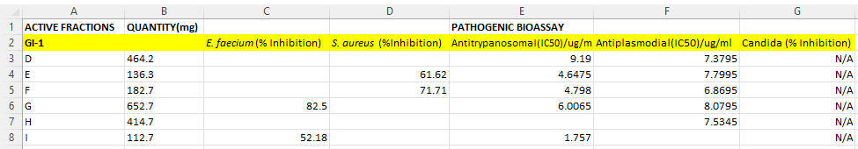
Fig.2.1 Bioassay results for GI-1 sample
Its Proton NMR as shown in Fig.2.2 has many peaks with many chemical shifts ranging from aliphatic alkyl groups to aromatic groups.

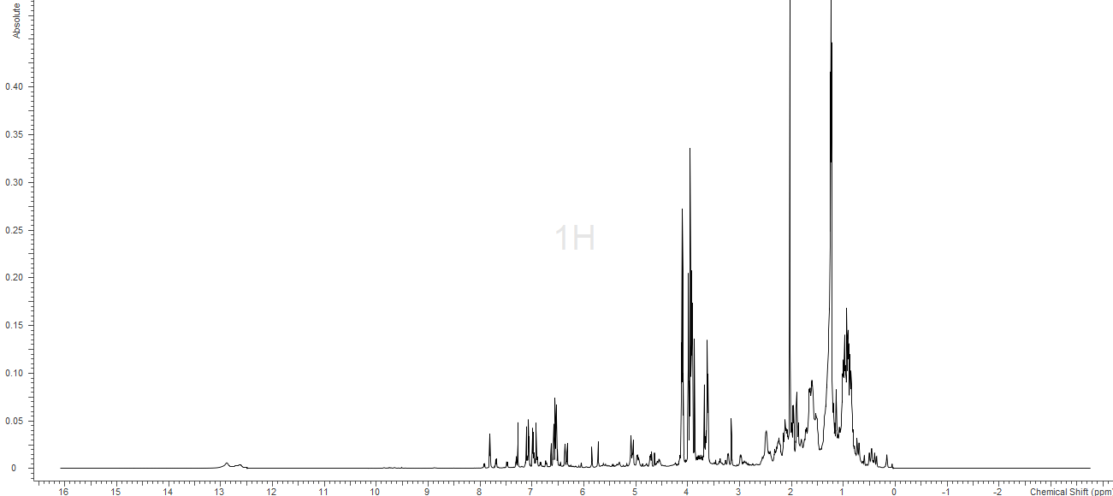
Fig.2.2 1H NMR of GI-1E
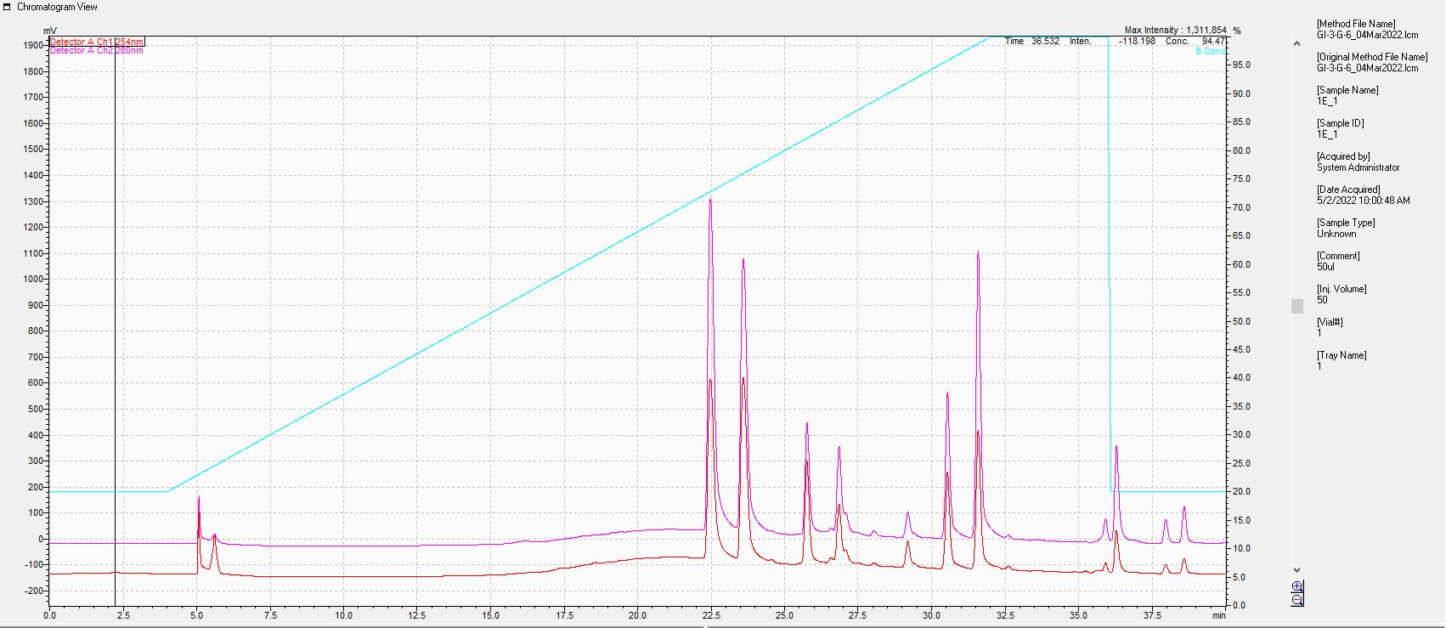
1-3
4
5
6
7
8
9
10
11-15
Fig.2.3 High Pressure Liquid Chromatography of GI-1E

FULL DATA SET FOR GI-1E-4
1H NMR (Proton NMR)
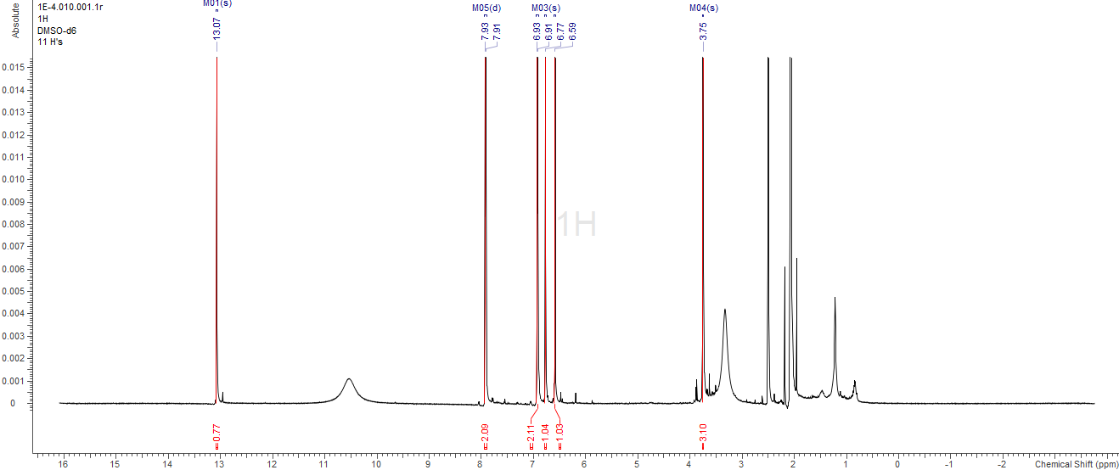

COSY (Correlation Spectroscopy)
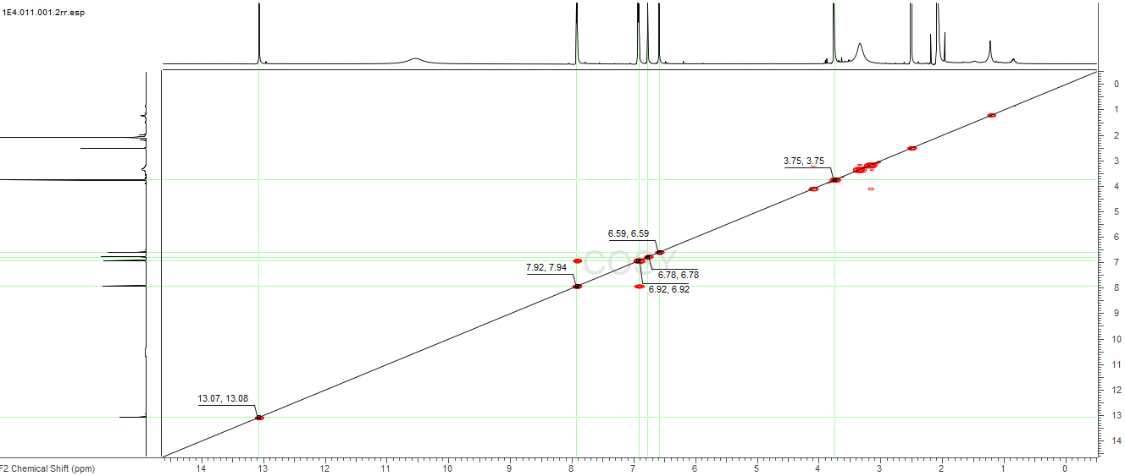

Mass Spectroscopy (PosMS)
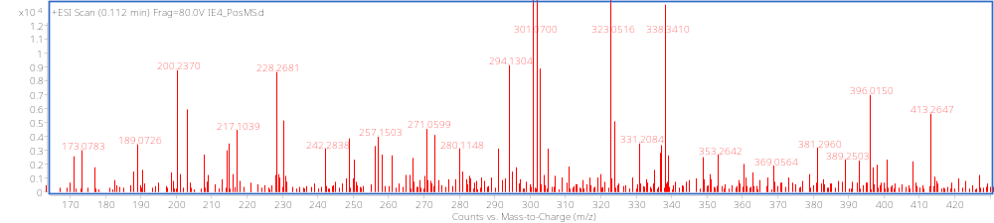

Mass Spectroscopy (NegMS)
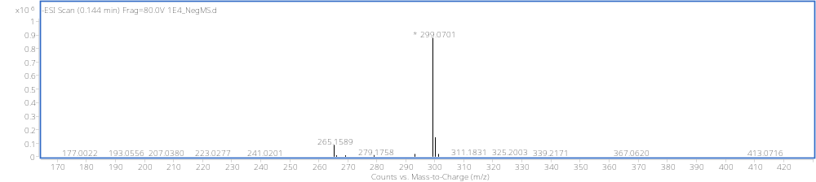

HSQC (Heteronuclear Single Quantum Coherence)
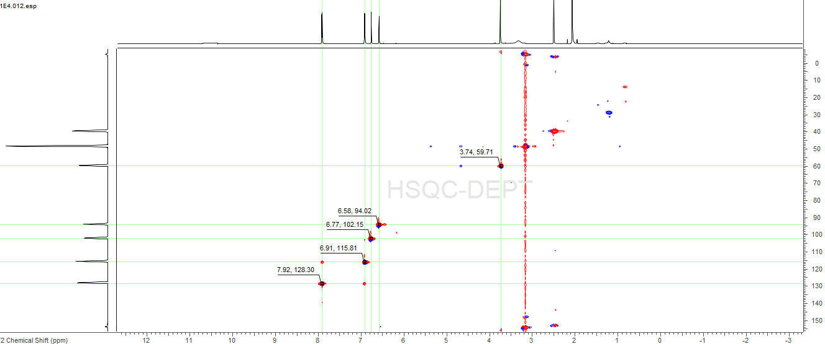

Carbon 13 Spectroscopy
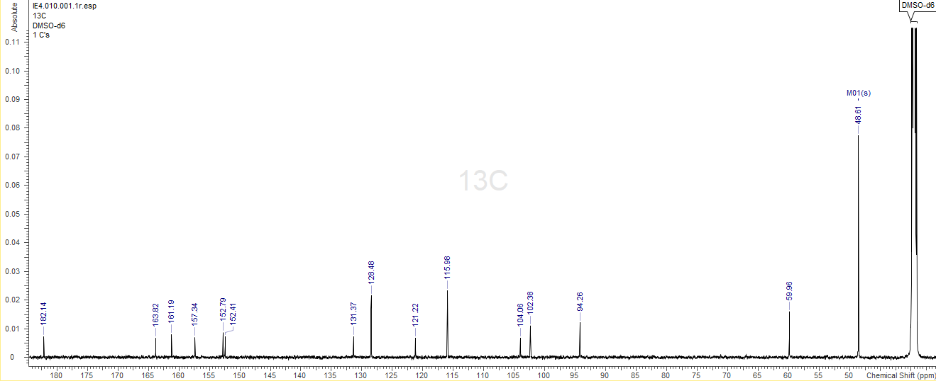

HMBC (Heteronuclear Multiple Bond Correlation)
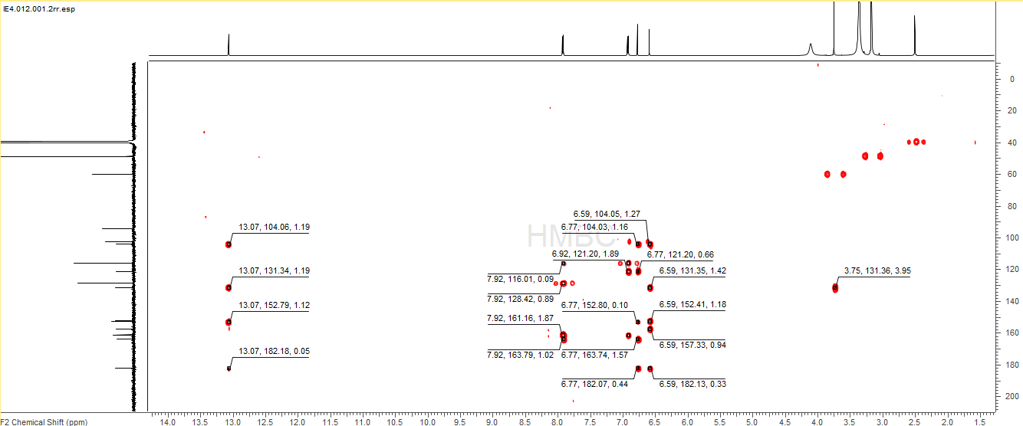

LITERATURE
Table 13C and 1H NMR spectral data for Hispidulin and Sample(1E4) in DMSO D6

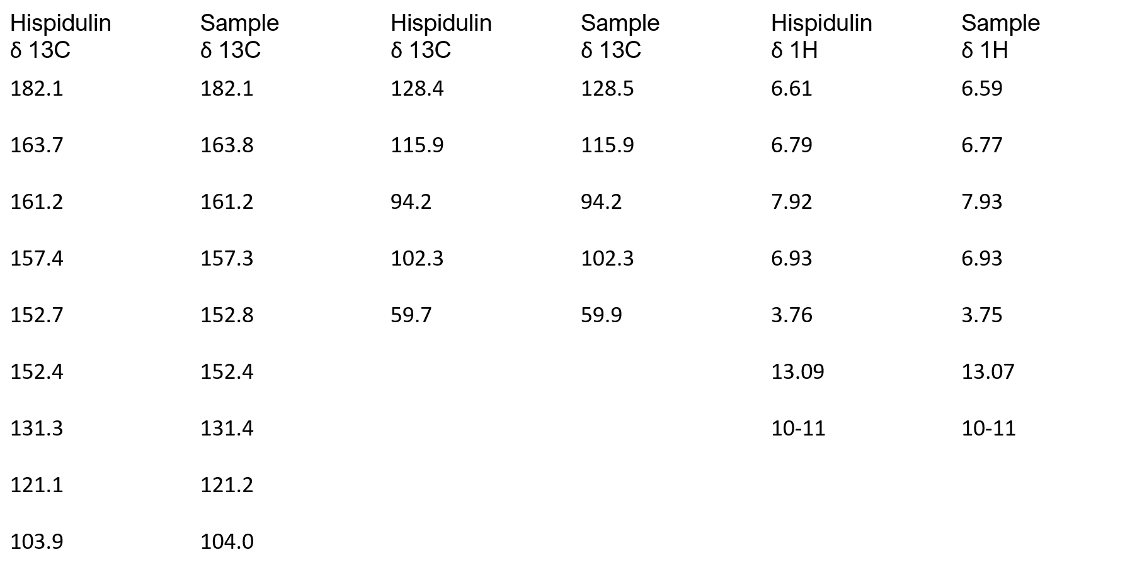

ANALYSIS
# | C Shift | H Label | H Shift | H Multiplicity | H Count | HMBC | PosMS | NegMS
A | 182.144 |  |  |  |  |  | M+H:301.07 | M-H:299.0701
B | 163.821 |  |  |  |  |  | M+Na:323.052
C | 161.192
D | 157.341 |  |  |  |  |  | M:300.062
E | 152.789
F | 152.413
G | 131.374
H | 128.484 | 2 | 7.92 | m | 2 | H,B,C,J
I | 121.223
J | 115.978 | 3 | 6.92 | d (8.90) | 2 | J,I,C
K | 104.057
L | 102.381 | 4 | 6.774 | s | 1 | K,I,F,B,A
M | 94.26 | 5 | 6.589 | s | 1 | K,G,D,A,E
N | 59.956 | 6 | 3.746 | s | 3 | G
O | 48.613
 |  | 1 | 13.071 | s | 1 | K,G,E,A
 |  | 7 | 10-11 | br,s

PROPOSED STRUCTURE
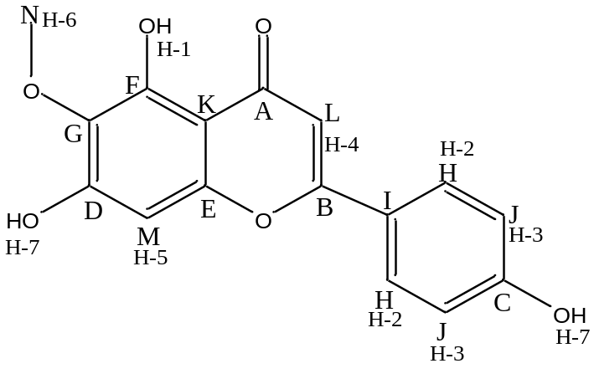
Fig. Structure of Hispidulin

FULL DATA SET FOR GI-1E-5
1H NMR (Proton Nuclear Magnetic Resonance)
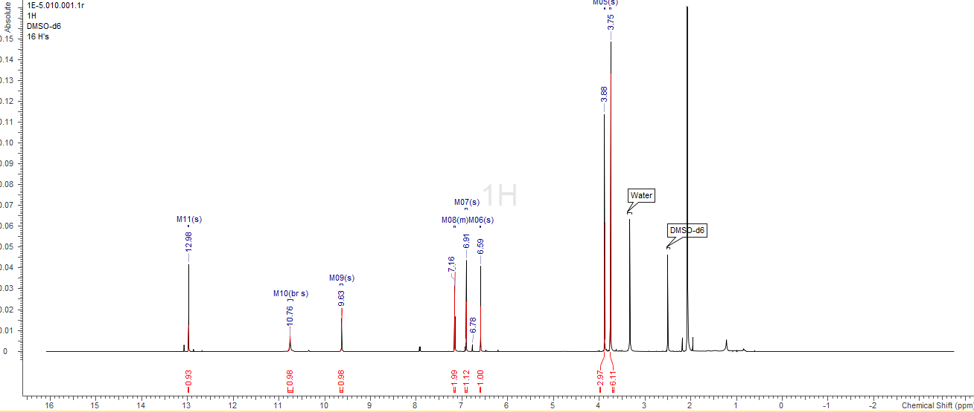

COSY(Correlation Spectroscopy)
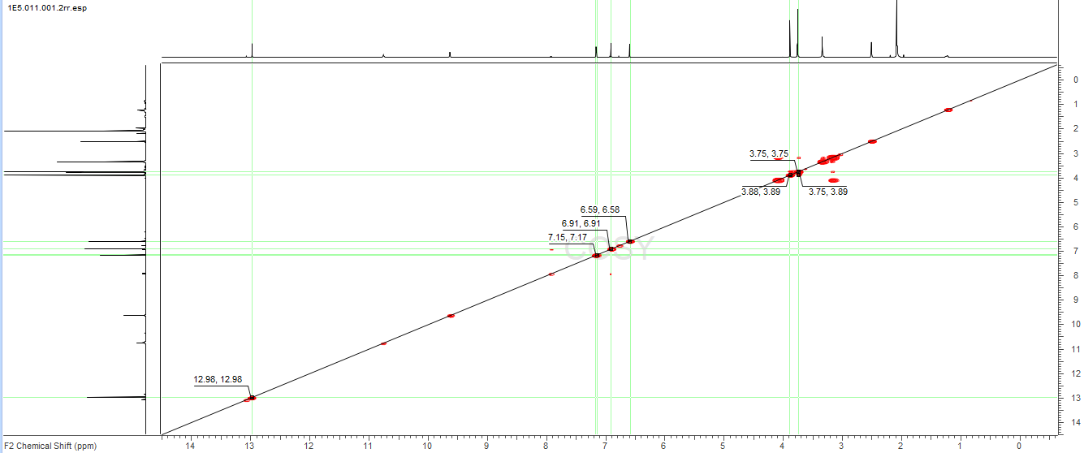

HSQC (Heteronuclear Single Quantum Coherence)
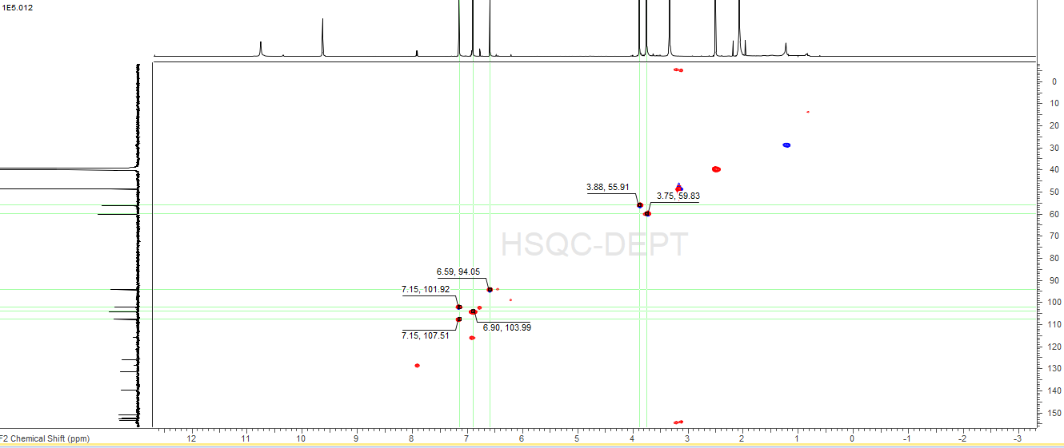

Carbon 13 Spectroscopy
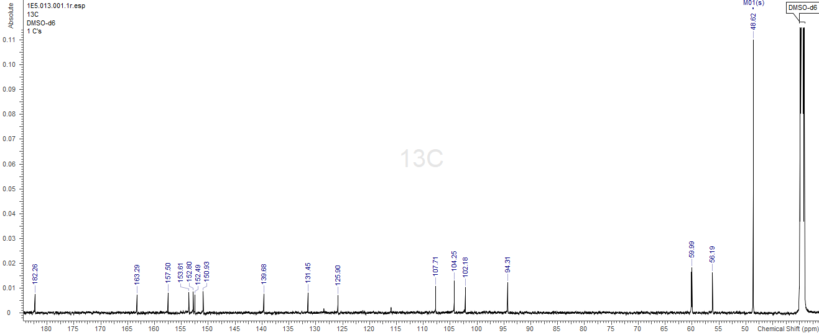

HMBC (Heteronuclear Multiple Bond Correlation)
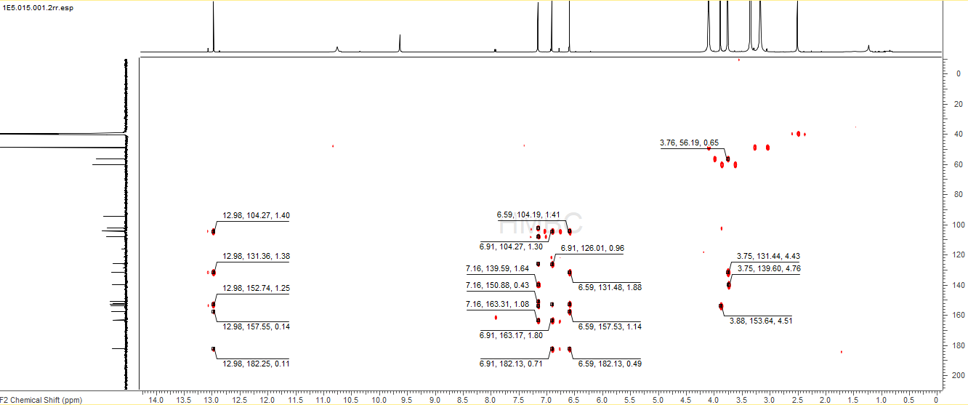

Mass Spectroscopy (PosMS)
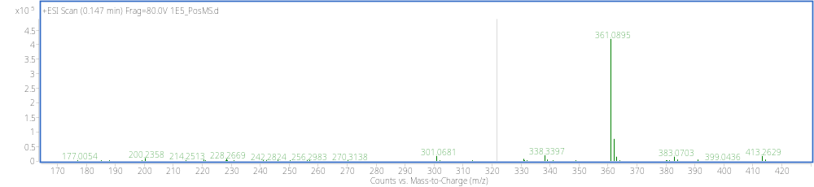

Mass Spectroscopy (NegMS)
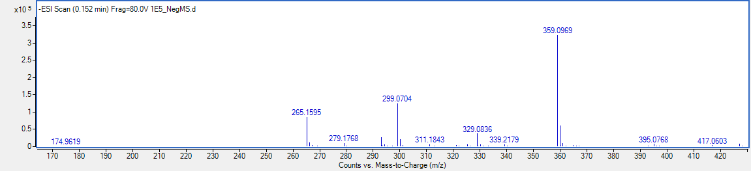

ANALYSIS
# | C Shift | # | H Shift | H Multiplicity | H Count | HMBC | PosMS | NegMS
A | 182.259 |  |  |  |  |  | M+H: 361.09 | M-H: 359.0969
B | 163.294 |  |  |  |  |  | M+Na: 383.071
C | 157.5
D | 153.605 |  |  |  |  |  | M: 360.082
E | 152.796
F | 152.493
G | 150.932
H | 139.683
I | 131.454
J | 125.898
K | 107.706 | 4 | 7.156 | d (1.45) | 2 | J,H,G,B,A
L | 104.252 | 5 | 6.908 | s | 1 | J,E,B,A
M | 102.179
N | 94.311 | 6 | 6.593 | s | 1 | I,F,C,A
O | 59.993 | 8 | 3.751 | d (3.63) | 7 | P,I,H,D
P | 56.192 | 7 | 3.881 | s | 3 | D
Q | 48.621
 |  | 1 | 12.975 | s | 1 | L,I,DC,A
 |  | 2 | 10.755 | br s | 1
 |  | 3 | 9.633 | s | 1

PROPOSED STRUCTURE
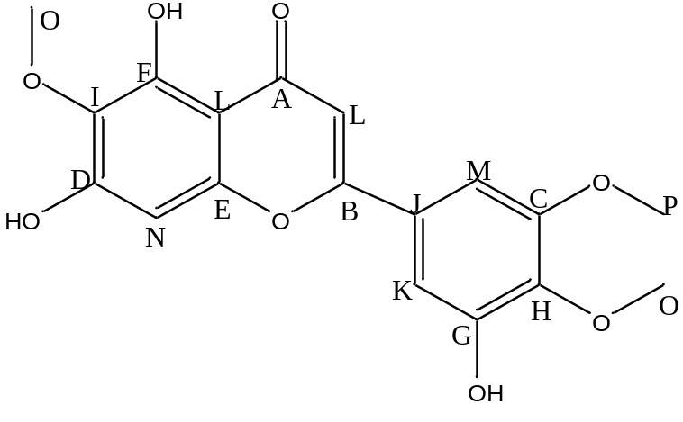
Fig. Structure of 5,7,3'-Trihydroxy-6,4',5'-trimethoxyflavone
FULL DATA FOR GI-1E-9
1H NMR (Proton Nuclear Magnetic Resonance)
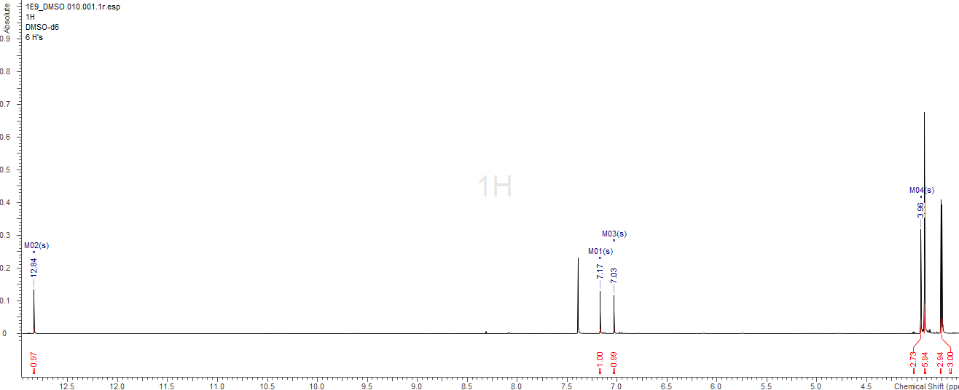

COSY (Correlation Spectroscopy)
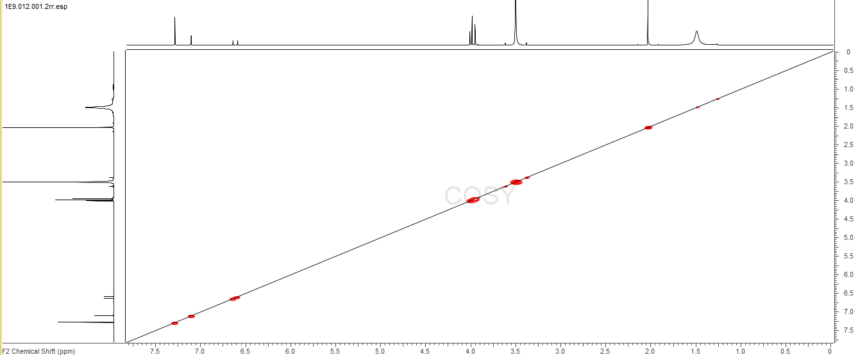

HSQC (Heteronuclear Single Quantum Coherence)
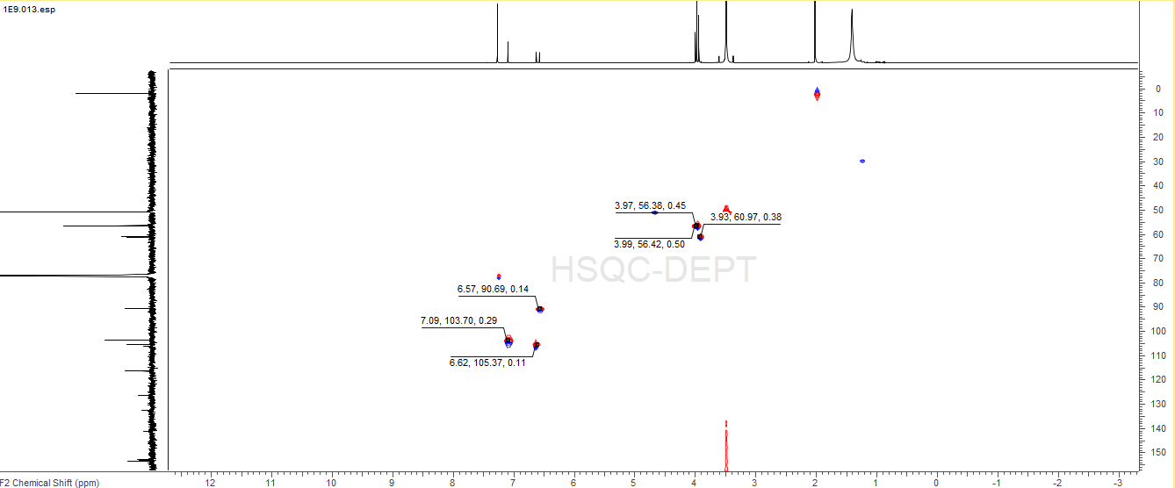

HMBC (Heteronuclear Multiple Bond Correlation)
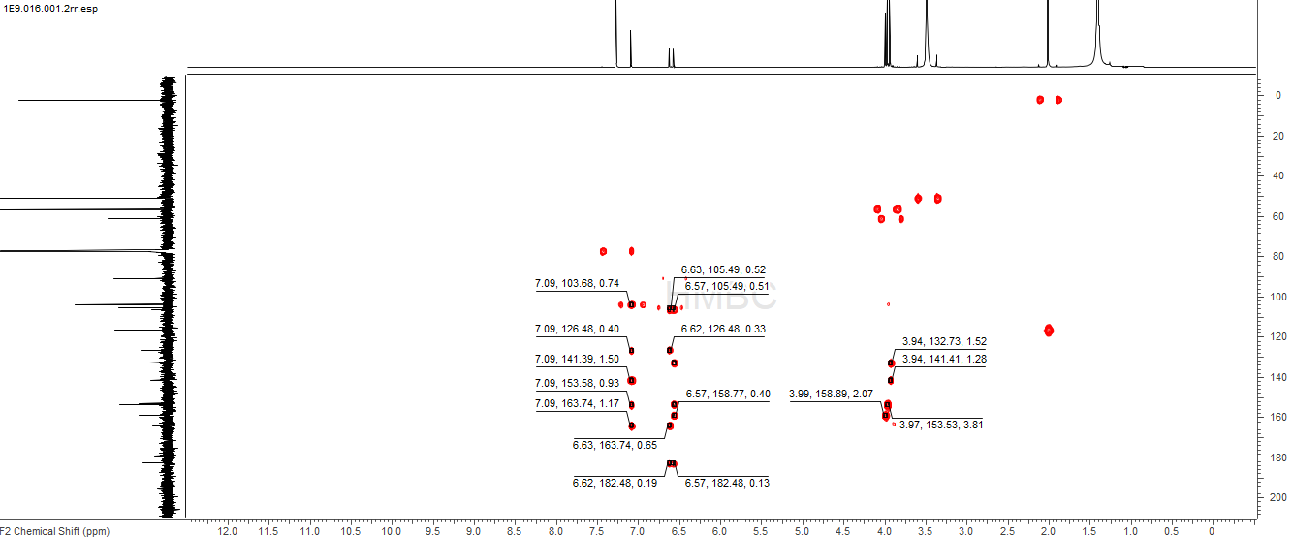

Carbon 13 Spectroscopy
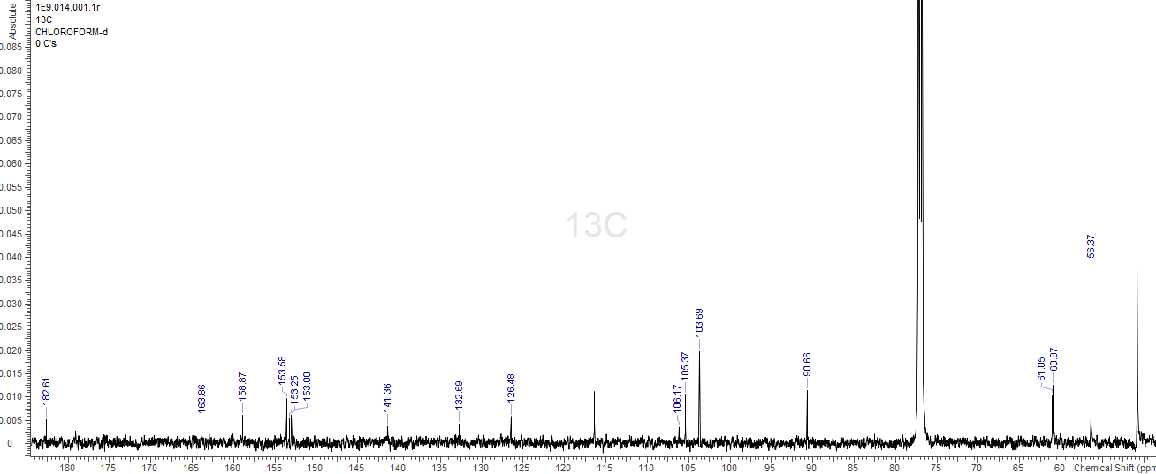

Mass Spectroscopy (PosMS)
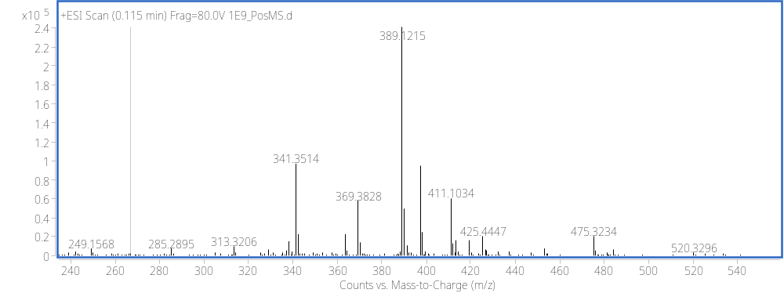

Mass Spectroscopy (NegMS)
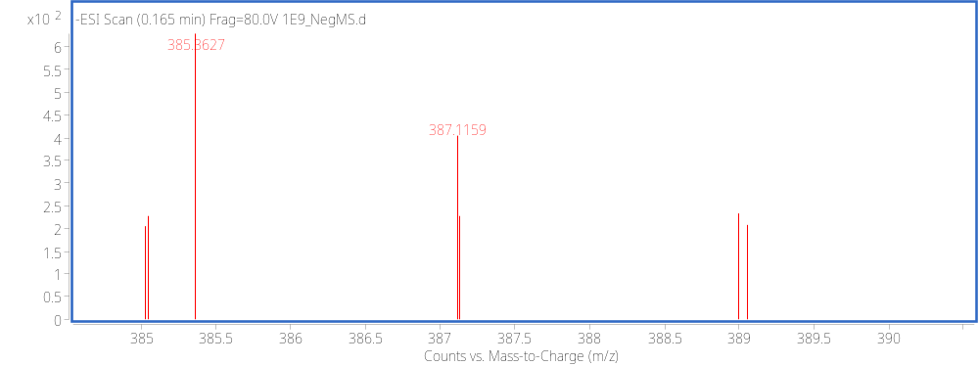

ANALYSIS
# | C Shift | # | H Shift | H Multiplicity | H Count | HMBC |  | PosMS | NegMS
A | 182.606 |  |  |  |  |  |  | M+H:389.1215 | M-H:387.1159
B | 163.85 |  |  |  |  |  |  | M+Na:411.1035
C | 158.872
D | 153.569 |  |  |  |  |  |  | M: 388.1137
E | 152.998
F | 141.359
G | 132.689
H | 126.483
I | 116.397
J | 106.167
K | 105.372 | 3 | 6.624 | s | 1 |  | H,B,A
L | 103.681 | 1 | 7.091 | s | 2 |  | H,F,D,B
M | 90.662 | 4 | 6.572 | s | 1 |  | K,G,C,A
N | 61.055 | 2 | 3.935 | d (0.91) | 6 |  | G,F
O | 60.87
P | 56.366 | 5 | 3.968 | s | 6 |  | D
 |  | 6 | 3.992 | s | 3 |  | C

PROPOSED STRUCTURE

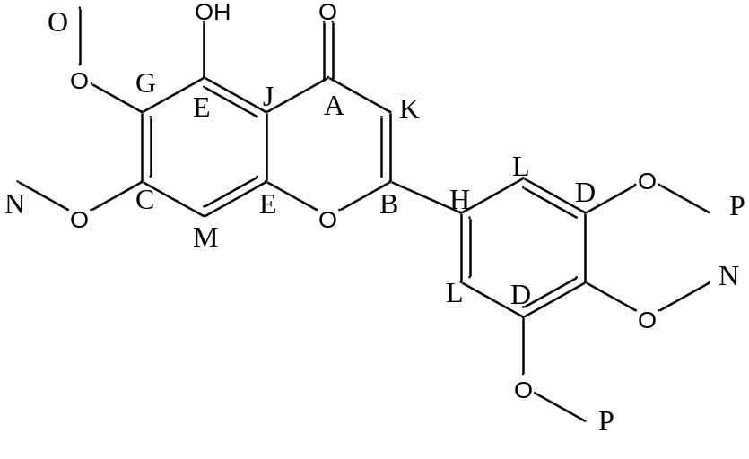
Fig. Structure of Gradenin A

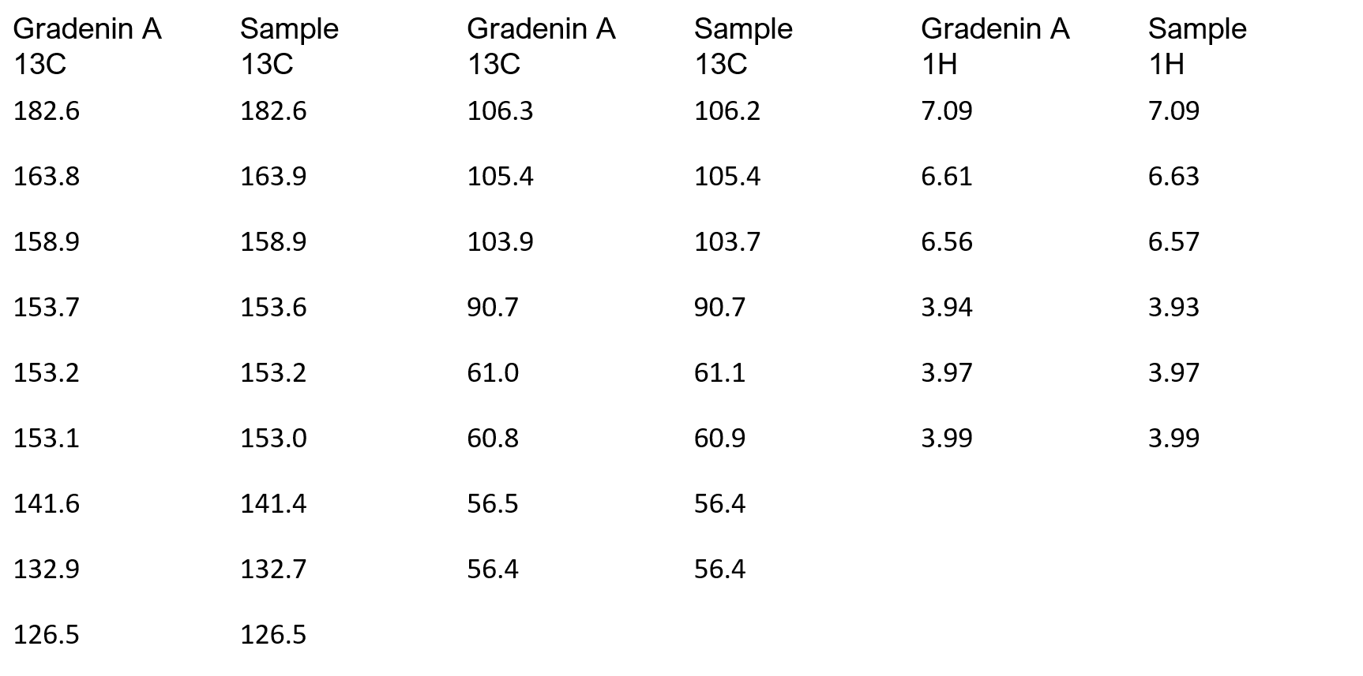
LITERATURE
Table I. 13C and 1H NMR spectral data for Gradenin A and Sample(1E9) in CDCl3

FULL DATA SET FOR GI-1E-10
1H NMR (Proton Nuclear Magnetic Resonance)
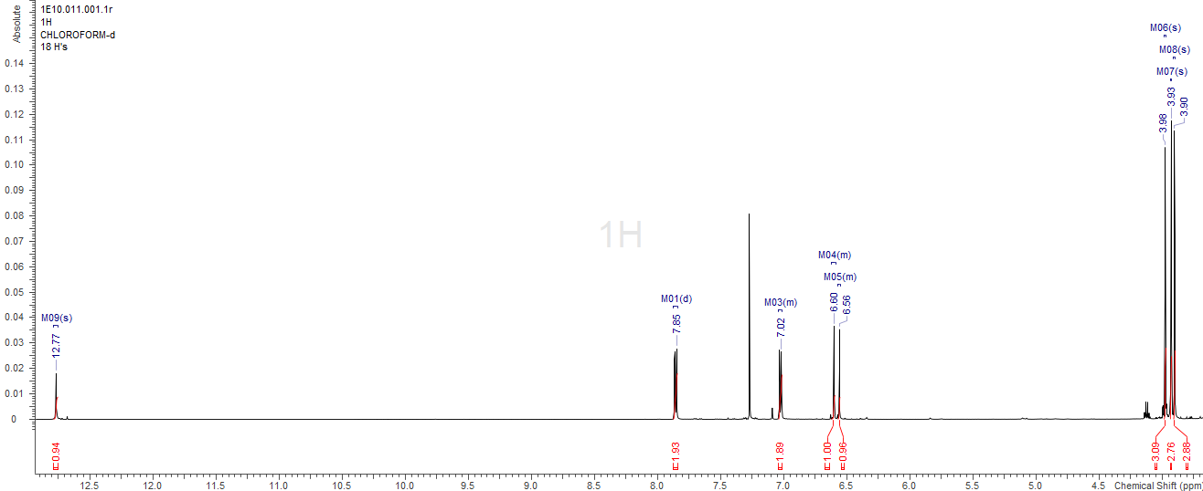

COSY (Correlation Spectroscopy)
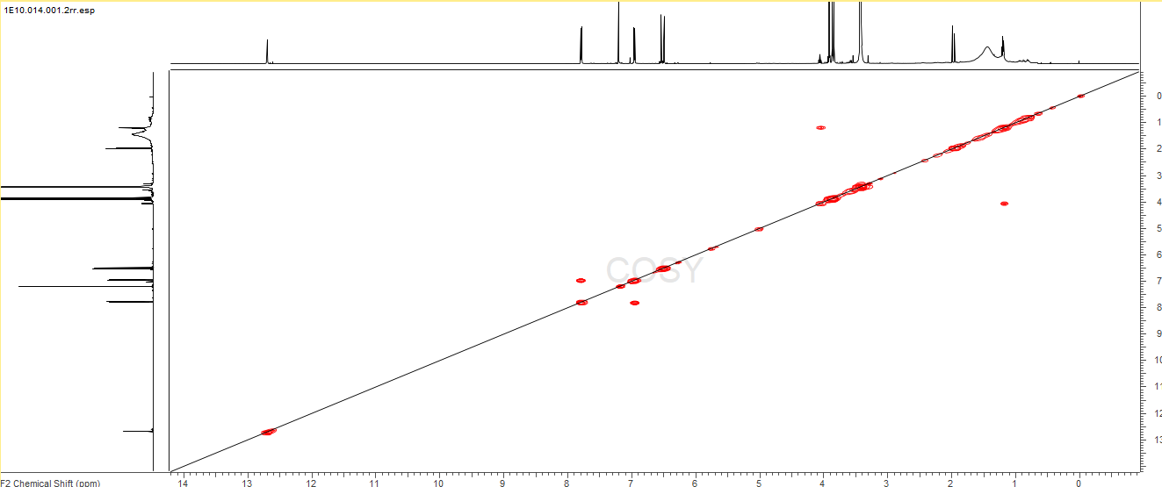

HSQC (Heteronuclear Single Quantum Coherence)
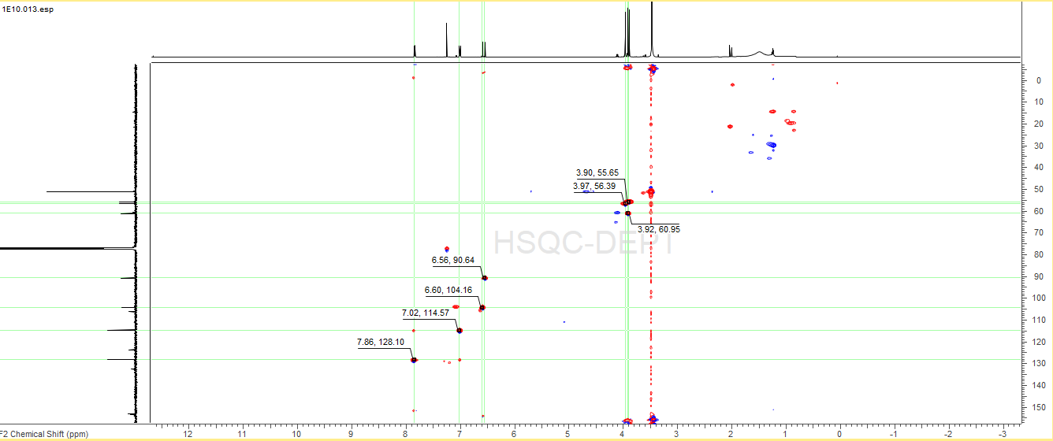

HMBC (Heteronuclear Multiple Bond Correlation)
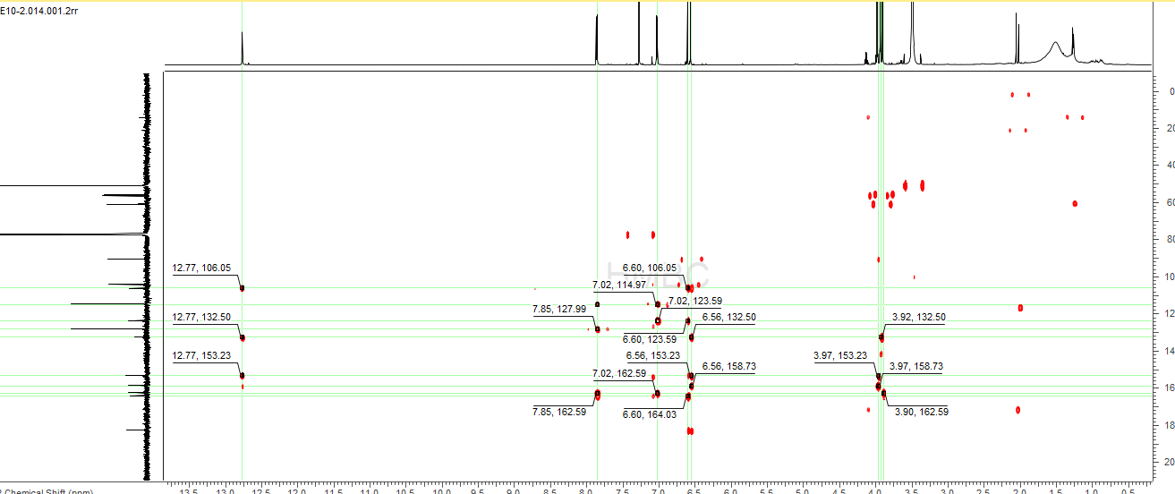

Carbon 13 Spectroscopy
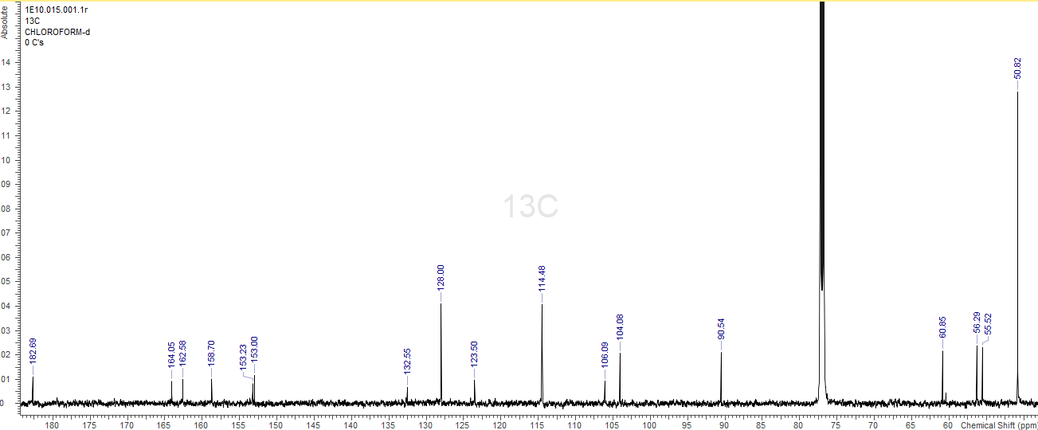

Mass Spectroscopy (PosMS)
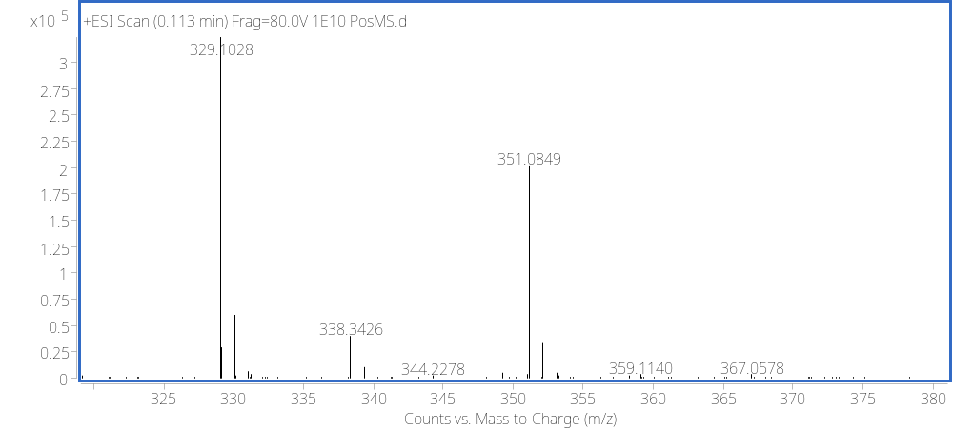

Mass Spectroscopy (NegMS)
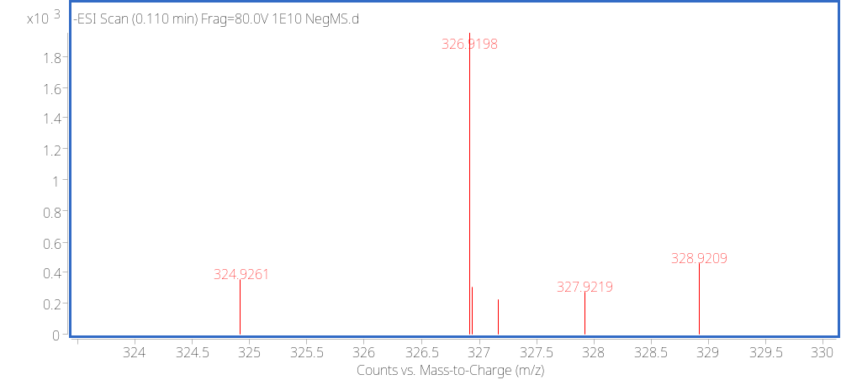

ANALYSIS
# | C Shift | # | H Shift | H Multiplicity | H Count | HMBC | PosMS | NegMS
A | 182.693 |  |  |  |  |  | M+H: 329.103 | M-H: 327.9219
B | 164.045 |  |  |  |  |  | M+Na:351.085
C | 162.579
D | 158.699 |  |  |  |  |  | M: 328.095
E | 153.23
F | 152.999
G | 132.552
H | 128
I | 123.499 | 2 | 7.857 | d (8.90) | 2 | H,C,J
J | 114.483 | 3 | 7.025 | d (8.90) | 2 | I,C
K | 106.087
L | 104.079 | 4 | 6.602 | s | 1 | I,B,A,E
M | 90.539 | 5 | 6.558 | s | 1 | K,G,E,D,A
N | 60.852 | 7 | 3.915 | m | 3 | G
O | 56.286 | 6 | 3.975 | s | 3 | D
P | 55.52 | 8 | 3.9 | s | 3 | C
Q | 50.817
 |  | 1 | 12.767 | s | 1 | K,G,E

PROPOSED STRUCTURE
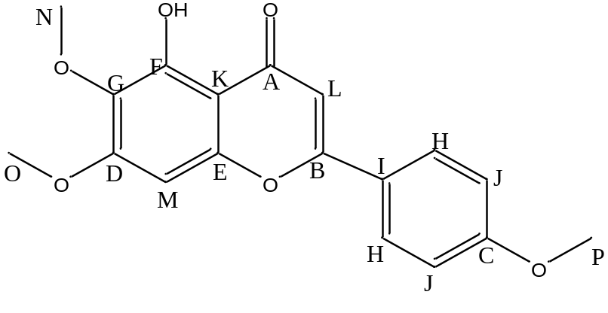
Fig. Structure of Salvigenin

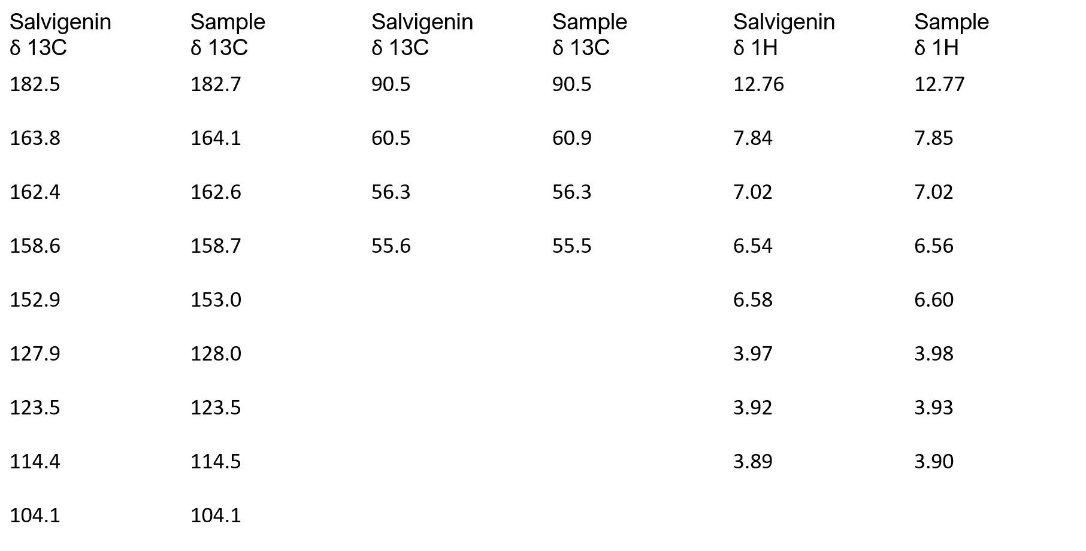
LITERATURE
Table II. 13C and 1H NMR spectral data for Salvigenin and Sample(1E10) in CDCl3

RESULTS AND DISCUSSION
Spectral data obtained from research lab as compared to literature confirms the flavonoids. These dereplicated compounds were confirmed by acquiring the full data set i.e., Global Natural Product Social dereplicator, SMART NMR, 2D NMR and mass spectrometry. The compounds which are Gradenin A, Hispidulin, 5,7,3'-Trihydroxy-6,4',5'-trimethoxyflavone and Salvigenin are known flavonoids that have great bioactivity against certain pathogens. Gradenin A shows activity against Salmonella typhimurium, Hispidulin has antifungal, antimutagenic, antioxidant, anti-inflammatory and antineoplastic properties (Patel & Patel, 2016) These different methoxy groups are responsible for different chemical properties and biological activities on each compound.

REFERENCE
1. Core E. Flora A Flora of The Queen Charlotte Islands. Part 1. Systematics Of the Vascular Plants J. A. Calder R. L. Taylor A Flora of The Queen Charlotte Islands. Part 2. Cytological Aspects of Vascular Plants R. L. Taylor G. A. Mulligan. BioScience 1969, 19 (10), 941-942.
2. Miller J, Sotheeswaran S Bud Exudate Composition And Ecogeography Of Fijian Gardenia Species (Rubiaceae). Biotropica.1993, 25 (1): 117.
3. Fact sheet about malaria. https://www.who.int/news-room/fact-sheets/detail/malaria (accessed Mar 14, 2022).
4. Patel K, Patel DK. Medicinal importance, pharmacological activities, and analytical aspects of hispidulin: A concise report. Journal of Traditional and Complementary Medicine. 2016; 7(3):360-366. Available at: https://doi.org/10.1016/j.jtcme.2016.11.003.
5. Jassbi AR et al. Antibacterial diterpenoids from astragalus brachystachys,” Zeitschrift für Naturforschung C. 2002; 57(11-12): 1016-1021. Available at: https://doi.org/10.1515/znc-2002-11-1211.
6. Rwangabo PC et al. Umuhengerin, a new antimicrobially active flavonoid from Lantana trifolia. Journal of Natural Products. 1988; 51(5):966-968. Available at: https://doi.org/10.1021/np50059a026.
7. World Journal of Pharmaceutical Research et al.. SJIF impact factor 5. ... (no date). Available at: https://www.researchgate.net/profile/Malik-Mohamed/publication/292326663_ANTIBACTERIAL_EFFECT_AND_RADICAL_SCAVENGING_ACTIVITY_OF_HISPIDULIN_AND_NEPETIN_A_TWO_FLVAONES_FROM_TARCONANTHUS_CAMPHORATUS_L/links/56ad160708ae19a385140879/ANTIBACTERIAL-EFFECT-AND-RADICAL-SCAVENGING-ACTIVITY-OF-HISPIDULIN-AND-NEPETIN-A-TWO-FLVAONES-FROM-TARCONANTHUS-CAMPHORATUS-L.pdf (Accessed: November 28, 2022).
8. Jalmakhanbetova RI et al. Isolation and in silico anti-covid-19 main protease (mpro) activities of flavonoids and a sesquiterpene lactone from Artemisia sublessingiana. Journal of Chemistry. 2021:1-8. Available at: https://doi.org/10.1155/2021/5547013.

