Supplementary Figures and Tables
Astrocytes in the external globus pallidus coordinate flexibility of action strategy

Sa-Ik Hong¹, Seungwoo Kang¹, Minryung Song², Minsu Abel Yang², Matthew Baker¹, Shinwoo Kang¹, Jeyeon Lee⁶, Sang Wan Lee^{2,3,4,5}, and Doo-Sup Choi^{1,7,8}

¹Department of Molecular Pharmacology and Experimental Therapeutics, Mayo Clinic, Rochester, Minnesota 55905. ²Department of Bio and Brain Engineering, ³Program of Brain and Cognitive Engineering, ⁴Korea Advanced Institute of Science and Technology (KAIST) for Health Science Technology, ⁵KAIST for Artificial Intelligence, KAIST, Daejeon, 34141, Republic of Korea. ⁶Department of Radiology, ⁷Department of Psychiatry and Psychology, ⁸Neuroscience Program, Mayo Clinic College of Medicine and Science, Rochester, Minnesota 55905.

Correspondence and request for materials should be addressed to Doo-Sup Choi, Ph.D., Department of Molecular Pharmacology and Experimental Therapeutics, Mayo Clinic College of Medicine and Science, 200 First Street SW, Rochester, Minnesota 55905, USA
Phone: (507) 284-5602 Fax: (507) 266-0824 Email: choids@mayo.edu

Keywords: external globus pallidus, astrocyte, goal-directed behavior, habit, reward-seeking behavior

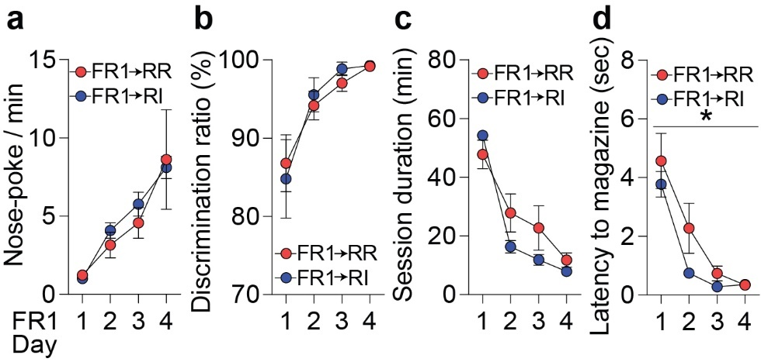
Supplementary Figure 1. Well-established and similar reward-seeking behaviors in the FR1-RR and -RI groups. Similar (a) nose-poking behavior, (b) discrimination ratio, (c) session duration, and (d) latency to magazine during the FR1 task in mice before training with either the RR or RI task. Four sessions of the FR1 task reduced latency time from nose-poke to magazine. Data represented mean ± SEM; a-d, n = 8/RR group, 7/RI group. *p < 0.05 comparing between 1st and 4th sessions. a-d, two-way repeated measures ANOVA followed by Bonferroni’s multiple comparisons tests.

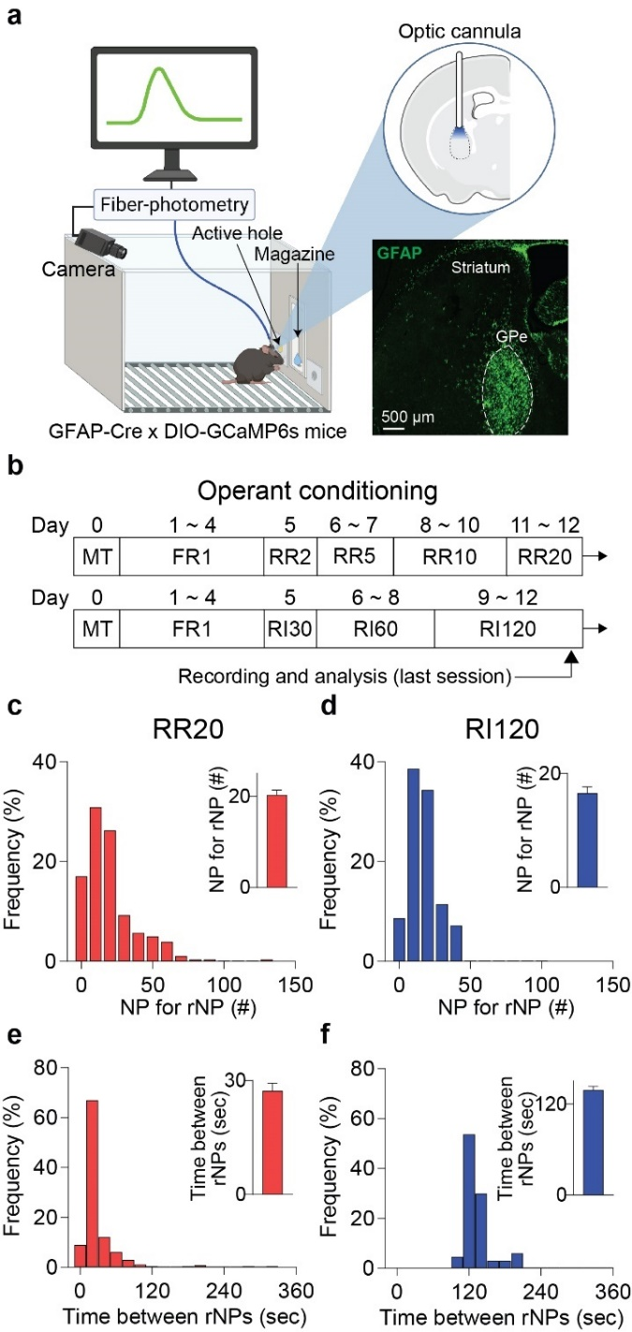
Supplementary Figure 2. Behavioral performances in the RR20 and RI120 tasks.
a, Experimental scheme for operant conditioning with fiber-photometry and GFAP expressions in the GPe. b, Schedules for operant conditioning and in vivo calcium imaging. Frequency distributions of the number of nose-poke for one rewarded nose-poke in the (c) RR20 and (d) RI120 tasks. Frequency distributions of time between two rewarded nose-pokes in the (e) RR20 and (f) RI120 tasks. Bin width was (c, d) 10 nose-pokes or (e, f) 20 sec. Data represented mean ± SEM; n = 282/RR group, 66/RI group. NP, nose-poke; RI, random interval; rNP, rewarded nose-poke RR, random ratio.

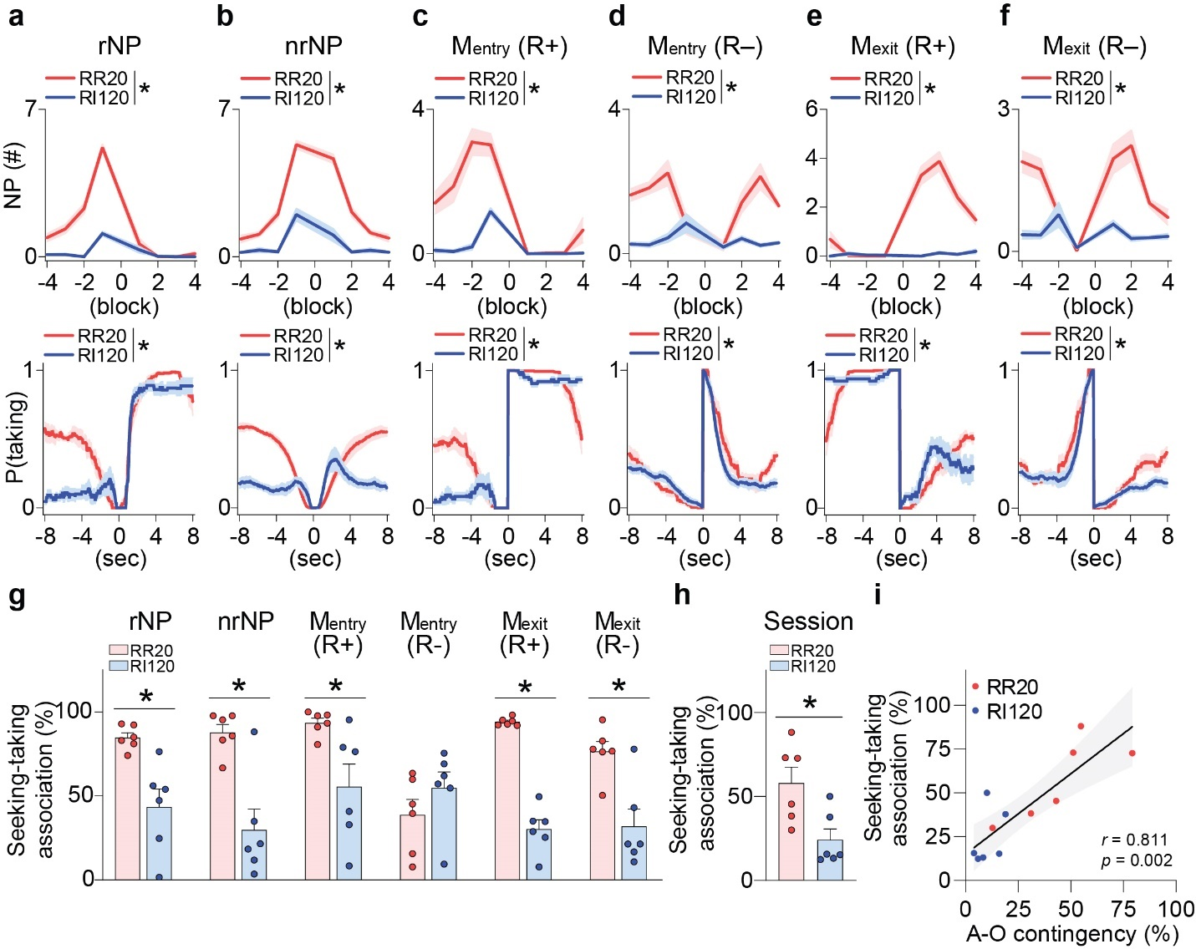
Supplementary Figure 3. Loosen A-O contingency resulted in disassociation between reward-seeking and -taking behaviors. Nose-poke rates (top) in the (a) rNP, (b) nrNP, (c) M_{entry} with reward, (d) M_{entry} without reward, (e) M_{exit} with reward, and (f) M_{exit} without reward. Probability of reward-taking behavior [P(taking)] (bottom) in the (a) rNP, (b) nrNP, (c) M_{entry} with reward, (d) M_{entry} without reward, (e) M_{exit} with reward, and (f) M_{exit} without reward. A bin was created with 2 seconds as one block. Comparison of seeking-taking association between the RR and RI tasks in (g) 6 behavior events and (h) total session. i, Correlation between A-O contingency and seeking-taking association. Data represented mean ± SEM; n = 6/group. *p < 0.05 comparing each group. a-f, Two-way repeated measures ANOVA followed by Bonferroni’s multiple comparisons tests; g and h, two-tailed Mann-Whitney test; i, Spearman correlation analysis. DV, devalued; M_{entry}, magazine entry; MT, magazine training; M_{exit}, magazine exit; nrNP, non-rewarded nose-poke; RI, random interval; rNP, rewarded nose-poke; RR, random ratio.
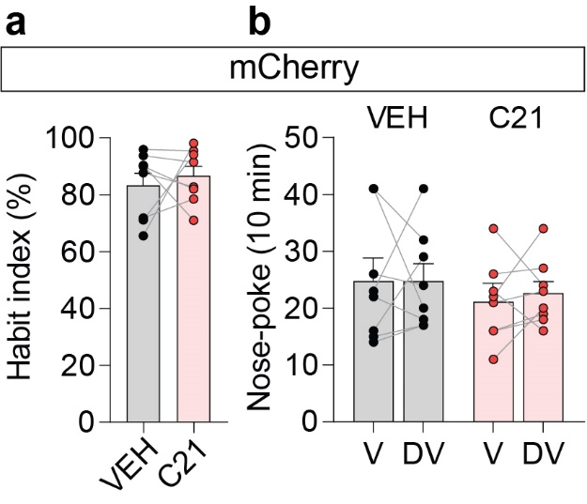
Supplementary Figure 4. No change in habit of the mCherry group after habit learning. a, Habit index of mCherry groups treated with vehicle (VEH) or compound 21 (3 mg/kg, i.p.; C21) after the random interval (RI) task. b, Nose-poking behaviors of the valued and devalued states after the RI task in mCherry group. Data represented mean ± SEM; n = 8/group. *p < 0.05 comparing each group. Two-tailed Wilcoxon matched-pairs signed rank test. C21, compound 21; DV, devalued; V, valued; VEH, vehicle.

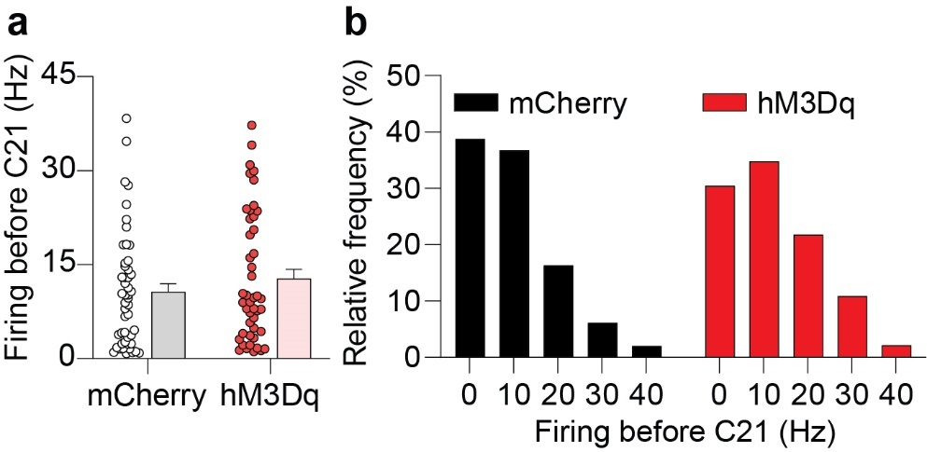
Supplementary Figure 5. No difference of firings between the mCherry and hM3Dq groups. a, Neuronal firings before C21 treatment in the mCherry and hM3Dq groups. b, Relative frequency of neuronal firings before C21 treatment in the mCherry and hM3Dq groups. Data represented mean ± SEM; n = 49 from 5 mice/mCherry group, n = 46 from 5 mice/hM3Dq group. a, Two-tailed Mann-Whitney test. C21, compound 21.

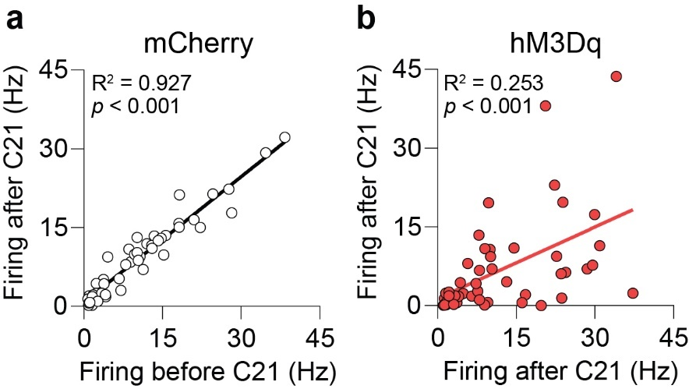
Supplementary Figure 6. Firings before and after C21 treatment in mCherry and hM3Dq groups. Spearman correlation analysis between firings before and after C21 treatment (3 mg/kg, i.p.) in the (a) mCherry and (b) hM3Dq groups. n = 49 from 5 mice/mCherry group, n = 46 from 5 mice/hM3Dq group. C21, compound 21.

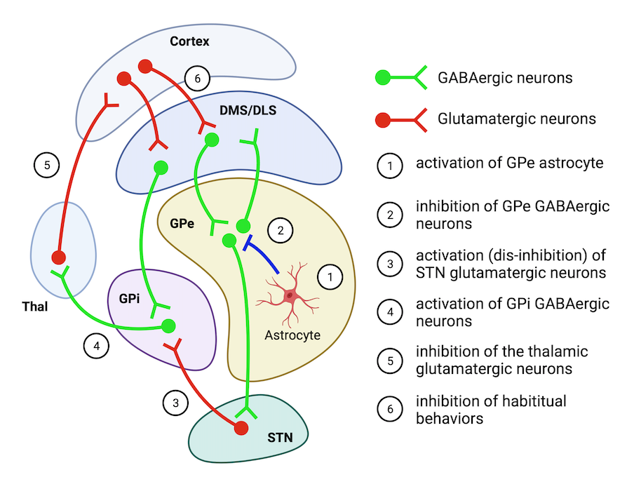

Supplementary Figure 7. Possible neural mechanisms underlying GPe astrocyte activation-induced dampens habitual reward-seeking behaviors. Activation of GPe astrocyte inhibits the inhibitory GABAergic neurons. Particularly, inhibition of downstream GABAergic inputs to the subthalamic nucleus (STN) may disinhibit STN glutamatergic innervation to the GPi, which will result in further inhibition of GPi GABAergic inputs to the thalamus (Thal) and/or counteract to the direct-pathway activation of medium spiny neurons (dMSNs). Reduced thalamic glutamatergic inputs to the cortex (presumably sensory-motor cortex), may inhibit repetitive habitual behaviors.
Supplementary Table 1. SVM AUC results to predict behavioral task types across time windows of fiber-photometry data
Event | SVM Data input |  |  |  | AUC
Event | Before |  | After |  | AUC
Event | Start (s) | End (s) | Start (s) | End (s) | AUC
Nose-poke | -2 | 0 | 0 | 1.5 | 0.681 ± 0.002
Nose-poke | -2 | 0.1 | 0.1 | 1.6 | 0.687 ± 0.002
Nose-poke | -2 | 0 | 0 | 2 | 0.683 ± 0.002
Nose-poke | -1.5 | 0 | 0 | 1.5 | 0.676 ± 0.002
Nose-poke | -1 | 0 | 0 | 1 | 0.643 ± 0.002
Magazine entry | -4 | -2 | 0 | 2 | 0.660 ± 0.002
Magazine entry | -3.6 | -1.6 | 0 | 2 | 0.668 ± 0.002
Magazine entry | -3.2 | -1.2 | 0 | 2 | 0.665 ± 0.002
Magazine entry | -2.8 | -0.8 | 0 | 2 | 0.663 ± 0.002
Magazine entry | -2.4 | -0.4 | 0 | 2 | 0.676 ± 0.002
Magazine entry | -2 | 0 | 0 | 2 | 0.705 ± 0.002
Magazine entry | -2 | 0 | 0.2 | 2.2 | 0.700 ± 0.002
Magazine entry | -2 | 0 | 0.4 | 2.4 | 0.696 ± 0.002
Magazine entry | -2 | 0 | 0.6 | 2.6 | 0.703 ± 0.002
Magazine entry | -2 | 0 | 0.8 | 2.8 | 0.707 ± 0.002
Magazine entry | -2 | 0 | 1 | 3 | 0.709 ± 0.002
Magazine entry | -1.5 | 0 | 0 | 1.5 | 0.717 ± 0.002
Magazine entry | -1 | 0 | 0 | 1 | 0.726 ± 0.002
Magazine exit | -4 | -2 | 0 | 2 | 0.818 ± 0.001
Magazine exit | -3.6 | -1.6 | 0 | 2 | 0.816 ± 0.001
Magazine exit | -3.2 | -1.2 | 0 | 2 | 0.815 ± 0.001
Magazine exit | -2.8 | -0.8 | 0 | 2 | 0.811 ± 0.001
Magazine exit | -2.4 | -0.4 | 0 | 2 | 0.809 ± 0.001
Magazine exit | -2 | 0 | 0 | 2 | 0.808 ± 0.001
Magazine exit | -2 | 0 | 0.2 | 2.2 | 0.798 ± 0.001
Magazine exit | -2 | 0 | 0.4 | 2.4 | 0.782 ± 0.001
Magazine exit | -2 | 0 | 0.6 | 2.6 | 0.764 ± 0.001
Magazine exit | -2 | 0 | 0.8 | 2.8 | 0.747 ± 0.001
Magazine exit | -2 | 0 | 1 | 3 | 0.733 ± 0.002
Magazine exit | -1.5 | 0 | 0 | 1.5 | 0.841 ± 0.001
Magazine exit | -1 | 0 | 0 | 1 | 0.866 ± 0.001

Supplementary Table 2. Summary of statistical analysis
Figure | Statistical Tests | Comparison | Value | p value
Fig. 1d | Mann-Whitney test | RR vs. RI | U = 6 | p = 0.009
Fig. 1e | Wilcoxon test | RR; V vs. DV | W = -34 | p = 0.016
Fig. 1e | Wilcoxon test | RI; V vs. DV | W = 6 | p = 0.672
Fig. 1f | Spearman correlation | A-O contingency vs. Habit index | r = -0.600 | p = 0.020
Fig. 1f | Simple linear regression | A-O contingency vs. Habit index | R² = 0.246 | p = 0.060
Fig. 2b | Two-way RM ANOVA | rNP; Interaction | F(480,4800) = 1.725 | p < 0.001
Fig. 2b | Two-way RM ANOVA | rNP; Time | F(480,4800) = 8.770 | p < 0.001
Fig. 2b | Two-way RM ANOVA | rNP; Group | F(1,10) = 8.565 | p = 0.015
Fig. 2b | Two-way RM ANOVA | nrNP; Interaction | F(480,4800) = 1.548 | p < 0.001
Fig. 2b | Two-way RM ANOVA | nrNP; Time | F(480,4800) = 6.306 | p < 0.001
Fig. 2b | Two-way RM ANOVA | nrNP; Group | F(1,10) = 9.136 | p = 0.013
Fig. 2c | Wilcoxon test | rNP; RR;  Before vs. After | W = -15 | p = 0.156
Fig. 2c | Wilcoxon test | rNP; RI;  Before vs. After | W = -13 | p = 0.219
Fig. 2c | Wilcoxon test | nrNP; RR;  Before vs. After | W = -19 | p = 0.063
Fig. 2c | Wilcoxon test | nrNP; RI;  Before vs. After | W = -11 | p = 0.313
Fig. 2d | Two-way ANOVA | RR vs. RI | F(1,21) = 1.759 | p = 0.199
Fig. 2d | Two-way ANOVA | R+ vs. R- | F(1,21) = 0.303 | p = 0.588
Fig. 2d | posthoc | RR R+ vs. RI R+ |  | p = 0.557
Fig. 2d | posthoc | RR R+ vs. RR R- |  | p = 0.946
Fig. 2d | posthoc | RI R+ vs. RI R- |  | p = 0.946
Fig. 2d | posthoc | RR R- vs. RI R- |  | p = 0.557
Fig. 2e | Two-way RM ANOVA | M_{entry} (R+); Interaction | F(480,4800) = 2.655 | p < 0.001
Fig. 2e | Two-way RM ANOVA | M_{entry} (R+); Time | F(480,4800) = 10.09 | p < 0.001
Fig. 2e | Two-way RM ANOVA | M_{entry} (R+); Group | F(1,10) = 12.16 | p = 0.006
Fig. 2e | Two-way RM ANOVA | M_{entry} (R-); Interaction | F(480,4800) = 2.768 | p < 0.001
Fig. 2e | Two-way RM ANOVA | M_{entry} (R-); Time | F(480,4800) = 9.273 | p < 0.001
Fig. 2e | Two-way RM ANOVA | M_{entry} (R-); Group | F(1,10) = 29.21 | p < 0.001
Fig. 2f | Wilcoxon test | M_{entry} (R+); RR;  Before vs. After | W = -21 | p = 0.031
Fig. 2f | Wilcoxon test | M_{entry} (R+); RI;  Before vs. After | W = -19 | p = 0.063
Fig. 2f | Wilcoxon test | M_{entry} (R-); RR;  Before vs. After | W = -21 | p = 0.031
Fig. 2f | Wilcoxon test | M_{entry} (R-); RI;  Before vs. After | W = -21 | p = 0.031

Figure | Statistical Tests | Comparison | Value | p value
Fig. 2g | Two-way ANOVA | RR vs. RI | F(1,21) = 14.82 | p = 0.001
Fig. 2g | Two-way ANOVA | R+ vs. R- | F(1,21) = 5.595 | p = 0.028
Fig. 2g | posthoc | RR R+ vs. RI R+ |  | p = 0.005
Fig. 2g | posthoc | RR R+ vs. RR R- |  | p = 0.115
Fig. 2g | posthoc | RI R+ vs. RI R- |  | p = 0.115
Fig. 2g | posthoc | RR R- vs. RI R- |  | p = 0.005
Fig. 2h | Two-way RM ANOVA | M_{exit} (R+); Interaction | F(480,4800) = 6.365 | p < 0.001
Fig. 2h | Two-way RM ANOVA | M_{exit} (R+); Time | F(480,4800) = 53.85 | p < 0.001
Fig. 2h | Two-way RM ANOVA | M_{exit} (R+); Group | F(1,10) = 7.396 | p = 0.022
Fig. 2h | Two-way RM ANOVA | M_{exit} (R-); Interaction | F(480,4800) = 11.20 | p < 0.001
Fig. 2h | Two-way RM ANOVA | M_{exit} (R-); Time | F(480,4800) = 29.45 | p < 0.001
Fig. 2h | Two-way RM ANOVA | M_{exit} (R-); Group | F(1,10) = 24.18 | p = 0.001
Fig. 2i | Wilcoxon test | M_{exit} (R+); RR;  Before vs. After | W = 21 | p = 0.031
Fig. 2i | Wilcoxon test | M_{exit} (R+); RI;  Before vs. After | W = 21 | p = 0.031
Fig. 2i | Wilcoxon test | M_{exit} (R-); RR;  Before vs. After | W = 21 | p = 0.031
Fig. 2i | Wilcoxon test | M_{exit} (R-); RI;  Before vs. After | W = 19 | p = 0.063
Fig. 2j | Two-way ANOVA | RR vs. RI | F(1,21) = 33.40 | p < 0.001
Fig. 2j | Two-way ANOVA | R+ vs. R- | F(1,21) = 1.139 | p = 0.298
Fig. 2j | posthoc | RR R+ vs. RI R+ |  | p < 0.001
Fig. 2j | posthoc | RR R+ vs. RR R- |  | p = 0.713
Fig. 2j | posthoc | RI R+ vs. RI R- |  | p = 0.713
Fig. 2j | posthoc | RR R- vs. RI R- |  | p < 0.001
Fig. 3b | Kruskal-Wallis test | Accuracy |  | p < 0.001
Fig. 3b | posthoc | Accuracy;  NP vs. M_{entry} | Z = 22.18 | p < 0.001
Fig. 3b | posthoc | Accuracy;  NP vs. M_{exit} | Z = 58.84 | p < 0.001
Fig. 3b | posthoc | Accuracy;  M_{entry} vs. M_{exit} | Z = 36.66 | p < 0.001
Fig. 3b | Kruskal-Wallis test | Sensitivity |  | p < 0.001
Fig. 3b | posthoc | Sensitivity;  NP vs. M_{entry} | Z = 24.86 | p < 0.001
Fig. 3b | posthoc | Sensitivity;  NP vs. M_{exit} | Z = 43.40 | p < 0.001
Fig. 3b | posthoc | Sensitivity;  M_{entry} vs. M_{exit} | Z = 18.53 | p < 0.001
Fig. 3b | Kruskal-Wallis test | Specificity |  | p < 0.001
Fig. 3b | posthoc | Specificity;  NP vs. M_{entry} | Z = 21.54 | p < 0.001
Fig. 3b | posthoc | Specificity;  NP vs. M_{exit} | Z = 59.55 | p < 0.001
Fig. 3b | posthoc | Specificity;  M_{entry} vs. M_{exit} | Z = 38.01 | p < 0.001

Figure | Statistical Tests | Comparison | Value | p value
Fig. 4c | Mann-Whitney test | hM3Dq; VEH vs. C21 | U = 0 | p = 0.008
Fig. 4c | Mann-Whitney test | mCherry; VEH vs. C21 | U = 9 | p = 0.540
Fig. 4d | Two-way RM ANOVA | hM3Dq; Interaction | F(2,22) = 0.018 | p = 0.982
Fig. 4d | Two-way RM ANOVA | hM3Dq; Time | F(1.800,19.80) = 95.96 | p < 0.001
Fig. 4d | Two-way RM ANOVA | hM3Dq; Group | F(1,11) = 0.775 | p = 0.397
Fig. 4d | Two-way RM ANOVA | mCherry; Interaction | F(2,22) = 0.128 | p = 0.880
Fig. 4d | Two-way RM ANOVA | mCherry; Time | F(2,22) = 39.17 | p < 0.001
Fig. 4d | Two-way RM ANOVA | mCherry; Group | F(1,11) = 0.175 | p = 0.684
Fig. 4f | Mann-Whitney test | RR vs. RI | U = 18 | p < 0.001
Fig. 4g | Wilcoxon test | RR; VEH vs. C21 | W = -57 | p = 0.079
Fig. 4g | Wilcoxon test | RI; VEH vs. C21 | W = -125 | p = 0.029
Fig. 4h | Wilcoxon test | RR VEH; V vs. DV | W = -105 | p < 0.001
Fig. 4h | Wilcoxon test | RR C21; V vs. DV | W = -105 | p < 0.001
Fig. 4i | Wilcoxon test | RI VEH; V vs. DV | W = -26 | p = 0.663
Fig. 4i | Wilcoxon test | RI C21; V vs. DV | W = -127 | p = 0.026
Fig. 5b | Two-way RM ANOVA | Interaction | F(49,4557) = 7.556 | p < 0.001
Fig. 5b | Two-way RM ANOVA | Time | F(49,4557) = 13.42 | p < 0.001
Fig. 5b | Two-way RM ANOVA | Group | F(1,93) = 43.13 | p = 0.075
Fig. 5d | Kolmogorov-Smirnov test | mCherry vs. hM3Dq | D = 0.486 | p < 0.001
Fig. 5e | Spearman correlation | mCherry;  Before x After | r = -0.130 | p = 0.494
Fig. 5e | Simple linear regression | mCherry;  Before x After | R² = 0.026 | p = 0.265
Fig. 5f | Spearman correlation | hM3Dq; Before x After | r = -0.103 | p = 0.494
Fig. 5f | Simple linear regression | hM3Dq; Before x After | R² = 0.015 | p = 0.420
Fig. 6c | Wilcoxon test | Before vs. After | W = 528 | p < 0.001
Fig. 6e | Two-way RM ANOVA | Interaction | F(2,22) = 0.659 | p = 0.527
Fig. 6e | Two-way RM ANOVA | Time | F(1.626,17.89) = 28.11 | p < 0.001
Fig. 6e | Two-way RM ANOVA | Group | F(1,11) = 0.713 | p = 0.417
Fig. 6f | Mann-Whitney test | Ctrl vs. Stim | U = 17 | p = 0.628
Fig. 6g | Mann-Whitney test | Ctrl vs. Stim | U = 19 | p = 0.836
Fig. 6h | Wilcoxon test | Ctrl vs. Stim | W = -35 | p = 0.039
Fig. 6j | Wilcoxon test | Ctrl; V vs. DV | W = -15 | p = 0.410
Fig. 6j | Wilcoxon test | Stim; V vs. DV | W = -39 | p = 0.020
Fig. S1a | Two-way RM ANOVA | Interaction | F(3,39) = 0.221 | p = 0.881
Fig. S1a | Two-way RM ANOVA | Time | F(1.197,15.56) = 11.60 | p = 0.003
Fig. S1a | Two-way RM ANOVA | Group | F(1,13) = 0.092 | p = 0.767
Fig. S1b | Two-way RM ANOVA | Interaction | F(3,39) = 0.267 | p = 0.849
Fig. S1b | Two-way RM ANOVA | Time | F(1.489,19.35) = 13.47 | p = 0.001
Fig. S1b | Two-way RM ANOVA | Group | F(1,13) = 0.030 | p = 0.865
Figure | Statistical Tests | Comparison | Value | p value
Fig. S1c | Two-way RM ANOVA | Interaction | F(3,39) = 4.513 | p = 0.008
Fig. S1c | Two-way RM ANOVA | Time | F(2.422,31.48) = 82.91 | p < 0.001
Fig. S1c | Two-way RM ANOVA | Group | F(1,13) = 0.878 | p = 0.366
Fig. S1d | Two-way RM ANOVA | Interaction | F(3,39) = 1.151 | p = 0.341
Fig. S1d | Two-way RM ANOVA | Time | F(1.923,25) = 33.84 | p < 0.001
Fig. S1d | Two-way RM ANOVA | Group | F(1,13) = 1.843 | p = 0.198
Fig. S1d | posthoc | FR1-RR; day 1 vs. 4 |  | p = 0.016
Fig. S1d | posthoc | FR1-RI; day 1 vs. 4 |  | p = 0.002
Fig. S3a  (rNP) | Two-way RM ANOVA | NP; Interaction | F(7,70) = 68.42 | p < 0.001
Fig. S3a  (rNP) | Two-way RM ANOVA | NP; Block | F(7,70) = 143.9 | p < 0.001
Fig. S3a  (rNP) | Two-way RM ANOVA | NP; Group | F(1,10) = 109.6 | p < 0.001
Fig. S3a  (rNP) | Two-way RM ANOVA | P(taking); Interaction | F(480,4800) = 9.506 | p < 0.001
Fig. S3a  (rNP) | Two-way RM ANOVA | P(taking); Time | F(480,4800) = 113.4 | p < 0.001
Fig. S3a  (rNP) | Two-way RM ANOVA | P(taking); Group | F(1,10) = 51.14 | p < 0.001
Fig. S3b  (nrNP) | Two-way RM ANOVA | NP; Interaction | F(7,70) = 40.92 | p < 0.001
Fig. S3b  (nrNP) | Two-way RM ANOVA | NP; Block | F(7,70) = 156.1 | p < 0.001
Fig. S3b  (nrNP) | Two-way RM ANOVA | NP; Group | F(1,10) = 98.73 | p < 0.001
Fig. S3b  (nrNP) | Two-way RM ANOVA | P(taking); Interaction | F(480,4800) = 24.04 | p < 0.001
Fig. S3b  (nrNP) | Two-way RM ANOVA | P(taking); Time | F(480,4800) = 30.66 | p < 0.001
Fig. S3b  (nrNP) | Two-way RM ANOVA | P(taking); Group | F(1,10) = 39.86 | p < 0.001
Fig. S3c  (M_{entry} R+) | Two-way RM ANOVA | NP; Interaction | F(7,70) = 14.73 | p < 0.001
Fig. S3c  (M_{entry} R+) | Two-way RM ANOVA | NP; Block | F(7,70) = 32.38 | p < 0.001
Fig. S3c  (M_{entry} R+) | Two-way RM ANOVA | NP; Group | F(1,10) = 85.99 | p < 0.001
Fig. S3c  (M_{entry} R+) | Two-way RM ANOVA | P(taking); Interaction | F(480,4800) = 12.23 | p < 0.001
Fig. S3c  (M_{entry} R+) | Two-way RM ANOVA | P(taking); Time | F(480,4800) = 192.3 | p < 0.001
Fig. S3c  (M_{entry} R+) | Two-way RM ANOVA | P(taking); Group | F(1,10) = 19.23 | p = 0.001
Fig. S3d  (M_{entry} R-) | Two-way RM ANOVA | NP; Interaction | F(7,70) = 10.53 | p < 0.001
Fig. S3d  (M_{entry} R-) | Two-way RM ANOVA | NP; Block | F(7,70) = 8.556 | p < 0.001
Fig. S3d  (M_{entry} R-) | Two-way RM ANOVA | NP; Group | F(1,10) = 45.57 | p < 0.001
Fig. S3d  (M_{entry} R-) | Two-way RM ANOVA | P(taking); Interaction | F(480,4800) = 3.117 | p < 0.001
Fig. S3d  (M_{entry} R-) | Two-way RM ANOVA | P(taking); Time | F(480,4800) = 98.09 | p < 0.001
Fig. S3d  (M_{entry} R-) | Two-way RM ANOVA | P(taking); Group | F(1,10) = 1.298 | p = 0.281
Fig. S3e  (M_{exit} R+) | Two-way RM ANOVA | NP; Interaction | F(7,70) = 38.58 | p < 0.001
Fig. S3e  (M_{exit} R+) | Two-way RM ANOVA | NP; Block | F(7,70) = 39.72 | p < 0.001
Fig. S3e  (M_{exit} R+) | Two-way RM ANOVA | NP; Group | F(1,10) = 184.7 | p < 0.001
Fig. S3e  (M_{exit} R+) | Two-way RM ANOVA | P(taking); Interaction | F(480,4800) = 5.121 | p < 0.001
Fig. S3e  (M_{exit} R+) | Two-way RM ANOVA | P(taking); Time | F(480,4800) = 147.2 | p < 0.001
Fig. S3e  (M_{exit} R+) | Two-way RM ANOVA | P(taking); Group | F(1,10) = 0.285 | p = 0.605
Fig. S3f  (M_{exit} R-) | Two-way RM ANOVA | NP; Interaction | F(7,70) = 12.57 | p < 0.001
Fig. S3f  (M_{exit} R-) | Two-way RM ANOVA | NP; Block | F(7,70) = 15.53 | p < 0.001
Fig. S3f  (M_{exit} R-) | Two-way RM ANOVA | NP; Group | F(1,10) = 48.52 | p < 0.001
Fig. S3f  (M_{exit} R-) | Two-way RM ANOVA | P(taking); Interaction | F(480,4800) = 2.923 | p < 0.001
Fig. S3f  (M_{exit} R-) | Two-way RM ANOVA | P(taking); Time | F(480,4800) = 90.83 | p < 0.001
Fig. S3f  (M_{exit} R-) | Two-way RM ANOVA | P(taking); Group | F(1,10) = 4.253 | p = 0.066

Figure | Statistical Tests | Comparison | Value | p value
Fig. S3g | Mann-Whitney test | rNP; RR vs. RI | U = 1 | p = 0.004
Fig. S3g | Mann-Whitney test | nrNP; RR vs. RI | U = 3 | p = 0.015
Fig. S3g | Mann-Whitney test | M_{entry} (R+); RR vs. RI | U = 3 | p = 0.015
Fig. S3g | Mann-Whitney test | M_{entry} (R-); RR vs. RI | U = 10 | p = 0.240
Fig. S3g | Mann-Whitney test | M_{exit} (R+); RR vs. RI | U = 0 | p = 0.002
Fig. S3g | Mann-Whitney test | M_{exit} (R-); RR vs. RI | U = 4 | p = 0.026
Fig. S3h | Mann-Whitney test | RR vs. RI | U = 4 | p = 0.026
Fig. S3i | Spearman correlation | A-O contingency x seeking-taking association | r = 0.811 | p = 0.002
Fig. S3i | Simple linear regression | A-O contingency x seeking-taking association | R² = 0.723 | p = 0.001
Fig. S4a | Wilcoxon test | VEH vs. C21 | W = 2 | p = 0.945
Fig. S4b | Wilcoxon test | VEH; V vs. DV | W = -1 | p = 0.969
Fig. S4b | Wilcoxon test | C21; V vs. DV | W = 12 | p = 0.445
Fig. S5a | Mann-Whitney test | mCherry vs. hM3Dq | U = 1010 | p = 0.387
Fig. S5b | Kolmogorov-Smirnov test | mCherry vs. hM3Dq | D = 0.162 | p = 0.566
Fig. S6a | Spearman correlation | mCherry;  Before x After | r = 0.955 | p < 0.001
Fig. S6a | Simple linear regression | mCherry;  Before x After | R² = 0.927 | p < 0.001
Fig. S6b | Spearman correlation | hM3Dq;  Before x After | r = 0.576 | p < 0.001
Fig. S6b | Simple linear regression | hM3Dq;  Before x After | R² = 0.253 | p < 0.001

Supplementary Table 3. Time range where significance exists (p < 0.05)
Figure | Comparison | Time range
Fig. 2b | rNP; RR vs. RI | 0.5 ~ 1 s
Fig. 2b | nrNP; RR vs. RI | -1.73333 ~ -0.86667 s
Fig. 2e | M_{entry} (R+); RR vs. RI | -0.56667 ~ 0 s; 7.46667 ~ 8 s
Fig. 2e | M_{entry} (R-); RR vs. RI | 2.86667 ~ 5.13333; 5.7 ~ 6.2 s
Fig. 2h | M_{exit} (R+); RR vs. RI | 0.66667 ~ 3.53333 s
Fig. 2h | M_{exit} (R-); RR vs. RI | 0.66667 ~ 3.36667 s
Fig. 5b | mCherry vs. hM3Dq | 30 ~ 40 min
Fig. S3a  (rNP) | NP; RR vs. RI | -4 ~ -1 block
Fig. S3a  (rNP) | P(taking); RR vs. RI | -8 ~ -2.53333 s
Fig. S3b  (nrNP) | NP; RR vs. RI | -3 ~ 3 block
Fig. S3b  (nrNP) | P(taking); RR vs. RI | -8 ~ -2.6; 4 ~ 8 s
Fig. S3c  (M_{entry} R+) | NP; RR vs. RI | -4 ~ -1 block
Fig. S3c  (M_{entry} R+) | P(taking); RR vs. RI | -8 ~ -3.96667; 7.26667 ~ 8 s
Fig. S3d  (M_{entry} R-) | NP; RR vs. RI | -4 ~ -2; 2 ~ 4 block
Fig. S3d  (M_{entry} R-) | P(taking); RR vs. RI | 1.7 ~ 1.8 s
Fig. S3e  (M_{exit} R+) | NP; RR vs. RI | 1 ~ 4 block
Fig. S3e  (M_{exit} R+) | P(taking); RR vs. RI | -8 ~ -7.3 s
Fig. S3f  (M_{exit} R-) | NP; RR vs. RI | -4 ~ -3; 1 ~ 3 block
Fig. S3f  (M_{exit} R-) | P(taking); RR vs. RI | 7.9 ~ 8 s

