Non-invasive and invasive respiratory managements for acute hypoxaemic respiratory failure: A network meta-analysis

Table of Contents

Tables
Table S1 PRISMA NMA checklist
……………………. 2-5
Table S2 Search strategy
……………………. 6-9
Table S3 Summary of risk of bias of the studies included in the Network Meta-analysis
……………………. 10-11
Table S4 Summary of Network Meta-analysis and GRADE assessment for the effects of non-invasive respiratory managements
……………………. 12-13
Table S5 Pre-planned sensitivity analysis for the effect of non-invasive respiratory managements on outcomes in the network meta-analysis (Excluding studies with helmet interfaces)
……………………. 14-15
Table S6 Pre-planned sensitivity analyses for the network rank test in the Network Meta-analysis (Excluding studies with helmet interfaces)
……………………. 16

Figures
Fig. S1 Summary of Random Effects Meta-analysis for direct comparisons of non-invasive respiratory managements for adults with AHRF (RevMan 5.3)
……………………. 17-18
Fig. S2 Comparison adjusted Funnel Plot for the network meta-analysis
……………………. 19
Fig. S3 Results of ranking probability in the Network Meta-analysis
……………………. 20

Supplementary Table S1 PRISMA NMA Checklist of Items to Include When Reporting A Systematic Review Involving a Network Meta-analysis

Section/Topic | Item # | Checklist Item | Reported on Page #
TITLE
Title | 1 | Identify the report as a systematic review incorporating a network meta-analysis (or related form of meta-analysis). | #1
ABSTRACT
Structured summary | 2 | Provide a structured summary including, as applicable:  Background: main objectives  Methods: data sources; study eligibility criteria, participants, and interventions; study appraisal; and synthesis methods, such as network meta-analysis.  Results: number of studies and participants identified; summary estimates with corresponding confidence/credible intervals; treatment rankings may also be discussed. Authors may choose to summarize pairwise comparisons against a chosen treatment included in their analyses for brevity.  Discussion/Conclusions: limitations; conclusions and implications of findings.  Other: primary source of funding; systematic review registration number with registry name. | #3-4
INTRODUCTION
Rationale | 3 | Describe the rationale for the review in the context of what is already known, including mention of why a network meta-analysis has been conducted. | #5-6
Objectives | 4 | Provide an explicit statement of questions being addressed, with reference to participants, interventions, comparisons, outcomes, and study design (PICOS). | #5-6
METHODS
Protocol and registration | 5 | Indicate whether a review protocol exists and if and where it can be accessed (e.g., Web address); and, if available, provide registration information, including registration number. | #6-7
Eligibility criteria | 6 | Specify study characteristics (e.g., PICOS, length of follow-up) and report characteristics (e.g., years considered, language, publication status) used as criteria for eligibility, giving rationale. Clearly describe eligible treatments included in the treatment network, and note whether any have been clustered or merged into the same node (with justification). | #8-9
Information sources | 7 | Describe all information sources (e.g., databases with dates of coverage, contact with study authors to identify additional studies) in the search and date last searched. | #9
Search | 8 | Present full electronic search strategy for at least one database, including any limits used, such that it could be repeated. | #9
Study selection | 9 | State the process for selecting studies (i.e., screening, eligibility, included in systematic review, and, if applicable, included in the meta-analysis). | #10
Data collection process | 10 | Describe method of data extraction from reports (e.g., piloted forms, independently, in duplicate) and any processes for obtaining and confirming data from investigators. | #10
Data items | 11 | List and define all variables for which data were sought (e.g., PICOS, funding sources) and any assumptions and simplifications made. | #11
Geometry of the network | S1 | Describe methods used to explore the geometry of the treatment network under study and potential biases related to it. This should include how the evidence base has been graphically summarized for presentation, and what characteristics were compiled and used to describe the evidence base to readers. | #11
Risk of bias within individual studies | 12 | Describe methods used for assessing risk of bias of individual studies (including specification of whether this was done at the study or outcome level), and how this information is to be used in any data synthesis. | #11-12
Summary measures | 13 | State the principal summary measures (e.g., risk ratio, difference in means). Also describe the use of additional summary measures assessed, such as treatment rankings and surface under the cumulative ranking curve (SUCRA) values, as well as modified approaches used to present summary findings from meta-analyses. | #12-14
Planned methods of analysis | 14 | Describe the methods of handling data and combining results of studies for each network meta-analysis. This should include, but not be limited to:  - Handling of multi-arm trials;  - Selection of variance structure;  - Selection of prior distributions in Bayesian analyses; and  - Assessment of model fit. | #12-13
Assessment of Inconsistency | S2 | Describe the statistical methods used to evaluate the agreement of direct and indirect evidence in the treatment network(s) studied. Describe efforts taken to address its presence when found. | #13
Risk of bias across studies | 15 | Specify any assessment of risk of bias that may affect the cumulative evidence (e.g., publication bias, selective reporting within studies). | #13-14
Additional analyses | 16 | Describe methods of additional analyses if done, indicating which were pre-specified. This may include, but not be limited to, the following:  - Sensitivity or subgroup analyses;  - Meta-regression analyses;  - Alternative formulations of the treatment network; and  - Use of alternative prior distributions for Bayesian analyses (if applicable). | #14
RESULTS†
Study selection | 17 | Give numbers of studies screened, assessed for eligibility, and included in the review, with reasons for exclusions at each stage, ideally with a flow diagram. | #14
Presentation of network structure | S3 | Provide a network graph of the included studies to enable visualization of the geometry of the treatment network. | #15
Summary of network geometry | S4 | Provide a brief overview of characteristics of the treatment network. This may include commentary on the abundance of trials and randomized patients for the different interventions and pairwise comparisons in the network, gaps of evidence in the treatment network, and potential biases reflected by the network structure. | #15
Study characteristics | 18 | For each study, present characteristics for which data were extracted (e.g., study size, PICOS, follow-up period) and provide the citations. | #15
Risk of bias within studies | 19 | Present data on risk of bias of each study and, if available, any outcome level assessment. | #16-17
Results of individual studies | 20 | For all outcomes considered (benefits or harms), present, for each study: 1) simple summary data for each intervention group, and 2) effect estimates and confidence intervals. Modified approaches may be needed to deal with information from larger networks. | #16-17
Synthesis of results | 21 | Present results of each meta-analysis done, including confidence/credible intervals. In larger networks, authors may focus on comparisons versus a particular comparator (e.g. placebo or standard care), with full findings presented in an appendix. League tables and forest plots may be considered to summarize pairwise comparisons. If additional summary measures were explored (such as treatment rankings), these should also be presented. | #16-17
Exploration for inconsistency | S5 | Describe results from investigations of inconsistency. This may include such information as measures of model fit to compare consistency and inconsistency models, P values from statistical tests, or summary of inconsistency estimates from different parts of the treatment network. | #16-17
Risk of bias across studies | 22 | Present results of any assessment of risk of bias across studies for the evidence base being studied. | #16-17
Results of additional analyses | 23 | Give results of additional analyses, if done (e.g., sensitivity or subgroup analyses, meta-regression analyses, alternative network geometries studied, alternative choice of prior distributions for Bayesian analyses, and so forth). | #18
DISCUSSION
Summary of evidence | 24 | Summarize the main findings, including the strength of evidence for each main outcome; consider their relevance to key groups (e.g., healthcare providers, users, and policy-makers). | #18
Limitations | 25 | Discuss limitations at study and outcome level (e.g., risk of bias), and at review level (e.g., incomplete retrieval of identified research, reporting bias). Comment on the validity of the assumptions, such as transitivity and consistency. Comment on any concerns regarding network geometry (e.g., avoidance of certain comparisons). | #22-23
Conclusions | 26 | Provide a general interpretation of the results in the context of other evidence, and implications for future research. | #23
FUNDING
Funding | 27 | Describe sources of funding for the systematic review and other support (e.g., supply of data); role of funders for the systematic review. This should also include information regarding whether funding has been received from manufacturers of treatments in the network and/or whether some of the authors are content experts with professional conflicts of interest that could affect use of treatments in the network. | #25

PICOS = population, intervention, comparators, outcomes, study design.
* Text in italics indicateS wording specific to reporting of network meta-analyses that has been added to guidance from the PRISMA statement.
† Authors may wish to plan for use of appendices to present all relevant information in full detail for items in this section.

Supplementary Table S2 Search strategy
- PubMed search strategy (Performed on May 30, 2021)
Number | Searched for
#1 | "Hypoxia"[mh] OR hypox*[tiab] OR "Respiratory Insufficiency"[mh] OR respiratory depression*[tiab] OR respiratory failure*[tiab] OR ventilatory depression*[tiab] OR respiratory insufficienc*[tiab] OR "Dyspnea"[mh] OR dyspnea*[tiab] OR "shortness of breath"[tiab] OR "Respiratory Distress Syndrome, Adult"[mh] OR acute respiratory distress[tiab] OR adult respiratory distress[tiab] OR respiratory distress syndrome*[tiab] OR AHRF[tiab] OR RDS[tiab] OR ARDS[tiab] OR "Acute Lung Injury"[mh] OR acute lung injur*[tiab] OR ALI[tiab]
#2 | "Respiratory Distress Syndrome, Newborn"[mh]
#3 | #1 or #2
#4 | "Noninvasive Ventilation"[mh] OR noninvasive ventilation*[tiab] OR non invasive ventilation*[tiab] OR NIV[tiab] OR NPPV[tiab] OR NIPPV[tiab] OR noninvasive positive pressure ventilation*[tiab] OR noninvasive mechanical ventilation*[tiab] OR noninvasive pressure support ventilation*[tiab] OR "Continuous Positive Airway Pressure"[mh] OR continuous positive airway pressure*[tiab] OR bilevel positive airway pressure*[tiab] OR biphasic positive airway pressure*[tiab] OR BIPAP[tiab]
#5 | "Oxygen Inhalation Therapy"[mh] OR HFNC[tiab] OR HHFNC[tiab] OR HHHFNC[tiab] OR HFNO[tiab] OR HFNT[tiab] OR HFNOT[tiab] OR HFO[tiab] OR HFOT[tiab] OR NHF[tiab] OR NHFC[tiab] OR NHFT[tiab] OR NHFO[tiab] OR NHFOT[tiab] OR high flow therap*[tiab] OR high flow oxygen[tiab] OR nasal high flow[tiab]
#6 | #4 or #5
#7 | ("Randomized Controlled Trial"[pt] OR "Controlled Clinical Trial"[pt] OR "Clinical Trials as Topic"[mh] OR randomized[tiab] OR placebo[tiab] OR randomly[tiab] OR trial[tiab] OR groups[tiab]) NOT (Animals [mh] NOT Humans [mh])
#8 | #3 and #6 and #7

Search terms included “pediatric” or “neonate,” because this systematic review was originally performed for clinical questions in the Japanese ARDS clinical practice guideline for adults and paediatrics. We excluded the studies among paediatric patients in the screening process.

Supplementary Table S2 Search strategy
- CENTRAL search strategy (Performed on May 30, 2021)
Number | Searched for
#1 | [mh Hypoxia] OR hypox*:ti,ab OR [mh "Respiratory Insufficiency"] OR "respiratory depression":ti,ab OR "respiratory failure":ti,ab OR "ventilatory depression":ti,ab OR "respiratory insufficiency":ti,ab OR [mh Dyspnea] OR dyspnea:ti,ab OR "shortness of breath":ti,ab OR [mh "Respiratory Distress Syndrome, Adult"] OR "acute respiratory distress":ti,ab OR "adult respiratory distress":ti,ab OR "respiratory distress syndrome":ti,ab OR AHRF:ti,ab OR RDS:ti,ab OR ARDS:ti,ab OR [mh "Acute Lung Injury"] OR "acute lung injury":ti,ab OR ALI:ti,ab
#2 | [mh "Respiratory Distress Syndrome, Newborn"]
#3 | #1 OR #2
#4 | [mh "Noninvasive Ventilation"] OR "noninvasive ventilation":ti,ab OR "non invasive ventilation":ti,ab OR NIV:ti,ab OR NPPV:ti,ab OR NIPPV:ti,ab OR "noninvasive positive pressure ventilation":ti,ab OR "noninvasive mechanical ventilation":ti,ab OR "noninvasive pressure support ventilation":ti,ab OR [mh "Continuous Positive Airway Pressure"] OR "continuous positive airway pressure":ti,ab OR "bilevel positive airway pressure":ti,ab OR "biphasic positive airway pressure":ti,ab OR BIPAP:ti,ab
#5 | [mh "Oxygen Inhalation Therapy"] OR HFNC:ti,ab OR HHFNC:ti,ab OR HHHFNC:ti,ab OR HFNO:ti,ab OR HFNT:ti,ab OR HFNOT:ti,ab OR HFO:ti,ab OR HFOT:ti,ab OR NHF:ti,ab OR NHFC:ti,ab OR NHFT:ti,ab OR NHFO:ti,ab OR NHFOT:ti,ab OR "high flow therapy":ti,ab OR "high flow oxygen":ti,ab OR "nasal high flow":ti,ab
#6 | #4 OR #5
#7 | #3 AND #6

Search terms included “pediatric” or “neonate,” because this systematic review was originally performed for clinical questions in the Japanese ARDS clinical practice guideline for adults and paediatrics. We excluded the studies among paediatric patients in the screening process.
Supplementary Table S2 Search strategy
- Embase search strategy (Performed on May 30, 2021)
Number | Searched for
S1 | (EMB.EXACT("hypoxia") OR (EMB.EXACT("paroxysmal dyspnea") OR EMB.EXACT("dyspnea")) OR (EMB.EXACT.EXPLODE("respiratory failure")))
S2 | (EMB.EXACT.EXPLODE("neonatal respiratory distress syndrome") OR EMB.EXACT.EXPLODE("acute lung injury") OR EMB.EXACT.EXPLODE("adult respiratory distress syndrome"))
S3 | (TI,AB(hypoxi* OR (respiratory p/0 (depression* OR failure* OR insufficienc*)) OR (ventilatory p/0 depression*) OR dyspnea* OR "shortness of breath" OR "acute respiratory distress" OR "adult respiratory distress" OR "respiratory distress syndrome" OR AHRF OR RDS OR ARDS OR (acute p/0 lung p/0 injur*) OR ALI))
S4 | (S1 or S2 or S3)
S5 | (EMB.EXACT("noninvasive ventilation"))
S6 | (TI,AB("noninvasive ventilation" OR "non invasive ventilation" OR NIV OR NPPV OR NIPPV OR "noninvasive positive pressure ventilation" OR "noninvasive mechanical ventilation" OR "noninvasive pressure support ventilation" OR "continuous positive airway pressure" OR "bilevel positive airway pressure" OR "biphasic positive airway pressure" OR BIPAP))
S7 | (EMB.EXACT("home oxygen therapy") OR EMB.EXACT("hyperbaric oxygen therapy") OR EMB.EXACT("oxygen therapy"))
S8 | (TI,AB(HFNC OR HHFNC OR HHHFNC OR HFNO OR HFNT OR HFNOT OR HFO OR HFOT OR NHF OR NHFC OR NHFT OR NHFO OR NHFOT OR ("high flow" p/0 (therap* OR oxygen)) OR "nasal high flow"))
S9 | (S5 or S6 or S7 or S8)
S10 | ((EMB.EXACT("controlled clinical trial") OR EMB.EXACT.EXPLODE("clinical trial (topic)") OR EMB.EXACT("randomized controlled trial")) OR (TI,AB(randomized) OR TI,AB(randomly) OR TI(trial) OR TI,AB(groups)) NOT (ANIMAL(YES) NOT HUMAN(YES)))
S11 | (S4 and S9 and S10)

Search terms included “pediatric” or “neonate,” because this systematic review was originally performed for clinical questions in the Japanese ARDS clinical practice guideline for adults and paediatrics. We excluded the studies among paediatric patients in the screening process.

Supplementary Table S2 Search strategy
- Ichushi search strategy (Performed on May 30, 2021)
Number | Searched for
#1 | 酸素欠乏/TH or 酸素欠乏/TA or anoxia/TA or Hypoxia/TA
#2 | 呼吸窮迫症候群-急性/TH or 急性呼吸窮迫症候群/TA or ARDS/TA
#3 | 急性肺損傷/TH or 急性肺損傷/TA or 急性肺障害/TA or 急性肺傷害/TA or ALI/TA
#4 | 呼吸不全/TH or 呼吸不全/TA or AHRF/TA
#5 | 呼吸困難/TH or 呼吸困難/TA
#6 | 呼吸窮迫症候群-新生児/TH or 新生児呼吸窮迫症候群/TA
#7 | #1 or #2 or #3 or #4 or #5 or #6
#8 | 非侵襲的補助換気/TH or 非侵襲的補助換気/TA or NPPV/TA or NIPPV/TA
#9 | 持続気道陽圧/TH or 持続気道陽圧/TA or CPAP/TA
#10 | 非侵襲的陽圧呼吸/TH or 非侵襲的陽圧呼吸/TA or BIPAP/TA
#11 | 酸素吸入療法/TH or 酸素吸入/TA
#12 | 酸素療法/TA or ハイフロー/TA or HFNC/TA or NHF/TA or HFO/TA
#13 | #8 or #9 or #10 or #11 or #12
#14 | #7 and #13
#15 | (#14) and (PT=会議録除く)
#16 | ランダム化比較試験/TH or ランダム化/AL or 無作為化/AL
#17 | 比較試験/AL
#18 | 臨床試験/TH or 臨床試験/AL
#19 | プラセボ/TH or プラセボ/AL
#20 | 対照/AL
#21 | コントロール/AL
#22 | 臨床研究・疫学研究/TH or 臨床研究/AL
#23 | #16 or #17 or #18 or #19 or #20 or #21 or #22
#24 | #15 and #23

Search terms included “pediatric” or “neonate,” because this systematic review was originally performed for clinical questions in the Japanese ARDS clinical practice guideline for adults and paediatrics. We excluded the studies among paediatric patients in the screening process.

Supplementary Table S3 Summary of risk of bias of the studies included in the Network Meta-analysis
- Short-term mortality
Source | Bias arising from the randomization process | Bias due to deviations from intended interventions | Bias due to missing outcome data | Bias in measurement of the outcome | Bias in selection of the reported result | Overall  risk of bias
Wysock 1995 | Low | Some concerns | Low | Low | Low | Some concerns
Antolnelli 1998 | Some concerns | Some concerns | Low | Low | Low | High
Antonelli 2000 | Low | Some concerns | Low | Low | Low | Some concerns
Confalonieri 1999 | Low | Some concerns | Low | Low | Low | Some concerns
Delcaux 2000 | Low | Some concerns | Some concerns | Low | Low | High
Martin 2000 | Some concerns | Some concerns | Low | Low | Low | High
Hilbert 2001 | Low | Some concerns | Low | Low | Low | Some concerns
Ferrer 2003 | Low | Some concerns | Low | Low | Low | Some concerns
Cosentini 2010 | Low | Some concerns | Low | Low | Low | Some concerns
Squadrone 2010 | Low | Some concerns | Low | Low | Low | Some concerns
Wermke 2012 | Low | Some concerns | Some concerns | Low | Low | High
Zhan 2012 | Low | Some concerns | Low | Low | Low | Some concerns
Brambilila 2014 | Some concerns | Some concerns | Low | Low | Low | High
Frat 2015 | Low | Some concerns | Low | Low | Low | Some concerns
Lemiale (JAMA) 2015 | Low | Some concerns | Low | Low | Low | Some concerns
Jones 2016 | Low | Some concerns | Low | Low | Low | Some concerns
Muncharaz 2017 | Low | Some concerns | Low | Low | Low | Some concerns
Azoulay 2018 | Low | Some concerns | Low | Low | Low | Some concerns
He 2019 | Low | Some concerns | Low | Low | Low | Some concerns
Andino 2020 | Low | Some concerns | Low | Low | Low | Some concerns
Awadallaha 2021 | Some concerns | Some concerns | Low | Low | Low | High
Grieco 2021 | Low | Some concerns | Low | Low | Low | Some concerns
Mendil 2021 | Some concerns | Some concerns | Low | Low | Low | High

Supplementary Table S3 Summary of risk of bias of the studies included in the Network Meta-analysis
- Intubation
Source | Bias arising from the randomization process | Bias due to deviations from intended interventions | Bias due to missing outcome data | Bias in measurement of the outcome | Bias in selection of the reported result | Overall  risk of bias
Wysock 1995 | Low | Some concerns | Low | Low | Low | Some concerns
Antonelli 2000 | Low | Some concerns | Low | Low | Low | Some concerns
Confalonieri 1999 | Low | Some concerns | Low | Low | Low | Some concerns
Delcaux 2000 | Low | Some concerns | Some concerns | Low | Low | High
Martin 2000 | Some concerns | Some concerns | Low | Low | Low | High
Hilbert 2001 | Low | Some concerns | Low | Low | Low | Some concerns
Ferrer 2003 | Low | Some concerns | Low | Low | Low | Some concerns
Cosentini 2010 | Low | Some concerns | Low | Low | Low | Some concerns
Squadrone 2010 | Low | Some concerns | Low | Low | Low | Some concerns
Wermke 2012 | Low | Some concerns | Some concerns | Low | Low | High
Zhan 2012 | Low | Some concerns | Low | Low | Low | Some concerns
Brambilila 2014 | Some concerns | Some concerns | Low | Low | Low | High
Azevedo 2015 | Some concerns | Some concerns | Low | Low | Low | High
Frat 2015 | Low | Some concerns | Low | Low | Low | Some concerns
Lamiale (CC) 2015 | Low | Some concerns | Low | Low | Low | Some concerns
Lemiale (JAMA) 2015 | Low | Some concerns | Low | Low | Low | Some concerns
Jones 2016 | Low | Some concerns | Low | Low | Low | Some concerns
Azoulay 2018 | Low | Some concerns | Low | Low | Low | Some concerns
He 2019 | Low | Some concerns | Low | Low | Low | Some concerns
Andino 2020 | Low | Some concerns | Low | Low | Low | Some concerns
Grieco 2021 | Low | Some concerns | Low | Low | Low | Some concerns
Mendil 2021 | Some concerns | Some concerns | Low | Low | Low | High
Supplementary Table S4 Summary of Network Meta-analysis and GRADE assessment for the effects of non-invasive respiratory managements
- Short-term mortality
Comparison | Direct estimate (95% CI) | Rating | Indirect estimate (95% CI) | Rating | node split analysis (P value) | Network estimate (95% CI) | Rating
HFNO vs SOT | 1.00 (0.72-1.38) | ⨁⨁◯◯  Low ^{a)} | 0.48 (0.21-1.10) | ⨁⨁◯◯  Low ^{b), c)} | 0.068 | 0.90 (0.65-1.25) | ⨁◯◯◯  Very low ^{a), b), f)}
PSV vs SOT | 0.76 (0.59-0.98) | ⨁⨁⨁⨁  High | 1.74 (0.75-4.04) | ⨁◯◯◯  Very Low ^{a), b)} | 0.077 | 0.81 (0.62-1.06) | ⨁◯◯◯  Low ^{e), f)}
CPAP vs SOT | 0.55 (0.31-0.95) | ⨁⨁⨁◯  Moderate ^{b), d)} | NA | - | - | 0.55 (0.31-0.95) | ⨁◯◯◯  Very low ^{b), d), f)}
IMV vs SOT | NA | - | 1.08 (0.59-1.98) | ⨁◯◯◯  Very low ^{a), b), c)} | - | 1.08 (0.59-1.98) | ⨁◯◯◯  Very low ^{a), b), c), f)}
HFNO vs IMV | NA | - | 0.83 (0.43-1.62) | ⨁◯◯◯  Very low ^{a), b), c)} | - | 0.83 (0.43-1.62) | ⨁◯◯◯  Very low ^{a), b), c), f)}
PSV vs IMV | 0.75 (0.43-1.30) | ⨁◯◯◯  Very low ^{a), b), c)} | NA | - | - | 0.75 (0.43-1.30) | ⨁◯◯◯  Very low ^{a), b), c), f)}
CPAP vs IMV | NA | - | 0.51 (0.22-1.15) | ⨁◯◯◯  Very low ^{b), c), e)} | - | 0.51 (0.22-1.15) | ⨁◯◯◯  Very low ^{b), c), d), e), f)}
PSV vs HFNO | 1.65 (0.92-2.95) | ⨁⨁◯◯  Low ^{b), e)} | 0.63 (0.41-0.99) | ⨁⨁⨁⨁  High | 0.005 | 0.90 (0.62-1.32) | ⨁◯◯◯  Very low ^{a), f)}
CPAP vs HFNO | NA | - | 0.61 (0.32-1.15) | ⨁⨁◯◯  Low ^{b), e)} | - | 0.61 (0.32-1.15) | ⨁◯◯◯  Very low ^{b), d), e), f)}
CPAP vs PSV | NA | - | 0.67 (0.37-1.24) | ⨁◯◯◯  Very low ^{a), b)} | - | 0.67 (0.37-1.24) | ⨁◯◯◯  Very low ^{a), b), d), f)}
- Very serious imprecision, b) Serious inconsistency, c) Serious risk of bias, d) Serious risk of bias, e) Serious imprecision, f) Serious incoherence.
Testing for global incoherence P= 0.023.
CI, confidence interval; CPAP, continuous positive airway pressure; HFNO, high-flow nasal oxygenation; IMV, invasive mechanical ventilation; NA, not applicable; PSV, pressure support ventilation; SOT, standard oxygen therapy
Supplementary Table S4 Summary of Network Meta-analysis and GRADE assessment for the effects of non-invasive respiratory managements
- Intubation
Comparison | Direct estimate (95%CI) | Rating | Indirect estimate (95%CI) | Rating | node split analysis (P value) | Network estimate (95%CI) | Rating
HFNO vs SOT | 0.87 (0.62-1.23) | ⨁⨁◯◯  Low ^{a)} | 0.76 (0.42-1.39) | ⨁◯◯◯  Very low ^{a), b)} | 0.902 | 0.84 (0.61-1.17) | ⨁⨁⨁◯  Moderate ^{d)}
PSV vs SOT | 0.68 (0.53-0.89) | ⨁⨁⨁◯  Moderate ^{b)} | 0.67 (0.34-1.32) | ⨁◯◯◯  Very low ^{a), b)} | 0.680 | 0.67 (0.51-0.89) | ⨁⨁⨁◯  Moderate ^{b)}
CPAP vs SOT | 0.48 (0.30-0.79) | ⨁⨁◯◯  Low ^{b), c)} | NA | - | - | 0.48 (0.30-0.79) | ⨁⨁◯◯  Low ^{b), c)}
PSV vs HFNO | 0.92 (0.60-1.39) | ⨁◯◯◯  Very low ^{a), b)} | 0.68 (0.41-1.11) | ⨁⨁◯◯  Low ^{b), d)} | 0.653 | 0.80 (0.56-1.14) | ⨁⨁◯◯  Low ^{b), d)}
CPAP vs HFNO | NA | - | 0.57 (0.32-1.03) | ⨁◯◯◯  Very low ^{b), c), d)} | - | 0.57 (0.32-1.03) | ⨁◯◯◯  Very low ^{b), c), d)}
CPAP vs PSV | NA | - | 0.72 (0.41-1.24) | ⨁◯◯◯  Very low ^{a), b), c)} | - | 0.72 (0.41-1.24) | ⨁◯◯◯  Very low ^{a), b), c)}
- Very serious imprecision, b) Serious inconsistency, c) Serious risk of bias, d) Serious imprecision
Testing for global incoherence P= 0.496.
CI, confidence interval; CPAP, continuous positive airway pressure; HFNO, high-flow nasal oxygenation; IMV, invasive mechanical ventilation; NA, not applicable; PSV, pressure support ventilation; SOT, standard oxygen therapy

Supplementary Table S5 Pre-planned sensitivity analysis for the effect of non-invasive respiratory managements on outcomes in the network meta-analysis (Excluding studies with helmet interfaces)
- Short-term mortality
comparison | All patients-Main analysis |  |  |  | Excluding studies with helmet interface
comparison | No. of studies | RR (95%CI) | Rating |  | No. of studies | RR (95%CI) | Rating
HFNO vs SOT | 5 | 0.90 (0.65-1.25) | Very low |  | 5 | 0.93 (0.68-1.27) | Very low
PSV vs SOT | 10 | 0.81 (0.62-1.06) | Low |  | 10 | 0.80 (0.62-1.04) | Low
CPAP vs SOT | 5 | 0.55 (0.31-0.95) | Very low |  | 2 | 0.79 (0.43-1.48) | Very low
HFNO vs IMV | 0 | 0.83 (0.43-1.62) | Very low |  | 0 | 0.87 (0.46-1.67) | Very low
PSV vs IMV | 3 | 0.75 (0.43-1.30) | Very low |  | 3 | 0.76 (0.45-1.27) | Very low
CPAP vs IMV | 0 | 0.51 (0.22-1.15) | Very low |  | 0 | 0.75 (0.32-1.74) | Very low
PSV vs HFNO | 2 | 0.90 (0.62-1.32) | Very low |  | 1 | 0.87 (0.59-1.27) | Very low
CPAP vs HFNO | 0 | 0.61 (0.32-1.15) | Very low |  | 0 | 0.86 (0.43-1.70) | Very low
CPAP vs PSV | 0 | 0.67 (0.37-1.24) | Very low |  | 0 | 0.99 (0.51-1.92) | Very low
Testing for global incoherence: Overall RCTs, P= 0.023; Excluding studies with helmet interface, P=0.006.
CI, confidence interval; CPAP, continuous positive airway pressure; HFNO, high-flow nasal oxygenation; IMV, invasive mechanical ventilation; PSV, pressure support ventilation; RR, risk ratio; SOT, standard oxygen therapy

Supplementary Table S5 Pre-planned sensitivity analysis for the effect of non-invasive respiratory managements on outcomes in the network meta-analysis (Excluding studies with helmet interfaces)
- Intubation
comparison | All patients-Main analysis |  |  |  | Excluding studies with helmet interfaces
comparison | No. of studies | RR (95%CI) | Rating |  | No. of studies | RR (95%CI) | Rating
HFNO vs SOT | 6 | 0.84 (0.61-1.17) | Moderate |  | 6 | 0.80 (0.59-1.10) | Moderate
PSV vs SOT | 10 | 0.67 (0.51-0.89) | Moderate |  | 10 | 0.70 (0.54-0.91) | High
CPAP vs SOT | 5 | 0.48 (0.30-0.79) | Low |  | 2 | 0.67 (0.39-1.16) | Very low
PSV vs HFNO | 3 | 0.80 (0.56-1.14) | Low |  | 2 | 0.87 (0.61-1.25) | Low
CPAP vs HFNO | 0 | 0.57 (0.32-1.03) | Very low |  | 0 | 0.83 (0.45-1.56) | Very low
CPAP vs PSV | 0 | 0.72 (0.41-1.24) | Very low |  | 0 | 0.95 (0.52-1.74) | Very low
Testing for global incoherence: Overall RCTs, P= 0.496; Excluding studies with helmet interface, P=0.349.
CI, confidence interval; CPAP, continuous positive airway pressure; HFNO, high-flow nasal oxygenation; IMV, invasive mechanical ventilation; PSV, pressure support ventilation; RR, risk ratio; SOT, standard oxygen therapy
Supplementary Table S6 Pre-planned sensitivity analyses for the network rank test in the Network Meta-analysis (Excluding studies with helmet interfaces)

- Short-term mortality
 | CPAP | PSV | HFNO | IMV | SOT
Best | 47.8% | 33.8% | 9.9% | 8.1% | 0.4%
2nd | 15.4% | 43.4% | 23.3% | 11.8% | 6.1%
3rd | 11.4% | 18.4% | 28.0% | 15.1% | 27.1%
4th | 13.5% | 4.1% | 24.2% | 15.4% | 42.8%
Worst | 11.9% | 0.3% | 14.6% | 49.6% | 23.6%
Mean rank | 2.3 | 1.9 | 3.1 | 3.9 | 3.8
SUCRA | 68.4 | 76.6 | 47.4 | 28.4 | 29.2

- Intubation
 | CPAP | PSV | HFNO | SOT
Best | 53.7% | 36.7% | 9.5% | 0.1%
2nd | 19.3% | 46.6% | 33.5% | 0.6%
3rd | 18.2% | 16.2% | 50.2% | 15.4%
Worst | 8.8% | 0.5% | 6.8% | 83.9%
Mean rank | 1.8 | 1.8 | 2.5 | 3.8
SUCRA | 72.6 | 73.2 | 48.6 | 5.6

CPAP, continuous positive airway pressure; HFNO, high-flow nasal oxygenation; IMV, invasive mechanical ventilation; PSV, pressure support ventilation; SCURA, surface under the cumulative ranking; SOT, standard oxygen therapy
Supplementary Fig. S1 Summary of Random Effects Meta-analysis for direct comparisons of non-invasive respiratory managements for adults with AHRF (RevMan 5.3)
- HFNO vs SOT
- Short-term mortality
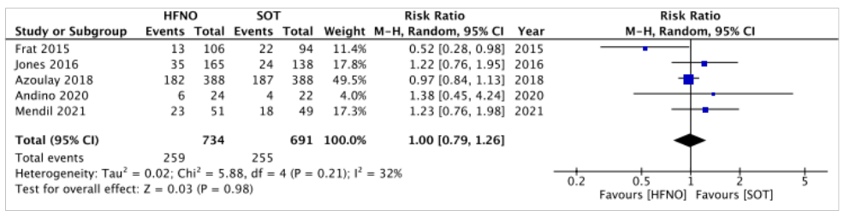
- Intubation
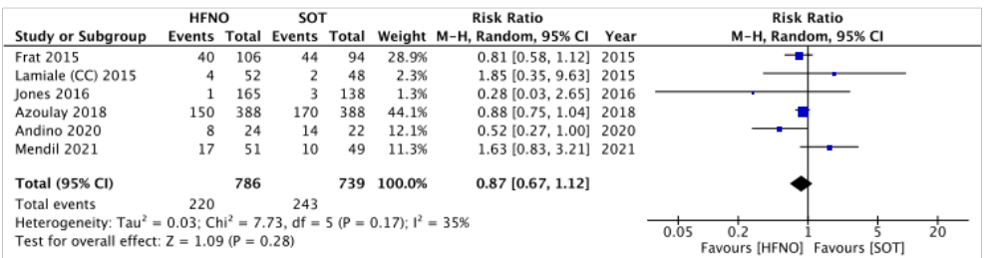
- PSV vs SOT
- Short-term mortality
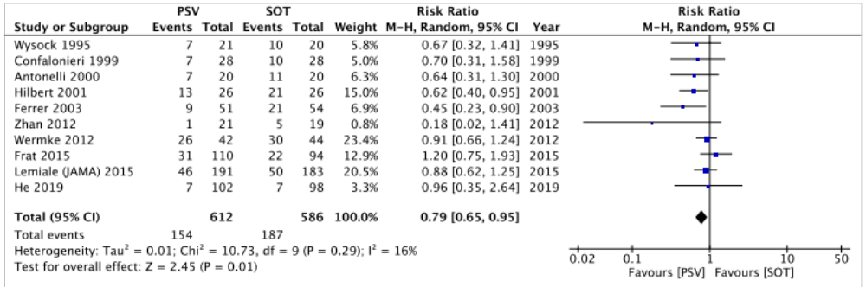
- Intubation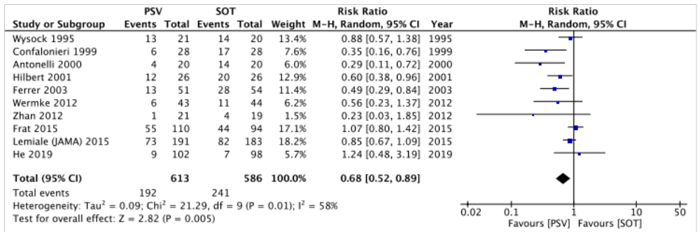

- CPAP vs SOT
- Short-term mortality
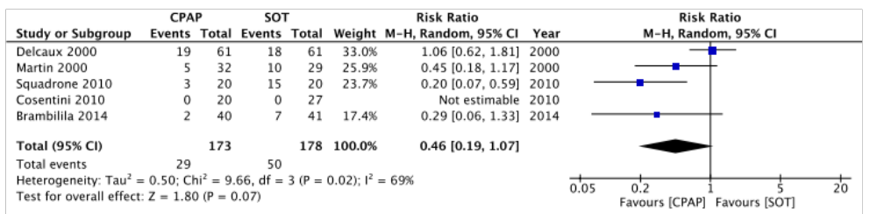
- Intubation
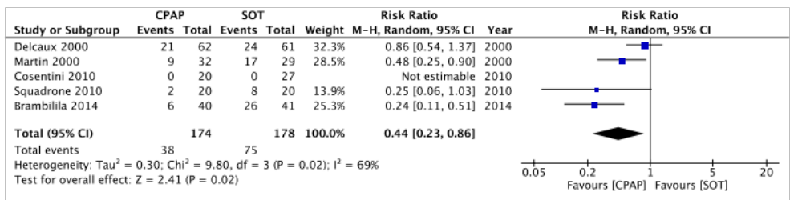
- PSV vs IMV
- Short-term mortality
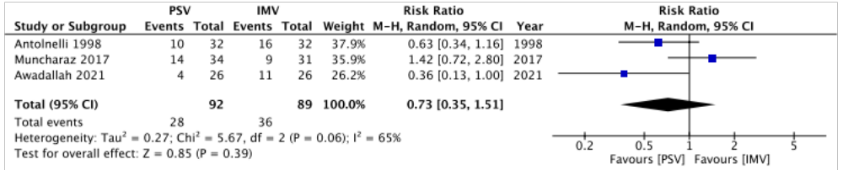
- PSV vs HFNO
- Short-term mortality
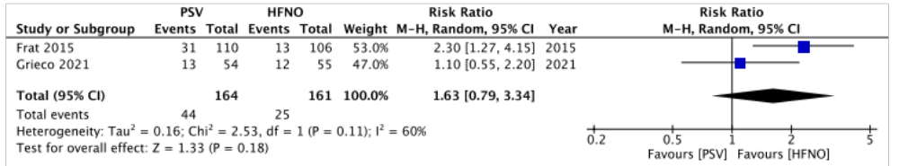
- Intubation
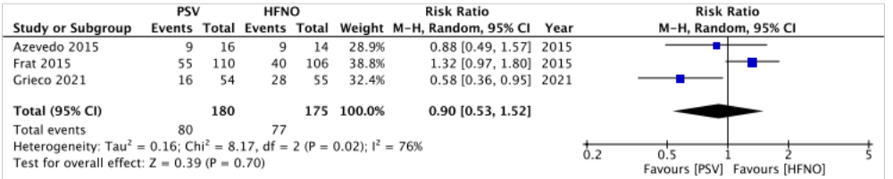
CI, confidence interval; CPAP, continuous positive airway pressure; HFNO, high-flow nasal oxygenation; IMV, invasive mechanical ventilation; PSV, pressure support ventilation; SOT, standard oxygen therapy
Supplementary Fig. S2 Comparison adjusted Funnel Plot for the network meta-analysis
- Short-term mortality
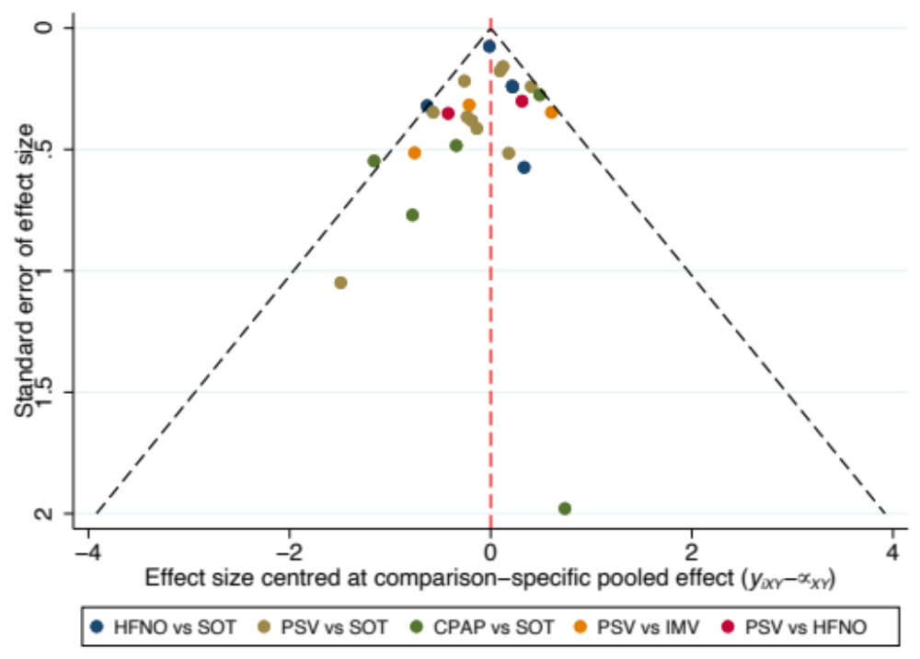
- Intubation
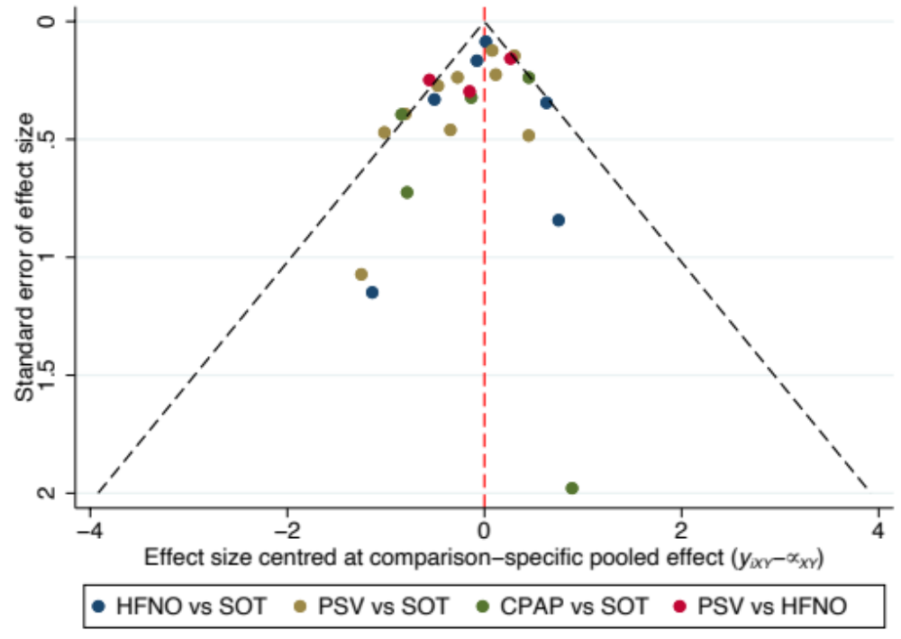
CPAP, continuous positive airway pressure; HFNO, high-flow nasal oxygenation; IMV, invasive mechanical ventilation; PSV, pressure support ventilation; SOT, standard oxygen therapy

Supplementary Fig. S3 Results of ranking probability in the Network Meta-analysis
- Short-term mortality
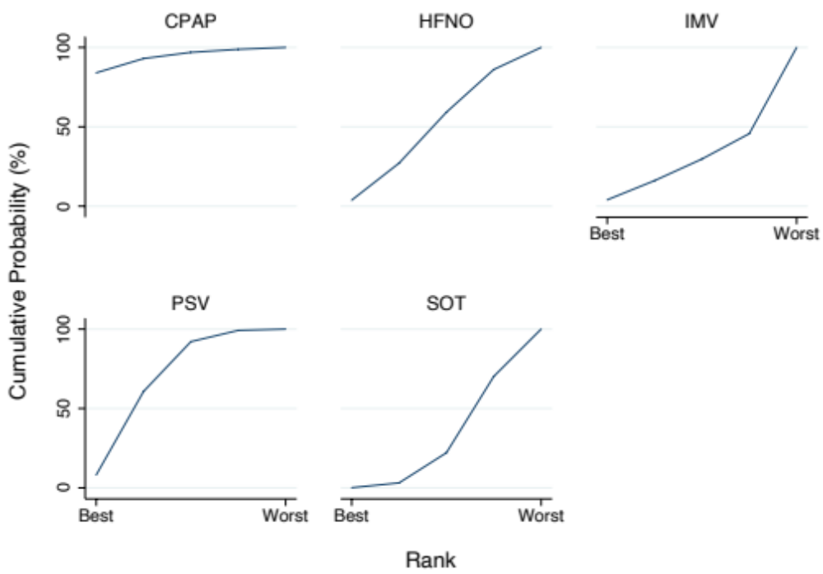

- Intubation
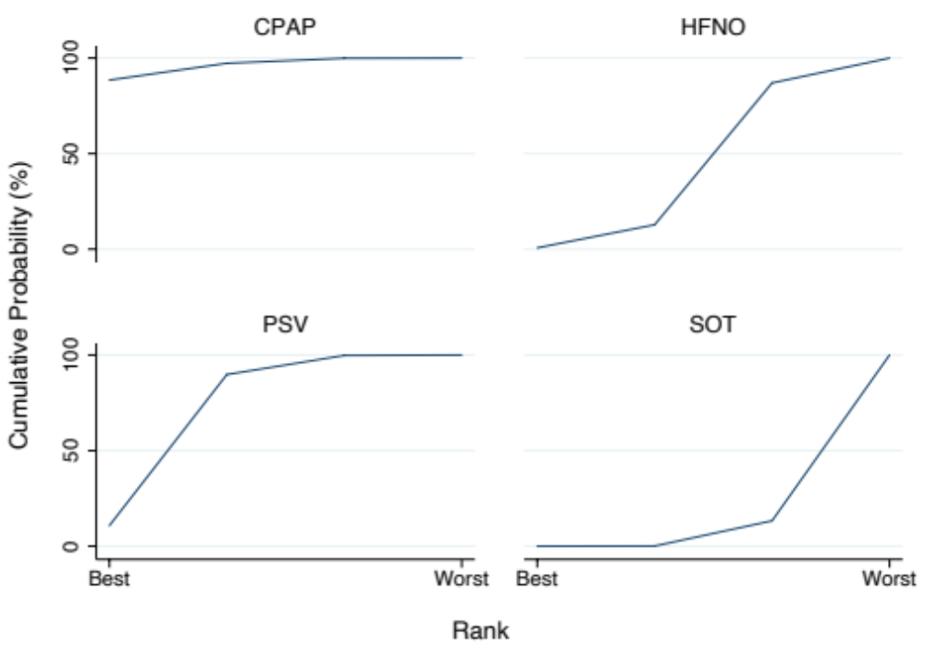
CPAP, continuous positive airway pressure; HFNO, high-flow nasal oxygenation; IMV, invasive mechanical ventilation; PSV, pressure support ventilation; SOT, standard oxygen therapy

