Health-related quality of life, social and economic consequences of COVID-19 in Italian critically ill survivors at 6-months follow-up

SUPPLEMENTARY MATERIAL
Table 1S. ﻿SF-36 domain scores for patients responding at the structured interview compared to Italian normalized data.

SF-36 domains | Covid 19 survivors  (N=79) | Apolone et al.²³  (N=2031) | p
Physical function | 78.23 (25.60) | 84.46 (23.18) | 0.0197
Role physical | 48.1 (48) | 78.21 (35.93) | < 0.0001
Bodily pain | 73.92 (28.77) | 73.67 (27.65) | 0.9373
General health | 43.8 (26.03) | 65.22 (22.18) | < 0.0001
Vitality | 57.03 (20.64) | 61.89 (20.69) | 0.0405
Social functioning | 64.4 (33.44) | 77.43 (23.34) | <0.0001
Role emotional | 76.79 (40.07) | 76.16 (37.25) | 0.8831
Mental health | 72.91 (19.31) | 66.59 (20.89) | 0.0082

Data are represented as mean (SD). Differences were analyzed using T-test.

Table 2S. EQ-5D-5L domain scores for patients responding at the structured interview compared to Italian normalized data.
EQ-5D-5L domains | Y/N | Covid-19 survivors  (N=79) | Scalone et al. ²⁷  (N=439) | p
Pain or discomfort | Y | 39 | 147 | 0.0105
 | N | 40 | 292 | 0.0105
Mobility | Y | 37 | 42 | < 0.0001
 | N | 42 | 397 | < 0.0001
Usual activities | Y | 35 | 37 | < 0.0001
 | N | 44 | 402 | < 0.0001
Anxiety and depression | Y | 26 | 116 | 0.2728
 | N | 53 | 323 | 0.2728
Self care | Y | 17 | 9 | < 0.0001
 | N | 62 | 430 | < 0.0001

Data are represented as numbers. Differences were analyzed using Fisher’s exact test.

Table 3S. Summary SF-36 scores and EQ-5D-5L VAS according to demographic, socio-economic and clinical characteristics
 |  | N | PHYSICAL  Component Score | MENTAL  Component Score | EQ5L-5D-VAS
Age (yrs) | < 65 | 43 | 45.4 | 52.4 | 80
Age (yrs) | < 65 | 43 | (35.9-51.3) | (46.8-57.1) | (60-90)
Age (yrs) | >65 | 36 | 42.5 | 50.4 | 77.5
Age (yrs) | >65 | 36 | (32.5-48.8) | (40.8-56.3) | (60-80)
 | p |  | p=0.2530 | p=0.6489 | p=0.2171
EDUCATION (ISCED) | 0-2 | 27 | 45.2 | 53.7 | 80
EDUCATION (ISCED) | 0-2 | 27 | (33.8-52.1) | (40.9-57.9) | (100-100)
EDUCATION (ISCED) | > 2 | 51 | 43.4 | 49.9 | 80
EDUCATION (ISCED) | > 2 | 51 | (33.8-36.9) | (40.9-46.4) | (60-85)
 | p |  | p=0.3776 | p=0.1035 | p=0.1731
Monthly  income € | < 1500 | 41 | 43.4 | 50.1 | 80
Monthly  income € | < 1500 | 41 | (36.5-48.1) | (41.4-57.5) | (70-90)
Monthly  income € | > 1500 | 35 | 48.2 | 53.3 | 80
Monthly  income € | > 1500 | 35 | 33.4-53.1) | (46.7-57) | (62.5-90)
 | p |  | p=0.2576 | p=0.4066 | p=0.1557
Comorbidities | 0-1 | 61 | 45.4 | 52.8 | 80
Comorbidities | 0-1 | 61 | (36.8-50.3) | (46.6-57.5) | (70-90)
Comorbidities | >1 | 18 | 35.4 | 41.3 | 65
Comorbidities | >1 | 18 | (25.1-48.3) | (27.1-52.6) | (42.5-80)
 | p |  | p=0.0311 | p=0.0013 | p=0.0068
PaO₂/FiO₂ on ICU admission | <150 | 34 | 37.3 | 50 | 70
PaO₂/FiO₂ on ICU admission | <150 | 34 | (32.6-48.7) | (37.3-57.2) | (60-80)
PaO₂/FiO₂ on ICU admission | >150 | 44 | 46.1 | 52.4 | 80
PaO₂/FiO₂ on ICU admission | >150 | 44 | (40-51.9) | (46.3-56) | (70-90)
 | p |  | p=0.0307 | P=0.2655 | p=0.0126
SAPS II | < 25 | 28 | 45.7 | 51.7 | 80
SAPS II | < 25 | 28 | (37.9-51.3) | (43.7-57.3) | (70-90)
SAPS II | > 25 | 51 | 43.2 | 52.1 | 80
SAPS II | > 25 | 51 | (33.5-49.3) | (45.2-56.8) | (60-80)
 | p |  | p=0.1142 | p=0.5184 | p=0.0799
M ventilation (days) | <15 | 34 | 43.4 | 52.4 | 80
M ventilation (days) | <15 | 34 | (35-51.2) | (44.9-57.2) | (70-90)
M ventilation (days) | >15 | 44 | 45.4 | 51 | 80
M ventilation (days) | >15 | 44 | (35.5-50) | (45.1-56) | (60-86.3)
 | p |  | p=0.4226 | p=0.5892 | p=0.2108
Hospital LOS (weeks) | <4 | 23 | 48.7 | 53.2 | 80
Hospital LOS (weeks) | <4 | 23 | (42.6-52.5) | (47.4-57.4) | (70-90)
Hospital LOS (weeks) | >4 | 56 | 41.7 | 50.6 | 80
Hospital LOS (weeks) | >4 | 56 | (33.1-49.0) | (40.1-56.7) | (60-82.5)
 | p |  | p=0.0144 | p=0.1781 | p=0.0792

Data are espressed ad median (25th -75th percentile) transformed SF-36 domains. Data are analized with Mann-Whitney U test, p< 0.05. ISCED, International Standard Classification of Education. ISCED 0: Early childhood education (‘less than primary’ for educational attainment), ISCED 1: Primary education, ISCED 2: Lower secondary education, ISCED 3: Upper secondary education, ISCED 4: Post-secondary non-tertiary education, ISCED 5: Short-cycle tertiary education, ISCED 6: Bachelor’s or equivalent level, ISCED 7: Master’s or equivalent level, ISCED 8: Doctoral or equivalent level; ICU: intensive care unit; SAPS II: Simplified Acute Physiology Score; LOS: length of stay; M Ventilation: duration of mechanical ventilation; LOS: length of stay.

Figure 1S. Study flow-chart

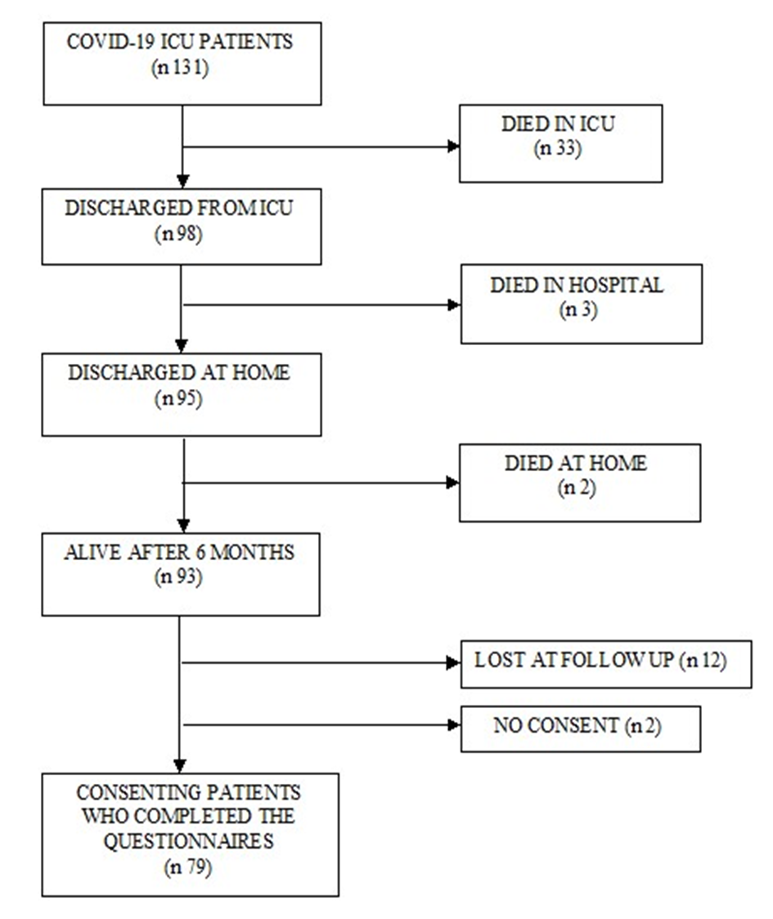

Figure 2S. Description and distribution of health professionals needs in critically ill, COVID-19 survivors.

