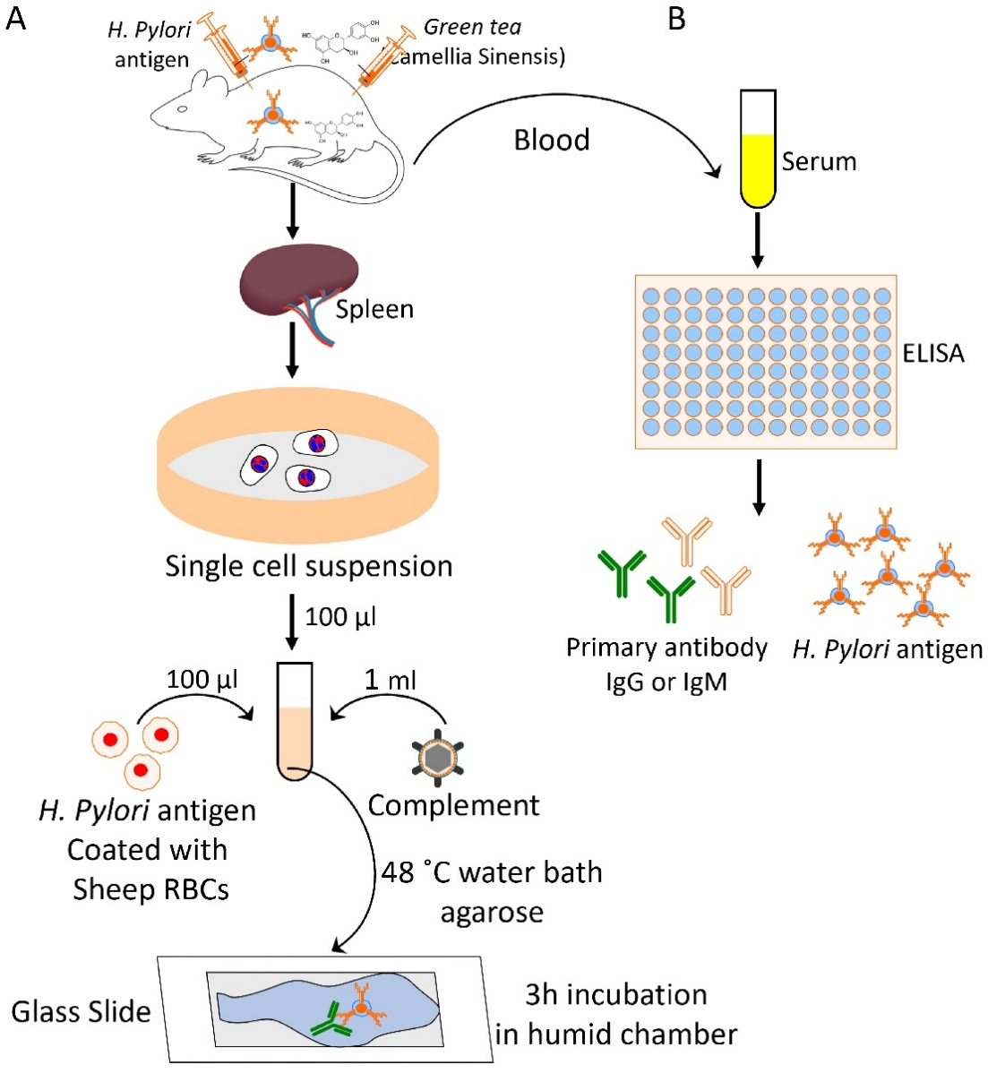

Supplementary Figure. 1. Schematic of the plaque assay and ELISA: Anti-H. pylori response to H. pylori antigen coated sRBCs with Camellia sinensis.

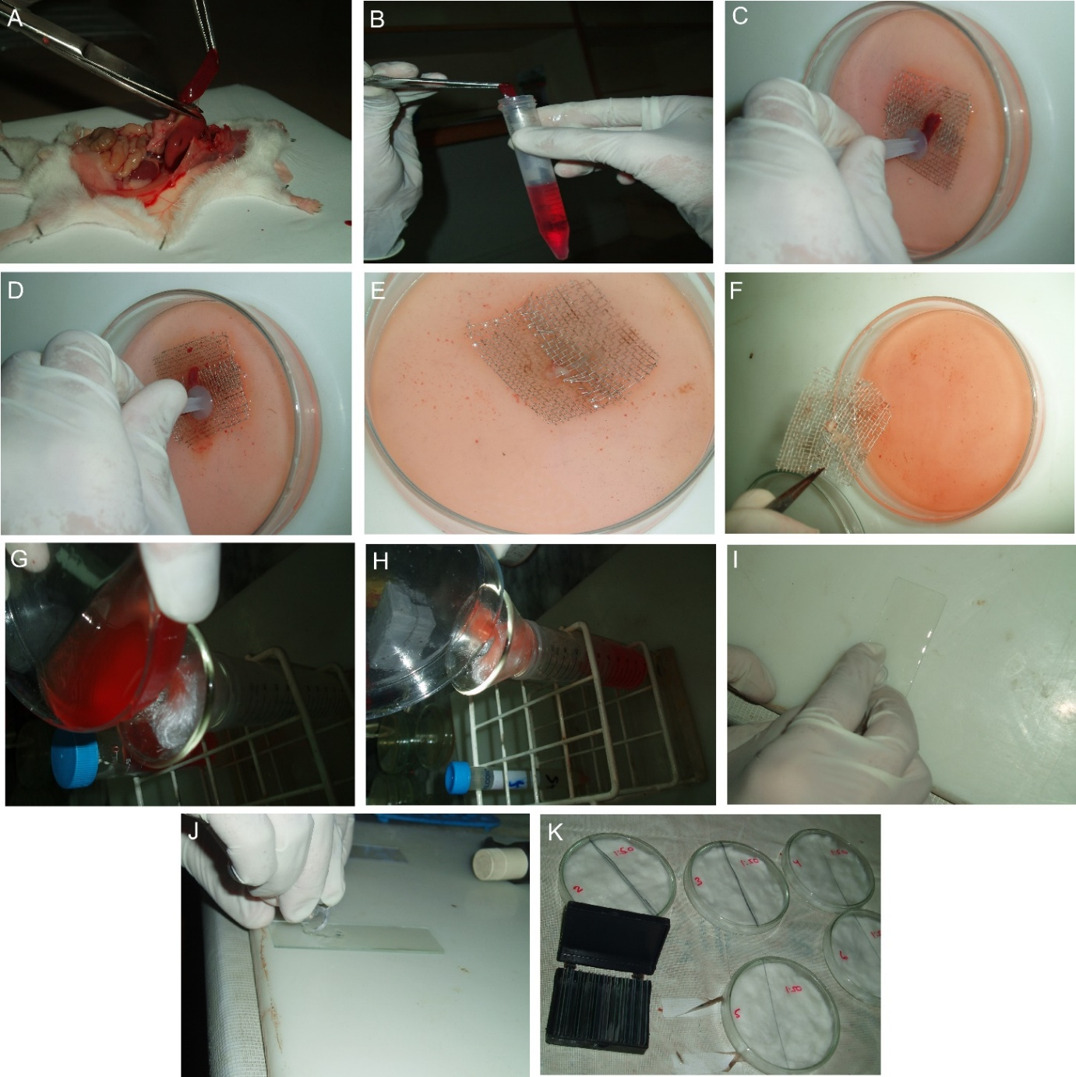
Supplementary Figure. 2. Plaque forming cell (PFC) assay to examine the anti-H. pylori secreting antibodies against H. pylori vaccine and CS. A-B) Separation of spleen from mice immunizes with antigen and stored in the media to count secreting B cell specific for their specific H. pylori antigen. C) Excised mouse spleen is placed on a 60-mesh stainless steel in a petri plate containing cell culture media. D-F) The spleen minced with firmly force into fragments and all the cells transferred into the conical test tube. G-H) allow the cells pass through a glass wool to prepare a cell suspension and collect the cells into the conical test tube. I-K) Mixture of H. pylori antigen coated with sheep RBCs, 0.1 ml spleen cell and 1 ml of complement overlay and incubated at 37C for 45-60 mins.

Supplementary Table S1. qRT-PCR primer sequences (Mouse)
Gene | Forward primer Sequence | Reverse primer sequence
Rpl32 | 5’GAGGTGCTGCTGATGTGC-3' | 5’GGCGTTGGGATTGGTGACT-3'
NF-kappaB | 5’GAGGATGGGATCTGCACTGT3’ | 5’TCTGTCATTCGTGCTTCCAG3’
IL-23 | 5’AGCCTTCTCTGCTCCCTGAT3’ | 5’GACTGAGGCTTGGAATCTGC3’
IL-8 | 5’CTGCGCCAACACAGAAATTA3’ | 5’TGAATTCTCAGCCCTCTTCAA3’
IL-18 | 5’GCATCAACTTTGTGGCAATG3’ | 5’ATAGAGGCCGATTTCCTTGG3’
TGF-beta | 5’CTGGCGATACCTCAGCAAC3’ | 5’TAAGGCGAAAGCCCTCAAT3’
IL-1β | 5’CCCAAGCAATACCCAAAGAA3’ | 5’TTGTGAGGTGCTGATGTACCA3’
IL-6 | 5’TTCGGTCCAGTTGCCTTCT3’ | 5’GGTGAGTGGCTGTCTGTGTG3’
Foxp3 | 5’TCCCAGAGTTCCTCCACAAC3’ | 5’ATTGAGTGTCCGCTGCTTCT3’
IL-16 | 5’ACACAGGGTTCTCGCTCAAC3’ | 5’GGGAGATAACGGACTGACCA3’
TNF-α | 5’GGCGTGGAGCTGAGAGATAA3’ | 5’GTGTGGGTGAGGAGCACAT3’
IL-10 | 5’GGCCTTGCTCTTGTTTTCAC3’ | 5’TTACCTGGAGGAGGTGATGC3’
Il13 | 5’TGAGGAGCTGGTCAACATCA3’ | 5’CAGGTTGATGCTCCATACCAT3’
Il17A | 5’CAATCCCACGAAATCCAGGATG3’ | 5’GGTGGAGATTCCAAGGTGAGG3’

Table S2: Table showing total lymphocytes counts with their number of plaques in control immunizes mice.
MICE | DILUTION | TOTAL LYMPHOCYTES COUNT/ml | % of B Cells | PFU/ spleen | PFU/ spleen | PFU/ spleen | PFU/ spleen | Mean of PFU/spleen | PFU/10⁶ spleen cells
CONTROL | 1:10 | 3. 1x10⁷ | 54% | 210 | 220 | 200 | 210 | 210 | 7 PFU/10⁶ spleen cells
CONTROL | 1:20 | 3. 1x10⁷ | 54% | 110 | 143 | 102 | 0 | 118 | 4 PFU/10⁶ spleen cells
CONTROL | 1:50 | 3. 1x10⁷ | 54% | 60 | 77 | 81 | 0 | 73 | 2PFU/10⁶ spleen cells
CONTROL | 1:100 | 3. 1x10⁷ | 54% | 0 | 0 | 0 | 0 | 0 | 0 PFU/10⁶ spleen cells
CONTROL | 1:1000 | 3. 1x10⁷ | 54% | 0 | 0 | 0 | 0 | 0 | 0 PFU/10⁶ spleen cells

Table S3: Table showing total lymphocytes count with their number of plaques in whole cell antigen immunizes mice.
MICE | DILUTION | TOTAL LYMPHOCYTES COUNT/ml | % of B Cells | PFU/ spleen | PFU/ spleen | PFU/ spleen | PFU/ spleen | Mean of PFU/spleen | PFU/10⁶ spleen cells
Whole cell antigen immunizes mice | 1:10 | 3. 9x10⁷ | 63% | 2045 | 2121 | 2150 | 2200 | 2129 | 55PFU/10⁶ spleen cells
Whole cell antigen immunizes mice | 1:20 | 3. 9x10⁷ | 63% | 1300 | 1039 | 1159 | 1129 | 1157 | 30 PFU/10⁶ spleen cells
Whole cell antigen immunizes mice | 1:50 | 3. 9x10⁷ | 63% | 900 | 1038 | 899 | 832 | 917 | 24PFU/10⁶ spleen cells
Whole cell antigen immunizes mice | 1:100 | 3. 9x10⁷ | 63% | 550 | 700 | 850 | 706 | 702 | 18 PFU/10⁶ spleen cells
Whole cell antigen immunizes mice | 1:1000 | 3. 9x10⁷ | 63% | 354 | 410 | 288 | 528 | 395 | 10 PFU/10⁶ spleen cells

Table S4: Table showing total lymphocytes counts with their number of plaques in whole cell antigen with green tea immunizes mice.
MICE | DILUTION | TOTAL LYMPHOCYTES COUNT/ml | % of B Cells | PFU/ spleen | PFU/ spleen | PFU/ spleen | PFU/ spleen | Mean of PFU/spleen | PFU/10⁶ spleen cells
Whole cell antigen with green tea immunizes mice: | 1:10 | 7. 3X10⁷ | 79% | 6406 | 6100 | 6430 | 6705 | 6410 | 88 PFU/10⁶ spleen cells
Whole cell antigen with green tea immunizes mice: | 1:20 | 7. 3X10⁷ | 79% | 5100 | 5024 | 6140 | 4628 | 5223 | 72 PFU/10⁶ spleen cells
Whole cell antigen with green tea immunizes mice: | 1:50 | 7. 3X10⁷ | 79% | 3000 | 3225 | 4014 | 2538 | 3194 | 44 PFU/10⁶ spleen cells
Whole cell antigen with green tea immunizes mice: | 1:100 | 7. 3X10⁷ | 79% | 2500 | 2050 | 2150 | 1853 | 2138 | 29PFU/10⁶ spleen cells
Whole cell antigen with green tea immunizes mice: | 1:1000 | 7. 3X10⁷ | 79% | 1090 | - | - | - | 1090 | 15 PFU/10⁶ spleen cells

Table S5: Table showing total lymphocytes count with their number of plaques in sonicate antigen immunize mice.
MICE | DILUTION | TOTAL LYMPHOCYTES COUNT/ml | % of B Cells | PFU/ spleen | PFU/ spleen | PFU/ spleen | PFU/ spleen | Mean of PFU/spleen | PFU/10⁶ spleen cells
Sonicate antigen immunize mice: | 1:10 | 5. 2x10⁷ | 68% | 12150 | 11300 | 10450 | 10300 | 11050 | 213PFU/10⁶ spleen cells
Sonicate antigen immunize mice: | 1:20 | 5. 2x10⁷ | 68% | 10600 | 9841 | 11291 | 8394 | 10032 | 193 PFU/10⁶ spleen cells
Sonicate antigen immunize mice: | 1:50 | 5. 2x10⁷ | 68% | 9500 | 9183 | 10839 | 7123 | 9161 | 176PFU/10⁶ spleen cells
Sonicate antigen immunize mice: | 1:100 | 5. 2x10⁷ | 68% | 8830 | 8600 | 9600 | 6307 | 8334 | 160PFU/10⁶ spleen cells
Sonicate antigen immunize mice: | 1:1000 | 5. 2x10⁷ | 68% | 8023 | 7234 | 8332 | 4819 | 7102 | 137 PFU/10⁶ spleen cells

Table S6: Table showing total lymphocytes count with their number of plaques in sonicate antigen with green tea immunize mice.
 |  |  |  | PFUxDilution factor/Spleen Cells Volume
MICE | DILUTION | TOTAL LYMPHOCYTES COUNT/ml | % of B Cells | PFU/ spleen | PFU/ spleen | PFU/ spleen | PFU/ spleen | Mean of PFU/spleen | PFU/10⁶ spleen cells
Sonicate antigen with green tea immunize mice: | 1:10 | 9. 1X10⁷ | 86% | 89776 | 91987 | 82134 | 77654 | 85388 | 938PFU/10⁶ spleen cells
Sonicate antigen with green tea immunize mice: | 1:20 | 9. 1X10⁷ | 86% | 69600 | 77273 | 73263 | 58238 | 69594 | 768PFU/10⁶ spleen cells
Sonicate antigen with green tea immunize mice: | 1:50 | 9. 1X10⁷ | 86% | 51800 | 57263 | 66282 | 43823 | 54792 | 602PFU/10⁶ spleen cells
Sonicate antigen with green tea immunize mice: | 1:100 | 9. 1X10⁷ | 86% | 23980 | 19820 | 21900 | 24900 | 22650 | 249PFU/10⁶ spleen cells
Sonicate antigen with green tea immunize mice: | 1:1000 | 9. 1X10⁷ | 86% | 19776 | 10394 | 15765 | 12183 | 14530 | 160PFU/10⁶ spleen cells

Table S7: Controls to detect the Immune Response to H. pylori in mice against H. pylori whole cell ELISA.
 | REACTIONS | FIRST READING | SECOND READING | Third reading | MEAN | STANDARD DEVIATION
Negative Control | HRP Conjugate secondary antibody (1:2500 diluted) | 0.148 | 0.126 | 0.093 | 0.1223 | 0.0276
Negative Control | BUFFER (-NV CONTROL) | 0.107 | 0.100 | 0.108 | 0.105 | 0.00435
Negative Control | H.pylori antibody serum | 0.051 | 0.108 | 0.096 | 0.085 | 0.03
Negative Control | H.pylori whole cell antigen (100ul=0.02mg/ml) | 0.186 | 0.169 | 0.164 | 0.173 | 0.0115
Negative Control | Mice serum | .070 | 0.146 | 0.287 | 0.1676 | 0.1101
Positive control | Gastritis patient serum | 3.342 | 2.296 | 1.984 | 2.5406 | 0.7112
MEAN OF NAGATIVE CONTROL | STANDARD DEVIATION OF ALL NEGATIVE CONTROL |  |  |  | CUTOFF VALUE  (MEAN+2SD)
0.1305 | 0.0386 |  |  |  | 0.2077

Table S8: Controls to detect the Immune Response to H. pylori in mice against H. pylori sonicate ELISA.
 | REACTIONS | FIRST READING | SECOND READING | Third reading | MEAN | STANDARD DEVIATION
Negative Control | HRP Conjugate secondary antibody (1:2500 diluted) | 0.246 | 0.228 | 0.283 | 0.2523 | 0.028
Negative Control | BUFFER (-NV CONTROL) | 0.267 | 0.240 | 0.238 | 0.2483 | 0.0161
Negative Control | H.pylori antibody serum | 0.231 | 0.205 | 0.292 | 0.364 | 0.0446
Negative Control | H.pylori sonicate antigen (100ul=0.01mg/ml) | 0.284 | 0.256 | 0.265 | 0.2683 | 0.0142
Negative Control | Mice serum | .334 | 0.312 | 0.321 | 0.322 | 0.011
Positive control | Gastritis patient serum | 3.355 | 2.267 | 1.976 | 2.5406 | 0.7268
MEAN OF NAGATIVE CONTROL | STANDARD DEVIATION OF ALL NEGATIVE CONTROL |  |  |  | CUTOFF VALUE(MEAN+2SD)
0.2909 | 0.0503 |  |  |  | 0.3915

Table S9: Helicobacter pylori antibody titre in control mice is determined by whole cell In house ELISA.
Mice with no immunization (control):
 | 1:10 | 1:100 | 1:1000 | 1:10000 | 1:100000 | 1:1000000 | 1:10000000 | 1:100000000 | 1:1000000000 | 1:10000000000
OD AT 450nm | 0.580 | 0.470 | 0.340 | 0.112 | 0.080 | 0.070 | 0.030 | 0.020 | 0.011 | 0.007
OD AT 450nm | 0.576 | 0.478 | 0.334 | 0.092 | 0.079 | 0.052 | 0.024 | 0.008 | 0.019 | 0.003
MEAN | 0.578 | 0.474 | 0.337 | 0.102 | 0.0795 | 0.061 | 0.027 | 0.014 | 0.015 | 0.005
SD | 0.0028 | 0.0056 | 0.0042 | 0.0141 | 0.0007 | 0.0127 | 0.0042 | 0.0084 | 0.00056 | 0.0028

Table S10: Helicobacter pylori antibody titre in control mice is determined by sonicate In house ELISA.
Mice with no immunization (control):
 | 1:10 | 1:100 | 1:1000 | 1:10000 | 1:100000 | 1:1000000 | 1:10000000 | 1:100000000 | 1:1000000000 | 1:10000000000
OD AT 450nm | 0.640 | 0.549 | 0.538 | 0.424 | 0.180 | 0.165 | 0.130 | 0.115 | 0.093 | 0.039
OD AT 450nm | 0.636 | 0.541 | 0.537 | 0.420 | 0.179 | 0.157 | 0.124 | 0.111 | 0.075 | 0.045
MEAN | 0.638 | 0.545 | 0.5375 | 0.422 | 0.1795 | 0.161 | 0.127 | 0.113 | 0.084 | 0.042
SD | 0.0028 | 0.0056 | 0.0007 | 0.0028 | 0.0007 | 0.0056 | 0.0042 | 0.0028 | 0.0127 | 0.0042

Table S11: Helicobacter pylori antibody titre in whole cell antigen immunizes mice serum is determined by In house ELISA.
Mice immunization with whole cell antigen:
 | 1:10 | 1:100 | 1:1000 | 1:10000 | 1:100000 | 1:1000000 | 1:10000000 | 1:100000000 | 1:1000000000 | 1:10000000000
OD AT 450nm | 2.370 | 1.699 | 1.341 | 0.852 | 0.497 | 0.216 | 0.190 | 0.177 | 0.125 | 0.096
OD AT 450nm | 2.358 | 1.693 | 1.343 | 0.840 | 0.495 | 0.200 | 0.186 | 0.167 | 0.116 | 0.082
MEAN | 2.364 | 1.696 | 1.342 | 0.846 | 0.496 | 0.208 | 0.188 | 0.172 | 0.121 | 0.089
SD | 0.0084 | 0.0042 | 0.0014 | 0.0084 | 0.0014 | 0.0113 | 0.0028 | 0.007 | 0.006 | 0.0098

Table S12: Helicobacter pylori antibody titre in sonicate antigen immunize mice serum is determined by In house ELISA.
Mice immunization with sonicate antigen:
 | 1:10 | 1:100 | 1:1000 | 1:10000 | 1:100000 | 1:1000000 | 1:10000000 | 1:100000000 | 1:1000000000 | 1:10000000000
OD AT 450nm | 2.448 | 2.335 | 1.73 | 1.301 | 0.742 | 0.503 | 0.376 | 0.313 | 0.215 | 0.204
OD AT 450nm | 2.447 | 2.329 | 1.71 | 1.305 | 0.732 | 0.502 | 0.375 | 0.312 | 0.214 | 0.203
MEAN | 2.4475 | 2.332 | 1.72 | 1.303 | 0.737 | 0.5025 | 0.3755 | 0.3125 | 0.2145 | 0.2036
SD | 0.0007 | 0.0042 | 0.0141 | 0.028 | 0.007 | 0.0007 | 0.0007 | 0.0007 | 0.0007 | 0.0007

Table S13: Helicobacter pylori antibody titre in whole cell antigen with green tea immunizes mice serum is determined by In house ELISA.
Mice immunization with whole cell antigen and green tea
 | 1:10 | 1:100 | 1:1000 | 1:10000 | 1:100000 | 1:1000000 | 1:10000000 | 1:100000000 | 1:1000000000 | 1:10000000000
OD AT 450nm | 3.70 | 3.527 | 3.255 | 2.514 | 2.317 | 1.200 | 0.846 | 0.434 | 0.330 | 0.262
OD AT 450nm | 3.68 | 3.523 | 3.249 | 2.513 | 2.309 | 1.199 | 0.835 | 0.433 | 0.326 | 0.248
MEAN | 3.69 | 3.525 | 3.252 | 2.5135 | 2.313 | 1.1995 | 0.841 | 0.4335 | 0.328 | 0.255
SD | 0.0141 | 0.0028 | 0.0042 | 0.0007 | 0.0056 | 0.0007 | 0.007 | 0.0007 | 0.0028 | 0.009

Table S14: Helicobacter pylori antibody titre in sonicate antigen with green tea immunize mice serum is determined by In house ELISA.
Mice immunization with sonicate antigen and green tea
 | 1:10 | 1:100 | 1:1000 | 1:10000 | 1:100000 | 1:1000000 | 1:10000000 | 1:100000000 | 1:100000000 | 1:1000000000
OD AT 450nm | 3.830 | 3.679 | 3.129 | 2.888 | 2.129 | 2.372 | 2.481 | 2.867 | 2.997 | 2.840
OD AT 450nm | 3.838 | 3.675 | 3.127 | 2.882 | 2.119 | 2.370 | 2.477 | 2.861 | 2.995 | 2.830
MEAN | 3.834 | 3.677 | 3.128 | 2.885 | 2.124 | 2.371 | 2.479 | 2.864 | 2.996 | 2.835
SD | 0.005 | 0.0028 | 0.0014 | 0.0042 | 0.007 | 0.0014 | 0.0028 | 0.0042 | 0.0014 | 0.007

