Supplementary material
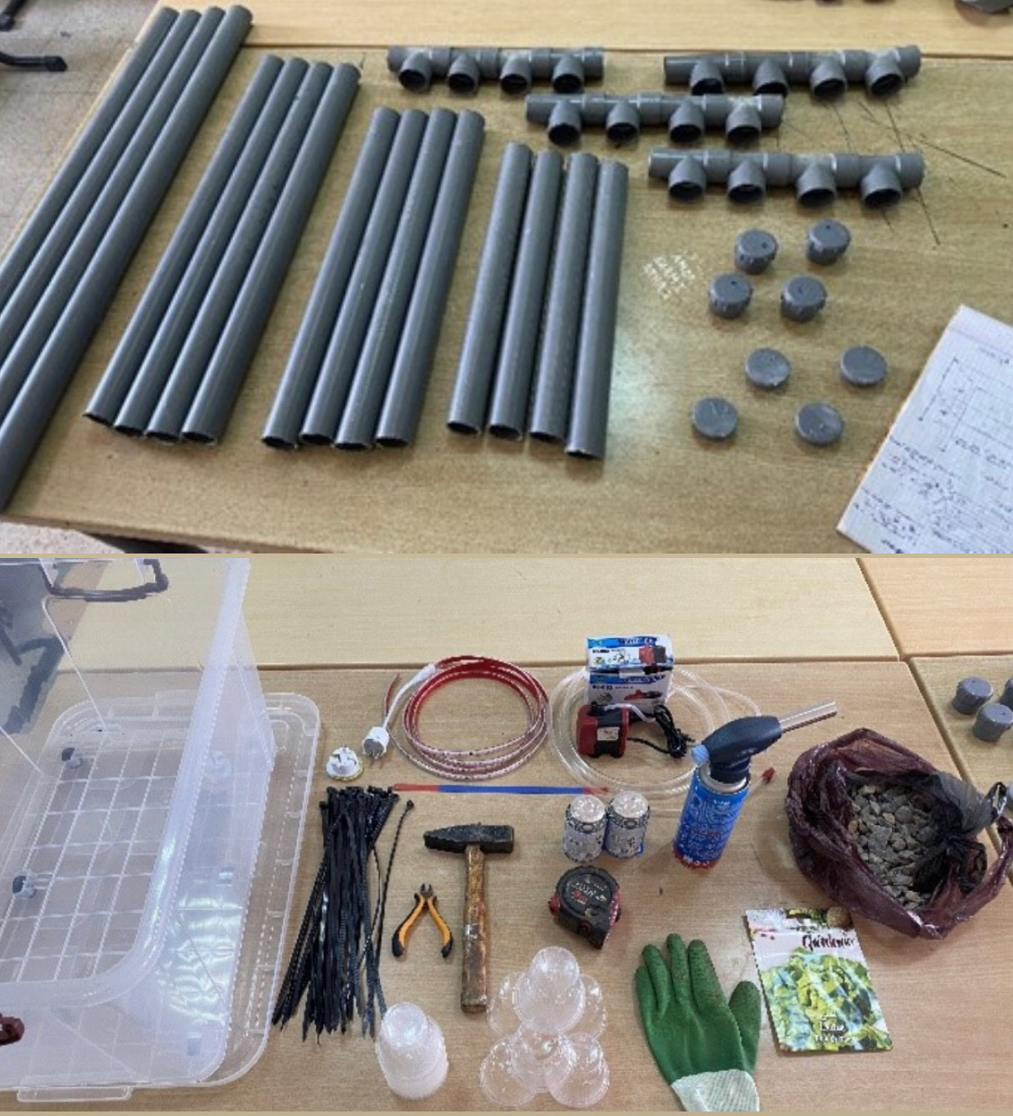
Supplementary figure S1. Overview of materials used in the intelligent hydroponic system.
A- PVC tubes and connectors forming the vertical cultivation channels, including pipe diameters and lengths.
B- Essential elements for the hydroponic system design and operation.
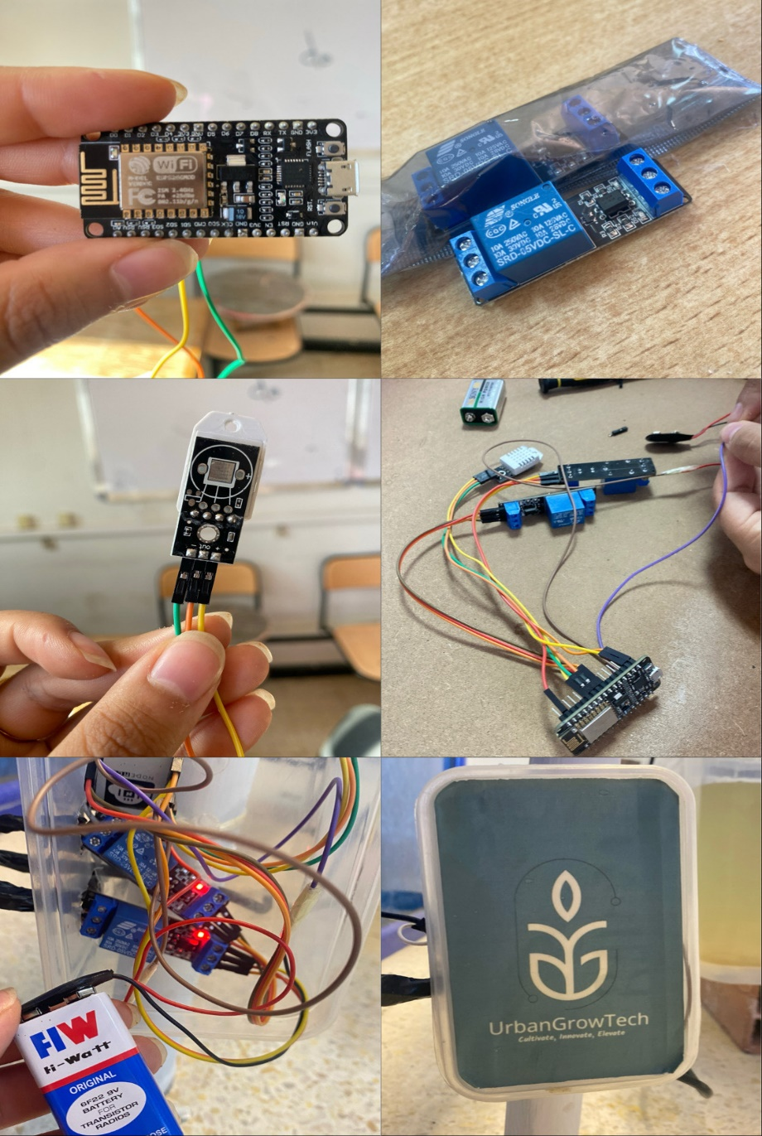
Supplementary figure S2. Iot components used for environmental monitoring and system automation.
- Microcontroller ESP8266.
- Relay 5v to control the irrigation pump and lighting.
- DHT22 sensors for air temperature and relative humidity.
- The conception of the IoT components.
- Open view of the IoT control box, showing the microcontroller (ESP8266), sensors, and wiring connected to the system.
- Closed view of the IoT control box, illustrating the protective enclosure and overall integration with the hydroponic setup.
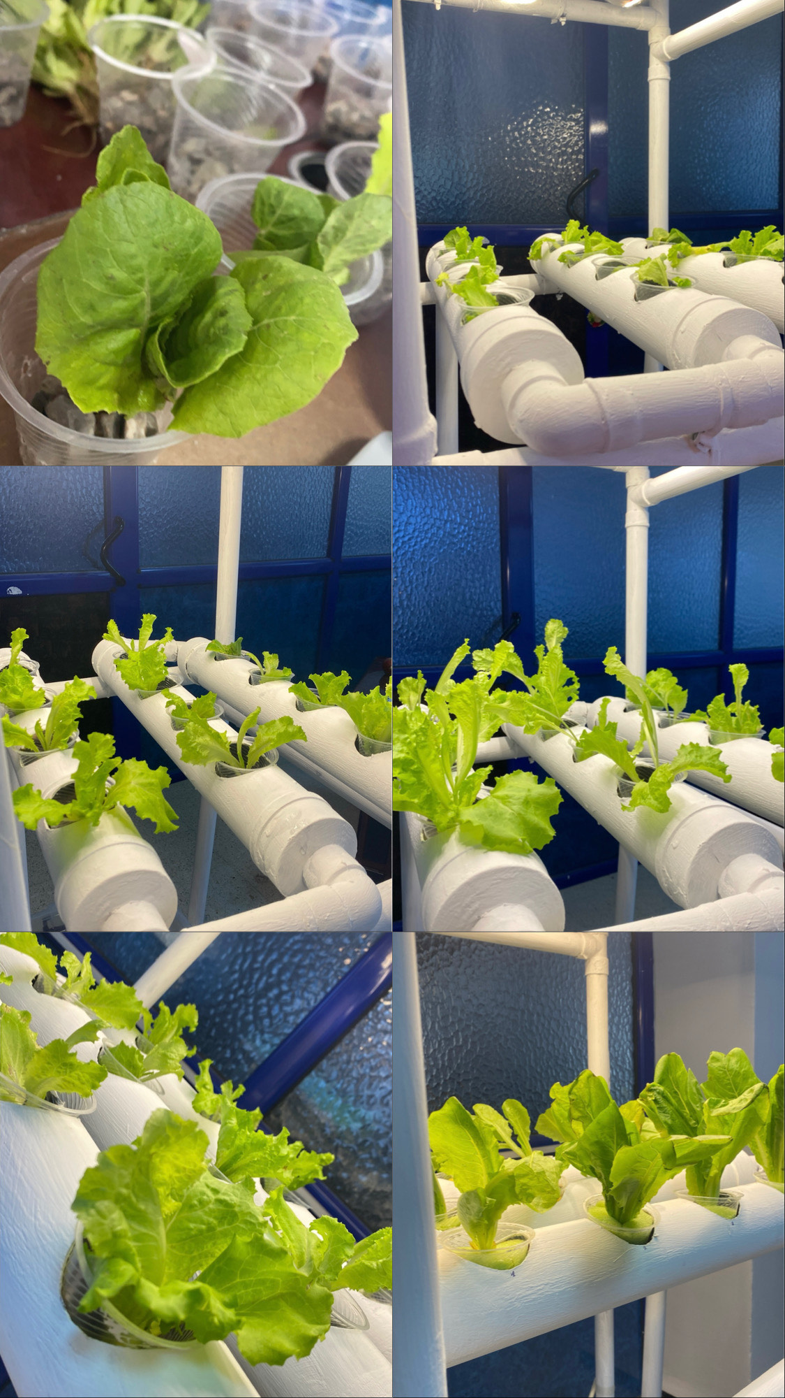
08/10/2024
09/10/2024
23/10/2024
15/10/2024
04/11/2024
11/11/2024
Supplementary figure S3. Phenological stages of romaine lettuce development over the 35-day growth cycle.
- Transplanting.
- 2-3 leaf stage
- 4-5 leaf stage.
- 8 leaf stage.
- Vegetative growth.
- Swelling stage.

