Supplementary materials

Supplementary Figure 1. Characterization of the vMSOT resolution for transcranial imaging.
Supplementary Figure 2. K18 tau fibril characterization.
Supplementary Figure 3. PBB5 characterization and staining on human brain.
Supplementary Figure 4. In vivo tau imaging with vMSOT.
Supplementary Figure 5. Epi-fluorescence imaging using PBB5 (i.v.) in P301L and wild-type mice
Supplementary Video 1. Non-invasive in vivo vMSOT of PBB5 probe distribution in P301L mouse brain at 60 minute post i.v. injection. vMSOT signals were unmixed for PBB5 (blue-green) and Hb/HbO (red-yellow, vascular signal component)
Supplementary Video 2. Non-invasive in vivo vMSOT imaging of PBB5 probe distribution in P301L mouse brain at 60 minute post i.v. injection. vMSOT signals were unmixed for PBB5 (blue-green) and Hb/HbO (red-yellow, vascular signal component) and overlaid with MRI brain-atlas shown in gray scale,
Supplementary Table 1: List of primary antibodies and compounds in western blot and immunohistochemistry

Supplementary Methods
Recombinant K18 tau fibrils production and characterization

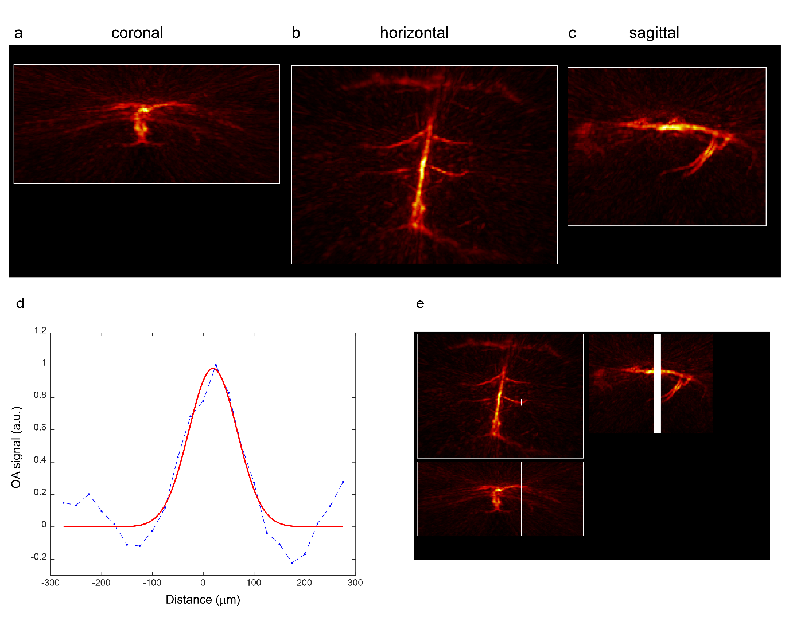
Supplementary Fig 1. Characterization of the vMSOT resolution for transcranial imaging. (a-c) MIP of the vMSOT image of the brain of a 6 weeks-old nude mouse (unmixed signal corresponding to oxygenated hemoglobin) through the intact scalp and skull in the coronal (a), horizontal (b) and sagittal (c) view; (e) One-dimensional vMSOT signal profile along the white line indicated in (e), blue line: raw profile; red line: fitted profile. The width of the fitted Gaussian curve is 115 μm.

Supplementary Fig 2. K18 tau Fibril characterization. (a) Thioflavin T assay on K18 4 repeat tau fibril and blank (dd. water)using spectrofluorometric measurements; (b) Western blot using anti-Tau (RD4) Antibody clone 1E1/A6 indicated K18 tau monomer.

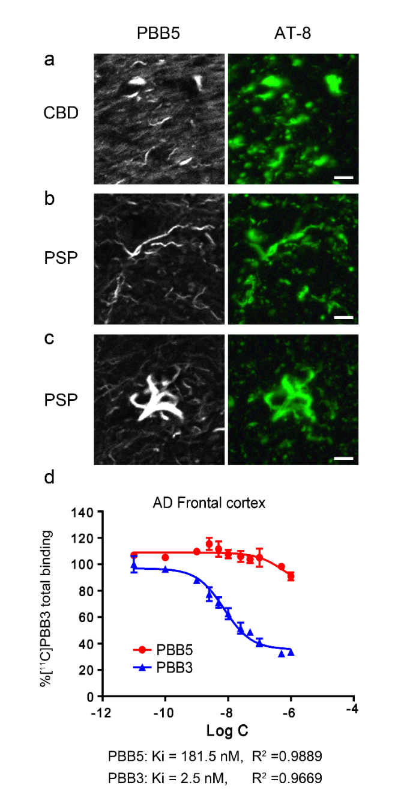
Supplementary Fig. 3 PBB5 characterization and staining on human brain. (a-c) PBB5-positive and AT-8-positive inclusions indicated argyrophilic threads (a, b) accumulated in oligodendrocytes and tufted astrocyte (c) in the caudate/putamen from patients with corticobasal degeneration (CBD) and motor cortex from progressive supranuclear palsy (PSP); scale bar = 10 μm. AT-8: an anti-phosphorylated tau antibody. (d) Binding of [¹¹C]PBB3 in cortical homogenates derived from Alzheimer’s disease (AD). Total (specific + non-specific) binding of 5 nM of [¹¹C]PBB3 in an AD temporal cortex sample blocked homologously by non-labelled PBB3 (blue) and heterologously by non-labelled PBB-5 (red). Inhibition of radioligand binding was described by 1-site model, and parameters resulting from curve fits are indicated;

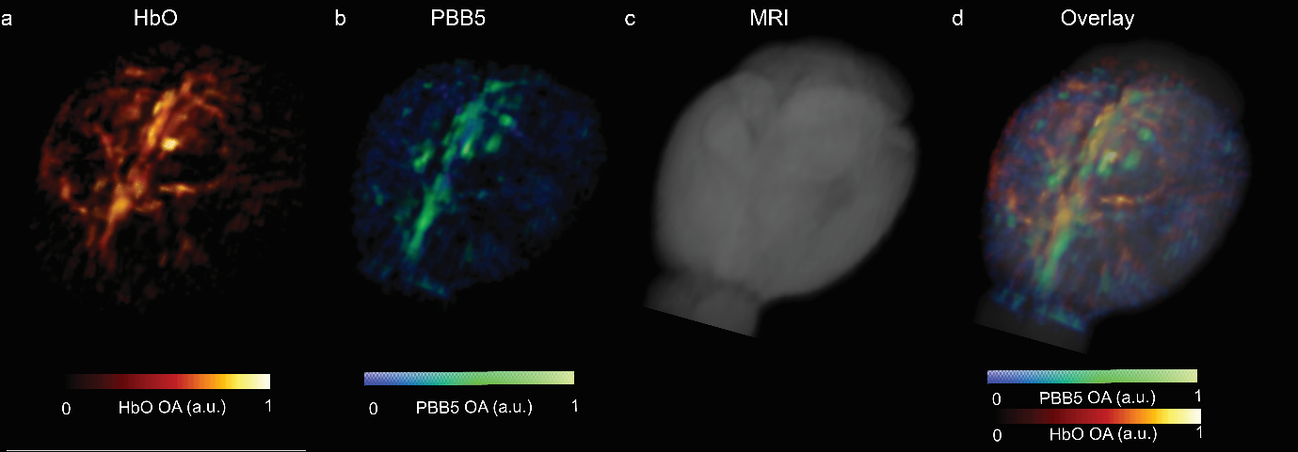
Supplementary Fig 4. In vivo tau imaging with vMSOT. 3D rendering of vMSOT data in one P301L mouse brain at 60 minute post PBB5 i.v. injection. (a) Image acquired at 600 nm excitation wavelength reveals the major cerebral vessels; (b) vMSOT image unmixed for PBB5 distribution; (c, d) Overlay of (a, b) on MRI structural data (c);

Supplementary Fig 5. Epi-fluorescence imaging using PBB5 (i.v.) in P301L and wild-type mice (a) Characterization of fluorescence intensity (FI) during perfusion after i.v. injection of PBB5 25 mg/kg weight using dynamic vMSOT imaging in brain of P301L (n=3) and wild-type mice (n=3). (b) ΔFI/FI in P301L (n=3) and wild-type mice (n=3) over 60 minute after i.v. injection PBB5 25 mg/kg weight.

Supplementary Table 1: List of primary antibodies and compounds in western blot and immunohistochemistry
Antibody/Compounds | Company | Cat. No. | Dilution
DAPI | Sigma | D9542-10MG | 1:1000
Goat-anti-Rabbit Alexa488 | Invitrogen | A11034 | 1:200
AT-8 | Invitrogen | MN1020 | 1:250 (human);  1:1000 (mouse)
PBB5 | RadiantDye |  | 50 μΜ
Normal goat Serum | Sigma
Anti-Tau (RD4) Antibody, clone 1E1/A6 | Sigma | 05-804 | 1:1000
Anti-mouse-IgG antibody conjugated to Horseradish Peroxidase | Jackson ImmunoResearch | 115-035-166 | 1:5000
Pierce™ ECL Western Blotting Substrate | ThermoFisher Scientific | 32106
VECTASHIELD fluorescent mounting media | Vector Laboratories | H-1000-10

Supplementary Methods
Recombinant K18 tau fibrils production and characterization
Recombinant K18 4R tau, were expressed and produced by E.coli as described previously [1, 2]. Transformation and culture: chemically competent Escherichia coli cells (strain BL21 DE3*) were transformed with the bacterial expression vector pRK172 containing the genomic sequence encoding for the 4 repeat Microtubular binding region (MTBR) of tau (kindly provided by the Marc Diamond lab). For transformation we used the standard heat shock method; frozen chemically competent cells were thawed on ice and 2 μL of the Tau k18 expression vector was added to the cells, which were incubated on ice for 30 minutes. Heat shock was performed at 42°C for 90 seconds and the transformed cells were incubated on ice for 4 minutes. 1 mL of sterile LB medium was added to the cells which were then incubated under agitation for 1 hour (37°C, 400 rpm). The solution was centrifuged (1000 × g, 2 minutes) and 700 µl of the supernatant were discarded. The pellet was resuspended in the remaining supernatant (≈ 300 µl) and spread onto an agar plate supplemented with ampicillin (10ug/mL) and incubated overnight (37 °C). The next morning, a single colony was picked with a sterile toothpick and incubated in 200 mL of sterile LB medium and ampicillin under agitation (120 rpm, 37°C) overnight. 20 mL of the preculture was transferred into 2 litres of sterile LB medium (containing ampicillin) and incubated under agitation (120 rpm, 37°C). A total of 6 litres of LB was prepared for tau K18 expression. The optical density at 590nm (OD590) was measured repeatedly. When OD590 reached 0.8, 1mL of 1M Isopropyl β-D-1-thiogalactopyranoside (IPTG) per Litre of growth medium was added and the incubation was continued overnight. On the next day the solution was centrifuged (3000 × g, 15 mins, 4°C) and the pellet was collected and stored at -20°C.
Extraction and Purification: The pellet was recovered from the freezer (-20°C), thawed on ice and resuspended in BRB80 buffer with 0.1% of β-Mercaptoethanol (BME) and 1mM of Phenylmethylsulfonyl fluoride (PMSF). Cell lysis was performed by sonication and subsequently letting the suspension flowing through a microfluidizer. The cells were sonicated three times in 50 mL aliquots at 50% power (Bandelin UW 2070 ultrasonic homogenizer), each round lasting 30 seconds. The probe of the sonicator was cooled down after three intervals to prevent overheating of the sample. The subsequent disruption of the bacteria (Microfluidics, M-110S) was performed at a pressure of 40 psi for two rounds. Afterwards, the suspension was centrifuged (3000 × g, 20 mins, 4°C) and the supernatant was recovered. The cell lysates were then cleared by a boiling step which consisted in incubating the supernatant for 10 minutes in a water bath set at 100C. after boiling the samples were incubated at room temperature for 1-2h till it reaches 25-30C. Using this procedure, heat sensitive proteins are irreversibly denaturated and therefore retained in the pellet when a centrifugation (3000 × g, 4°C, 15 min) step is subsequently applied to the sample. The supernatant was filtered through a 0.22 µm polyethersulfone (PES) membrane (Steritop Filter, Millipore Express PLUS) and afterwards stored on ice.
Cation exchange chromatography: Cation exchange chromatography was performed using a phosphocellulose column: 3 g of Cellulose Phosphate (SigmaAldrich (discontinued), CAS: 9015-14-9) was washed with NaOH (0.5 M), sodium phosphate (0.5M, pH 7), HCl (0.5M) and twice more with sodium phosphate (0.5 M, pH 7). The washed cellulose phosphate mesh was poured into a borosilicate glass chromatography column (Sigma, 18 mL, Luer-Lock). The column was packed and equilibrated by letting 100mL of BRB80 buffer containing 0.1% BME flowing through. Chromatography was performed at 4°C with a flow rate of 0.3 mL/min (pump: Pharmacia Biotech P-50). The column was subsequently eluted with BRB80 + 0.1% BME with increasing volumes of NaCl: 30 mL of 0.2M NaCl in BRB80 + BME, 30 mL of 0.4 M NaCl in BRB80 + BME, 30 mL of 0.6M NaCl in BRB80 + BME and 30 mL 1M NaCl in BRB80 + BME. 10mL fractions were collected and analysed by SDS-PAGE to identify the fractions containing the protein of interest. For the SDS-PAGE, aliquots from each elution fraction, the flow-through, and the solution before chromatography were mixed with Laemmli sample buffer and subsequently boiled at 95 °C for 5 minutes. The gel (NuPAGE 4-12 % Bis-Tris, ThermoFisher Scientific) was loaded with 15 µL of sample per well and 2 µL of Protein Standard (BioRad Precision Plus Protein Dual Color Standard) and run at a constant voltage of 160 V. The gel was stained with a Coomassie-based stain (InstantBlue, expedeon) (and stored in H₂O for later on performed western blot).

Dialysis and Lyophilization: Based on the readout of the SDS-page, the fractions containing the highest amount of protein (corresponding to the fractions showing the most prominent bands at around 15 kDa) were selected and pooled. The protein solution was then dialysed (3 kDa cutoff membrane, Spectrum Spectra/Por) against milliQ H2O at 4°C for three days. Every 12 hours the water in the dialysis container was exchanged. After dialysis the protein solution was collected in falcon tubes and frozen in liquid nitrogen, and finally lyophilized (Alpha 2-4 LD, Christ). Long term storage of the lyophilized samples was conducted at -80°C.
Fibrillization: To induce fibrillization, the lyophilized proteins were dissolved in PBS buffer pH 7.4 (Gibco) containing 0.05% NaN3. The proteins were resuspended in 200 μl of PBS/NaN3 and several aliquots were prepared in 1.5 ml Eppendorf tubes. For fibrilization, the protein solutions were incubated at 37°C under agitation (500-700 RPM) in a Eppendorf thermomixer.

Thioflavin T (ThT) assay: After the incubation of the protein solutions the fibrillization was verified by Thiaflovin T fluorescence assay: 45 μL of ThT 5μM was mixed with 5 μL of Tau k18, in a 45 µL quartz cuvette (quartz SUPRASIL Ultra Micro Cell, Hellma). The mixtures were incubated for 1 minute, resuspended with a pipette and the fluorescence intensity in the spectrum of 460-500 nm was measured with a Spectrofluorometer (FluoroMax-4, Horiba Jobin Yvon) using an excitation wavelength of 450 nm.

Western blot: The gel (Novex 10-20%, Tricine, ThermoFisher Scientific) was loaded with 10 μg of Tau K18. The samples were mixed with Laemmli sample buffer and boiled at 95 °C for 5 minutes. SDS-PAGE was performed at 100 V for 1h45 min. The gel was transferred to a nitrocellulose membrane (part of Invitrogen iBlot Transfer Stack, nitrocellulose, ThermoFisher Scientific) using a dry blotting system (Invitrogen iBlot 2, ThermoFisher Scientific). The membrane was washed with 1× PBS, 0.1 % Tween 20 (PBST) and blocked with 5 % fat-free milk. Tau K18 were detected using a monoclonal Tau antibody (Anti-Tau 4-repeat isoform RD4, clone 1E1/A6, Sigma Aldrich 05-804). The primary antibodies were diluted in 5% fat-free milk (anti Tau 1:1’000). As a secondary antibody a purified anti-Mouse-IgG antibody conjugated to Horseradish Peroxidase was used (Jackson ImmunoResearch, 115-035-166) which was diluted 1:5’000 in 5% fat-free milk. The membranes were incubated with the primary antibodies at 4 °C overnight. The membranes were washed with PBST and subsequently incubated with the secondary antibodies at room temperature for 2 hours and then washed with PBST. To detect Tau K18 ECL Prime Western Blotting Detection Reagents (Cytiva, RPN2232) were used. Pictures were taken with ImageQuant LAS 4000 (GE Healthcare).
Reference
1. Burmann BM, Gerez JA, Matecko-Burmann I, Campioni S, Kumari P, Ghosh D, Mazur A, Aspholm EE, Sulskis D, Wawrzyniuk M et al: Regulation of alpha-synuclein by chaperones in mammalian cells. Nature 2019.
2. Gerez JA, Prymaczok NC, Rockenstein E, Herrmann US, Schwarz P, Adame A, Enchev RI, Courtheoux T, Boersema PJ, Riek R et al: A cullin-RING ubiquitin ligase targets exogenous alpha-synuclein and inhibits Lewy body-like pathology. Sci Transl Med 2019, 11(495).

