SUPPLEMENTARY INFORMATION
Different impact of suspended Al₂O₃ nanoparticles on microbial communities in aqueous environments: formation of 2D-networks (without humic acids) or 3D-colonies (with humic acids)

MATERIALS AND METHODS
NP suspensions. Composition of the Saline solution.
The composition of the saline solution used to simulate natural waters inorganic matrix (SIM) maintains the ions proportion of Puelche Aquifer ¹. The concentrations of each ion in the SIM solution were: 678.8 ppm Cl⁻, 400 ppm SO₄⁻²; 21.2 ppm NO₃⁻; 206.6 ppm Na⁺; 37.8 ppm K⁺; 555 ppm Ca⁺²; 716.6 Mg²⁺. Ionic strength of the SIM solution was 0.1126M and pH was adjusted to 8.5. The following salts were used without further purification: MgSO₄.7H₂O (99,5 % Applichem), MgCl₂.6 H₂O (99% Cicarelli), Na₂CO₃. H₂O (99% Timber), KCl (99% Biopack), NaNO₃ (99% Biopack), CaCl₂ (99% Anhedra), NaCl (99% Anhedra), AcNa(99%, Sigma Aldrich). The selected NP concentration corresponds to a level that was slightly below the concentration able to inhibit the growth of P. aeruginosa cultures (subinhibitory concentration) measured by the halo method.
All aqueous solutions were prepared with deionized ultrapure water (Milli-Q purified, 18.2 MΩcm and 6 ppb TOC).

The different solutions/suspensions employed were: Control (SIM without NP); HA-Control (SIM with 10ppm of HA, without NP); Al₂O₃-NP (50ppm Al₂O₃-NP suspension in SIM); HA-Al₂O₃-NP (50ppm Al₂O₃-NP suspension with 10ppm of HA in SIM). With the aim of comparison ZnO-NP were also employed: ZnO-NP (50ppm ZnO-NP suspension in SIM); HA-ZnO-NP (50ppm ZnO-NP suspension with 10ppm of HA in SIM).
Humic acids (HA) sodium salts were purchased from Sigma Aldrich and used without further purification. A concentration of 10 ppm HA was employed in all the experiments. All aqueous solutions were prepared with deionized ultrapure water (Milli-Q purified, 18.2 MΩcm and 6 ppb TOC).

Biofilm formation
Biofilms were formed during 1h on sterilized glass slides that were immersed in the bacteria-containing flask (P. aeruginosa suspension OD⁵⁹⁰ = 0.5) parallel to the lateral walls. Diluted culture medium (1/10 Nutrient Broth, DCM), was employed to emulate natural conditions as previously reported in the literature ^{2,3}. The whole system was subsequently incubated at 31 ºC for 1 h (1h-biofilms). Occasionally, 2h-biofilms were obtained. Then, the slides were washed off with sterile phosphate buffer solution (PBS). One of them were observed by epifluorescence microscopy (BX51 microscope Olympus Corp., Tokio, Japan). The remaining samples were introduced into a multiwell plate (24 wells). Each well contained 1 mL of diluted culture medium with 50 ppm of either Al₂O₃-NP or HA-Al₂O₃-NP using the diluted culture medium without (control) and with 10 ppm of HA (HA-control) as controls. Afterwards, the samples were incubated at 31 ºC for 24 h. After the incubation period, loosely adherent bacteria of the biofilms were washed off two times with sterile PBS. For bacterial enumeration, biofilmed slides were sonicated during 15 minutes in a sterile flask containing 1mL of PBS to peel off the microbes and the resulting suspension diluted for bacterial counting in agar plates. After this 24h period the number of attached bacteria reached ca. 4.5x10⁶⁺ CFU/cm².
A scheme of biofilm formation similar to that described previously with additional pretreatment to preserve biological material was used to perform SEM observations ⁴. The 24h-biofilmed glasses were fixed using 2% glutaraldehyde solution and the dehydrated using different ethanol solutions, starting at concentrations close to 50% and finishing with absolute ethanol (99%). Finally, a dehydration with critical CO₂ and a coverage with Au layer was performed.

Characterization assays and spectroscopic analysis:
Dynamic Light Scattering (DLS) results were obtained at 25.0 ± 0.1°C with a Malvern Zetasizer Nano (Malvern Instruments; UK) after appropriate dilutions of NP suspensions. Each system was analyzed three times.
FTIR spectra were obtained with a Bruker EQUINOX 25 spectrometer using KBr disks as holders. Spectra were taken in the 4000-400 cm⁻¹ range with 1 cm⁻¹ resolution. Solid phases of NP suspensions were also analysed.
For the absorption experiments, HA solutions of different concentrations were added to 50 ppm Al₂O₃-NP suspension in SIM solution until the absorption equilibrium was reached. Then, the samples were subsequently centrifuged at 6000 G and the supernatant was analyzed with a double-beam Shimadzu UV-1800 spectrophotometer in a 1 cm quartz cuvette at a scan rate of 300 nm min and 1 nm bandpass. The E₄₆₅/E₆₆₅ relationship was calculated after measuring the absorbance values at 465 nm and 645 nm.
Inductively coupled plasma (icp) atomic emission spectroscopy (Perkin Elmer Optima Modelo 7000DV) was employed to analyse the concentration of Aluminium in the liquid phase. To perform the measurements, the samples containing 50ppm Al₂O₃-NP suspensions were filtrated using 45 µm Nylon membrane.

RESULTS
Epifluorescence microscopy
Bacterial adhesion and biofilm formation was analyzed by epifluorescence microscopy Olympus DP71 (Olympus Corp., Tokyo, Japan) after staining with acridine orange (AO) following the procedures reported in the literature ². To this purpose, P. aeruginosa biofilms were formed on sterilized glass slides during 2 h. After the incubation period, the substrates with biofilms were rinsed with PBS solution and dyed using the AO (50 μl of the dye solution) and subsequently kept in the dark (10 min) at room temperature. Finally, the substrates were rinsed with sterile water and immediately observed using an epifluorescence microscope. The microscope filter used was U-MWB2 (excitation 460–490 nm and emission 520 nm) and the images were taken by a color video camera connected to the microscope. Figure S1 showed that isolated bacteria were attached on the surface and small 3D microbial agglomerates were formed.

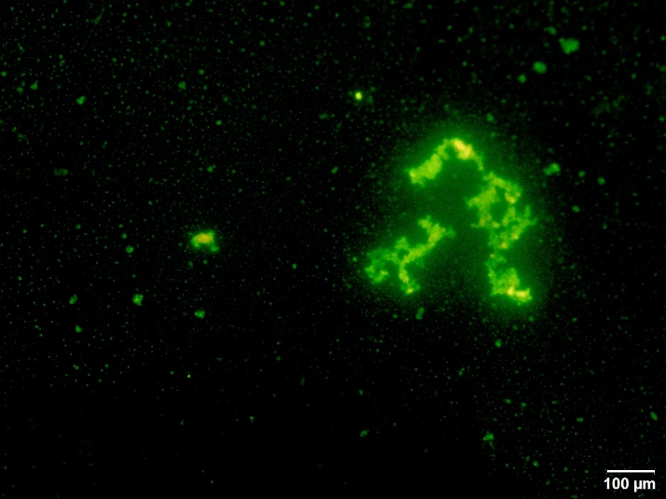
Figure S1. Epifluorescence microscopy of a 2h-biofilm stained with acridine orange. Microbial aggregates and isolated bacteria can be distinguished in green.

DLS results
Dynamic Light Scattering (DLS) results were obtained at 25.0 ± 0.1°C with a Malvern Zetasizer Nano (Malvern Instruments; UK) after appropriate dilutions of the NP suspensions. Each system was analyzed three times. Results are shown in Table S1.
Table S1. DLS analysis of the size of nanoparticle suspension in different aqueous media
Sample | Diameter (nm) | Standard deviation
Al₂O₃-NP in pure water | 388 | 14
Al₂O₃-NP in SIM | 244 | 49
Al₂O₃-NP in SIM | 974 | 186
Al₂O₃-NP in 10 ppm de AH | 727 | 201

E₄₆₅/E₆₆₅ spectroscopic analysis
The spectroscopic E₄₆₅/E₆₆₅ analysis was used to identify possible changes in the aliphatic/aromatic components of the solutions due to the presence of HA ^{5,6,7}. Figure S3 shows that the relationship E₄₆₅/E₆₆₅ measured for different concentrations of HA, without the presence of NP, is nearly constant and ≅ 5. Unlikely, in the liquid filtrate obtained after the exposure of Al₂O₃-NP suspension to different concentrations of HA followed by filtration, revealed that E₄₆₅/E₆₆₅ is close to 3. Thus, the E465/E665 ratio in the liquid filtrate of a Al₂O₃-NP suspension containing HA (HA-Al₂O₃-NP) indicates that the high molecular weight aromatic structures remain in the liquid filtrate and the low molecular weight aromatic compounds containing carboxylic and/or carbonyl groups are adsorbed on the Al₂O₃-NP surface.
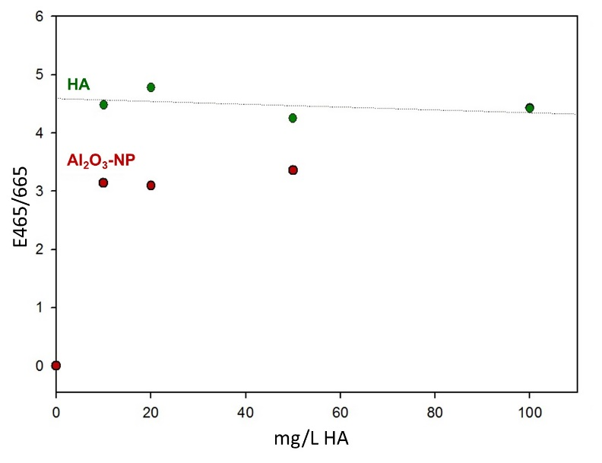
Figure S2. E_{465/665} vs HA concentration for HA solutions (green) and 50 ppm Al₂O₃-NP in HA solutions.

ATR-FTIR spectroscopy
FTIR spectra were obtained with a Bruker EQUINOX 25 spectrometer using KBr disks as holders. Occasionally, spectra were obtained with FT-IR Agilent Cary 630 with ATR Single Bounce. Spectra were taken in the 4000-400 cm⁻¹ range with 1 cm⁻¹ resolution.
In Figure S3 (left) the ATR-IR spectra corresponding to HA, Al₂O₃-NP and the solid phase obtained by centrifugating a 50 ppm Al₂O₃-NP suspension and 10 ppm HA are shown. Figure S3 (right) includes the spectra of the liquid phase obtained after centrifugating a 50 ppm Al₂O₃-NP suspension and that corresponding to the Al₂(SO₄)₃ solution.
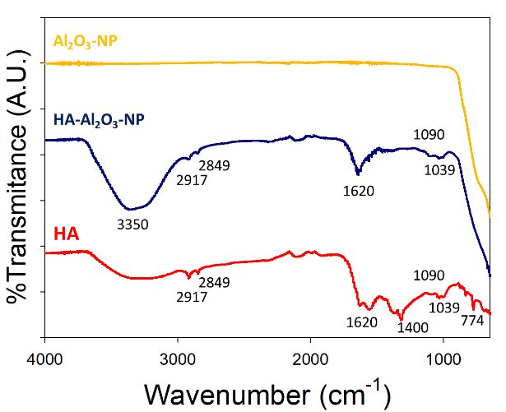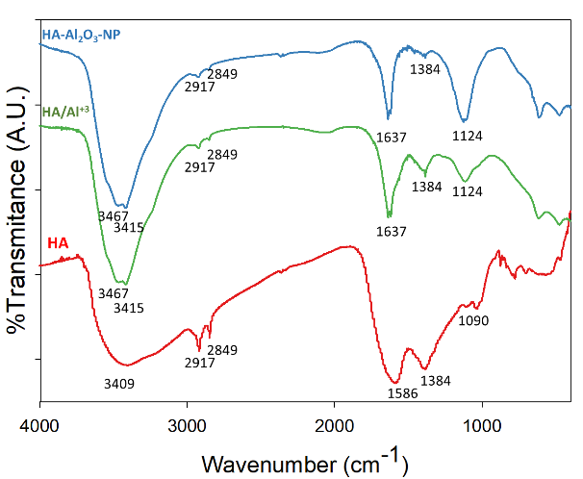
Figure S3. FTIR and ATR spectra.
Left: ATR spectra obtained with Al₂O₃-NP solid phase (yellow), HA-Al₂O₃-NP solid phase after filtration (blue).
Right: FTIR spectra obtained with HA + Al₂(SO₄)₃ solution (green) and HA-Al₂O₃-NP liquid filtrate (light blue).

HA spectrum which characterization has been previously made by Tatzber et al ⁸ is shown in Figure 3. The spectra of the solid phase obtained after filtration of HA-Al₂O₃-NP is also shown in Figure S3 (HA-Al₂O₃-NPs, (left)). The comparison reveals that there are several peaks HA-Al₂O₃-NP spectrum that are not observed in the case of Al₂O₃-NP. Thus, the contributions at 2917, 2849 cm⁻¹ can be attributed to the -CH bond vibration of adsorbed aliphatic molecules. The peak at 1090 cm⁻¹ is generally assigned to the -OH vibration in aliphatic compounds. The band at 1620 suggests the presence of adsorbed phenolic moieties and the signal at 3350 cm⁻¹ is usually assigned to the presence of alcoholic, phenolic and carboxylic groups interacting on the surface.
The supernatant solution (Figure S3, right) obtained from HA-Al₂O₃-NP (HA-Al₂O₃-NP (l)) was also analysed through the evaluation of KBr pellets properly obtained. A 10 ppm HA solution was used as control. A pellet with Al₂(SO₄)₃ + 10ppm HA solution was also employed. The HA sample spectrum showed a broad band in the 3000 - 4000 cm⁻¹ region, with maxima at 3467 and 3415 cm⁻¹ associated to the complex with covalent bonds between Al³⁺ and the HA molecules. On the other hand, the shift of the band at 1586 cm⁻¹ to 1637 cm⁻¹ can be attributed to the carboxylate groups with covalent coordinated bonds formed when HA and Al³⁺ are present ^{9,10}. Additionally, a shift from the 1090 cm⁻¹ (HA) to 1114 and 1124 cm⁻¹ for HA-Al₂(SO₄)₃ and HA-Al₂O₃-NP, respectively, also indicates the formation of coordination complexes between Al³⁺ and the organic aliphatic molecules with -OH groups. Thus, the formation of complexes between Al³⁺ and carboxylates or -OH groups of HA molecules seem to be promoted when the Al₂O₃-NP and HA are present. In the liquid phase the bands in the 1550-1380 nm range are usually attributed to OH of phenols, COO⁻ and –CH₃ groups, amide II and aromatic C=C.

References
1. Manzano M, Zabala ME. El fondo químico natural del sistema acuífero de la cuenca del Río Matanza – Riachuelo. 2012;(September):222.
2. Miñán A, Schilardi PL, Fernández Lorenzo De Mele M. The importance of 2D aggregates on the antimicrobial resistance of Staphylococcus aureus sessile bacteria. Mater Sci Eng C. 2016;61. doi:10.1016/j.msec.2015.12.034
3. Tosato MG, Schilardi P, Lorenzo de Mele MF, Thomas AH, Lorente C, Miñán A. Synergistic effect of carboxypterin and methylene blue applied to antimicrobial photodynamic therapy against mature biofilm of Klebsiella pneumoniae. Heliyon. 2020;6(3):0-5. doi:10.1016/j.heliyon.2020.e03522
4. Rodríguez Sartori D, Bertuola M, Miñán A, Gonik E, Gonzalez MC, De Mele MFL. Environmentally Induced Changes of Commercial Carbon Nanotubes in Aqueous Suspensions. Adaptive Behavior of Bacteria in Biofilms. ACS Omega. 2021;6(8):5197-5208. doi:10.1021/acsomega.0c05114
5. Niu H, Yang H, Tong L. Structural characterization and adsorption capability of carbonaceous matters extracted from carbonaceous gold concentrate. Minerals. 2021;11(1):1-17. doi:10.3390/min11010023
6. Chen J, Gu B, LeBoeuf EJ, Pan H, Dai S. Spectroscopic characterization of the structural and functional properties of natural organic matter fractions. Chemosphere. 2002;48(1):59-68. doi:10.1016/S0045-6535(02)00041-3
7. Tavares MC, Oliveira LC, Pinheiro JP, et al. Organic matter leached from tropical soils by simulated rain, hard (NaOH) and soft (NaNO3) extractions: A realistic study about risk assessment in soils. J Braz Chem Soc. 2021;32(3):534-541. doi:10.21577/0103-5053.20200207
8. Tatzber M, Stemmer M, Spiegel H, et al. FTIR-spectroscopic characterization of humic acids and humin fractions obtained by advanced NaOH, Na4P2O7, and Na 2CO3 extraction procedures. J Plant Nutr Soil Sci. 2007;170(4):522-529. doi:10.1002/jpln.200622082
9. Sadtler Research Laboratories, Simons WW. The Sadtler Handbook of Infrared Spectra. (Simons WW, Son H and, eds.). W.W. Simons, Heyden and Son; 1978.
10. Djebaili K, Mekhalif Z, Boumaza A, Djelloul A, XPS, FTIR, EDX, and XRD Analysis of Al₂O₃ Scales Grown on PM2000 Alloy, J Spectroscopy, 2015, Article ID 868109, 16 pages, 2015. https://doi.org/10.1155/2015/868109,

