Table S1. Summary of one-way ANOVA results for all measured properties of CMC nanocomposite films, including corresponding effect sizes (η²).
Variable | F-value | p-value | η² | Interpretation
Solubility (%) | 108.34 | 8.12×10⁻⁷ | 0.976 | Very strong treatment effect
Moisture (%) | 18.51 | 5.87×10⁻⁴ | 0.874 | Strong effect
Contact angle (°) | 36.64 | 5.07×10⁻⁵ | 0.932 | Very strong effect
WVP (g/m·Pa·s) | 8.98 | 0.0061 | 0.771 | Strong effect
Thickness (µm) | 5.80 | 0.0202 | 0.688 | Moderate-strong effect
ΔE | 39.04 | 4.01×10⁻⁵ | 0.936 | Very strong effect
YI | 37.29 | 4.85×10⁻⁵ | 0.933 | Very strong effect
WI | 18.39 | 5.7×10⁻⁴ | 0.875 | Strong effect
L* | not significant | p > 0.05 | — | No treatment effect
a*, b* | not significant | p > 0.05 | — | Pure hue components unaffected
Ra, RMS, Skewness, Kurtosis, PtV | not significant | p > 0.05 | — | AFM metrics not significantly different

Table S2. Variable contributions (%) to the first two principal components (PC1 and PC2) obtained from PCA of standardized film properties.
Variable | Contribution (%) | Rank
WI | 23.20 | 1
a* | 18.21 | 2
Moisture | 17.39 | 3
ΔE | 16.22 | 4
Thickness | 15.69 | 5
b* | 15.21 | 6
YI | 13.64 | 7
Contact angle | 13.50 | 8
Ra | 12.98 | 9
RMS | 12.87 | 10
Solubility | 11.33 | 11
L* | 8.58 | 12
PtV | 8.20 | 13
Skewness | 5.41 | 14
Kurtosis | 5.06 | 15
*PC1 = 42.36%, PC2 = 22.59%; cumulative variance = 64.95%

Table S3. Cluster membership of CMC nanocomposite films obtained from hierarchical cluster analysis (HCA) using 2-, 3-, and 4-cluster solutions.
Sample ID | k = 2 | k = 3 | k = 4
1 | 1 | 1 | 1
2 | 2 | 2 | 2
3 | 1 | 3 | 3
4 | 2 | 2 | 4
5 | 1 | 1 | 1
6 | 2 | 2 | 2
7 | 1 | 3 | 3
8 | 2 | 2 | 4
9 | 1 | 1 | 1
10 | 2 | 2 | 2
11 | 1 | 3 | 3
12 | 2 | 2 | 4
*Pcu consistently clusters separately at k = 3 and k = 4.

Table S4. PERMANOVA results assessing the global multivariate effect of film formulation on standardized physicochemical, optical, and surface parameters.
Term | Df | Sum Sq | R² | F | p-value
Treatment | 3 | 8986.8 | 0.9963 | 717.46 | 0.253
Residuals | 8 | 33.4 | 0.0037 | — | —

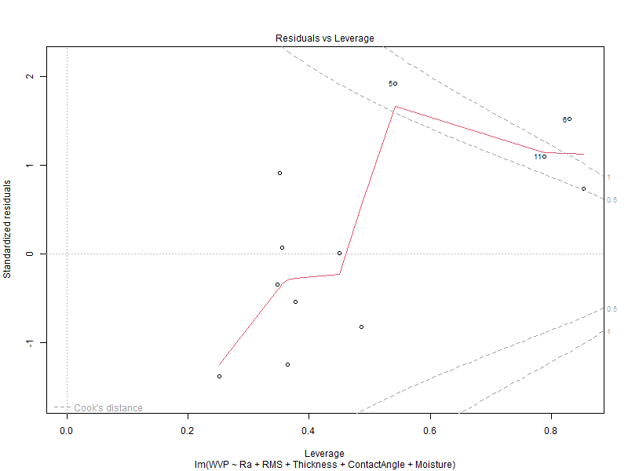
Figure S1. Residual diagnostic plots for the multiple linear regression model predicting water vapor permeability (WVP), including residuals versus fitted values and normal Q–Q plot.

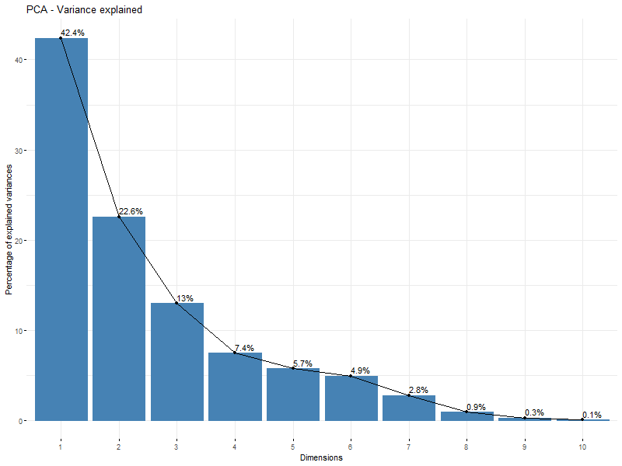
Figure S2. Scree plot of eigenvalues from principal component analysis, showing the proportion of variance explained by each principal component.

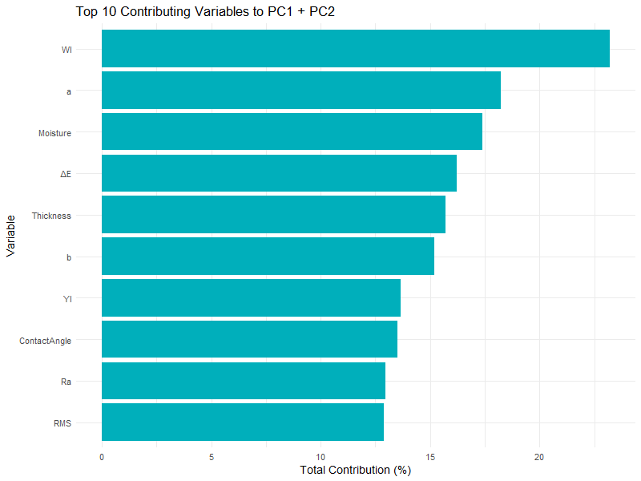
Figure S3. Variables with the highest contributions to PC1 and PC2, highlighting key parameters driving multivariate differentiation among film formulations.

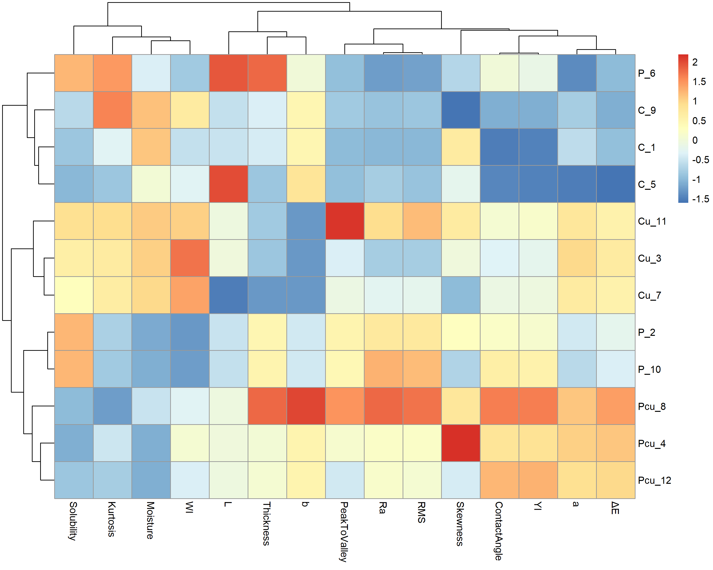
Figure S4. Heatmap of standardized physicochemical, optical, barrier, and AFM parameters for all CMC film formulations.

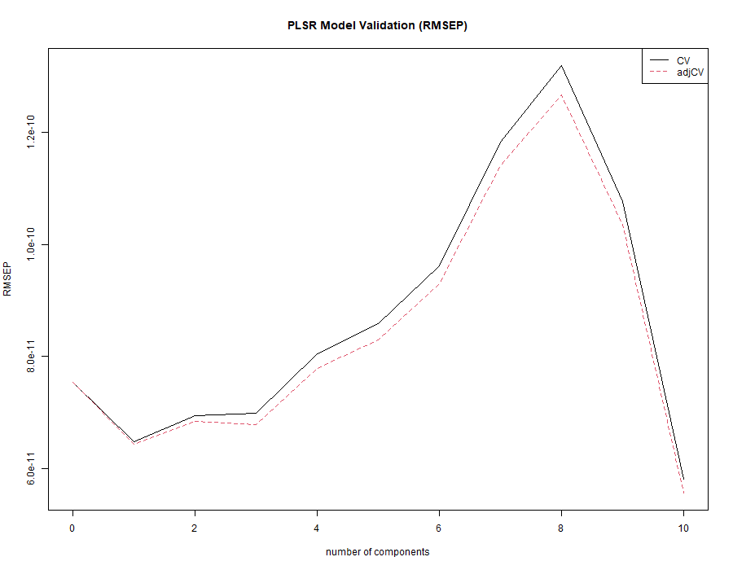
Figure S5. Root mean square error of prediction (RMSEP) as a function of latent components in partial least squares regression (PLSR) modeling of water vapor permeability.

