Supplementary file

Table S1: Classification of Respiratory Diseases with ICD-9-CM and ICD-10-CM Codes
Table S2: Classification of Heart Diseases with ICD-9-CM and ICD-10-CM Codes
Table S3. Table S3. All the cardioselective and non- cardioselective beta-blockers
Figure S1. Variable contribution to propensity score model
Figure S2. Covariate balance before and after adjustment

Table S1. Classification of Respiratory Diseases with ICD-9-CM and ICD-10-CM Codes
Disease Category | ICD-9-CM Codes | ICD-10-CM Codes | Description
COPD | 49120, 49121, 49122 | J440, J441, J449 | Chronic obstructive pulmonary disease, with acute exacerbation
Asthma | 49300, 49301, 49302, 49310, 49312, 49320, 49321, 49322, 49382, 49390, 49391, 49392 | J4520, J4521, J4530, J4531, J4540, J4541, J4550, J4551, J4552, J45901, J45902, J45909, J45991, J45998, J8283 | Various asthma types (mild intermittent, mild persistent, moderate persistent, severe persistent), eosinophilic asthma

Table S2. Classification of Heart Diseases with ICD-9-CM and ICD-10-CM Codes
Disease Category | ICD-9-CM Codes | ICD-10-CM Codes | Description
Heart Failure | 4280, 4281, 42820, 42822, 42823, 42830, 42832, 42833, 42840, 42842, 42843, 4289 | I5082, I5084, I5089, I509, I0981, I5020, I5022, I5023, I5030, I5032, I5033, I5040, I5042, I5043, 39891 | Acute/chronic heart failure, systolic/diastolic heart failure
Arrhythmia | 4270, 4271, 4272, 42731, 42732 | I471, I472, I479, I480, I481, I4811, I4819, I482, I4820, I4821, I483, I484, I4891, I4892, I498 | Atrial fibrillation, supraventricular tachycardia, ventricular tachycardia
Atherosclerotic Heart Disease | 41402, 41401, 41404, 41405, 4144 | I2510, I25110, I25111, I25118, I25119, I2583, I2584 | Coronary atherosclerosis, ischemic cardiomyopathy
Myocardial Infarction | 41001, 41002, 41010, 41011, 41012, 41021, 41022, 41031, 41032, 41040, 41041, 41042, 41051, 41081, 41082, 41090, 41091, 41092, 4110, 412 | I2101, I2102, I2109, I2111, I2119, I2121, I2129, I213, I214, I219, I21A1, I21A9, I220, I221, I222, I228, I229, I232, I234, I235, I236, I238, I240, I252 | Acute MI, MI of different anatomical sites
Angina Pectoris | 4139 | I201, I208, I209, I25110, I25111, I25118, I25119, I25700, I25708, I25709, I25710, I25711, I25718, I25719, I25720, I25721, I25728, I25729, I25790 | Stable and unstable angina
Cardiomyopathy | 4251, 4255, 4257, 4258, 4259, 42511, 42518 | B3324, I255, I420, I421, I422, I425, I426, I427, I429, I43 | Hypertrophic, restrictive, and dilated cardiomyopathy
Heart Disease | 3918, 39890, 40200, 40201, 40210, 40211, 40290, 40291, 41189, 4148, 4149, 4168, 42989, 4299 | I0989, I099, I110, I119, I248, I249, I2510, I25110, I25111, I25118, I25119, I2589, I259, I279 | Broad category of other heart diseases and heart involvement in other conditions
Hypertension | 4010 | I160, I161 | Hypertensive emergency/urgency

Table S3. All the cardioselective and non- cardioselective beta-blockers.
Cardioselective beta-blockers | Non-cardioselective beta-blockers
acebutolol | alprenolol
atenolol | oxprenolol
betaxolol | pindolol
bevantolol | propranolol
bisoprolol | timolol
celiprolol | sotalol
epanolol | nadolol
metoprolol | mepindolol
nebivolol | carteolol
talinolol | tertatolol
practolol | bopindolol
esmolol | bupranolol
landiolol | penbutolol
 | cloranolol

Figure S1. Variable contribution to propensity score model
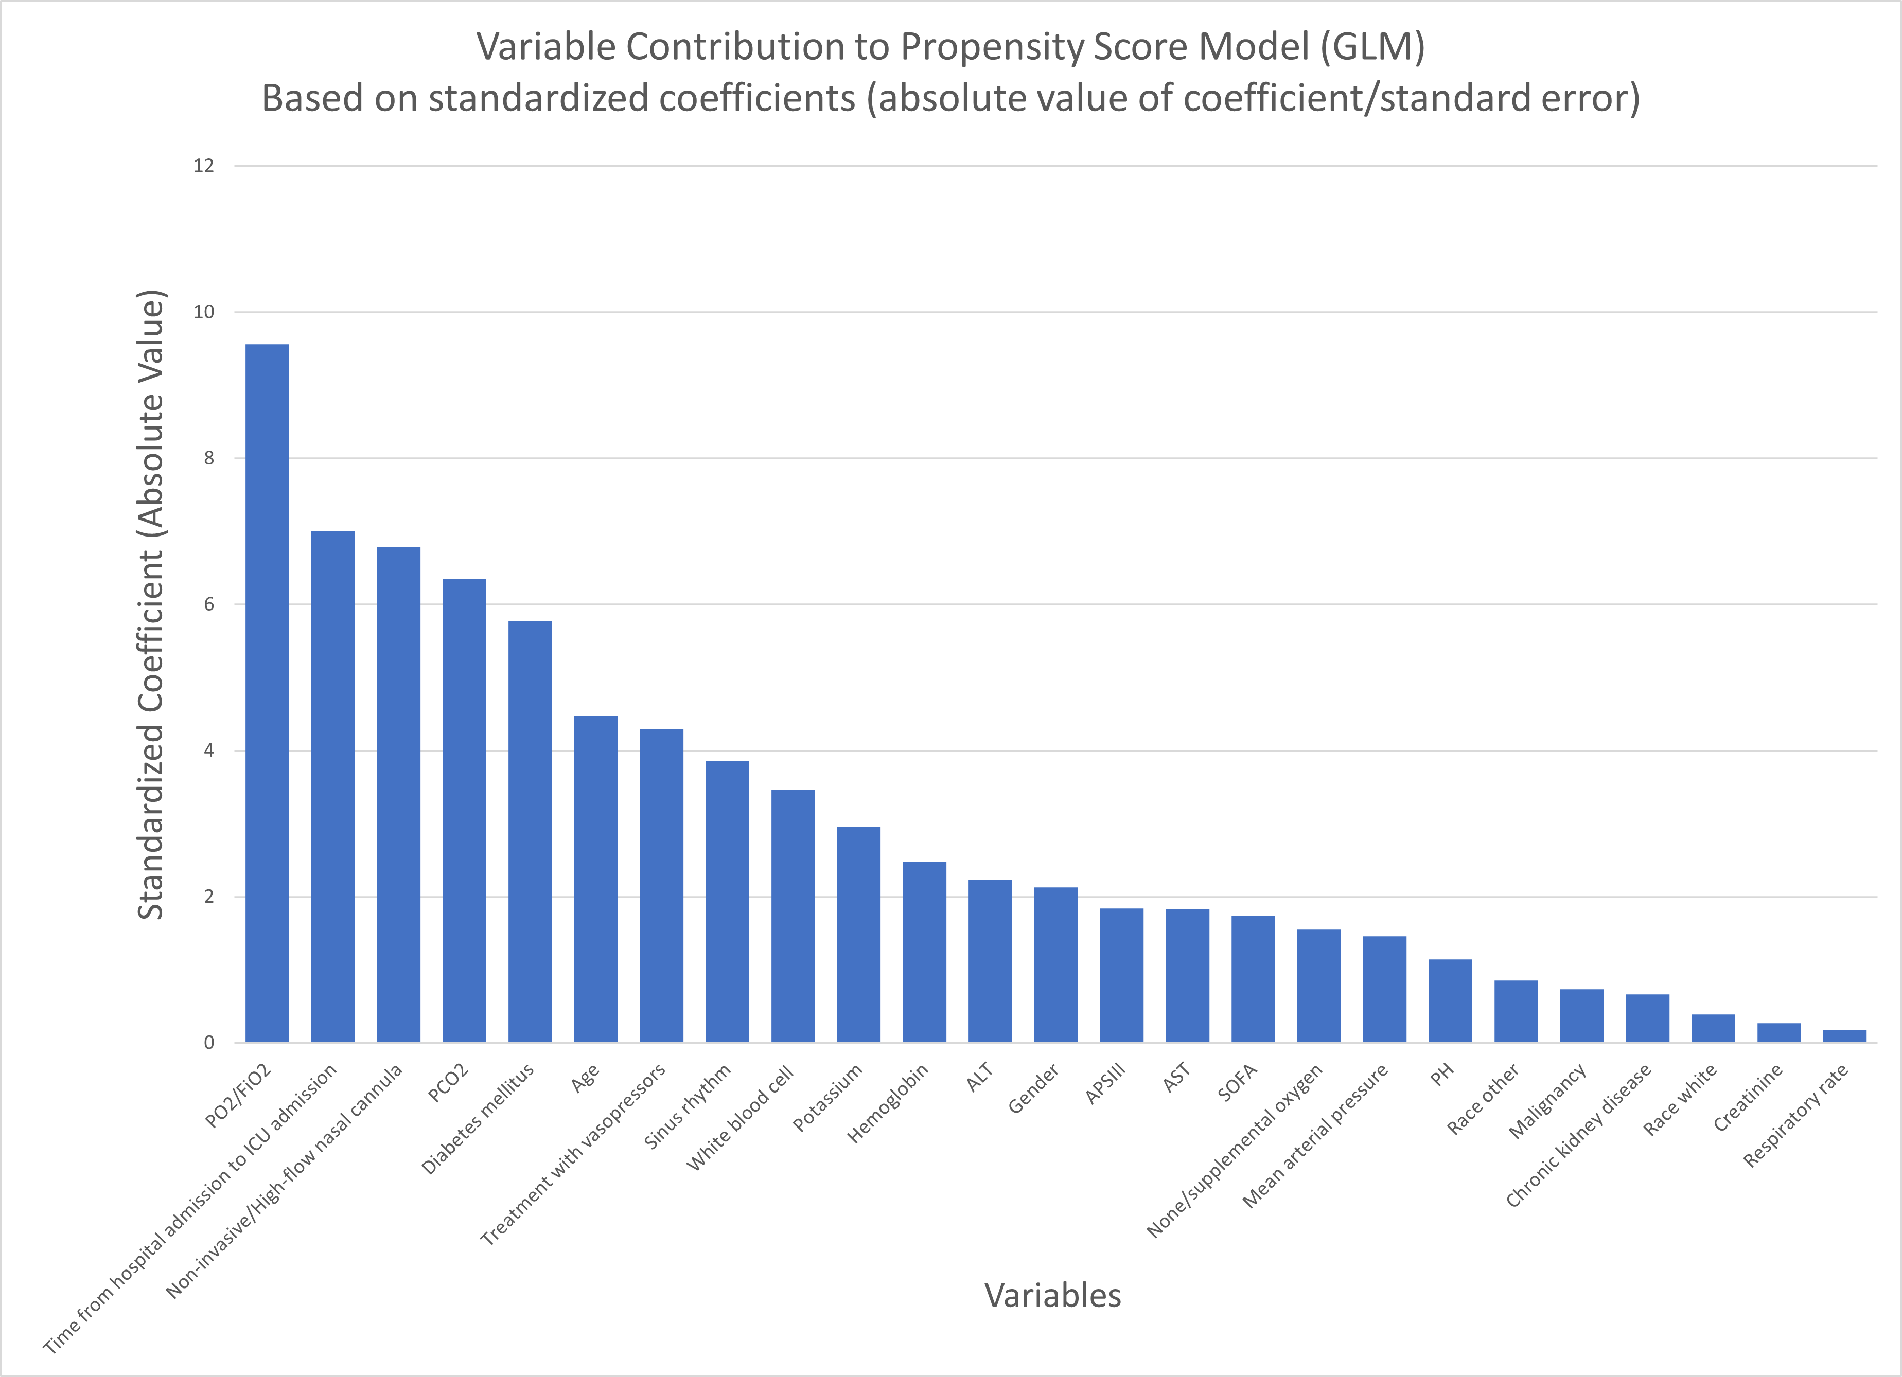
Figure S2. Covariate balance before and after adjustment

