Supplementary files
Description of Halomicrobium halophilum sp. nov., a halophilic archaeon producing exopolysaccharides
Bing-bing Liu^{1†}, Shu-hong Xu^{1†}, Jiang-hao Zhu¹, Zi-qing Chen¹, Rong Shi², Manik Prabhu Narsing Rao^{5*}, Wen-Jun Li^{3,4}*
¹Key Laboratory for Industrial Microbiology of Henan province, School of Biological and Chemical Engineering, Nanyang Institute of Technology, Nanyang 473000, PR China
²Hunan Institute for Drug Control, NMPA Key Laboratory for Pharmaceutical Excipients Engineering Technology Research, Changsha, 410001, PR China
³State Key Laboratory of Biocontrol, Guangdong Provincial Key Laboratory of Plant Stress Biology, School of Life Sciences, Sun Yat-Sen University, Guangzhou 510275, PR China
⁴State Key Laboratory of Ecological Safety and Sustainable Development in Arid Lands, Xinjiang Institute of Ecology and Geography, Chinese Academy of Sciences, Urumqi 830011, PR China
⁵Instituto de Ciencias Aplicadas, Facultad de Ingeniería, Universidad Autónoma de Chile, Centro de Investigación e Innovación, Avenida Del Valle 534, Huechuraba 8581151, Chile
†These authors contributed equally to this work
*Authors for correspondence
Wen-Jun Li
E-mail: liwenjun3@mail.sysu.edu.cn
Manik Prabhu Narsing Rao
E-mail: deene.manik@gmail.com; manik.narsing@uautonoma.cl

Halosimplex rubrum R27^{T} rrnB (KF434757)
Halosimplex pelagicum R2^{T} rrnB (KF434756)
Halosimplex carlsbadense 2-9-1^{T} rrnC (HQ263563)
Halosimplex carlsbadense 2-9-1^{T} rrnD (HQ263564)
Halosimplex pelagicum R2^{T} rrnA (HM159602)
Halosimplex carlsbadense 2-9-1^{T} rrnB (HQ263562)
Halosimplex aquaticum XZYJT29^{T} rrnB (KX585242)
Halosimplex salinum YPL4^{T} rrnA (NR_177327)
Halosimplex aquaticum XZYJT29^{T} rrnA (KX585241)
Halosimplex salinum YPL4^{T} rrnB (NR_177328)
Halosimplex halophilum TH32^{T} (NR_177418)
Halosimplex rubrum R27^{T} rrnA (HM159603)
Halosimplex carlsbadense 2-9-1^{T} rrnA (HQ263561)
Halomicrobium zhouii TBN51^{T} rrnC (HQ215547)
YIM-93990^{T} rrnA (PV350694)
YIM-93990^{T} rrnB (PV350695)
Halomicrobium zhouii TBN51^{T} rrnA (HM063952)
Halomicrobium zhouii TBN51^{T} rrnB (HQ215546)
Halomicrobium mukohataei JCM9738^{T} rrnA (EF645690)
Halomicrobium salinisoli LT50^{T} rrnB (MZ798423)
Halomicrobium mukohataei JCM9738^{T} rrnB (EF645691)
Halomicrobium salinisoli LT50^{T} rrnC (MZ798429)
Halomicrobium salinisoli LT50^{T} rrnA (KM496559)
Halomicrobium urmianus DC8^{T} (KM596805)
Methanospirillum hungatei JF-1^{T} (NR_074177)
99
100
99
91
58
90
97
75
94
99
100
97
93
54
81
82
99
0.02

Fig. S1. Neighbor-joining phylogenetic tree based on 16S rRNA gene sequence showing the relationships between strain YIM 93990^{T} and closely related species. Bootstrap values (expressed as percentages of 1000 replications) greater than 50 % are shown at branch points. Bar, 0.02 substitutions per nucleotide position. Methanospirillum hungatei JF-1^{T} was used as an outgroup.

Halosimplex aquaticum XZYJT29^{T} rrnA (KX585241)
Halosimplex salinum YPL4^{T} rrnB (NR_177328)
Halosimplex halophilum TH32^{T} (NR_177418)
Halosimplex rubrum R27^{T} rrnA (HM159603)
Halosimplex carlsbadense 2-9-1^{T} rrnA (HQ263561)
Halosimplex carlsbadense 2-9-1^{T} rrnB (HQ263562)
Halosimplex pelagicum R2^{T} rrnA (HM159602)
Halosimplex carlsbadense 2-9-1^{T} rrnD (HQ263564)
Halosimplex carlsbadense 2-9-1^{T} rrnC (HQ263563)
Halosimplex rubrum R27^{T} rrnB (KF434757)
Halosimplex pelagicum R2^{T} rrnB (KF434756)
Halosimplex aquaticum XZYJT29^{T} rrnB (KX585242)
Halosimplex salinum YPL4^{T} rrnA (NR_177327)
Halomicrobium zhouii TBN51^{T} rrnC (HQ215547)
YIM-93990^{T} rrnA (PV350694)
YIM-93990^{T} rrnB (PV350695)
Halomicrobium salinisoli LT50^{T} rrnC (MZ798429)
Halomicrobium salinisoli LT50^{T} rrnB (MZ798423)
Halomicrobium salinisoli LT50^{T} rrnA (KM496559)
Halomicrobium urmianus DC8^{T} (KM596805)
Halomicrobium zhouii TBN51^{T} rrnA (HM063952)
Halomicrobium zhouii TBN51^{T} rrnB (HQ215546)
Halomicrobium mukohataei JCM9738^{T} rrnA (EF645690)
Halomicrobium mukohataei JCM9738^{T} rrnA (EF645690)
Methanospirillum hungatei JF-1^{T} (NR_074177)
89
82
64
72
99
65
55
66
94
84
100
78
54
65
56

Fig. S2. Maximum-parsimony phylogenetic tree based on 16S rRNA gene sequence showing the relationships between strain YIM 93990^{T} and closely related species. Bootstrap values (expressed as percentages of 1000 replications) greater than 50 % are shown at branch points. Methanospirillum hungatei JF-1^{T} was used as an outgroup.

Halosimplex carlsbadense JCM 11222^{T} (AB477192)
Halosimplex pelagicum R2^{T} (KF434759)
Halosimplex rubrum R27^{T} (KF434760)
Halosimplex litoreum YGH94^{T} (KJ921126)
Halosimplex halophilum TH32^{T} (MF458300)
Halosimplex salinum YPL4^{T} (MH324936)
Halosimplex aquaticum XZYJT29^{T} (OP751022)
Halomicrobium urmianum DC8^{T} (KP276262)
Halomicrobium salinisoli LT50^{T} (MF447867)
Halomicrobium mukohataei JCM 9738^{T} (AB477172)
YIM 93990^{T} (PX270318)
Halomicrobium zhouii TBN51^{T} (JN120804)
Methanospirillum hungatei JF-1^{T} (NC_007796)
100
100
66
70
91
100
69
73
97
64
0.05

Fig. S3. Neighbor-joining phylogenetic tree based on rpoB' gene sequence showing the relationships between strain YIM 93990^{T} and closely related species. Bootstrap values (expressed as percentages of 1000 replications) greater than 50 % are shown at branch points. Bar, 0.05 substitutions per nucleotide position. Methanospirillum hungatei JF-1^{T} was used as an outgroup.

Halosimplex pelagicum R2^{T} (KF434759)
Halosimplex rubrum R27^{T} (KF434760)
Halosimplex carlsbadense JCM 11222^{T} (AB477192)
Halosimplex litoreum YGH94^{T} (KJ921126)
Halosimplex halophilum TH32^{T} (MF458300)
Halosimplex salinum YPL4^{T} (MH324936)
Halosimplex aquaticum XZYJT29^{T} (OP751022)
Halomicrobium urmianum DC8^{T} (KP276262)
Halomicrobium salinisoli LT50^{T} (MF447867)
Halomicrobium mukohataei JCM 9738^{T} (AB477172)
YIM 93990^{T} (PX270318)
Halomicrobium zhouii TBN51^{T} (JN120804)
Methanospirillum hungatei JF-1^{T} (NC_007796)
100
98
68
64
62
90
78
90
0.05

Fig. S4. Maximum-likelihood tree based on rpoB' gene sequence showing the relationships between strain YIM 93990^{T} and closely related species. Bootstrap values (expressed as percentages of 1000 replications) greater than 50 % are shown at branch points. Bar, 0.05 substitutions per nucleotide position. Methanospirillum hungatei JF-1^{T} was used as an outgroup.

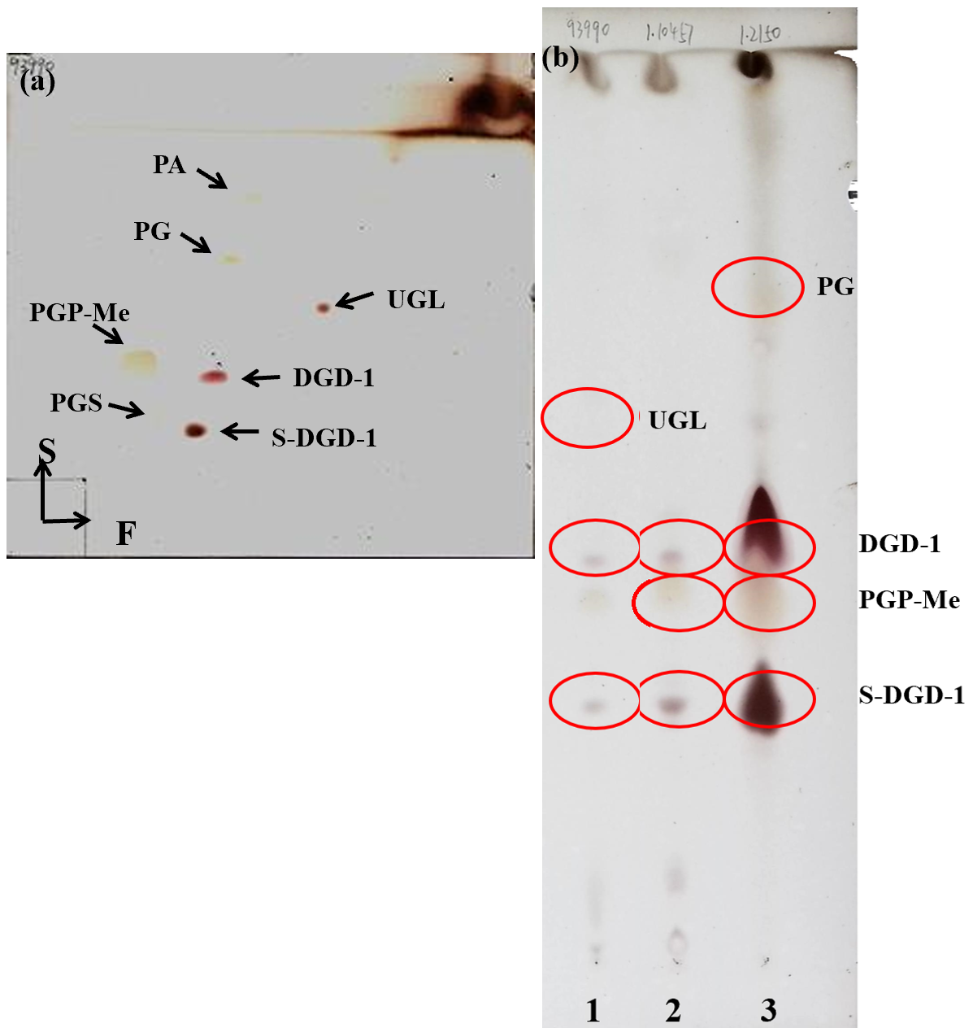
Fig. S5. Polar lipids profile of: 1) strain YIM 93990^{T}, 2) Halomicrobium zhouii CGMCC 1.10457^{T}, 3) Haloferax volcanii CGMCC 1.2150^{T}. a) Two-dimensional thin-layer chromatography (TLC) with the conditions as follows: Silica Gel 60 thin-layer plates (10×10cm) were spotted with 10.0 μl of a whole-cell lipid extract. Chloroform/methanol/water (65:25:4, by vol) was used in the first direction, and chloroform/acetic acid/methanol/water (80:18:12:5, by vol) was used in the second direction. The plate was sprayed with phosphomolybdate reagent, followed by heating at 150 ºC for 3 min to detect all polar lipids. b) Single-dimensional TLC with the exhibition layer agent chloroform/acetic acid/methanol/water (80:25:12:5, by vol). Abbreviation: Phosphatidic acid (PA), phosphatidylglycerol (PG), phosphatidylglycerol phosphate methyl ester (PGP-Me), phosphatidylglycerol sulfate (PGS), mannosyl glucosyl diether (DGD-1), sulfated mannosyl glucosyl diethers (S-DGD-1), and unidentified glycolipid (UGL).

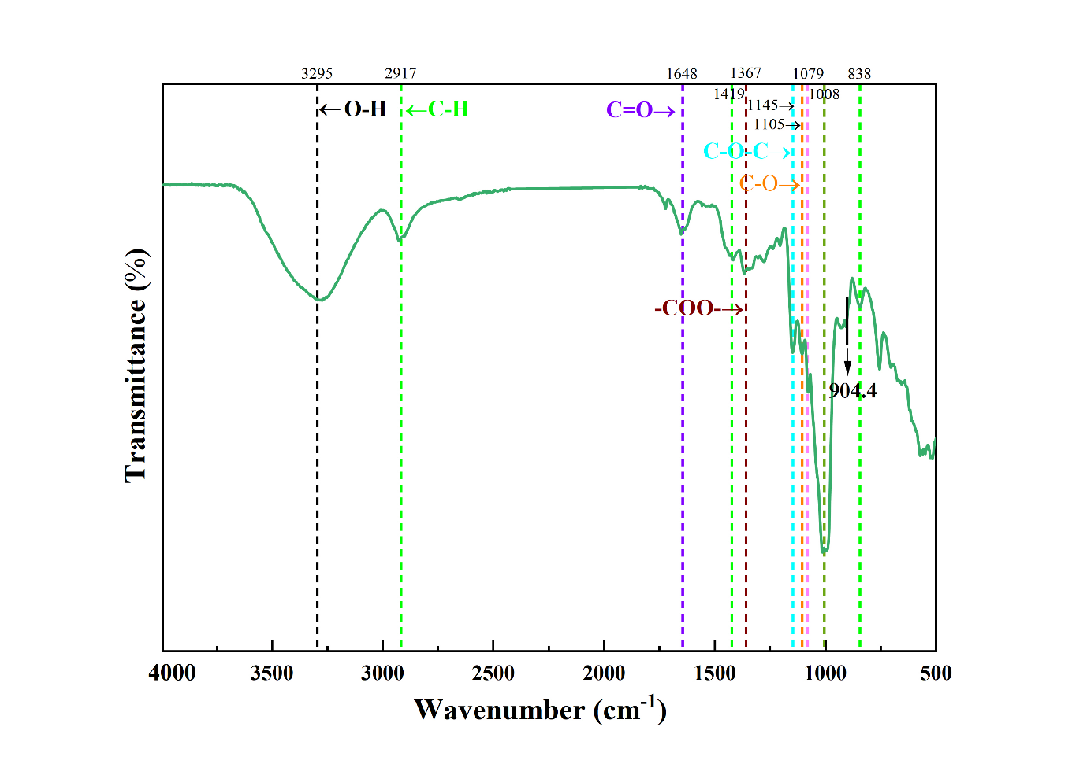
Fig. S6. Fourier transform infrared spectroscopy of strain YIM 93990^{T} EPS.

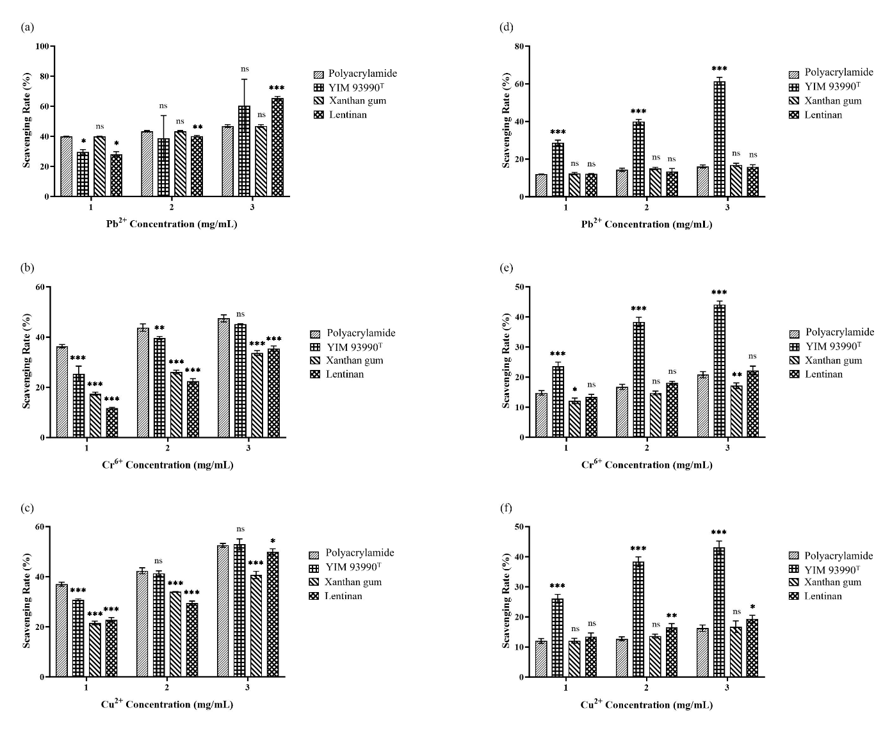
Fig. S7. Metal removal rates. 1) 1 mg/ml concentration, 2) 2 mg/ml concentration, 3) 3 mg/ml concentration.

