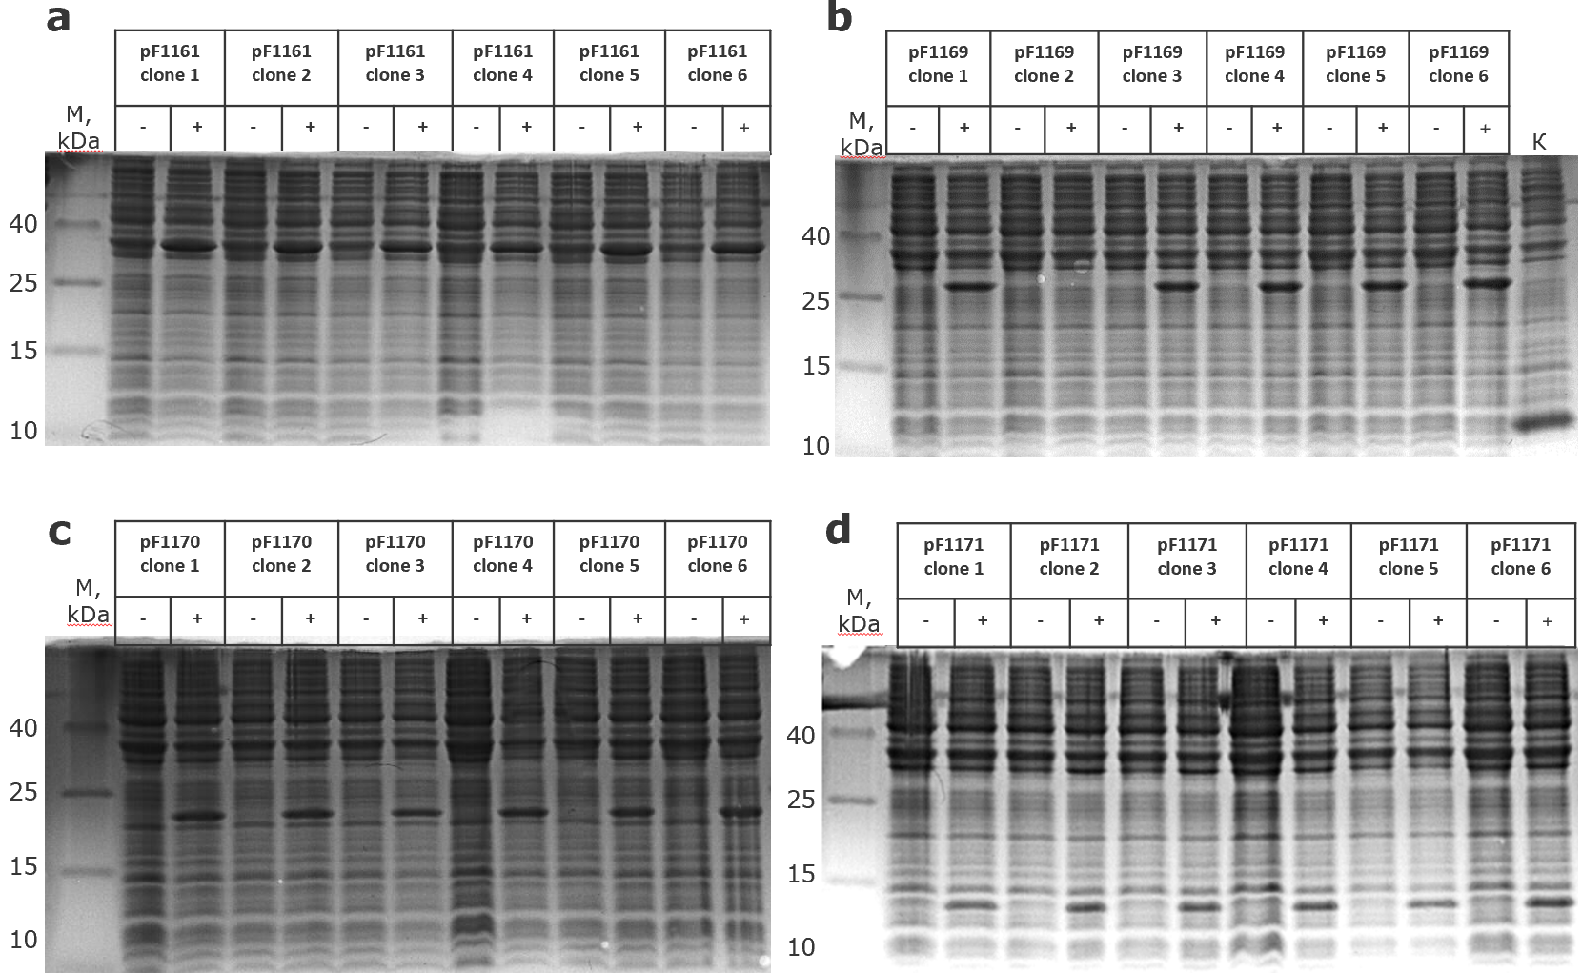
Fig. 1 SDS-PAGE of six clones: A - BL21\pF1161; B - BL21\pF1169; C - BL21\pF1170; D - BL21\pF1171

