Supplementary Materials for

A Novel Gain-of-Function Mutation in BMPR2 in a Patient with Variant Fibrodysplasia Ossificans Progressiva
Myung-Jin Kim¹*, Eunyoung Jung¹*, Dayeon Kim¹, Nayoung Oh¹, Chang Ho Shin², Hye Ran Lee², Yoon-Young Kim³, Hyun Mo Ryoo⁴, Suk-Won Jin^{5,6}, Young Yang¹, Woong Yang Park⁷, Jungmin Lee⁸, Frederick S. Kaplan⁹, Tae-Joon Cho^{2,10,#} and Yonghwan Kim^{1,#}

#Co-corresponding author. E-mail: yhkim@sookmyung.ac.kr (Y.K.); tjcho@snu.ac.kr (T.J.C.)

Including,
Supplementary Materials and Methods
Fig. S1. Scheme of BMPR2 genomic DNA editing induced by CRISPR-Cas9 in patient-derived fibroblasts
Fig. S2. Generation of iPSCs from patient-derived fibroblasts
Fig. S3. Differentiation of MSCs from established iPSCs
Fig. S4. mRNA level of TGF-β signaling target genes
Fig. S5. Depletion of type I or type II TGF-β receptors by siRNA in BMPR2E376K variant results in repression of SMAD activation
Fig. S6. Osteogenic differentiation ability of BMP/SMAD signal hyper-activated by BMPR2E376K variant in C2C12 cells.
Table S1. qPCR primer list.

Supplementary Materials and Methods
CRISPR-Cas9 mediated gene correction
Along with 10 μM single-stranded oligodeoxynucleotides (ssODN) donor template, 4 μg of S.pyogenes Cas9 (SpCas9) protein and 1 μg of guide RNA selectively targeting mutated allele of FOP patients were prepared as RNP complex and delivered into fibroblasts obtained from patients with Neon electroporator (Invitrogen). Target sequence for CRISPR-Cas9 is as follows; 5’-agataatgcagccataagcaagg-3’ (PAM sequence:underlined). To distinguish the corrected allele from wild type and to prevent the recurrent cleavage, donor template was designed as follows; 5’- ccatgaggctgactggaaatagactggtgcgcccaggggaggaagataatgcagccatCTCcgaggtgagtgtatacaaaaggtatcacactgatgtactttgaaatgataatttaatta (upper underlined: codon matched sense mutation, italic underlined: corrected base). 1 week after electroporation, frequency of properly corrected allele from pooled fibroblasts were analyzed by targeted deep sequencing. Based on that frequency, cells were dissociated and re-plated in 96-well plates at the density of 1/3 cell per well to obtain single cell colony. After single cell colony isolation, gDNAs of each clone were harvested and analyzed by targeted deep sequencing, and proper colonies were selected for further experiments.
Targeted deep sequencing
To quantify Indel ratio and analyze the sequence after CRISPR-Cas9 treatments, target region was amplified with PCR primers hybridizing the target amplicon sequences with illumina barcode sequences by nested PCR. PCR products were purified, denatured by NaOH, and subjected to 2x250 paired-end sequencing with an Illumina MiSeq. Paired-end reads from MiSeq were analyzed by Cas-Analyzer (http://www.rgenome.com). PCR primers used in this experiment were as follows; hBMPR2 E7 F1: 5’- gcctccttttacagccctat-3’, hBMPR2 E7 R1: 5’- aactttacccttgcctcaaa-3’, hBMPR2 E7 dF1: 5’- ACACTCTTTCCCTACACGACGCTCTTCCGATCTacagcagaaatgtcctag, hBMPR2 E7 dR1: 5’- GTGACTGGAGTTCAGACGTGTGCTCTTCCGATCTctctttaccttaggtgat.
Establishment of iPSCs from patient-derived cells
A total of 1x10⁶ fibroblasts (BJ as controls, FOP BMPR2-E376K patient-derived, and gene-corrected BMPR2-restored) were dissociated into single cells using 0.5% trypsin-EDTA (Invitrogen). The cells were transfected with three reprogramming plasmids (pCXLE-hOCT4-shp53, pCXLE-hSK, pCXLE-hUL; Addgene, Cambridge, MA, USA), each at 1 µg, using the Neon Transfection System (Invitrogen) under the following conditions: pulse voltage 1650V, pulse width 10 ms, and pulse number 3.
The transfected cells were seeded into 6 cm culture dishes and cultured in fibroblast culture medium for 5 days. After 5 days, the cells were seeded onto vitronectin-coated 6-well plates at a density of 1x10⁴ cells per well and cultured in fibroblast culture medium for an additional 24 h. Vitronectin coating was prepared by adding 1 mL of 5 µg/mL vitronectin solution to each well and incubating at room temperature for at least 1 h. After 24 h, the medium was replaced with human iPSC induction medium (TeSR™-E7™ Medium; STEMCELL Technologies), and the medium was refreshed daily for 2~3 weeks. During this period, colonies resembling human embryonic stem cells appeared. These colonies were harvested and transferred to new vitronectin-coated dishes and cultured in iPSC maintenance medium (TeSR™-E8™ Medium; STEMCELL Technologies). For routine passaging, non-enzymatic dissociation was performed by adding 0.5 mM EDTA to the culture dish for approximately 5 min at room temperature to detach iPSC clumps, which were then reseeded onto vitronectin-coated plates.
Differentiation of MSCs from established iPSCs
Undifferentiated iPSCs were treated with collagenase IV (10 mg/mL, Worthington Biochemical Corporation) at 37°C for 10 min to detach the cells from the culture dish. The detached cells were cultured as clumps in suspension in 6 cm petri dishes for 7 days to form embryoid bodies (EBs). During EB formation, the culture medium consisted of DMEM/F12, 10% KnockOut Serum Replacement, 100 U/mL penicillin-streptomycin, 0.1 mM NEAA, and 0.1 mM β-mercaptoethanol (all from Invitrogen). On day 7 of EB formation, the EBs were plated onto culture dishes coated with 0.1% gelatin (Sigma) and replaced with MSC differentiation medium consisting of MEM-alpha, 10% FBS, 100 U/mL penicillin-streptomycin (all from Invitrogen), supplemented with 2% B27, 1% ITS (Insulin-Transferrin-Selenium), and 1% chemically defined lipid concentrate. Cells with morphology similar to MSCs were observed between 7 and 10 days after switching to the differentiation medium. Approximately 2 weeks after the start of differentiation, the cells were washed with 1X PBS and dissociated using 0.5% Trypsin-EDTA. The cells were then cultured in MSC expansion medium, consisting of MEM-alpha, 10% FBS, and 100 U/mL penicillin-streptomycin, to establish MSCs.
Flow cytometry
0.5 x 10⁶ MSCs were resuspended in 500 μL of phosphate-buffered saline (PBS) and incubated for 30 min at 4℃ with 1:100 dilution of antibodies, CD34 (Cat#368512), CD73 (Cat#344006), CD90 (Cat#328110), and CD105(Cat#323208) from Biolegend, respectively. After washing twice with 1 mL of PBS, the labelled MSCs were resuspended in 500 μL of PBS and subjected to flow cytometry for analysis. Acquisitions were carried out using a AttuneTM NxT Flow Cytometer (ThermoFisher).

Supplementary Figures
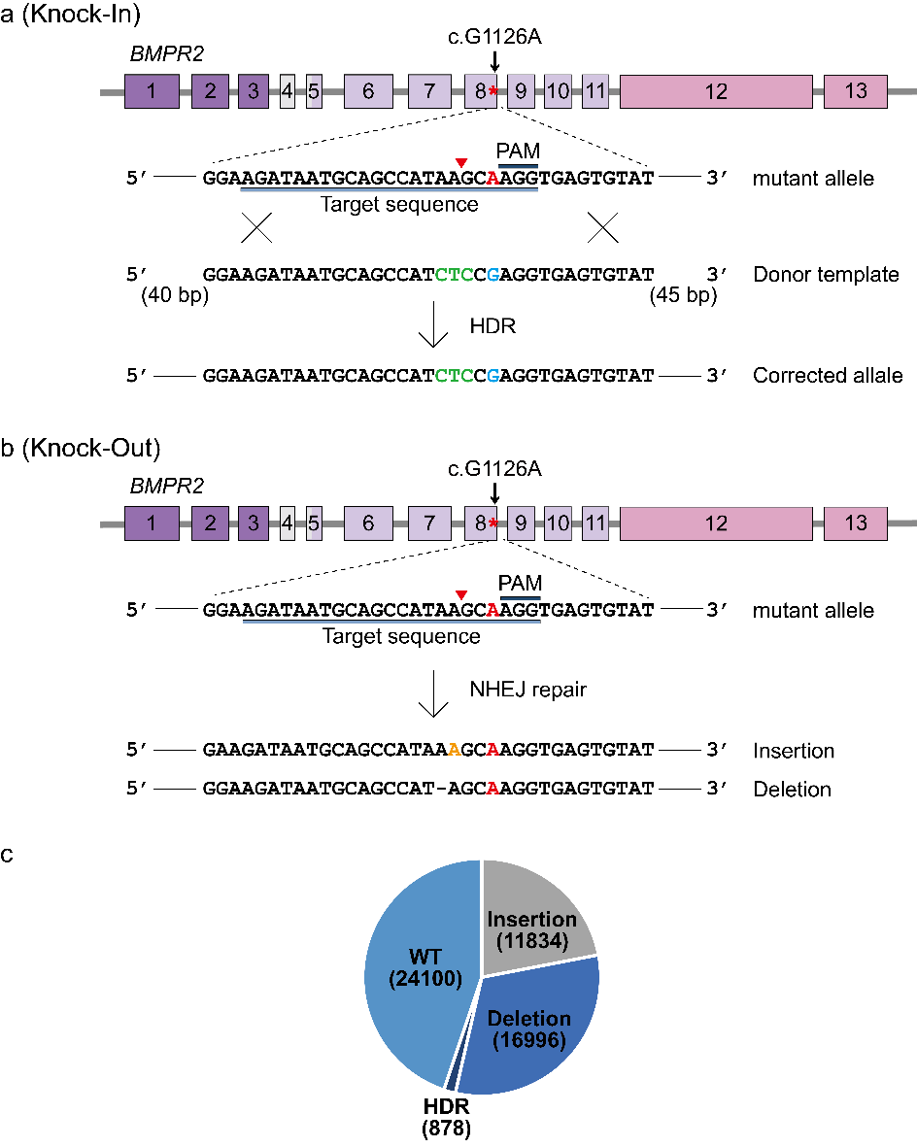

Fig. S1. Scheme of BMPR2 genomic DNA editing induced by CRISPR-Cas9 in patient-derived fibroblasts.
A plus strand single-guide RNA (sgRNA, light blue box) sequence targeting BMPR2 exon 8 in the region that corresponds to G to A (red text) missense mutation site was designed adjacent to a Protospacer Adjacent Motif (PAM, dark blue box). Precise cleavage of the third nucleotide (a red arrowhead) from PAM by RNA-guided Cas9 induced double-strand breaks (DSB) in the BMPR2 mutant allele. The DSB is repaired by one of two general repair pathways: homology directed repair (HDR) and non-homologous end joining (NHEJ). a HDR generates a specific single nucleotide modification by using a knock-in donor template (120 mer) with synonymous mutations (CTC, green text) and wildtype G nucleotide (blue text). b NHEJ-mediated DSB repair frequently induces nucleotide insertions or deletions at the DSB site of BMPR2 mutant allele that causes amino acid insertions, deletions, or frameshift mutations leading to premature stop codons within the open reading frame of BMPR2 gene. c Patterns of deep sequencing reads induced by sgRNA of BMPR2 mutant allele. The efficiency of HDR from the pool of deep sequencing reads was about 1.63%. Indels of the total reads were about 53.6%.
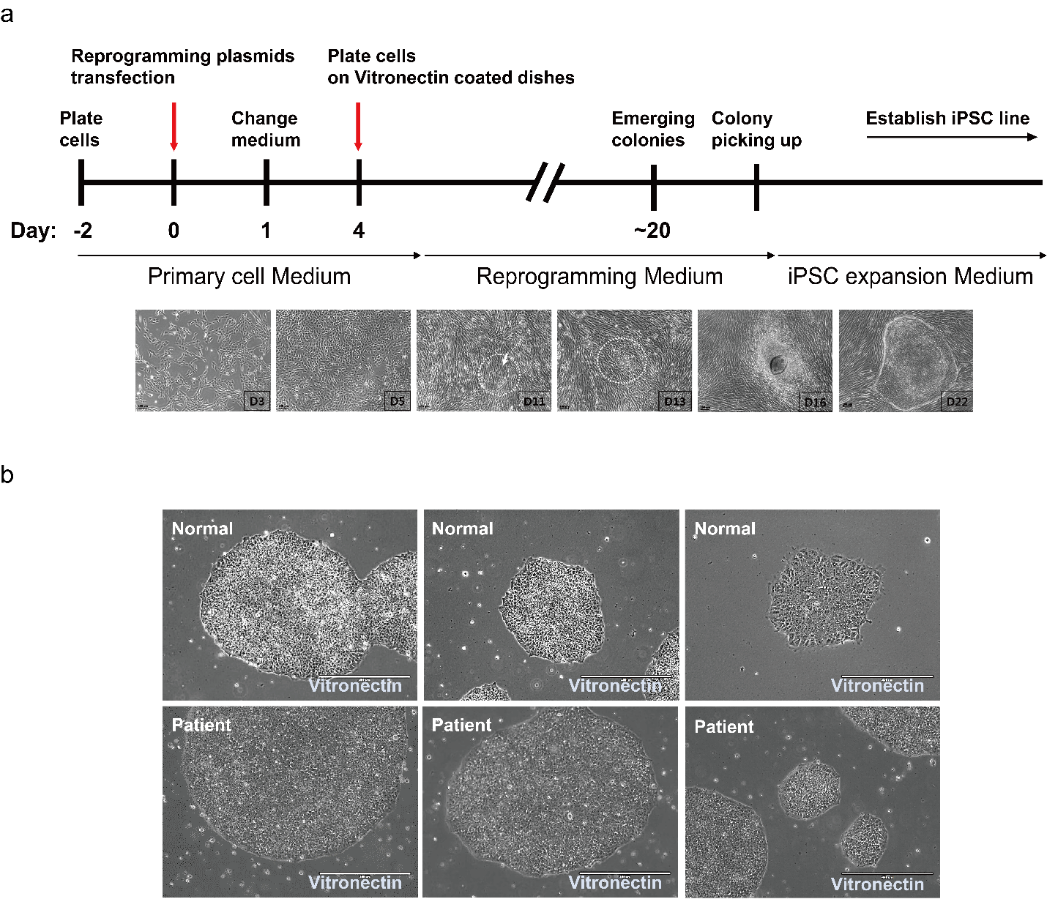

Fig. S2. Generation of iPSCs from patient-derived fibroblasts.
a Generation schedule of iPSCs from normal BJ and FOP patient-derived BMPR2-E376K fibroblasts. Fibroblasts (1x10⁶ cells) were dissociated into single cells and transfected with three reprogramming plasmids such as pCXLE-hOCT4-shp53, pCXLE-hSK, and pCXLE-hUL. The transfected cells were seeded onto 6-well plates coated with vitronectin solution (5 µg/ml) at a density of 1x10⁴ cells per well. After culturing fibroblasts, the medium was replaced with human iPSC induction medium (TeSRTM-E7TM). After 2-3 weeks, colonies with morphology similar to human embryonic stem cells were observed. Scale bar is 100 μm. b The harvested colonies from normal and patient were transferred to new dishes coated with vitronectin and cultured in iPSC medium (TeSRTM-E8TM). The colonies were passaged to establish iPSCs. Scale bar is 400 μm.

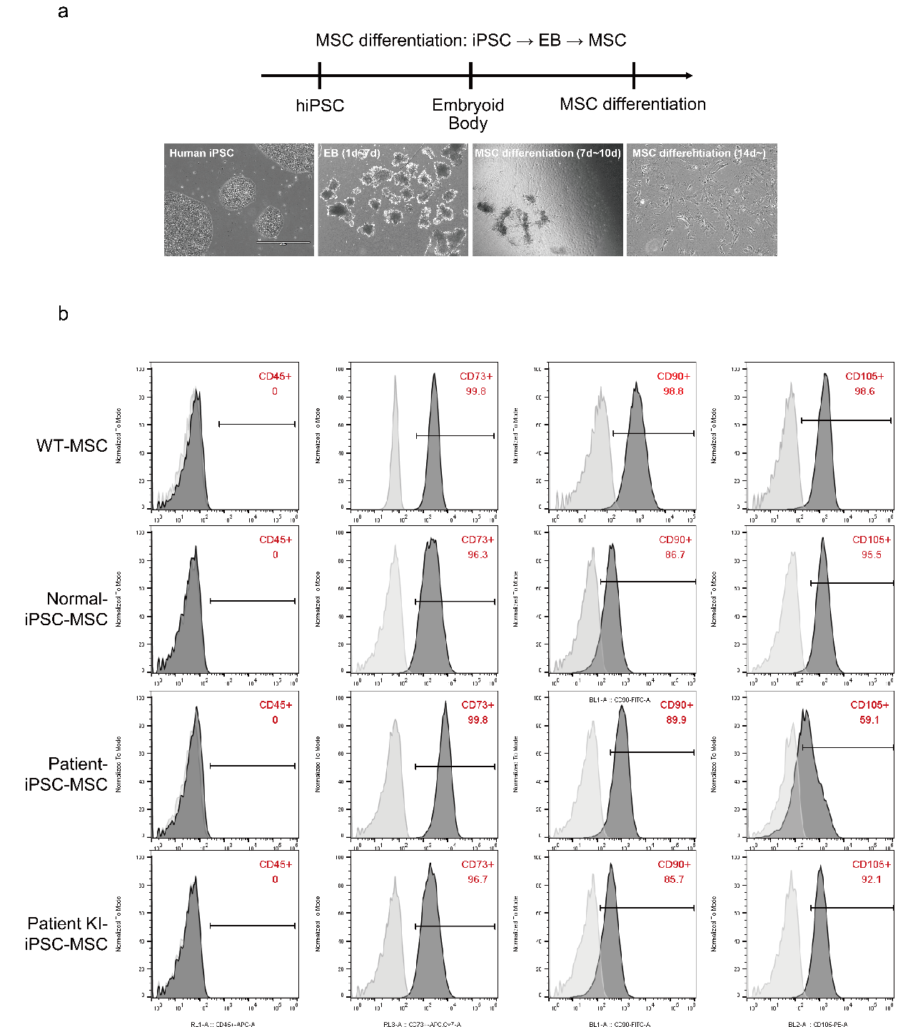

Fig. S3. Differentiation of MSCs from established iPSCs.
a Undifferentiated iPSCs were treated with collagenase IV at 37°C for 10 min to detach cells from the culture dish. The cells were then cultured as clump types in suspension for 7 days to form embryoid bodies. On day 7 of embryoid body formation, the clumps were plated onto gelatin-coated dishes and cultured in MSC differentiation medium. After 7-10 days, cells with MSC-like morphology were observed. These cells were further expanded in MSC culture medium to establish MSCs. Scale bar is 400 μm. b To validate the established MSCs, the expression of MSC surface markers, CD73, CD90, and CD105, was analyzed using flow cytometry.

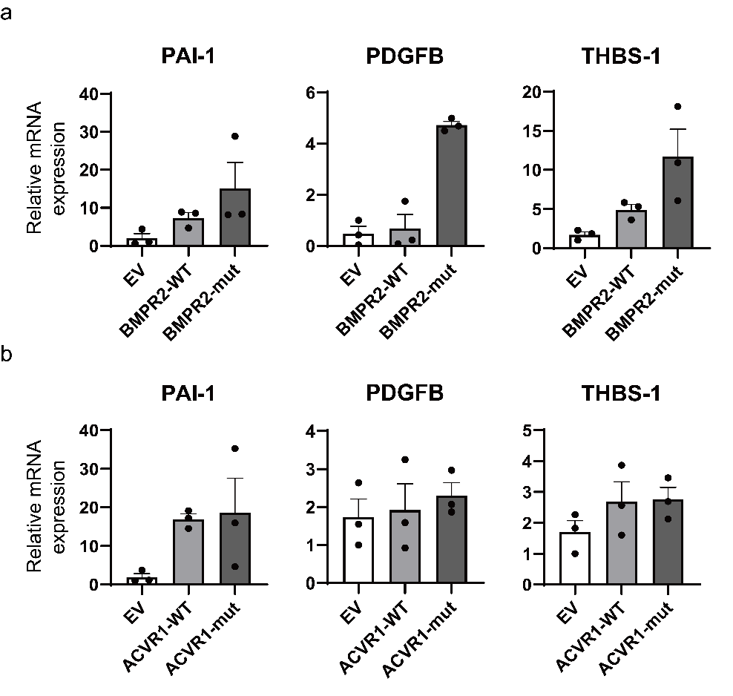

Fig. S4. mRNA level of TGF-β signaling target genes.
a-b To examine mRNA expression pattern of TGF-β signaling regulated by FOP-causative variants, (a) empty vector (EV), BMPR2^{WT,} or BMPR2^{E376K}, (b) EV, ACVR1^{WT}, or ACVR1^{R206H} construct was transiently transfected into HEK293T cells. Expression level of TGF-β target genes including PAI-1, PDGFB, and THBS-1 was measured by RT-qPCR. Error bars indicate the standard deviation of three replicates. Data are the mean ± SEM (n=3).

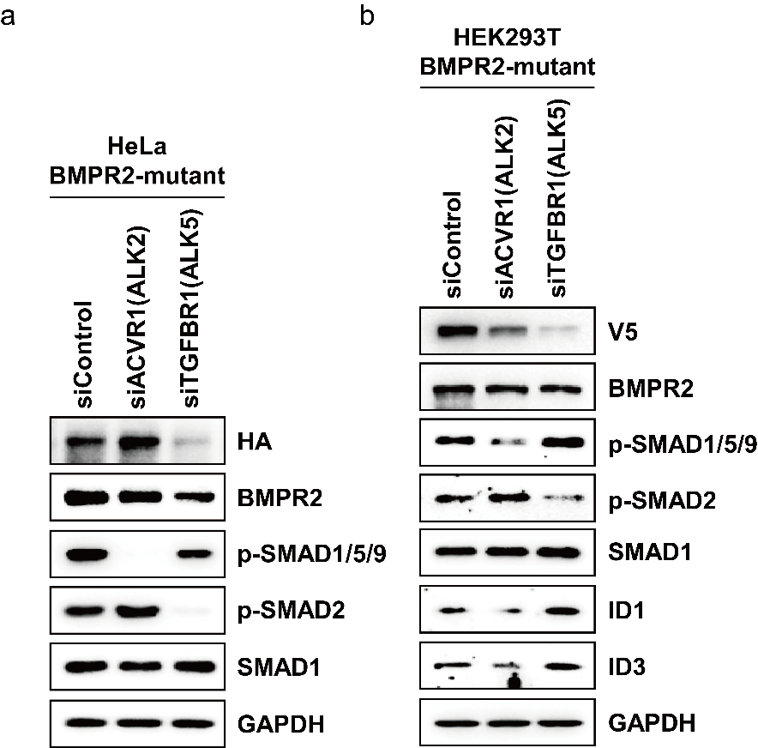

Fig. S5. Depletion of type I or type II TGF-β receptors by siRNA in BMPR2^{E376K} variant results in repression of SMAD activation.
a-b HeLa (a) and HEK293T (b) cells expressing BMPR2^{E376K} variant were transfected with siRNA for ACVR1 (ALK2) or TGFBR1 (ALK5), a type I receptor and then phosphorylation of SMAD1/5/9 and SMAD2 were detected by western blotting.

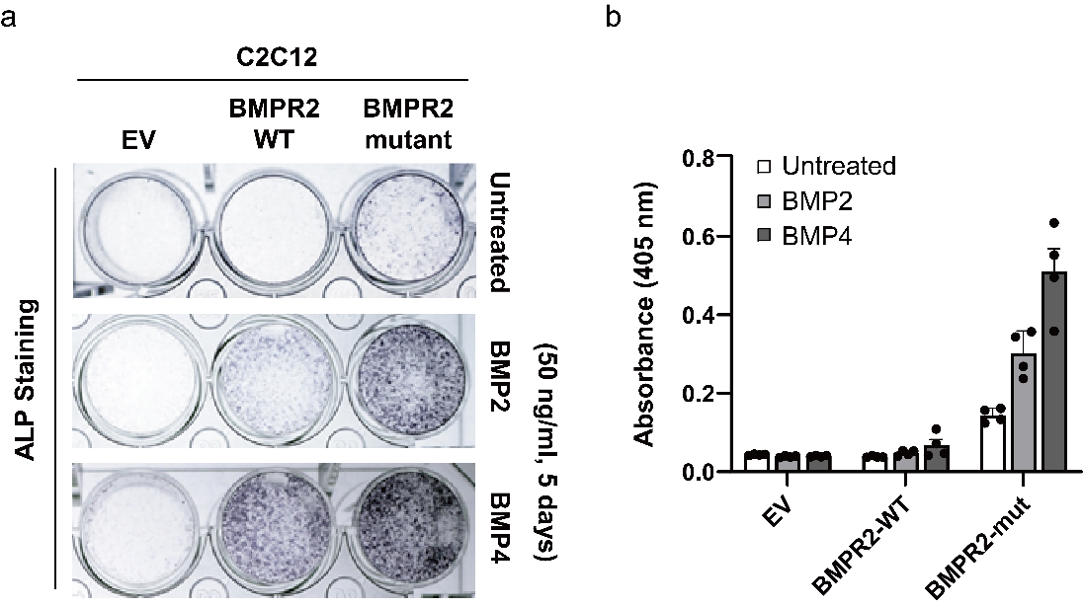

Fig. S6. Osteogenic differentiation ability of BMP/SMAD signal hyper-activated by BMPR2^{E376K} variant in C2C12 cells.
a To differentiate from C2C12 cells to osteoblasts, cells were incubated in osteogenic differentiation medium without or with BMP2 or BMP4 (50 ng/ml) at 37℃ with 5% CO₂. After 5 days, ALP staining was performed. b For quantitation of ALP activity, lysates from osteogenic differentiated cells for 5 days were incubated 0.67 M pNPP solution for 30 minutes at 37℃ and then the reaction was immediately followed by analyzing in absorbance at 405 nm. Error bars indicate the standard deviation of four replicates. Data are the mean ± SEM (n=4).

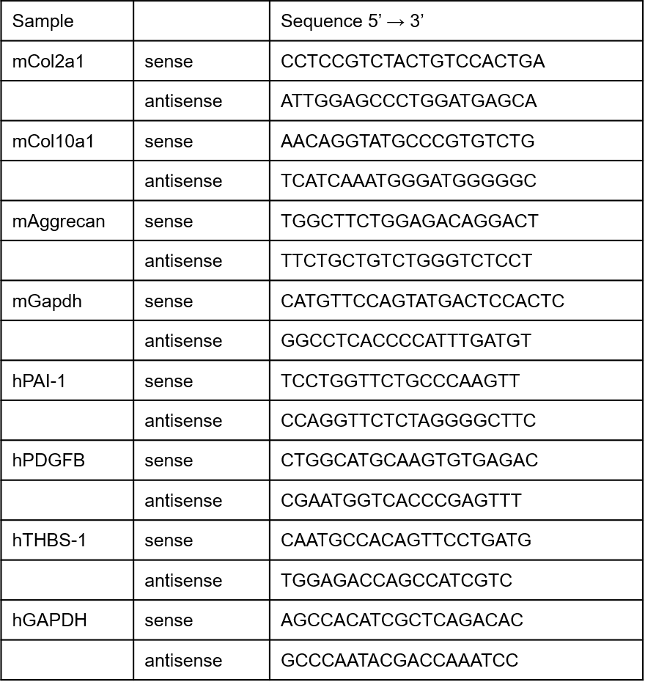

Table S1. qPCR primer list.
PCR primers were designed from program tools of NCBI (Primer-BLAST) or Roche (ProbeFinder version 2.50).

