Table1 The prevalence of MM cases and rates among men ≥ 60 years in 1990 and 2021, with EAPC from 1990 to 2021.
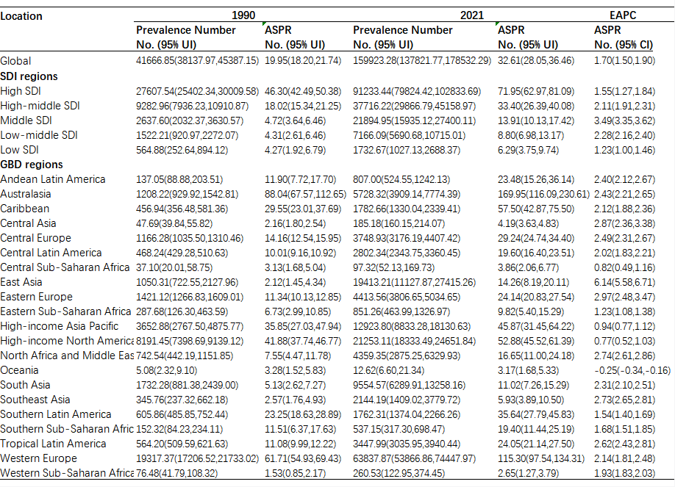

Table2 The incidence of MM cases and rates among men ≥ 60 years in 1990 and 2021, with EAPC from 1990 to 2021.
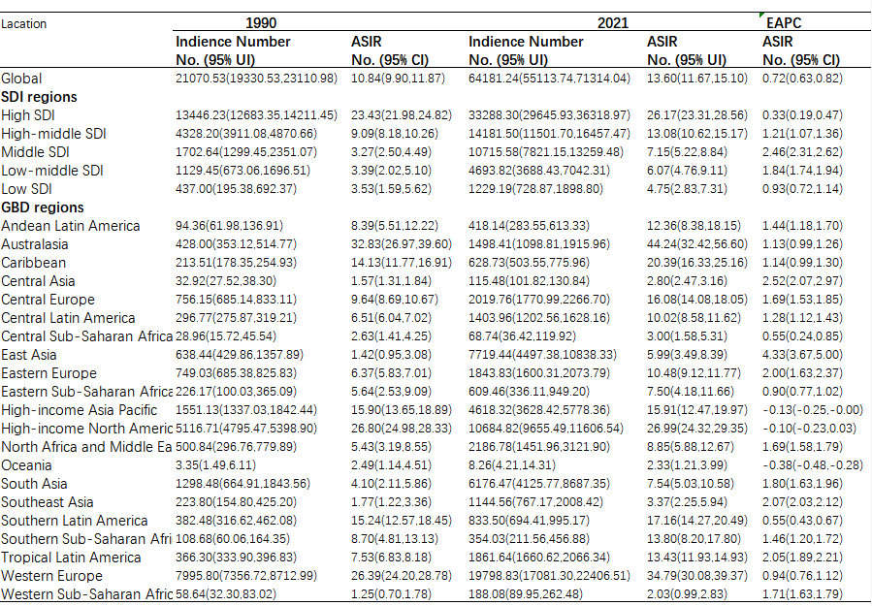

Table3 The DALY of MM cases and rates among men ≥ 60 years in 1990 and 2021, with EAPC from 1990 to 2021.
