Dust Suppresses Aerosol First Indirect Effects in Marine Warm Clouds over the North Atlantic Ocean

Satyendra K. Pandey,¹ Adeyemi A. Adebiyi¹, Yang Lian,² V. Vinoj³, and Xue Zheng⁴
¹Department of Life and Environmental Sciences, University of California - Merced, Merced, CA, USA
²Indian Institute of Tropical Meteorology, Pune, Maharashtra, India
³School of Earth, Ocean and Climate Sciences, Indian Institute of Technology Bhubaneswar, Odisha, India
⁴Atmospheric, Earth, and Energy Division, Lawrence Livermore National Laboratory, Livermore, CA, USA

Supplementary Information

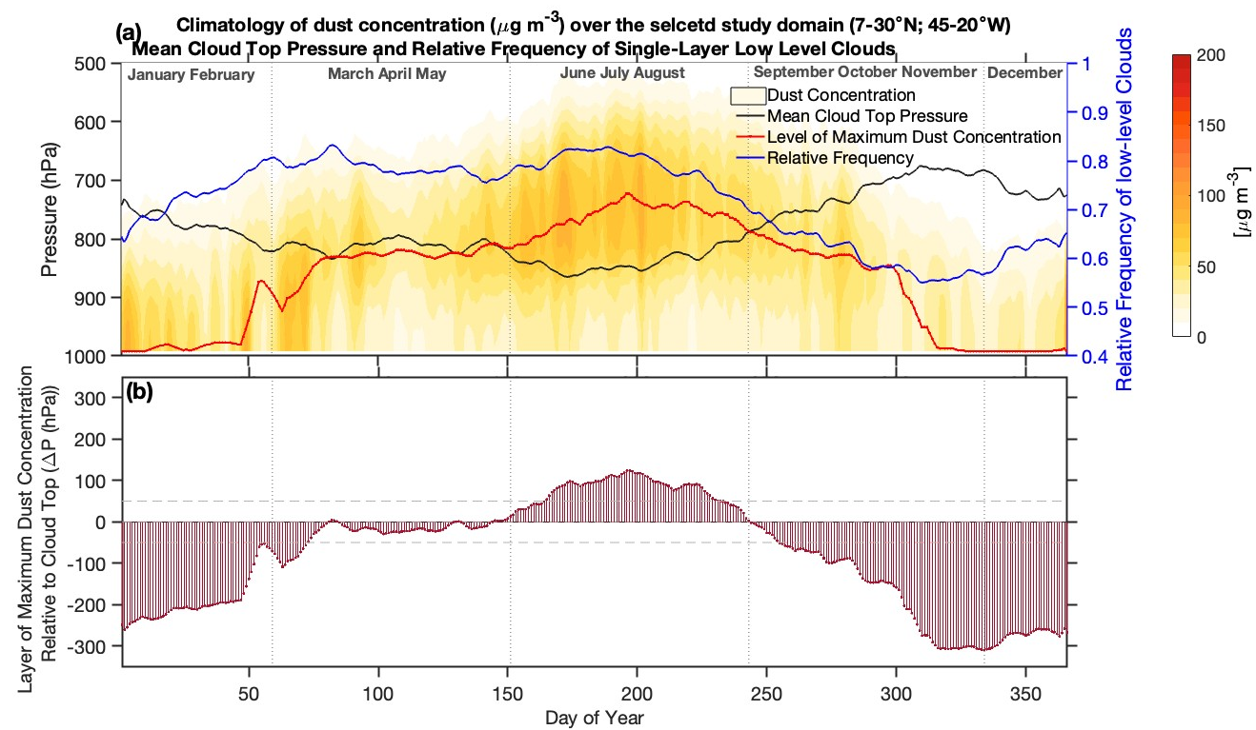
Figure S1. (a) Climatological vertical profile of dust concentration (orange shading) from MERRA-2 over the study domain for 2003-2024, showing the pressure level of maximum dust concentration (red line), the mean cloud-top pressure (black line), and the relative frequency of low-level clouds (blue line) derived from MODIS observations. (b) Relative position of the pressure level of maximum dust concentration with respect to cloud-top pressure, indicating that the dust maxima are located close to the mean cloud top during March-May.

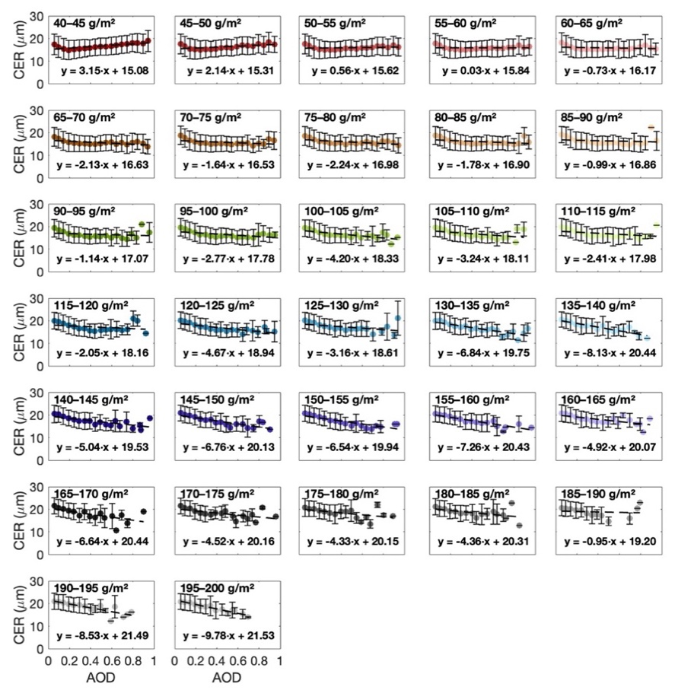
Figure S2. Variation of CER as a function of AOD (MODIS), grouped based on LWP bins of bin-width 5 g m⁻².

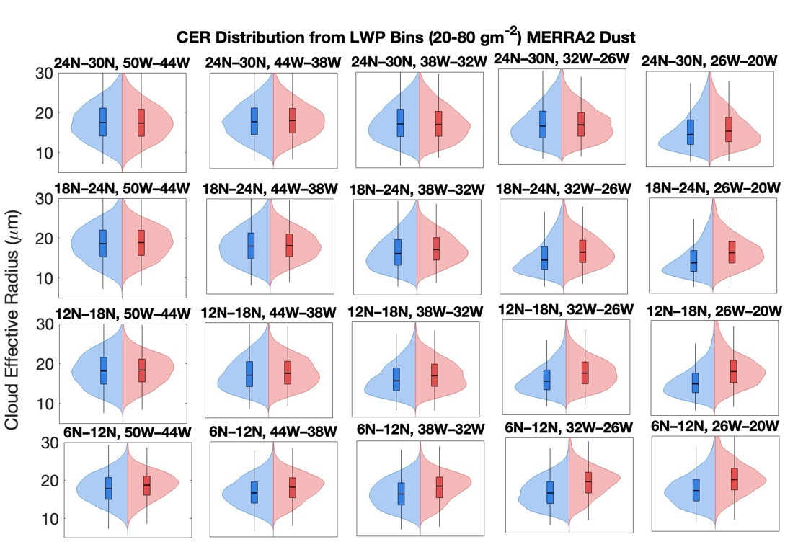
Figure S3. Distribution of MODIS retrieved cloud effective radius for low (blue color) and high (red color) dust days across low LWP ranges (20–80 gm⁻²).
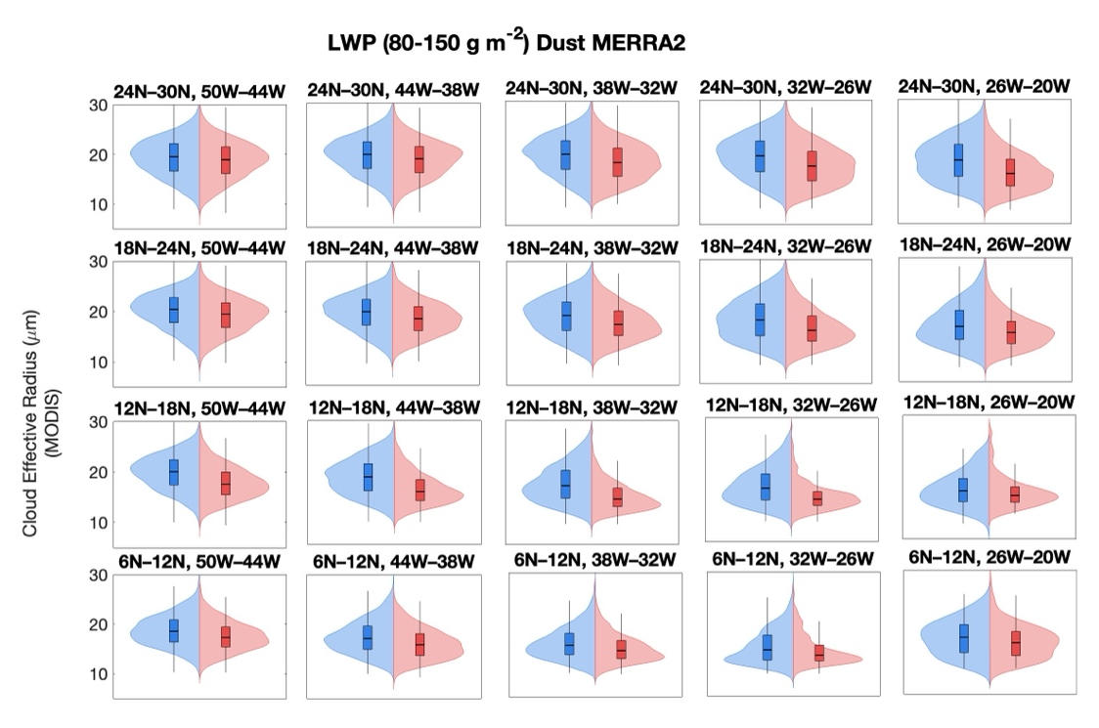
Figure S4. Distribution of MODIS retrieved cloud effective radius for low (blue color) and high (red color) dust days across low LWP ranges (80–150 gm⁻²).
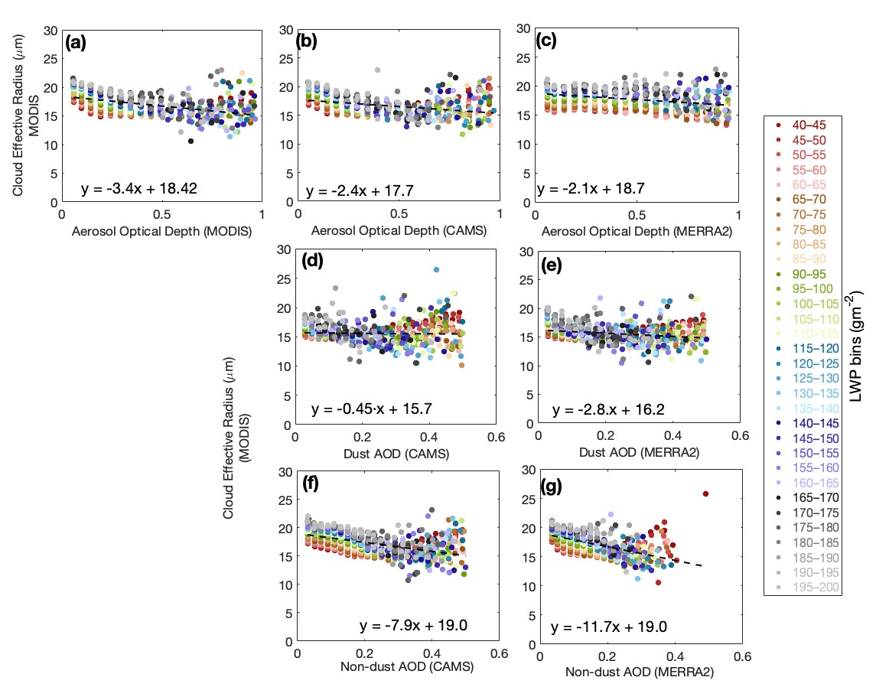
Figure S5. Scatter plot showing cloud effective radius (μm) from MODIS as a function of aerosol optical depth from (a) MODIS, (b) CAMS, and (c) MERRA2, over Atlantic (45-20 ºW, 7-20 ºN; shown black box Fig 1a) for the year 2003-2024 in March to May. Changes in effective radius sensitivity to dust optical depth from (d) CAMS, (e) MERRA2, and to non-dust AOD (c) CAMS and (d) MERRA2. Marker colors indicate corresponding liquid water path (g m⁻²) values given in the legend above the plot.

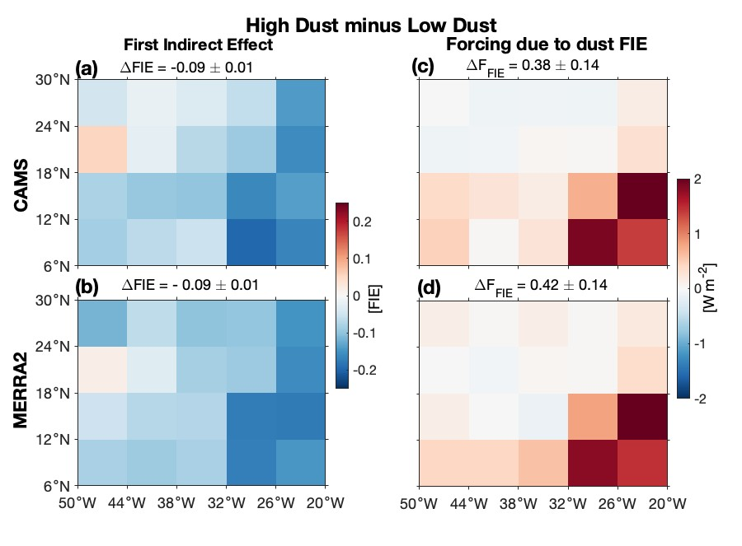
Figure S6. Spatial distribution of the difference between high-dust and low-dust days (high minus low) in the first aerosol indirect effect (FIE) and the associated radiative forcing due to dust FIE. (a and b) are the differences in FIE, and (c and d) corresponding TOA radiative forcing (W m⁻²), averaged for all selected LWP (20–150 g m⁻²) bins. Upper panels use CAMS dust optical depth, and lower panels use MERRA-2 dust, with all other cloud and aerosol properties from MODIS. Domain-mean values (± Standard Error calculated across the grid boxes) are shown in each panel.
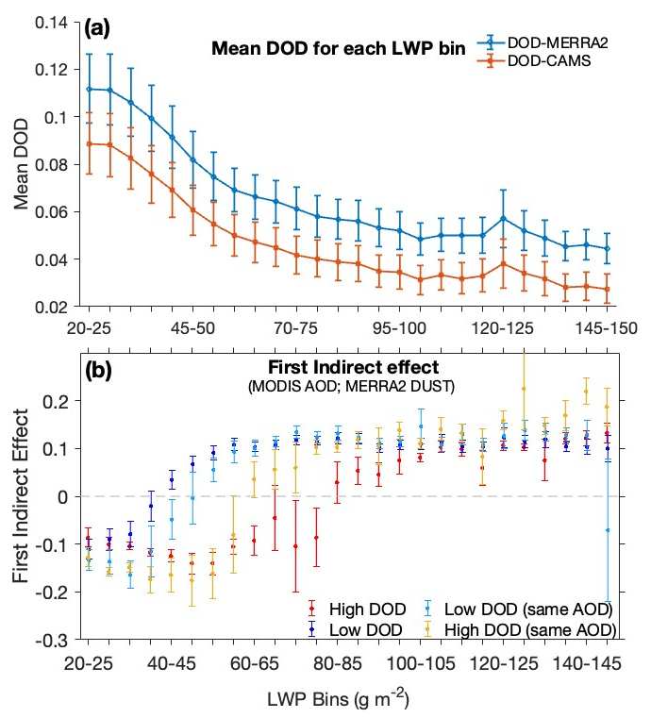
Figure S7. (a) Mean DOD across the LWP bins used to define low- and high-dust conditions, shown for MERRA-2 (blue) and CAMS (orange). (b) First indirect effect for low-dust (blue) and high-dust (red) conditions (as in Fig. 3a), along with FIE values computed using a matched AOD range for both low-dust (light blue) and high-dust (orange) days. Error bars denote the standard error.

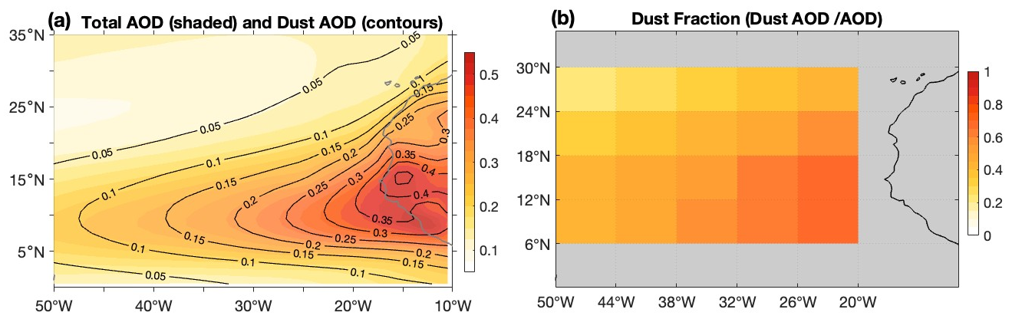
Figure S8. (a) Mean spatial distribution of total aerosol optical depth (AOD; shaded) during MAM (2003–2024), with overlaid contours of dust optical depth (black). (b) Fraction of dust optical depth relative to total AOD over the 6° × 6° grid boxes.

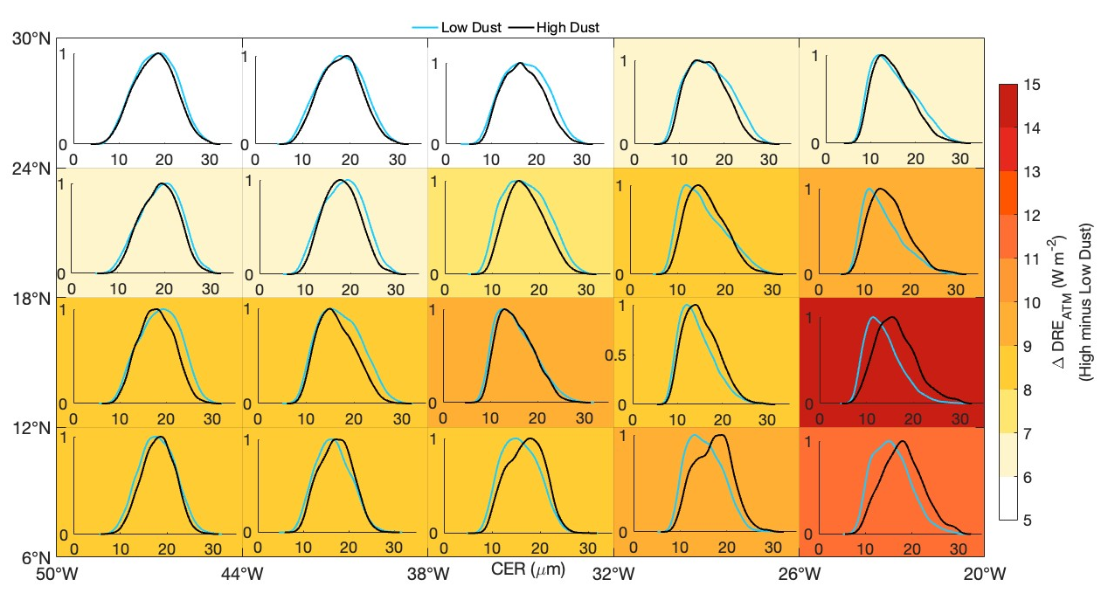
Figure S9. Effect of dust-induced atmospheric radiative warming indicated as positive values of direct radiative effect (DRE_{ATM}) on cloud-droplet size distribution. In the background, dust-induced changes in atmospheric radiative effect (W m⁻²) along with the distribution of CER for each 6°×6° box. For inset boxes, the x and y axes show CER (μm) and the normalized probability density function, respectively.
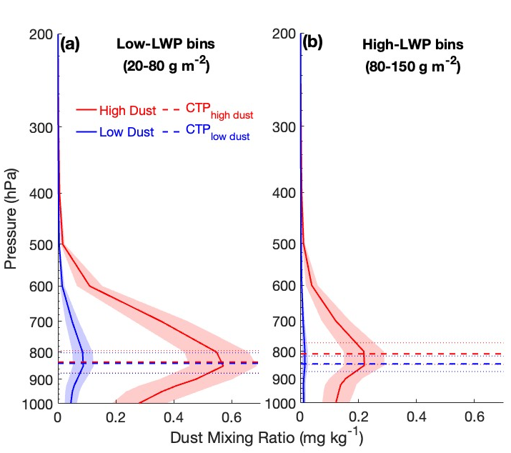
Figure S10. Vertical profiles of total dust mass mixing ratio (mg kg⁻¹) from CAMS for high-dust (red) and low-dust (blue) conditions for (a) low-LWP bins (20–80 g m⁻²) and (b) high-LWP bins (80–150 g m⁻²). Shaded regions show ± 1 standard error computed for all $6°×6°$ boxes. Dashed horizontal lines show the corresponding mean cloud-top pressure (CTP) for high-dust (red) and low-dust (blue) cases, with dotted lines indicating ± standard error.
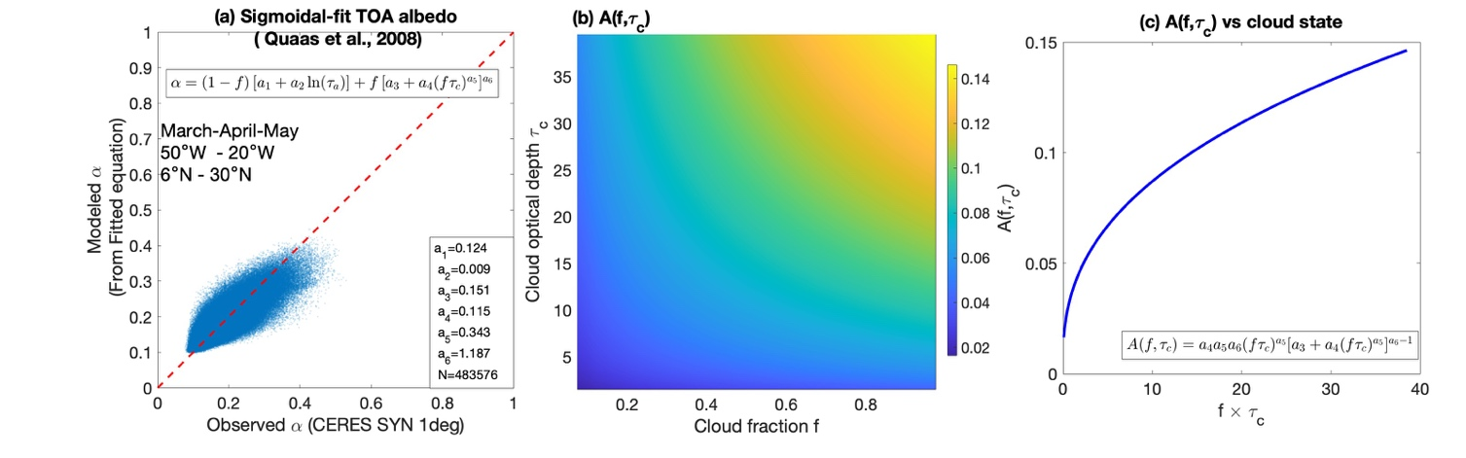
Figure S11. (a) Sigmoidal fit of top-of-atmosphere (TOA) all-sky albedo as a function of cloud state following the formulation of Quaas et al. (2008)¹. The observed top of atmosphere (TOA) albedo from CERES SYN1deg is shown against the modeled albedo obtained from the sigmoidal parameterization $α≈(1-f) [α_{1}+α_{2}ln⁡(τ_{a})]+f [α_{3}+α_{4}(fτ_{c})^{α_{5}}]^{α_{6}}$, where $f$ is low-cloud fraction and $τ_{c}$is low-cloud optical depth. The red dashed line indicates the 1:1 reference. The fit is derived using March–April–May (MAM) data over the eastern North Atlantic (50°W–20°W, 6°N–30°N), restricted to low-cloud-dominated grids.
(b) Dependence of $A\left(f,τ_{c}\right)=a_{4}a_{5}a_{6}{\left(fτ_{c}\right)}^{a5}{\left[a_{3}+a_{4}{\left(fτ_{c}\right)}^{a_{5}}\right]}^{a_{6}-1}$ on cloud fraction $f$ and cloud optical depth $τ_{c}$. (c) $A(f,τ_{c})$ on the combined parameters $fτ_{c}$.

Section S1. Formulation Forcing associated with dust FIE
Here, the radiative forcing associated with the dust-induced first indirect effect is expressed in terms of cloud droplet effective radius, assuming constant liquid water path (LWP) and applying standard warm-cloud relationships. Forcing due to dust first indirect effect is written as following Amiri-Farhani et al.,^{1,2}
$F_{FIE,dust}=f.A\left(f,τ_{c}\right).\frac{1}{3}.\frac{d\ln{N_{d}}}{d\ln{τ}}.\left[\ln\left(τ_{a}\right)-\ln\left(τ_{a}-τ_{d}\right)\right]. F↓$ …(1)
where $N_{d}$ is cloud droplet number concentration, $τ_{c}$ is cloud optical depth, $τ_{a}$ and $τ_{dust}$ are total aerosol and dust optical depth, $f$ is cloud fraction, $A\left(f,τ_{c}\right)$ is calculated using a sigmoidal fit shown in Figure (S11), and F↓ is the daily mean incoming solar radiation at the top of the atmosphere. For liquid clouds: ^{3–5}
$r_{e}∝\frac{LWP}{N_{d}^{\frac{1}{3}}}$ …(2)
Taking logarithms
$\ln{N_{d}}=\ln{LWP}-3\ln{r_{e}}+const$ …(3)
Differentiating with respect to $\ln{τ_{a}}$
$\frac{d\ln{N_{d}}}{d\ln{τ_{a}}}=\frac{d\ln{LWP}}{d\ln{τ_{a}}}-3\frac{d\ln{r_{e}}}{d\ln{τ_{a}}}$ …(4)
For a constant LWP, which will be
$\frac{d\ln{N_{d}}}{d\ln{τ_{a}}}=-3\frac{d\ln{r_{e}}}{d\ln{τ_{a}}}$ …(5)
Substituting into
${ F}_{FIE,dust}=-f.A\left(f,τ_{c}\right).\frac{d\ln{r_{e}}}{d\ln{τ_{a}}}.\left[\ln\left(τ_{a}\right)-\ln\left(τ_{a}-τ_{d}\right)\right]. F↓$ …(6)
$F_{FIE,dust}=f.A\left(f,τ_{c}\right).FIE.\left[\ln\left(τ_{a}\right)-\ln\left(τ_{a}-τ_{d}\right)\right]. F↓$ …(7)
To determine $A\left(f,τ_{c}\right)$ which depends on cloud fraction and cloud optical depth, we use the sigmoidal fit described by Quaas et al., 2008¹ . To calculate the empirical coefficient of fitting parameters comparing all-sky albedo in CERES SYN 1deg data, and with the following albedo $α$ calculated using the sigmoidal fit as a function of aerosol optical depth, cloud optical depth, and cloud fraction
$α≈(1-f) [a_{1}+a_{2}ln⁡(τ_{a})]+f [a_{3}+a_{4}(fτ_{c})^{a_{5}}]^{a_{6}}$ …(8)
Values of fitting parameters are given in Fig. S11a, which was further used to estimate the value of $A\left(f,τ_{c}\right)$
$A\left(f,τ_{c}\right)=a_{4}a_{5}a_{6}{\left(fτ_{c}\right)}^{a5}{\left[a_{3}+a_{4}{\left(fτ_{c}\right)}^{a_{5}}\right]}^{a_{6}-1}$ …(9)
We find similar dependence $A\left(f,τ_{c}\right)$ on cloud fraction and cloud optical depth to those given in Patel et al.,⁶ derived for Indian oceanic and continental regions. Based on the above formulations, we created a lookup table $A\left(f,τ_{c}\right)$ that was used for each LWP category, based on mean cloud fraction and cloud optical depth.
References
1. Quaas, J., Boucher, O., Bellouin, N. & Kinne, S. Satellite-based estimate of the direct and indirect aerosol climate forcing. Journal of Geophysical Research Atmospheres 113, 1–9 (2008).
2. Amiri-Farahani, A., Allen, J. R., Neubauer, D. & Lohmann, U. Impact of Saharan dust on North Atlantic marine stratocumulus clouds: Importance of the semidirect effect. Atmos Chem Phys 17, 6305–6322 (2017).
3. Painemal, D. & Zuidema, P. Assessment of MODIS cloud effective radius and optical thickness retrievals over the Southeast Pacific with VOCALS-REx in situ measurements. Journal of Geophysical Research Atmospheres 116, 1–16 (2011).
4. Brenguier, J.-L. Cloud microphysical and radiative properties for parameterization and satellite monitoring of the indirect effect of aerosol on climate. J Geophys Res 108, 8632 (2003).
5. Brenguier, J.-L. et al. Radiative Properties of Boundary Layer Clouds: Droplet Effective Radius versus Number Concentration. J Atmos Sci 57, 803–821 (2000).
6. Patel, P. N., Quaas, J. & Kumar, R. A new statistical approach to improve the satellite-based estimation of the radiative forcing by aerosol-cloud interactions. Atmos Chem Phys 17, 3687–3698 (2017).

