SUPPLEMENTARY MATERIALS

Supplementary Figures
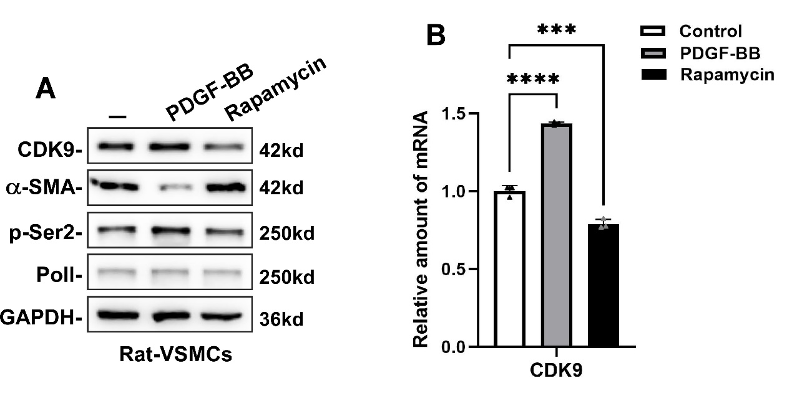
Supplementary Figure 1. The CDK9 level after PDGF-BB or Rapamycin treatment in rat-VSMCs. (A) Western blot analysis of CDK9, p-Ser2, α-SMA and PoII levels in rat-VSMCs after PDGF-BB or Rapamycin treatment for 24 h. (B) The mRNA level of CDK9 was determined by qRT-PCR in rat-VSMCs after PDGF-BB or Rapamycin treatment for 24 h. GAPDH was used as the housekeeping control. Data shown are the means ± SD.

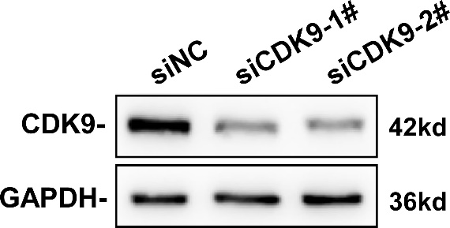
Supplementary Figure 2. The knockdown efficacy of CDK9 siRNAs. VSMCs were transfected with siNC (negative control), siCDK9-1#, or siCDK9-2#. The expression of CDK9 was detected by Western blot.

Supplementary Tables

Supplementary Table S1. Primers used for qRT-PCR

Gene | Forward | Reverse
h-GAPDH | GAAGGTGAAGGTCGGAGTC | GAAGATGGTGATGGGATTTC
h-CDK9 | ACTTCTGCGAGCATGACCTT | AAAGTCTGCCAGCTTCAGGA
h-α-SMA | GTCCCAGACATCAGGGAGTAA | TCGGATACTTCAGCGTCAGGA
h-SM22a | CCGTGGAGATCCCAACTGG | CCATCTGAAGGCCAATGACAT
h-CNN1 | ATGTCCTCTGCTCACTTC | ATACTTCTGGGCCAGCTTGTT
h-PCNA | GGCGTGAACCTCACCAGTAT | TCTCGGCATAACGTGCAAA
h-Twist1 | ACCCAGTCGCTGAACGAG | CCAGACCGAGAAGGCGTA
Rat-GAPDH | AGACAGCCGCATCTTCTTGT | CTTGCCGTGGGTAGAGTCAT
Rat-Twist1 | GTCGCTGAACGAGGCATT | CCAGACGGAGAAGGCGTA
Rat-CDK9 | AGCTCTGTGGCTCCATCACT | AAGTCATGGTTGAGGGCATC
Rat-SM22a | CACCTATCCTCAGCCTCAGC | TTCAAAGGACATTGGCTTCC

Supplementary Table S2. The dilution concentration of the primary antibodies used in Western blot assays and immunofluorescence staining

Antibody | Brand | Cat No. | Dilution
CDK9 | Abclonal | A0886 | 1:500
p-Ser2 | Bethyl | A300-654A | 1:1000
α-SMA | Boster | BM0002 | 1:500
POII | santacruz | sc-55492 | 1:500
GAPDH | Abclonal | A19056 | 1:2000
KLF4 | Abclonal | A13673 | 1:500
PCNA | CST | 13110S | 1:500
OPN | Abclonal | A21084 | 1:500
SM22a | Proteintech | 60213-1-Ig | 1:500
CNN1 | Abclonal | A3734 | 1:500
Vimentin | Abcam | ab92547 | 1:1000
Twist1 | Proteintech | 25465-1-AP | 1:500
Twist1 | Abclonal | A3237 | 1:500
α-Tubulin | Abclonal | A6830 | 1:2000

Supplementary Table S3. siRNA sequences of CDK9 used in this study
Items |  | Sequences of siRNA (5’-3’)
siCDK9-1# | sense | GGUAGUAAUACCGUGGUUTT
siCDK9-1# | antisense | ACACCAGGUAAUACUACCTT
siCDK9-2# | sense | GUGGACACAUCUAUGAGCUGUTT
siCDK9-2# | antisense | ACAGCUCUAUGAUGUUGUCCACTT
Negative control | sense | UUCUCCGAACGUGUCACGUTT
Negative control | antisense | ACGUGACACGUUCGGAGAATT

