Supplementary Materials
Supplementary Table S1. Top 26 features for all participants based on weighted importance
Features | Controls  (n = 43) | Early PDs  (n = 63)
P1_MedLat_COP-COM | 28.05±4.43 | 31.31±2.90
TP_COM_Speed | 0.29±0.07 | 0.19±0.06
P1_Left_BF_iEMG (µV) | 347.87±267.38 | 662.55±769.48
P2_COM_Pspeed | 0.80±0.16 | 0.63±0.16
P1_COM_Sway_Area | 36.52±27.88 | 25.05±20.90
P2_Right_RF_iEMG (µV) | 606.38±358.90 | 503.77±219.47
P1_Left_Ankle_ROM | 4.52±9.51 | 9.79±13.95
STS_P_Right_RF_iEMG (µV) | 545.59±457.63 | 905.67±800.01
P2_Left_BF_PAmp (µV) | 23.65±13.02 | 37.55±23.67
P1_Right_Hip_Mom | 2.88±1.69 | 7.34±7.53
P1_Right_Ankle_POW | 0.01±0.02 | 0.10±0.20
P2_AP_COP-COM | 54.40±32.32 | 31.93±14.23
P1_Left_GAS_RMS (µV) | 3.99±5.98 | 2.64±2.07
P1_RMS_ASI_TA | 46.97±20.15 | 40.29±19.42
P1_Median_Freq | 851.53±19.27 | 848.44±51.72
P1_Right_RF_PAmp (µV) | 45.09±37.40 | 63.71±73.60
STS_P_RMS_ASI_GAS | 35.60±20.82 | 28.69±19.71
P2_Left_Vetical_PGRF | 0.80±0.37 | 1.03±0.10
P2_RMS_ASI_TA | 41.80±16.16 | 44.89±23.58
P2_T10_For_ROM | 18.80±10.25 | 17.75±7.33
P2_Right_RF_RMS (µV) | 9.06±5.49 | 6.93±3.24
STS_P_RMS_ASI_TA | 46.98±22.15 | 42.51±18.95
P1_Left_Knee_ROM | 15.66±9.77 | 24.20±22.68
P2_Right_TCH | 7.94±1.45 | 7.22±1.05
P1_AP_COP-COM | 32.83±14.31 | 23.15±8.00
P2_Left_BF_iEMG (µV) | 520.80±288.94 | 891.15±921.84
All data are presented as mean ± standard deviation. HC: Healthy control; PD: Parkinson’s disease; P1: Phase 1; MedLat: Mediolateral; COP: Center of press; COM: Center of mass; TP: Total phase; BF: Biceps femoris; iEMG: Integrated electromyography; µV: Microvolt; P2: Phase 2; Pspeed: Peak speed; ROM: Range of motion; STS_P: Sit-to-stand phase; PAmp: Peak amplitude; Mom: Moment; POW: Power; AP: Anterior-Posterior; GAS: Gastrocnemius; RMS: Root mean square; ASI: Asymmetry Index; TA: Tibialis anterior; Freq: Frequency; PGRF: Peak ground reaction force; T10: The 10th thoracic vertebra; For: Forward; TCH: Toe clearance height.

Supplementary Table S2. Accuracies, precision, recall, and F1 scores of the seven classifiers from five-fold cross-validation
 | MLs | Early-stage PD vs. HC  (200 Features) | Early-stage PD vs. HC  (26 Features) | Early-stage PD vs. HC  (3 Features)
Accuracy | LR | 78.6±5.5 | 88.2±4.6 | 76.2±6.2
Accuracy | KNN | 75.3±8.8 | 83.4±7.6 | 83.3±3.5
Accuracy | NB | 84.9±3.5 | 82.5±2.3 | 73.8±4.2
Accuracy | LDA | 78.6±9.6 | 81.0±5.0 | 78.6±7.7
Accuracy | QDA | 76.2±3.8 | 88.1±2.9 | 76.2±5.5
Accuracy | SVM | 79.5±8.5 | 80.2±5.7 | 78.6±3.7
Accuracy | RF | 87.3±3.2 | 92.1±2.8 | 84.9±5.3
Precision | LR | 79.5±4.9 | 88.8±4.2 | 77.3±7.2
Precision | KNN | 75.6±9.0 | 84.3±8.3 | 83.8±3.2
Precision | NB | 86.5±3.9 | 83.4±2.4 | 77.3±5.5
Precision | LDA | 79.7±8.5 | 81.4±5.1 | 79.7±8.5
Precision | QDA | 84.0±1.6 | 88.6±3.0 | 78.7±5.8
Precision | SVM | 80.5±8.4 | 81.9±5.2 | 79.0±8.4
Precision | RF | 88.4±3.4 | 92.4±2.9 | 85.8±6.1
Recall | LR | 78.6±5.5 | 88.2±4.6 | 76.2±6.2
Recall | KNN | 75.3±8.8 | 83.4±7.6 | 83.3±3.5
Recall | NB | 84.9±3.5 | 82.5±2.3 | 73.8±4.2
Recall | LDA | 78.6±9.6 | 81.0±5.0 | 78.6±7.7
Recall | QDA | 76.2±3.8 | 88.1±2.9 | 76.2±5.5
Recall | SVM | 79.5±8.5 | 80.2±5.7 | 78.6±8.7
Recall | RF | 87.3±3.2 | 92.1±2.8 | 84.9±5.3
F1 score | LR | 78.4±5.8 | 88.1±4.7 | 76.1±6.0
F1 score | KNN | 75.3±8.8 | 83.3±7.6 | 83.3±3.0
F1 score | NB | 84.7±3.5 | 82.4±2.4 | 73.1±4.3
F1 score | LDA | 78.1±10.3 | 80.9±5.0 | 78.4±7.7
F1 score | QDA | 74.7±4.3 | 88.0±2.9 | 75.7±7.7
F1 score | SVM | 79.3±8.7 | 79.9±6.0 | 78.5±8.8
F1 score | RF | 87.2±3.2 | 92.0±2.8 | 84.8±5.2
Values are expressed as mean (%) ± standard deviation (%) from five-fold cross-validation. Mean values presented in boldface denote the best performance (highest value) for each metric; MLs: Machine-learning techniques; PD: Parkinson’s disease; HC: Healthy control LR: Logistic regression; KNN: K-nearest neighbors; NB: Naїve Bayes; LDA: Linear discriminant analysis; QDA: Quadratic discriminant analysis; SVM: Support vector machine; RF: Random Forest.

Supplementary Table S3. Model evaluation metrics for RF and XGBoost
Model | Accuracy | Precision | Recall | F1 Score | AUC
RF | 0.77±0.12 | 0.78±0.13 | 0.77±0.12 | 0.76±0.13 | 0.89±0.06
XGBoost | 0.70±0.08 | 0.70±0.09 | 0.70±0.08 | 0.69±0.09 | 0.81±0.06
Mean (%) ± standard deviation (%) values are calculated from five-fold cross-validation. AUC: Area under the receiver operating characteristic curve; RF: Random Forest; XGBoost: Extreme Gradient Boosting.

Supplementary Table S4. Model parameters of the seven classifiers estimated by grid search
MLs | Early-stage PD vs.  HC  (200 Features) | Early-stage PD vs.  HC  (26 Features) | Early-stage PD vs.  HC  (3 Features)
LR | C=0.01 | C=0.01 | C=10
KNN | k=5 | k=9 | k=3
NB | - | - | -
LDA | n_components=1 | n_components=1 | n_components=1
QDA | reg_param=0.001 | reg_param=0.5 | reg_param=0.5
SVM | C = 7.63,  gamma = 0.0001,  kernel = rbf | C= 443.67,  gamma=0.00001,  kernel=rbf | C= 6660.85,  gamma=0.1,  kernel=rbf
RF | max_depth=25,  n_estimators=1500 | max_depth=15,  n_estimators=1500 | max_depth=10,  n_estimators=500
ML: Machine learning; PD: Parkinson’s disease; HC: Healthy control; LR: Logistic regression (C is the inverse of the regularization strength); KNN: K-nearest neighbor (k is the number of neighbors); NB: Naïve Bayes; LDA: linear discriminant analysis (n_components is the number of components); QDA: quadratic discriminant analysis (reg_param is the regularization of the per-class covariance); SVM: support vector machine; RF: Random forest (C is the regularization parameter, and gamma is the kernel coefficient); “n_estimators” is the number of trees in the forest, and “max_depth” is the maximum depth of the tree.

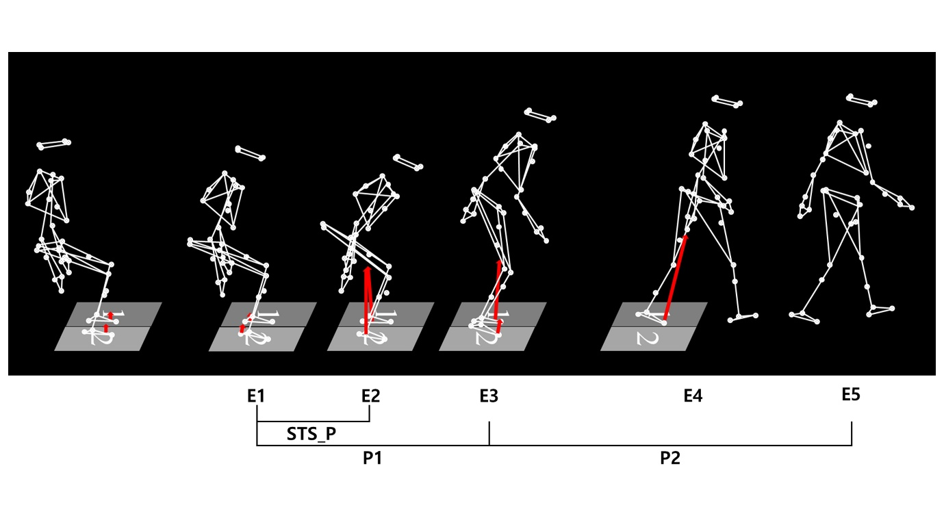Supplementary Fig. S1. Definition of events and phases. Event 1 (E1) marks the onset of forward movement of the C7 marker. Event 2 (E2) is the time at which the anteroposterior ground reaction force peaks during seat-off, when the buttocks lift from the chair. Event 3 (E3) corresponds to heel-off of the first stepping foot. Event 4 (E4) is the heel-strike of the first stepping foot. Event 5 (E5) is the second heel-strike of the opposite limb, marking the completion of the second step. The analysis intervals are defined as: the sit-to-stand phase from E1 to E2 (STS_P), the first interval from E1 to E3 (P1), and the second interval from E3 to E5 (P2).

