SUPPLEMENTARY INFORMATION

Title: Longitudinal preclinical evaluation of the novel radioligand [¹¹C]CHDI-626 for PET imaging of mutant huntingtin aggregates in Huntington’s Disease

Journal: European Journal of Nuclear Medicine and Molecular Imaging

Authors: Daniele Bertoglio¹, Jeroen Verhaeghe¹, Alan Miranda¹, Leonie wyffels^{1,2}, Sigrid Stroobants^{1,2}, Ladislav Mrzljak³, Vinod Khetarpal³, Mette Skinbjerg³, Longbin Liu³, Celia Dominguez³, Ignacio Munoz-Sanjuan³, Jonathan Bard³, Steven Staelens^{1,*}

¹Molecular Imaging Center Antwerp (MICA), University of Antwerp, Wilrijk, Belgium
²Department of Nuclear Medicine, Antwerp University Hospital, Edegem, Belgium
³CHDI Management/CHDI Foundation, Los Angeles, CA, USA

*Corresponding author

Prof. Dr. Steven Staelens
MICA, University of Antwerp, Universiteitsplein 1, Wilrijk, Belgium
Tel. +32 03265 2820

Email: steven.staelens@uantwerpen.be

Daniele Bertoglio, PhD
MICA, University of Antwerp, Universiteitsplein 1, Wilrijk, Belgium
Tel. +32 032652816; Email: daniele.bertoglio@uantwerpen.be

Orcid: https://orcid.org/0000-0003-4205-5432

Short running title: Imaging mHTT in Huntington’s Disease

Supplementary Information
Fig. S1 [¹¹C]CHDI-626 plasma radiochromatograms at 5, 15, and 25 min post-injection (p.i.). Both young and aged WT a and HET b mice displayed a comparable rapid metabolism of the radioligand following intravenous injection with the formation of at least 2 species of radiometabolites ([¹¹C]M). Data are presented as % of area per collected sample (mean) in the radiochromatogram

Fig. S2 [¹¹C]CHDI-626 brain radiochromatograms at 5, 15, and 25 min post-injection (p.i.). Following intravenous injection, both young a and aged c wild-type mice displayed a comparable profile with increasing contribution over time of radiometabolites ([¹¹C]M) from the blood fraction due to the rapid wash-out of the radioligand from the brain. In contrast, young b and aged d heterozygous mice displayed a profile with the stable contribution over time of radiometabolites ([¹¹C]M) from blood fraction. Data are presented as % of total counts per min (mean) in the radiochromatogram

Fig. S3 Fraction of [¹¹C]CHDI-626 contributing to the total brain signal. Brain profile of intact radioligand in young (4M) and aged (10M) WT and HET zQ175DN mice appeared to be dependent on the mHTT load

Table S1 Scan parameters during the longitudinal PET imaging study in WT and HET zQ175DN mice.
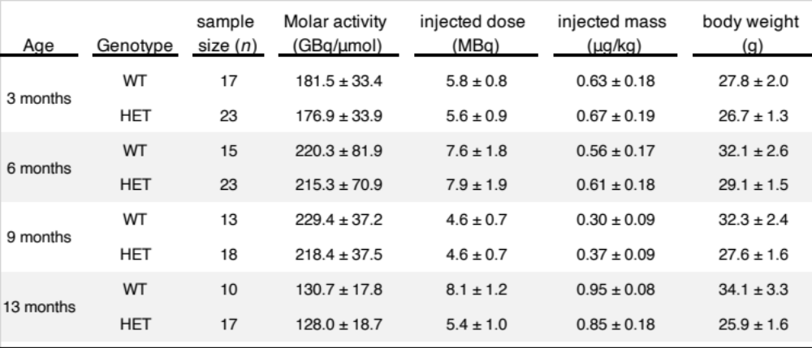
Values are expressed as mean (SD)

Table S2 V_{T (IDIF)} values and genotypic difference during the longitudinal PET imaging study in WT and HET zQ175DN mice.
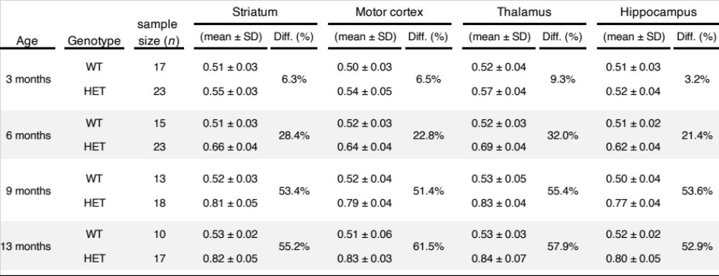
Values are expressed as mean (SD)

