Supporting Information
Resiquimod-encapsulated MOF525 for Sustained Immunostimulant Release and Synergistic Photodynamic–Immunotherapy in Colorectal Cancer
Na Kyeong Lee, Nea Young Chun, Yu Jin Oh, Ulziituya Batjargal, Min-Seok Kim, WonJun Jang, Tae-Eun Park , Han-Jun Kim, Wooram Park*, Chun Gwon Park*, Se-Na Kim*
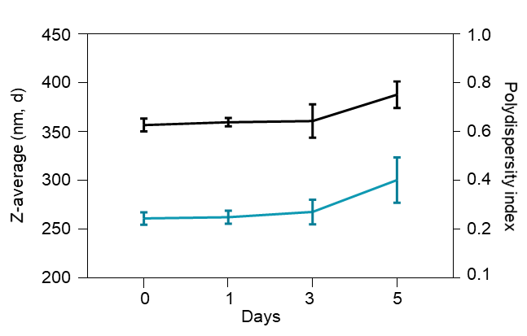
Figure S1. Hydrodynamic stability of MOF525 in serum-containing conditions. The Z-average diameter and polydispersity index of MOF525 were measured by DLS to assess colloidal stability in PBS supplemented with 5% FBS. MOF525 maintained stable size distribution with minimal aggregation over the measured time points (n = 3).
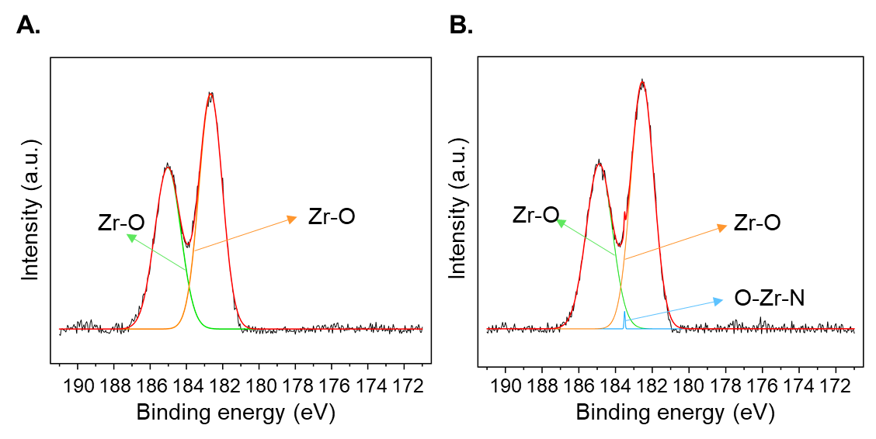
Figure S2. XPS spectra in the Zr 3d region of (A) MOF525 and (B) R848@MOF525. In the pristine MOF525, the Zr 3d spectrum shows a characteristic Zr–O bonding peak. After loading R848, R848@MOF525 displays an additional signal corresponding to O–Zr–N bonding, suggesting that the amine-containing functional group of R848 coordinates to the open metal sites of Zr in MOF525.
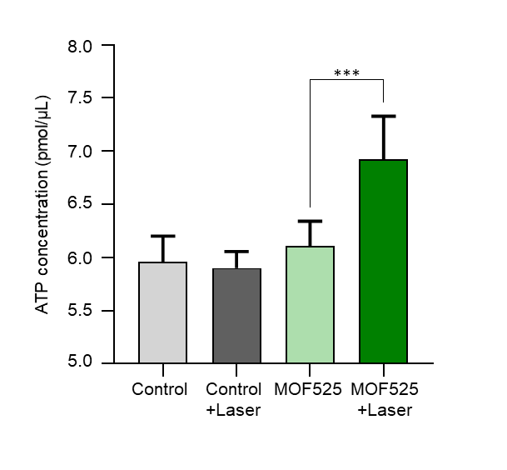
Figure S3. Quantification of ATP release as a DAMP signal following different treatment conditions. ATP levels were measured using a colorimetric ATP assay to evaluate extracellular ATP release. CT26 cells were assigned to four groups: non-treated control, laser irradiation only, MOF525 only, and MOF525 with laser irradiation. Combined treatment with MOF525 and laser irradiation induced the highest ATP release compared with other groups (n=5). ***P < 0.001 compared to MOF525 treated group.
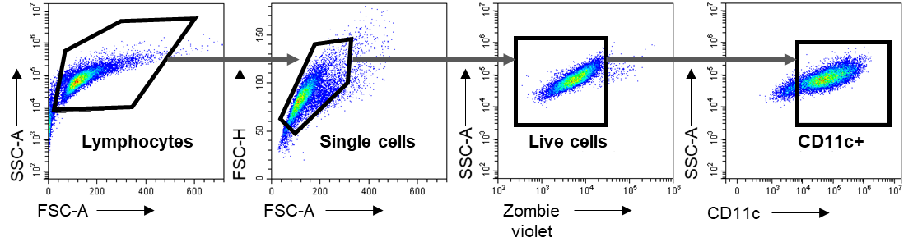
Figure S4. Gating strategy for BMDC.

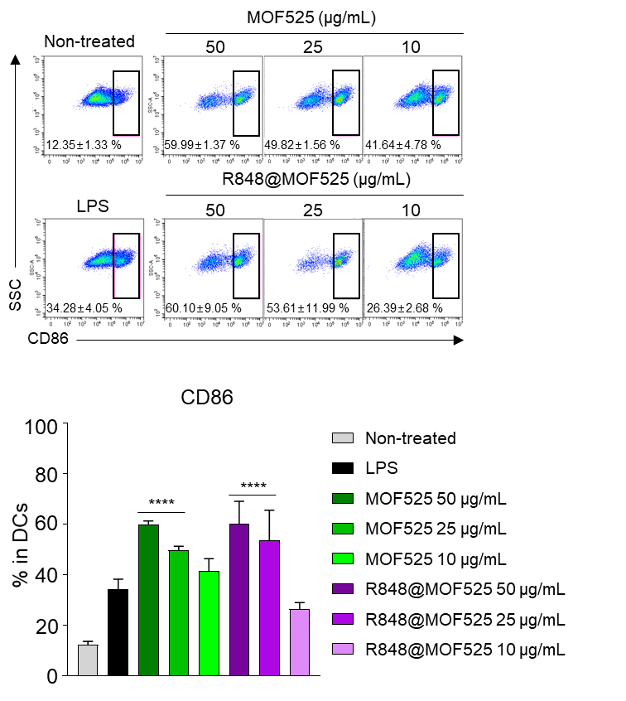
Figure S5. CD86 expression in BMDCs at different MOF treatment concentrations in vitro (n=5). ****P < 0.0001 compared to LPS treated group.

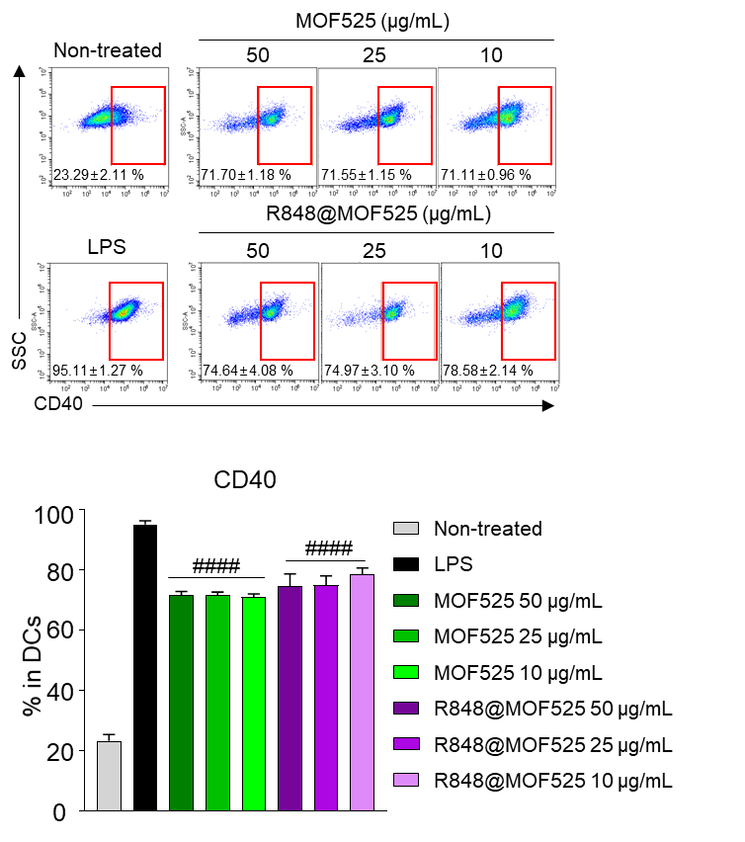
Figure S6. CD40 expression in BMDCs at different MOF treatment concentrations in vitro (n=5). ####P < 0.0001 compared to non- treated group.

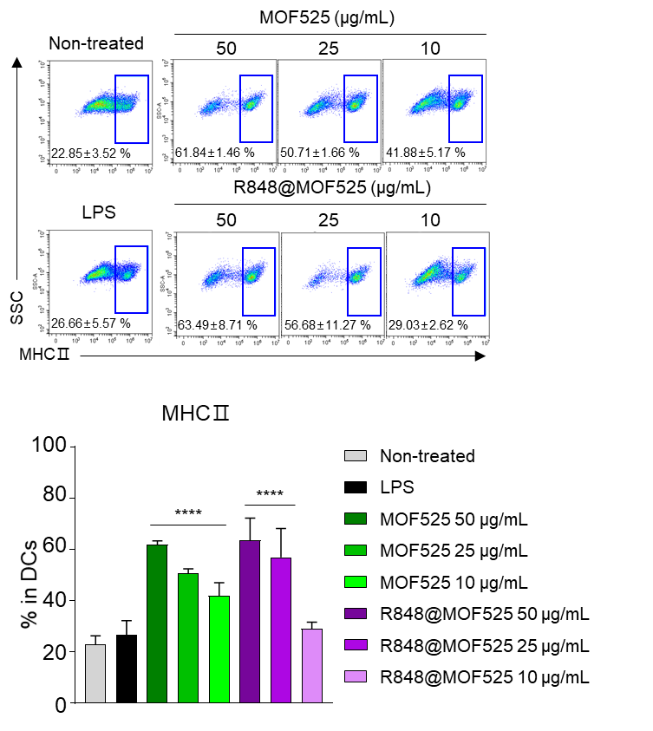
Figure S7. MHCII expression in BMDCs at different MOF treatment concentrations in vitro (n=5). ****P < 0.0001 compared to the LPS-treated group.

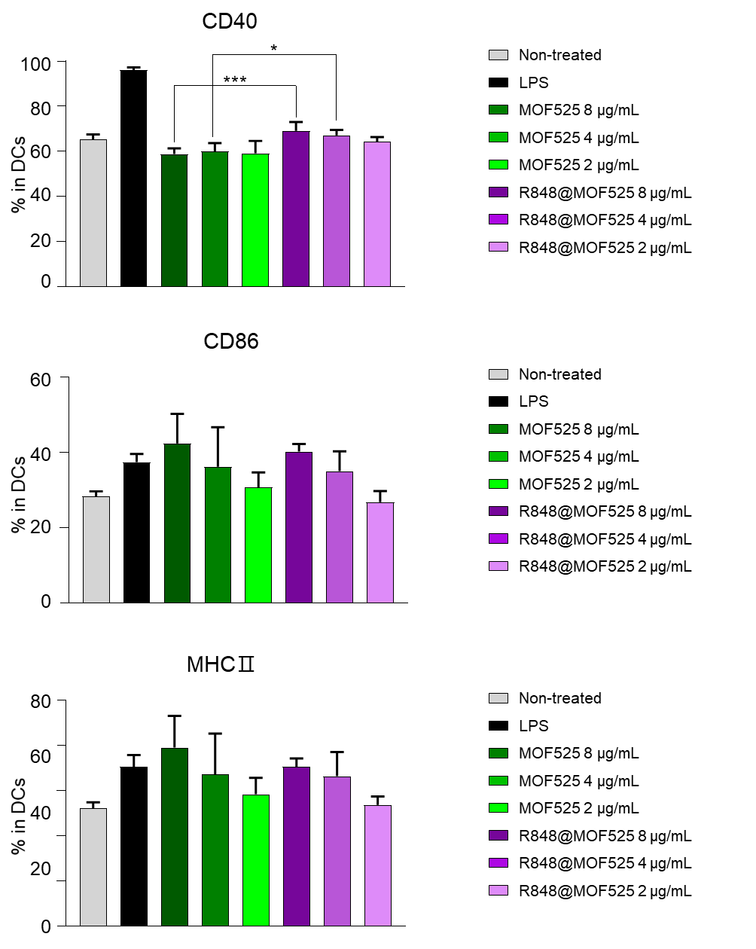
Figure S8. Expression of BMDCs maturation cell markers at treatment concentrations of below 10 µg/mL (n=5). ***P < 0.001, *P < 0.05.
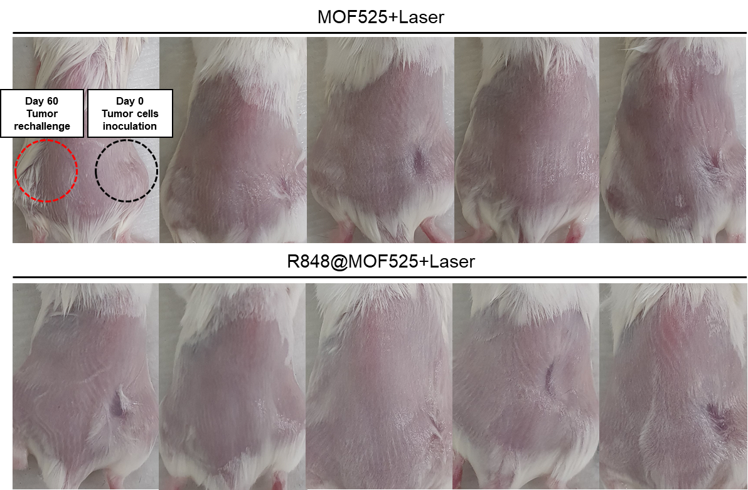
Figure S9. Tumor rechallenge test evaluating long-term immune memory and protective effects of MOF. Representative image of a mouse 3 weeks after tumor rechallenge.

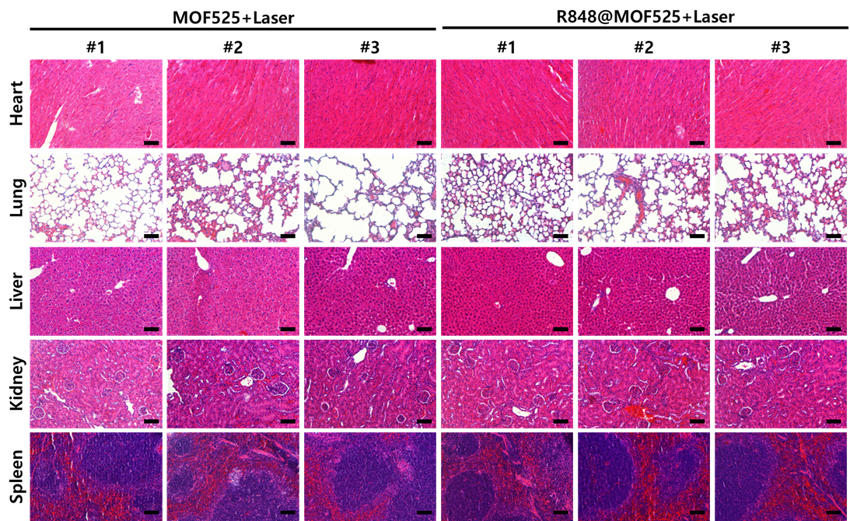
Figure S10. Histopathological assessment of vital organs following tumor rechallenge. Representative H&E stained sections of heart, lung, liver, kidney, and spleen (Scale bar=100 μm).

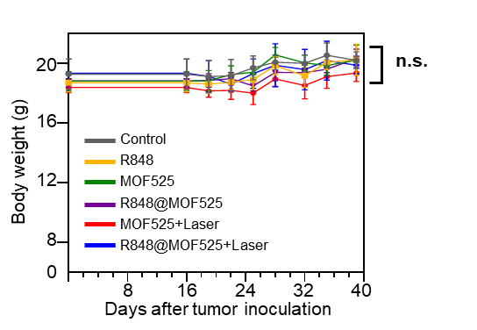
Figure S11. Body weight in the different groups of mouse (n=5). n.s, not significant.

