Supplementary Figure 1. Survival outcomes in the entire cohort.
Kaplan-Meier estimates of (A) progression-free survival (PFS) and (B) overall survival (OS) for all 289 patients included in the study. The number at risk at each time point (years) is shown below the graphs.

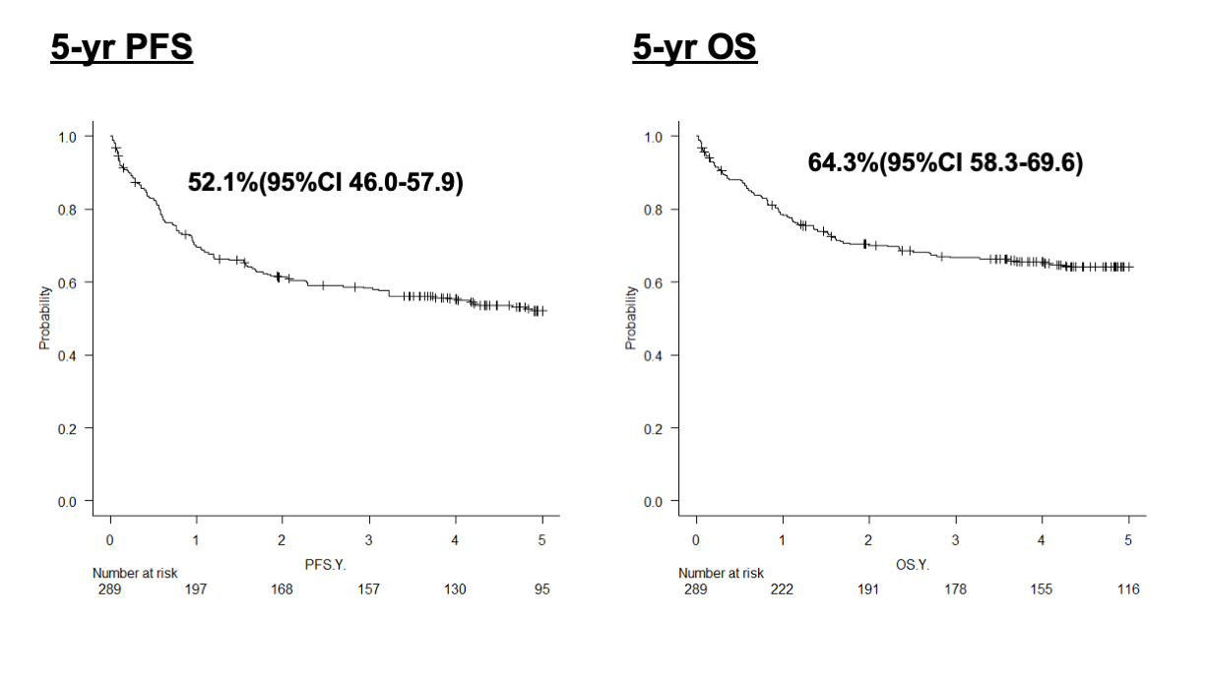

Supplementary Figure 2.
Receiver operating characteristic (ROC) curve analysis for serum albumin levels. The optimal cutoff value for predicting overall survival was determined to be 3.6 g/dL based on the Youden index, yielding a sensitivity of 63.5% and a specificity of 74.1%.
