Supplementary data
Figure S1. A computational workflow for docking, MD simulation, and mechanistic analysis of HDAC and JNK targets.
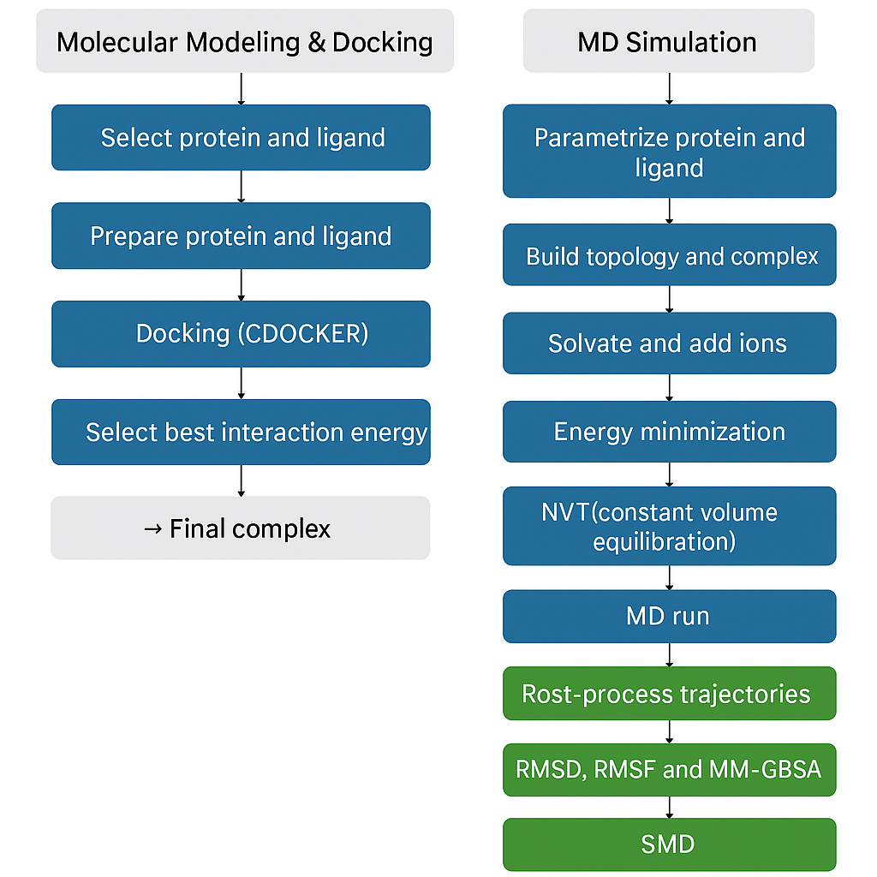

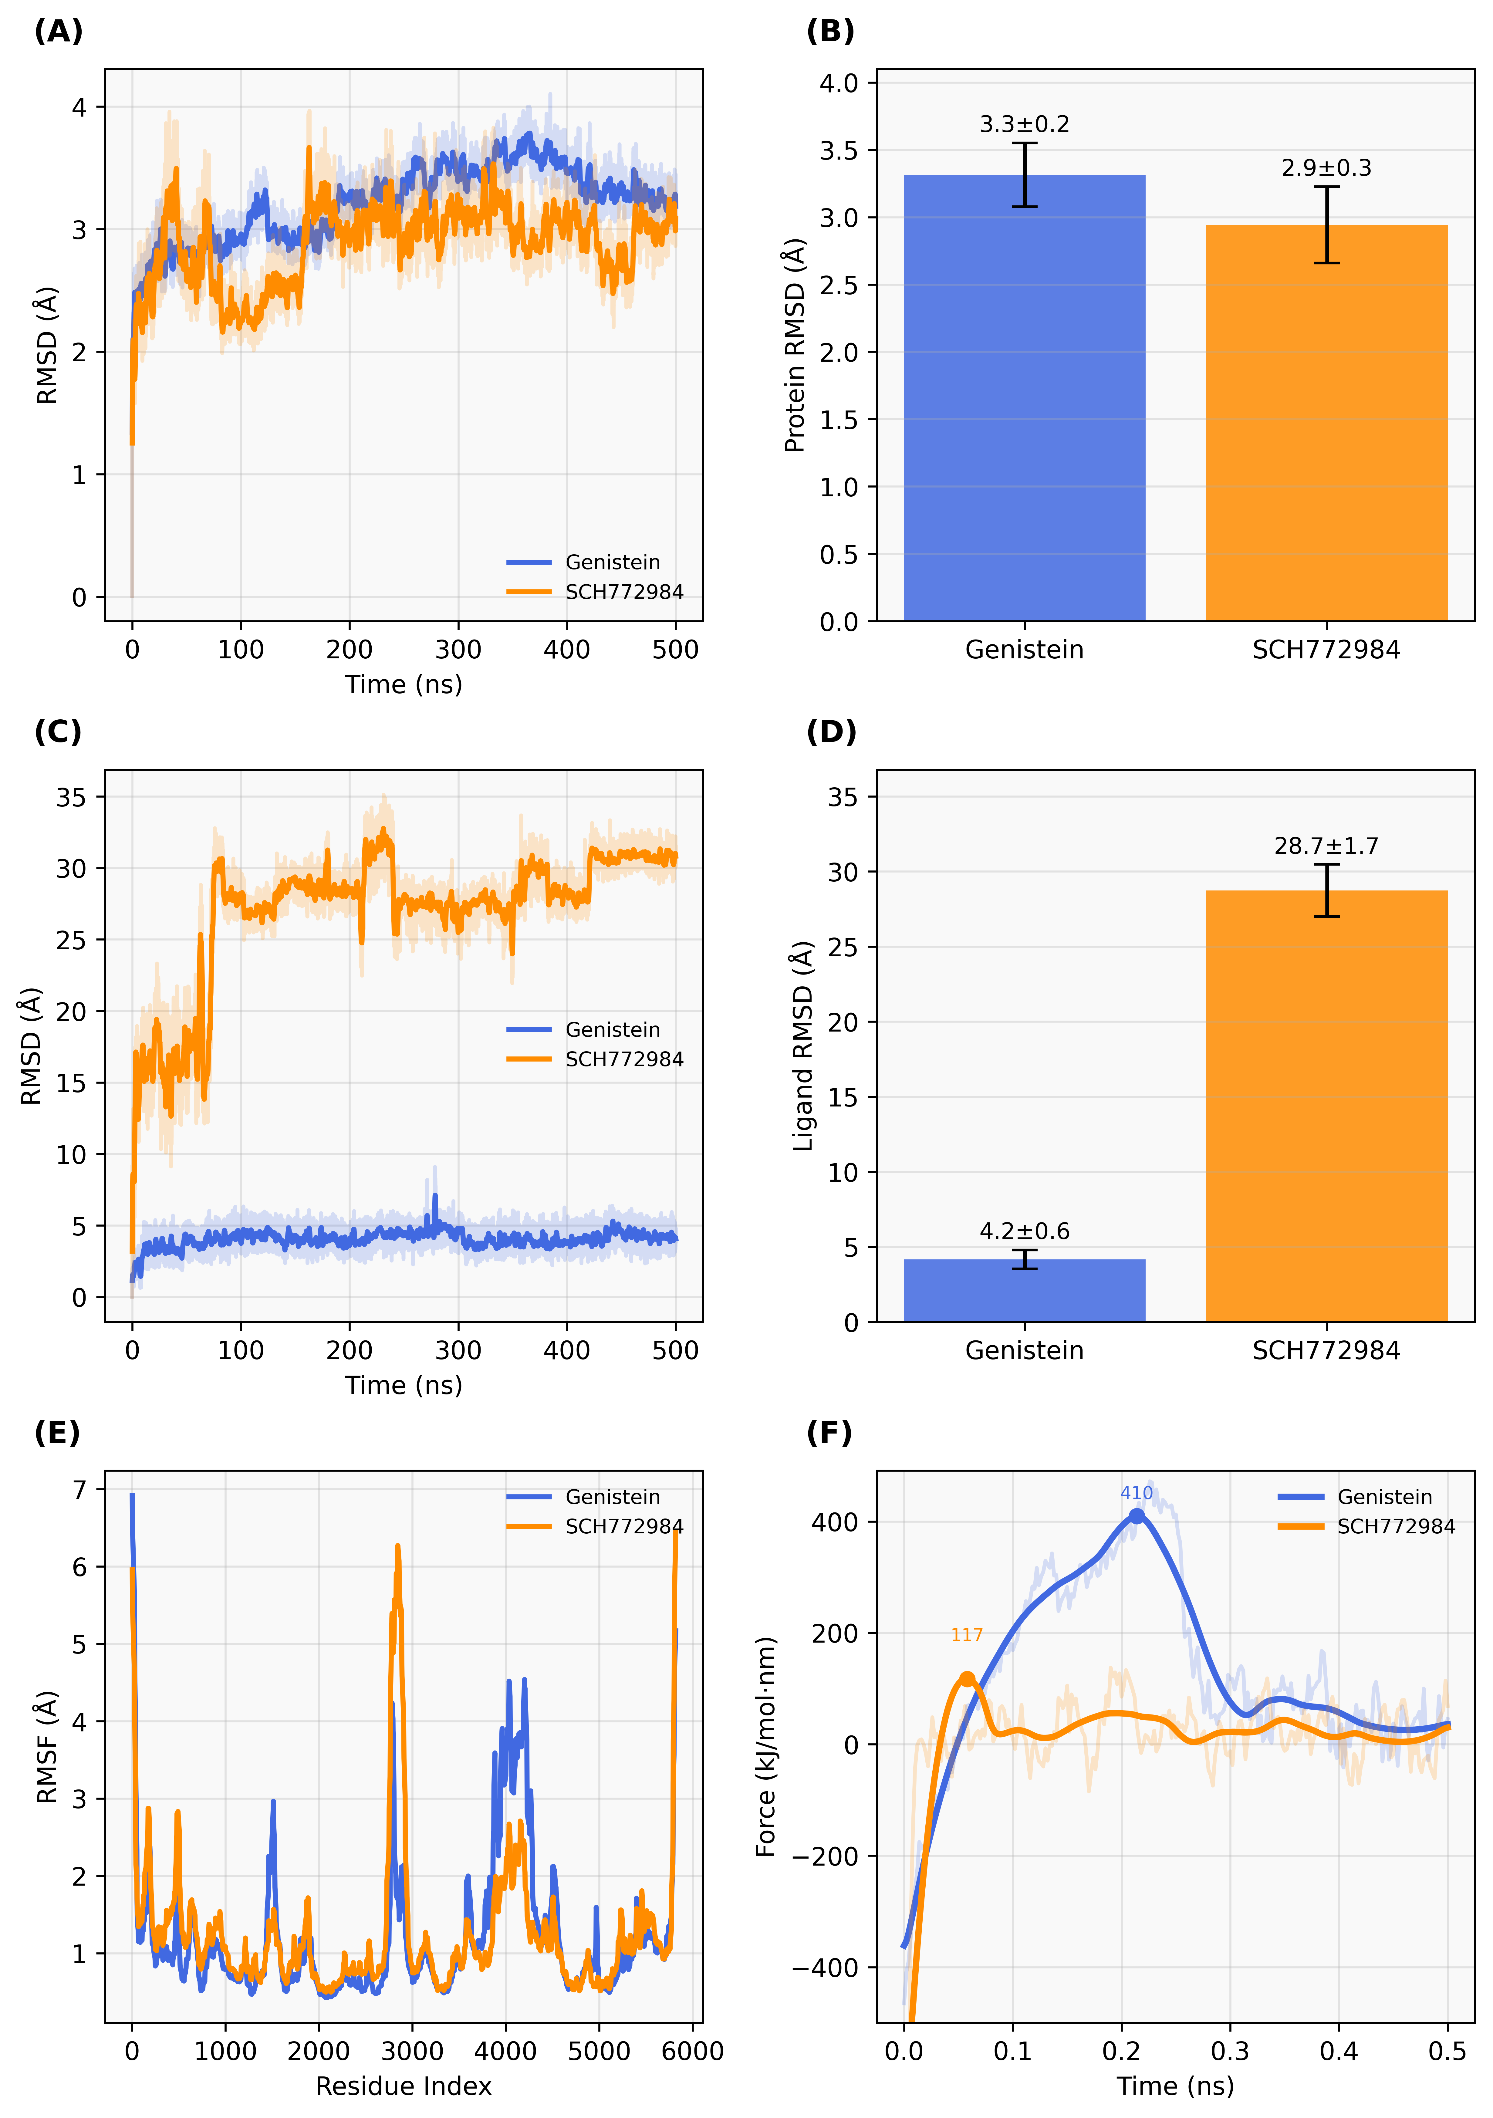

Figure S2. Binding dynamics of genistein and SCH772984 in JNK1.
a, Protein backbone RMSD over 500 ns. b, Mean ± standard deviation (SD) for protein RMSD (100–500 ns). c, Ligand RMSD trajectories. d, Mean ± SD for ligand RMSD (100–500 ns). e, Protein RMSF profiles. f, SMD force-time curves showing ligand unbinding behavior.

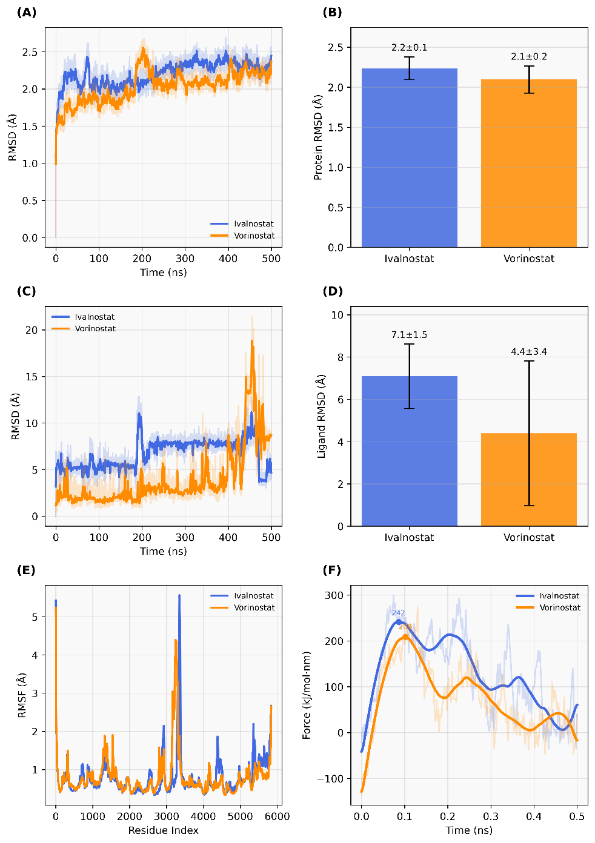

Figure S3. Comparative binding dynamics of ivaltinostat and vorinostat.
a, Protein backbone RMSD during 500-ns simulations. b, Mean ± standard deviation (SD) for protein RMSD calculated over 100–500 ns. c, Ligand RMSD trajectories showing binding-pose stability. d, Mean ± SD for ligand RMSD values. e, Per-residue RMSF profiles of the HDAC-ligand complexes. f, SMD force-time curves comparing the mechanical strength required to dissociate each ligand from the active site.

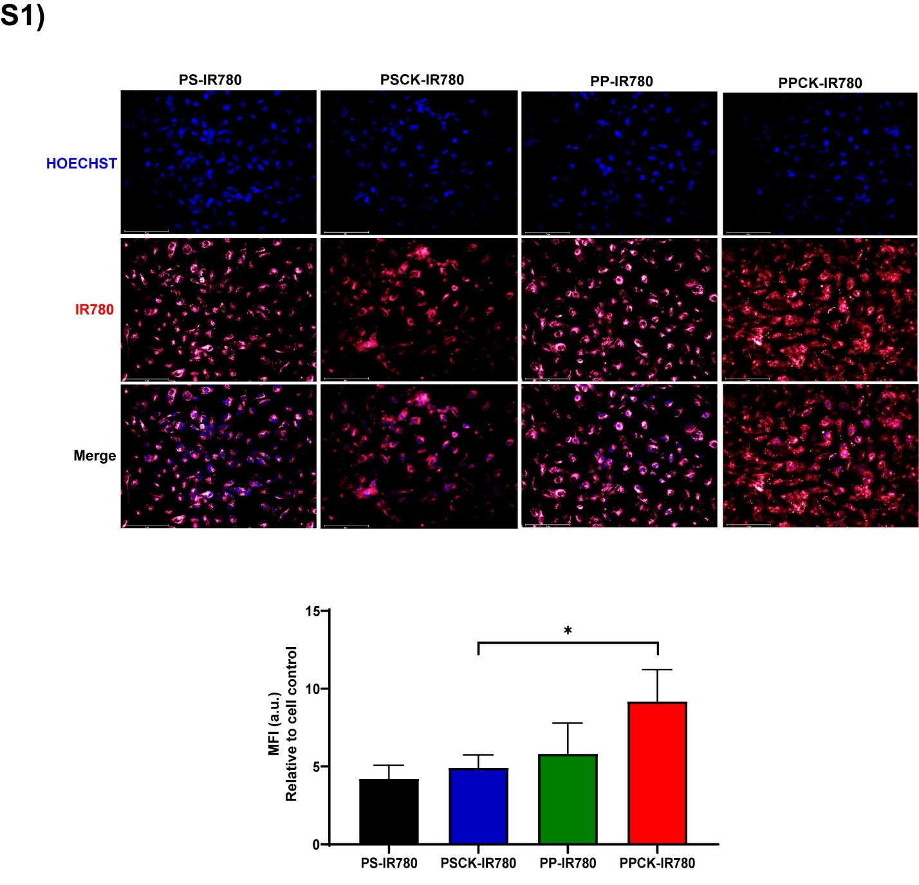
Figure S4. Cellular uptake of non–ROS-responsive formulations and PPCK-IR780.
a. Confocal images of HK-2 cells treated with PS-IR780, PSCK-IR780, PP-IR780, or PPCK-IR780 for 4 h. Hoechst stains nuclei (blue) and IR780 fluorescence is shown in red. Scale bar: 50 µm.
b. MFI quantification shows significantly higher uptake in the PPCK-IR780 group compared to other formulations (p < 0.05). Data = mean ± SD (n = 3).

Table S1. Binding energy comparison between the reference and test ligands for HDAC and MAPK targets, with ivaltinostat and genistein showing the most favorable interactions.

S. No | Ligands | CDOCKER Interaction Energy (kcal/mol) | MMGBSA Binding Energy (kcal/mol)
 | HDAC Inhibitor
1 | Co-crystallized ligand (Vorinostat) | −59.1736 | −18.86
2 | Trichostatin | −54.4656 | Positive (77.31)
3 | Ivaltinostat (CG-200745) | −74.5785 | −28.42
 | Anti-oxidant or TGF-B signaling inhibitor
1 | Co-crystallized ligand SCH772984 | −66.1824 | −24.20
2 | Sulfadimethoxine | −41.9099 | −10.29
3 | Genistein | −52.6343 | −21.39

Table S2. The list of primary and secondary antibodies for immunoblotting

 | Host | Reactivity | Supplier | Cat. No.
Bax | Rabbit | Human, Mouse | Cell signaling | #2772
Bcl-2 | Rabbit | Human, Mouse | Cell signaling | #3498
Caspase-3 | Rabbit | Human, Mouse | Cell signaling | #9662
Cleaved caspase-3 | Rabbit | Human, Mouse | Cell signaling | #9661
Erk1/2 | Rabbit | Human, Mouse | Cell signaling | #9102
JNK | Rabbit | Human, Mouse | Cell signaling | #9252
p38 | Rabbit | Human, Mouse | Cell signaling | #9212
Phopho-Erk1/2 | Rabbit | Human, Mouse | Cell signaling | #9101
Phopho JNK | Rabbit | Human, Mouse | Cell signaling | #9251
Phospho p38 | Rabbit | Human, Mouse | Cell signaling | #9215
Phospho Smad2/3 | Rabbit | Human, Mouse | Cell Signaling | #8828
Smad4 | Rabbit | Human, Mouse | Cell Signaling | #38454
Smad2/3 | Rabbit | Human, Mouse | Cell Signaling | #3102
Transforming growth factor-β | Rabbit | Human, Mouse | Cell Signaling | #3711
α-smooth muscle actin | Mouse | Human, Mouse | Sigma-Aldrich | A2547
β-actin | Mouse | Human, Mouse | Sigma-Aldrich | A3854

Table S3. The list of primer sequences for real-time qPCR

 | Forward | Reverse
mActa2 (αSMA) | ACTGGGACGACATGGAAAAG | CATCTCCAGAGTCCAGCACA
mGapdh | TGTGTCCGTCGTGGATCTGA | GATGCCTGCTTCACCACCTT
mIl-6 | ACAACCACGGCCTTCCCTACTT | CACGATTTCCCAGAGAACATGTG
mCcl2 (MCP-1) | ATCCCAATGAGTAGGCTGGAGAGC | CAGAAGTGCTTGAGGTGGTTGTG
mFn1 (fibronectin) | ACACGGTTTCCCATTACGCCAT | AATGACCACTGCCAAAGCCCAA
mTgfb1 (TGFβ) | CAACAATTCCTGGCGTTACCTTGG | GAAAGCCCTGTATTCCGTCTCCTT
mTnf (TNFα) | AGCCCCCAGTCTGTATCCTT | GGTCACTGTCCCAGCATCTT

