SUPPLEMENTARY A: TOOLS

A.1. Ensembl Biomart query for acceptor splice-site collection
Exon start positions indicate acceptor sites in a genomic sequence except for the ones which contain the initiator codon. Therefore, we have collected transcript start and exon region start positions on protein coding-genes through Ensembl Biomart as shown in Supplementary Figure 1. If exon region start is same with transcript start, it is omitted since it is the exon with initiator codon and neighbor of 5’ UTR but not the splice-site.

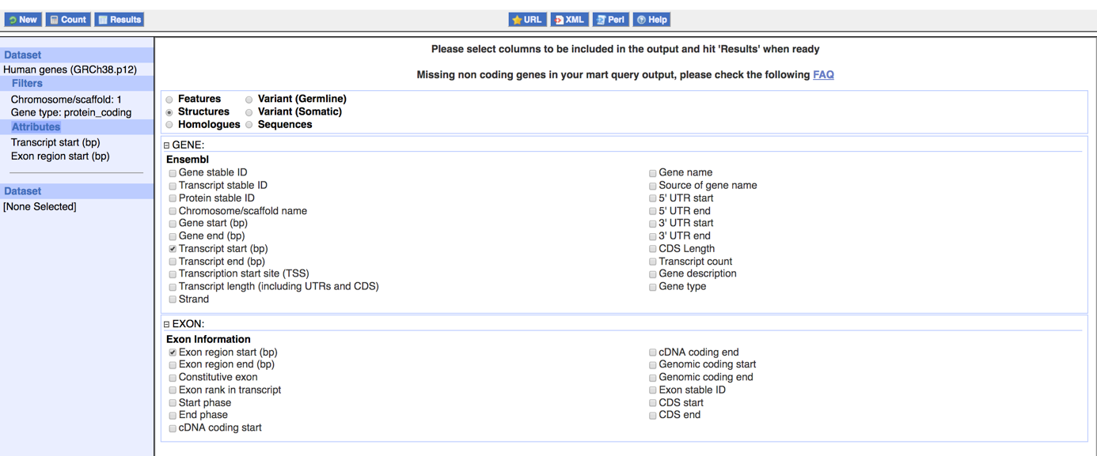
Supplementary Figure 1. Acceptor site query through Ensembl Biomart for protein coding genes of chromosome 1. For all other 23 chromosomes, queries are formed in the same manner.

A.2. Perl script and R code utilized for downloading the sequences from UCSC DAS server
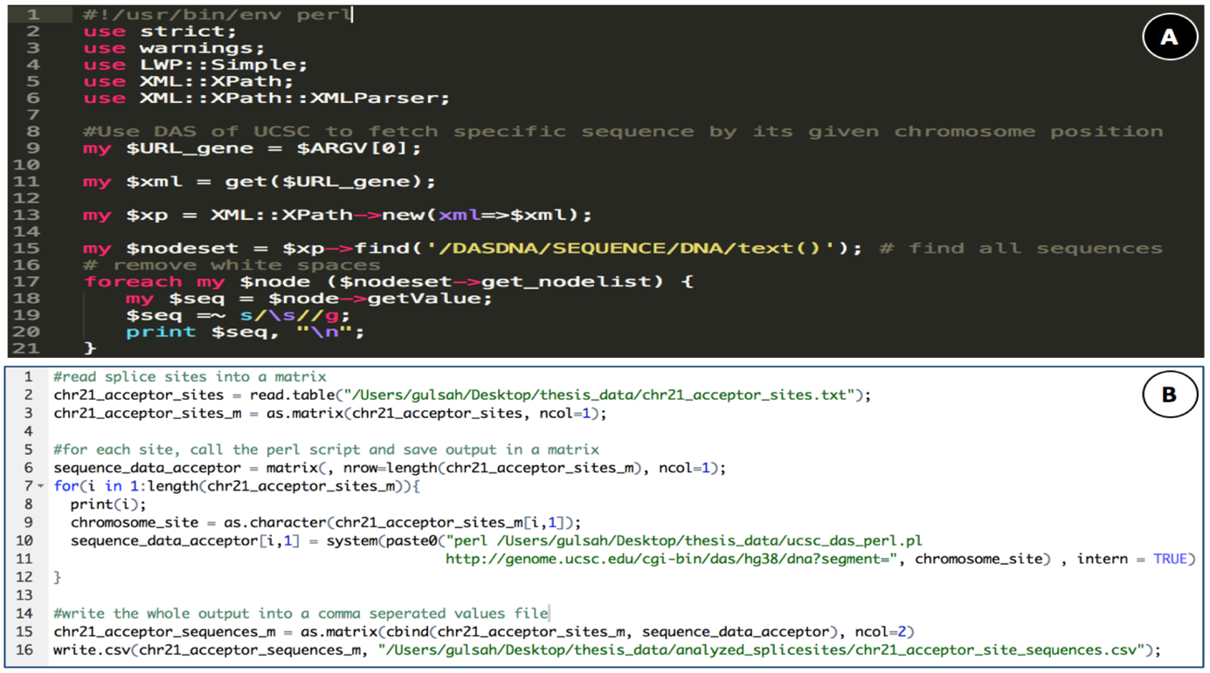
Supplementary Figure 2. A: Perl script used for downloading sequences from USCS DAS Server (directly taken from the forum entry reached through https://www.biostars.org/p/6156) B: R script for running Perl script and collecting its output in csv format for further inspection.

A.3. MEME ChIP run configuration
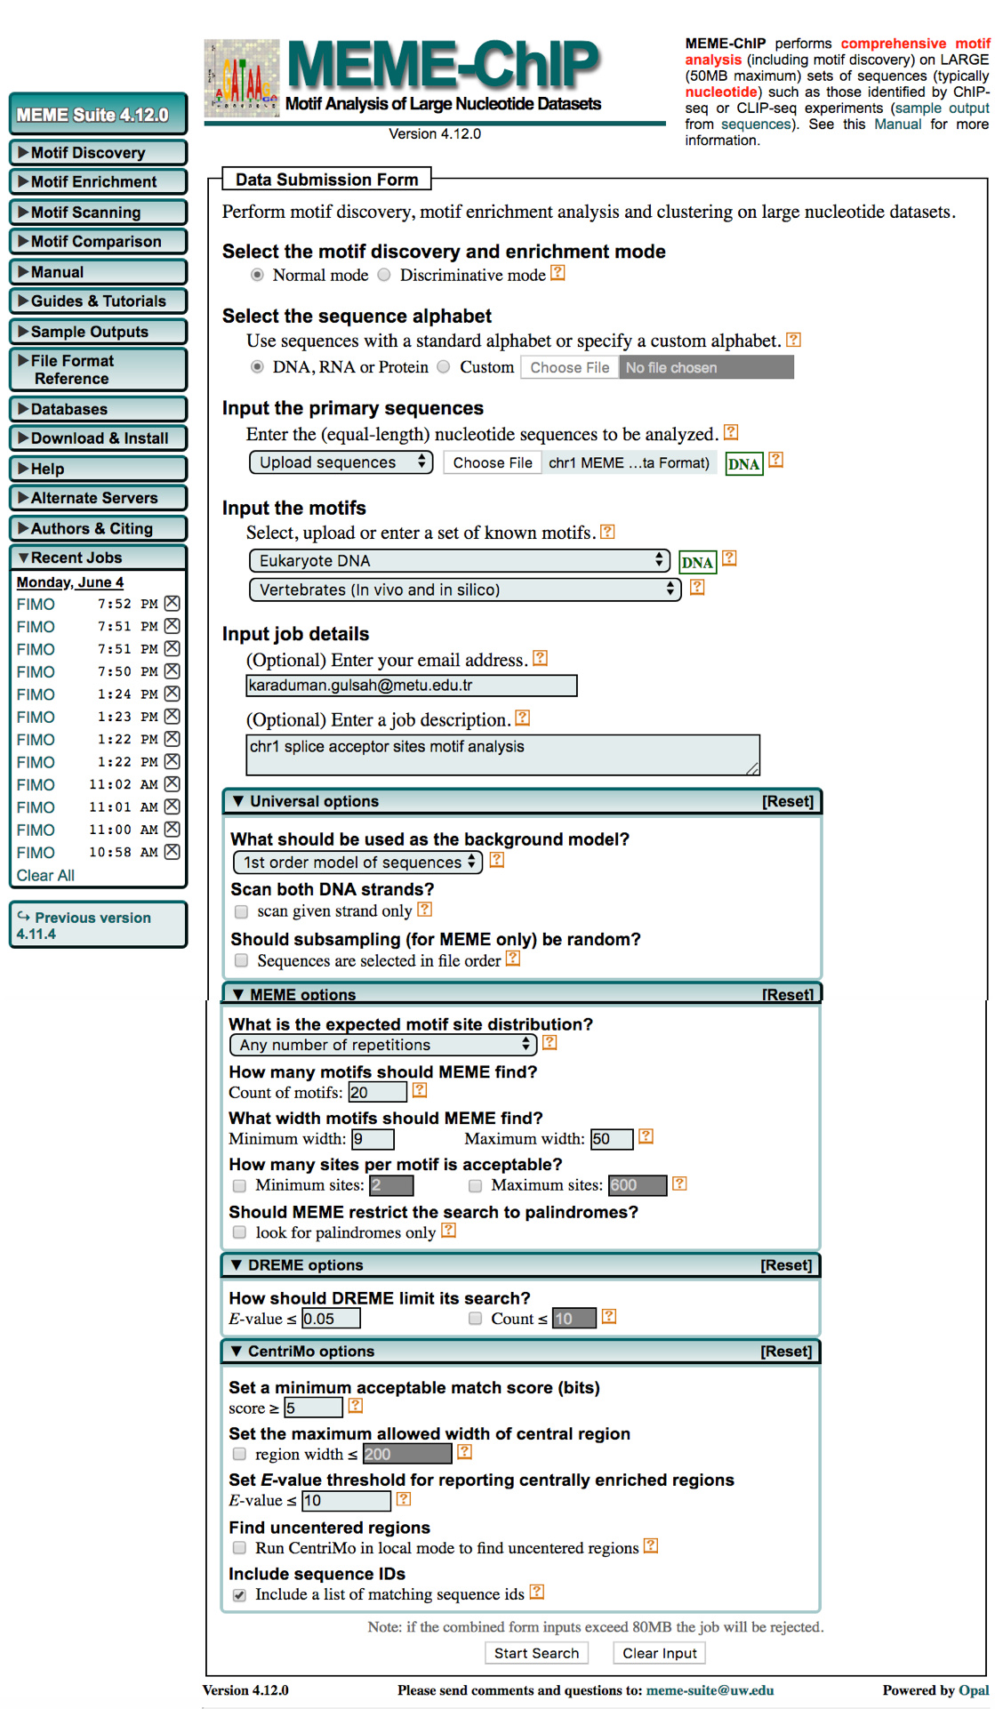
Supplementary Figure 3. MEME ChIP run with default configuration except for MEME which is arranged to find 20 motifs with 9 to 50 nucleotides long.

SUPPLEMENTARY B: LIST OF KNOWN AND NOVEL MOTIFS

B.1. List of known motifs
Supplementary Table 1. List of previously known motifs.
1. Alx1_DBD_1 | 78. FOXO4_DBD_2 | 155. MA0050.2 | 232. NKX6-2_DBD | 309. UP00024_1 | 386. UP00155_1
2. Alx1_DBD_2 | 79. FOXO4_DBD_3 | 156. MA0056.1 | 233. NKX6-2_full | 310. UP00024_2 | 387. UP00157_1
3. ALX3_DBD | 80. FOXO6_DBD_2 | 157. MA0057.1 | 234. NOTO_DBD | 311. UP00025_1 | 388. UP00158_1
4. ALX3_full_1 | 81. FOXP3_DBD | 158. MA0063.1 | 235. Nr2e1_DBD_1 | 312. UP00025_2 | 389. UP00164_1
5. ALX3_full_2 | 82. GBX1_DBD | 159. MA0065.2 | 236. NR2E1_full_1 | 313. UP00028_2 | 390. UP00164_2
6. Alx4_DBD | 83. Gbx1_DBD | 160. MA0079.3 | 237. ONECUT3_DBD | 314. UP00029_1 | 391. UP00166_1
7. ALX4_DBD | 84. Gbx2_DBD | 161. MA0084.1 | 238. OTX2_DBD_2 | 315. UP00030_1 | 392. UP00167_1
8. ARX_DBD | 85. GBX2_DBD_1 | 162. MA0087.1 | 239. PAX4_DBD | 316. UP00030_2 | 393. UP00168_1
9. Arx_DBD | 86. GBX2_DBD_2 | 163. MA0108.2 | 240. PAX4_full | 317. UP00032_1 | 394. UP00169_1
10. Barhl1_DBD_1 | 87. GSC2_DBD | 164. MA0109.1 | 241. PAX7_DBD | 318. UP00033_2 | 395. UP00170_1
11. Barhl1_DBD_2 | 88. GSX1_DBD | 165. MA0125.1 | 242. PDX1_DBD_1 | 319. UP00034_1 | 396. UP00171_1
12. Barhl1_DBD_3 | 89. GSX2_DBD | 166. MA0135.1 | 243. PDX1_DBD_2 | 320. UP00037_1 | 397. UP00172_1
13. BARHL2_DBD_1 | 90. HESX1_DBD_1 | 167. MA0142.1 | 244. PHOX2A_DBD | 321. UP00039_1 | 398. UP00173_1
14. BARHL2_DBD_2 | 91. HMBOX1_DBD | 168. MA0148.3 | 245. PHOX2B_DBD | 322. UP00039_2 | 399. UP00174_1
15. BARHL2_DBD_3 | 92. HMX1_DBD | 169. MA0151.1 | 246. PHOX2B_full | 323. UP00041_1 | 400. UP00175_1
16. BARHL2_full_1 | 93. HMX2_DBD | 170. MA0152.1 | 247. PITX1_DBD | 324. UP00043_2 | 401. UP00179_1
17. BARHL2_full_2 | 94. HNF1A_full | 171. MA0155.1 | 248. PITX1_full_1 | 325. UP00045_2 | 402. UP00180_1
18. BARHL2_full_3 | 95. HNF1B_full_1 | 172. MA0158.1 | 249. PITX3_DBD | 326. UP00047_1 | 403. UP00182_1
19. BARX1_DBD_1 | 96. HNF1B_full_2 | 173. MA0442.2 | 250. POU1F1_DBD_1 | 327. UP00051_1 | 404. UP00187_1
20. BARX1_DBD_2 | 97. HOMEZ_DBD | 174. MA0471.1 | 251. POU1F1_DBD_2 | 328. UP00054_2 | 405. UP00188_1
21. BSX_DBD | 98. HOXA1_DBD | 175. MA0480.1 | 252. POU2F1_DBD_1 | 329. UP00058_2 | 406. UP00189_1
22. CART1_DBD | 99. HOXA10_DBD_1 | 176. MA0481.2 | 253. POU2F1_DBD_2 | 330. UP00059_1 | 407. UP00191_1
23. CDX1_DBD | 100. HOXA10_DBD_2 | 177. MA0485.1 | 254. POU2F2_DBD_1 | 331. UP00061_1 | 408. UP00194_1
24. CDX2_DBD | 101. Hoxa11_DBD_1 | 178. MA0493.1 | 255. POU2F2_DBD_2 | 332. UP00061_2 | 409. UP00196_1
25. CPEB1_full | 102. Hoxa11_DBD_2 | 179. MA0497.1 | 256. Pou2f2_DBD_2 | 333. UP00062_1 | 410. UP00197_1
26. DLX1_DBD | 103. HOXA13_DBD_1 | 180. MA0504.1 | 257. POU2F3_DBD_1 | 334. UP00063_2 | 411. UP00200_1
27. Dlx1_DBD | 104. HOXA13_full_1 | 181. MA0507.1 | 258. POU2F3_DBD_2 | 335. UP00064_1 | 412. UP00200_2
28. Dlx2_DBD | 105. HOXA13_full_2 | 182. MA0514.1 | 259. POU3F1_DBD_1 | 336. UP00069_1 | 413. UP00202_1
29. DLX2_DBD | 106. Hoxa2_DBD | 183. MA0515.1 | 260. POU3F1_DBD_2 | 337. UP00070_2 | 414. UP00206_1
30. DLX3_DBD | 107. HOXB13_DBD_1 | 184. MA0516.1 | 261. POU3F2_DBD_1 | 338. UP00071_1 | 415. UP00207_1
31. DLX4_DBD | 108. HOXB2_DBD | 185. MA0517.1 | 262. POU3F2_DBD_2 | 339. UP00073_1 | 416. UP00208_2
32. DLX5_FL | 109. HOXB3_DBD | 186. MA0528.1 | 263. POU3F3_DBD_1 | 340. UP00073_2 | 417. UP00209_1
33. DLX6_DBD | 110. HOXB5_DBD | 187. MA0593.1 | 264. POU3F3_DBD_2 | 341. UP00074_1 | 418. UP00209_2
34. DRGX_DBD | 111. HOXC10_DBD_1 | 188. MA0599.1 | 265. POU3F3_DBD_3 | 342. UP00074_2 | 419. UP00211_1
35. EGR4_DBD_1 | 112. Hoxc10_DBD_1 | 189. MA0601.1 | 266. POU3F4_DBD_1 | 343. UP00075_1 | 420. UP00212_1
36. EMX1_DBD_1 | 113. Hoxc10_DBD_2 | 190. MA0602.1 | 267. POU3F4_DBD_2 | 344. UP00077_1 | 421. UP00213_1
37. EMX1_DBD_2 | 114. HOXC10_DBD_2 | 191. MA0606.1 | 268. POU4F1_DBD | 345. UP00077_2 | 422. UP00214_1
38. EMX2_DBD_1 | 115. HOXC10_DBD_3 | 192. MA0612.1 | 269. POU4F2_DBD | 346. UP00078_1 | 423. UP00215_1
39. EMX2_DBD_2 | 116. HOXC11_DBD_1 | 193. MA0614.1 | 270. POU4F3_DBD | 347. UP00079_2 | 424. UP00217_1
40. EN1_full_1 | 117. HOXC11_DBD_2 | 194. MA0618.1 | 271. POU5F1P1_DBD_1 | 348. UP00082_2 | 425. UP00218_1
41. EN1_full_2 | 118. HOXC11_full_2 | 195. MA0619.1 | 272. POU5F1P1_DBD_2 | 349. UP00086_1 | 426. UP00221_1
42. EN2_DBD | 119. HOXC12_DBD_1 | 196. MA0621.1 | 273. POU6F2_DBD_1 | 350. UP00086_2 | 427. UP00224_1
43. En2_DBD | 120. HOXC13_DBD_1 | 197. MA0625.1 | 274. PRDM1_full | 351. UP00089_1 | 428. UP00225_1
44. ESX1_DBD | 121. HOXD11_DBD_1 | 198. MA0627.1 | 275. PROP1_DBD | 352. UP00090_2 | 429. UP00229_1
45. ESX1_full | 122. HOXD11_DBD_2 | 199. MA0628.1 | 276. PROP1_full | 353. UP00091_1 | 430. UP00234_1
46. EVX1_DBD | 123. HOXD12_DBD_1 | 200. MA0630.1 | 277. PRRX1_DBD | 354. UP00093_1 | 431. UP00236_1
47. EVX2_DBD | 124. HOXD12_DBD_4 | 201. MA0648.1 | 278. PRRX1_full_1 | 355. UP00094_2 | 432. UP00238_1
48. FOXB1_DBD_3 | 125. Hoxd13_DBD_1 | 202. MA0722.1 | 279. PRRX1_full_2 | 356. UP00096_1 | 433. UP00240_1
49. FOXB1_full | 126. HOXD13_DBD_1 | 203. MA0733.1 | 280. Prrx2_DBD | 357. UP00096_2 | 434. UP00241_1
50. FOXC1_DBD_1 | 127. Hoxd13_DBD_2 | 204. MA0851.1 | 281. PRRX2_full | 358. UP00097_2 | 435. UP00242_1
51. Foxc1_DBD_1 | 128. Hoxd3_DBD | 205. MA0852.2 | 282. RAX_DBD | 359. UP00099_2 | 436. UP00244_1
52. Foxc1_DBD_2 | 129. HOXD8_DBD | 206. MA0853.1 | 283. RAXL1_DBD | 360. UP00101_1 | 437. UP00248_1
53. FOXC1_DBD_2 | 130. Hoxd9_DBD_1 | 207. MA0897.1 | 284. SHOX_DBD | 361. UP00101_2 | 438. UP00250_1
54. FOXC1_DBD_3 | 131. Hoxd9_DBD_2 | 208. MA0898.1 | 285. SHOX2_DBD | 362. UP00105_1 | 439. UP00251_1
55. FOXC2_DBD_1 | 132. Hoxd9_DBD_3 | 209. MA0904.1 | 286. Shox2_DBD | 363. UP00108_1 | 440. UP00252_1
56. FOXC2_DBD_2 | 133. IRF7_DBD_1 | 210. MA0910.1 | 287. SOX9_DBD | 364. UP00113_1 | 441. UP00254_1
57. FOXC2_DBD_3 | 134. Irx3_DBD | 211. MA1103.1 | 288. SP1_DBD | 365. UP00114_1 | 442. UP00255_1
58. FOXD2_DBD_1 | 135. IRX5_DBD | 212. MA1104.1 | 289. SP3_DBD | 366. UP00115_1 | 443. UP00257_1
59. FOXD2_DBD_2 | 136. ISX_DBD_1 | 213. MA1107.1 | 290. SP8_DBD | 367. UP00116_1 | 444. UP00260_1
60. FOXD3_DBD_1 | 137. ISX_DBD_2 | 214. MA1115.1 | 291. TEF_FL | 368. UP00118_1 | 445. UP00262_1
61. FOXD3_DBD_2 | 138. ISX_full | 215. MA1117.1 | 292. Uncx_DBD_1 | 369. UP00121_1 | 446. UP00263_1
62. Foxg1_DBD_3 | 139. KLF16_DBD | 216. MA1125.1 | 293. UNCX_DBD_1 | 370. UP00124_1 | 447. UP00267_1
63. FOXI1_full_1 | 140. LBX2_DBD_2 | 217. MA1148.1 | 294. UNCX_DBD_2 | 371. UP00125_1 | 448. UP00390_1
64. FOXJ2_DBD_1 | 141. LHX2_DBD_1 | 218. MA1149.1 | 295. Uncx_DBD_2 | 372. UP00127_1 | 449. VAX1_DBD
65. FOXJ2_DBD_2 | 142. Lhx4_DBD | 219. MA1152.1 | 296. UP00002_1 | 373. UP00128_1 | 450. VAX2_DBD
66. FOXJ2_DBD_3 | 143. LHX6_full_1 | 220. MEOX1_full | 297. UP00004_1 | 374. UP00129_1 | 451. VENTX_DBD_1
67. FOXJ3_DBD_1 | 144. Lhx8_DBD_2 | 221. Meox2_DBD | 298. UP00007_1 | 375. UP00130_1 | 452. Vsx1_DBD
68. Foxj3_DBD_2 | 145. LHX9_DBD_1 | 222. MEOX2_DBD_1 | 299. UP00007_2 | 376. UP00133_1 | 453. VSX1_DBD
69. Foxj3_DBD_3 | 146. LHX9_DBD_2 | 223. MIXL1_full | 300. UP00012_1 | 377. UP00134_1 | 454. VSX2_DBD
70. FOXJ3_DBD_3 | 147. LMX1A_DBD | 224. MNX1_DBD | 301. UP00013_2 | 378. UP00140_1 | 455. Zfp740_DBD
71. Foxj3_DBD_4 | 148. LMX1B_DBD | 225. MSX1_DBD_1 | 302. UP00014_1 | 379. UP00141_1 | 456. ZNF740_DBD
72. Foxk1_DBD_2 | 149. LMX1B_full | 226. MSX1_DBD_2 | 303. UP00016_1 | 380. UP00142_1 | 457. ZNF740_full
73. FOXL1_full_1 | 150. MA0031.1 | 227. MSX2_DBD_2 | 304. UP00016_2 | 381. UP00144_1
74. FOXL1_full_2 | 151. MA0036.3 | 228. Msx3_DBD_2 | 305. UP00021_1 | 382. UP00145_1
75. FOXO1_DBD_1 | 152. MA0040.1 | 229. NKX6-1_DBD | 306. UP00022_1 | 383. UP00149_1
76. FOXO1_DBD_3 | 153. MA0041.1 | 230. Nkx6-1_DBD | 307. UP00023_1 | 384. UP00150_1
77. FOXO3_full_3 | 154. MA0047.2 | 231. NKX6-1_full | 308. UP00023_2 | 385. UP00151_1

B.2. List of novel motifs detected by DREME
Supplementary Table 2. List of novel motifs detected by DREME algorithm.
1. AAAAAMAA | 8. AAATRY | 15. DAAATR | 22. RGRAA
2. AAAAHAAA | 9. ACATWY | 16. DTTTCY | 23. RGRAAA
3. AAAAMAAA | 10. AGAAA | 17. RAAATA | 24. RGRAAR
4. AAANAAAA | 11. AGRAA | 18. RAAATR | 25. RRGAAA
5. AAARAAAA | 12. AGRAAR | 19. RAAAYR | 26. TAWATR
6. AAARCA | 13. AYATWY | 20. RGAAA | 27. TGGGRA
7. AAATRH | 14. CYTCCCW | 21. RGAAR | 28. WCCCCR

B.3. List of novel motifs detected by MEME
Supplementary Table 3. List of novel motifs detected by MEME algorithm.
1. AAAAAWWAAAWAWAWAWAAAHA
2. AAAARWAAAAAA
3. AAAWWHAWWRAAWWWWWAWAWWMWAWAWAWA
4. AAWDWATWHWTWDWATTWWTNTATTTDTWTTTWWTTTWWWWWTTWWWTWW
5. ATWTWWAAAATWAAWAWWTHWHWTDDNAAAAWWWWWDAAWWWWTDWWWAW
6. AWAAWWAAAHAWTAAAAATAAA
7. AWAWAWWADAWWWAWAWWWAWA
8. AWKAMASARDAAAARARAAAAA
9. CCCCRSCCYCMYCCTBCYCCYC
10. CYCTCCYTNCCACMCT
11. DRMAWNARARNRADAYWRHATHTHAAAAAADAAAAAWVHADNWAVW
12. GGGCTGGGG
13. GGRRACAGAGRCYCAGAGRGRG
14. GGRRRSWGGGGRRRRGSAGRGBDSGGAGGGR
15. GNSGGGGASSGGGGCSDGGGSDGRGGGNGGGGAGGGGVGGGBR
16. MAAARAAAAAAAAAAARDTNAR
17. RGDGRGAWGGRDRRGGDGRGASRGGARRGRR
18. RGGSAGGGGGRRGRRG
19. RGRRAARGRRAGAGAG
20. STGGGGTGGGKG
21. TNTWTWWWTTTWWWKTWWDWRTTTTWAWTWT
22. TTTATWWBTWWTTWWTWTWTAWWWATKWWTW
23. TTTTTTTTTTTTNAKW
24. TWTWNWWTYANWRWWWTWHTHWTWWWTMTTTNTWWTWWWAWKTTWWAWWT
25. WAAAAAWAADAWVAAA
26. WTATWAWAAAAWDAAAWAAWAW
27. WTWWAAAWWTWHWAATAWAWAW
28. WWAAWWWWWARAWAWAWWAATA
29. WWAWAWWADWHARWHWWWRTYWWAWWAAAWWWRAWWAWWAWDWAAA
30. WWAWRAAAAAAAWAAA
31. WWTWTWTTWWWWWTYWKWWWBWTWTTTWHWT
32. YCCYTCCCASCYCCYC
33. YSYYYYYYCTSYCYBYCYBYCY

SUPPLEMENTARY C: GENE LISTS USED IN DAVID FUNCTIONAL ANNOTATION ANALYSIS
Supplementary Table 4. Gene list for homo sapiens TFs for which DAVID’s functional annotation analysis held.
1. ALX3 | 28. FOXD2 | 55. HOXB2 | 82. SRY | 109. PHOX2A | 136. OTX2
2. ALX4 | 29. FOXD3 | 56. HOXB3 | 83. TBP | 110. RAX2 | 137. PAX7
3. ARX | 30. FOXI1 | 57. HOXB5 | 84. PDX1 | 111. RAX | 138. PHOX2B
4. BARHL2 | 31. FOXJ2 | 58. HOXC10 | 85. FOXA1 | 112. UNCX | 139. PITX1
5. BARX1 | 32. FOXJ3 | 59. HOXC11 | 86. NFATC2 | 113. VAX1 | 140. PITX3
6. BSX | 33. FOXL1 | 60. HOXC12 | 87. INSM1 | 114. VENTX | 141. POU1F1
7. ALX1 | 34. FOXO1 | 61. HOXC13 | 88. HOXA5 | 115. EGR4 | 142. POU2F1
8. CDX1 | 35. FOXO3 | 62. HOXD11 | 89. SOX10 | 116. ONECUT3 | 143. POU2F3
9. CDX2 | 36. FOXO4 | 63. HOXD12 | 90. E2F6 | 117. POU3F1 | 144. POU3F2
10. CPEB1 | 37. FOXO6 | 64. HOXD13 | 91. FOXP1 | 118. POU4F1 | 145. POU3F3
11. DLX1 | 38. FOXP3 | 65. HOXD8 | 92. MEF2C | 119. POU4F3 | 146. POU3F4
12. DLX2 | 39. GBX1 | 66. IRF7 | 93. NR2C2 | 120. FOXK1 | 147. POU4F2
13. DLX3 | 40. GBX2 | 67. IRX5 | 94. POU2F2 | 121. FOXK2 | 148. POU5F1B
14. DLX4 | 41. GSC2 | 68. ISX | 95. SP2 | 122. GATA6 | 149. POU6F2
15. DLX5 | 42. GSX1 | 69. KLF16 | 96. STAT1 | 123. KLF9 | 150. PRDM1
16. DLX6 | 43. GSX2 | 70. LBX2 | 97. ZNF263 | 124. POU5F1 | 151. PROP1
17. DRGX | 44. HESX1 | 71. LHX2 | 98. FOXP2 | 125. RELB | 152. PRRX1
18. EMX1 | 45. HMBOX1 | 72. LHX6 | 99. KLF5 | 126. ZNF384 | 153. PRRX2
19. EMX2 | 46. HMX1 | 73. LHX9 | 100. LBX1 | 127. PPARA | 154. SHOX2
20. EN1 | 47. HMX2 | 74. LMX1A | 101. NFATC3 | 128. RARA | 155. SOX9
21. EN2 | 48. HNF1A | 75. LMX1B | 102. POU6F1 | 129. SOX15 | 156. SP3
22. ESX1 | 49. HNF1B | 76. FOXD1 | 103. SHOX | 130. MNX1 | 157. SP8
23. EVX1 | 50. HOMEZ | 77. GATA2 | 104. GSC | 131. MSX1 | 158. TEF
24. EVX2 | 51. HOXA1 | 78. IRF1 | 105. MEOX1 | 132. MSX2 | 159. VAX2
25. FOXB1 | 52. HOXA10 | 79. MZF1 | 106. MIXL1 | 133. NKX6-1 | 160. VSX1
26. FOXC1 | 53. HOXA13 | 80. PAX4 | 107. NKX6-2 | 134. NOTO | 161. VSX2
27. FOXC2 | 54. HOXB13 | 81. SP1 | 108. MEOX2 | 135. NR2E1 | 162. ZNF740

Supplementary Table 5. Gene list for mus musculus TFs for which DAVID’s functional annotation analysis held.
1. Alx1 | 29. Foxc1 | 57. Hoxb13 | 85. Klf1 | 113. Phox2b | 141. Sox4
2. Alx3 | 30. Foxg1 | 58. Hoxb4 | 86. Klf7 | 114. Pitx2 | 142. Sox5
3. Alx4 | 31. Foxj1 | 59. Hoxb5 | 87. Lhx1 | 115. Pou1f1 | 143. Sox6
4. Arid3a | 32. Foxj2 | 60. Hoxb7 | 88. Lhx2 | 116. Pou2f1 | 144. Sox7
5. Arid3b | 33. Foxj3 | 61. Hoxb8 | 89. Lhx3 | 117. Pou2f2 | 145. Sox8
6. Arid5a | 34. Foxk1 | 62. Hoxb9 | 90. Lhx4 | 118. Pou2f3 | 146. Sp4
7. Arx | 35. Foxl1 | 63. Hoxc10 | 91. Lhx5 | 119. Pou3f1 | 147. Srf
8. Ascl2 | 36. Foxo1 | 64. Hoxc13 | 92. Lhx8 | 120. Pou3f2 | 148. Sry
9. Barhl1 | 37. Gabpa | 65. Hoxc4 | 93. Lhx9 | 121. Pou3f3 | 149. Tcf1
10. Barhl2 | 38. Gata3 | 66. Hoxc5 | 94. Lmx1a | 122. Pou3f4 | 150. Tcf3
11. Barx2 | 39. Gbx1 | 67. Hoxc6 | 95. Lmx1b | 123. Pou4f3 | 151. Tcf7
12. Bbx | 40. Gbx2 | 68. Hoxc8 | 96. Mafb | 124. Prop1 | 152. Tcfap2e
13. Bcl6b | 41. Gcm1 | 69. Hoxc9 | 97. Meox2 | 125. Prrx2 | 153. Tlx2
14. Cdx1 | 42. Glis2 | 70. Hoxd1 | 98. Msx1 | 126. Rhox6 | 154. Uncx
15. Cdx2 | 43. Gsh2 | 71. Hoxd10 | 99. Msx3 | 127. Rxra | 155. Uncx4.1
16. Dbx1 | 44. Hmbox1 | 72. Hoxd13 | 100. Mtf1 | 128. Shox2 | 156. Vax1
17. Dbx2 | 45. Hmx2 | 73. Hoxd3 | 101. Nfatc2 | 129. Sox1 | 157. Vsx1
18. Dlx1 | 46. Hmx3 | 74. Hoxd8 | 102. Nkx2-5 | 130. Sox11 | 158. Zbtb7b
19. Dlx2 | 47. Homez | 75. Hoxd9 | 103. Nkx6-1 | 131. Sox12 | 159. Zfp105
20. Dlx3 | 48. Hoxa10 | 76. Pdx1 | 104. Nkx6-3 | 132. Sox13 | 160. Zfp128
21. Dlx4 | 49. Hoxa11 | 77. Irf3 | 105. Nobox | 133. Sox14 | 161. Zfp187
22. Egr1 | 50. Hoxa2 | 78. Irx2 | 106. Nr2e1 | 134. Sox15 | 162. Zfp281
23. Elf3 | 51. Hoxa3 | 79. Irx3 | 107. Obox5 | 135. Sox17 | 163. Zfp410
24. En1 | 52. Hoxa4 | 80. Irx4 | 108. Otx1 | 136. Sox18 | 164. Zfp740
25. En2 | 53. Hoxa5 | 81. Irx5 | 109. Otx2 | 137. Sox2
26. Esrra | 54. Hoxa6 | 82. Irx6 | 110. Pax6 | 138. Sox21
27. Esx1 | 55. Hoxa7 | 83. Isgf3g | 111. Pax7 | 139. Sox3
28. Foxa2 | 56. Hoxa9 | 84. Isl2 | 112. Phox2a | 140. Sox30

SUPPLEMENTARY D: UCSC BLAT QUERY
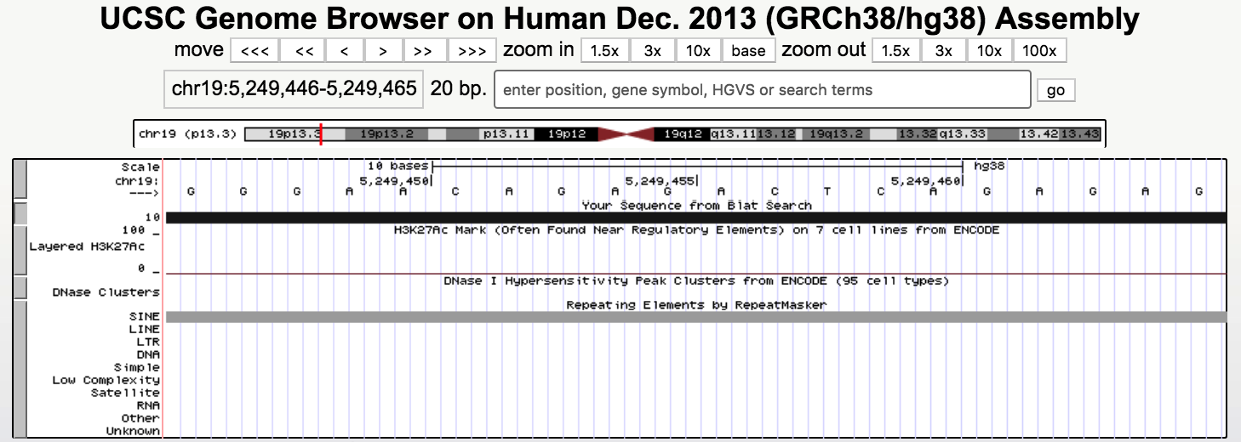

Supplementary Figure 4. UCSC BLAT Search Results for an alternative of GGRRACAGAGRCYCAGAGRGRG (i.e. GGGAACAGAGACTCAGAGAGAG) has shown that the first 20nt long part of the sequence is a SINE repeat.

SUPPLEMENTARY E: FREQUENCY OF NOVEL MOTIF OCCURRENCES
Supplementary Table 6. Percent occurrence frequency of novel motifs with <20nt length in the identified 8 regions around the acceptor dinucleotide. Highest frequencies are marked as red. 31 motifs are most frequently observed in Region 6 and 7 motifs are most frequently observed in Region 5. Other regions are not preferred by any of the motifs in the first rank of occurrence.
Motif Id | Region1 | Region2 | Region3 | Region4 | Region5 | Region6 | Region7 | Region8
AAAAAMAA | 11,81% | 12,98% | 12,90% | 12,48% | 13,03% | 25,89% | 5,06% | 5,84%
AAAAHAAA | 11,81% | 13,00% | 12,95% | 12,60% | 13,14% | 25,82% | 4,95% | 5,72%
AAAAMAAA | 11,74% | 12,91% | 12,88% | 12,56% | 13,08% | 25,95% | 5,07% | 5,82%
AAAARWAAAAAA | 12,19% | 13,92% | 13,77% | 13,45% | 14,35% | 24,39% | 3,43% | 4,49%
AAANAAAA | 11,58% | 12,77% | 12,76% | 12,43% | 12,93% | 25,96% | 5,47% | 6,10%
AAARAAAA | 11,58% | 12,77% | 12,76% | 12,43% | 12,93% | 25,96% | 5,47% | 6,10%
AAARCA | 11,70% | 12,72% | 12,81% | 12,79% | 13,23% | 18,33% | 9,17% | 9,26%
AAATRH | 12,56% | 13,65% | 13,77% | 13,89% | 14,48% | 17,23% | 6,96% | 7,46%
AAATRY | 12,46% | 13,45% | 13,61% | 13,93% | 14,46% | 15,48% | 8,15% | 8,47%
ACATWY | 12,06% | 13,00% | 13,29% | 13,59% | 13,98% | 14,08% | 9,88% | 10,13%
AGAAA | 11,32% | 11,92% | 12,13% | 12,11% | 11,85% | 14,72% | 14,03% | 11,93%
AGRAA | 11,47% | 12,15% | 12,40% | 12,49% | 12,51% | 15,93% | 12,19% | 10,86%
AGRAAR | 11,13% | 12,04% | 12,25% | 12,33% | 12,39% | 16,89% | 11,97% | 10,99%
AYATWY | 12,49% | 13,42% | 13,61% | 14,04% | 14,61% | 13,28% | 9,34% | 9,20%
CYCTCCYTNCCACMCT | 10,96% | 12,95% | 12,75% | 13,11% | 15,52% | 15,91% | 9,00% | 9,79%
CYTCCCW | 12,09% | 12,69% | 12,51% | 12,62% | 13,70% | 13,21% | 11,28% | 11,91%
DAAATR | 12,64% | 13,69% | 13,81% | 13,89% | 14,51% | 17,39% | 6,76% | 7,32%
DTTTCY | 11,43% | 12,40% | 12,56% | 12,58% | 12,68% | 18,30% | 10,42% | 9,64%
GGGCTGGGG | 12,14% | 12,99% | 12,67% | 12,87% | 15,10% | 12,64% | 10,14% | 11,45%
RAAATA | 12,81% | 13,79% | 13,77% | 13,60% | 14,10% | 20,01% | 5,57% | 6,35%
RAAATR | 12,55% | 13,57% | 13,62% | 13,56% | 14,21% | 19,29% | 6,29% | 6,92%
RAAAYR | 12,32% | 13,29% | 13,38% | 13,23% | 13,74% | 20,72% | 6,35% | 6,96%
RGAAA | 11,27% | 11,86% | 12,09% | 12,12% | 11,98% | 17,54% | 12,26% | 10,88%
RGAAR | 10,80% | 11,46% | 11,69% | 11,74% | 11,55% | 14,85% | 14,72% | 13,19%
RGGSAGGGGGRRGRRG | 10,70% | 12,65% | 12,44% | 12,59% | 14,33% | 19,03% | 8,86% | 9,40%
RGRAA | 11,32% | 12,00% | 12,25% | 12,33% | 12,29% | 16,11% | 12,55% | 11,15%
RGRAAA | 11,15% | 12,06% | 12,24% | 12,34% | 12,40% | 18,64% | 11,05% | 10,11%
RGRAAR | 11,05% | 11,97% | 12,22% | 12,29% | 12,37% | 17,13% | 11,78% | 11,18%
RGRRAARGRRAGAGAG | 10,21% | 12,35% | 12,26% | 12,11% | 13,30% | 23,19% | 8,10% | 8,48%
RRGAAA | 11,21% | 12,06% | 12,13% | 12,15% | 12,25% | 17,02% | 12,06% | 11,12%
STGGGGTGGGKG | 11,32% | 12,77% | 12,50% | 12,80% | 15,28% | 12,82% | 10,78% | 11,74%
TAWATR | 12,84% | 13,83% | 13,98% | 14,42% | 15,04% | 15,50% | 6,76% | 7,64%
TGGGRA | 11,91% | 12,63% | 12,63% | 12,72% | 13,51% | 12,50% | 11,86% | 12,24%
TTTTTTTTTTTTNAKW | 11,83% | 14,19% | 14,03% | 13,80% | 14,79% | 23,48% | 3,51% | 4,37%
WAAAAAWAADAWVAAA | 12,02% | 14,41% | 14,34% | 14,19% | 15,27% | 22,13% | 3,38% | 4,26%
WCCCCR | 12,07% | 12,62% | 12,51% | 12,61% | 13,56% | 11,81% | 12,06% | 12,75%
WWAWRAAAAAAAWAAA | 11,70% | 14,04% | 13,89% | 13,70% | 14,66% | 23,77% | 3,83% | 4,41%
YCCYTCCCASCYCCYC | 10,67% | 12,69% | 12,60% | 12,97% | 15,21% | 15,13% | 10,07% | 10,65%

Supplementary Table 7. Percent occurrence frequency of 31 novel motifs with <20nt length in the identified 3 sub regions on Region 6. Highest frequencies are marked as red. 27 motifs are most frequently observed in Region 6_3 and 4 of them are observed in Region 6_2 mostly. Region 6_2 indicates the branch point region.
Motif Id | Region 6_1 | Region 6_2 | Region 6_3
AAAAAMAA | 12,66% | 30,26% | 57,08%
AAAAHAAA | 12,77% | 30,28% | 56,95%
AAAAMAAA | 12,67% | 30,05% | 57,28%
AAAARWAAAAAA | 14,71% | 35,87% | 49,42%
AAANAAAA | 12,56% | 29,66% | 57,79%
AAARAAAA | 12,56% | 29,66% | 57,79%
AAARCA | 18,10% | 34,36% | 47,54%
AAATRH | 20,59% | 40,57% | 38,84%
AAATRY | 22,93% | 42,85% | 34,22%
ACATWY | 24,30% | 45,02% | 30,68%
AGAAA | 19,53% | 32,83% | 47,63%
AGRAA | 19,24% | 35,40% | 45,36%
AGRAAR | 17,95% | 32,31% | 49,74%
CYCTCCYTNCCACMCT | 22,31% | 32,98% | 44,71%
DAAATR | 20,31% | 39,67% | 40,03%
DTTTCY | 17,32% | 31,95% | 50,73%
RAAATA | 16,99% | 34,91% | 48,09%
RAAATR | 18,10% | 37,14% | 44,77%
RAAAYR | 16,28% | 33,73% | 49,99%
RGAAA | 17,12% | 30,66% | 52,22%
RGAAR | 19,06% | 31,47% | 49,47%
RGGSAGGGGGRRGRRG | 17,34% | 30,40% | 52,26%
RGRAA | 18,80% | 32,13% | 49,07%
RGRAAA | 16,55% | 30,81% | 52,64%
RGRAAR | 17,83% | 30,78% | 51,40%
RGRRAARGRRAGAGAG | 14,08% | 32,76% | 53,16%
RRGAAA | 17,87% | 31,52% | 50,62%
TAWATR | 23,07% | 41,31% | 35,62%
TTTTTTTTTTTTNAKW | 15,75% | 35,25% | 49,00%
WAAAAAWAADAWVAAA | 17,18% | 38,20% | 44,62%
WWAWRAAAAAAAWAAA | 37,55% | 37,55% | 46,82%

