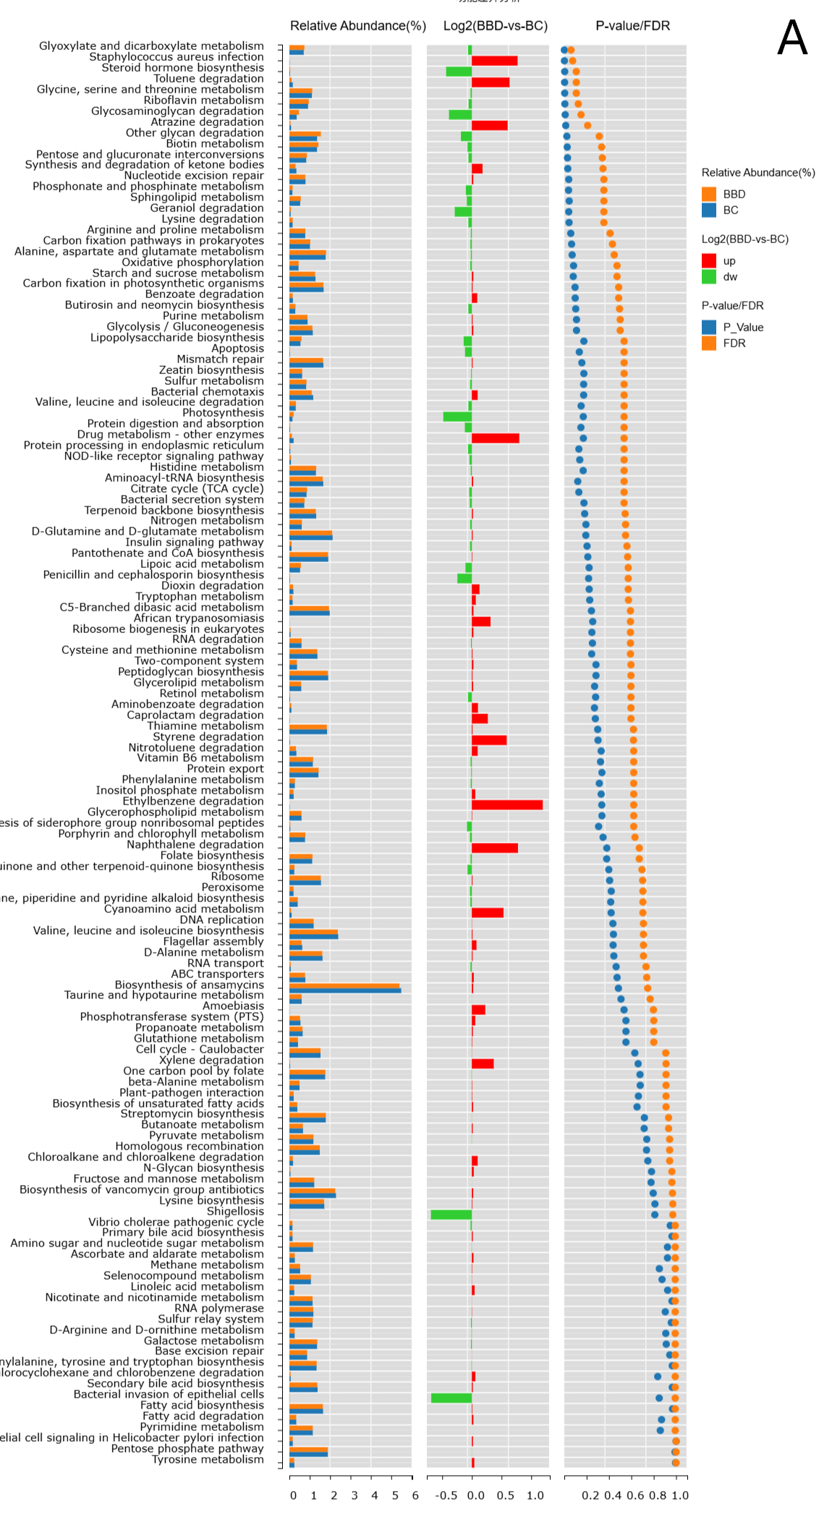
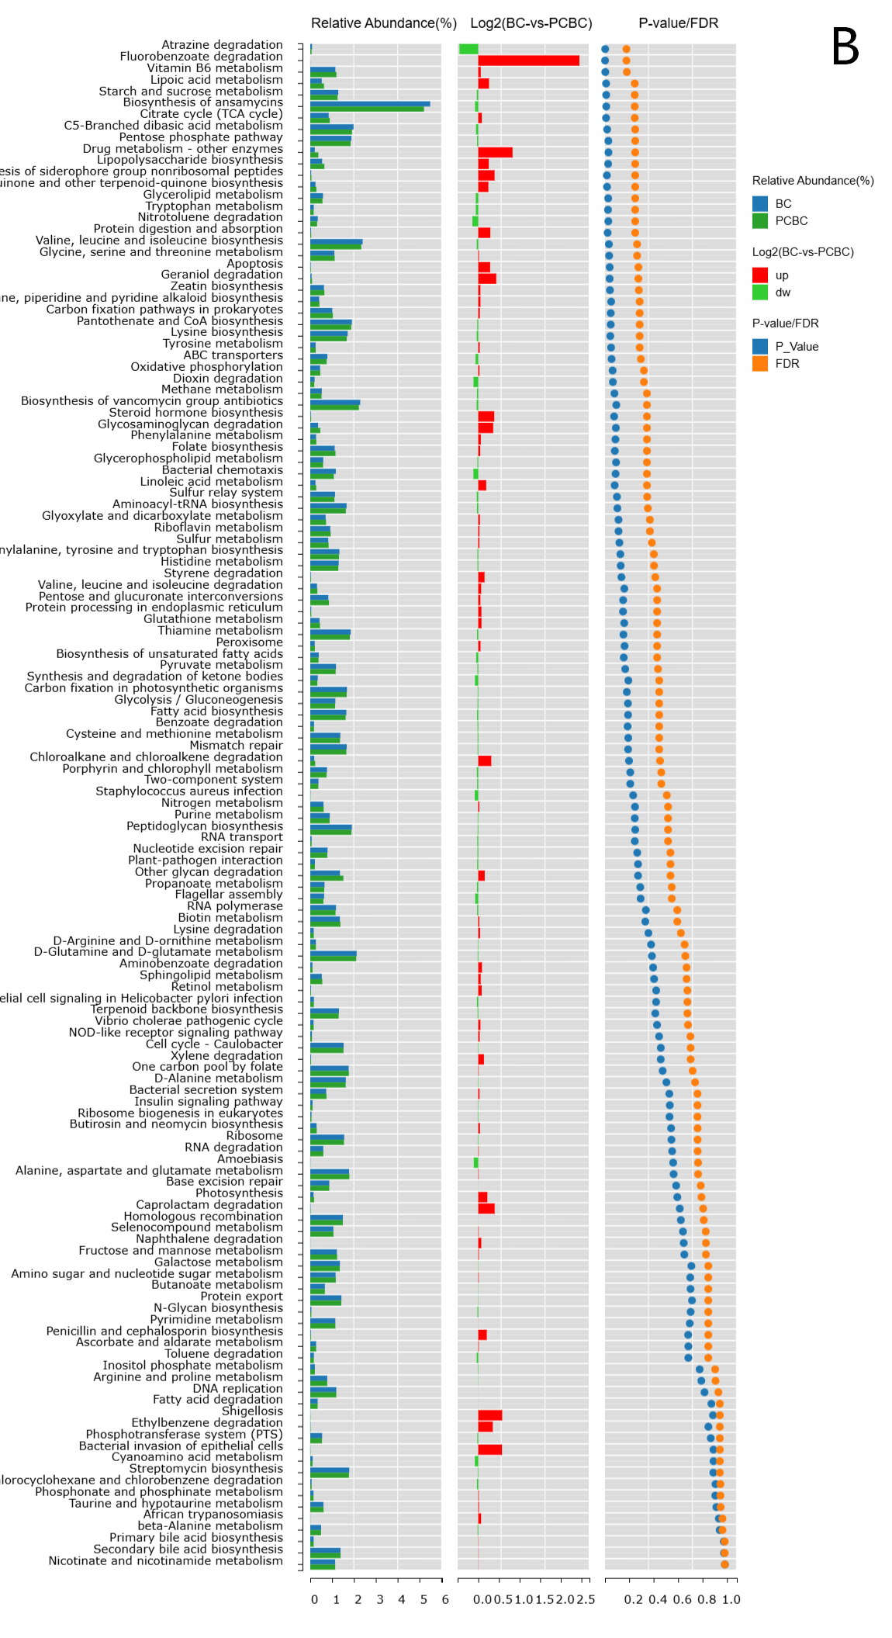
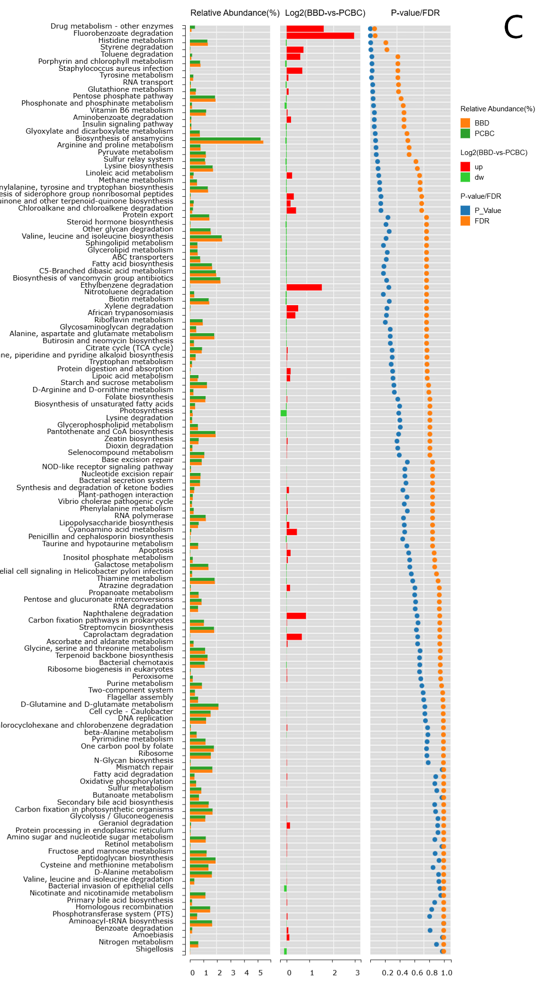
Supplementary Figures 1A–C (A) Differences in gut microbial functions between BBD and BC based on KEGG level 3 pathways. (B) Comparison of KEGG level 3 functional pathways before and after chemotherapy (BC vs. PCBC). (C) KEGG level 3 pathway differences between PCBC and BBD (Wilcoxon test, P < 0.05, *P < 0.01).

