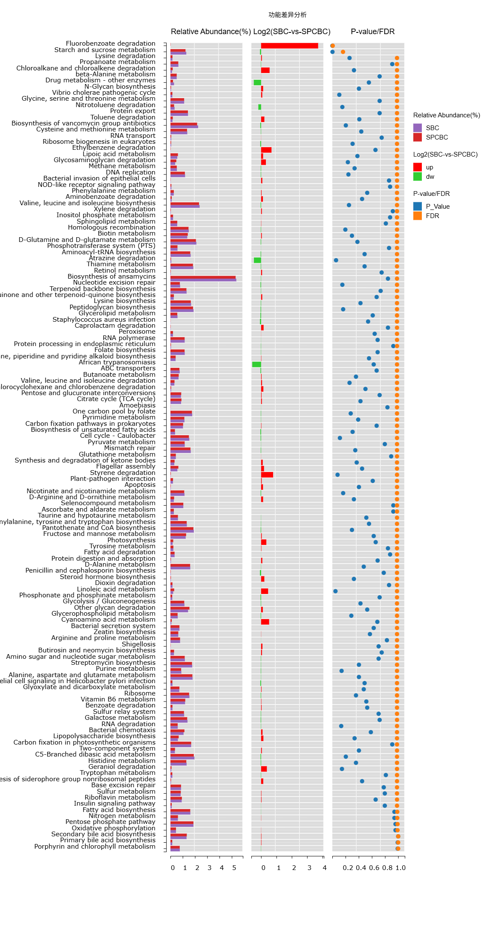
Supplementary Figures 2. Bar plots of the relative abundances of KEGG level 3 functional categories.

