Supplementary Information
Supplementary Tables 1: Strains used in this study
Stains |  | Description
BY4741 | cir⁺, Mat a | leu2∆0;met15∆0;ura3∆0;his3∆1
BY4742 | cir⁺, Mat alpha | leu2∆0;lys2∆0;ura3∆0;his3∆1
ANY015 | cir⁰, Mat a | BY4741, Δ2μ plasmid
ANY156 | cir⁰, Mat alpha | BY4742, Δ2μ plasmid
ANY051 | cir⁰, Mat a | ANY015, T_{adh1}- I-SceI -P_{gal1}-KanMX::ho
ANY626 | cir⁰, Mat alpha | ANY156, T_{adh1}- I-SceI -P_{gal1}-KanMX::ho
ANY310 | cir⁰, Mat a | ANY015, ho::NAT-P_{gals}-FLP
ANY057 | cir⁰, Mat a | ANY051, ANP023
ANY058 | cir⁰, Mat a | ANY051, ANP024
JSY066 | cir⁰, Mat a | ANY051, prb1Δ; pep4Δ
JSY072 | cir⁰, Mat a | ANY051, prb1Δ; pep4Δ; yps1Δ
ANY077 | cir⁰, Mat a | ANY015, p2μ
ANY020 | cir⁰, Mat a | ANY051, YTp-I
ANY021 | cir⁰, Mat a | ANY051, YTp-C
ANY141 | cir⁰, Mat a/alpha | ANY626 crossed with ANY310, YTp-I
ANY041 | cir⁰, Mat a | ANY051, YTp-CL
ANY118 | cir⁰, Mat a/alpha | ANY626 crossed with ANY310, YTp-IL
JSY010 | cir⁰, Mat a | ANY051, YTp-CL-V(CAC)
JSY011 | cir⁰, Mat a | ANY051, YTp-CL-V(TAC)
JSY012 | cir⁰, Mat a | ANY051, YTp-CL-V(AAC)
ANY228 | cir⁰, Mat a | JSY066, YTp-CL-GLP-1
ANY229 | cir⁰, Mat a | JSY072, YTp-CL-GLP-1
ANY693 | cir⁰, Mat a | ANY051, T_{adh1}- I-SceI -P_{gal1}-KanMX+Nat-P_{pgk1}-AtIPK-T_{tef1}+P_{tdh3}-SCck::ho, YTp-CL-CRT
ANY694 | cir⁰, Mat a | ANY051, YTp-CL-EGT
ANY695 | cir⁺, Mat a | BY4741, BZP119

Supplementary Table 2: Plasmids used in this study
Plasmid | Description | Detail
pRS413 | Yeast centromeric plasmid vector with a HIS3 selectable marker,
pRS423 | Yeast episomal vector with a HIS3 selectable marker
BZP119 | Based on pRS423, inserting β-carotenoid biosynthetic pathway | pRS423-P_{pgk1}-CRTE-T_{adh1}-P_{gap}-CRTI-T_{adh1}-P_{tef2}-CRTYB-T_{tef2}
ANP104 | The pRS413 plasmid into which the mCherry was inserted | pRS413-P_{tef2}-mCherry-T_{adh1}
ANP106 | The pRS423 plasmid into which the mCherry was inserted | pRS423-P_{tef2}-mCherry-T_{adh1}
p2μ | 2μ plasmid inserted mCherry, serving as the control | 2μ plasmid-HIS3-P_{tef2}-mCherry-T_{adh1}
YTp-C | Based on 2μ plasmid, changing promoter of FLP from its original promotor to P_{cyc1}, inserting CEN into CDS region of FLP and using URA3 marker instead of HIS3 | 2μ plasmid-URA3-P_{tef2}-mCherry-T_{adh1}-P_{cyc1}-FLP inserted with CEN
ANP023 | Based on YTp-C, changing promoter of FLP from P_{cyc1} promoter to P_{tdh3,} | 2μ plasmid-URA3-P_{tef2}-mCherry-T_{adh1}-P_{tdh3}-FLP inserted with CEN
ANP024 | Based on YTp-C, changing promoter of FLP from P_{cyc1} promoter to P_{leu2d,} | 2μ plasmid-URA3-P_{tef2}-mCherry-T_{adh1}-P_{leu2d}-FLP inserted with CEN
YTp-I | Based on p2μ, inserting CEN into CDS region of FLP | 2μ plasmid-HIS3-P_{tef2}-mCherry-T_{adh1}-P_{flp}-FLP inserted with CEN
YTp-CL | Based on YTp-C, introducing P_{leu2d}-LEU2 system to further increase the plasmid copy number and using HIS3 marker instead of URA3 | 2μ plasmid-P_{leu2d}-LEU2-T_{leu2}-HIS3-P_{tef2}-mCherry-T_{adh1}-P_{cyc1}-FLP inserted with CEN
YTp-IL | Based on YTp-I, introducing P_{leu2d}-LEU2 system to further increase the plasmid copy number | 2μ plasmid-P_{leu2d}-LEU2-T_{leu2}-HIS3-P_{tef2}-mCherry-T_{adh1}-P_{flp}-FLP inserted with CEN
YTp-CL-V(CAC) | Based on YTp-CL, inserting tRNA^{Val}_{CAC} cassette | 2μ plasmid-P_{leu2d}-LEU2-T_{leu2}-HIS3-P_{tef2}-mCherry-T_{adh1}-P_{cyc1}-FLP inserted with CEN;V(CAC)tDNA
YTp-CL-V(TAC) | Based on YTp-CL, inserting tRNA^{Val}_{TAC} cassette | 2μ plasmid-P_{leu2d}-LEU2-T_{leu2}-HIS3-P_{tef2}-mCherry-T_{adh1}-P_{cyc1}-FLP inserted with CEN;V(TAC)tDNA
YTp-CL-V(AAC) | Based on YTp-CL,inserting tRNA^{Val}_{AAC} cassette | 2μ plasmid-P_{leu2d}-LEU2-T_{leu2}-HIS3-P_{tef2}-mCherry-T_{adh1}-P_{cyc1}-FLP inserted with CEN; V(AAC)tDNA
YTp-CL-GLP-1 | Based on YTp-CL, inserting mCherry-GLP-1 fused protein to replace mCherry | 2μ plasmid-P_{leu2d}-LEU2-T_{leu2}-HIS3-P_{tef2-}mCherry-DDDDK-GLP-1-T_{adh1}-P_{cyc1}-FLP inserted with CEN
YTp-CL-CRT | Based on YTp-CL, inserting β-carotenoid biosynthetic pathway | 2μ plasmid-P_{leu2d}-LEU2-T_{leu2}-HIS3-P_{tef2}-mCherry-T_{adh1}-P_{cyc1}-FLP inserted with CEN; P_{pgk1}-CRTE-T_{adh1}-P_{gap}-CRTI-T_{adh1}-P_{tef2}-CRTYB-T_{tef2}
YTp-CL-EGT | Based on YTp-CL, inserting ergthrothioneine biosynthetic pathway | 2μ plasmid-P_{leu2d}-LEU2-T_{leu2}-HIS3-P_{tef2}-mCherry-T_{adh1}-P_{cyc1}-FLP inserted with CEN; P_{pgk1}-NcEgt1-T_{tef1}-P_{tdh3}-CpEgt2-T_{tef2}

Supplementary Table 3: Primers used in this study
Primer | Description | Sequence (5’-3’)
ANO125 | R primer that tests CEN cut | AGCTCATGAATGTGGCTCTC
ANO512 | F primer that tests CEN cut | ATGCCACAATTTGGTATATTATGTAAAACAC
ANO143 | qPCR quantification for AMP on the plasmid | TGACTTGGTTGAGTACTCACC
ANO144 | qPCR quantification for AMP on the plasmid | TGTCACGCTCGTCGTTTGGTA
WHO433 | qPCR quantification for ALG9 on the chromosome | CACGGATAGTGGCTTTGGTGAACAATTAC
WHO434 | qPCR quantification for ALG9 on the chromosome | TATGATTATCTGGCAGCAGGAAAGAACTTGGG
TAC F | qPCR quantification for tRNA_{TAC} | TGGTCCAGTGGTTCAAGACG
TAC R | qPCR quantification for tRNA_{TAC} | TTCGAACTCGGGATCTTCGC
AAC F | qPCR quantification for tRNA_{AAC} | GGTTTCGTGGTCTAGTCGGT
AAC R | qPCR quantification for tRNA_{AAC} | GGACGTTCTGCGTGTTAAGC
CAC F | qPCR quantification for tRNA_{CAC} | TGTAGCGGCTATCACGTTGC
CAC R | qPCR quantification for tRNA_{CAC} | AGGATCGAACTCGGGACCTT
Synthetic sequence 1 | Synthetic linker-DDDDK-GLP-1 sequence | CGTGGAGGTGGAGGAGACGACGATGACAAGGAAGGTACTTTCACCTCTGACGTTTCCTCTTACTTGGAAGGTCAAGCTGCCAAGGAATTCATCGCTTGGTTGGTCAGAGGTAGAGGTTAA

Supplementary experimental data：
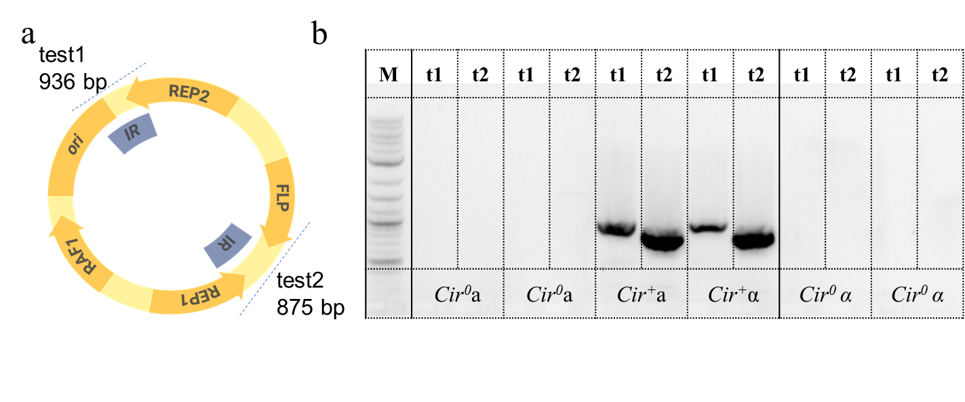
Fig. S1. Colony PCR in yeast was performed to verify the loss of the endogenous 2μ plasmid. (a) Schematic diagram of endogenous 2μ plasmid. Test 1 and 2 represent the two amplicons specific to endogenous 2μ plasmid with indicated sizes. (b) The gel electrophoresis results of colony PCR. Cir⁺a and Cir⁺α were used as positive controls.

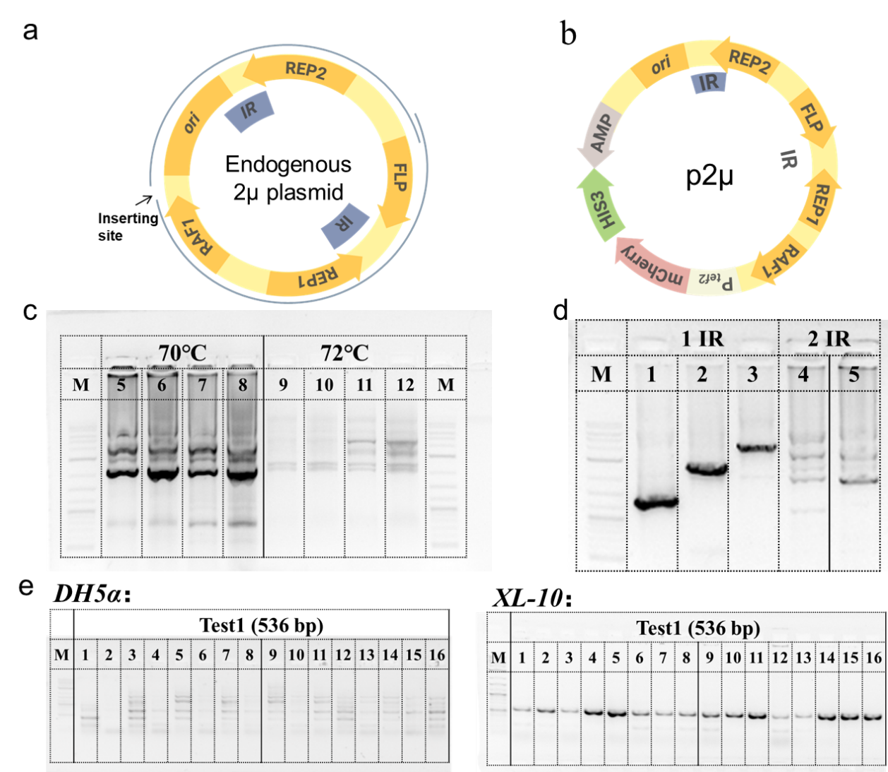
Fig. S2 A series of methods were optimized for the engineering of the 2μ plasmid: (a) The map of wild-type 2μ plasmid. (b) The map of p2μ. A moderate-strength P_{tef2} was used to drive the expression of mCherry. Plasmid-required elements and a HIS3 selectable marker were inserted into p2μ. (c) PCR protocol: an extension temperature of 70 ℃ or 72 ℃ was ineffective to generate a single, specific band. (d) Amplification strategy: the fragment was amplified in two separate segments (as illustrated in figure), each containing only one Inverted Repeat (IR) sequence, with the extension temperature of 68 ℃. (e) Bacterial host for recombination: the XL-10 strain (deficient in intracellular recombinase activity) yielded verified correct clones, whereas the DH5α strain did not.

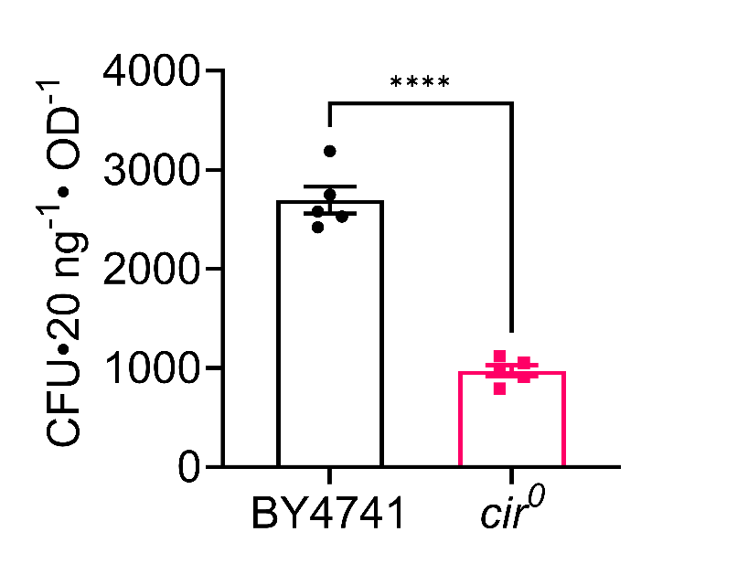
Fig. S3. The transformation efficiency of the p2μ plasmid in Cir⁺ versus Cir⁰ strains. Each experiment was conducted from six biological replicates (n=6), data points and error bars representing the standard deviation across replicates were shown. Statistical significance was determined by two-tailed unpaired Student’s t-test (****P < 0.0001).

Fig. S4. PCN of pRS423 with or without the mCherry expression cassette were quantified using qPCR and shown as the mean ± SD from three technical replicates. The PCN of pRS423 without mCherry was approximately 20; in contrast, following the addition of mCherry expression cassette, its copy number decreased to approximately 8.8.

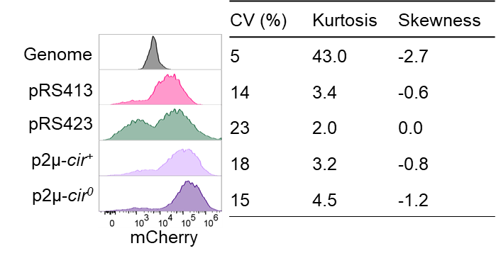
Fig. S5. Population heterogeneity in plasmid systems characterized by flow cytometry. CV, coefficient of variation. The fluorescence values collected from Fig. 1e were logarithmically transformed (base 10), and then CV for the log10-transformed data was computed as the ratio of the standard deviation to the mean. Log10-transformed flow cytometry fluorescence data were also used to calculate the kurtosis and skewness. Kurtosis measures the degree of "peakedness" or "flatness" of a data distribution. A normal distribution has a kurtosis of 3. When kurtosis > 3, the distribution is more peaked than a normal distribution; when kurtosis < 3, the distribution is flatter than a normal distribution. Skewness measures the asymmetry of a data distribution. When skewness = 0, the distribution is symmetric; when skewness > 0, the distribution is right-skewed (positively skewed), with a longer right tail; when skewness < 0, the distribution is left-skewed (negatively skewed), with a longer left tail. All data in the table represent the mean of three biological replicates.

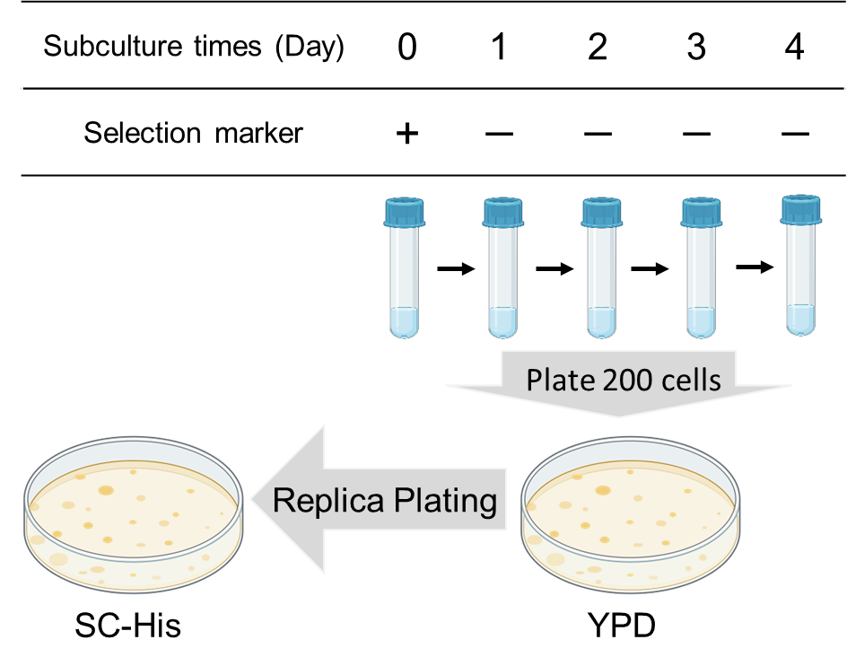
Fig. S6. Schematic diagram of the plasmid stability assay based on replica plating. The colonies grown on the selective medium are designated as Day 0 of the assay, followed by four subsequent subcultures. From the yeast culture harvested daily, approximately 200 cells are plated onto the non-selective YPD medium; the colonies on this YPD plate are then replica-plated onto the selective medium. The plasmid retention rate is defined as the ratio of the number of colonies on the selective medium plate to that on the YPD medium.

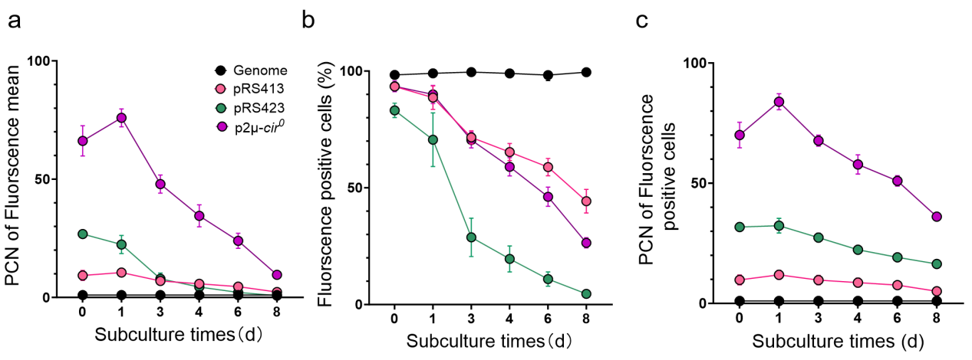
Fig. S7. Plasmid stability dynamics assessed via flow cytometry: (a) PCN calculated based on the mean fluorescence intensity. (b) Proportion of fluorescence-positive cells, and (c) PCN calculated from the fluorescence intensity of fluorescence-positive cells. Cells carrying different plasmids were diluted 10-fold and subcultured daily into 100 μl YPD medium in a 96-well plate, (30℃, 24 h, 800 rpm). All data points in the figure represent the mean ± SD from four biological replicates. Genome: the same mCherry cassete integrated into HO locus.

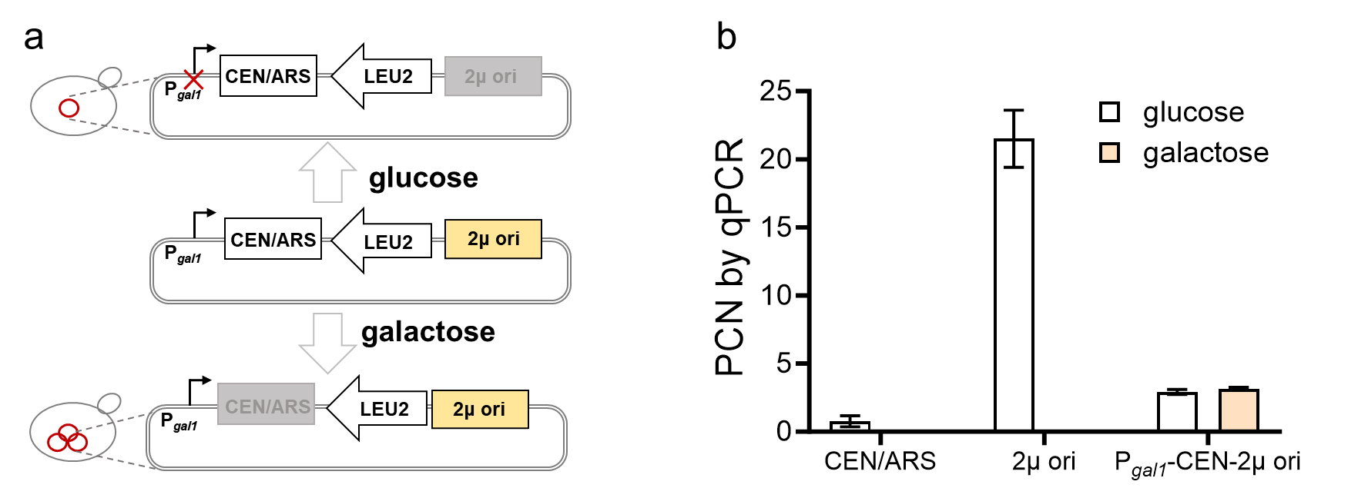
Fig. S8. The “P_{gal1}-CEN-2μ ori” system failed to mediate PCN transition. (a) Mechanism of the designed switch. The P_{gal1} promoter is repressed in the glucose medium, thus the CEN/ARS element is functional. In contrast, the P_{gal1} is activated in galactose medium, leading to continuous transcription that interferes with CEN/ARS function to enable the 2μ origin to function. (b) The copy number of “P_{gal1}-CEN-2μ ori” system remained approximately 3 both before and after induction. PCN was quantified by qPCR and shown as the mean ± SD from three technical replicates.

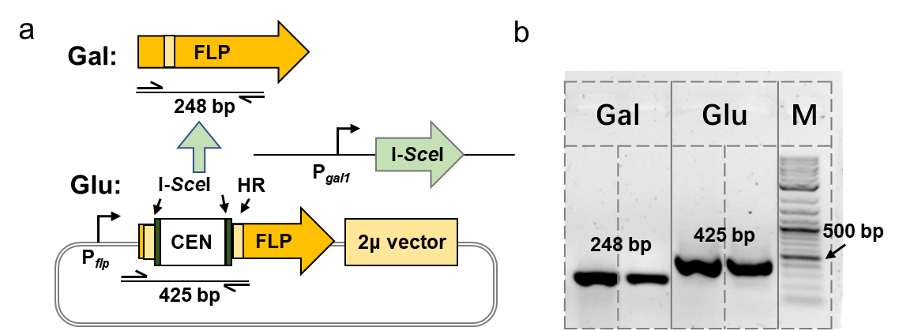
Fig. S9. PCN amplification strategy driven by Flp recombinase expression. (a) Schematic of the PCN amplification mechanism. In glucose medium, the CEN element maintains single-copy segregation. Upon galactose induction, I-SceI endonuclease encoded in the genome excises CEN, enabling FLP to restore its full-length CDS via recombination mediated by 40 bp homologous regions (HR), and Flp expression then drives PCN amplification. (b) Colony PCR verification of CEN excision pre-induction (glucose, Glu) and post-induction (galactose, Gal). The expected PCR product sizes were 425 bp (before excision) and 248 bp (after excision), respectively. Gal: galactose; Glu: glucose; M: DNA marker.

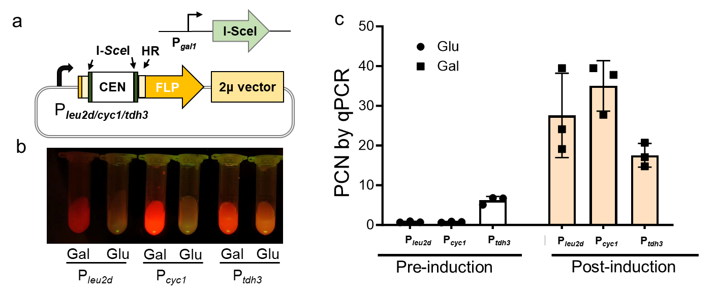
Fig. S10. The PCN could be influenced by the promoter strength of FLP. (a) Engineered replacement of the FLP promoter. The native FLP promoter was replaced with P_{leu2d}/P_{cyc1}/P_{tdh3}. (b) Visual assessment of mCherry expression under blue light irradiation. Cultures of the three strains at equal cell density exhibited distinct red fluorescence under blue light, corresponding to different levels of mCherry expression. (c) The PCN of constructs with different promoters pre- and post-induction (mean ± SD from three biological replicates).

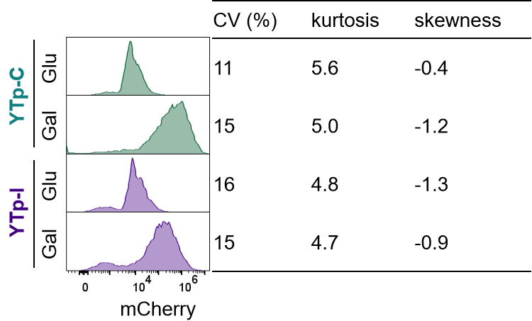
Fig. S11. Population heterogeneity of the YTp system before and after induction was analyzed by flow cytometry. The calculation methods for CV, kurtosis and skewness were identical to that described in Fig. S5. The lower kurtosis of the YTp-I system prior to induction can be attributed to a heavy-tailed distribution.

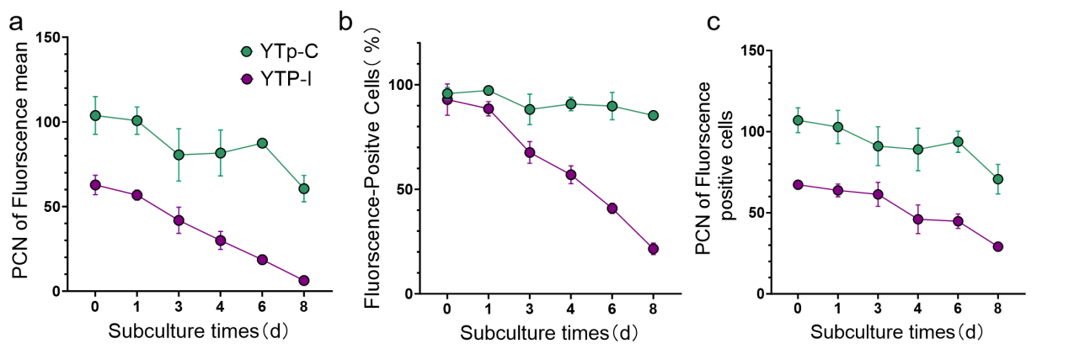
Fig. S12. Plasmid stability dynamics of the YTp system after induction assessed by flow cytometry. It should be noted that the decrease in the mean fluorescence intensity of YTp-I cell population (a) is mainly due to the loss of plasmid, since the proportion of fluorescence-positive cells declined quickly (b), but the PCN of the fluorescence-positive cells remains relatively stable (c). For YTp-C, the proportion of fluorescence-positive cells remains quite stable during the entire assay period. All data points in the figure represent the mean ± SD from four biological replicates. The experimental method was identical to that described in Fig. S7. The assay was performed using a method identical to that in Fig. S7.

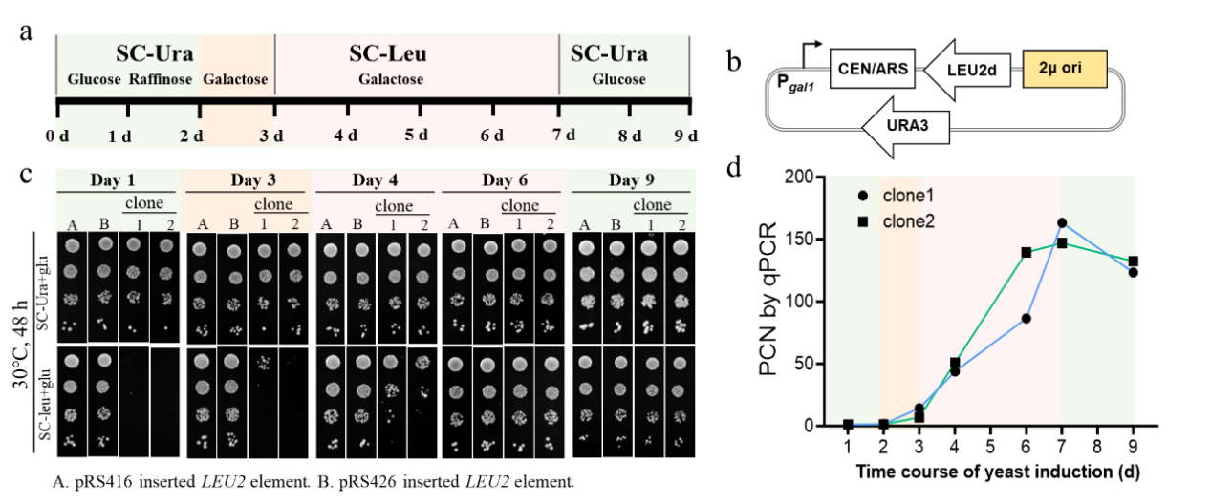
Fig. S13. The PCN increase in the “P_{gal1}-CEN-2μ ori-LEU2d” system is a gradual process. (a) Time-course protocol for the induction process. A transformant is first cultured in SC-Ura+glucose, then transferred to raffinose medium to deplete glucose. Subsequent induction in SC-Leu+galactose medium repress CEN/ARS function and increase PCN. Both leucine auxotrophy and galactose are withdrawn after Day 7. (b) Plasmid map of the “P_{gal1}-CEN-2μ ori-LEU2d” system. This plasmid contains the 2μ ori but does not include any of the 2μ-encoded proteins. (c) Growth profile during induction via a serial dilution spotting assay, and strains A and B were used as control. (d) PCN during the induction process were determined by qPCR. Two independent colonies were assayed with the mean of three technical replicates.

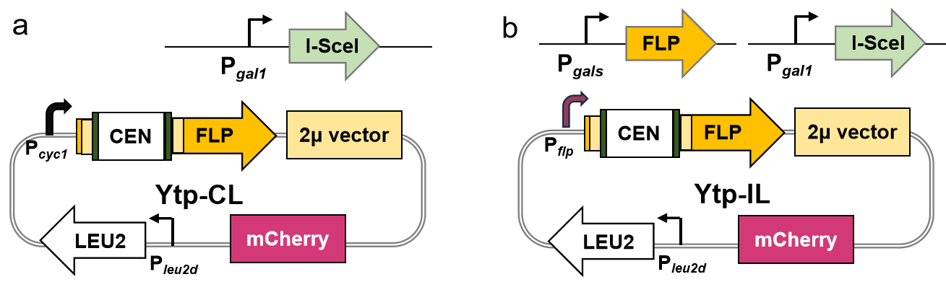
Fig. S14. The maps of YTp-CL (a) and YTp-IL (b). Compared with the selectable marker of YTp-C, that of YTp-CL is switched from URA3 to HIS3. In addition, both constructs are engineered to incorporate the Leu2d cassette.

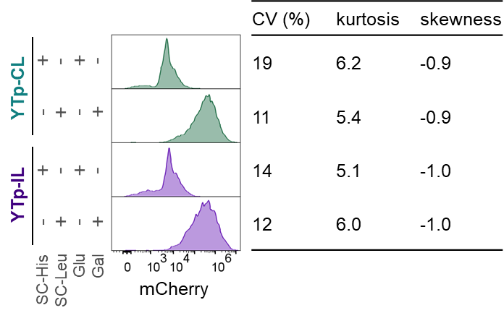
Fig. S15. Population heterogeneity of YTp-L system before and after induction analyzed by flow cytometry. The calculation methods for CV, kurtosis and skewness coefficients were identical to that described in Fig. S5.

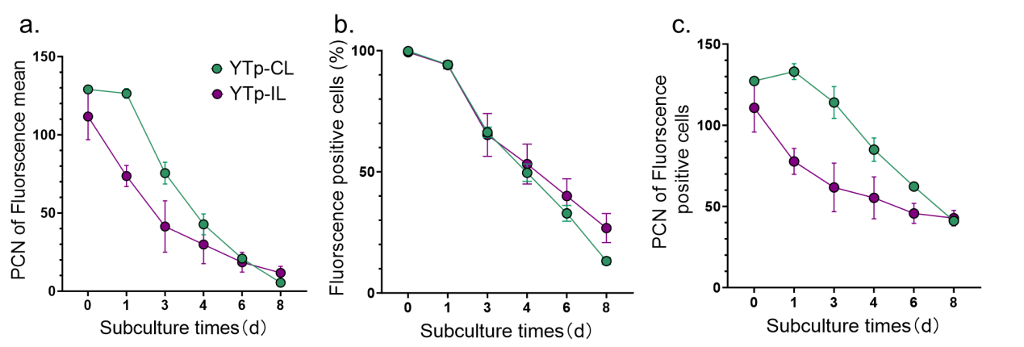
Fig. S16. Plasmid stability of YTp-CL and YTp-IL after induction, as assessed by flow cytometry. It should be noted that the mean fluorescence intensity of all cells (a), the proportion of fluorescence-positive cells (b), and the PCN of the fluorescence-positive cells (c) all showed a declining trend. The experimental method was identical to that described in Fig. S7. All data points in the figure represent the mean ± SD from four biological replicates.

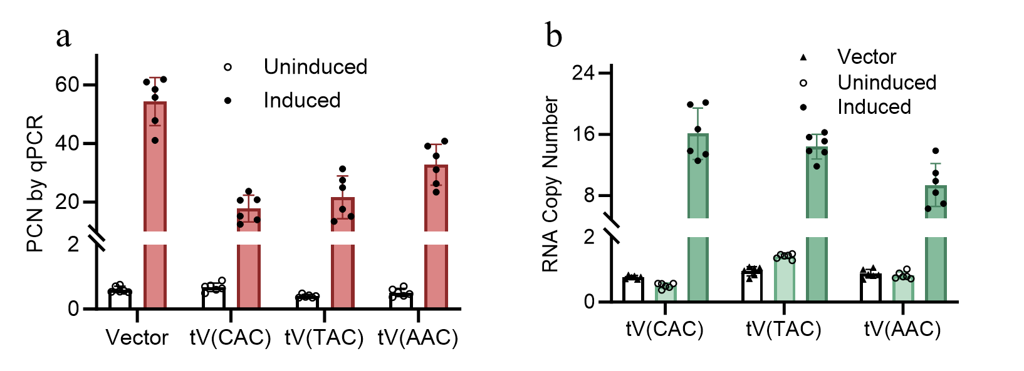
Fig. S17. PCN changes of the YTp-CL vector overexpressing tRNA^{Val} (a) and corresponding tRNA levels changes (b) before and after induction. The PCN was normalized to 1 copy per genome, and the tRNA levels were normalized to the mean of UBC6, ALG9, and TAF10 RNAs in the strain with the corresponding empty vector, a method that has been shown to give reliable tRNA quantification¹. Data were quantified via qPCR from two biological replicates, each from three technical replicates.

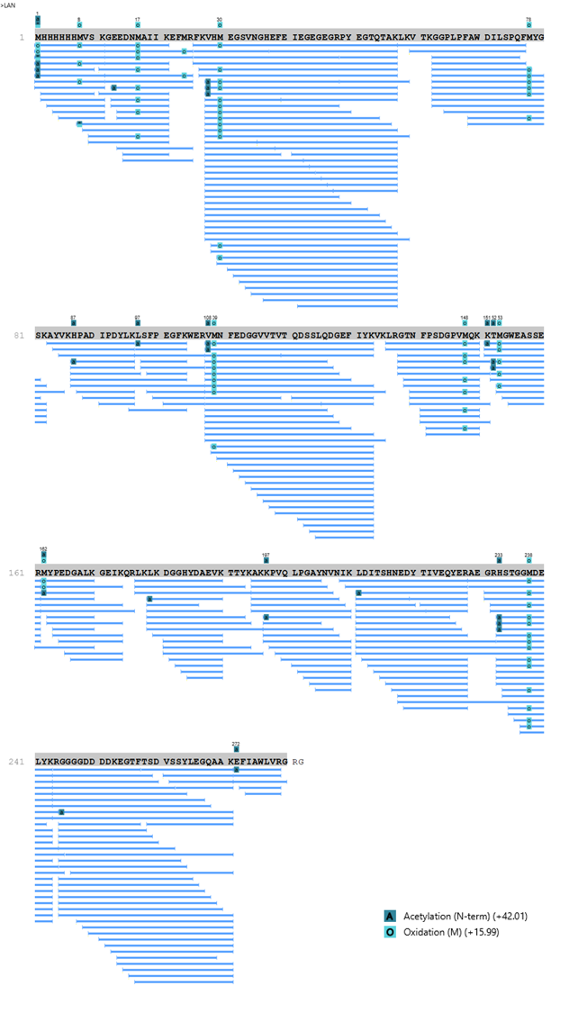
Fig. S18. Mass spectrometry identification of mCherry-GLP-1. Mass spectrometry (MS) analysis revealed that the full-length form of mCherry-GLP-1 was detected, which indicated the successful production of the intact protein.

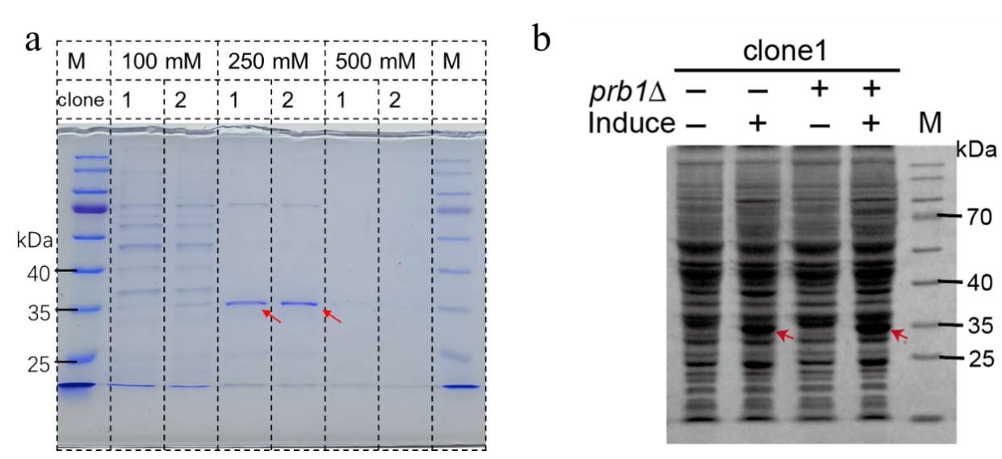
Fig. S19. (a) Coomassie-stained SDS-PAGE gel of mCherry-GLP-1 following nickel-affinity purification. Lanes 2, 4, and 6 displayed protein samples from clone 1, whereas lanes 3, 5, and 7 represented protein samples from clone 2. Lanes 2 and 3 were eluted with 100 mM imidazole, lanes 4 and 5 with 250 mM imidazole, and lanes 6 and 7 with 500 mM imidazole. (b) Analysis of mCherry-GLP-1 by Coomassie-stained SDS-PAGE. Lanes 1 and 3 corresponded to uninduced strains, while lanes 2 and 4 represented induced strains. The background strain genotypes for lanes 1 and 2 were yps1Δ pep4Δ, and for lanes 3 and 4 were yps1Δ pep4Δ prb1Δ.

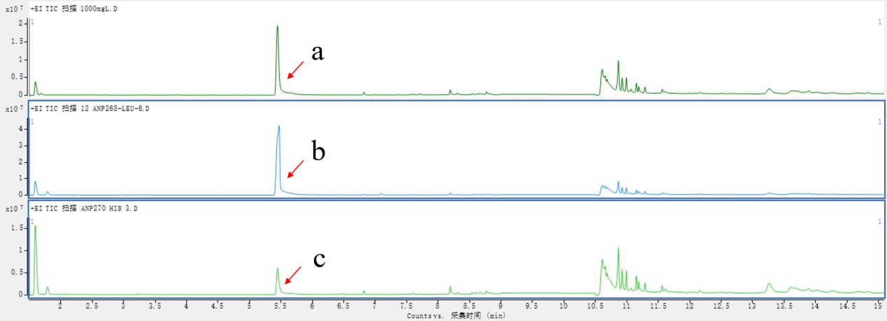
Fig. S20. GC-MS chromatograms of 2-phenylethanol (2-PE). (a) 1 g/L 2-PE standard solution; (b) The culture supernatant from the engineered strain after induction; (c) The culture supernatant from the engineered strain before induction. 2-PE elutes at a retention time of 5.5 min.

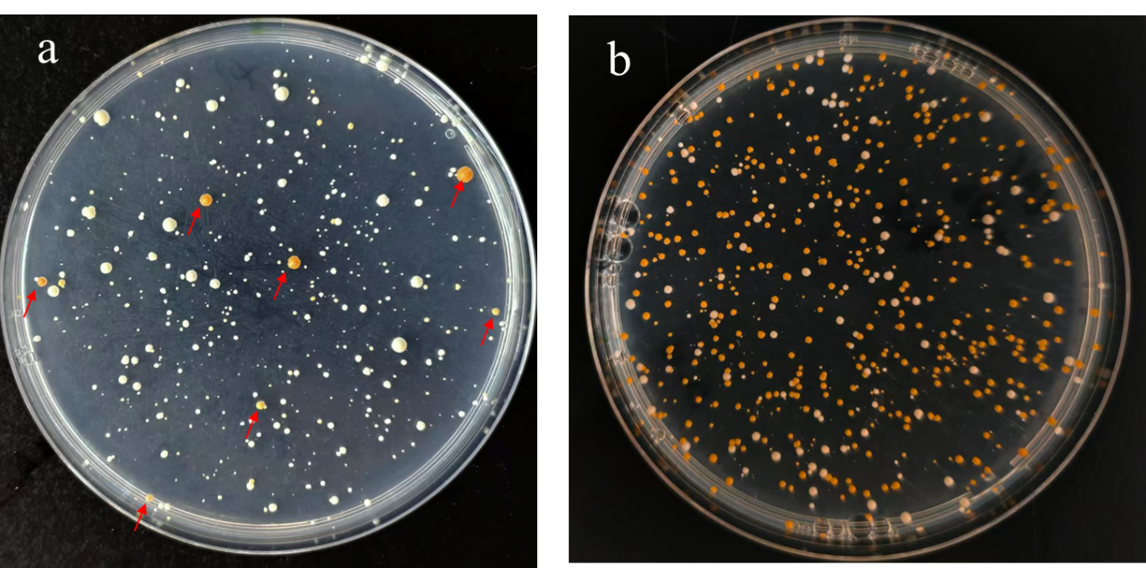
Fig. S21. Transformation plates of yeast transformed with pRS423 (a) and YTp-CL (b) with β-carotenoid biosynthesis genes (30℃, 4 d). In the YTp-CL system, the proportion (81.3%) of yellow colonies was higher than that in pRS425 (2.0%), demonstrating superior metabolic compatibility and population homogeneity.

Reference:
- Torrent, M., Chalancon, G., De Groot, N. S., Wuster, A. & Madan Babu, M. Cells alter their tRNA abundance to selectively regulate protein synthesis during stress conditions. Sci. Signal. 11, eaat6409 (2018).

