Supplementary Information
Chlorosome-inspired controlled assembly of 2D porphyrin heterostructures toward directed energy transfer and charge separation

Yifei Lei^{1,2}, Jiangshan Zhang^{1,2}, Yifei Han², Shixing Lei², Song-Hai Xie¹, Shu Wang³, Zhiyuan Huang^{3,}*, Dan-Wei Zhang^{1,}*, Zhan-Ting Li^{2,}*, Li-Zhu Wu^{3,}*, Chen-Ho Tung³, and Jia Tian^{2,}*

¹Department of Chemistry, Fudan University, 2205 Songhu Road, Shanghai 200438, China.
²State Key Laboratory of Organometallic Chemistry and Shanghai Hongkong Joint Laboratory in Chemical Synthesis, Shanghai Institute of Organic Chemistry, University of Chinese Academy of Sciences, Chinese Academy of Sciences, Shanghai 200032, China.
³Key Laboratory of Photochemical Conversion and Optoelectronic Materials, Technical Institute of Physics and Chemistry, The Chinese Academy of Sciences, Beijing 100190, China.

E-mail: huangzhiyuan@mail.ipc.ac.cn; zhangdw@fudan.edu.cn; ztli@mail.sioc.ac.cn; lzwu@mail.ipc.ac.cn; tianjia@sioc.ac.cn

Table of Contents

I. General Remarks S3
II. Synthetic procedures S7
III. Graphs and Microscopies S14
IV. Tables S44
V. ¹H and ¹³C NMR Spectra S46
References S64

I. General Remarks
Reagents and Solvents were purchased as reagent grade and used as received. MeOH and deionized water used in self-assembly are of HPLC grade. ¹H NMR and ¹³C NMR were recorded with a Bruker AVANCE Ⅲ HD 400MHz spectrometer. The residual deuterated solvent was used as the internal reference for ¹H NMR (CDCl₃: δ_{H} = 7.26 ppm, CD₃OD: δ_{H} = 3.31 ppm, DMSO-d₆ δ_{H} = 2.50 ppm). High-resolution mass spectrometry (HR-MS) for the characterization of new compounds was performed on a Waters G2-XS TOF.
Target molecules can be dissolved in MeOH, dimethyl sulfoxide (DMSO), and N, N-dimethylformamide (DMF). Except for SPPZn, all of them exhibit poor water solubility (<10 μM). After metal coordination, the centered N-H signal of free-base porphyrins at -3 in ¹H NMR disappeared. The Q-band of Ultraviolet-Visible (UV-vis) absorption spectroscopy changed from four peaks to two (Supplementary Fig. 1). Changes in shape and relative intensity of fluorescence emission spectra for different porphyrins gave further evidence for the successful synthesis of different metal-centered porphyrins (Supplementary Fig. 1).
Ultraviolet–visible spectroscopy (UV-vis) was performed in 1 cm path length quartz cells using an Agilent Cary 100 UV-vis spectrophotometer with a Greatwall HX Series circulating pump for temperature control. Temperature-dependent UV-vis experiments were carried out under the circulating water of two sealed cells. The following equation calculates the degree of aggregation (α_{agg}):
$α_{\text{agg}}= \frac{A-A_{mono}}{A_{agg}-A_{mono}}$ (Eq 1)
A, A_{mono}, and A_{agg} are the absorption of current temperature, the absorption of monomers (at high temperature), and the absorption of aggregations (at the lowest temperature), respectively. In the Meijer-Schenning-van der Schoot model,¹ supramolecular polymerization comprises two periods: nucleation and elongation. A non-sigmoidal cooling curve can be fitted in this model from the following equation:
$α_{\text{agg}} = α_{\text{SAT}}\{1 - exp[\left(-h_{e}\right) × \left(T - T_{e}\right) / (R × T_{e}^{2})]\}$(Eq 2)
α_{SAT}, h_{e}, T_{e}, T, R stand for the constant term introduced during the fitting process, the enthalpy release during elongation, the critical elongation temperature, the current temperature, and the molar gas constant, respectively.
Fluorescence spectroscopy was performed with a SHIMADZU RF-6000 spectrofluorometer in a 1 cm path length quartz cell. All target porphyrins were excited at 430 nm. The scanning rate, excitation bandwidth, and emission bandwidth were 2000 nm/min, 10 nm, and 10 nm, respectively. Fluorescence quenching experiments were carried out by adding different amounts of acceptor solution (0.5 mM TPPCo in MeOH containing 5 μM TPPZn) to donor solution (5 μM porphyrins in MeOH/H₂O, v/v = 1/1) to give an acceptor-to-donor molar ratio of 2% to 400%.MeOH
Self-assembly was conducted in 4 mL or 20 mL vials in heating modules. The detailed seeded growth method was as follows: TPPZn solid was dissolved in MeOH to give a 1 mM solution; a portion of this was diluted with MeOH and H₂O to yield a 0.1 mM MeOH/H₂O (v/v = 1/1) solution. The solution was heated in a 60 °C heating module for 30 min, slowly cooled to room temperature (20 °C), and placed at r.t. for more than one day (called annealing). The freshly prepared 2DZn platelets (self-seeding samples, called SN) were then sonicated using a FS-150NS sonication rod (Baihang, Jiangsu, φ = 3 mm, 120 W) under an ice-water bath at 0 °C for 15 min and reannealed at 40 °C for 10 min to obtain seeds. The 1 mM TPPZn solution mentioned above was then used to prepare a monomer solution containing 0.5 mM TPPZn and 2% (v/v) 2,2,2-trifluoroethanol (TFE) in MeOH. Seeds were quartered, diluted in 10 μM in MeOH/H₂O (v/v = 1/1), and placed in 40 °C heating module together with the monomer solution. About 10 min later, various volumes of monomer solution were added to the seeds using a pipette. Samples of molar ratio of monomer to seed (n_{m}/n_{s}) = 2, 4, 6, 8 were then vortexed for 4 s and slowly cooled to 20 °C. For heteroepitaxial growth, monomer solution with [TPPCo] = 0.5 mM in MeOH was added to GZn (30 μM in MeOH/H₂O (v/v = 1/1)) at molar ratios of monomer to seed (Co/Zn) ranging from 0.1 to 2 at 40 °C and cooled periodically to r.t.
Transmission electron microscopy (TEM) images were obtained on a Tecnai G² F20 S-Twin or a JEOL JEM-2100, with acceleration voltages of 80 kV or 200 kV, respectively. A sample solution (5 μL) was dropped onto a 300-mesh Copper grid with a 6-nm-thick carbon layer, wicked with filter paper, and dried in a desiccator overnight. Cryogenic TEM was performed using a JEOL CryoARM at 300kV with a Gatan K3 CCD camera.
Atom force microscopy (AFM) images were captured on a Bruker JPK Nano Wizard Sense system AFM. The microscope was equipped with the DirectOverlay 2 software module and a Tap150AI-G probe (tip radius of 10 nm). A sample solution (10-20 μL) was deposited on a clean, flat silicon surface for 5 min, then removed by a dry N₂ flow. More than 20 nanosheets were measured, with an average height of 6.8 nm.
Ultrafiltration was performed using 15 mL Millipore ultrafiltration spin columns (4 mL sample pool, 30 kD pore size) in a XiangYi H1850 centrifuge at 6000 rpm for 30 minutes. Samples for solution-phase Small Angle X-ray Scattering (SAXS) and Wide Angle X-ray Scattering (WAXS) were prepared by ultrafiltration of 3.0 mL of 0.1 mM TPPM assemblies into 0.1 mL. 10 μL of the liquid above was transferred into 1-mm-diameter quartz tubes. SAXS and WAXS experiments were performed at Beamline BL16B1, Shanghai Synchrotron Radiation Facility (SSRF). The flux of the incident X-ray beam was about 2 × 10¹¹ photons s⁻¹. The signal was collected with a Rayonix SX-165 CCD (Rayonix, Evanston, IL, USA) area detector with 2048 × 2048 pixels and a pixel size of 80 × 80 µm². Samples were exposed for 30-300 s on the X-ray, and the two-dimensional (2D) scattering patterns were then azimuthally integrated to generate scattering vector magnitude q vs. intensity plots, where q is defined as
$q=4πsinθ / λ$ (Eq 3)
where θ denotes half of the total scattering angle, and λ is the X-ray wavelength, 1.24 Å.
For statistical size analysis of 2D assemblies, more than 80 nanosheets in TEM images were traced by hand in ImageJ to determine their length (L) and width (W, the distance between the two long sides). Values of number average length (L_{n}), number average area (A_{n}), weight average area (A_{w}), polymer dispersity index (PDI), the aspect ratio, and the standard error (SE) of each sample were calculated as shown below:
$L_{n} = \frac{\sum_{i=1}^{n}{L_{i}N_{i}}}{\sum_{i=1}^{n}{N_{i}}}$ (Eq 4) $A_{n} = \frac{\sum_{i=1}^{n}{A_{i}N_{i}}}{\sum_{i=1}^{n}{N_{i}}}$ (Eq 5) $A_{W} = \frac{\sum_{i=1}^{n}{N_{i}A_{i}^{2}}}{\sum_{i=1}^{n}{N_{i}}A_{i}}$ (Eq 6)
$PDI = \frac{A_{w}}{A_{n}}$ (Eq 7) $Aspect Ratio = \frac{1}{n}\sum_{i=1}^{n}{\frac{L_{i}}{W_{i}}}$ (Eq 8) $SE=\frac{S}{\sqrt{n}}= \frac{\sqrt{\sum_{i=1}^{n}{{{(A}_{i}-A_{n})}^{2}}}}{\sqrt{n(n-1)}}$(Eq 9)
n and N_{i} are the total number and the number of items, respectively. S denotes sample variance.
High-resolution confocal laser scanning microscope (CLSM) was performed on a Leica STELLARIS 5 using 100× oil immersion objective in lightning mode. Fluorescence lifetime imaging microscopy (FLIM) was performed on a PicoQuant MicroTime 200 using a 100× oil-immersion objective. The detector was a Single-Photon Avalanche Diode (SPAD). The dwell time was 5 μs. SymPhoTime 64 was used to fit the lifetime using a 3rd-order decay curve. A sample solution (4 μL) was sealed between two cover slides. Samples are imaged using the 405 nm excitation laser and 561-690 nm dark field detector. Under intense laser excitation, the samples photobleached during imaging. Triethylenediamine (DABCO) was added to the sample solution (2% w/v) when Co/Zn was 0.2 or 0.5 to suppress fluorescence quenching.
Calculation for energy transfer efficiency (Φ_{ET}) and Stern-Volmer Plot by fluorescence quenching on acceptor (A) to donor (D) was carried out by the following method:
$Φ_{ET}=1 - \frac{I}{I_{0}}$ (Eq 10)
I and I₀ are the fluorescence intensity of one particular amount of A added to the D solution and the fluorescence intensity of the D solution only. TPPZn/Co fluorescence quenching system can be fitted using the Stern-Volmer function:^{2,3}
$\frac{I_{0}}{I}=1+K_{SV}×[A]$ (Eq 11)
K_{SV} is the Stern-Volmer quenching constant, and [A] is the concentration of acceptor. In the assembly system, K_{SV} describes the radiative transition property of donors.
Femtosecond (0 to 5500 ps) pump-probe transient absorption spectra (fs-TAS) measurements were performed using HELIOS FIRE, Ultrafast Systems. The pump pulses at 400-750 nm were generated with an optical parametric amplifier (Apollo-T, Ultrafast Systems). The femtosecond white light probe pulses were generated by focusing the 1 kHz Ti: Sapphire amplifier (SPFIRE ACE, 800 nm fundamental, 100 fs pulse width) output onto sapphire (fs-TA, VIS: 420-800 nm). The spot diameters of the pump and probe beams focused on the sample were approximately 100 μm. The samples ([TPPZn] = 30 μM in MeOH/H₂O (v/v = 1/1)) were placed in 2 mm quartz cuvettes, nitrogen was bubbled through the solutions, and the solutions were vigorously stirred during all measurements. In this work, the sample solutions were excited by a 400 nm pump beam and detected at 430-750 nm.

II. Synthetic procedures

Scheme S1 Synthesis of target Zn-porphyrins.
General procedure 1: synthesis of methyl multi-alkoxybenzoate⁵⁻⁷
Methyl multi-hydroxybenzoate, 1-Bromohexadecane, K₂CO_{3,} and tetrabutylammonium bromide (TBAB) were added in acetone and heated to reflux under N₂ for 2-4 days. After cooling to room temperature, the solvent was removed under reduced pressure. Dichloromethane (DCM) and distilled water were added to the reaction mixture, and the organic phase was dispensed and washed with distilled water and saturated NaCl solution. After drying over Na₂SO₄, the crude product was further purified by elution on a silica gel column with hexane/ethyl acetate (EA) (20/1, v/v) to yield methyl multi-alkoxybenzoates.

General procedure 2: synthesis of alkoxybenzonic acid⁵⁻⁷
Methyl alkoxybenzoate and KOH were dissolved in a tetrahydrofuran(THF)/EtOH/H₂O mixture and heated to reflux for 2 h. After the mixture was cooled to room temperature, 1 M HCl aq. was added dropwise to the solution until pH = 3. The resulting precipitate was filtered, washed with distilled water three times, and dried under vacuum to give alkoxybenzonic acid.
General procedure 3: synthesis of target metal-porphyrins⁸
B2, alkoxybenzonic acid, n-(3-dimethylaminopropyl)-n'-ethylcarbodiimide hydrochloride (EDCI), and 4-dimethylaminopyridine (DMAP) were dissolved in chloroform. Under N₂ in dark conditions, the mixture was stirred at room temperature for 24 h. Then the mixture was washed with saturated NaHCO₃ solution (20 mL), distilled water (20 mL), and saturated NaCl solution (20 mL). After drying over Na₂SO₄ and concentrating by rotary evaporation, the crude product was further purified by elution on a silica gel column with DCM/MeOH (v/v = 50/1) to yield electrically neutral porphyrin precursors.
Then, these precursors, together with chloroform and N,N-dimethylformamide (DMF) (v/v = 1/1), were added to a Schlenk tube. CH₃I was added before the mixture was stirred and heated to 40 °C in the dark for 24 h. After cooling to room temperature and evaporating overnight in a fume hood, the solvent was removed under reduced pressure, leaving a black solid. The solid was dissolved in 20 mL of anhydrous DMF for metal coordination.
Zn(OAc)₂ or Co(OAc)₂ was added to the solution above, which was then stirred in the dark under r.t. or 45 °C for 24 h. After the solution turned dark green or purplish-red, an overdose of NH₄PF₆ and H₂O was added. The resulting precipitate was filtered, washed three times with distilled water, and dried to give the hexafluorophosphate. The hexafluorophosphate solid was then dissolved in acetonitrile (MeCN) and mixed with tetrabutyl ammonium chloride monohydrate (TBACl·H₂O) solution (saturated in MeCN). The resulting precipitate was filtered, washed twice with MeCN, and dried under vacuum to give the target products.

T-COOMe was prepared in a 36% yield as a white solid (0.62 g) using general procedure 1. Methyl gallate (0.37 g, 2.0 mmol), 1-Bromohexadecane (1.95 g, 6.4 mmol), K₂CO₃ (1.38 g, 10.0 mmol), and TBAB (3.2 mg, 0.050 mmol) were added in acetone (50 mL). ¹H NMR (400 MHz, CDCl₃) δ 7.25 (s, 2H), 4.00 (t, J = 4.6 Hz, 6H), 3.89 (s, 3H), 1.77 (dt, J = 28.2, 7.4 Hz, 6H), 1.46 (q, J = 7.4 Hz, 6H), 1.26 (s, 72H), 0.88 (t, J = 6.8 Hz, 9H).
T-COOH was prepared in a 93% yield as a white solid using general procedure 2. ¹H NMR (400 MHz, CDCl₃) δ 7.31 (s, 2H), 4.03 (q, J = 7.0 Hz, 6H), 1.78 (dq, J = 21.8, 7.4 Hz, 6H), 1.47 (q, J = 7.0 Hz, 6H), 1.26 (s, 72H), 0.88 (t, J = 6.8 Hz, 9H).

m-D-COOMe was prepared in a 42% yield as a white solid (0.53 g) using general procedure 1. Methyl 3,5-dihydroxybenzoate (0.34 g, 2.0 mmol), 1-Bromohexadecane (1.5 g, 5.0 mmol), K₂CO₃ (0.70 g, 5.0 mmol), and TBAB (36 mg, 0.10 mmol) were added in acetone (45 mL). ¹H NMR (400 MHz, CDCl₃) δ 7.16 (s, 2H), 6.64 (s, 1H), 3.97 (t, J = 6.6 Hz, 4H), 3.90 (s, 3H), 1.78 (m, 4H), 1.45 (m, 4H), 1.27 (s, 48H), 0.88 (t, J = 6.6 Hz, 6H).
m-D-COOH was prepared in a 92% yield as a white solid using general procedure 2. ¹H NMR (400 MHz, CDCl₃) δ 7.21 (d, J = 2.4 Hz, 2H), 6.68 (s, 1H), 3.98 (t, J = 6.4 Hz, 4H), 1.78 (m, 4H), 1.26 (m, 52H), 0.88 (t, J = 6.8 Hz, 6H).

o-D-COOMe was prepared in a 56% yield as a white solid (0.70 g) using general procedure 1. Methyl 3,4-dihydroxybenzoate (0.34 g, 2.0 mmol), 1-Bromohexadecane (1.8 g, 6.0 mmol), and K₂CO₃ (0.83 g, 6.0 mmol) were added in acetone (70 mL). ¹H NMR (400 MHz, CDCl₃) δ 7.63 (dd, J = 8.4, 2.0 Hz, 1H), 7.53 (d, J = 2.0 Hz, 1H), 6.86 (d, J = 8.4 Hz, 1H), 4.04 (td, J = 6.8, 3.6 Hz, 4H), 3.88 (s, 3H), 1.83 (dq, J = 10.8, 6.6 Hz, 4H), 1.47 (t, J = 7.6 Hz, 4H), 1.26 (s, 48H), 0.88 (t, J = 6.8 Hz, 6H).
o-D-COOH was prepared in a 71% yield as a white solid using general procedure 2. ¹H NMR (400 MHz, CDCl₃) δ 7.71 (dd, J = 8.4, 2.0 Hz, 1H), 7.58 (d, J = 2.0 Hz, 1H), 6.89 (d, J = 8.4 Hz, 1H), 4.06 (q, J = 6.8 Hz, 4H), 1.84 (q, J = 6.8 Hz, 4H), 1.47 (d, J = 7.6 Hz, 4H), 1.26 (s, 48H), 0.88 (t, J = 6.8 Hz, 6H).

S-COOMe was synthesized by the following method. Methylparaben (1.5 g, 10 mmol), 1-Bromo-hexadecane (3.1 g, 10 mmol), and K₂CO₃ (2.1 g, 15 mmol) were added in MeCN (80 mL) and heated to 70 °C under N₂ for 24 hours. After cooling to room temperature, deionized water (70 mL) was added. The precipitate was filtered, washed with distilled water three times, and dried to give the white crystal S-COOMe (3.8 g, 99%). ¹H NMR (400 MHz, CDCl₃) δ 8.00-7.95 (m, 2H), 6.92-6.87 (m, 2H), 4.00 (t, J = 6.8 Hz, 2H), 3.88 (s, 3H), 1.84-1.75 (m, 2H), 1.45 (m, 2H), 1.26 (s, 24H), 0.88 (t, J = 7.2 Hz, 3H).
S-COOH was prepared in an 87% yield as a white solid using general procedure 2. ¹H NMR (400 MHz, CDCl₃) δ 8.04 (d, J = 8.8 Hz, 2H), 6.93 (d, J = 8.8 Hz, 2H), 4.02 (t, J = 6.8 Hz, 2H), 1.81 (p, J = 6.8 Hz, 2H), 1.46 (m, 2H), 1.26 (s, 24H), 0.88 (t, J = 7.2 Hz, 3H).

B1 was synthesized by the following method.^{[5]} 4-Pyridinecarboxaldehyde (6.4 g, 60 mmol) and 4-acetamidobenzaldehyde (3.5 g, 22 mmol) were dissolved in propionic acid (320 mL) and were stirred at 80 °C for 30 min. Pyrrole (5.4 g, 80 mmol) was then added to the reaction mixture, which was heated to reflux for 5 h. After the mixture was cooled, propionic acid was removed under reduced pressure. 4 M KOH aqueous (120 mL) was slowly added to the mixture until the pH reached 8-9; a black solid was obtained. The mixture was sonicated and filtered, then washed with distilled water (100 mL ×3) and dried to give the crude product. The black solid was dissolved in DCM and MeOH and purified by column chromatography twice, using DCM/MeOH (v/v = 60/1 to 30/1), yielding a purple solid B1 0.60 g (5%). ¹H NMR (400 MHz, DMSO-d₆) δ 10.40 (s, 1H), 9.05 (d, J = 4.4 Hz, 6H), 8.98-8.79 (m, 8H), 8.27 (d, J = 4.4 Hz, 6H), 8.15 (d, J = 8.0 Hz, 2H), 8.06 (d, J = 8.0 Hz, 2H), 2.23 (s, 3H), -3.00 (s, 2H).
B2 was synthesized by the following method. B1 (0.17 mg, 0.25 mmol) was dissolved in trifluoroacetic acid (TFA, 12 mL) and distilled water (12 mL), and heated to 85 °C under N₂ for 6 h. After the mixture cooled, TFA was removed under reduced pressure. 1 M Na₂CO₃ aq. was slowly added to the mixture until the pH reached 8-9, precipitating a purple solid. DCM (120 mL) was added to the mixture, and the organic phase was then washed with distilled water (100 mL) and saturated NaCl solution (100 mL). After drying over Na₂SO₄, DCM was removed under reduced pressure to yield a purple solid B2 (0.15 g, yield 92%). ¹H NMR (400 MHz, DMSO-d₆) δ 9.05 (d, J = 5.2 Hz, 8H), 8.87 (s, 6H), 8.27 (d, J = 4.8 Hz, 6H), 7.87 (d, J = 8.0 Hz, 2H), 7.02 (d, J = 8.0 Hz, 2H), 5.64 (s, 2H), -2.93 (s, 2H).

TPP was prepared in a 66% yield as a purple solid (58 mg) using general procedure 3. B2 (38 mg, 0.06 mmol), T-COOH (0.13 g, 0.15 mmol), EDCI (0.19 g, 1 mmol), and DMAP (0.12 g, 1 mmol) were dissolved in chloroform (25 mL). ¹H NMR (400 MHz, CDCl₃) δ 9.05 (d, J = 3.2, 6H), 9.01 (d, J = 3.2, 2H), 8.85 (d, J = 6.4 Hz, 6H), 8.23 (d, J = 8.0, 2H), 8.16 (d, J = 4.8, 8H), 8.08 (d, J = 8.0, 2H), 7.24 (s, 2H), 4.12 (dt, J = 19.0, 6.4 Hz, 6H), 1.85 (dt, J = 33.2, 7.2 Hz, 6H), 1.54 (t, J = 7.6 Hz, 6H), 1.27 (d, J = 6.4 Hz, 72H), 0.87 (t, J = 6.8 Hz, 9H), -2.86 (s, 2H). ¹³C NMR (101 MHz, CDCl₃) δ 165.90, 162.35, 153.27, 150.01, 148.05, 137.30, 135.04, 129.23, 118.34, 117.26, 105.90, 73.50, 69.46, 36.81, 31.78, 31.75, 30.21, 29.61, 29.56, 29.51, 29.46, 29.29, 29.27, 29.22, 29.20, 25.97, 22.54, 22.52, 13.94. MS: m/z calculated: 1458.0131; found: 1458.0150.
TPPZn was prepared in an overall 78% yield as a dark green solid (45 mg) using general procedure 3. ¹H NMR (400 MHz, CD₃OD) δ 9.34 (d, J = 6.4 Hz, 6H), 9.15-9.10 (m, 6H), 9.01 (d, J = 4.8 Hz, 2H), 8.92 (d, J = 6.4 Hz, 6H), 8.20 (q, J = 8.0 Hz, 4H), 7.45 (s, 2H), 4.80 (s, 9H), 4.19 (t, J = 6.4 Hz, 4H), 4.09 (t, J = 6.4 Hz, 2H), 1.88 (m, 6H), 1.61 (m, 6H), 1.30 (d, J = 8.4 Hz, 72H), 0.88 (q, J = 6.8 Hz, 9H). ¹³C NMR (101 MHz, CD₃OD) δ 161.54, 150.22, 144.86, 136.06, 134.11, 133.35, 120.67, 70.39, 33.09, 30.88, 30.84, 30.63, 30.52, 27.41, 23.75, 14.45. MS: m/z calculated: 521.9966, 800.4793; found: 521.9988, 800.4860.
TPPCo was prepared in an 83% overall yield as a black solid (31 mg) using general procedure 3. MS: m/z calculated: 519.9954, 797.4813; found: 519.9963, 797.4794.
TPPH₂-PF₆, the free-base porphyrin, which can be easily characterized, was synthesized using the DMF solution mentioned in general procedure 3. NH₄PF₆ and H₂O were added to the solution. The resulting brown precipitate was filtered, washed with distilled water and dried to give the brown solid TPPH₂-PF₆. (23 mg, yield 100%) ¹H NMR (400 MHz, DMSO-d₆) δ 10.57 (s, 1H), 9.47 (d, J = 6.4 Hz, 6H), 9.20-8.94 (m, 14H), 8.30-8.20 (dd, J = 24.8 Hz, 8.0 Hz, 4H), 7.38 (s, 2H), 4.72 (s, 9H), 4.13 (t, J = 6.0 Hz, 4H), 3.98 (t, J = 6.4 Hz, 2H), 1.80 (m, 4H), 1.71 (t, J = 6.6 Hz, 2H), 1.52 (m, 6H), 1.24 (d, J = 7.2 Hz, 72H), 0.84 (t, J = 7.2 Hz, 9H), -2.99 (s, 2H). ¹³C NMR (101 MHz, DMSO-d₆) δ 156.60, 144.16, 134.71, 132.12, 118.83, 115.26, 106.44, 68.64, 47.84, 31.26, 29.85, 29.04, 28.99, 28.68, 25.66, 22.05, 13.86. MS: m/z calculated: 501.0264; found: 501.0264. TPPH₂-Cl can be prepared from ion exchange.

m-DPP was prepared in 70% yield as a purple solid (66 mg) using general procedure 3. B2 (49 mg, 78 μmol), m-D-COOH (0.12 g, 0.20 mmol), EDCI (87 mg, 0.46 mmol) and DMAP (52 mg, 0.45 mmol) were dissolved in chloroform (30 mL). ¹H NMR (400 MHz, CDCl₃) δ 9.29 (s, 2H), 9.05 (s, 3H), 8.99 (d, J = 4.8 Hz, 2H), 8.84 (m, 3H), 8.72-8.44 (m, 6H), 8.21 (s, 4H), 8.05-8.19 (dd, J = 37.2 Hz, 7.2 Hz, 4H), 7.12 (d, J = 8.4 Hz, 2H), 6.70 (s, 1H), 4.07 (t, J = 6.4 Hz, 4H), 1.84 (q, J = 7.2 Hz, 4H), 1.29 (m, 52H), 0.87 (t, J = 5.6 Hz, 6H), -2.86 (s, 2H). ¹³C NMR (101 MHz, CDCl₃) δ 160.85, 148.16, 135.31, 129.52, 118.53, 117.48, 105.68, 104.92, 68.63, 32.01, 29.79, 29.75, 29.72, 29.70, 29.51, 29.45, 29.34, 26.17, 22.77, 14.20. MS: m/z calculated: 609.3881; found: 609.3883.

m-DPPZn was prepared in a 93% overall yield as a dark green solid (30 mg) using general procedure 3. ¹H NMR (400 MHz, CD₃OD) δ 9.34 (d, J = 6.0 Hz, 6H), 9.12 (s, 6H), 9.01 (d, J = 4.8 Hz, 2H), 8.92 (d, J = 5.2 Hz, 6H), 8.21 (q, J = 7.2 Hz, 4H), 7.24 (s, 2H), 6.76 (s, 1H), 4.80 (s, 9H), 4.11 (t, J = 8.0 Hz, 4H), 1.83 (m, 4H), 1.58-1.21 (m, 52H), 0.87 (t, J = 6.4 Hz, 6H). ¹³C NMR (101 MHz, CD₃OD) δ 162.01, 161.51, 152.87, 150.21, 149.69, 144.82, 136.04, 135.21, 134.06, 133.36, 133.06, 132.29, 120.57, 116.63, 107.30, 69.44, 33.06, 30.78, 30.74, 30.67, 30.46, 30.44, 30.34, 27.15, 23.71, 14.42. MS: m/z calculated: 680.3567; found: 680.3571.

m-DPPH₂-PF₆, the free-base porphyrin which can be easily characterized, was prepared using the same method as above. ¹H NMR (400 MHz, DMSO-d₆) δ 10.64 (s, 1H), 9.47 (d, J = 6.0 Hz, 6H), 9.19-8.94 (m, 14H), 8.32 (d, J = 8.2 Hz, 2H), 8.21 (d, J = 8.2 Hz, 2H), 7.23 (s, 2H), 6.79 (s, 1H), 4.71 (s, 9H), 4.10 (t, J = 6.4 Hz, 4H), 1.82-1.73 (m, 4H), 1.53-1.18 (m, 52H), 0.83 (t, J = 6.8 Hz, 6H), -2.99 (s, 2H). ¹³C NMR (101 MHz, DMSO-d₆) δ 165.70, 160.00, 156.69, 144.25, 132.21, 118.87, 115.37, 114.49, 67.93, 47.93, 31.35, 29.11, 29.07, 29.03, 28.77, 28.68, 25.57, 22.15, 14.00. MS: m/z calculated: 703.3976; found: 703.3975. m-DPPH₂-Cl can be prepared from ion exchange.

o-DPP was prepared in a 40% yield as a purple solid (37 mg) using general procedure 3. B2 (47 mg, 75 μmol), o-D-COOH (0.11 g, 0.17 mmol), EDCI (58 mg, 0.30 mmol), and DMAP (46 mg, 0.40 mmol) were dissolved in chloroform (30 mL). ¹H NMR (400 MHz, CDCl₃) δ 9.05 (t, J = 5.6 Hz, 6H), 8.99 (d, J = 5.2 Hz, 2H), 8.85 (s, 4H), 8.83 (d, J = 5.2 Hz, 2H), 8.24-8.13 (m, 8H), 8.08 (d, J = 8.4 Hz, 2H), 7.64 (d, J = 2.2 Hz, 1H), 7.56 (dd, J = 8.4, 2.2 Hz, 1H), 7.01 (d, J = 8.4 Hz, 1H), 4.14 (dt, J = 16.0, 6.6 Hz, 4H), 1.90 (m, 4H), 1.57-1.48 (m, 4H), 1.27 (d, J = 5.8 Hz, 48H), 0.88 (q, J = 6.8 Hz, 6H), -2.86 (s, 2H). ¹³C NMR (101 MHz, CDCl₃) δ 165.93, 152.85, 150.29, 149.53, 148.45, 148.40, 138.55, 137.47, 135.37, 129.54, 127.37, 121.39, 119.94, 118.61, 117.59, 117.17, 113.29, 112.63, 69.75, 69.44, 32.08, 31.66, 31.59, 30.30, 29.88, 29.82, 29.60, 29.52, 29.44, 29.32, 26.23, 26.19, 22.84, 14.25. MS: m/z calculated: 1217.7678; found: 1217.7663.

o-DPPZn was prepared in an overall 54% yield as a dark green solid (12 mg) using general procedure 3. ¹H NMR (400 MHz, CD₃OD) δ 9.34 (d, J = 5.6 Hz, 6H), 9.11 (m, 6H), 9.02 (d, J = 5.2 Hz, 2H), 8.91 (d, J = 5.6 Hz, 6H), 8.24-8.14 (q, J = 8.8 Hz, 4H), 7.74 (t, J = 12.0 Hz, 2H), 7.13 (d, J = 7.6 Hz, 1H), 4.80 (s, 9H), 4.17 (m, 4H), 1.87 (m, 4H), 1.59 (m, 4H), 1.30 (d, J = 9.6 Hz, 48H), 0.94-0.84 (m, 6H). ¹³C NMR (101 MHz, CD₃OD) δ 161.52, 152.90, 150.22, 150.16, 149.69, 144.83, 139.36, 136.06, 135.24, 134.08, 133.37, 133.07, 132.29, 120.56, 116.64, 114.64, 70.63, 70.16, 33.12, 33.09, 30.86, 30.84, 30.82, 30.79, 30.53, 30.50, 30.41, 27.36, 23.77, 23.75, 14.47, 14.45. MS: m/z calculated: 680.3567, 441.9152; found: 680.3562, 441.9150.

o-DPPH₂-PF₆, the free-base porphyrin which can be easily characterized, was prepared using the same method as above. ¹H NMR (400 MHz, DMSO-d₆) δ 10.53 (s, 1H), 9.47 (d, J = 6.4 Hz, 6H), 9.18-8.95 (m, 14H), 8.31 (d, J = 8.2 Hz, 2H), 8.20 (d, J = 8.2 Hz, 2H), 7.75 (d, J = 8.4 Hz, 1H), 7.67 (s, 1H), 7.18 (d, J = 8.4 Hz, 1H), 4.72 (s, 9H), 4.12 (q, J = 6.0 Hz, 4H), 1.78 (q, J = 7.2 Hz, 4H), 1.54-1.47 (m, 4H), 1.28 (m, 48H), 0.84 (q, J = 6.8 Hz, 6H), -2.98 (s, 2H). ¹³C NMR (101 MHz, DMSO-d₆) δ 165.92, 157.04, 152.34, 148.57, 144.60, 140.34, 135.53, 135.17, 132.76, 132.57, 127.42, 123.42, 121.94, 119.15, 115.72, 114.83, 113.76, 113.01, 69.18, 68.84, 48.29, 48.26, 31.74, 31.72, 31.58, 30.25, 29.55, 29.51, 29.46, 29.29, 29.25, 29.16, 29.14, 26.12, 26.08, 22.53, 22.51, 14.37, 14.34. MS: m/z calculated: 420.6098; found: 420.6107. o-DPPH₂-Cl can be prepared from ion exchange.

SPP was prepared in a 41% yield as a purple solid (24 mg) using general procedure 3. B2 (38 mg, 60 μmol), S-COOH (50 mg, 0.14 mmol), EDCI (40 mg, 0.20 mmol), and DMAP (40 mg, 0.30 mmol) were dissolved in chloroform (25 mL). ¹H NMR (400 MHz, CDCl₃) δ 9.00 (m, 8H), 8.84 (s, 4H), 8.81 (d, J = 5.6 Hz, 2H), 8.24-8.11 (m, 10H), 8.08 (d, J = 8.0 Hz, 2H), 8.01 (d, J = 8.0 Hz, 2H), 7.07 (d, J = 8.8 Hz, 2H), 4.08 (t, J = 6.4 Hz, 2H), 1.90-1.83 (m, 2H), 1.55-1.45 (m, 2H), 1.28 (s, 24H), 0.89 (t, J = 7.2 Hz, 3H), -2.87 (s, 2H). ¹³C NMR (101 MHz, CDCl₃) δ 165.65, 162.39, 150.04, 150.00, 148.26, 148.21, 138.35, 137.27, 135.19, 129.33, 129.03, 126.69, 121.20, 118.46, 117.38, 116.97, 114.63, 68.36, 31.91, 29.68, 29.59, 29.56, 29.38, 29.34, 29.13, 26.00, 22.67, 14.11. MS: m/z calculated: 977.5231; found: 977.5315.

SPPZn was prepared in an overall 84% yield as a dark green solid (7.0 mg) using general procedure 3. ¹H NMR (400 MHz, CD₃OD) δ 9.34 (d, J = 6.0 Hz, 6H), 9.12 (d, J = 5.6 Hz, 6H), 9.01 (d, J = 4.8 Hz, 2H), 8.92 (d, J = 6.0 Hz, 6H), 8.19 (q, J = 9.6 Hz, 4H), 8.10 (d, J = 8.0 Hz, 2H), 7.13 (d, J = 8.0 Hz, 2H), 4.80 (s, 9H), 4.13 (t, J = 6.4 Hz, 2H), 1.90-1.81 (m, 2H), 1.31 (s, 24H), 0.90 (t, J = 7.0 Hz, 3H). ¹³C NMR (101 MHz, CD₃OD) δ 161.51, 152.90, 150.21, 150.15, 149.68, 144.81, 139.33, 136.04, 135.22, 134.06, 133.36, 133.05, 132.28, 130.77, 120.51, 116.63, 115.46, 69.37, 33.07, 30.78, 30.69, 30.47, 30.30, 27.13, 23.73, 14.43. MS: m/z calculated: 560.2336, 362.1664; found: 560.2336, 362.1662.

SPPH₂-PF₆, the free-base porphyrin which can be easily characterized, was prepared using the same method as above. ¹H NMR (400 MHz, DMSO-d₆) δ 10.59 (s, 1H), 9.46 (d, J = 6.8 Hz, 6H), 9.18-8.95 (m, 14H), 8.32 (d, J = 8.4 Hz, 2H), 8.21 (d, J = 8.4 Hz, 2H), 8.10 (d, J = 8.8 Hz, 2H), 7.16 (d, J = 8.8 Hz, 2H), 4.72 (s, 9H), 4.12 (t, J = 6.4 Hz, 2H), 1.78 (p, J = 7.4 Hz, 2H), 1.47 (m, 2H), 1.26 (s, 24H), 0.89 (t, J = 7.2 Hz, 3H), -2.98 (s, 2H). ¹³C NMR (101 MHz, DMSO d₆) δ 165.57, 161.66, 156.66, 144.20, 139.98, 135.12, 134.79, 132.16, 129.83, 126.83, 123.05, 118.70, 115.32, 114.43, 114.27, 67.88, 47.91, 31.34, 29.08, 29.05, 29.02, 29.01, 28.79, 28.75, 28.62, 25.51, 22.14, 14.01. MS: m/z calculated: 340.5280; found: 340.5352. SPPH₂-Cl can be prepared from ion exchange.

III. Graphs and Microscopies
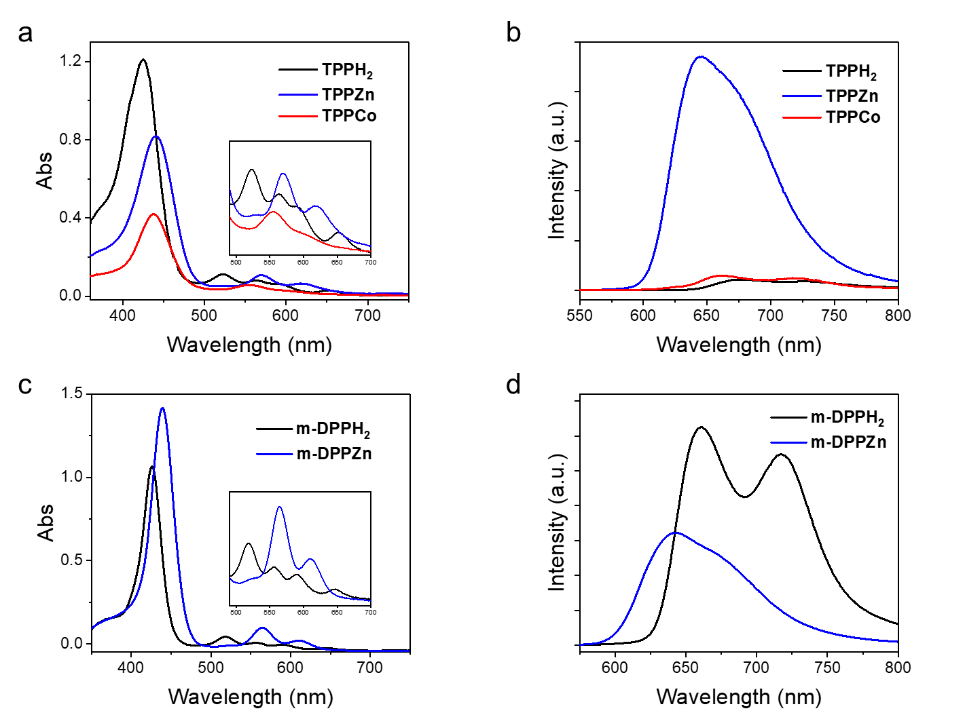
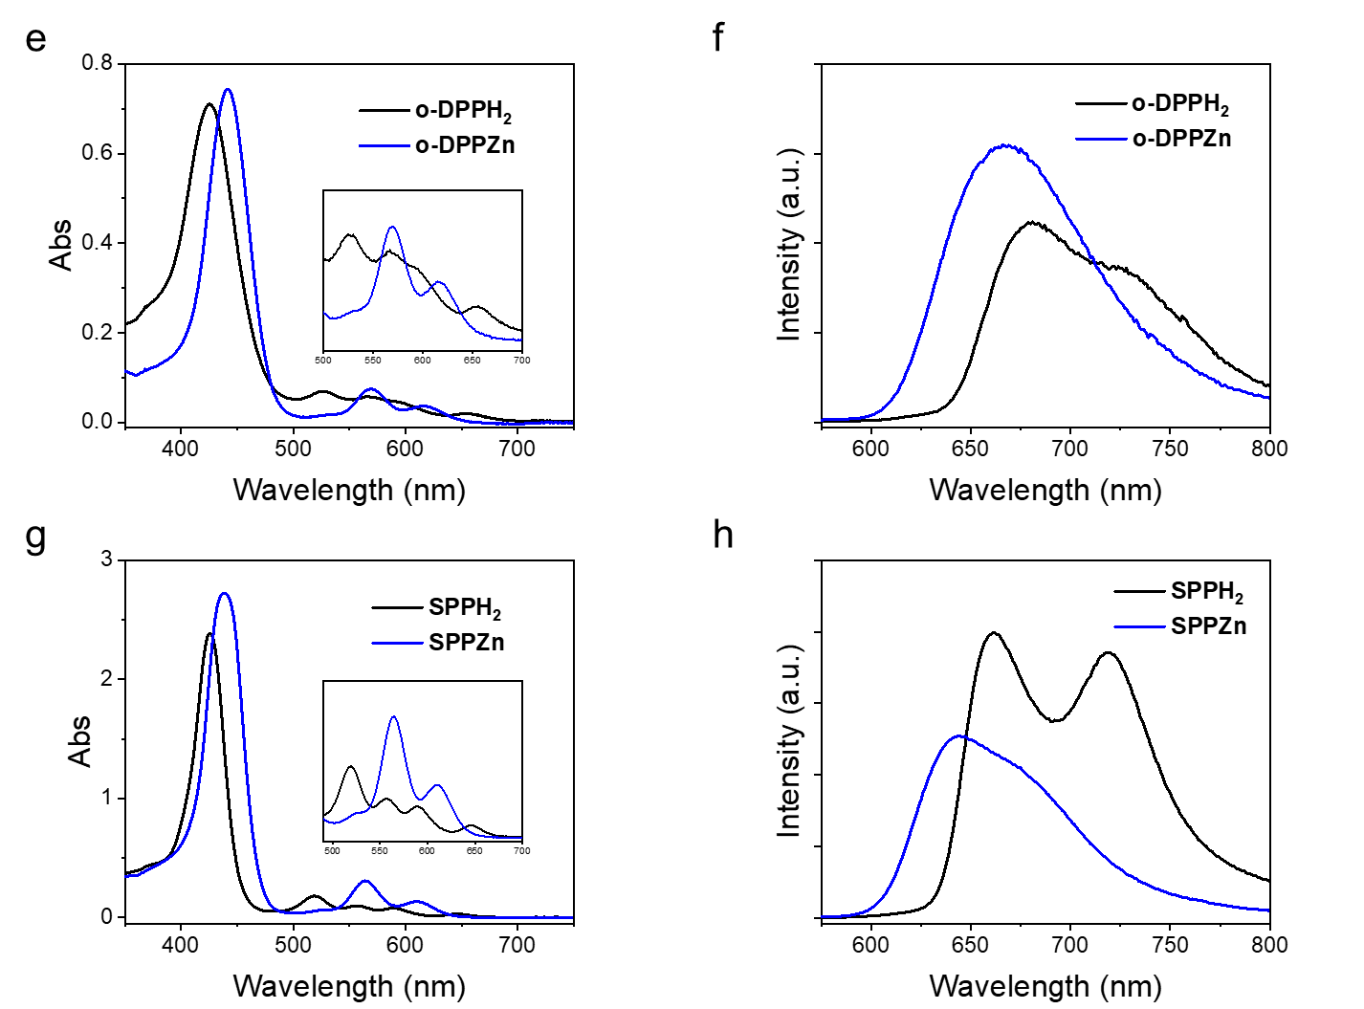
Supplementary Fig. 1 | UV-vis spectra (a,c,e,g. Inset: magnification of Q-band absorption) and fluorescence emission spectra (b,d,f,h. Excitation wavelength: 430 nm) of 10 μM target molecules in MeOH/H₂O (v/v = 1/1).
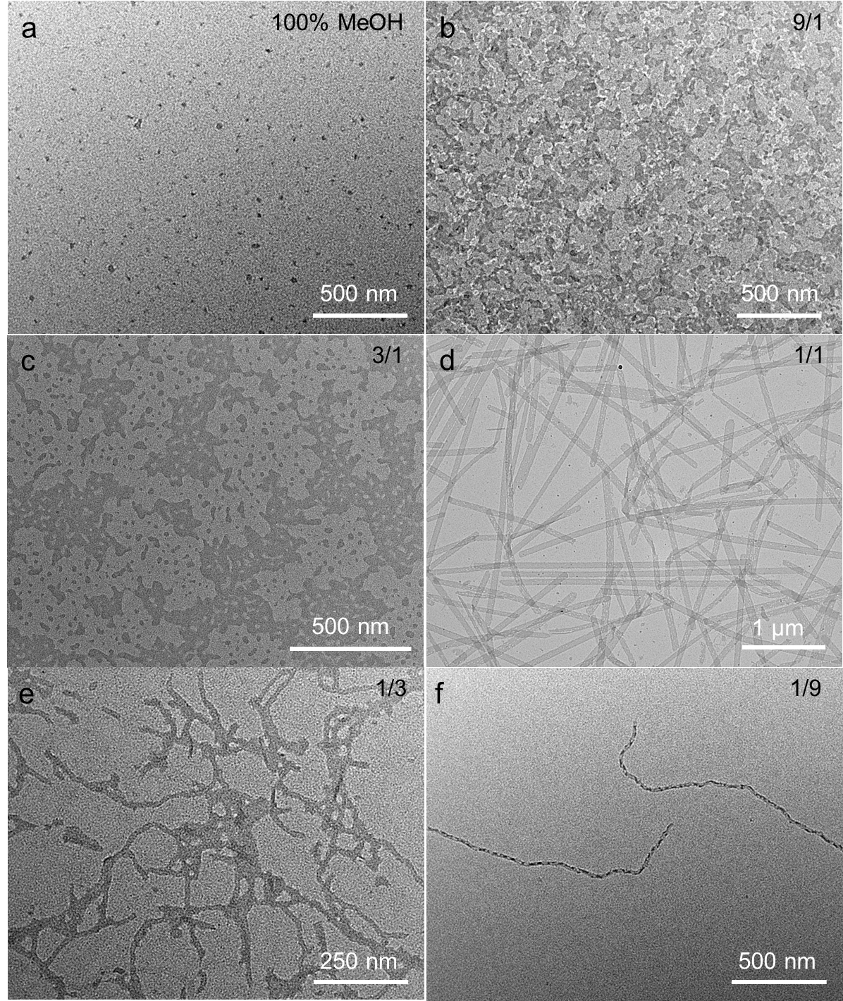
Supplementary Fig. 2 | TEM images of the assemblies formed by annealing of 0.1 mM TPPZn solution at a volume ratio of MeOH to H₂O of 100% (a); 9/1 (b); 3/1 (c); 1/1 (d); 1/3 (e); and 1/9 (f).

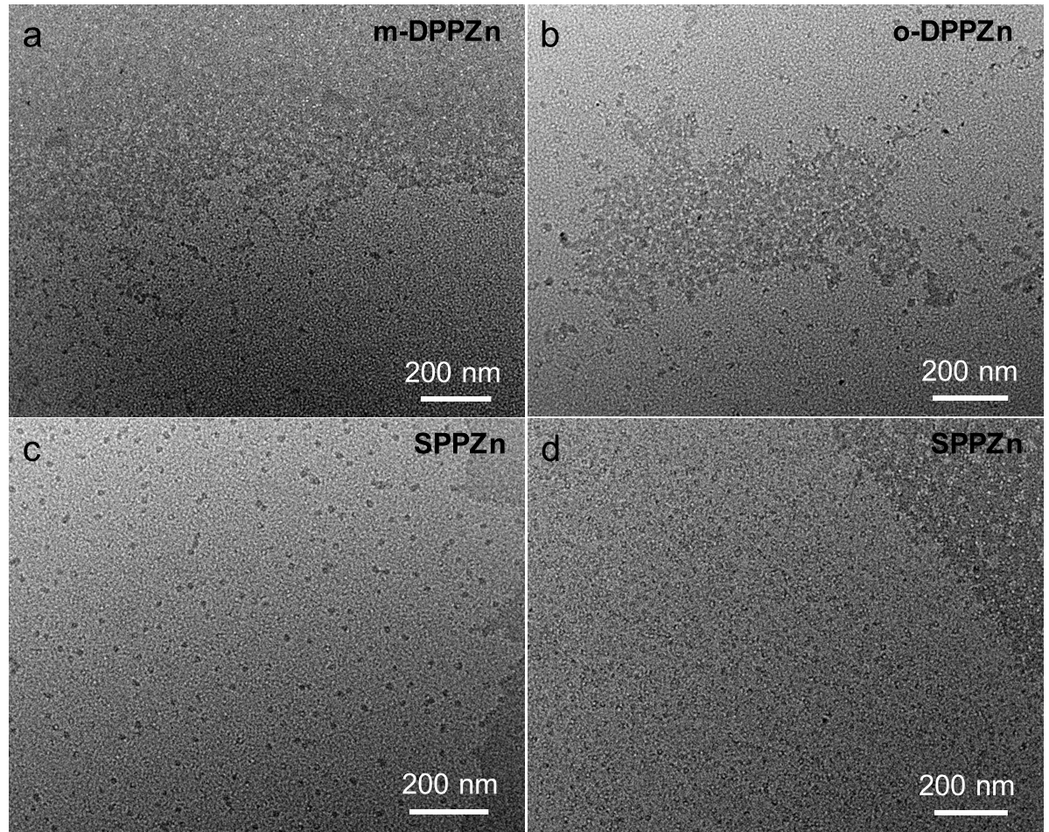
Supplementary Fig. 3 | TEM images of the assemblies formed by annealing of 0.1 mM Zn-porphyrins in MeOH/H₂O (v/v = 1/1) (a-c) or in water (d). (a) m-DPPZn, (b) o-DPPZn, (c,d) SPPZn.

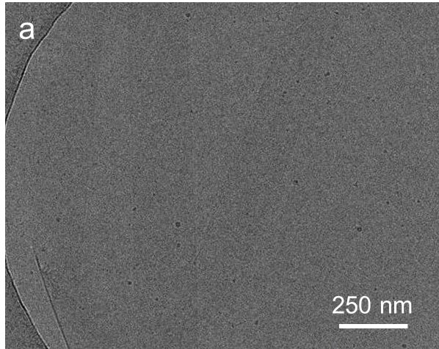
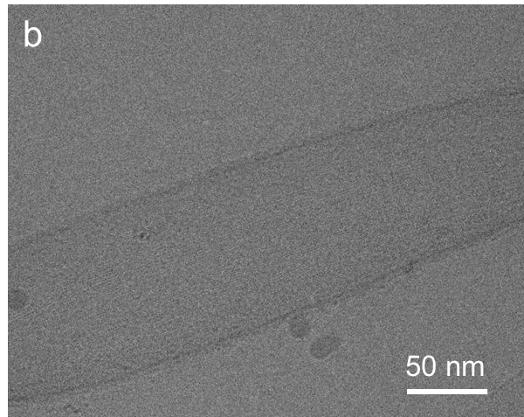
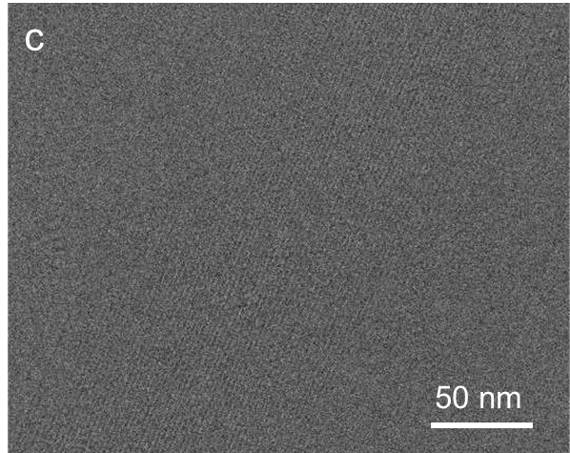
Supplementary Fig. 4 | Cryo-TEM images of SN ([TPPZn] = 0.2 mM) in MeOH/H₂O (v/v = 1/1) under the magnification of 8000 × (a) or 20,000 × (b,c).

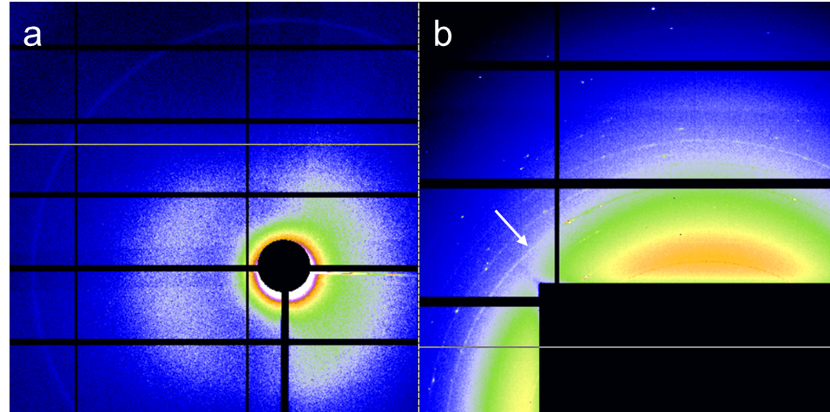
Supplementary Fig. 5 | SAXS (a) and WAXS (b) graphs for SN ([TPPZn] = 3 mM) suspension in MeOH/H₂O (v/v = 1/1).

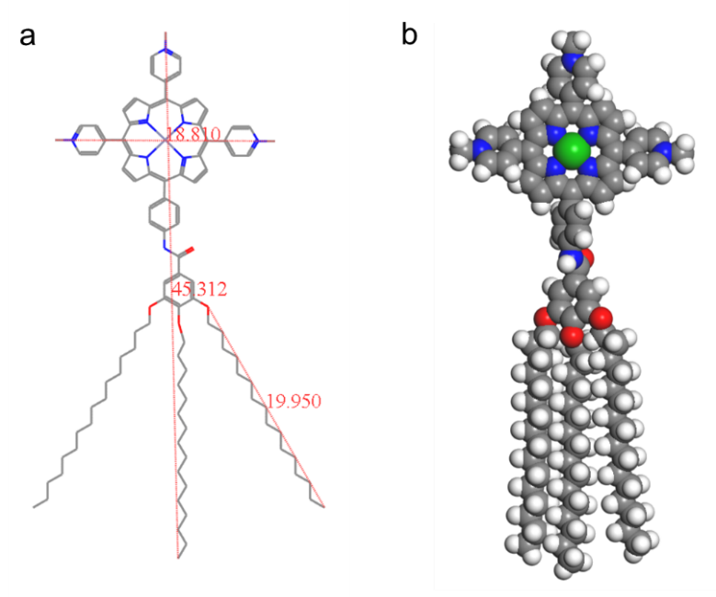
Supplementary Fig. 6 | (a) Molecular size (unit: Å) and (b) CPK model of TPPZn. Atoms in colors of white, grey, blue, red, and green represent H, C, N, O, Zn, respectively.

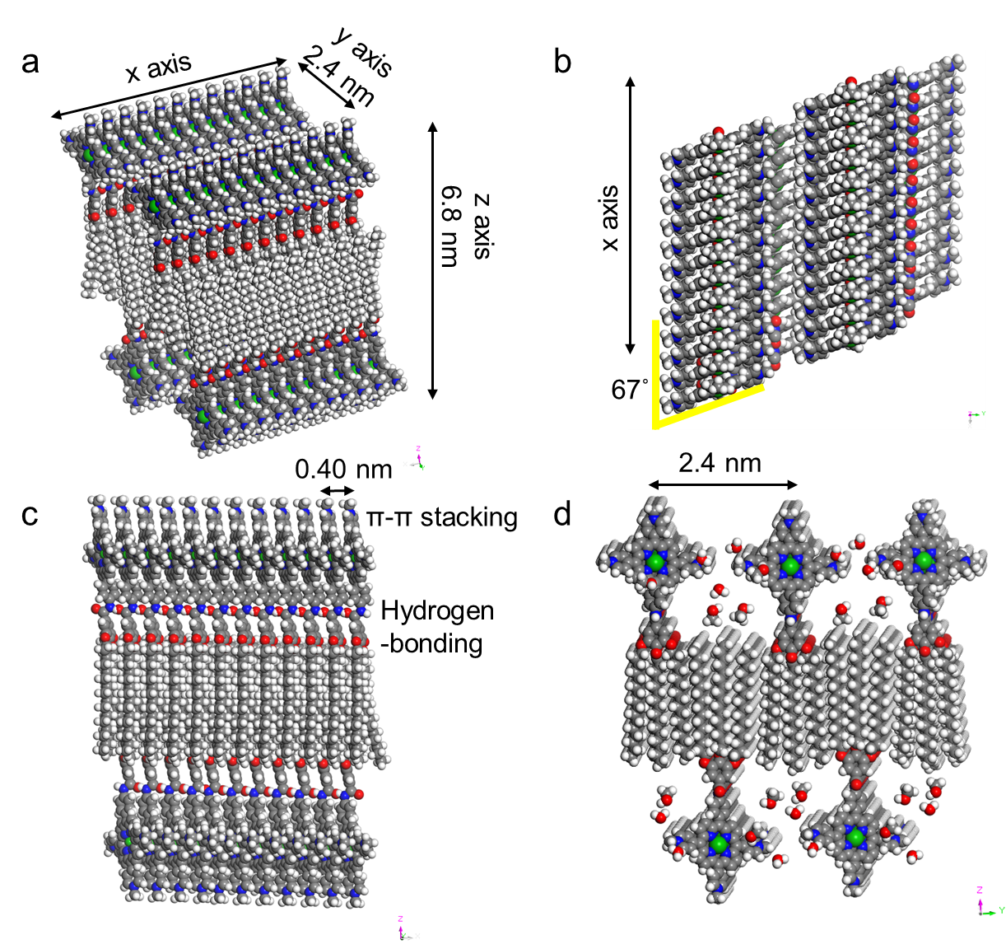
Supplementary Fig. 7 | Proposed stacking mode of 2DZn platelets in MeOH/H₂O (v/v = 1/1) under Material Studio. (a) 3D perspective view. (b) xy plane with alkyl chains hidden. (c) xz plane. (d) yz plane with solvent molecules added.

Supplementary Fig. 8 | UV-vis absorption spectra of 10 μM TPPZn in MeOH and in MeOH/H₂O (v/v = 1/1).

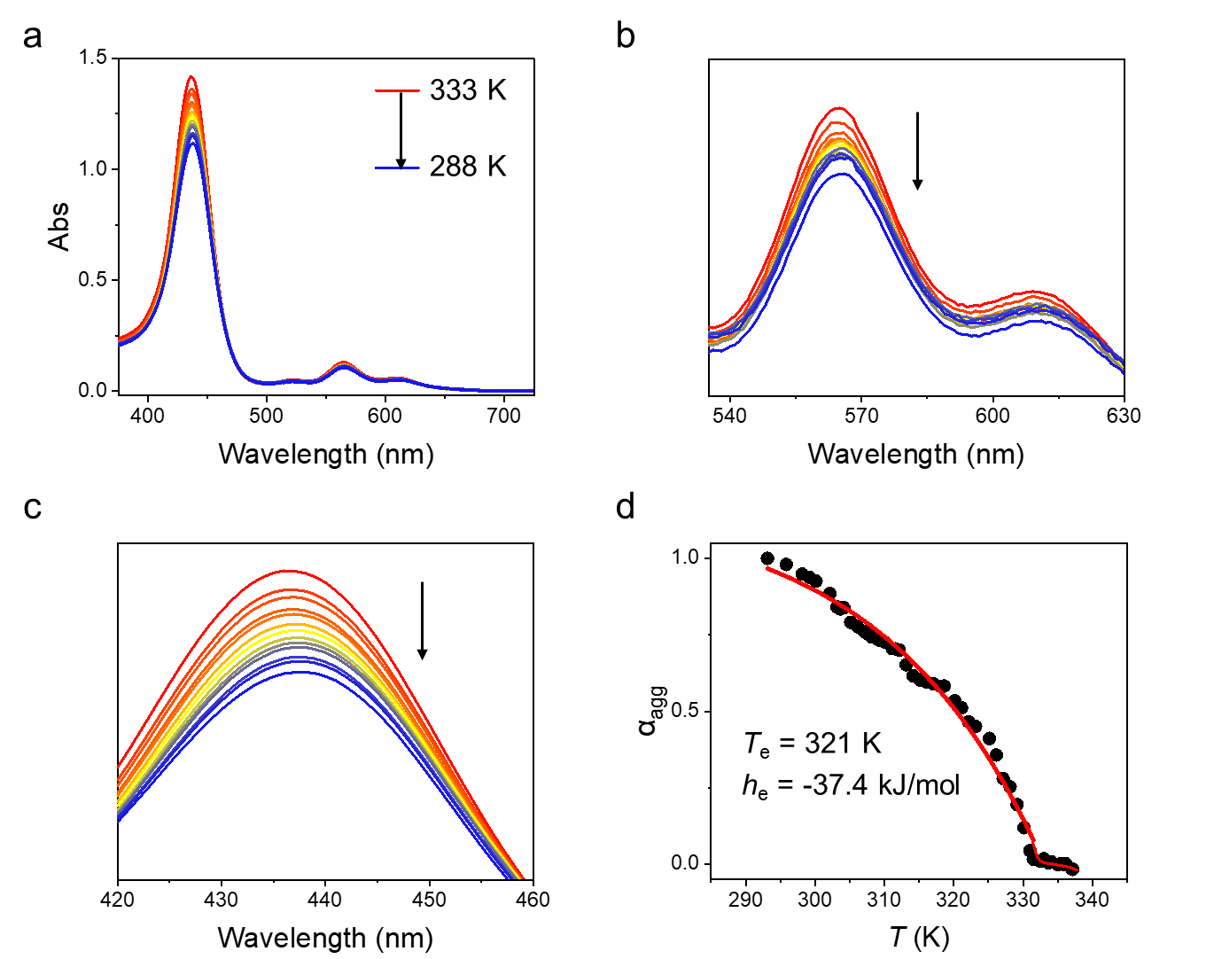
Supplementary Fig. 9 | (a-c) Temperature-dependent UV-vis spectra and (d) cooling curve at 0.5 °C/min of SN ([TPPZn] = 10 μM in MeOH/H₂O (v/v = 1/1)). (b,c) The magnification of (a) at the Soret band or Q-band of TPPZn.

Supplementary Fig. 10 | Temperature-dependent SAXS integral curves of SN suspension ([TPPZn] = 3 mM in MeOH/H₂O (v/v = 1/1)). The suspension was heated at 5 °C/min from 30 °C to 60 °C, cooled to room temperature, and then placed for 24 hours.

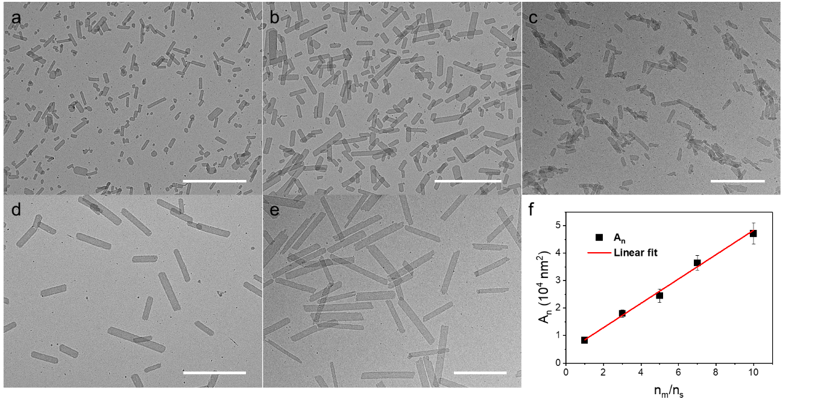
Supplementary Fig. 11 | Paralleled seeded growth experiment of TPPZn. (a) Seeds formed by sonication of SN in the ice water bath for 30 min. (b-e) Growth of different molar ratios of monomer to seed (n_{m}/n_{s}) = 1, 3, 5, 7, respectively. Scalebar: 1 μm. (f) Linear dependence of the platelet area on n_{m}/n_{s}, A_{n} = (4.4 n_{m}/n_{s} + 4.1) × 10³ nm², R² = 0.99, error bar: standard error (SE) of the average area.

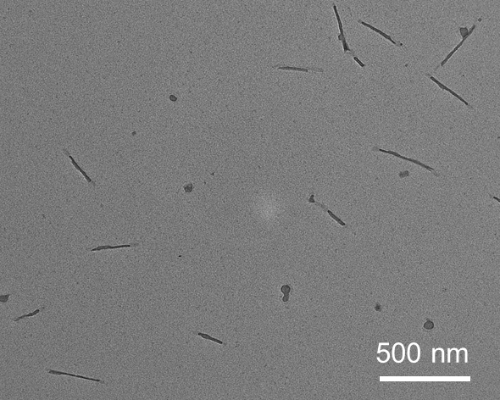
Supplementary Fig. 12 | TEM image of the nanowires formed by 0.1 mM TPPCo treated by annealing at 60 °C for 30 min in MeOH/H₂O (v/v = 1/1).

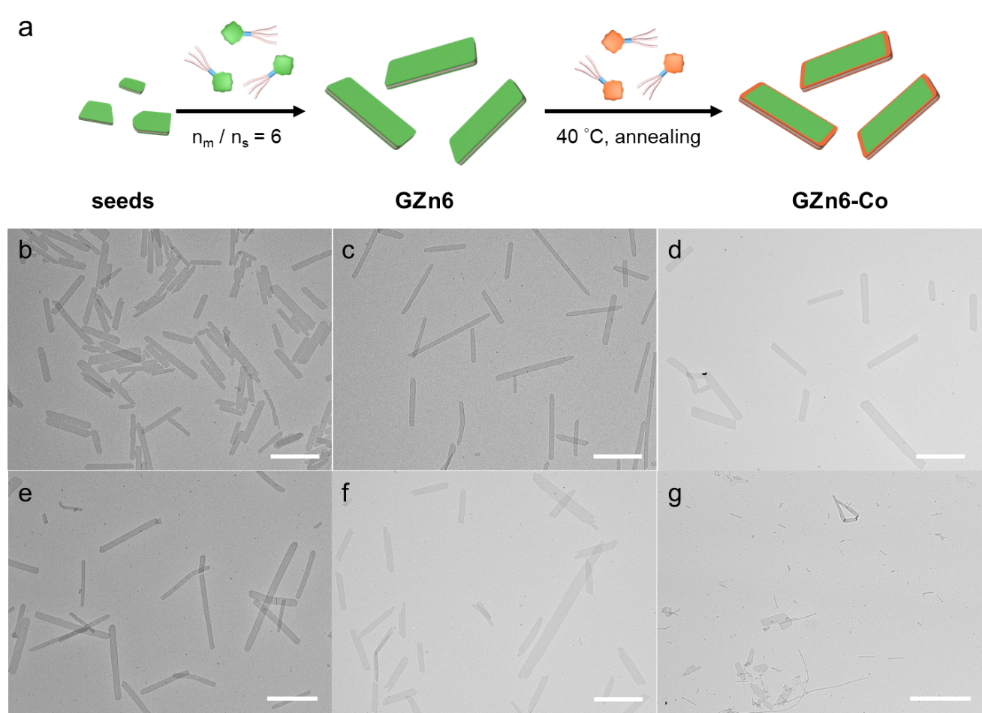
Supplementary Fig. 13 | Schematic presentation (a) and TEM images of 2D hetero-nanostructures formed by epitaxial growth of different molar ratios of monomer to seed (Co/Zn) = 0 (b), 0.1 (c), 0.2 (d), 0.5 (e), 1 (f), 2 (g). Scalebar: 1 μm.

Supplementary Fig. 14 | UV-vis absorption spectra of 10 μM TPPCo (b) in different solvents.

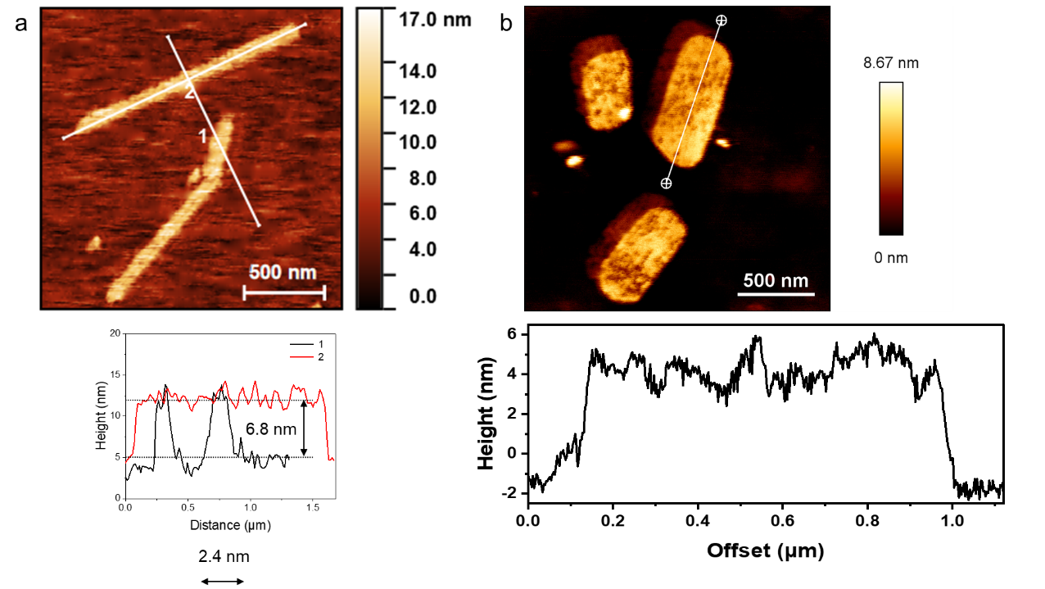
Supplementary Fig. 15 | AFM image and measured height of GZn6 (a) and GZn6-Co0.2 (b). Samples were prepared at [TPPZn] = 20 μM in MeOH/H₂O (v/v = 1/1).

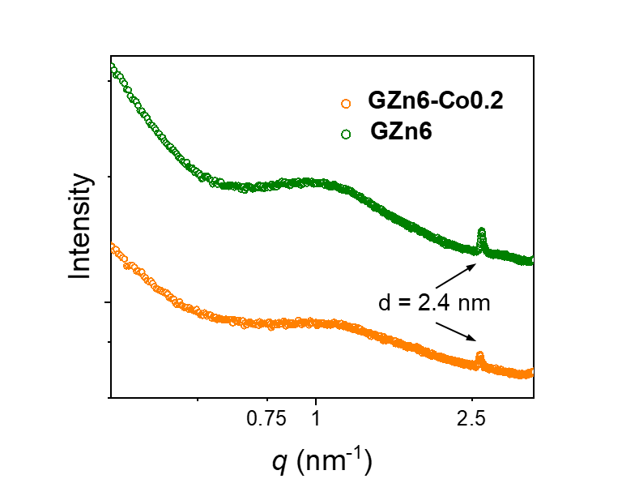
Supplementary Fig. 16 | SAXS integral curve of GZn6 or GZn6-Co0.2 ([TPPZn] = 3 mM suspension in MeOH/H₂O).

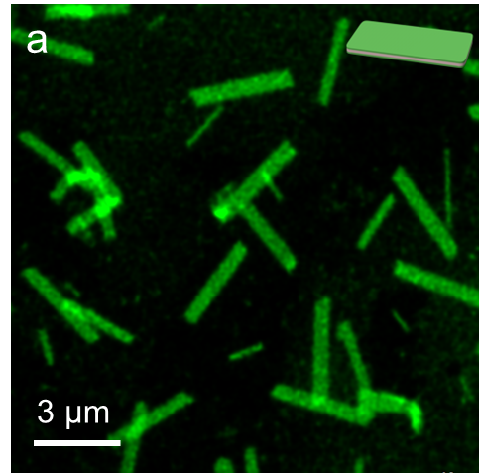
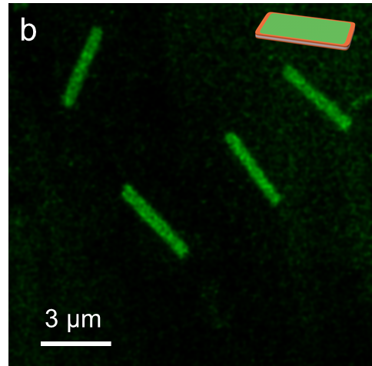
Supplementary Fig. 17 | CLSM images of SN (a) or 2D heterostructures (b) at [TPPZn] = 10 μM in MeOH/H₂O (v/v = 1/1).

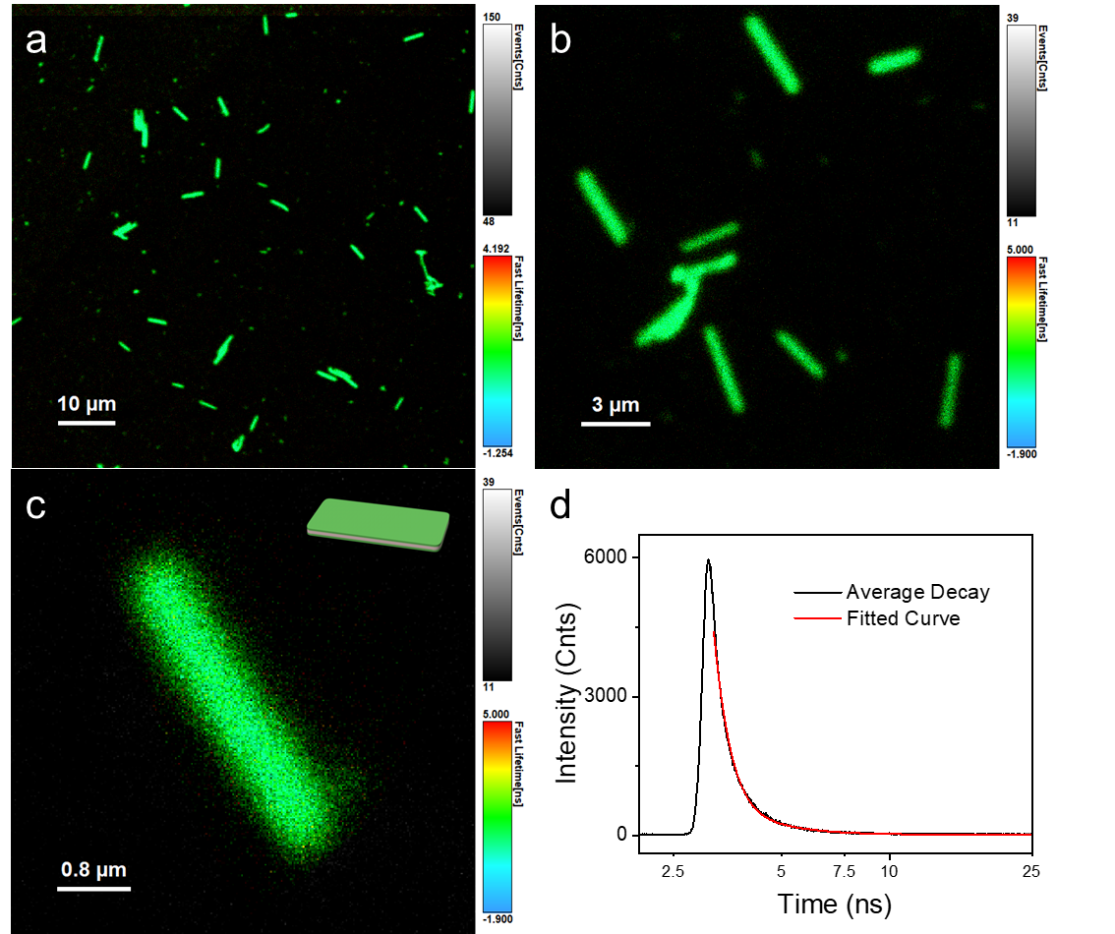
Supplementary Fig. 18 | FLIM images (a-c) of SN at [TPPZn] = 10 μM in MeOH/H₂O (v/v = 1/1). (d) Lifetime fitting of the single platelet in image c, with an average fluorescence lifetime at 2.2 ns.

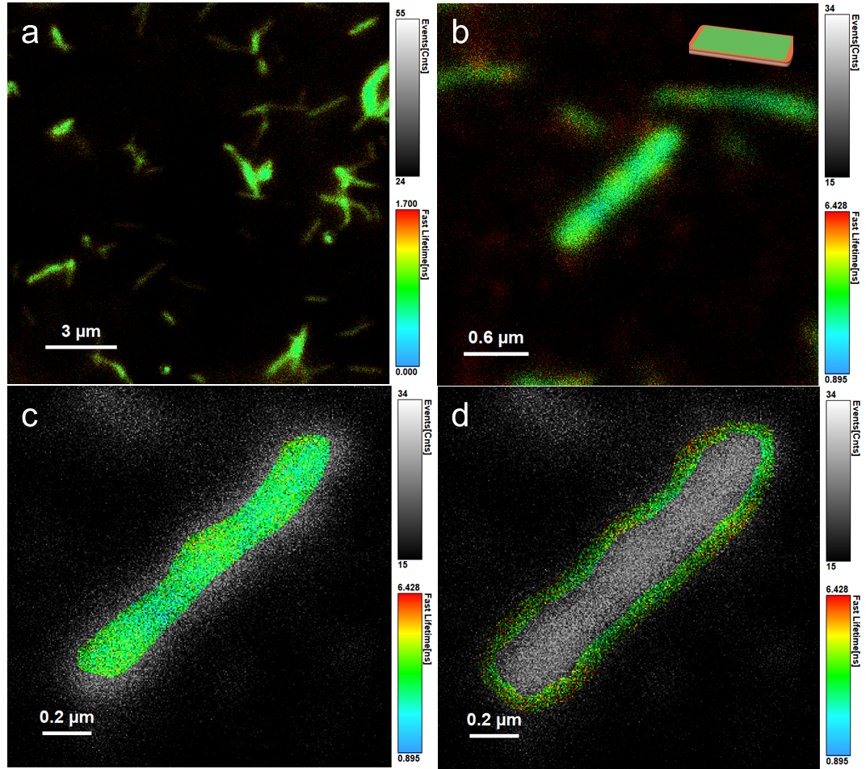
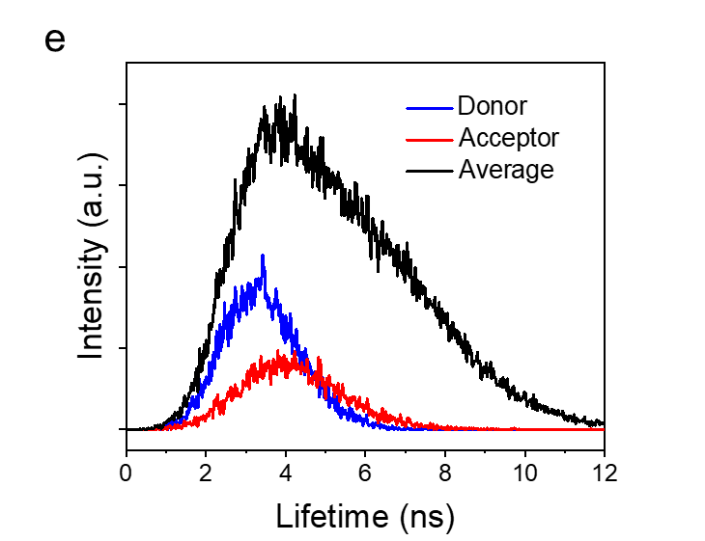
Supplementary Fig. 19 | FLIM images (a-d) and corresponding lifetime distribution curves (e) of different parts of GZn6-Co0.1 (Co/Zn = 0.1, [TPPZn] = 20 μM in MeOH/H₂O (v/v = 1/1)). Donor (blue line), acceptor (red line), and average (black line) represent the inner part (c), the outer part (d), and the entire assembly (b), respectively.

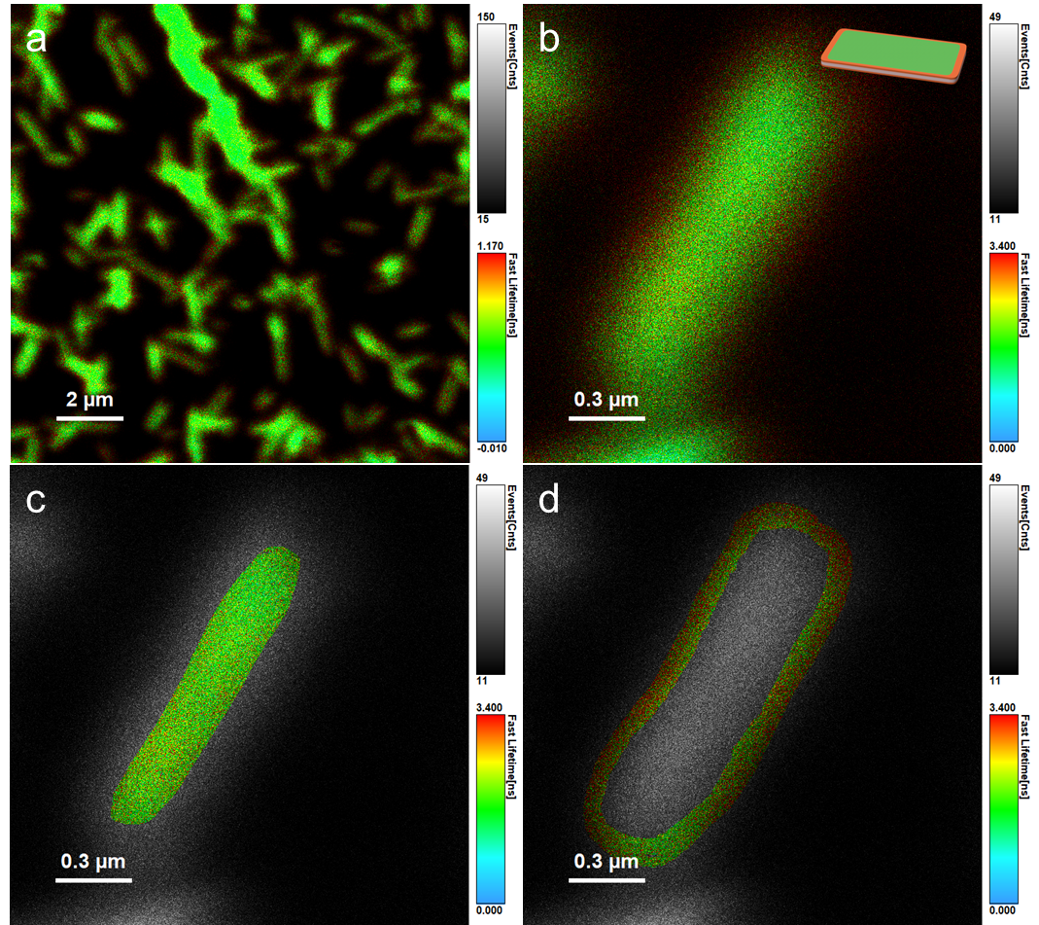
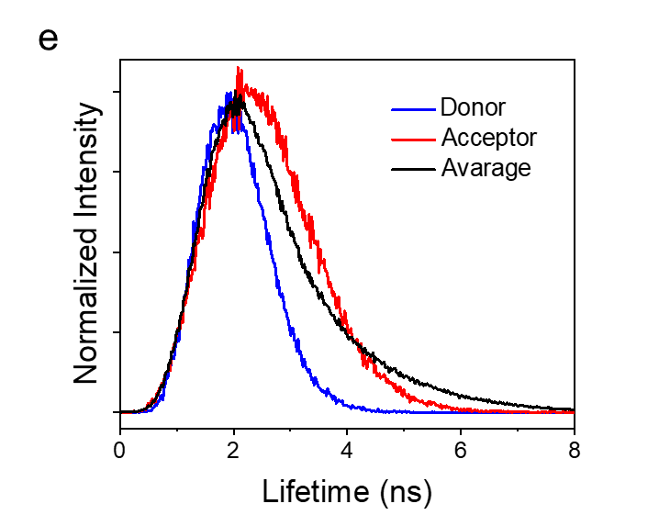
Supplementary Fig. 20 | FLIM images (a-d) and corresponding lifetime distribution curves (e) of different parts of GZn6-Co0.2 (Co/Zn = 0.2, [TPPZn] = 20 μM in MeOH/H₂O (v/v = 1/1) with 2% w/v DABCO). Donor (blue line), acceptor (red line), and average (black line) represent the inner part (c), the outer part (d), and the entire assembly (b), respectively.

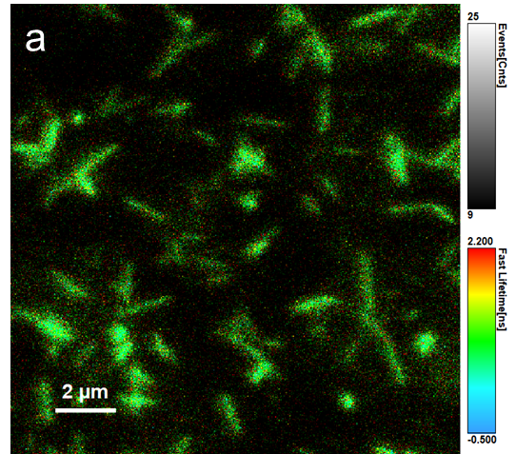
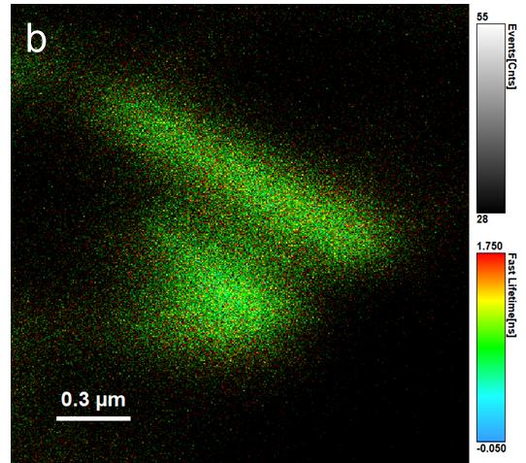
Supplementary Fig. 21 | FLIM images of GZn6-Co0.5 (Co/Zn = 0.5, [TPPZn] = 20 μM in MeOH/H₂O (v/v = 1/1) with 2% w/v DABCO). Fluorescence intensity was too low to fit a lifetime precisely.

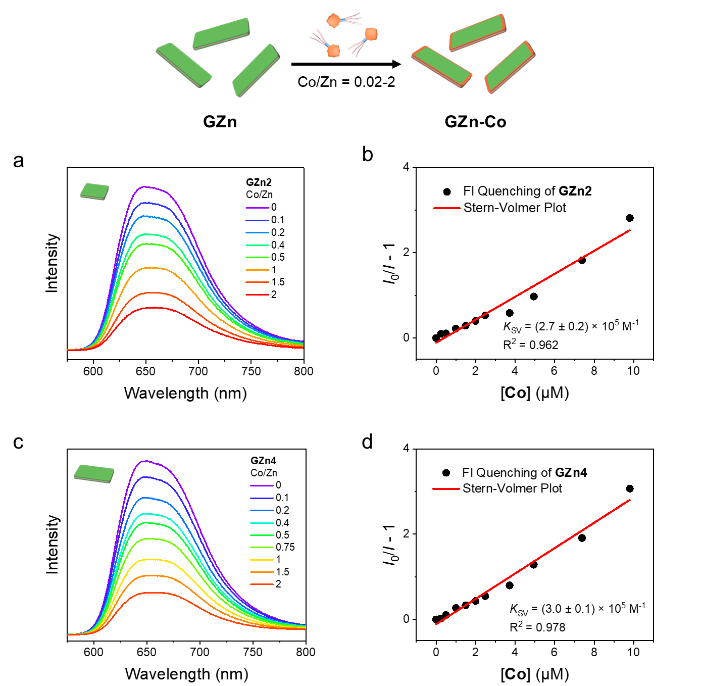
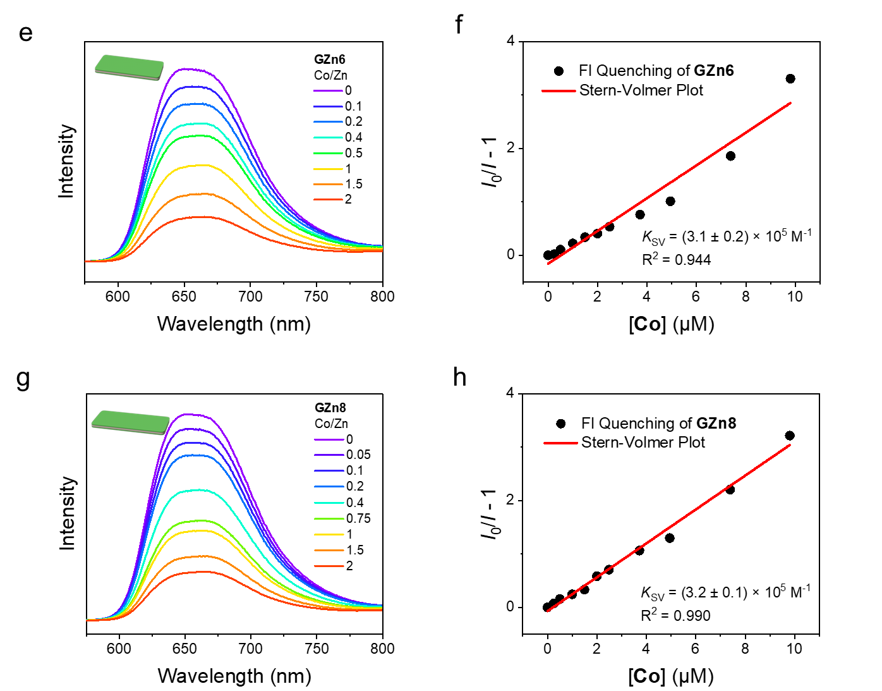
Supplementary Fig. 22 | Fluorescence quenching and Stern-Volmer analysis of 2D heterostructures. The donor was prepared by seeded growth in Fig. 3 and diluted to 5 μM in MeOH/H₂O (v/v = 1/1).The acceptor solution contained of 0.1 mM TPPCo and 5 μM TPPZn in MeOH. (a,b) GZn2. (c,d) GZn4. (e,f) GZn6. (g,h) GZn8.
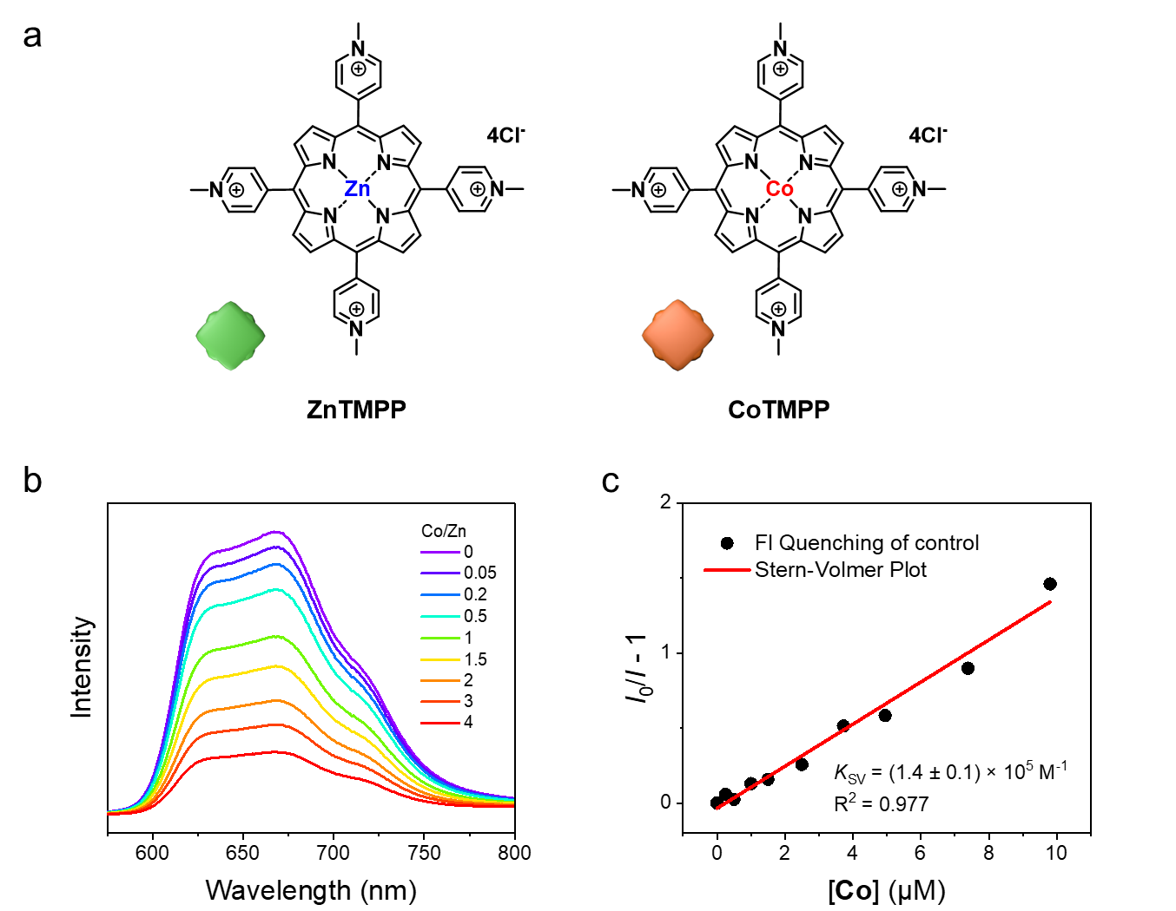
Supplementary Fig. 23 | (a) Chemical structure of cationic free molecules for the control of porphyrins without the formation of molecular arrays. (b) Fluorescence quenching emission spectra and (c) Stern-Volmer analysis of the free molecules. ZnTMPP was dissolved at 5 μM in MeOH/H₂O (v/v = 1/1). The acceptor solution contained 0.1 mM CoTMPP and 5 μM ZnTMPP in MeOH.

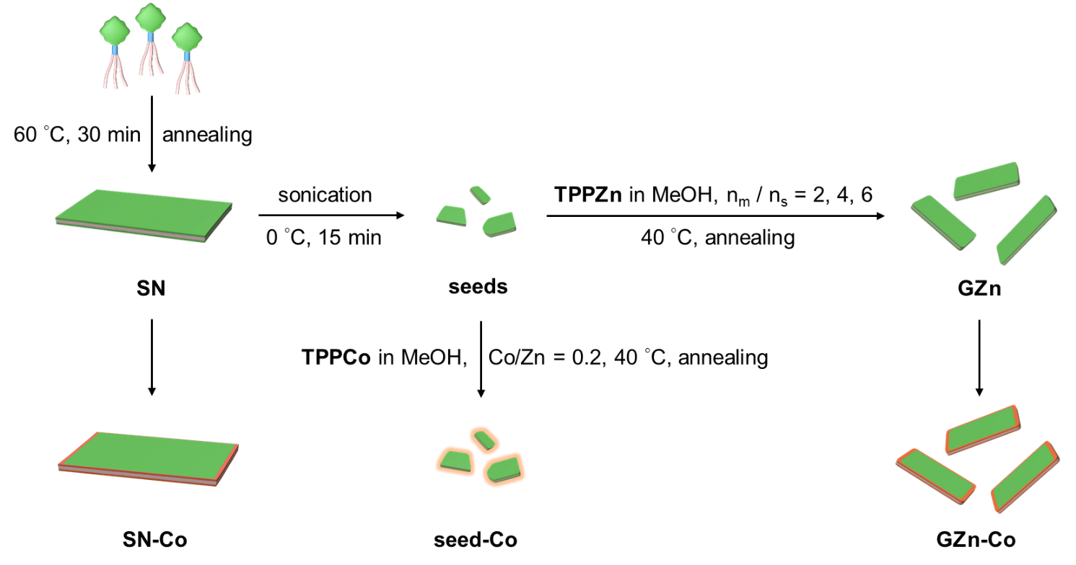
Supplementary Fig. 24 | Graphical presentation of samples for femtosecond transient absorption spectra (fs-TAS). SN formed by self-nucleation had the largest A_{n}. Seeds prepared by sonication of SN obtained the smallest A_{n} and the highest PDI. GZn and 2D heterostructures (Co/Zn = 0.2) were prepared by seeded growth and epitaxial growth, as mentioned in Fig. 3 and Fig. 4. Samples were prepared at [TPPZn] = 30 μM in MeOH/H₂O (v/v = 1/1).

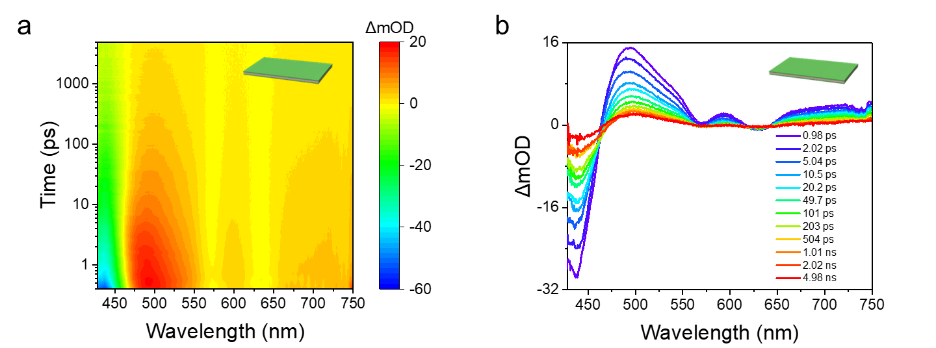
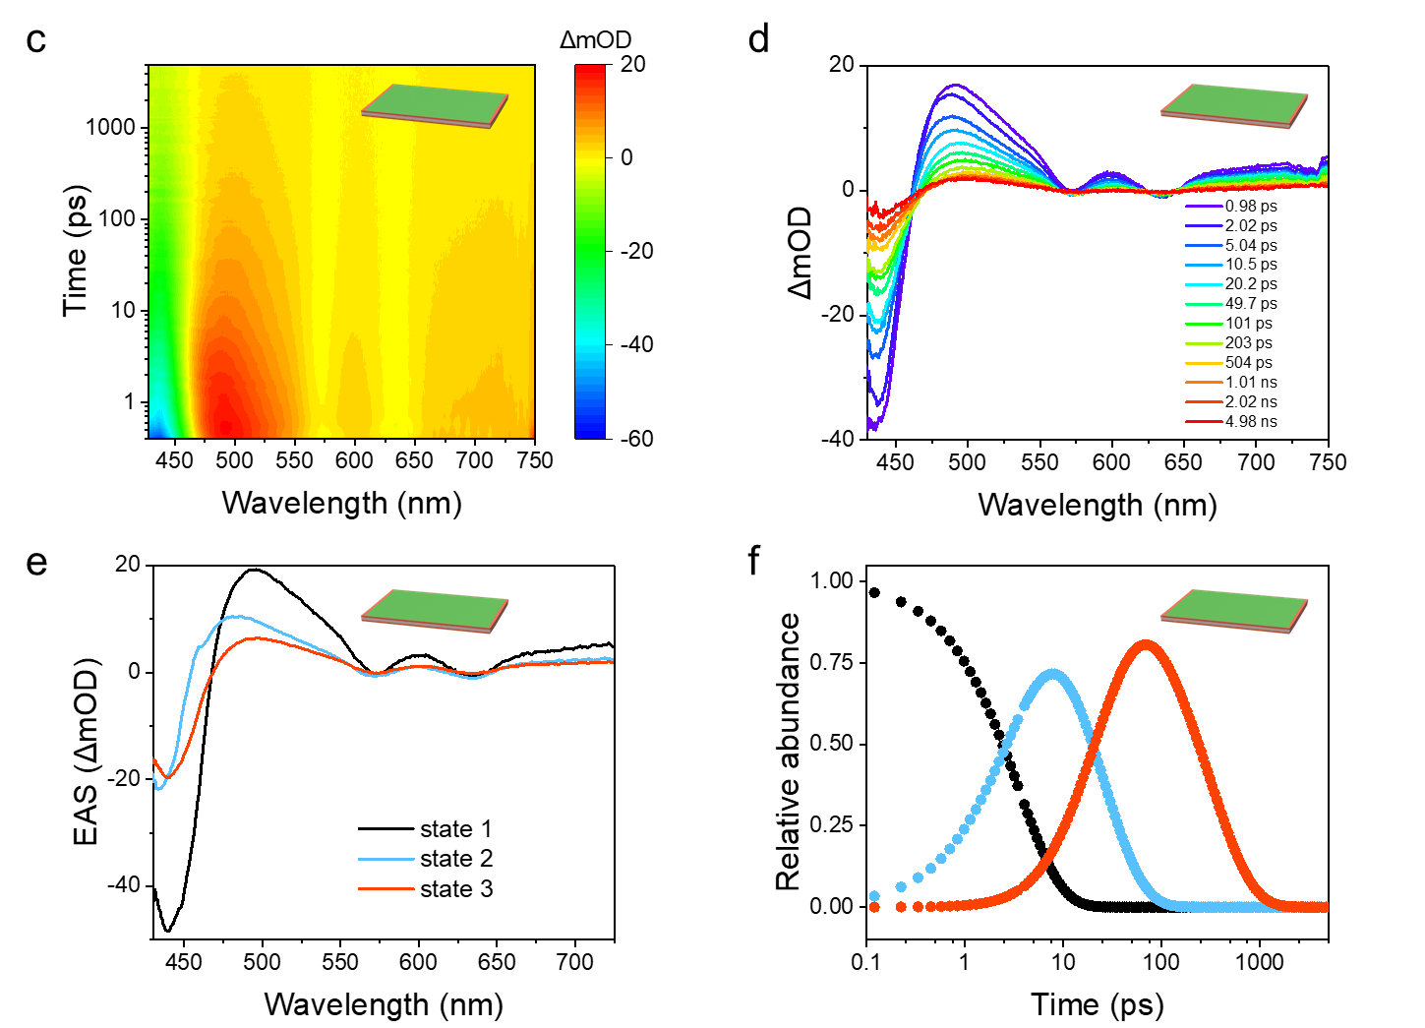

Supplementary Fig. 25 | 2D fs-TAS and curves of SN (a,b) and SN-Co (c,d). OD, optical density. (e) Evolution-associated difference spectra (EAS) via global fitting analysis to 3 excitation states for SN-Co according to the kinetic model in Fig. 5e. (f) Time evolution of state population for SN-Co.

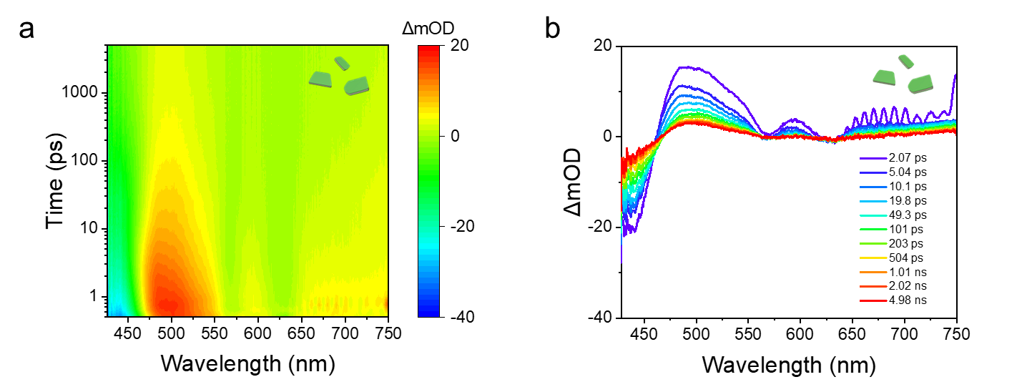

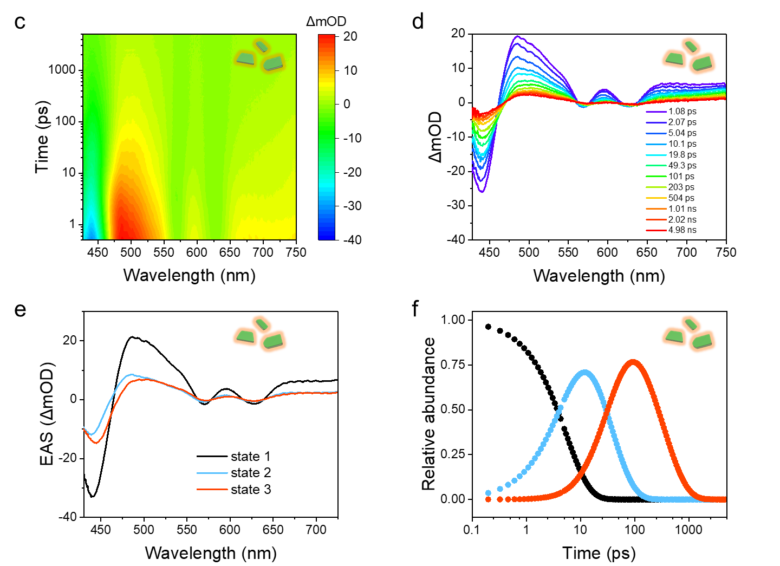
Supplementary Fig. 26 | 2D fs-TAS and curves of seeds (a,b) and seed-Co (c,d). OD, optical density. (e) Evolution-associated difference spectra (EAS) via global fitting analysis to 3 excitation states for seed-Co according to the kinetic model in Fig. 5e. (f) Time evolution of state population for seed-Co.

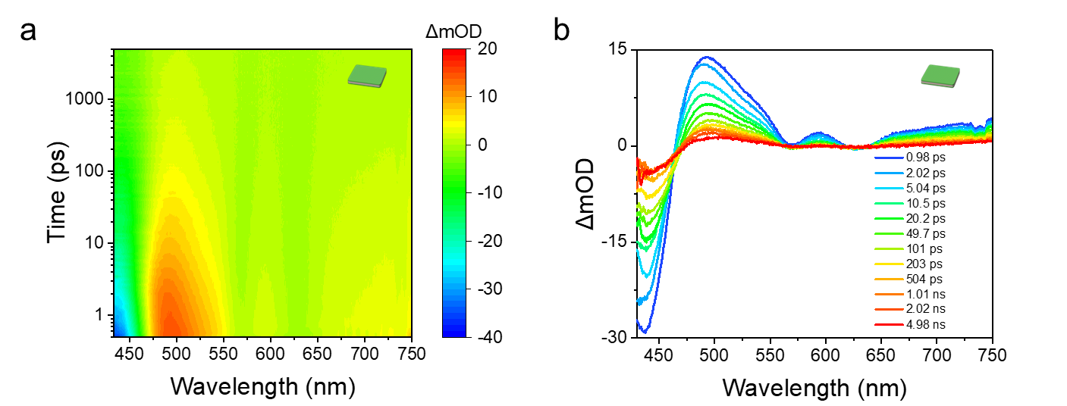
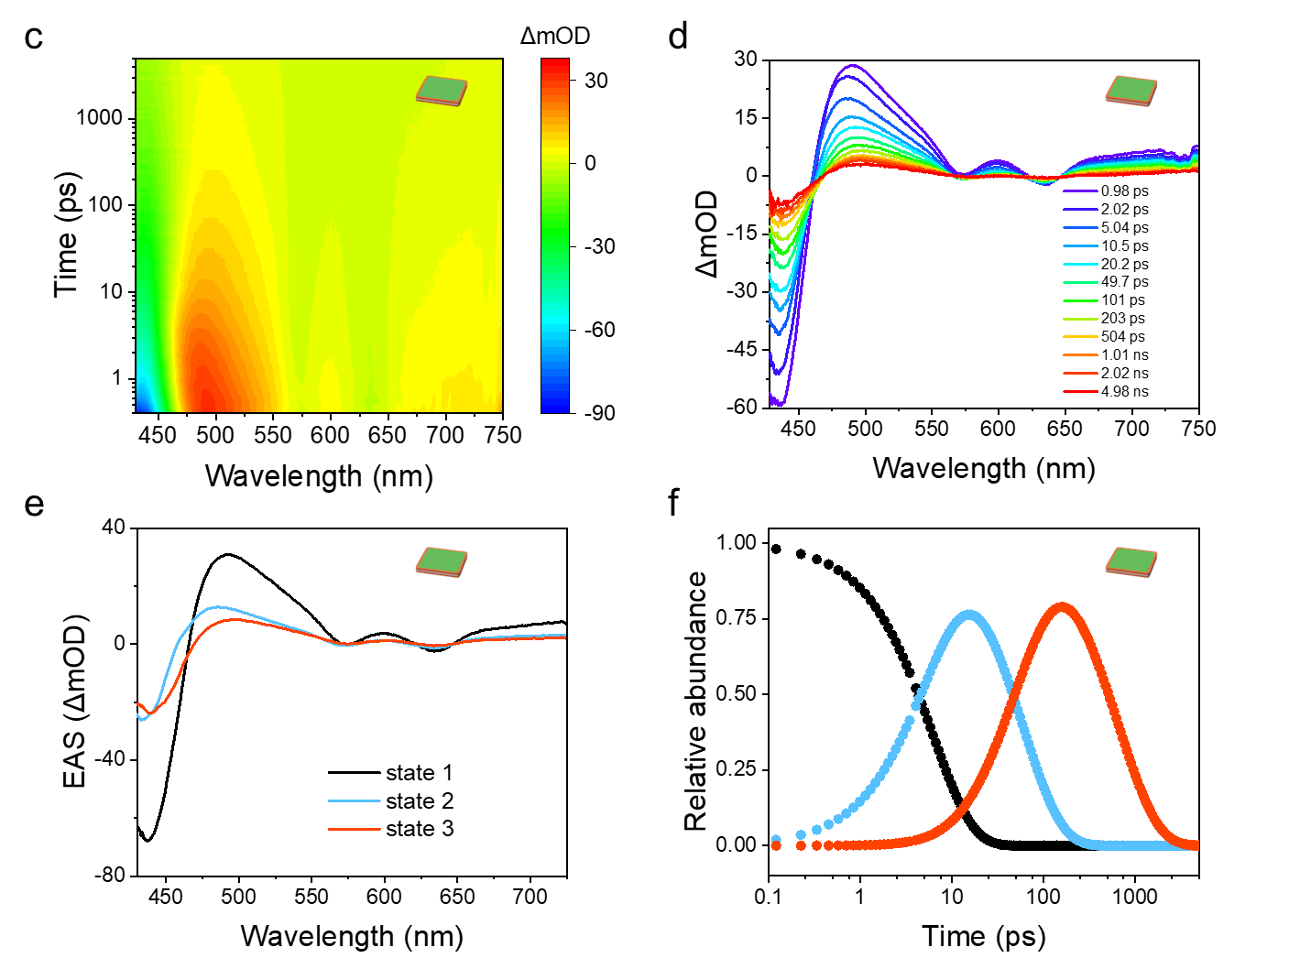

Supplementary Fig. 27 | 2D fs-TAS and curves of GZn2 (a,b) and GZn2-Co (c,d). OD, optical density. (e) Evolution-associated difference spectra (EAS) via global fitting analysis to 3 excitation states for GZn2-Co according to the kinetic model in Fig. 5e. (f) Time evolution of state population for GZn2-Co.

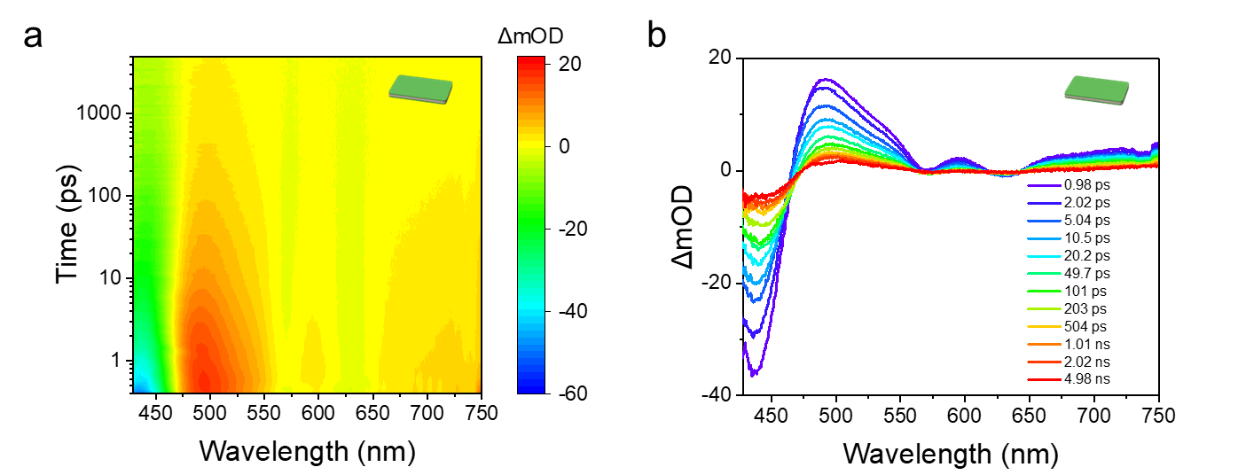
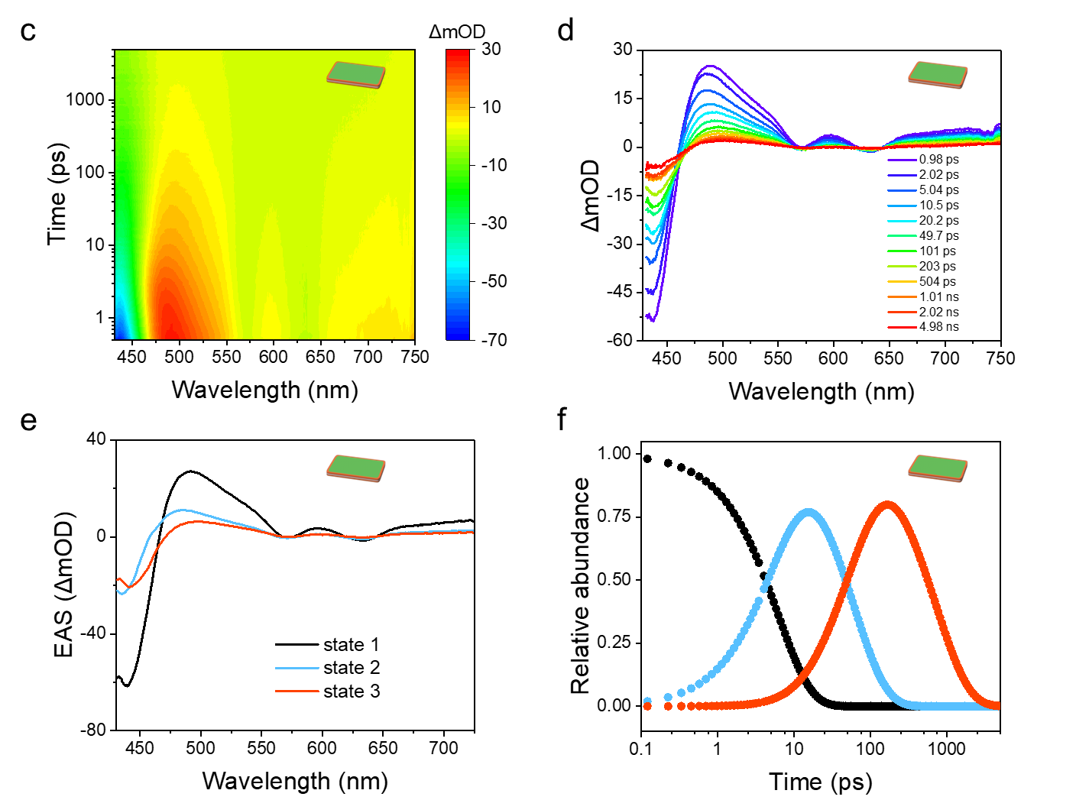

Supplementary Fig. 28 | 2D fs-TAS and curves of GZn4 (a,b) and GZn4-Co (c,d). OD, optical density. (e) Evolution-associated difference spectra (EAS) via global fitting analysis to 3 excitation states for GZn4-Co according to the kinetic model in Fig. 5e. (f) Time evolution of state population for GZn4-Co.

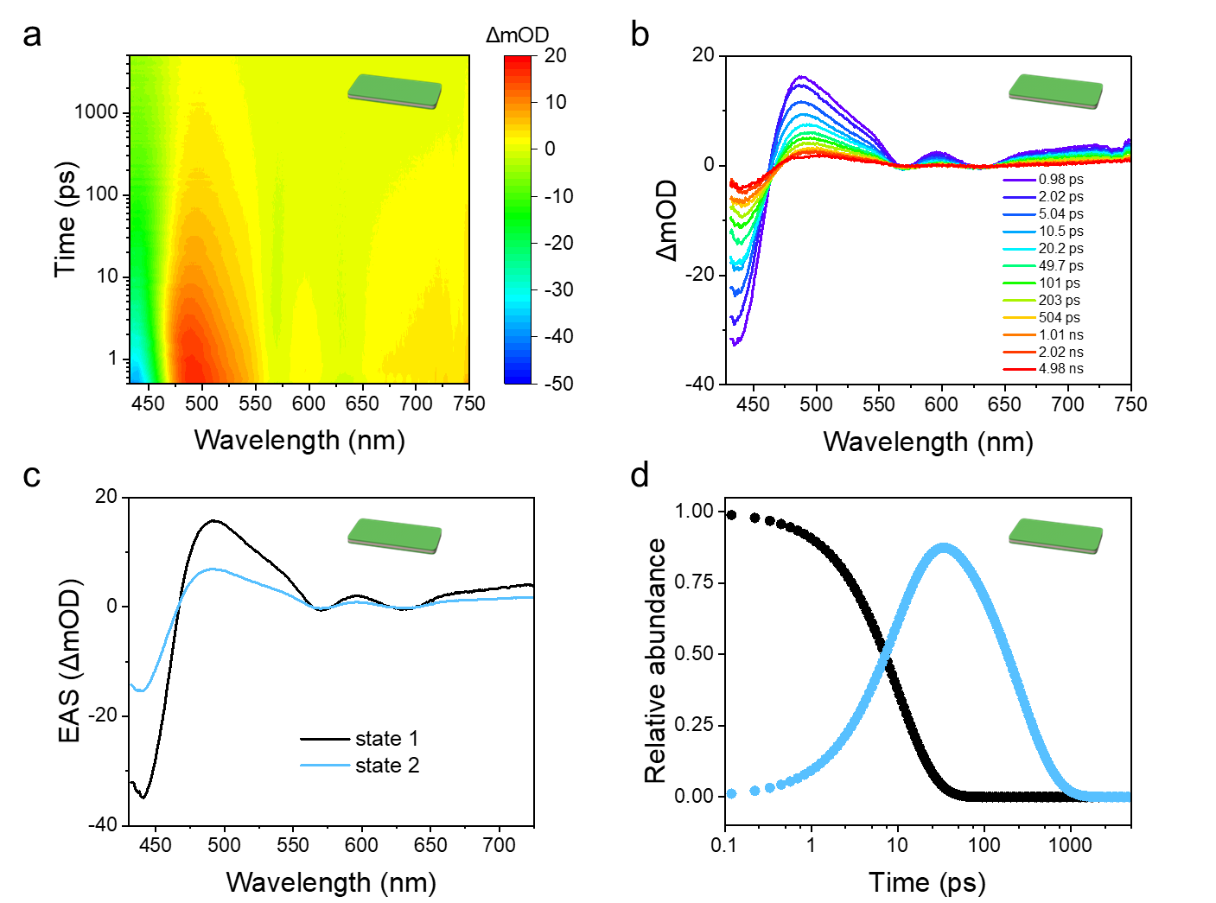
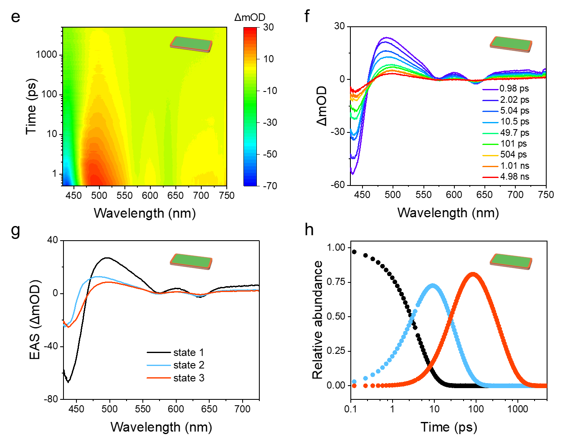
Supplementary Fig. 29 | 2D fs-TAS and curves of GZn6 (a,b) and GZn6-Co (e,f). OD, optical density. (c) Evolution-associated difference spectra (EAS) via global fitting analysis to 2 excitation states for GZn6 according to the two-stage kinetic model. (d) Time evolution of state population for GZn6. (g) EAS for GZn6-Co according to the three-stage kinetic model. (h) State population for GZn6-Co.

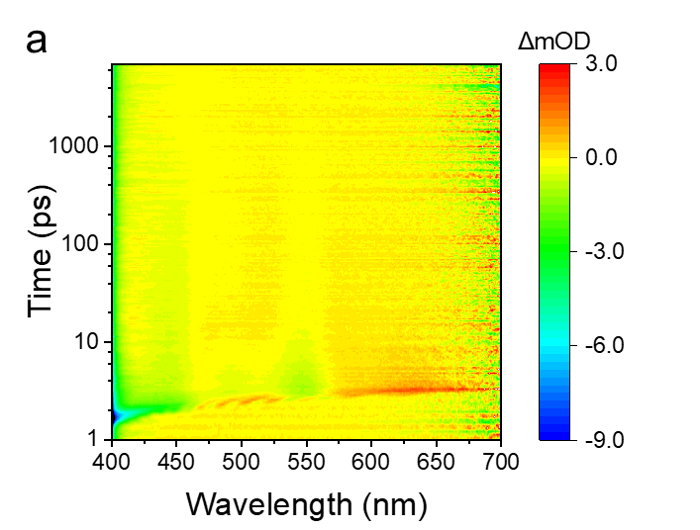
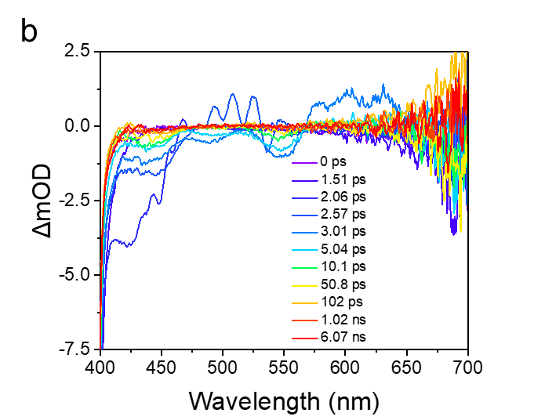
Supplementary Fig. 30 | Fs-TAS and curves of 0.2 mM TPPCo in MeOH/H₂O (v/v = 1/1) after annealing at 60 °C for 30 min and placing at 20 °C for 24 h.

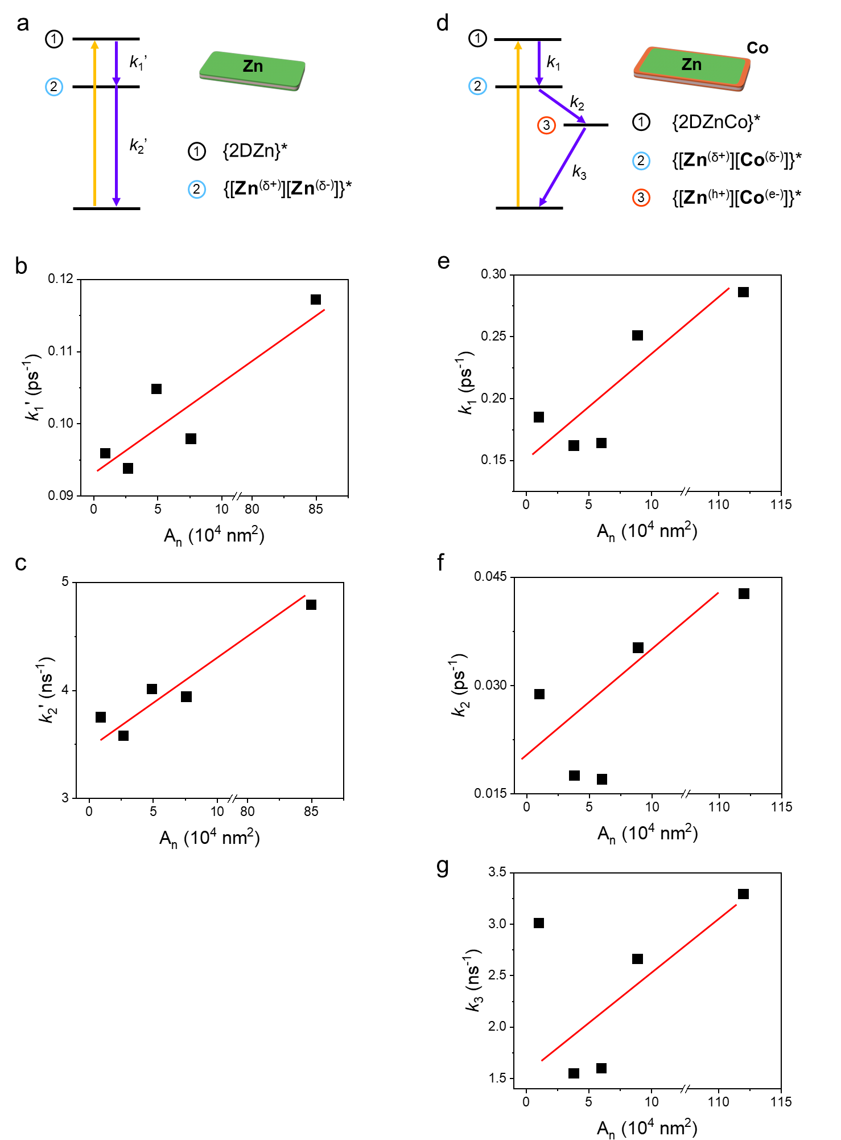
Supplementary Fig. 31 | (a) 2-stage kinetic decay model and (b,c) rate constants fitted (k₁’ and k₂’) of 2D Zn-porphyrin platelets with various A_{n} via global fitting of fs-TAS data. (d) 3-stage kinetic decay model and (e-g) rate constants fitted (k₁, k_{2,} and k₃) of 2D heterostructures with various A_{n} via global fitting of fs-TAS data. Red lines are indicative trend lines for the excited-state size effect.

IV. Tables
Supplementary Table 1. Statistical data of 2D TPPZn-seeded growth. A_{n} and PDI stand for the number-average area of platelets and the polydispersity index, respectively. SN represents 2D platelets formed by self-nucleation. GZn and the following number represents platelets formed by seeded growth experiments and the molar ratio of monomer to seed (n_{m}/n_{s}).
Sample Name | A_{n} (× 10⁴ nm²) | PDI | Aspect Ratio
SN (Fig. 2a) | 27 | 1.44 | 8.3
Seeds (Fig. 3b) | 0.90 | 2.03 | 2.1
GZn2 (Fig. 3c) | 2.7 | 1.71 | 7.9
GZn4 (Fig. 3d) | 4.9 | 1.31 | 7.2
GZn6 (Fig. 3e) | 7.6 | 1.33 | 7.7
GZn8 (Fig. 3f) | 9.6 | 1.57 | 9.5

Supplementary Table 2. Statistical data of seeded growth of TPPCo on GZn6. A_{n} and PDI stand for the number-average area of platelets and the polydispersity index, respectively. GZn6 represents 2DZn platelets used for seeded growth. GZn6-Co and the following number represent the co-assembly formed by the seeded growth experiment and the relative molar ratio of monomer to seed (Co/Zn).
Sample Name | A_{n} (× 10⁴ nm²) | PDI | Aspect Ratio
GZn6 | 7.6 | 1.33 | 7.7
GZn6-Co0.1 | 8.3 | 1.34 | 6.6
GZn6-Co0.2 | 8.9 | 1.48 | 6.1
GZn6-Co0.5 | 6.7 | 1.34 | 6.2
GZn6-Co1 | 9.5 | 1.72 | 7.1

Supplementary Table 3. Fitted fluorescence lifetime of GZn6-Co of different Co/Zn under FLIM. Lifetime was measured in various regions of a single nanosheet, which was manually obtained. τ_{D}, τ_{A}, and τ_{Ave} denote the lifetimes at the inner, outer, and entire nanosheet, respectively (see Fig. 4 and Supplementary Figs. 21-23). For GZn6, the nanosheet as a whole exhibited a lifetime of 2.2 ns.
Sample Name | Co/Zn | τ_{Ave} (ns) | τ_{D} (ns) | τ_{A} (ns)
GZn6 | 0 | 2.2 | 2.2 | -
GZn6-Co0.1 | 0.1 | 3.0 | 1.8 | 4.2
GZn6-Co0.2 | 0.2 | 2.0 | 1.4 | 2.1

Supplementary Table 4. Comparison of key photophysical parameters of the controlled assemblies with recently reported donor-acceptor supramolecular systems via global fitting.
Donor-acceptor | Exciton migration  k₁ (10¹¹ s⁻¹) | Charge separation  k₂ (10¹⁰ s⁻¹) | Electron injection  τ₃ (ns) | References
GZn6 | 0.98 | - | - | This work
GZn6-Co | 2.5 | 3.5 | <0.38 | This work
Nalg-4 + C2 | 5.6 | 1.6 | <2.4 | [9]
[PBI]₅Ru₄POM | 7.3 | 4.0 | <1.1 | [10]
(ZnP)₃−H₂P−C₆₀ | 0.83 | 0.37 | <8.3 | [11]

V. ¹H and ¹³C NMR Spectra
Supplementary Fig. 32 | ¹H NMR spectra of B1

Supplementary Fig. 33 | ¹H NMR spectra of B2
Supplementary Fig. 34 | ¹H NMR spectra of T-COOMe

Supplementary Fig. 35 | ¹H NMR spectra of T-COOH
Supplementary Fig. 36 | ¹H NMR spectra of TPP

Supplementary Fig. 37 | ¹³C NMR spectra of TPP
Supplementary Fig. 38 | ¹H NMR spectra of TPPH₂-PF₆

Supplementary Fig. 39 | ¹³C NMR spectra of TPPH₂-PF₆
Supplementary Fig. 40 | ¹H NMR spectra of TPPZn

Supplementary Fig. 41 | ¹³C NMR spectra of TPPZn
Supplementary Fig. 42 | ¹H NMR spectra of m-D-COOMe

Supplementary Fig. 43 | ¹H NMR spectra of m-D-COOH
Supplementary Fig. 44 | ¹H NMR spectra of m-DPP

Supplementary Fig. 45 | ¹³C NMR spectra of m-DPP
Supplementary Fig. 46 | ¹H NMR spectra of m-DPPH₂-PF₆

Supplementary Fig. 47 | ¹³C NMR spectra of m-DPPH₂-PF₆
Supplementary Fig. 48 | ¹H NMR spectra of m-DPPZn

Supplementary Fig. 49 | ¹³C NMR spectra of m-DPPZn
Supplementary Fig. 50 | ¹H NMR spectra of o-D-COOMe

Supplementary Fig. 51 | ¹H NMR spectra of o-D-COOH
Supplementary Fig. 52 | ¹H NMR spectra of o-DPP

Supplementary Fig. 53 | ¹³C NMR spectra of o-DPP
Supplementary Fig. 54 | ¹H NMR spectra of o-DPPH₂-PF₆

Supplementary Fig. 55 | ¹³C NMR spectra of o-DPPH₂-PF₆
Supplementary Fig. 56 | ¹H NMR spectra of o-DPPZn

Supplementary Fig. 57 | ¹³C NMR spectra of o-DPPZn
Supplementary Fig. 58 | ¹H NMR spectra of S-COOMe

Supplementary Fig. 59 | ¹H NMR spectra of S-COOH
Supplementary Fig. 60 | ¹H NMR spectra of SPP

Supplementary Fig. 61 | ¹³C NMR spectra of SPP
Supplementary Fig. 62 | ¹H NMR spectra of SPPH₂-PF₆

Supplementary Fig. 63 | ¹³C NMR spectra of SPPH₂-PF₆
Supplementary Fig. 64 | ¹H NMR spectra of SPPZn

Supplementary Fig. 65 | ¹³C NMR spectra of SPPZn

References
- Helmich, F. et al. Dilution-induced self-assembly of porphyrin aggregates: A consequence of coupled equilibria. Angew. Chem. Int. Ed. 49, 3939−3942 (2010).
- Wu, C. et al. Energy transfer in a nanoscale multi-chromophoric system: Fluorescent dye-doped conjugated polymer nanoparticles. J. Phys. Chem. C 112, 1772−1781 (2008).
- Mu, B. et al. Bioinspired polymeric supramolecular columns as efficient yet controllable artificial light-harvesting platform. Nat. Commun. 15, 903−912 (2024).
- Katagiri, T. & Amao, Y. Visible light driven selective NADH regeneration using a system of water-soluble zinc porphyrin and homogeneous polymer-dispersed rhodium nanoparticles. New J. Chem. 45, 15748−15752 (2021).
- Janni, D. S. & Manheri, M. K. Hierarchical preferences of hydroxylated oxanorbornane-based achiral amphiphiles. Langmuir 29, 15182−15190 (2013).
- Ziessel, R. et al. Tuning organogels and mesophases with phenanthroline ligands and their copper complexes by inter- to intramolecular hydrogen bonds. J. Am. Chem. Soc. 126, 12403−12413 (2004).
- Suárez, S. et al. Lanthanide luminescent mesomorphic complexes with macrocycles derived from diaza-18-crown-6. New J. Chem. 29, 1323−1334 (2005).
- Yap, S. Y. et al. Synthesis of a porphyrin with histidine-like chelate: An efficient path towards molecular PDT/SPECT theranostics. Chem. Commun. 56, 11090−11093 (2020).
- Yu, J. et al. Artificial spherical chromatophore nanomicelles for selective CO₂ reduction in water. Nat. Catal. 6, 464-475 (2023).
- Bonchio, M. et al. Hierarchical organization of perylene bisimides and polyoxometalates for photo-assisted water oxidation. Nat. Chem. 11, 146-153 (2019).
- Wolf, M. et al. Rigid, branched porphyrin antennas: control over cascades of unidirectional energy funneling and charge transfer. J. Am. Chem. Soc. 139, 11779-11788 (2017).

