Appendix A: Data Sources and Spatial Extent
Table A1. Spatial extent defined for each study area
City | Coordinates (Extent) | Approx. Area (km²) | Description of Coverage
Riyadh | 46.28°E – 47.17°E; 24.13°N – 25.01°N | ~6,290 | Covers the entire metropolitan region on the Najd Plateau, including the historic core, residential belts, and recent outward expansion zones.
Jeddah | 470,475 E – 559,515 E; 2,323,665 N – 2,444,925 N (UTM) | ~10,800 | Encompasses the full coastal urban corridor along the Red Sea, including port districts, wadi systems, and new development fronts.
Makkah | 567,975 E – 603,915 E; 2,347,815 N – 2,379,555 N (UTM) | ~1,140 | Includes the holy precinct, central basin, adjacent valleys, and mountainous terrain subject to recent development.
Madinah | 545,535 E – 583,845 E; 2,686,575 N – 2,723,205 N (UTM) | ~1,400 | Covers the elongated sedimentary basin, the historic core around the Prophet’s Mosque, and peripheral expansion constrained by surrounding lava fields (Harrats).
Table A2. Summary of satellite datasets used for LULC classification across the four study areas.
City | Sensor(s) | Years Used | Path/Row or Tile | Cloud Cover | Notes / Purpose
Jeddah | Landsat 5 TM, Landsat 7 ETM+, Landsat 8 OLI | 1984, 1994, 2004, 2014, 2024 | 170/045 | 0% | Acquisition from Microsoft Planetary Computer (MPC); used for 40-year LULC analysis
Madinah | Landsat 5 TM, Landsat 7 ETM+, Landsat 8 OLI | 1984, 1994, 2004, 2014, 2024 | 170/043 | 0% | All scenes cloud-free; consistent spatial coverage across all years
Makkah | Landsat 5 TM, Landsat 8 OLI, ASTER L1A | 1984, 1994, (2004 ASTER), 2014, 2024 | 169/045 | 0% | ASTER used for 2004 due to Landsat data gap; harmonised for classification
Riyadh | Landsat 5 TM, Landsat 8 OLI, Sentinel-2 L2A | 1984, 1994, 2004, 2014, 2024 | 165/043, 166/043 + Sentinel tile 38RPN | 0–7% | Multiple path/rows merged; Sentinel-2 used for 2024 accuracy enhancement
Appendix B: Standard Formulations used in Methodology
In NDVI, the differences in red and near-infrared reflectance were used to examine interdecadal fluctuations in vegetation cover. Together, these analyses provide a multi-layered understanding of the region’s land cover trajectories across forty years.
$NDVI=\frac{NIR-Red}{NIR+Red}$ (B1)
Db expresses the compactness of the built-up footprint and is defined as Equation 2 in which higher Db values indicate more intensive land coverage and consolidated urban development, whereas lower Db values reflect more diffuse or spatially scattered growth patterns.
$Db=\frac{A_{built-up}}{A_{total}}$ (B2)
Temporal changes in PD therefore offer a direct indication of whether growth in each decade was dominated by dispersed, patch-based expansion or by infilling and morphological consolidation.
$PD=\frac{N}{A}×10,000$ (B3)
Whereas PD captures the number of discrete urban patches, ED reflects the complexity, irregularity, and spatial discontinuity of their perimeters. It is defined in Equation A4, where E represents the total edge length of built-up patches and A denotes the landscape area.
$ED=\frac{E}{A}×10,000$ (B4)
KDE was applied to examine the spatial distribution of urban clustering. Prior to KDE, the vector layers representing the built-up footprint were subjected to geometry validation to ensure topological correctness. Centroid points were generated for each polygonal unit, forming the input for KDE in QGIS. A 2 km kernel radius was employed, and quantile-based classification with a 15-class “Reds” colour ramp was used to illustrate density gradients. The spatial resolution of the output corresponded to the native resolution of the source imagery: 30 m for 1984, 1994, 2004, and 2014, and 10 m for 2024 due to the availability of finer Sentinel-2 data. KDE values for the earlier years ranged from approximately 0.000014 to 364.46 points per square kilometre, while the 2024 outputs provided enhanced precision owing to higher-resolution input. The resulting heatmaps facilitated a detailed understanding of urban densification and the emergence of development hotspots.
Future built-up expansion was simulated using an integrated ANN–CA–Markov framework, following established practices in spatial urban modelling. The Markov component quantified the stochastic likelihood of land-cover transitions between classes using the standard conditional probability formulation.
$P_{ij}=\operatorname{Pr}\left(X_{t+1}=j | X_{t}=i\right)$ (B5)
Where P_{ij} represents the probability of transition from class i at time t to class j at time t+1 . These probabilities were assembled into a transition probability matrix, which was derived from observed land-cover changes during the periods 2004–2014 and 2014–2024, thereby providing the quantitative basis for estimating the magnitude of future transitions.
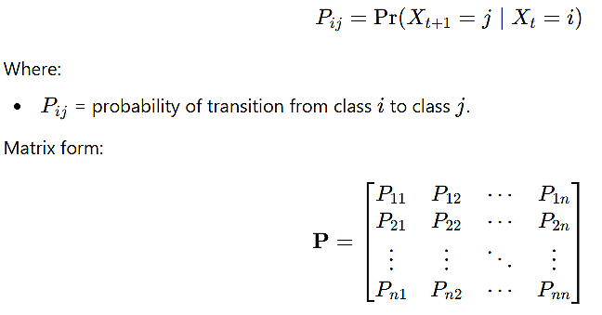
(B6)

To allocate these transitions spatially, transition potentials were generated using an Artificial Neural Network (ANN) trained on a stratified random sample of observed transitions. The ANN incorporated slope, elevation, distance-to-roads, and population density as predictor variables. Each hidden neuron was computed using the following equation
$$h_{k}=f\left(\sum_{m=1}^{M}{w_{km}x_{m}}+b_{k}\right)$$ | (B7)
and the final transition potential surface was produced a below:
$$TP=g\left(\sum_{k=1}^{K}{v_{k}h_{k}}+c\right)$$ | (B8)
where X_{m} denotes input variables, W_{km} and V_{k} are synaptic weights, and f(0) and g(0) denote activation functions. A 70/30 training–validation split was used to optimise model generalisation and prevent overfitting. Spatial allocation of transitions was conducted using a Cellular Automata (CA) model employing a 5×5 Moore neighbourhood to reproduce contiguity-driven urban growth. The CA update rule was defined as:
$$S_{t+1}\left(x,y\right)=\arg{\max_{j}\left[TP_{j}\left(x,y\right)+λN_{j}\left(x,y\right)\right]}$$ | (B9)
Appendix C: Population data
Table C1. The 2025 population and importance of the four cities.
City | Population 2025 in millions | Importance / Key Role
Riyadh | 7,9 | Capital city; administrative & political centre; largest city and economic core of the Kingdom
Jeddah | 5,6 | Major commercial hub; main Red Sea port; gateway for pilgrims to Makkah; second-largest urban centre in Saudi Arabia
Makkah (Mecca) | 2,2 | Holiest city in Islam; centre of annual pilgrimage (Hajj & Umrah); immense religious and cultural importance globally
Madinah (Medina) | 1,6 | Second-holiest city in Islam; important religious and historical centre; major destination for pilgrims and cultural heritage site
Appendix D: Kappa Validation for CA-Markov Model
Model performance was evaluated using a back-cast simulation, in which the model predicted the 2024 land-cover map from 2014 conditions. Comparison with the observed 2024 classification demonstrated strong agreement, as reflected in the overall, histogram, and location Kappa values reported in Table 5. These results confirm that the integrated ANN–CA–Markov configuration provides a robust and reliable basis for forecasting near-term built-up expansion under existing development trajectories.
Table D1. Kappa-based validation metrics for the CA–Markov model (2034 prediction)
City | Kappa (overall) | Kappa (histogram) | Kappa (location)
Riyadh | 0.68 | 0.71 | 0.90
Jeddah | 0.85 | 0.87 | 0.93
We Makkah | 0.61 | 0.63 | 0.90
Madinah | 0.72 | 0.74 | 0.92
Appendix E: Population Density Mapping
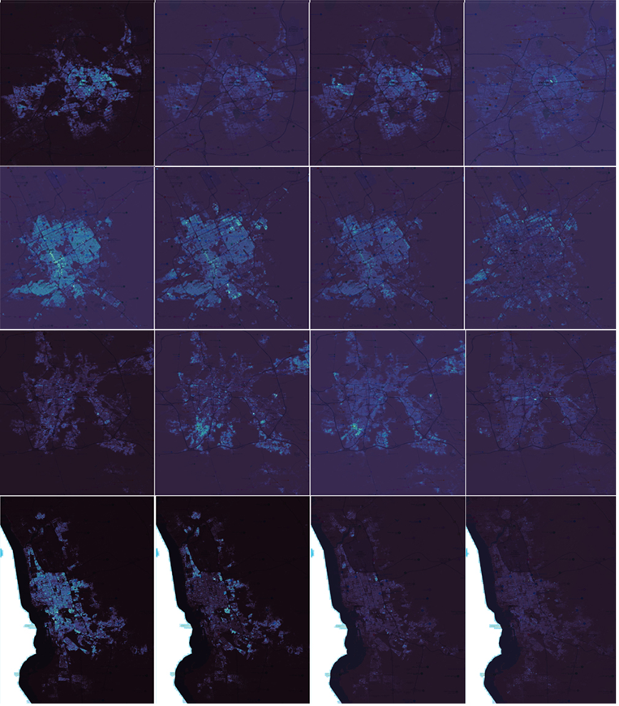
Figure E1. Decadal changes in population density derived from GHSL (1985–2025).Each column represents a decadal difference map from left to right (1985–1995), (1995–2005), (2005–2015), and (2015–2025). Rows correspond to the four study cities from top to bottom: Madinah, Riyadh, Makkah, and Jeddah. Brighter cyan values indicate areas of increasing population density, while darker purple tones represent stable or low-density regions.

