Supplementary Materials
Supplementary Table 1. Demographic and clinical characteristics of the total sample as well as test set and validation set sub-samples
Demographic characteristics (N=2420) | n (%)/ M (SD)
Demographic characteristics (N=2420) | Total sample | Train set (n=1210) | Test set (n=1210)
Age | 33.15 (9.38) | 33.27 (9.49) | 33.04 (9.27)
Social status | 5.63 (1.44) | 5.67 (1.41) | 5.58 (1.47)
Gender
Male | 395 (16.3%) | 194 (16.0%) | 201 (16.6%)
Female | 2025 (83.7%) | 1016 (84.0%) | 1009 (83.4%)
Education
High school/technical secondary school or below | 33 (1.4%) | 14 (1.2%) | 19 (1.6%)
Associate degree/Junior college | 200 (8.3%) | 96 (7.9%) | 104 (8.6%)
Bachelor degree | 1255 (51.9%) | 641 (53.0%) | 614 (50.7%)
Postgraduate degree | 932 (38.5%) | 459 (37.9%) | 473 (39.1%)
Ethnic
Han | 2291 (94.7%) | 1153 (95.3%) | 1138 (94.0%)
Other | 129 (5.3%) | 57 (4.7%) | 72 (6.0%)
Emotional disorders
Yes | 190 (7.9%) | 77 (6.4%) | 113 (9.3%)
No | 2230 (92.1%) | 1133 (93.6%) | 1097 (90.7%)
Psychotherapy
Yes | 216 (8.9%) | 99 (8.2%) | 117 (9.7%)
No | 2204 (91.1%) | 1111 (91.8%) | 1093 (90.3%)
Occupation
Student | 521 (21.5%) | 269 (22.2%) | 252 (20.8%)
Teacher | 367 (15.2%) | 179 (14.8%) | 188 (15.5%)
Other | 1532 (63.3%) | 762 (63.0%) | 770 (63.6%)
Kessler-10
Low (10–15) | 155 (6.4%) | 80 (6.6%) | 75 (6.2%)
Moderate (16–21) | 409 (16.9%) | 210 (17.4%) | 199 (16.4%)
High (22–29) | 860 (35.5%) | 448 (37.0%) | 412 (34.0%)
Very high (30–50) | 996 (41.2%) | 472 (39.0%) | 524 (43.3%)
Kessler-10_total | 27.39 (7.54) | 27.01 (7.40) | 27.78 (7.66)

Supplementary Table 2. Reliability and Validity Analysis of the Engaging in Life Scale (ELS-17)
Factor | α | ω | MR | CR | AVE
Work/Study | 0.87 | 0.88 | 0.89 | 0.90 | 0.65
Sleep routine | 0.91 | 0.91 | 0.89 | 0.93 | 0.78
Socializing | 0.88 | 0.88 | 0.87 | 0.91 | 0.71
Leisure | 0.83 | 0.84 | 0.85 | 0.87 | 0.64
MR: marginal reliability

Supplementary Table 3. Heterotrait-Monotrait Ratio of the Engaging in Life Scale (ELS-17)
 | Sleep routine | Work/Study | Socializing | Leisure
Sleep routine | 1 | 0.826 | 0.734 | 0.722
Work/Study | 0.826 | 1 | 0.798 | 0.731
Socializing | 0.734 | 0.798 | 1 | 0.668
Leisure | 0.722 | 0.731 | 0.668 | 1

Supplementary Table 4. The selection frequencies across runs via the ant colony optimization
Item | factor | frequency | loading
LES7 | Leisure | 8 | 0.797369126538397
LES8 | Leisure | 7 | 0.863334226657031
LES9 | Leisure | 3 | 0.648465789751429
LES11 | Leisure | 2 | 0.543827945285276
LES2 | Work/Study | 9 | 0.920447450361172
LES1 | Work/Study | 7 | 0.917408350898947
LES3 | Work/Study | 4 | 0.66892080331517
LES14 | Socializing | 10 | 0.747731474233018
LES15 | Socializing | 10 | 0.706897646553573
LES21 | Sleep routine | 10 | 0.776438825076789
LES20 | Sleep routine | 6 | 0.883091721614404
LES23 | Sleep routine | 4 | 0.691272399129521

Supplementary Table 5. Reliability and Validity Analysis of the ELS-8
Factor | α | ω | MR | CR | AVE
Leisure | 0.849 | 0.843 | 0.658 | 0.887 | 0.796
Work/Study | 0.875 | 0.868 | 0.674 | 0.911 | 0.837
Socializing | 0.874 | 0.877 | 0.687 | 0.918 | 0.848
Sleep routine | 0.788 | 0.800 | 0.733 | 0.843 | 0.731
MR：marginal reliability

Supplementary Table 6. Heterotrait-Monotrait Ratio of the Engaging in Life Scale (ELS-8)
 | Leisure | Work/Study | Socializing | Sleep routine
Leisure | 1 | 0.715 | 0.747 | 0.705
Work/Study | 0.715 | 1 | 0.676 | 0.671
Socializing | 0.747 | 0.676 | 1 | 0.695
Sleep routine | 0.705 | 0.671 | 0.695 | 1

Supplementary Table 7. Correlations between the ELS-8 scale and criterion-related variables.
 | LET | SWLS | WHO-5 | Kessler-10 | PSS-SF
Total | 0.463 *** | 0.490 *** | 0.592 *** | -0.694 *** | -0.631 ***
Work/Study | 0.366 *** | 0.430 *** | 0.503 *** | -0.597 *** | -0.565 ***
Socializing | 0.443 *** | 0.417 *** | 0.507 *** | -0.600 *** | -0.541 ***
Leisure | 0.398 *** | 0.410 *** | 0.506 *** | -0.561 *** | -0.499 ***
Sleep routine | 0.332 *** | 0.373 *** | 0.451 *** | -0.548 *** | -0.492 ***
Note: LET = Life Engagement Test; SWLS = Satisfaction With Life Scale; WHO-5 = World Health Organization Well-Being Index; Kessler-10 = Kessler Psychological Distress Scale; PSS-SF = The Short Form Perceived Stress Scale. *** p < .001.

Supplementary Table 8. English and Chinese versions of the Engaging in Life Scale-17 (ELS-17)
English Version: The following items assess how much your psychological or physical discomfort (e.g., tension, sadness, anger, stomach pain, dizziness) has affected your daily life over the past two weeks. Each item is rated on a five-point scale: 1 = Not at all true, 2 = Slightly true, 3 = Neutral, 4 = Mostly true, 5 = Completely true. Note: Please respond according to your actual experience. If you are unable to engage in certain activities for reasons unrelated to psychological or physical discomfort, select “Not at all true.”
Chinese Version: 以下题目旨在评估您的心理或身体不适感受对日常生活的影响程度（不适感受可能包括：紧张、低落、生气、胃痛、头晕等）。请根据您过去两周（14天）的主观体验作答。本量表采用 5 级评分：1 = 完全不符合，2 =不太符合，3 = 中立，4 = 比较符合，5 = 完全符合。注意：请完全依据题目的描述进行选择。例如，如果您无法投入学习或工作任务，但这一情况与心理或身体不适无关，请选择“完全不符合”。
English Version: 1. Psychological or physical discomfort makes me procrastinate or give up on work/study tasks. *
Chinese Version: 1.心理或身体上的不适使我拖延或放弃工作/学习任务。*
English Version: 2. Psychological or physical discomfort makes it hard to focus on current work/study tasks. *
Chinese Version: 2. 心理或身体上的不适导致我难以将注意投入到正在进行的工作/学习任务中。*
English Version: 3. I spend excessive time managing psychological or physical discomfort, forcing me to reduce work/study commitments. *
Chinese Version: 3. 我需要花很多时间处理心理或身体上的不适，因而不得不减少工作/学习的安排。*
English Version: 4. I frequently pause/interrupt work/study due to psychological or physical fluctuations. *
Chinese Version: 4. 我因为心理或身体感受的波动而需要频繁暂停或中断我的工作/学习。*
English Version: 5. Psychological or physical discomfort makes it hard to initiate physical activities/hobbies (walking, chores, sports, movies, travel). *
Chinese Version: 5. 心理或身体上的不适使我难以开始身体活动/兴趣爱好（步行、做家务、运动健身、看电影、旅行等）。*
English Version: 6. Psychological or physical discomfort makes it difficult for me to focus on ongoing physical activities/hobbies. *
Chinese Version: 6. 心理或身体上的不适导致我难以将注意投入到正在进行的身体活动或兴趣爱好中。*
English Version: 7. I need to spend considerable time addressing psychological or physical discomfort, which forces me to reduce engagement in physical activities or hobbies. *
Chinese Version: 7.我需要花很多时间处理心理或身体上的不适，因而不得不减少身体活动或兴趣爱好的安排。*
English Version: 8. I often interrupt physical activities/hobbies due to psychological or physical fluctuations. *
Chinese Version: 8. 我因为心理或身体感受的波动而常常需要中断身体活动或兴趣爱好活动。*
English Version: 9. I can devote sufficient time/energy to physical activities/hobbies.
Chinese Version: 9. 我能够投入对我来说足够的时间精力在身体活动或兴趣爱好上。
English Version: 10. Psychological or physical discomfort affects my normal social interactions. *
Chinese Version: 10. 心理或身体上的不适影响我正常与他人互动。*
English Version: 11. Psychological or physical discomfort makes it hard to focus during social activities. *
Chinese Version: 11. 心理或身体上的不适导致我难以将注意投入到正在进行的社交活动中。*
English Version: 12. Managing psychological or physical discomfort requires so much time that I must reduce social interactions. *
Chinese Version: 12. 我需要花很多时间处理心理或身体上的不适，因而不得不减少与他人的互动。*
English Version: 13. I frequently pause/leave social interactions due to psychological or physical fluctuations. *
Chinese Version: 13. 我因为心理或身体感受的波动而经常在与人互动的过程中中途停下或离开。*
English Version: 14. Psychological or physical discomfort affects my sleep routine. *
Chinese Version: 14. 心理或身体上的不适影响我的作息。*
English Version: 15. Psychological or physical discomfort draws my attention to bodily sensations when trying to sleep. *
Chinese Version: 15. 心理或身体上的不适导致我在尝试入睡时将注意投入到不适感上。*
English Version: 16. Managing psychological or physical discomfort prevents me from maintaining a regular sleep schedule. *
Chinese Version: 16. 我需要花很多时间处理心理和身体上的不适，导致我无法维持合理的作息。*
English Version: 17. Psychological or physical fluctuations cause frequent delays in bedtime/wake-up times. *
Chinese Version: 17. 心理或身体感受的波动导致我经常推迟睡觉和起床的时间。*
*Indicates reverse-scored items.

Supplementary Table 9. English and Chinese versions of the Engaging in Life Scale-8 (ELS-8)
English Version: The following items assess how much your psychological or physical discomfort (e.g., tension, sadness, anger, stomach pain, dizziness) has affected your daily life over the past two weeks. Each item is rated on a five-point scale: 1 = Not at all true, 2 = Slightly true, 3 = Neutral, 4 = Mostly true, 5 = Completely true. Note: Please respond according to your actual experience. If you are unable to engage in certain activities for reasons unrelated to psychological or physical discomfort, select “Not at all true.”
Chinese Version: 以下题目旨在评估您的心理或身体不适感受对日常生活的影响程度（不适感受可能包括：紧张、低落、生气、胃痛、头晕等）。请根据您过去两周（14天）的主观体验作答。本量表采用 5 级评分：1 = 完全不符合，2 =不太符合，3 = 中立，4 = 比较符合，5 = 完全符合。注意：请完全依据题目的描述进行选择。例如，如果您无法投入学习或工作任务，但这一情况与心理或身体不适无关，请选择“完全不符合”。
English Version: 1. Psychological or physical discomfort makes me procrastinate or give up on work/study tasks. *
Chinese Version: 1.心理或身体上的不适使我拖延或放弃工作/学习任务。*
English Version: 2. Psychological or physical discomfort makes it hard to focus on current work/study tasks. *
Chinese Version: 2. 心理或身体上的不适导致我难以将注意投入到正在进行的工作/学习任务中。*
English Version: 3. Psychological or physical discomfort makes it hard to initiate physical activities/hobbies (walking, chores, sports, movies, travel). *
Chinese Version: 3. 心理或身体上的不适使我难以开始身体活动/兴趣爱好（步行、做家务、运动健身、看电影、旅行等）。*
English Version: 4. Psychological or physical discomfort makes it difficult for me to focus on ongoing physical activities/hobbies. *
Chinese Version: 4. 心理或身体上的不适导致我难以将注意投入到正在进行的身体活动或兴趣爱好中。*
English Version: 5. Psychological or physical discomfort makes it hard to focus during social activities. *
Chinese Version: 5. 心理或身体上的不适导致我难以将注意投入到正在进行的社交活动中。*
English Version: 6. Managing psychological or physical discomfort requires so much time that I must reduce social interactions. *
Chinese Version: 6. 我需要花很多时间处理心理或身体上的不适，因而不得不减少与他人的互动。*
English Version: 7. Psychological or physical discomfort draws my attention to bodily sensations when trying to sleep. *
Chinese Version: 7. 心理或身体上的不适导致我在尝试入睡时将注意投入到不适感上。*
English Version: 8. Managing psychological or physical discomfort prevents me from maintaining a regular sleep schedule. *
Chinese Version: 8. 我需要花很多时间处理心理和身体上的不适，导致我无法维持合理的作息。*
*Indicates reverse-scored items.

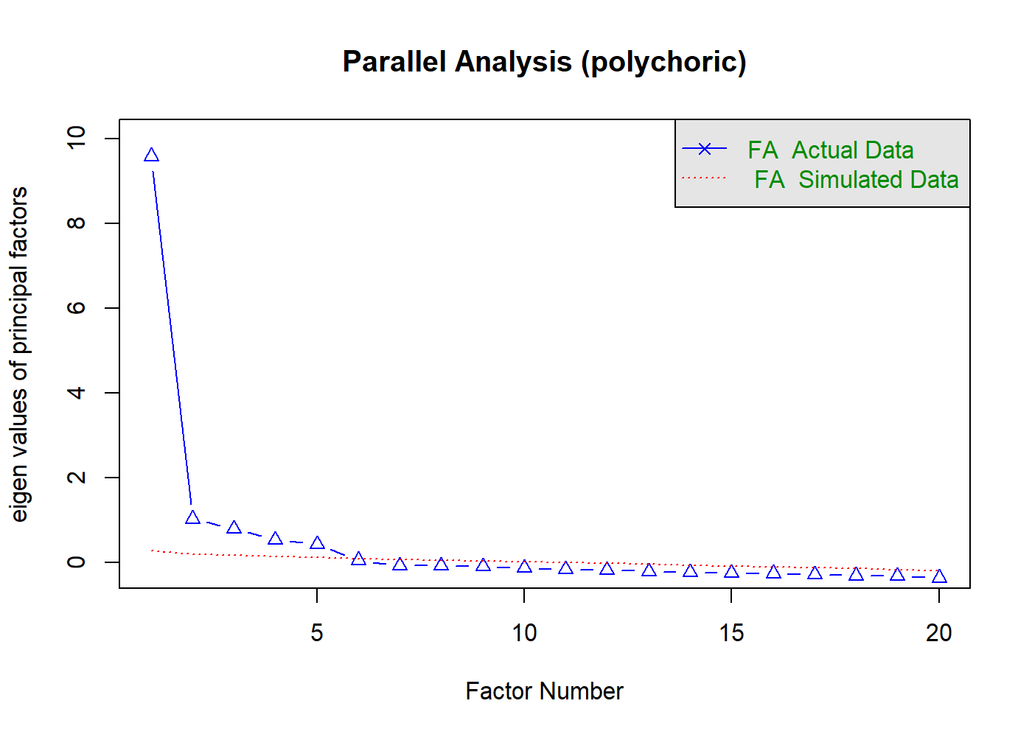
Supplementary Figure 1. Results of the Parallel Analysis (Polychoric Correlations)

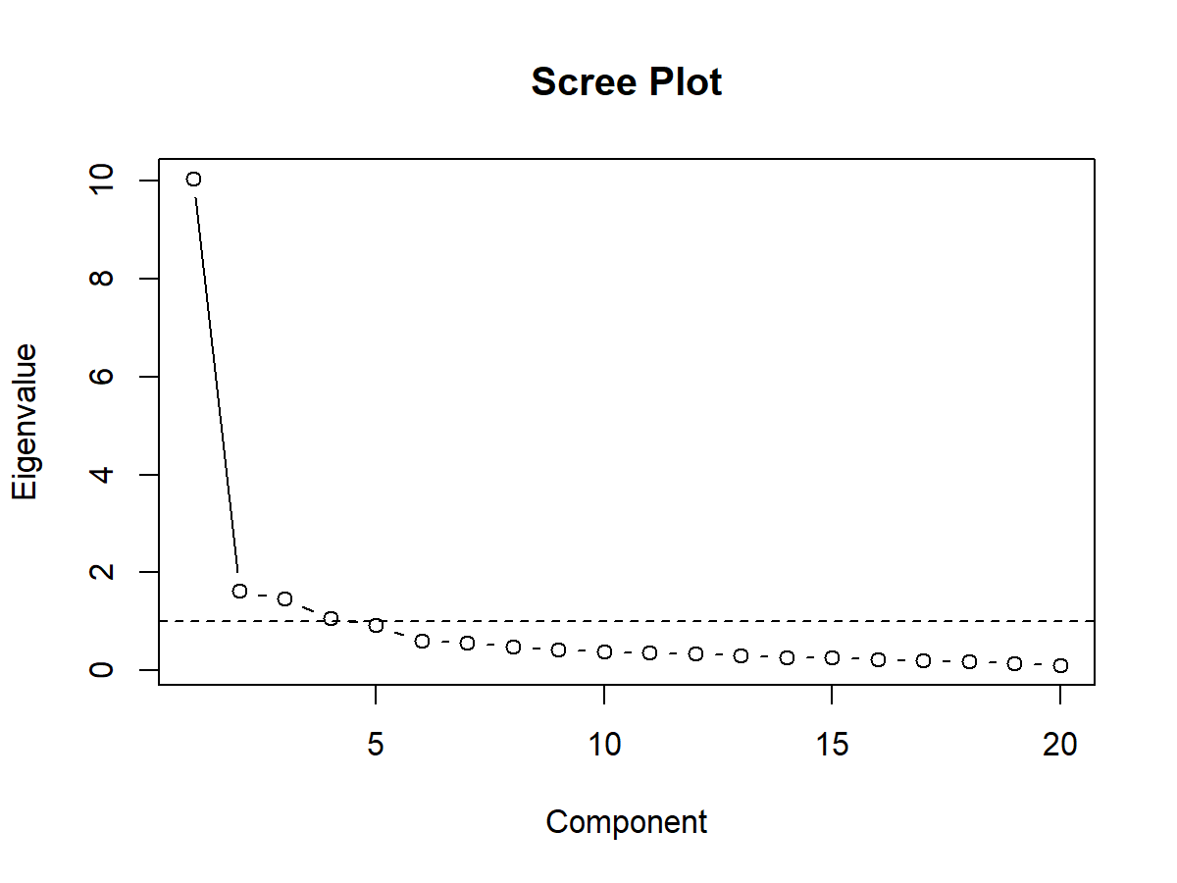
Supplementary Figure 2. Scree Plot of Eigenvalues for Principal Component Analysis

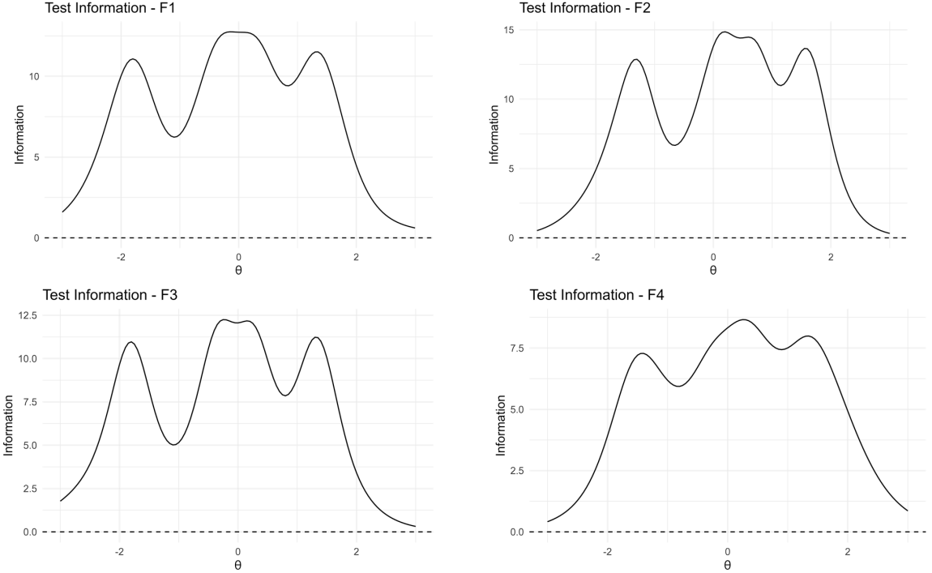
Supplementary Figure 3. Test information curves for the four factors of the long-form Engaging in Life Scale (ELS-17)

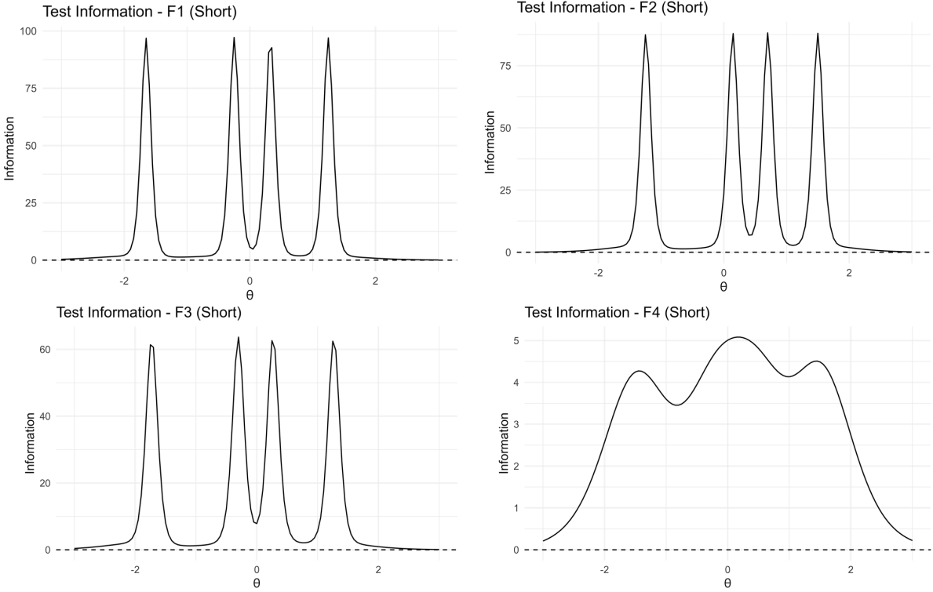
Supplementary Figure 4. Test information curves for the four factors of the short-form Engaging in Life Scale (ELS-8)

Supplementary Methods: Ant Colony Optimization (ACO)
The ant colony optimization (ACO) algorithm is a probabilistic, population-based metaheuristic inspired by the foraging behavior of real ants. In nature, ants collectively discover the shortest path between their nest and a food source by depositing and following pheromone trails: paths leading to food more efficiently receive stronger pheromone reinforcement, increasing the likelihood that subsequent ants will follow the same route.
In the context of psychometric scale reduction, this principle is applied to identify the optimal subset of items from a larger item pool. Each “ant” probabilistically selects a series of items to form a candidate path—that is, a possible short-form version of the scale. The psychometric performance of each candidate path is then evaluated against predefined fitness criteria, such as model fit, reliability, and validity. Paths with better overall performance are assigned higher pheromone values, increasing their probability of being selected in subsequent iterations. Through this iterative process of exploration and exploitation, the algorithm gradually converges toward a subset of items that provides the most favorable balance of psychometric properties (Leite et al., 2008; Schroeders et al., 2016).
Compared with traditional item-reduction methods that typically rely on fixed thresholds or factor loadings and often overlook inter-item dependencies, ACO allows for simultaneous multidimensional optimization. It integrates multiple psychometric
targets—such as structural validity, internal consistency, and criterion-related associations—within a single adaptive search process. This feature substantially enhances the likelihood of generating a short form that is both psychometrically robust and theoretically representative, while minimizing information loss (Olaru et al., 2019).

References
Leite, W. L., Huang, I.-C., & Marcoulides, G. A. (2008). Item selection for the development of short forms of scales using an ant colony optimization algorithm. Multivariate Behavioral Research, 43(3), 411-431.
Olaru, G., Schroeders, U., Hartung, J., & Wilhelm, O. (2019). Ant Colony Optimization and Local Weighted Structural Equation Modeling. A Tutorial on Novel Item and Person Sampling Procedures for Personality Research. European Journal of Personality, 33(3), 400-419. https://doi.org/10.1002/per.2195
Schroeders, U., Wilhelm, O., & Olaru, G. (2016). Meta-heuristics in short scale construction: Ant colony optimization and genetic algorithm. PloS one, 11(11), e0167110.

