Supplementary Materials
Supplementary Table 1. Demographic and clinical characteristics of the total sample as well as test set and validation set sub-samples
Demographic characteristics (N=2420) | n (%)/ M (SD)
Demographic characteristics (N=2420) | Total sample | Train set (n=1210) | Test set (n=1210)
Age | 33.15 (9.38) | 33.27 (9.49) | 33.04 (9.27)
Social status | 5.63 (1.44) | 5.67 (1.41) | 5.58 (1.47)
Gender
Male | 395 (16.3%) | 194 (16.0%) | 201 (16.6%)
Female | 2025 (83.7%) | 1016 (84.0%) | 1009 (83.4%)
Education
High school/technical secondary school or below | 33 (1.4%) | 14 (1.2%) | 19 (1.6%)
Associate degree/Junior college | 200 (8.3%) | 96 (7.9%) | 104 (8.6%)
Bachelor degree | 1255 (51.9%) | 641 (53.0%) | 614 (50.7%)
Postgraduate degree | 932 (38.5%) | 459 (37.9%) | 473 (39.1%)
Ethnic
Han | 2291 (94.7%) | 1153 (95.3%) | 1138 (94.0%)
Other | 129 (5.3%) | 57 (4.7%) | 72 (6.0%)
Emotional disorders
Yes | 190 (7.9%) | 77 (6.4%) | 113 (9.3%)
No | 2230 (92.1%) | 1133 (93.6%) | 1097 (90.7%)
Psychotherapy
Yes | 216 (8.9%) | 99 (8.2%) | 117 (9.7%)
No | 2204 (91.1%) | 1111 (91.8%) | 1093 (90.3%)
Occupation
Student | 521 (21.5%) | 269 (22.2%) | 252 (20.8%)
Teacher | 367 (15.2%) | 179 (14.8%) | 188 (15.5%)
Other | 1532 (63.3%) | 762 (63.0%) | 770 (63.6%)
Kessler-10
Low (10–15) | 155 (6.4%) | 80 (6.6%) | 75 (6.2%)
Moderate (16–21) | 409 (16.9%) | 210 (17.4%) | 199 (16.4%)
High (22–29) | 860 (35.5%) | 448 (37.0%) | 412 (34.0%)
Very high (30–50) | 996 (41.2%) | 472 (39.0%) | 524 (43.3%)
Kessler-10_total | 27.39 (7.54) | 27.01 (7.40) | 27.78 (7.66)

Supplementary Table 2. Reliability and Validity Analysis of the Engaging in Life Scale (ELS-17)
Factor | α | ω | MR | CR | AVE
Work/Study | 0.87 | 0.88 | 0.89 | 0.90 | 0.65
Sleep routine | 0.91 | 0.91 | 0.89 | 0.93 | 0.78
Socializing | 0.88 | 0.88 | 0.87 | 0.91 | 0.71
Leisure | 0.83 | 0.84 | 0.85 | 0.87 | 0.64
MR: marginal reliability

Supplementary Table 3. Heterotrait-Monotrait Ratio of the Engaging in Life Scale (ELS-17)
 | Sleep routine | Work/Study | Socializing | Leisure
Sleep routine | 1 | 0.826 | 0.734 | 0.722
Work/Study | 0.826 | 1 | 0.798 | 0.731
Socializing | 0.734 | 0.798 | 1 | 0.668
Leisure | 0.722 | 0.731 | 0.668 | 1

Supplementary Table 4. The selection frequencies across runs via the ant colony optimization
Item | factor | frequency | loading
LES7 | Leisure | 8 | 0.797369126538397
LES8 | Leisure | 7 | 0.863334226657031
LES9 | Leisure | 3 | 0.648465789751429
LES11 | Leisure | 2 | 0.543827945285276
LES2 | Work/Study | 9 | 0.920447450361172
LES1 | Work/Study | 7 | 0.917408350898947
LES3 | Work/Study | 4 | 0.66892080331517
LES14 | Socializing | 10 | 0.747731474233018
LES15 | Socializing | 10 | 0.706897646553573
LES21 | Sleep routine | 10 | 0.776438825076789
LES20 | Sleep routine | 6 | 0.883091721614404
LES23 | Sleep routine | 4 | 0.691272399129521

Supplementary Table 5. Reliability and Validity Analysis of the ELS-8
Factor | α | ω | MR | CR | AVE
Leisure | 0.849 | 0.843 | 0.658 | 0.887 | 0.796
Work/Study | 0.875 | 0.868 | 0.674 | 0.911 | 0.837
Socializing | 0.874 | 0.877 | 0.687 | 0.918 | 0.848
Sleep routine | 0.788 | 0.800 | 0.733 | 0.843 | 0.731
MR：marginal reliability

Supplementary Table 6. Heterotrait-Monotrait Ratio of the Engaging in Life Scale (ELS-8)
 | Leisure | Work/Study | Socializing | Sleep routine
Leisure | 1 | 0.715 | 0.747 | 0.705
Work/Study | 0.715 | 1 | 0.676 | 0.671
Socializing | 0.747 | 0.676 | 1 | 0.695
Sleep routine | 0.705 | 0.671 | 0.695 | 1

Supplementary Table 7. Correlations between the ELS-8 scale and criterion-related variables.
 | LET | SWLS | WHO-5 | Kessler-10 | PSS-SF
Total | 0.463 *** | 0.490 *** | 0.592 *** | -0.694 *** | -0.631 ***
Work/Study | 0.366 *** | 0.430 *** | 0.503 *** | -0.597 *** | -0.565 ***
Socializing | 0.443 *** | 0.417 *** | 0.507 *** | -0.600 *** | -0.541 ***
Leisure | 0.398 *** | 0.410 *** | 0.506 *** | -0.561 *** | -0.499 ***
Sleep routine | 0.332 *** | 0.373 *** | 0.451 *** | -0.548 *** | -0.492 ***
Note: LET = Life Engagement Test; SWLS = Satisfaction With Life Scale; WHO-5 = World Health Organization Well-Being Index; Kessler-10 = Kessler Psychological Distress Scale; PSS-SF = The Short Form Perceived Stress Scale. *** p < .001.

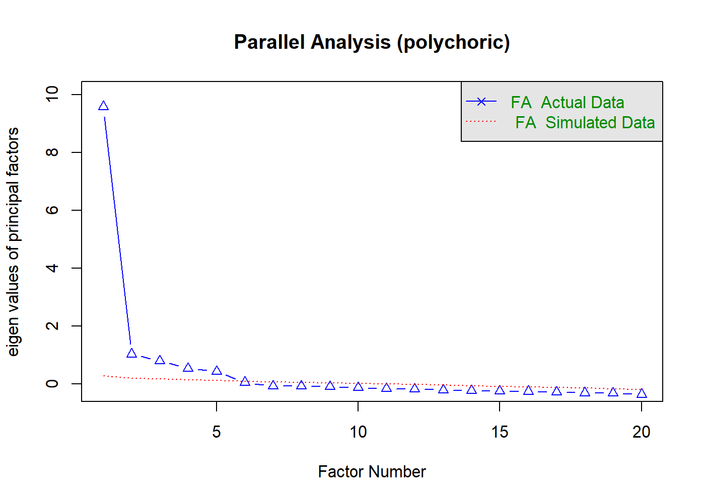
Supplementary Figure 1. Results of the Parallel Analysis (Polychoric Correlations)

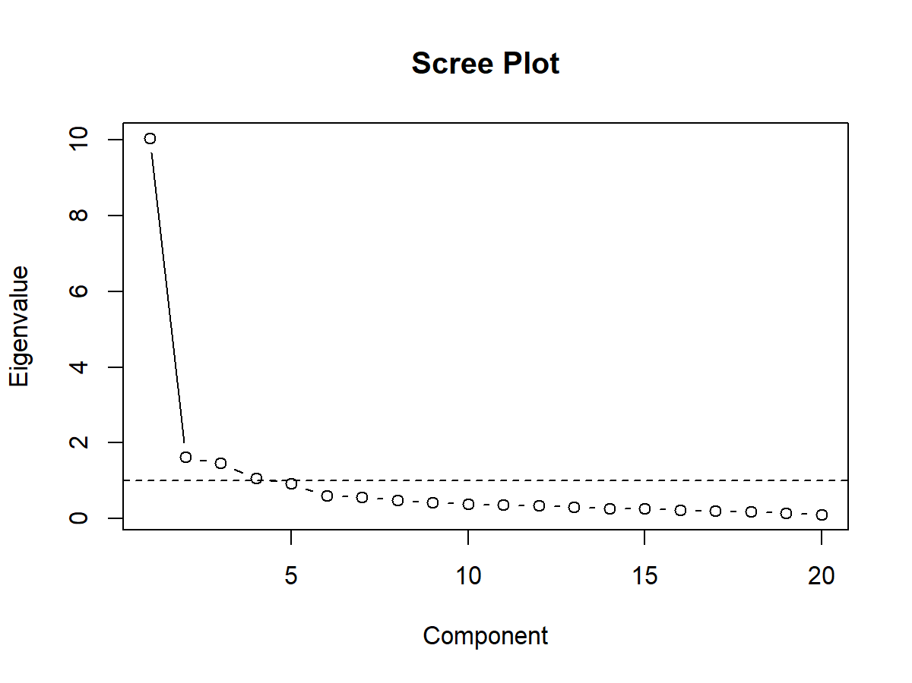
Supplementary Figure 2. Scree Plot of Eigenvalues for Principal Component Analysis

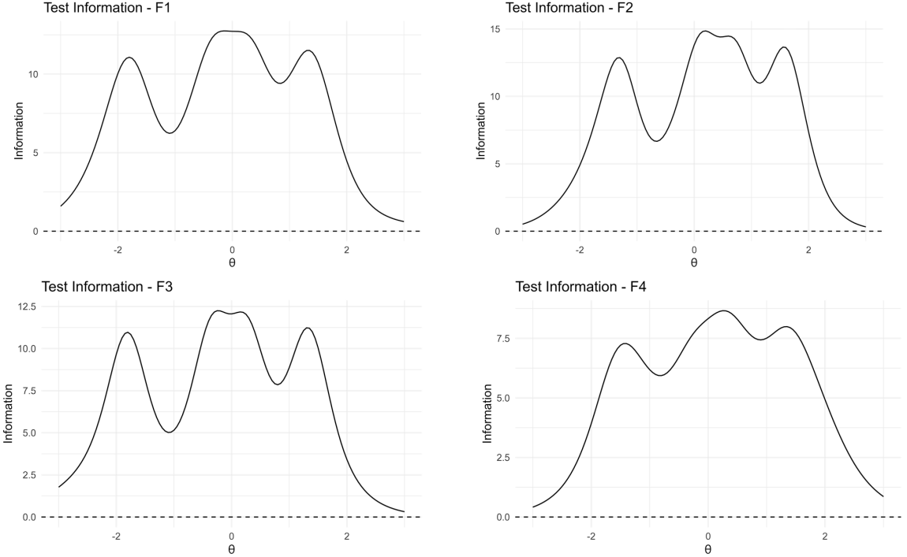
Supplementary Figure 3. Test information curves for the four factors of the long-form Engaging in Life Scale (ELS-17)

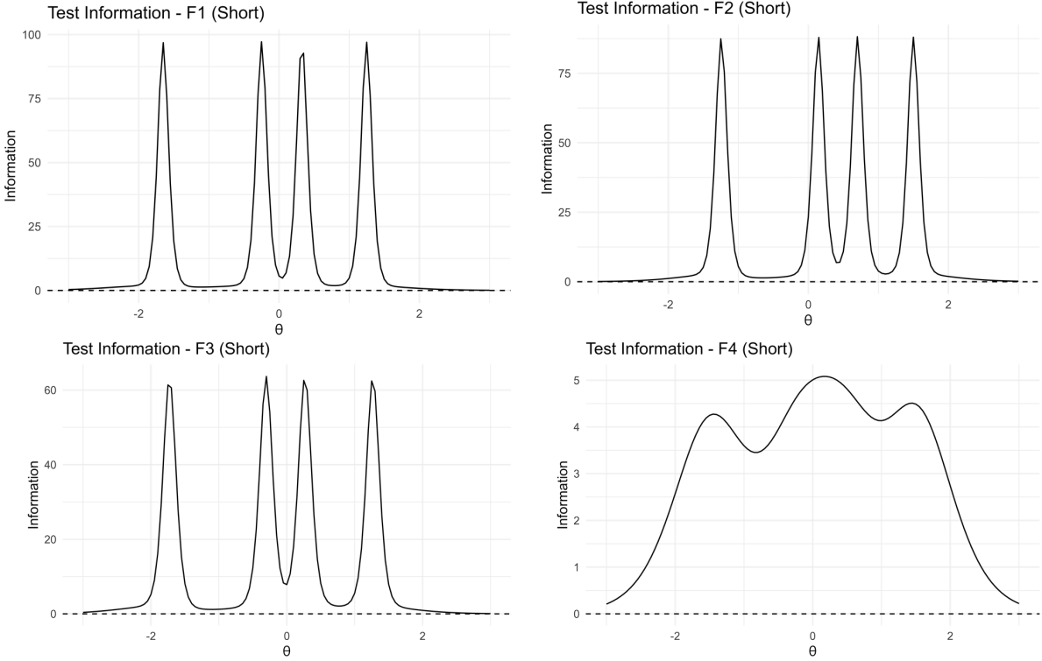
Supplementary Figure 4. Test information curves for the four factors of the short-form Engaging in Life Scale (ELS-8)

Supplementary Methods: Ant Colony Optimization (ACO)
The ant colony optimization (ACO) algorithm is a probabilistic, population-based metaheuristic inspired by the foraging behavior of real ants. In nature, ants collectively discover the shortest path between their nest and a food source by depositing and following pheromone trails: paths leading to food more efficiently receive stronger pheromone reinforcement, increasing the likelihood that subsequent ants will follow the same route.
In the context of psychometric scale reduction, this principle is applied to identify the optimal subset of items from a larger item pool. Each “ant” probabilistically selects a series of items to form a candidate path—that is, a possible short-form version of the scale. The psychometric performance of each candidate path is then evaluated against predefined fitness criteria, such as model fit, reliability, and validity. Paths with better overall performance are assigned higher pheromone values, increasing their probability of being selected in subsequent iterations. Through this iterative process of exploration and exploitation, the algorithm gradually converges toward a subset of items that provides the most favorable balance of psychometric properties (Leite et al., 2008; Schroeders et al., 2016).
Compared with traditional item-reduction methods that typically rely on fixed thresholds or factor loadings and often overlook inter-item dependencies, ACO allows for simultaneous multidimensional optimization. It integrates multiple psychometric
targets—such as structural validity, internal consistency, and criterion-related associations—within a single adaptive search process. This feature substantially enhances the likelihood of generating a short form that is both psychometrically robust and theoretically representative, while minimizing information loss (Olaru et al., 2019).

References
Leite, W. L., Huang, I.-C., & Marcoulides, G. A. (2008). Item selection for the development of short forms of scales using an ant colony optimization algorithm. Multivariate Behavioral Research, 43(3), 411-431.
Olaru, G., Schroeders, U., Hartung, J., & Wilhelm, O. (2019). Ant Colony Optimization and Local Weighted Structural Equation Modeling. A Tutorial on Novel Item and Person Sampling Procedures for Personality Research. European Journal of Personality, 33(3), 400-419. https://doi.org/10.1002/per.2195
Schroeders, U., Wilhelm, O., & Olaru, G. (2016). Meta-heuristics in short scale construction: Ant colony optimization and genetic algorithm. PloS one, 11(11), e0167110.

