Table 3: Synthesis of 2-amino-4H- pyran derivates ª

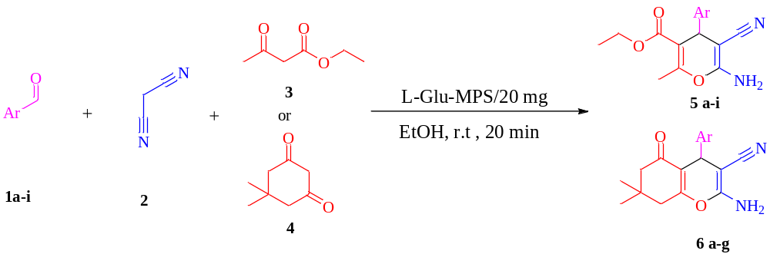
Yield ^{b} | M.P (^{O}C) ^{[Ref]} | (min) Time | Structure | Product | Entry
96 | ⁽⁴⁰⁾175-177 | 25 | 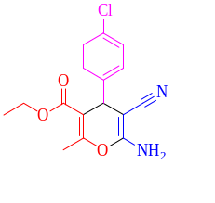 | 5a | 1
97 | ⁽⁴⁰⁾173-175 | 35 | 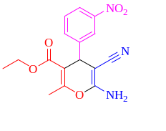 | 5b | 2
98 | ⁽⁴⁰⁾190-188 | 30 | 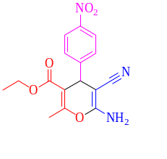 | 5c | 3
95 | ⁽⁴¹⁾132-130 | 30 | 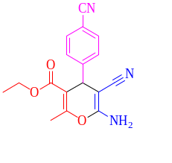 | 5d | 4
96 | ⁽⁴⁰⁾134-132 | 25 | 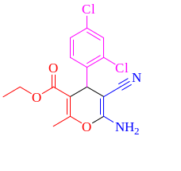 | 5e | 5
97 | ⁽⁴⁰⁾192-188 | 40 | 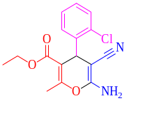 | 5f | 6
98 | ⁽⁴²⁾136-134 | 25 | 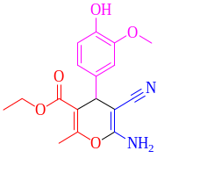 | 5g | 7
90 | ⁽⁴²⁾192-190 | 30 | 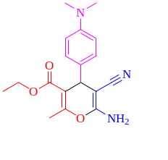 | 5h | 8
96 | ⁽⁴³⁾170-168 | 25 | 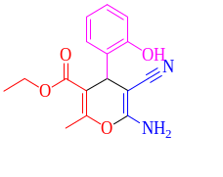 | 5i | 9
95 | ⁽³²⁾229-227 | 25 | 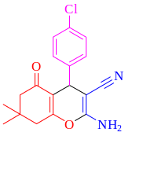 | 6a | 10
90 | ⁽³¹⁾210-208 | 10 | 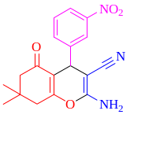 | 6b | 11
96 | ⁽³²⁾191-189 | 30 | 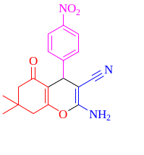 | 6c | 12
88 | ⁽³²⁾139-137 | 40 | 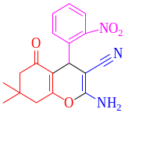 | 6d | 13
98 | ⁽³²⁾120-118 | 25 | 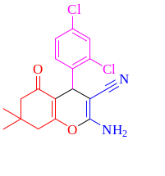 | 6e | 14
94 | ⁽³²⁾242-240 | 25 | 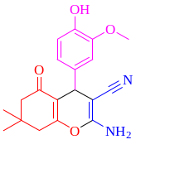 | 6f | 15
96 | ⁽⁴⁴⁾230-228 | 25 | 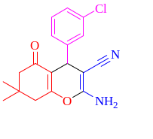 | 6g | 16
^{a:} Aldehydes (1 mmol), dimedone (1 mmol), and ethyl acetoacetate (1 mmol), in the presence of the L-Glu-MPS (20 mg) in EtOH (10ml). ^{b} Isolated yield,

