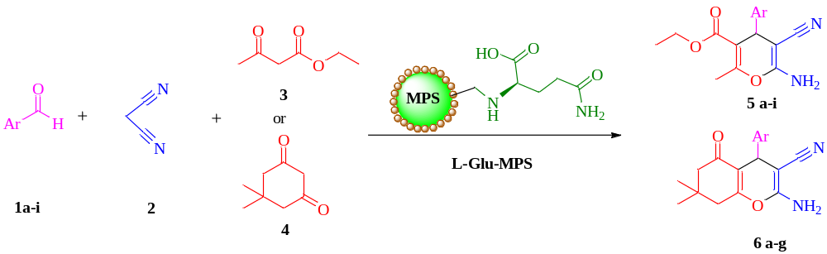
Scheme 1: Synthesis of 2-amino-4H-pyran with nanocatalyst L-Glu-MPS
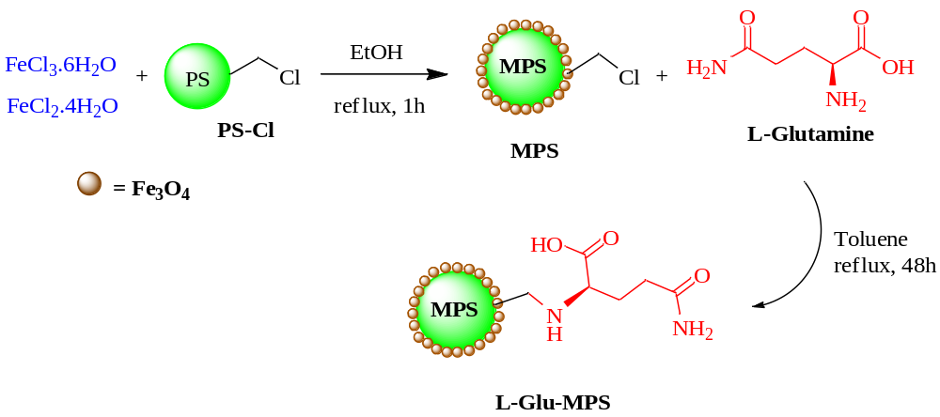

Scheme 2: Synthesis of L-Glu-MPS nanocatalyst
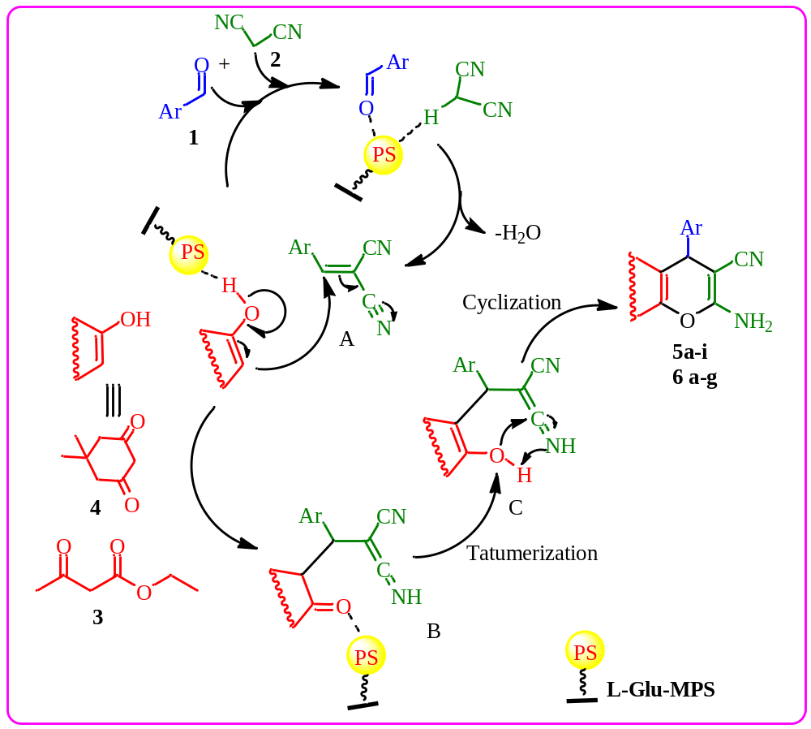
Scheme 3: A plausible mechanism of synthesis of 2-amino-4H-pyran

