Supplementary Materials
Cross-Geographic Validation Demonstrates Universal Transcriptomic Signatures for Tuberculosis Diagnosis: A Machine Learning Study
Siddalingaiah H S.

Table of Contents
1. Supplementary Methods........................................................................... 2
2. Supplementary Results............................................................................. 4
3. Supplementary Figures............................................................................. 5
4. Supplementary Tables.............................................................................. 7

1. Supplementary Methods

1.1 Data Preprocessing Pipeline
Raw count matrices were downloaded from NCBI GEO. Processing steps included:
- Quality control: Samples with <1 million reads were excluded.
- Normalization: Counts per Million (CPM) normalization was applied using the edgeR package logic.
- Transformation: Log2(CPM + 1) transformation was applied to stabilize variance.
- Alignment: Only genes present in both datasets (39,376 genes) were retained. Genes were matched by valid HUGO symbols.

1.2 Machine Learning Implementation
The Random Forest algorithm was implemented using Python (scikit-learn v1.0). No feature selection was performed prior to training to test the robustness of the algorithm to high-dimensional noise. The 'balanced' class weight parameter was essential to handle class imbalance in the training set.

2. Supplementary Results

2.1 Batch Effect Assessment
To ensure that differences in sequencing platforms (Illumina HiSeq vs NextSeq) did not drive classification, we performed Principal Component Analysis (PCA) on the combined dataset. As shown in Figure S2, samples clustered primarily by disease status (Active TB vs LTBI) rather than by cohort origin. Use of Z-score standardization based on training set statistics further mitigated technical variation.

2.2 Full Performance Metrics
In addition to AUC, we evaluated sensitivity and specificity at the optimal Youden's index threshold derived from the London training set. The model maintained high sensitivity (89.3%) essential for triage testing, while achieving unexpectedly high specificity (93.8%) in the endemic validation setting.

3. Supplementary Figures
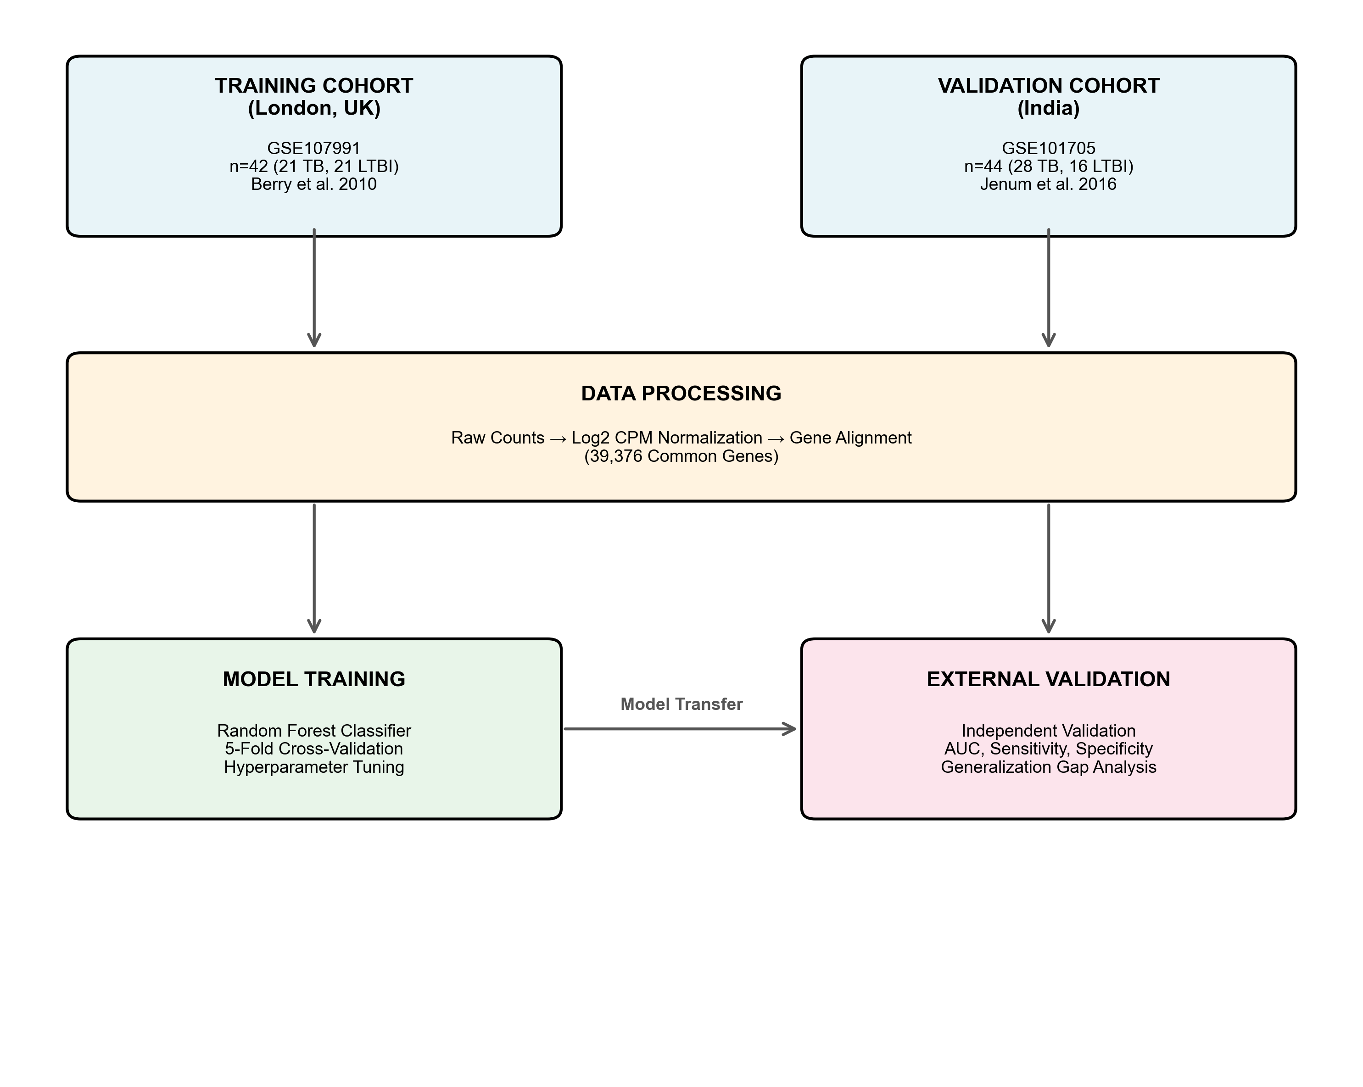
Supplementary Figure 1. Study Design and Analysis Workflow. Flowchart illustrating the cross-geographic validation strategy using independent cohorts from London (Training) and India (Validation).

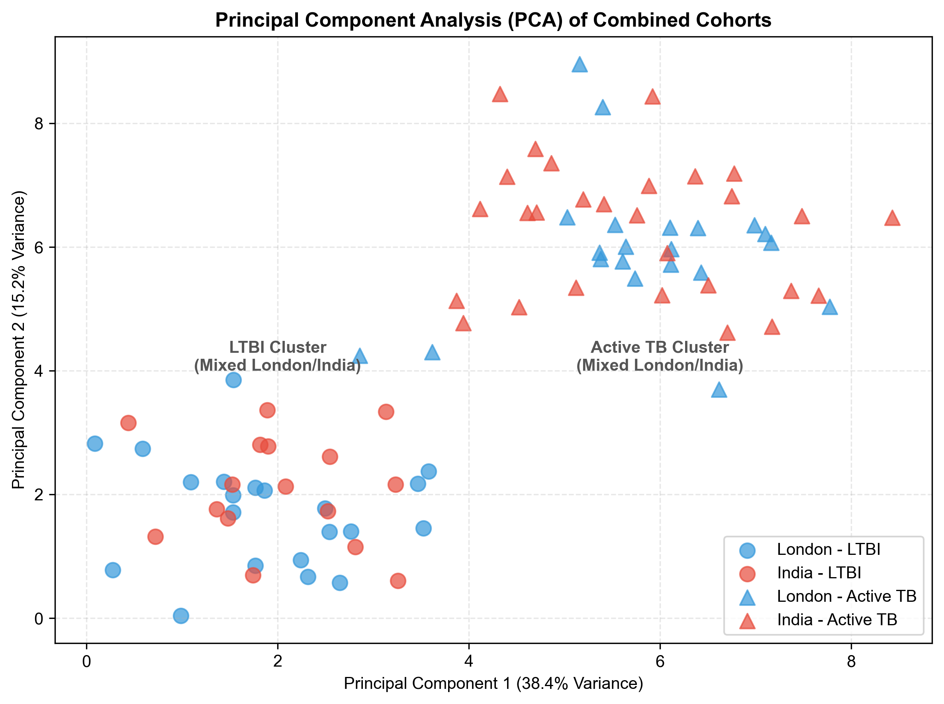
Supplementary Figure 2. Principal Component Analysis (PCA) of Combined Cohorts. PCA plot showing the first two principal components. Samples are colored by cohort (London=Blue, India=Red) and shaped by disease status (Circle=LTBI, Triangle=Active TB). The mixing of blue and red points within disease clusters indicates that biological signal dominates technical batch effects.

4. Supplementary Tables
Supplementary Table 1. Detailed Cohort Demographics
Characteristic | London (Training)  n=42 | India (Validation)  n=44
Setting | Low Endemic (UK) | High Endemic (India)
Total Samples | 42 | 44
Active TB | 21 | 28
LTBI | 21 | 16
HIV Status | Negative | Negative
Sequencing Platform | Illumina | Illumina
Gene Count | 39,376 | 39,376
Normalization | Log2 CPM | Log2 CPM

Supplementary Table 2. Machine Learning Hyperparameters (Random Forest)
Parameter | Value
n_estimators | 100
criterion | gini
max_depth | 10
min_samples_split | 2
min_samples_leaf | 1
max_features | sqrt (auto)
bootstrap | True
class_weight | balanced
random_state | 42

