Supplementary Material
S1. Detailed Behavioral Task Procedures
S1.1 Working Memory (N-back) Task
Each condition (1-back and 2-back) consisted of 3 separate blocks, totaling 6 blocks. The order of the conditions was counterbalanced across participants to control for order effects. Each block contained a sequence of 27 trials, among which 9 were pre-determined targets (i.e., matching stimuli), resulting in a target probability of 33.3%. Each trial began with a fixation cross ("+") displayed for 500 ms, followed by the digit stimulus presented for 2000 ms. The inter-stimulus interval (ISI) was 0 ms, meaning the next trial commenced immediately after the stimulus offset. A rest period of 20,000 ms was provided between blocks, and participants could initiate the next block by pressing the spacebar.

S1.2 Sustained Attention (VCPT) Task
During the test, the letters A, B, C, D, E, F, G, H, I, J, O, and X were presented randomly on a computer screen. The participants were instructed to press the spacebar when they saw the letter X followed by the letter O. A total of 240 letters were displayed, including 24 target O-X sequences. Each letter was presented for 200 ms, with a 1300-ms inter-stimulus interval. Subjects were instructed to respond as quickly and accurately as possible.

Table S1: Brain regions with significant differences in dALFF, dfALFF, and dReHo between pre- and post-decaffeinated coffee (window size = 60 TRs).
Index | Brain Region(AAL) | Cluster size (mm³) | Peak MNI coordinate |  |  | Peak t-value
Index | Brain Region(AAL) | Cluster size (mm³) | X | Y | Z | Peak t-value
dALFF
 | Left fusiform gyrus | 1863 | -27 | -81 | -18 | -4.326
 | Bilateral supplementary motor area | 1836 | -3 | 0 | 51 | 4.302
dReHo
 | Bilateral supplementary motor area | 2052 | 3 | -12 | 51 | 4.529
Abbreviations: AAL, automated anatomical labelling atlas; MNI: Montreal Neurological Institute. dALFF, dynamic amplitude of low-frequency fluctuations; dReHo, dynamic regional homogeneity;

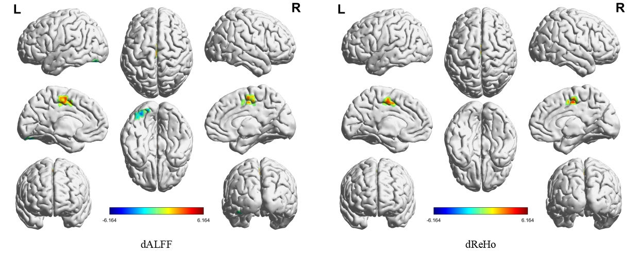
Figure S1: Brain regions with significant differences in dALFF and dReHo between pre- and post-decaffeinated coffee (window size = 60 TRs). Abbreviations: dALFF, dynamic amplitude of low-frequency fluctuations; dReHo, dynamic regional homogeneity.

Table S2: Brain regions with significant differences in dALFF, dfALFF, and dReHo between pre- and post-decaffeinated coffee (window size = 80 TRs).
Index | Brain Region(AAL) | Cluster size (mm³) | Peak MNI coordinate |  |  | Peak t-value
Index | Brain Region(AAL) | Cluster size (mm³) | X | Y | Z | Peak t-value
dALFF
 | Left fusiform gyrus | 2673 | -27 | -81 | -18 | -4.821
 | Bilateral supplementary motor area | 1998 | -3 | 0 | 51 | 4.390
dReHo
 | Bilateral supplementary motor area | 2160 | 3 | -12 | 51 | 4.425
Abbreviations: AAL, automated anatomical labelling atlas; MNI: Montreal Neurological Institute. dALFF, dynamic amplitude of low-frequency fluctuations; dReHo, dynamic regional homogeneity.

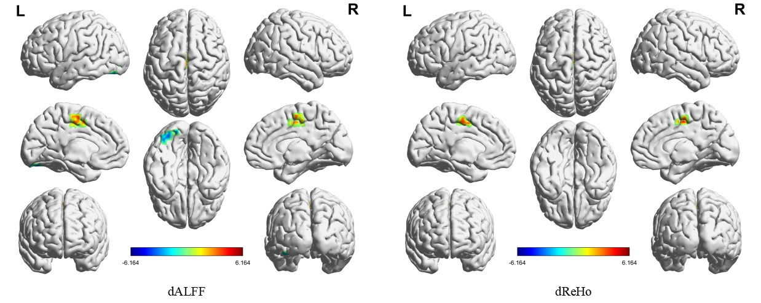
Figure S2: Brain regions with significant differences in dALFF and dReHo between pre- and post-decaffeinated coffee (window size = 80 TRs). Abbreviations: dALFF, dynamic amplitude of low-frequency fluctuations; dReHo, dynamic regional homogeneity.

