Table S2. Comparison of α-diversity of different taxonomic units from two methods.
Method | Taxonomic | Sample | Shannon | Simpson | SR | Pielou
16S rRNA | ASV | S59 | 2.296064517 | 0.774277414 | 302 | 0.402082806
16S rRNA | ASV | S62 | 2.216908321 | 0.766631939 | 271 | 0.395726758
16S rRNA | ASV | S63 | 3.078650567 | 0.877058007 | 459 | 0.502304674
16S rRNA | ASV | S64 | 1.955941562 | 0.669319728 | 254 | 0.35322801
Metagenomic | Genus | S59 | 3.595706527 | 0.887223733 | 1250 | 0.504243099
Metagenomic | Genus | S62 | 3.731727229 | 0.923645868 | 1228 | 0.524624304
Metagenomic | Genus | S63 | 3.573444495 | 0.911100503 | 1268 | 0.500118461
Metagenomic | Genus | S64 | 2.920309491 | 0.828899898 | 1130 | 0.415408356

Figure S1. Analysis of microbial community structure and diversity across different domains revealed by metagenomic sequencing. (a) Relative abundance proportion of the top 20 bacterial genera. (b) Relative abundance proportion of the top 20 viral genera. (c) Relative abundance proportion of the top 20 eukaryotic genera. (d) Relative abundance proportion of the top 20 archaeal genera.
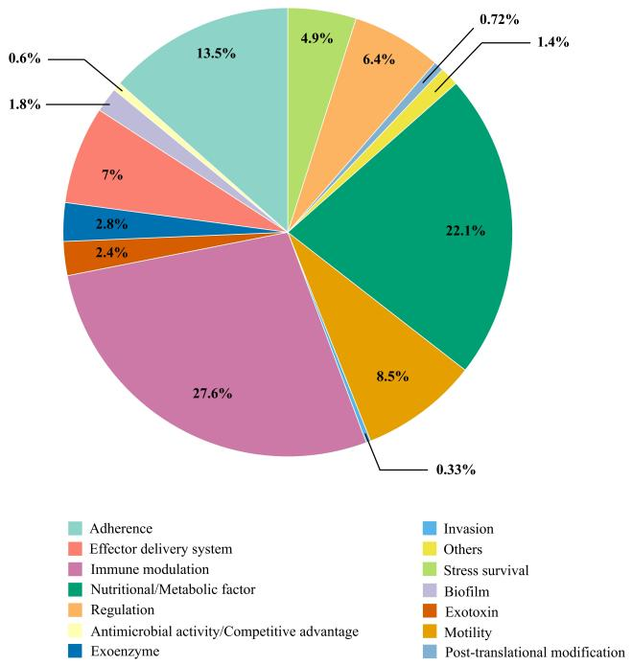
Figure S2. The relative abundance and the composition of VFGs.

