Supplementary Information

Dynamic Modulation of Immune-Neural Axis via Controlled Magnesium-Releasing Nanocapsules Accelerates Cranial Bone Regeneration

Yilin Mao¹, Qixuan He¹, Tianle Li¹, Jiusi Guo¹, Kelvin W.K.Yeung², Yuxiong Su³, Jie Shen, Xianglong Han⁴, Jian Wang⁴, Wei Qiao^{1,5*}
*Corresponding author
1. Applied Oral Sciences and Community Dental Care, Faculty of Dentistry, The University of Hong Kong, Hong Kong SAR, China
2. Orthopaedics and Traumatology, School of Clinical Medicine, LKS Faculty of Medicine, The University of Hong Kong, Hong Kong SAR, China
3. Oral and Maxillofacial Surgery, Faculty of Dentistry, The University of Hong Kong, Hong Kong SAR, China
4. State Key Laboratory of Oral Diseases, National Clinical Research Center for Oral Diseases, Department of Prosthodontics, West China Hospital of Stomatology, Sichuan University, Sichuan Province, China
5. Shenzhen Key Laboratory for Innovative Technology in Orthopaedic Trauma, The University of Hong Kong-Shenzhen Hospital, Shenzhen, China

Table 1. The Primers used for RT-qPCR (GAPDH was used as a housekeeping gene)
Gene | Sequences 5’–3’
hIL10 | Forward: 5’-TCAAGGCGCATGTGAACTCC-3’  Reverse: 5’-GATGTCAAACTCACTCATGGCT-3’
hIL1B | Forward：5’-ATGATGGCTTATTACAGTGGCAA-3’  Reverse：5’-GTCGGAGATTCGTAGCTGGA-3’
hTGFB1 | Forward：5’-GGCCAGATCCTGTCCAAGC-3’  Reverse：5’-GTGGGTTTCCACCATTAGCAC-3’
hIL8 | Forward：5’-TTTTGCCAAGGAGTGCTAAAGA-3’  Reverse：5’-AACCCTCTGCACCCAGTTTTC-3’
hCCL5 | Forward：5’-CCAGCAGTCGTCTTTGTCAC-3’  Reverse：5’-CTCTGGGTTGGCACACACTT-3’
hMRC1 | Forward：5’-TCCGGGTGCTGTTCTCCTA-3’  Reverse：5’-CCAGTCTGTTTTTGATGGCACT-3’
hRUNX2 | Forward：5’-TGGTTACTGTCATGGCGGGTA-3’  Reverse：5’-TCTCAGATCGTTGAACCTTGCTA-3’
hCOL1A1 | Forward：5’-GAGGGCCAAGACGAAGACATC-3’  Reverse：5’-CAGATCACGTCATCGCACAAC-3’
hALP | Forward：5’-AACATCAGGGACATTGACGTG-3’  Reverse：5’-GTATCTCGGTTTGAAGCTCTTCC-3’
hGAPDH | Forward：5’-GGAGCGAGATCCCTCCAAAAT-3’  Reverse：5’-GGCTGTTGTCATACTTCTCATGG-3’
hPTGS2 | Forward：5’-CTGGCGCTCAGCCATACAG-3’  Reverse：5’-CGCACTTATACTGGTCAAATCCC-3’
mTrpv1 | Forward：5’-CCGGCTTTTTGGGAAGGGT-3’  Reverse：5’-GAGACAGGTAGGTCCATCCAC-3’
mEp4 | Forward：5’-CCCTCCTATACCTGCCAGACC-3’  Reverse：5’-CATGCGTACCTGGAAGCAAA-3’
mTubb3 | Forward：5’-CCCAGCGGCAACTATGTAGG-3’  Reverse：5’-CCAGACCGAACACTGTCCA-3’
mCalca | Forward：5’-GAGGGCTCTAGCTTGGACAG-3’  Reverse：5’-AAGGTGTGAAACTTGTTGAGGT-3’
mGapdh | Forward：5’-ATGTGTCCGTCGTGGATCTGA-3’  Reverse：5’-ATGCCTGCTTCACCACCTTCTT-3’

Figure S1. Mg²⁺ release profile of PNC tested by ICP-OES.

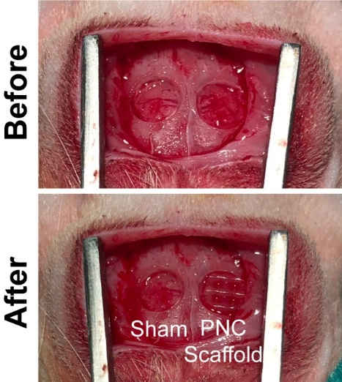
Figure S2. Representative photograph showing the 3D-printed PNC scaffold placed in the rat critical-sized cranial bone defect.
Figure S3. Nanocapsules loaded with different concentration of MgCl₂ for dual-phase Mg²⁺ release. A-B) SEM-EDS mapping (A) and EDS spectra (B) of PNC and Mg-PNC loaded with different concentrations of MgCl₂. Scale bar = 1 µm. C) Magnesium-to-calcium ratio of Mg-PNC with distinct MgCl₂ concentrations. D-E) FT-IR (D) and XRD patterns (E) of PNC and Mg-PNC loaded with different concentrations of MgCl₂. F) Representative TEM images of PNC and Mg-PNC. Scale bar= 50nm. * p < 0.05, ** p < 0.01, *** p < 0.001.

Figure S4. Surface elemental distribution and swelling behavior of PNC and Mg-PNC. A) EDS mapping of elemental distribution in PNC and Mg-PNC scaffolds. B) The elemental composition measured by EDS. C) Swelling ratio curve of PNC and Mg-PNC in PBS for 1 day. **p < 0.01, ****p < 0.0001.

