List of Supplementary figures and table:
Supplementary Figure S 1: Phylogenetic relationships (ML) of Petaurista constructed based the cytochrome b gene (a) and 16s RNA gene(b). 2
Supplementary Figure S 2: A): Wet preserved skin of the Yunnan Giant Flying Squirrel (Petaurista yunanensis) (ZSI 32336), archived at the Mammal &amp; Osteology Section, Zoological Survey of India, Kolkata, India. (i) dorsal pelage and (ii) ventral pelage. 2

Supplementary Table 1: Sample details of Petaurista species and GenBank accession number used in the present study 3
Supplementary Table 2 : List of Petaurista specimens and their Cranio-dental measurement archived in the National Zoological Collection of the Zoological Survey of India used in the present morphometric trait analysis. 4
Supplementary Table 3: AMOVA results for 25 cranial morphometric measurements of Petaurista species. 7

Observed Body Morphological Traits
The dorsal pelage of the specimen (Figure 1a) is a rich reddish-brown to dark chestnut, consistent with published descriptions of Petauristayunnanensis. The fur is dense and evenly distributed across the dorsum and upper limbs, with a faintly darker margin along the patagium, indicating a well-developed gliding membrane. The tail is broad, bushy, and nearly equal in length to the head-body axis, displaying a uniform coloration with a subtly lighter distal tip. The ears are small, rounded, and covered with short fur, lacking any prominent tufts. Ventral pelage (Figure 1b) is pale cream to light brown, providing a strong contrast with the dorsal coloration; fur here is slightly less dense but remains plush. The limbs are robust, with well-developed patagia extending from the forelimbs to the hindlimbs, edged with dark brown to blackish fur. The digits are elongated, bearing curved claws adapted for arboreal locomotion. While the soles are not visible, they are presumed to be padded and bare, as typical in gliding sciurids.

Observed Cranio-Dental Morphological Traits
The skull (Figure 2) exhibits a moderately arched dorsal profile with a gently sloping forehead and a domed cranium (Figure 2a). The rostrum is short and broad. Zygomatic arches are laterally flared and robust, with a well-developed zygomatic plate (Figure 2c). The auditory bullae are small and compressed (Figure 2b), distinguishing Petaurista yunnanensis from sympatric congeners such as P. philippensis, which possess more inflated bullae. Dentition is characterized by large, procumbent upper incisors and broad, bunodont cheek teeth with low, rounded cusps (Figure 2b, d). Tooth rows are nearly parallel, and the dental arcade is broadly U-shaped. The palate is wide, flat, and extends beyond the last molars, with visible palatal foramina (Figure 2b). The postorbital processes are prominent and laterally projecting (Figure 2b). The mandible is robust, with a high coronoid process (Figure 2e); the lower incisors are thick and heavily worn (Figure 2d).

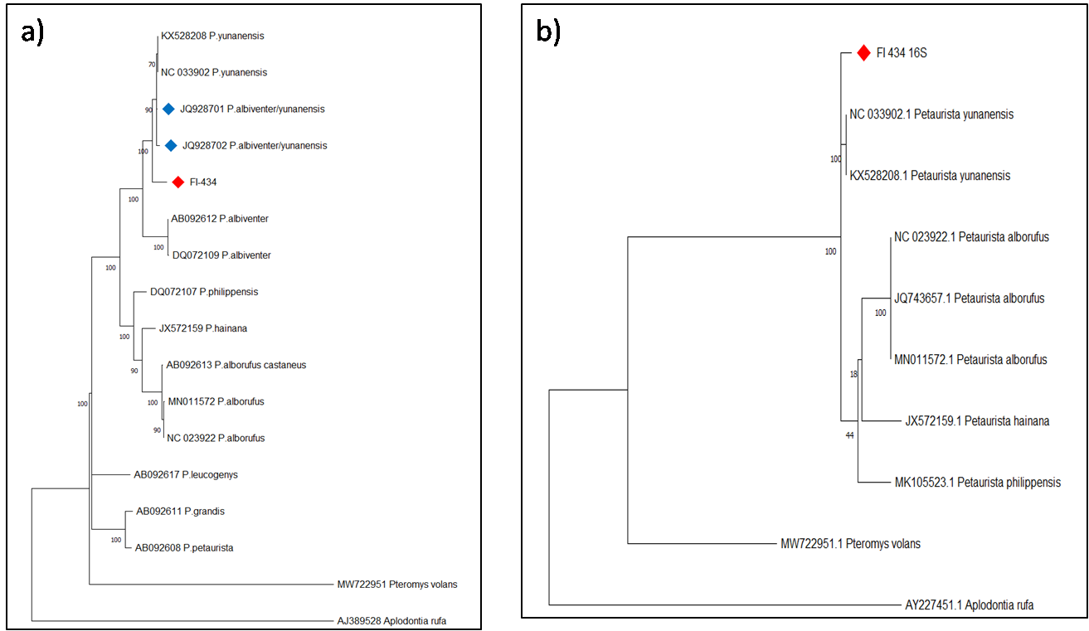
Supplementary Figure S 1: Phylogenetic relationships (ML) of Petaurista constructed based the cytochrome b gene (a) and 16s RNA gene(b).
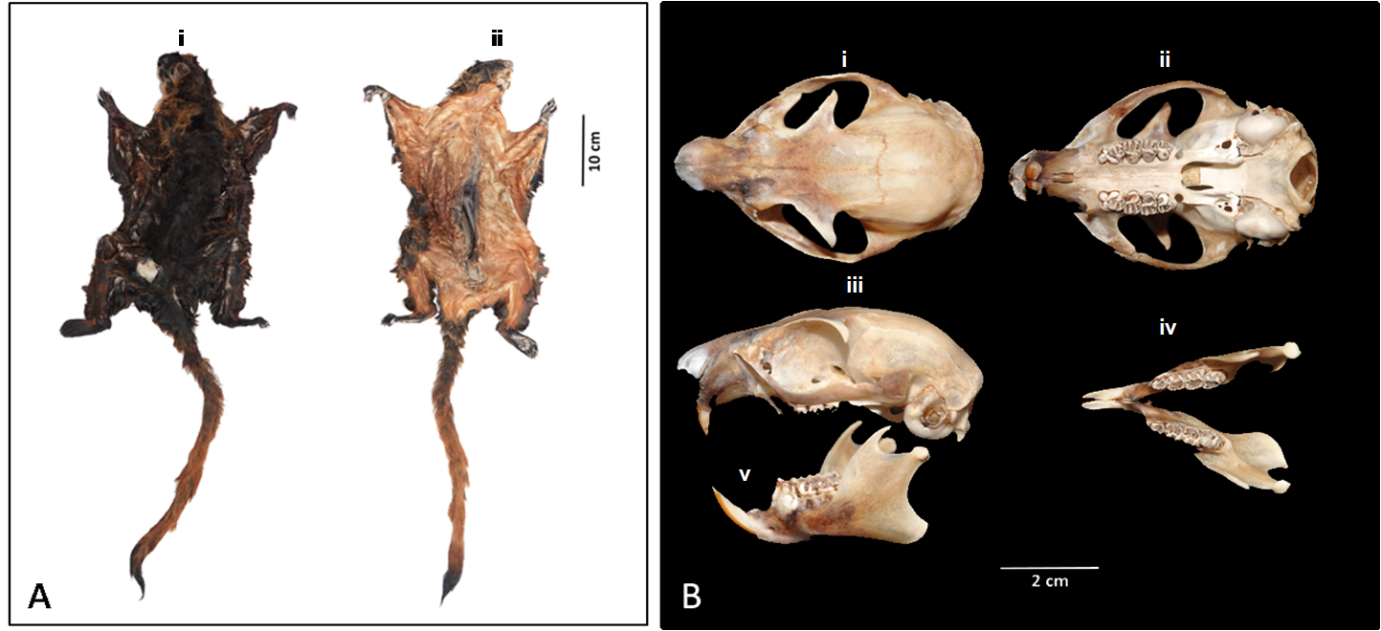
Supplementary Figure S 2: A): Wet preserved skin of the Yunnan Giant Flying Squirrel (Petaurista yunanensis) (ZSI 32336), archived at the Mammal &amp; Osteology Section, Zoological Survey of India, Kolkata, India. (i) dorsal pelage and (ii) ventral pelage.
B): Cranium and mandible of the Yunnan Giant Flying Squirrel (Petaurista yunanensis) (ZSI 32336), archived at the Mammal &amp; Osteology Section, Zoological Survey of India, Kolkata, India. From top to bottom, i) dorsal, ii) ventral, and iii) lateral views of the cranium, and iv) lateral, and v) occlusal views of the mandible.

Supplementary Table 1: Sample details of Petaurista species and GenBank accession number used in the present study
ACCESSION NUMBER | LOCATION | CITATION | SPECIES
NC033902 | China | Wei et al. 2016 | P.yunanensis
KX528208 | China | Wei et al. 2016 | P.yunanensis
JQ928701 | Yunlong, Yunnan, China | Li et al. 2013 | P.albiventer/yunanensis
JQ928702 | Gongshan, Yunnan, China | Li et al. 2013 | P.albiventer/yunanensis
DQ072109 | Pakistan | Li et al. 2013 | P.albiventer
AB092612 | Ayubia National Park, Pakistan | Li et al. 2013 | P.albiventer
DQ072107 | Yunnan, China | Li et al. 2013 | P.phillipensis
JX572159 | Hainana,China | Kong et al. 2015 | P.hainana
MN011572 | Guizhou, China | Zhang et al. | P.alborufus
NC023922 | Direct submission NCBI | Xu,H. and Wang,Q 2023 | P.alborufus
AB092613 | Southern China | Oshida et al. 2004 | P.alborufus castaneus
AB092617 | Ehime,Japan | Oshida et al. 2004 | P.leucogenys
AB092611 | Nantou,Taiwan | Oshida et al. 2004 | P.grandis
AB092608 | Laos | Oshida et al. 2004 | P.petaurista
MK105523 | Northern Myanmar/Northern Laos | G. Li et al. 2020 | P.phillipensis
MW722951 | Direct submission NCBI | Lim et al. 2018 | Pteromys volans
AJ389528 | France | Montgelard et al. 2002 | Aplodontia rufa
AY227451 | Direct submission NCBI | Mercer and Roth 2003 | Aplodontia rufa

Supplementary Table 2 : List of Petaurista specimens and their Cranio-dental measurement archived in the National Zoological Collection of the Zoological Survey of India used in the present morphometric trait analysis.
Reg. No. | Species recognised as | GSL | LUI | UIM | DL | UML | RH | GCH | NW | GNW | NBL | IOB | FBL | FBW | ZB | BB | OCW | TBL | LIL | LIC | LICD | LIA | MH | RMH | LML | LMI
20785 | Petaurista alborufus | 78.58 | 12.88 | 20.94 | 15.37 | 16.86 | 25.34 | 28.2 | 13.61 | 15.86 | 23.64 | 19.38 | 28.44 | 14.96 | 52 | 38.88 | 18.92 | 13.52 | 16.74 | 48.34 | 54.26 | 54.38 | 32.75 | 18.36 | 18.71 | 17.75
20786 | Petaurista alborufus | 81.86 | 9.58 | 21.28 | 16.81 | 16.95 | 24.07 | 27 | 14.19 | 15.7 | 24.19 | 19.14 | 29.42 | 14.81 | 51.49 | 36.64 | 19.1 | 11.86 | 18.51 | 47.01 | 53.47 | 56.24 | 32.54 | 15.05 | 18.94 | 18.58
15058 | Petaurista petaurista | 73.27 | 12.04 | 19.13 | 14.1 | 16.85 | 23.51 | 27.65 | 14.03 | 15.11 | 23.36 | 17.75 | 26.59 | 14.62 | 49.35 | 35.64 | 18.87 | 13.16 | 15.32 | 41.26 | 51.67 | 51.98 | 30.29 | 14.19 | 16.48 | 17.62
25526 | Petaurista petaurista | 83.34 | 10.17 | 22.84 | 18.35 | 17.47 | 26.48 | 29.32 | 15.39 | 19.04 | 25.31 | 18.88 | 29.92 | 17.43 | 51.7 | 39.55 | 20.37 | 14.55 | 16.84 | 49.31 | 56.69 | 57.92 | 35.1 | 16.33 | 18.46 | 19.74
26665 | Petaurista petaurista | 81.55 | 11.35 | 19.82 | 17.57 | 16.73 | 25.13 | 27.69 | 15.71 | 16.05 | 26.29 | 19.44 | 27.78 | 14.17 | 52.86 | 38.04 | 18.21 | 13.59 | 14.63 | 47.32 | 55.56 | 55.96 | 32.67 | 17.08 | 17.96 | 17.88
26666 | Petaurista petaurista | 80.71 | 16.07 | 22.68 | 17.81 | 17.25 | 24.86 | 28.75 | 15.82 | 16.85 | 22.88 | 19.79 | 28.66 | 15.14 | 52.02 | 39.14 | 22.22 | 14.15 | 17.38 | 49.03 | 55.89 | 56.79 | 34.4 | 15.12 | 17.54 | 18.81
23786 | Petaurista petaurista | 79.54 | 11.37 | 20.39 | 16.01 | 17.4 | 24.98 | 29.3 | 15.86 | 16.97 | 19.86 | 19.13 | 28.89 | 16.33 | 49.42 | 36.02 | 18.7 | 12.83 | 17.93 | 46.56 | 54.95 | 56.02 | 31.82 | 15.54 | 18.88 | 18.65
23785 | Petaurista petaurista | 80.25 | 9.98 | 21.19 | 17.2 | 16.91 | 25.17 | 28.91 | 12.68 | 16.73 | 25.32 | 17.98 | 27.5 | 16.01 | 51.62 | 37.19 | 18.38 | 13.49 | 15.7 | 48.19 | 53.78 | 54.04 | 34.36 | 15.32 | 18.22 | 18.03
23787 | Petaurista petaurista | 77.81 | 10.03 | 21.18 | 17.38 | 16.57 | 23.77 | 30.57 | 15.08 | 16.04 | 25.15 | 17.38 | 26.65 | 15.19 | 52.36 | 37.93 | 20.03 | 14.41 | 14.02 | 48.01 | 54.44 | 55.58 | 34.09 | 15.53 | 17.97 | 19.12
9719 | Petaurista petaurista | 72.43 | 8.82 | 19.34 | 15.24 | 16.56 | 21.78 | 28.11 | 12.87 | 14.72 | 20.85 | 20.02 | 27.42 | 14.85 | 47.04 | 36.56 | 18.39 | 14.65 | 17.5 | 41.39 | 49.98 | 50.49 | 27.42 | 15.83 | 17.86 | 16.1
9714 | Petaurista cineraceus | 74.64 | 8.15 | 19.31 | 15.51 | 16.03 | 25.33 | 26.08 | 13.85 | 15.82 | 24.6 | 21.69 | 27.54 | 16.41 | 51.38 | 41.89 | 18.68 | 13.63 | 14.74 | 43.29 | 50.65 | 52.22 | 31.03 | 17.19 | 18.88 | 15.96
24270 | Petaurista caniceps | 59.83 | 8.47 | 17.39 | 12.62 | 13.29 | 18.44 | 23.17 | 10.16 | 11.38 | 15.65 | 14.72 | 21.46 | 11.85 | 39.35 | 29.61 | 13.92 | 12.43 | 12.69 | 37.06 | 41.59 | 43.6 | 25.58 | 12.85 | 14.35 | 15.08
24269 | Petaurista caniceps | 57.76 | 7.8 | 15.14 | 13.59 | 13.22 | 18.47 | 21.93 | 10.23 | 11.4 | 16.37 | 15.67 | 23.76 | 10.21 | 37.8 | 27.74 | 13.73 | 12.08 | 13.23 | 34.28 | 39.04 | 40.05 | 23.24 | 11.83 | 15.21 | 15.28
24273 | Petaurista caniceps | 64.16 | 7.9 | 17.36 | 14.31 | 13.5 | 20.11 | 24.94 | 10.93 | 11.79 | 19.05 | 15.98 | 22.5 | 11.57 | 39.92 | 30.88 | 15.61 | 13.69 | 13.93 | 38.02 | 43.1 | 44.95 | 26.87 | 11.76 | 15.86 | 15.02
24267 | Petaurista caniceps | 62.17 | 10.71 | 15.87 | 11.8 | 14.44 | 20.03 | 24.34 | 11.05 | 12.42 | 20.18 | 15.11 | 22.08 | 11.7 | 40.45 | 30.52 | 14.05 | 12.23 | 12.48 | 37.97 | 42.3 | 44.08 | 26.15 | 12.68 | 14.61 | 13.51
24194 | Petaurista caniceps | 66.65 | 9.48 | 18.42 | 13.93 | 15.88 | 22.49 | 26.06 | 11.88 | 12.11 | 21.59 | 16.9 | 25.97 | 13.26 | 45.89 | 32.25 | 14.44 | 11.82 | 16.35 | 40.07 | 47.79 | 48.74 | 28.52 | 14.38 | 17.65 | 15.61
24271 | Petaurista caniceps | 63.78 | 8.61 | 17.26 | 13.91 | 14.24 | 18.09 | 23.32 | 11.42 | 11.85 | 20.71 | 15.03 | 22.85 | 11.3 | 40.29 | 29.69 | 14.54 | 12.07 | 14.26 | 39.61 | 43.98 | 44.62 | 26.11 | 14.35 | 14.43 | 15.57
9732 | Petaurista magnificus | 70.33 | 9.41 | 21.98 | 14.29 | 14.07 | 24.06 | 29.22 | 12.02 | 17.49 | 21.31 | 18.23 | 25.22 | 14.27 | 45.94 | 34.17 | 17.86 | 12.77 | 13.95 | 43.64 | 49.54 | 49.6 | 31.27 | 16.22 | 16.15 | 17.24
23263 | Petaurista nobilis | 71.17 | 6.7 | 19.18 | 14.57 | 14.94 | 21.26 | 27.98 | 11.86 | 13.98 | 20.83 | 17.57 | 23.98 | 13.65 | 46.38 | 35.56 | 17.63 | 12.27 | 14.96 | 42.95 | 48.73 | 48.54 | 29.27 | 14.28 | 16.33 | 16.39
23254 | Petaurista nobilis | 74.39 | 8.95 | 21.63 | 19.54 | 16.19 | 22.75 | 23.99 | 14.09 | 15.05 | 22.75 | 17.64 | 27.58 | 12.68 | 48.77 | 35.46 | 15.89 | 12.5 | 13.89 | 43.95 | 50.33 | 50.74 | 26.53 | 15.07 | 17.36 | 18.21
18616 | Petaurista nobilis | 71.91 | 8.54 | 22.44 | 17.25 | 15.21 | 22.81 | 24.84 | 14.33 | 15.31 | 19.99 | 18.65 | 29.4 | 14.29 | 48.2 | 36.24 | 18.39 | 13.02 | 13.56 | 44.23 | 48.55 | 50.46 | 30.11 | 12.88 | 18.83 | 17.85
23259 | Petaurista nobilis | 70.16 | 8.73 | 21.48 | 18.24 | 14.38 | 22.37 | 23.35 | 14.19 | 15.77 | 20.12 | 17.56 | 27.31 | 13.47 | 47.9 | 35.1 | 16.47 | 11.17 | 14.15 | 43.58 | 49.48 | 49.83 | 28.61 | 15.16 | 16.42 | 18.95
24276 | Petaurista nobilis | 74.04 | 10.42 | 22.67 | 17.97 | 14.76 | 22.11 | 23.93 | 15.31 | 16.49 | 23.36 | 16.6 | 30.11 | 13.27 | 47.37 | 34.24 | 18.25 | 12.89 | 16.53 | 45.63 | 51.81 | 52.52 | 29.49 | 15.27 | 17.19 | 20.89
24274 | Petaurista nobilis | 71.88 | 10.96 | 19.38 | 13.8 | 15.5 | 21.7 | 26.35 | 11.9 | 13.85 | 21.74 | 17.54 | 27.34 | 13.05 | 46.94 | 34.06 | 17.24 | 13.22 | 16.23 | 45.96 | 49.84 | 50.39 | 30.5 | 15.32 | 17.22 | 16.19
23261 | Petaurista nobilis | 67.54 | 8.85 | 17.92 | 13.4 | 11.41 | 21.76 | 25.84 | 12.82 | 13.31 | 21.26 | 18.07 | 24.39 | 11.05 | 44.34 | 33.16 | 16 | 12.64 | 13.95 | 39.61 | 46.89 | 47.77 | 27.57 | 14 | 15.89 | 15.62
24277 | Petaurista nobilis | 70.97 | 10.92 | 18.44 | 13.72 | 15.96 | 22.03 | 24.72 | 13.84 | 14.75 | 19.66 | 19.14 | 25.43 | 12.47 | 46.57 | 35 | 16.84 | 12.72 | 17.19 | 41.17 | 49.85 | 50.84 | 29.8 | 14.97 | 17.7 | 16.32
24275 | Petaurista nobilis | 73.55 | 8.75 | 18.89 | 14.25 | 16.4 | 22.9 | 26.81 | 14.61 | 15.21 | 19.71 | 17.7 | 26.06 | 13.56 | 46.38 | 35.38 | 17.21 | 13.01 | 15.55 | 42.02 | 49.01 | 50.6 | 29.51 | 14.89 | 17.71 | 16.47
21297 | Petaurista petaurista | 68.48 | 9.58 | 18.32 | 14.35 | 14 | 20.79 | 27.24 | 12.56 | 14.48 | 19.62 | 18.18 | 23.78 | 14.19 | 45.2 | 32.48 | 15.69 | 14.24 | 13.42 | 39.43 | 47 | 47.55 | 27.86 | 14.16 | 15.89 | 15.03
15054 | Petaurista albiventer | 69.75 | 10.37 | 16.58 | 14.49 | 15.87 | 21.89 | 27.2 | 12.21 | 13.81 | 19.94 | 16.58 | 24.91 | 13.67 | 44.99 | 32.95 | 16.02 | 13.1 | 15.67 | 42.01 | 46.77 | 48.05 | 30.13 | 15.3 | 16.03 | 14.93
15052 | Petaurista albiventer | 67.27 | 9.19 | 15.54 | 13.48 | 15.27 | 19.51 | 26.12 | 12.82 | 14.22 | 20.58 | 17.31 | 23.38 | 12.39 | 43.81 | 31.86 | 16.45 | 12.38 | 14.33 | 36.86 | 44.79 | 46.63 | 29.71 | 14.53 | 16.24 | 13.39
15053 | Petaurista albiventer | 59.31 | 10.57 | 15.48 | 12.72 | 11.61 | 18.19 | 20.12 | 8.56 | 9.92 | 19.59 | 12.63 | 20.83 | 9.45 | 34.87 | 24.25 | 12.75 | 14.11 | 15.42 | 34.48 | 38.26 | 38.87 | 21.63 | 12.3 | 11.48 | 14.21
15046 | Petaurista petaurista | 70.78 | 9.88 | 18.26 | 15.03 | 16.23 | 24.58 | 26.51 | 12.71 | 15.59 | 21.85 | 19.05 | 25.56 | 12.87 | 46.66 | 34.13 | 16.98 | 13.36 | 15.38 | 43.08 | 50.06 | 52.39 | 29.87 | 15.01 | 17.91 | 17.36
15048 | Petaurista petaurista | 74.66 | 13.82 | 20.08 | 15.75 | 17.11 | 23.93 | 27.08 | 12.65 | 14.91 | 23.76 | 16.77 | 27.17 | 13.46 | 46.88 | 35.88 | 17.82 | 15.14 | 16.61 | 43.93 | 51.3 | 53.63 | 31.15 | 16.44 | 17.83 | 18.09
16348 | Petaurista philippensis | 80.29 | 10.05 | 21.34 | 16.57 | 16.63 | 25.08 | 28.24 | 15.41 | 15.78 | 24.43 | 20.85 | 28.12 | 15.97 | 52.92 | 39.75 | 18.24 | 13.85 | 12.5 | 47.09 | 54.53 | 53.54 | 31.75 | 16.96 | 18.22 | 17.31
9746 | Petaurista petaurista | 66.2 | 6.6 | 16.72 | 14.54 | 15.13 | 23.15 | 24.42 | 11.6 | 14.09 | 20.65 | 17.4 | 23.77 | 12.31 | 45.66 | 32.84 | 15.81 | 11.83 | 11.06 | 39.34 | 44.9 | 45.25 | 27.16 | 13.59 | 15.84 | 14.44
21294 | Petaurista philippensis | 66.61 | 9.33 | 17.65 | 12.75 | 13.52 | 20.84 | 24.34 | 11.95 | 13.79 | 18.88 | 17.25 | 24.77 | 12.75 | 42.54 | 31.53 | 14.2 | 12.72 | 14.33 | 38.68 | 44.14 | 45.64 | 27.67 | 13.41 | 15.18 | 14.49
21295 | Petaurista philippensis | 66.05 | 12.54 | 17.64 | 13.32 | 13.34 | 19.64 | 24.25 | 10.83 | 13.5 | 18.79 | 17.44 | 24.12 | 12.54 | 43.48 | 32.07 | 15.26 | 12.06 | 15.05 | 40.36 | 45.59 | 45.52 | 26.56 | 12.66 | 14.69 | 15.24
26696 | Petaurista philippensis | 66.94 | 10.17 | 16.89 | 13.87 | 13.82 | 20.16 | 25.14 | 12.64 | 14.31 | 18.66 | 16.88 | 24.34 | 13.14 | 43.25 | 32.88 | 14.87 | 13.25 | 15.85 | 36.01 | 42.25 | 45.86 | 25.26 | 13.42 | 15.23 | 14.41
21293 | Petaurista philippensis | 66.73 | 7.64 | 17.47 | 12.95 | 13.32 | 20.7 | 25.5 | 12.46 | 14.84 | 20.36 | 16.59 | 23.47 | 12.76 | 45.15 | 33.33 | 15.33 | 13 | 15.4 | 39.85 | 45 | 46.46 | 27.92 | 14.14 | 15.41 | 14.47
20074 | Petaurista philippensis | 74.8 | 11.16 | 20.58 | 15.77 | 15.99 | 23.39 | 26.46 | 12.95 | 15.08 | 21.72 | 17.25 | 28.21 | 14.39 | 50.51 | 37.63 | 17.26 | 15.45 | 15.27 | 45.2 | 52.78 | 54.09 | 33.17 | 15.85 | 17.58 | 17.41
20075 | Petaurista philippensis | 73.31 | 9.34 | 19.34 | 16.22 | 15.33 | 23.97 | 27.1 | 12.69 | 14.88 | 21.21 | 17.94 | 28.77 | 14.33 | 47.04 | 36.53 | 17 | 13.87 | 16.01 | 43.57 | 50.42 | 51.21 | 30.51 | 16.5 | 17.14 | 16.93
20076 | Petaurista philippensis | 72.29 | 9.63 | 19.17 | 15.26 | 16.11 | 23.53 | 26.36 | 12.38 | 14.99 | 21.03 | 17.45 | 26.49 | 13.41 | 48.69 | 34.69 | 17.38 | 15.44 | 13.71 | 41.7 | 50.46 | 50.91 | 29.77 | 15.56 | 17.73 | 16.61
20077 | Petaurista philippensis | 74.42 | 9.69 | 20.91 | 17.17 | 15.62 | 23.38 | 26.99 | 12.3 | 15.17 | 22.14 | 16.64 | 27.05 | 14.16 | 48.85 | 36.39 | 17.09 | 14.85 | 16.78 | 46.15 | 52.68 | 53.44 | 29.87 | 15.44 | 17.53 | 17.92
20078 | Petaurista philippensis | 71.12 | 9.16 | 18.58 | 15.11 | 15.18 | 22.47 | 25.97 | 12.37 | 13.87 | 21.33 | 17.33 | 27.49 | 14.99 | 47.8 | 35.3 | 17.09 | 13.86 | 15.22 | 42.9 | 48.96 | 50.61 | 30.33 | 15.94 | 16.69 | 16.02
20079 | Petaurista philippensis | 68.99 | 10.89 | 18.35 | 14.17 | 14.71 | 21.03 | 26.06 | 12.14 | 14.13 | 19.7 | 16.71 | 27.32 | 13.79 | 44.04 | 33.67 | 16.72 | 13.92 | 14.6 | 40.32 | 45.47 | 46.64 | 26.12 | 14.66 | 16.65 | 16.16
20080 | Petaurista philippensis | 74.24 | 8.37 | 20.01 | 16.28 | 15.05 | 22.96 | 27.67 | 13.66 | 15.47 | 22.17 | 17.98 | 31.51 | 14.42 | 46.16 | 37.48 | 17.56 | 14.28 | 13.44 | 42.7 | 49.31 | 51.5 | 29.93 | 16.36 | 16.48 | 17.27
15067 | Petaurista philippensis | 71.85 | 12.17 | 20.33 | 16.25 | 15.11 | 22.64 | 24.69 | 13.93 | 15.71 | 20.99 | 17.46 | 26.16 | 13.48 | 46.66 | 34.93 | 16.71 | 15.52 | 15.9 | 42.33 | 48.25 | 50.81 | 30.34 | 15.43 | 16.87 | 16.88
15071 | Petaurista philippensis | 80.57 | 14.62 | 19.93 | 17.19 | 16.49 | 26.46 | 24.49 | 13.31 | 17.51 | 24.37 | 22.7 | 22.64 | 13.12 | 48.52 | 30.51 | 19.47 | 17.33 | 19.73 | 41.85 | 52.47 | 55.97 | 32.78 | 17.05 | 16.56 | 16.15
20073 | Petaurista philippensis | 74.57 | 10.98 | 21.02 | 17.16 | 16.71 | 23.38 | 25.52 | 13.74 | 14.66 | 21.94 | 18.23 | 27.76 | 15 | 49.37 | 35.15 | 17.42 | 14.18 | 17.25 | 45.24 | 53.19 | 54.02 | 30.24 | 15.87 | 16.61 | 18.14
9805 | Petaurista philippensis | 71.21 | 10.33 | 18.13 | 12.9 | 15.18 | 23.28 | 26.3 | 10.6 | 13.9 | 21.01 | 18.02 | 25.58 | 14.47 | 45.63 | 33.94 | 17.23 | 13.77 | 15.02 | 40.3 | 48.35 | 48.18 | 28.52 | 14.83 | 17.49 | 16.04
3808 | Petaurista philippensis | 63.71 | 6.66 | 14.76 | 11.56 | 13.59 | 18.83 | 24.93 | 10.35 | 12.55 | 16.37 | 17.35 | 21.8 | 11.98 | 41.08 | 30.49 | 14.25 | 12.71 | 14.54 | 35.87 | 41.67 | 43.53 | 25.24 | 12.81 | 15.13 | 13.55
9708 | Petaurista philippensis | 74.64 | 10.24 | 19.76 | 14.45 | 15.43 | 22.12 | 27.14 | 13.01 | 14.61 | 21.62 | 18.53 | 25.43 | 15.95 | 47.59 | 35.78 | 17.19 | 15.4 | 16.15 | 44.36 | 50.89 | 51.6 | 31.76 | 16.97 | 16.69 | 16.95
23717 | Petaurista sybilla | 58.36 | 9.61 | 15.36 | 11.92 | 12.99 | 18.34 | 23.68 | 10.28 | 11.39 | 17.01 | 17.67 | 20.76 | 10.56 | 39.27 | 28.62 | 14.35 | 10.92 | 11.75 | 34.58 | 38.9 | 39.68 | 22.49 | 11.81 | 14.01 | 13.54
32336 | FI-434 | 71.8 | 9.32 | 17.41 | 13.65 | 16.61 | 21.55 | 27.33 | 12.77 | 14.17 | 20.91 | 18.42 | 23.7 | 14.89 | 45.17 | 31.82 | 17.03 | 11.95 | 14.96 | 41.67 | 48.67 | 48.72 | 28.58 | 15.22 | 16.13 | 15.64

The measurements include Greater Skull Length (GSL), Length of Upper Incisor (LUI), Upper Incisor to Molar Length (UIM), Length of Diastema (DL), Upper Molar Length (UML), Rostrum Height (RH), Greater Cranial Height (GCH), Nasal Width (NW), Greater Nasal Width (GNW), Nasal Bone Length (NBL), Interorbital Breadth (IOB), Frontal Bone Length (FBL), Frontal Bone Width (FBW), Zygomatic Breadth (ZB), Braincase Breadth (BB), Occipital Condyle Width (OCW), Tympanic Bulla Length (TBL), Lower Incisor Length (LIL), Lower Incisor to Coronoid (LIC), Lower Incisor to Condyle (LICD), Lower Incisor to Angular (LIA), Mandibular Height (MH), Ramus to Molar Height (RMH), Lower Molar Length (LML), and Lower Molar to Incisor Length (LMI).

Supplementary Table 3: AMOVA results for 25 cranial morphometric measurements of Petaurista species.
 | Trait Index | F_value | P_value
GSL* | GSL* | 8.487 | 7.69E-07
LUI | Length of U Incisor | 1.533 | 0.174
UIM* | U incisor to Molar* | 4.689 | 3.55E-04
DL* | Diastema L* | 2.714 | 0.0163
UML* | Upper Molar L* | 4.506 | 4.97E-04
RH** | Ros H** | 7.927 | 1.73E-06
GCH** | G Cranial H** | 6.265 | 2.31E-05
NW* | Nasal W* | 4.319 | 7.04E-04
GNW** | G Nasal W** | 10.427 | 5.67E-08
NBL* | Nasal bone L* | 4.118 | 0.00103
IOB** | Inter Orbital breadth** | 6.122 | 2.92E-05
FBL* | Frontal bone L* | 4.022 | 0.00124
FBW* | Frontal bone W* | 4.991 | 2.06E-04
ZB** | ZB** | 7.647 | 2.63E-06
BB** | BB** | 7.326 | 4.27E-06
OCW** | Occipital condyle W** | 6.92 | 8.03E-06
TBL* | Tympanic bulla L* | 4.585 | 4.30E-04
LIL* | Lower.Incisor.L | 2.005 | 0.0687
LIC** | Lower.I.to.Coroniod** | 5.02 | 0.000195
LICD** | Lower.I.to.Condyl** | 6.36 | 0.00002
LIA** | Lower.I.to. ** | 6.753 | 0.00001
MH | angular | 6.753 | 0.00001
RMH | MH** | 6.317 | 0.00002
LML | Ramus.to. | 4.095 | 0.00107
LMI | Molar.H* | 4.095 | 0.00107
GSL* | Lower.molar.L** | 4.92 | 0.00023
LUI* | Lower.molar.to.I* | 4.085 | 0.00109
 | Significant * , Highly significant **

