Supplementary Figure S 1: Maximum-likelihood phylogenetic tree reconstructed based on the mitochondrial gene using MEGA X. a) based on Cytochrome b gene, and (b) based on 12S rRNA. Samples from the study were marked with red boxes while green dots represent the misidentified sequences of M. gongsiansis submitted to GenBank. 2
Supplementary Figure S 2: Neighbor-joining (NJ) phylogenetic tree reconstructed with MEGA X based on the mitochondrial gene. 1(a) based on Cytochrome b gene, and 1(b) based on 12S rRNA. Samples from the current study are in MT ID. 3

Supplementary Table S 1: List of complete dataset of the sequences of Muntjac, with Accession number and geographic origin used in the study…………………………………………………………………………………………………………………………..……..4

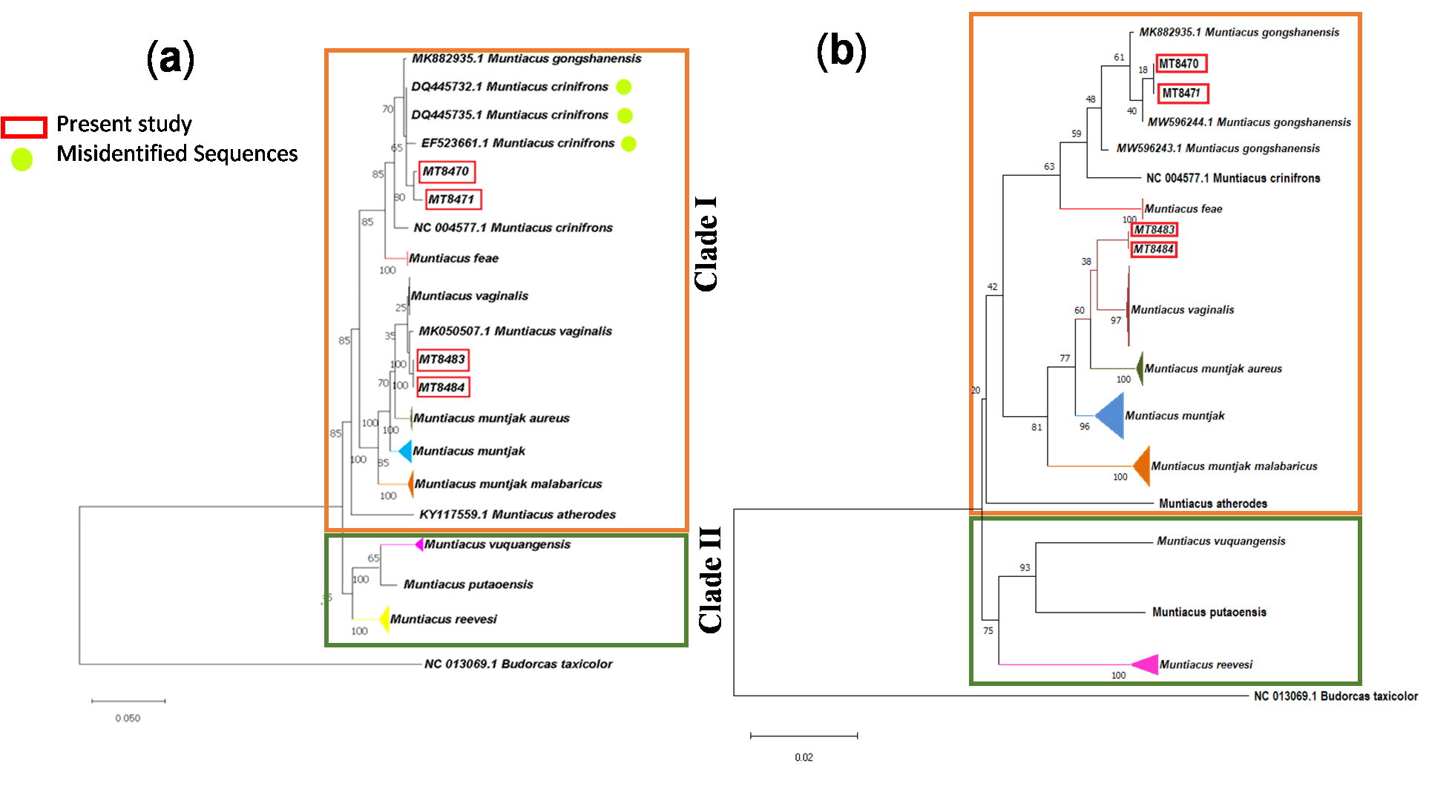
Supplementary Figure S 1: Maximum-likelihood phylogenetic tree reconstructed based on the mitochondrial gene using MEGA X. a) based on Cytochrome b gene, and (b) based on 12S rRNA. Samples from the study were marked with red boxes while green dots represent the misidentified sequences of M. gongsiansis submitted to GenBank.
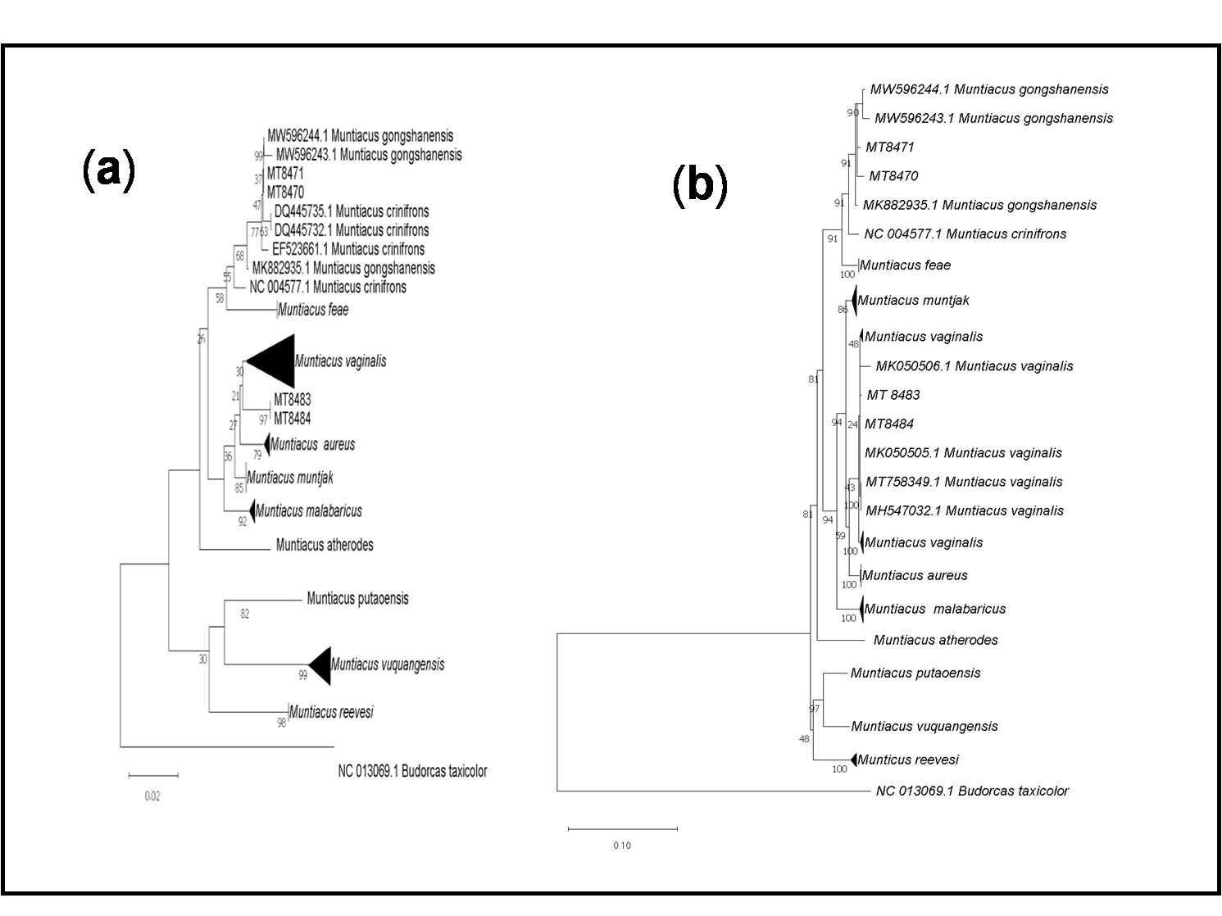
Supplementary Figure S 2: Neighbor-joining (NJ) phylogenetic tree reconstructed with MEGA X based on the mitochondrial gene. 1(a) based on Cytochrome b gene, and 1(b) based on 12S rRNA. Samples from the current study are in MT ID.
Supplementary Table S 1: List of complete dataset of the sequences of Muntjac, with Accession number and geographic origin used in the study.
S. No. | Accession No. | Location | Citations | Species | Gene
1 | MK882935 | China | Unpublish | Muntiacus gongshanensis | Cytb, 12S rRNA
2 | MW596243 | China | Zhang et al. 2021 | Muntiacus gongshanensis | Cytb, 12S rRNA
3 | MW596244 | China | Zhang et al. 2021 | Muntiacus gongshanensis | Cytb, 12S rRNA
5 | EF523661 | Namdapha, India | James et al 2007 | Muntiacus crinifrons | Cytb
6 | NC 004577 | China | Li et al 2017 | Muntiacus crinifrons | Cytb, 12S rRNA
7 | DQ445732 | China | Chen et al 2008 | Muntiacus crinifrons | Cytb
8 | DQ445735 | China | Chen et al 2008 | Muntiacus crinifrons | Cytb
9 | MG857663 | Thailand | Srisodsuk et al 2018 | Muntiacus feae | Cytb, 12S rRNA
10 | NC 041100 | Thailand | Srisodsuk et al 2019 | Muntiacus feae | Cytb, 12S rRNA
11 | MH547032 | Northeast India | Singh et al 2018 | Muntiacus vaginalis | Cytb
12 | MT758349 | Chhattisgarh, India | Singh et al 2021 | Muntiacus vaginalis | Cytb, 12S rRNA
13 | MT758350 | Chhattisgarh, India | Singh et al 2021 | Muntiacus vaginalis | Cytb, 12S rRNA
14 | MK050505 | Northeast India | Singh et al 2021 | Muntiacus vaginalis | Cytb, 12S rRNA
15 | MK050506 | Northeast India | Singh et al 2021 | Muntiacus vaginalis | Cytb, 12S rRNA
16 | MK050507 | Northeast India | Singh et al 2021 | Muntiacus vaginalis | Cytb, 12S rRNA
17 | MT671399 | Andaman, India | Singh et al 2021 | Muntiacus vaginalis | Cytb, 12S rRNA
18 | AY225986 | China | Shi et al 2003 | Muntiacus muntjak | Cytb
19 | KY117560 | Southeast asia | Mohd Salleh et al 2017 | Muntiacus muntjak | Cytb
20 | MT671400 | Himachal Pradesh, India | Singh et al 2021 | Muntiacus aureus | Cytb, 12S rRNA
21 | MT671404 | Uttarakhand, India | Singh et al 2021 | Muntiacus aureus | Cytb, 12S rRNA
22 | MT671405 | Karnataka, India | Singh et al 2021 | Muntiacus malabaricus | Cytb, 12S rRNA
23 | MT671405 | Karnataka, India | Singh et al 2021 | Muntiacus malabaricus | Cytb, 12S rRNA
24 | MT671406 | Karnataka, India | Singh et al 2021 | Muntiacus malabaricus | Cytb, 12S rRNA
25 | MT671407 | Western Ghats, India | Singh et al 2021 | Muntiacus malabaricus | Cytb, 12S rRNA
26 | MT671408 | Western Ghats, India | Singh et al 2021 | Muntiacus malabaricus | Cytb, 12S rRNA
27 | KY117559 | Southeast Asia | Mohd Salleh et al 2017 | Muntiacus atherodes | Cytb, 12S rRNA
28 | NC 036430 | China | Li et al 2017 | Muntiacus putaoensis | Cytb, 12S rRNA
29 | NC 016920 | India | Hassanin et al 2012 | Muntiacus vuquangensis | Cytb, 12S rRNA
30 | KJ425275 | Unknown | Malik et al 2014 | Muntiacus vuquangensis | Cytb
31 | KJ425283 | Unknown | Malik et al 2014 | Muntiacus vuquangensis | Cytb
32 | KJ425284 | Unknown | Malik et al 2014 | Muntiacus vuquangensis | Cytb
33 | KJ425285 | Unknown | Malik et al 2014 | Muntiacus vuquangensis | Cytb
34 | KY117561 | Southeast Asia | unpublished | Muntiacus reevesi | Cytb, 12S rRNA
35 | PQ063858 | Dong , India | This Study | Muntiacus vaginalis | Cytb
36 | PQ063859 | Dong , India | This Study | Muntiacus vaginalis | Cytb
37 | PQ063856 | Dong , India | This Study | Muntiacus gongshanensis | Cytb
38 | PQ063857 | Dong , India | This Study | Muntiacus gongshanensis | Cytb
39 | PX512265 | Dong , India | This Study | Muntiacus gongshanensis | 12S rRNA
40 | PX512266 | Dong , India | This Study | Muntiacus gongshanensis | 12S rRNA
41 | PX512267 | Dong , India | This Study | Muntiacus vaginalis | 12S rRNA
42 | PX512268 | Dong , India | This Study | Muntiacus vaginalis | 12S rRNA

