Appendix:

Appendix Table 1. Distribution of caregiving roles (N = 591)
 | Without legal proxy arrangement (N = 411) |  |  |  | With legal proxy arrangement (legal agent)  (N = 180)
 | Digital medical proxy status |  |  |  | Digital medical proxy status
Digital financial proxy status | Non-proxy | Informal proxy | Formal proxy | Total | Non-proxy | Informal proxy | Formal proxy | Total
Non-proxy | 241 (58.6%) | 20 (4.9%) | 24 (5.8%) | 285 (69.3%) | 21 (11.7%) | 5 (2.8%) | 10 (5.6%) | 36 (20.0%)
Informal proxy | 27 (6.6%) | 27 (6.6%) | 11 (2.7%) | 65 (15.8%) | 9 (5.0%) | 6 (3.3%) | 9 (5.0%) | 24 (13.3%)
Formal proxy | 21 (5.1%) | 17 (4.1%) | 21 (5.1%) | 59 (14.4%) | 14 (7.8%) | 16 (8.9%) | 88 (48.9%) | 118 (65.6%)
Total | 289 (70.3%) | 65 (15.8%) | 57 (13.9%) | 411 (100.0%) | 45 (25.0%) | 27 (15.0%) | 108 (60.0%) | 180 (100.0%)

Appendix Table 2. Multivariable regression results of missed opportunities.
 | Number of “No, but I should have” responses | P-value
IADL score | -0.013 [-0.057, 0.032] | (0.556)
ADL score | 0.033* [0.006, 0.059] | (0.012)
IADL digital assistance score | 0.021 [-0.128, 0.169] | (0.758)
Care management | 0.026 [-0.027, 0.078] | (0.263)
Finance digital proxy
Non-digital proxy (ref) | 0.000
Informal proxy | -0.084 [-0.577, 0.427] | (0.747)
Formal proxy | 0.224 [-0.242, 0.697] | (0.375)
Medical digital proxy
Non-digital proxy (ref) | 0.000
Informal proxy | 0.510* [0.013, 1.026] | (0.044)
Formal proxy | -0.060 [-0.525, 0.410] | (0.814)
Legal proxy
Non-proxy (ref) | 0.000
Legal proxy | -0.582** [-1.045, -0.121] | (0.009)
Model | Negative binomial regression
Observations | 584
AIC | 1956.6
BIC | 2100.8
RMSE | 2.88
Notes: + p < 0.1, * p < 0.05, ** p < 0.01, *** p < 0.001
Adjusted models are controlled for age, gender, marital status, education, housing, employment status, income, race, religion, sibling status.

Appendix Figure 1. Proportion of caregivers who indicated they should have completed the SDM behaviors
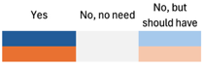
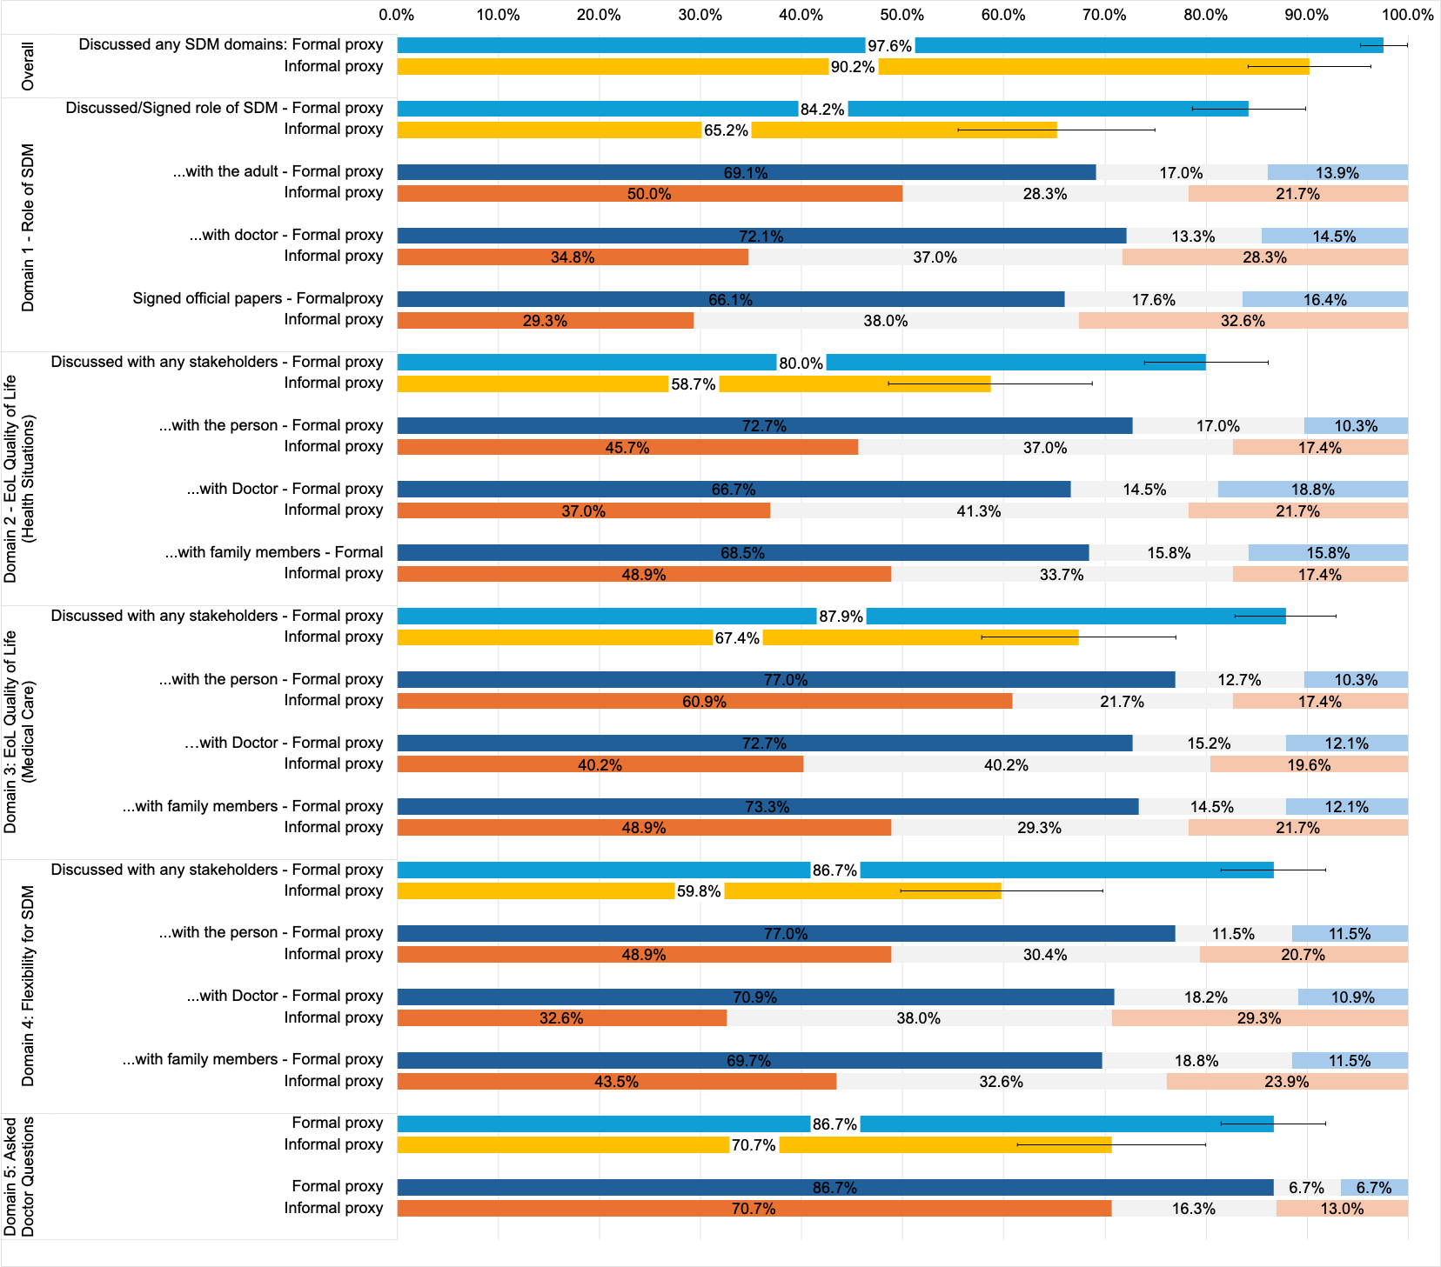
Notes: EoL: end-of-life; HS: Health situations; SDM Flex: surrogate decision-making flexibility.

