Mesenchymal Stem Cells Promote Healing of Radiation-Induced Skin Injury by Enhancing Mitochondrial Function
Guangyan He^{a,b,1}, Yang Xu^{b,1}, Wengfeng Li^{b}, Xiaorui Shi^{c}, Xueli Pan^{a*}, Chunmeng Shi^{a,b*}
ªSchool of Public Health, the Key Laboratory of Environmental Pollution Monitoring and Disease Control, Ministry of Education, Guizhou Medical University, Guiyang 561113, China
^{b}Institute of Rocket Force Medicine, State Key Laboratory of Trauma and Chemical Poisoning, Third Military Medical University (Army Medical University), Gaotanyan Road Street, Shapingba district, Chongqing 400038, China
^{c}Department of Plastic Surgery, State Key Laboratory of Trauma and Chemical Poisoning, Southwest Hospital, Third Military Medical University (Army Medical University), Gaotanyan Road Street, Shapingba district, Chongqing 400038, China

¹These authors contributed equally to the study.

*Corresponding author: Email: xuelipan@gmc.edu.cn, shicm@tmmu.edu.cn.
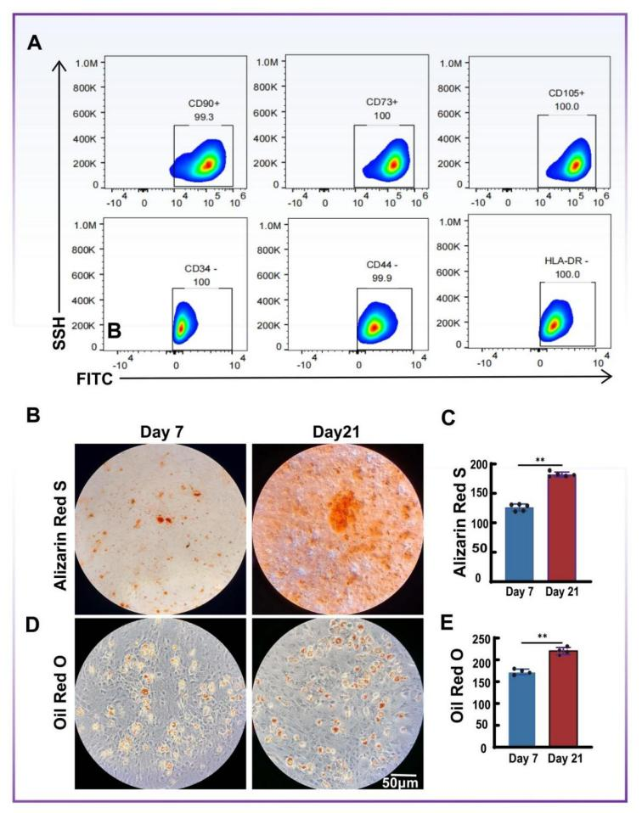
Fig. S1. Identification and characterization of HUCMSCs. (A) Flow cytometric characterization of surface markers: positive markers CD90, CD73, CD105; negative markers CD34, CD44, HLA-DR. Characterization of HUCMSCs. (B) Representative Oil Red O staining showing lipid droplet formation at Day 7 and Day 21 following adipogenic induction. (C) Semi-quantitative analysis of Oil Red O staining. (D) Representative Alizarin Red staining showing mineralized nodules at Day 7 and Day 21 following osteogenic induction. (E) Semi-quantitative analysis of Alizarin Red staining. n=3 (**p < 0.01).

